SUPPLEMENTARY FILE
Table S.1. Techniques used for the analysis of chemical components in tested samples
Sr. No. | Analyte | Techniques
Sr. No. | Analyte | Labstat International | Enthalpy Analytical
1. | Nitrosamines
 | Tobacco Specific Nitrosamines | GC-TEA | GC/MS/MS.
 | Volatile Nitrosamines and  N-Nitroso Alkanolamines | LC-MS/MS | GC-TEA
 | N-nitrososarcosine | GC-MS | GC-MS
2. | PAH | GC-MS (SIM) | GC-MS

Table S.2. Technical procedures followed to assess the chemical components
Constituent | Lab A | Lab B
Volatile Nitrosamines | A sample of tobacco product (1.5g) was spiked with an internal standard mixture solution, and extracted with 50mL of distilled water. A portion of the aqueous extract was centrifuged, filtered and acidified using ammonium sulphamate/sulphuric acid and then saturated with ammonium sulphate. The extract was then passed through a ChemElut® cartridge using ethyl formate containing 2% ethanol. The eluate was evaporated to approx. 0.8mL and then was diluted with 1% formic acid solution. The nitrosamines were then determined by liquid chromatography- APCI+-tandem mass spectrometry detection. The mass detector was operated under multiple reaction monitoring (MRM) mode. | Tobacco aliquots were extracted in water, filtered, and solvent-exchanged for analysis by GC/MS/MS.
NSAR | 2 g of the ground and homogenized tobacco (from a freshly opened source) was spiked with internal standard (IS), and extracted with 25mL 2% formic acid solution and shaken for 45 minutes. The extraction solution was allowed to stand for 15min and then the supernatant was filtered through a 0.45µm syringe filter into an amber collection vial. The extract was applied to an ISOLUTE HM-N (or equivalent such as CHEM ELUTE) cartridge to perform solid phase supported liquid-liquid extraction. The cartridge was then eluted with ethyl formate, and the eluent evaporated to dryness. This was then taken up in methanol containing 2% formic acid for analysis by LC- MS/MS.  A 5µL aliquot of the sample solution was injected to the LC-MS system. The analyte was separated and determined by LC-MS/MS with negative electrospray ionization (ESI) under multiple reaction mode (MRM). | This analytical method is applicable to the determination of N-Nitrososarcosine (NSAR) in smokeless tobacco products within the range 25–1000 ng/g. NSAR and the added internal standard were extracted from tobacco using an aqueous solution containing 0.05% v/v H₂SO₄ with 1% ammonium sulfamate, sodium chloride and ethyl acetate. After mechanical shaking, the layers were allowed to settle and the organic layer was transferred to a clean, dry vial. The solution was evaporated to dryness and redissolved in EtOAc. The sample was then dried with Na₂SO₄, filtered, derivatized with BSTFA and analyzed by GC-MS.
NDELA | A sample of tobacco product (1g) was spiked with NDELA-d8 (the internal standard), and extracted with 50mL of water at 40°C for 16 hours. A portion of the aqueous extract (20mL) was centrifuged, filtered and acidified using ammonium sulphamate/sulphuric acid and then saturated with ammonium sulphate. The extract was then passed through a ChemElut® cartridge using ethyl formate containing 2% ethanol as an eluent. The eluate was evaporated to approx. 1mL and then subjected to SPE clean-up (florisil). Hydroxynitrosamines were eluted from the florisil cartridge with methanol. The sample was concentrated to near-dryness, and the residue was diluted with 0.01% formic acid solution. The hydroxynitrosamines were then determined by liquid chromatography-APCI+-tandem mass spectrometry detection. The mass detector was operated under multiple reaction monitoring (MRM) mode. | This method is applicable to the determination of NDELA in smokeless tobacco products within the range 0.4 – 10 μg/g. NDELA was extracted from tobacco with water. After the internal standard was added, the analytes are partitioned into ethyl acetate with the assistance of sodium sulfate. The ethyl acetate extracts were reduced to ~ 5 mL, filtered and derivatized with (N, O-Bistrifluoroacetamide) BSTFA. The sample was spiked with internal standard (NBHBA- N-nitroso-butyl-N-(4-hydroxylbutyl) amine), vortexed, filtered and derivatized with BSTFA. Samples were analyzed using a GC with a TEA (thermal energy analyzer) and typically reported on a ng/g basis.
PAH | Selected PAHs were extracted from a sample of tobacco after a saponification with an alcoholic KOH solution and partitioning into iso-octane. The iso-octane extract was evaporated to 2 to 3mL on a rotary evaporator. The concentrated sample was then passed through a 3mL NH2 (200 mg) plus silica gel (750 mg) cartridge by using the RapidTrace SPE Workstation and PAHs retained were eluted with 13mL hexane. The solvent was evaporated to 2mL in the Turbovap evaporator and transferred to an autosampler vial for GCMS analysis. The mass detector was operated under Selected Ion Monitoring (SIM) mode. | The calibration range specified in the method is from 0.5 ng/ml to 100 ng/ml using GC-MS. This is equivalent to 5.0 to 1000 ng/g of sample. The PAH content of tobacco products was determined by extracting the tobacco with methanol followed by solid-phase extraction (SPE) prior to gas chromatography/mass spectrometric analysis.  Naphthalene by GC-MS  0.25 g of tobacco was extracted into 15 mL of methanol. A solution of mixed internal standards was added and the samples were shaken for 30 minutes, followed by centrifugation if necessary. The extracts were then filtered and analyzed by GC-MS. The concentrations of the analytes were determined using an internal standard and are reported on a μg/g basis.

Table S.3: Limit of Detection and Limit of Quantitation of Measured Components
Sr. No | Chemical Name | Structure | LOD | LOQ | LOD | LOQ
Sr. No | Chemical Name | Structure | (LAB B) |  | (LAB A)
 | Nitrosamines (ng/g) |  | ng/g (dry weight basis)
 | Tobacco Specific Nitrosamines
 | Nitrosoanabasine (NAB) | 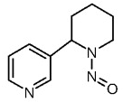 | 1.29 | 12.9 | 31.0 | 103
 | 4-(N-nitrosomethylamino)-1- (3-pyridyl)-1-butanone (NNK) | 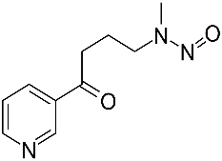 | 1.29 | 12.9 | 81.5 | 272
 | N-Nitrosonornicotine (NNN) | 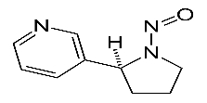 | 3.27 | 13.1 | 54.0 | 180
 | Volatile Nitrosamines
 | NDMA | 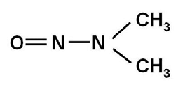 | 1.70 | 12.9 | 0.863 | 2.88
 | NPIP | 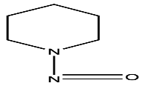 | 3.32 | 12.9 | 0.861 | 2.87
 | NPYR | 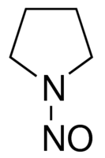 | 1.29 | 12.9 | 1.42 | 4.72
 | NMOR | 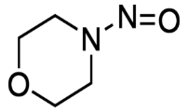 | 4.35 | 12.9 | 0.436 | 1.45
 | NSAR (N-Nitrososarcosine) | 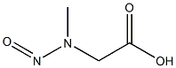 | 43.2 | 130 | 0.782 | 2.61
 | NDELA  (N-Nitroso Alkanolamines) | 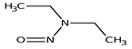 | 202 | 605 | 0.599 | 2.00
 | Polyaromatic Hydrocarbons (ng/g)
 | Naphthalene | 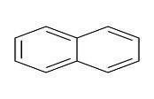 | 316 | 948 | 0.063 | 0.210
 | Benzo(a)anthracene | 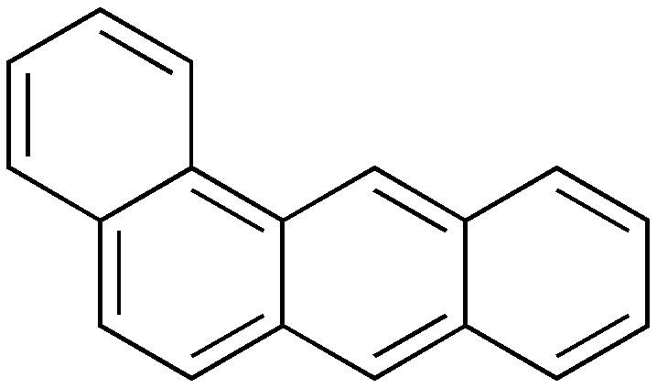 | 0.638 | 6.43 | 0.046 | 0.152
 | Chrysene | 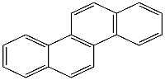 | 0.638 | 6.35 | 0.029 | 0.097
 | Benzo(b)fluoranthene | 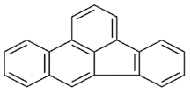 | 0.638 | 6.38 | 0.106 | 0.352
 | Benzo(k)fluoranthene | 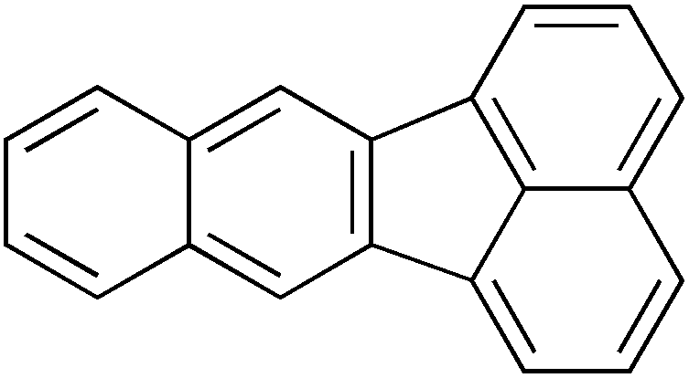 | 1.02 | 6.34 | 0.074 | 0.247
 | Benzo(a)pyrene | 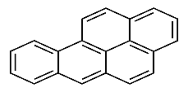 | 0.638 | 6.42 | 0.066 | 0.221
 | Indeno(1,2,3-cd)pyrene | 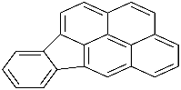 | 0.638 | 6.34 | 0.063 | 0.211
 | Dibenz(a,h)anthracene | 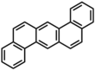 | 0.638 | 6.38 | 0.077 | 0.258

Table S.4: Order of Constituents based on Mean Value (Ranges of Concentration in Descending manner)
 |  | Lab A | Lab B
NNK | higher to lower | HMH > SMH > MMH > MGT > HGT > Rest all values are NQ | SMH > MMH > BSN > HKH > MGT > MKH > HGT > SKH > SPT > MPT > HPT > HMH.
NAB | higher to lower | HMH > MMH > SMH > HKH > SKH > MKH > MGT > HGT, BSN, MPT= NQ > HPT, SPT=ND | HMH > SMH > MMH > SKH > MKH > HKH > BSN > MGT > HGT > SPT > MPT > HPT = NQ
NNN | higher to lower | HMH > MMH > SMH > HKH > SKH > BSN > MKH > MGT > HGT > SPT > MPT > HPT | HMH > SMH > MMH > SKH > MKH > BSN > HKH > HGT > MGT > SPT > MPT > HPT
NDELA | higher to lower | MMH > HMH > MGT > BSN > MPT > SMH > HPT > SKH > HGT > SPT = HKH = MKH = NQ | All values are NQ and/ or ND.
NSAR | lower to higher | SPT < MPT < HGT < MGT < BSN < SKH < MMH < SMH < HMH | MMH < SMH < HMH. Rest all values are NQ and/ or ND.
NDMA | Higher to lower | HMH > SMH > MKH > MMH > HGT > MPT > BSN > SPT > MGT > SKH > HPT | HMH > Rest all values are NQ and/ or ND.
NPYR | Higher to lower | HMH > SMH > MMH > HKH > MKH > HPT > Rest all values are ND | HMH > MMH > SMH > SKH > rest all values are NQ and/ or ND.
NAP | higher to lower | HMH < HPT < SPT < HGT < MGT < MPT < SMH < MMH < HKH < SKH < BSN < MKH | All values are NQ and/ or ND.
BAA | higher to lower | MMH > SMH > HMH > SPT > HPT > MPT > MKH > HKH = SKH > HGT > BSN > MGT. | MMH > SMH > HMH > HPT > HKH > MPT > SPT > Rest all values are NQ
CHY | higher to lower | MMH > SMH > HMH > SPT > HPT > MPT > MKH > HKH > SKH > BSN > MGT > HGT | MMH > SMH > HMH > HKH > SKH > HPT > SPT > MPT > Rest all values are NQ
BBF | higher to lower | HMH > MMH > SMH > SKH > HKH > SPT > MKH > HPT > BSN > MPT > MGT > HGT | SMH > MMH > HMH > Rest all values are NQ
BKF | higher to lower | SMH > MMH > HMH > SKH > HKH > SPT > HPT > MKH > BSN > MPT > MGT > HGT | SMH > MMH > HMH > Rest all values are NQ
BAP | higher to lower | SMH > MMH > HMH > HKH > SPT > HPT > SKH > MPT > MKH > MGT = HGT > BSN | SMH > MMH > HMH > Rest all values are NQ
IPYR | higher to lower | SMH > MMH > HMH > MKH > HKH > SKH > HPT > SPT > BSN > MPT > MGT > HGT > BSN | SMH > HMH > Rest all values are ND
DBAA | higher to lower | SMH > MMH > HMH > SPT > HPT > rest all values are NQ and or ND | All values are ND

- SOME MEASUREMENTS OF THE SAME SAMPLE SHOW LARGE DIFFERENCES WHEN DONE IN LAB A AND B.
In the present study, test samples were analyzed at two different labs. The test results vary between labs to labs. It doesn't depend on the academics of different labs but it is solely dependent on the different time points, some other variations, and importantly the calibration of different equipment at labs. This clarifies that result of tests done in the same method and conditions from different labs can be very similar but not the same.
In case of using reference sample: the differences between reference ranges from different labs typically are generally not significant, but it is possible that one lab will report a result as being within range while another could report that same result as being out of range. Each lab establishes its own normal ranges for test results. The ranges are based on various factors, such as the sampling method, the instruments used, and the techniques used to analyze components. However, the composition of commercial tobacco samples changes frequently with the changing marketplace, making comparisons of results difficult.

The differences or equivalence of products depend on various sources of variability like analytical methods, manufacturing processes, agricultural practices and environmental conditions.
For tobacco products, important sources of variability can be brought by:
i) the raw tobaccos used due to the inherent natural variability of agricultural products,
ii) the non-tobacco raw material which may differ due to different suppliers or possibly because one supplier has several manufacturing sites.
All these sources of variability, which are not attributed to the analytical measurements, which are frequently called production batch variability or batch-to-batch variability, need to be taken into account for product comparison.

