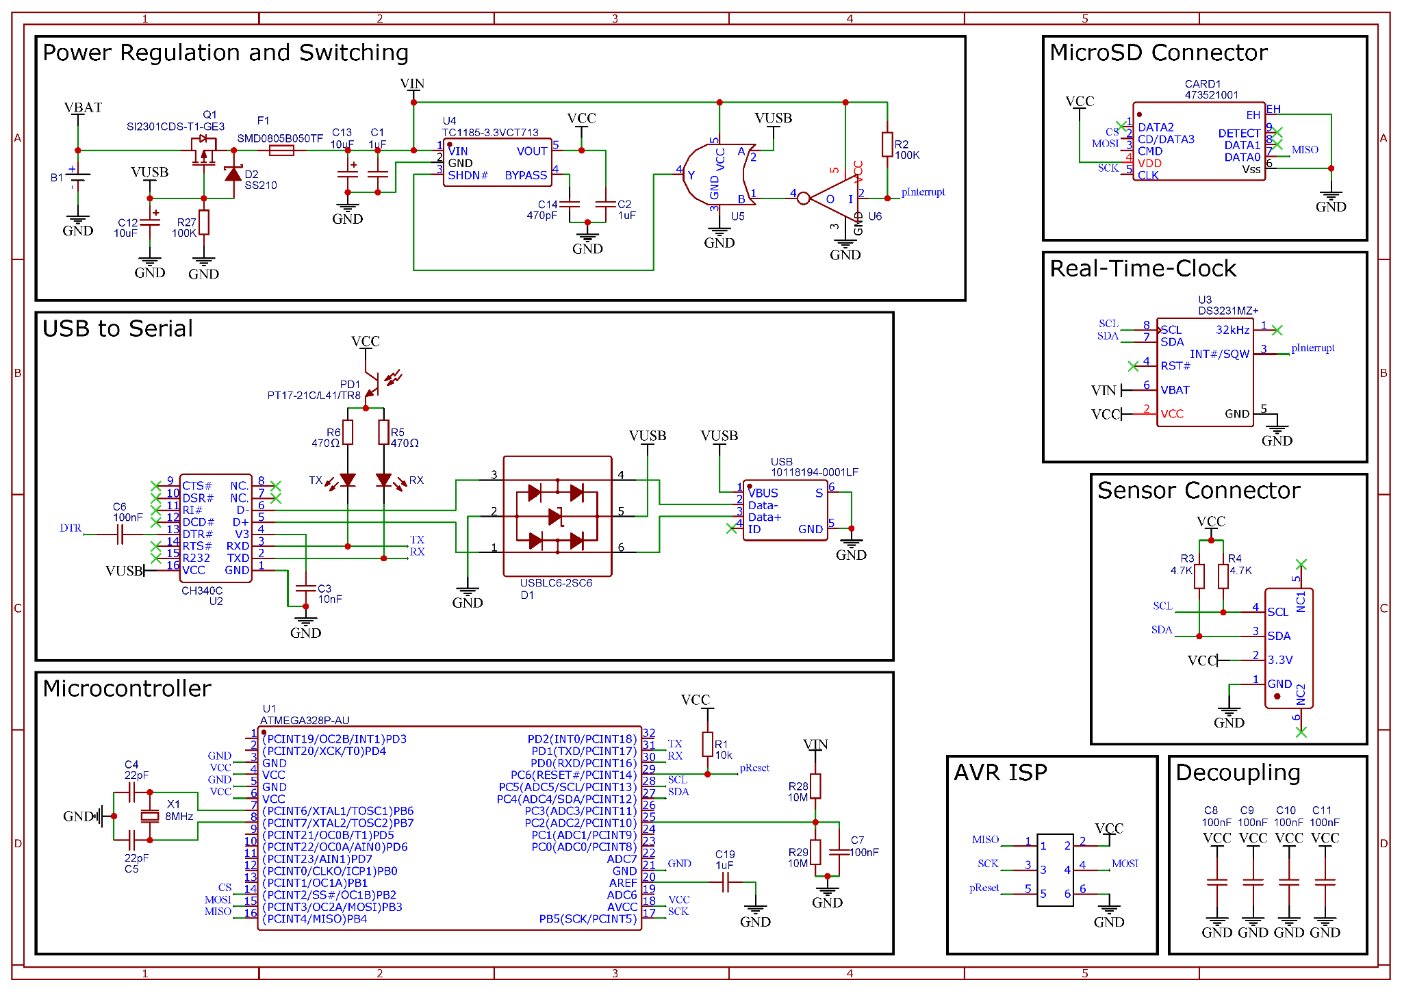
Figure S1: OpenOBS-328 schematic.

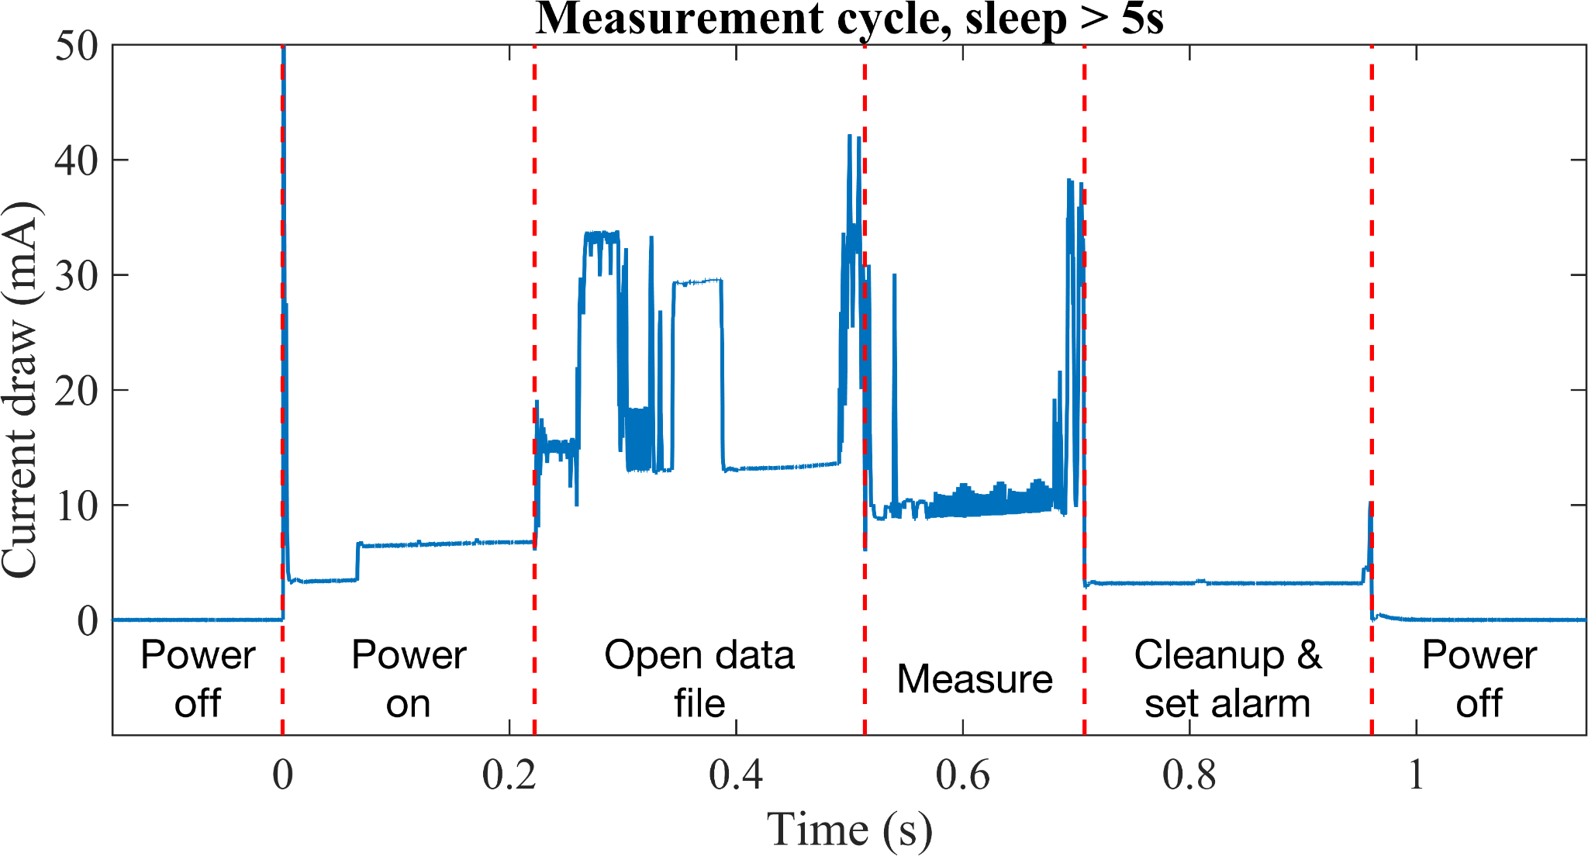
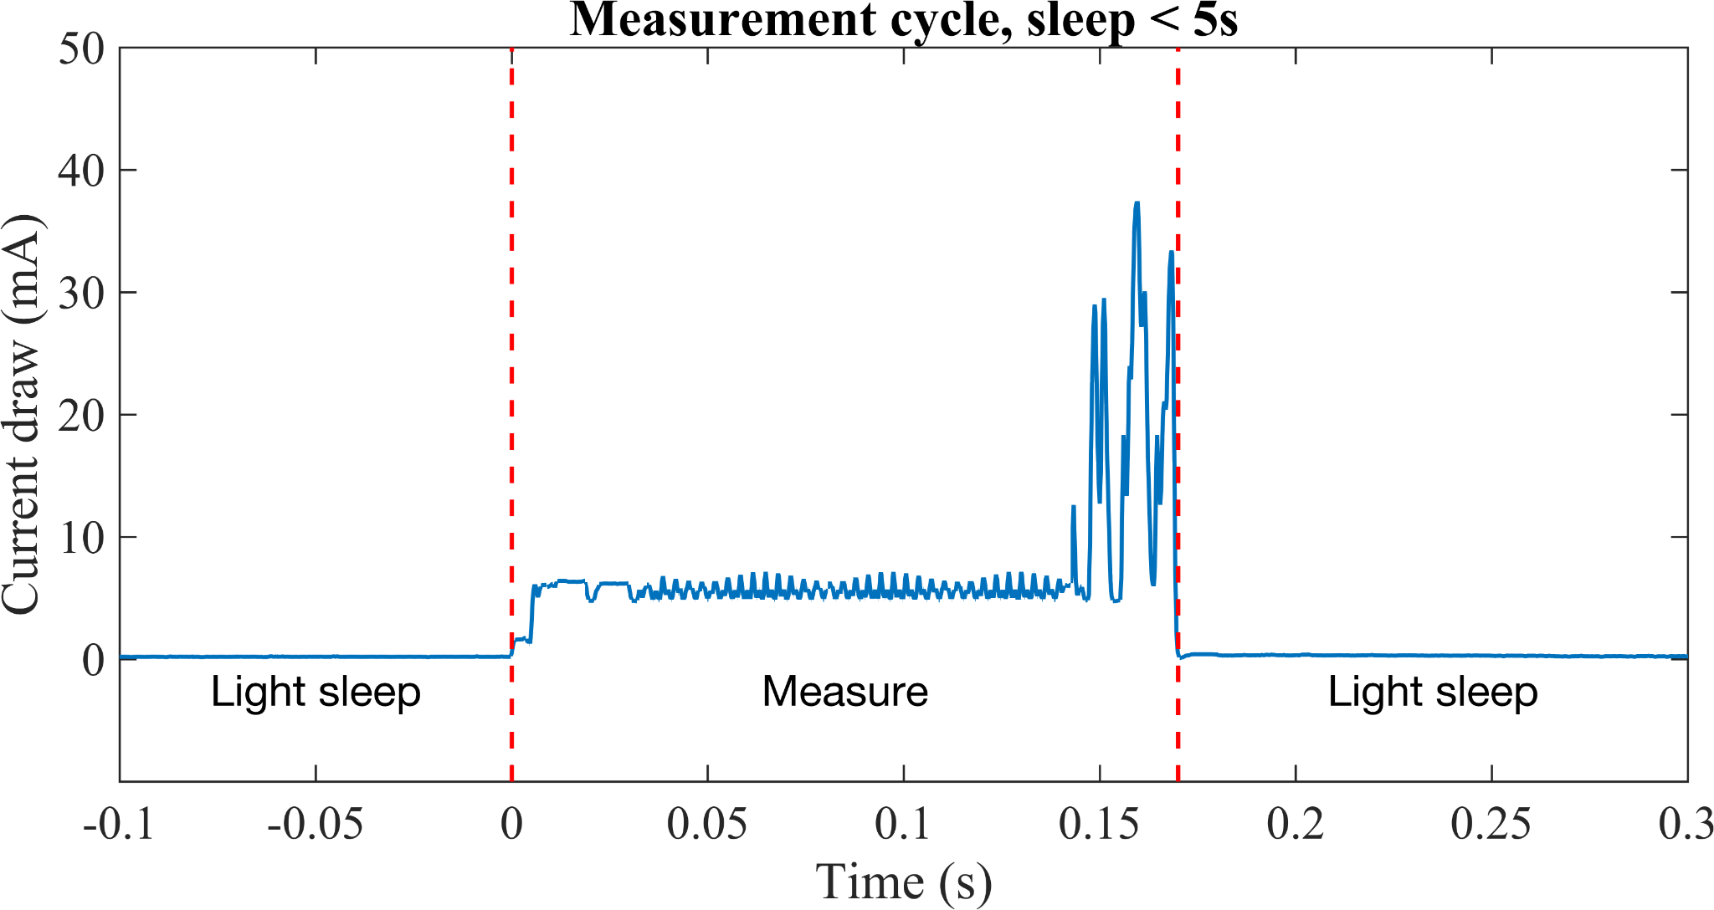
Figure S2: Current draw of the OpenOBS-328 during the measurement cycles.

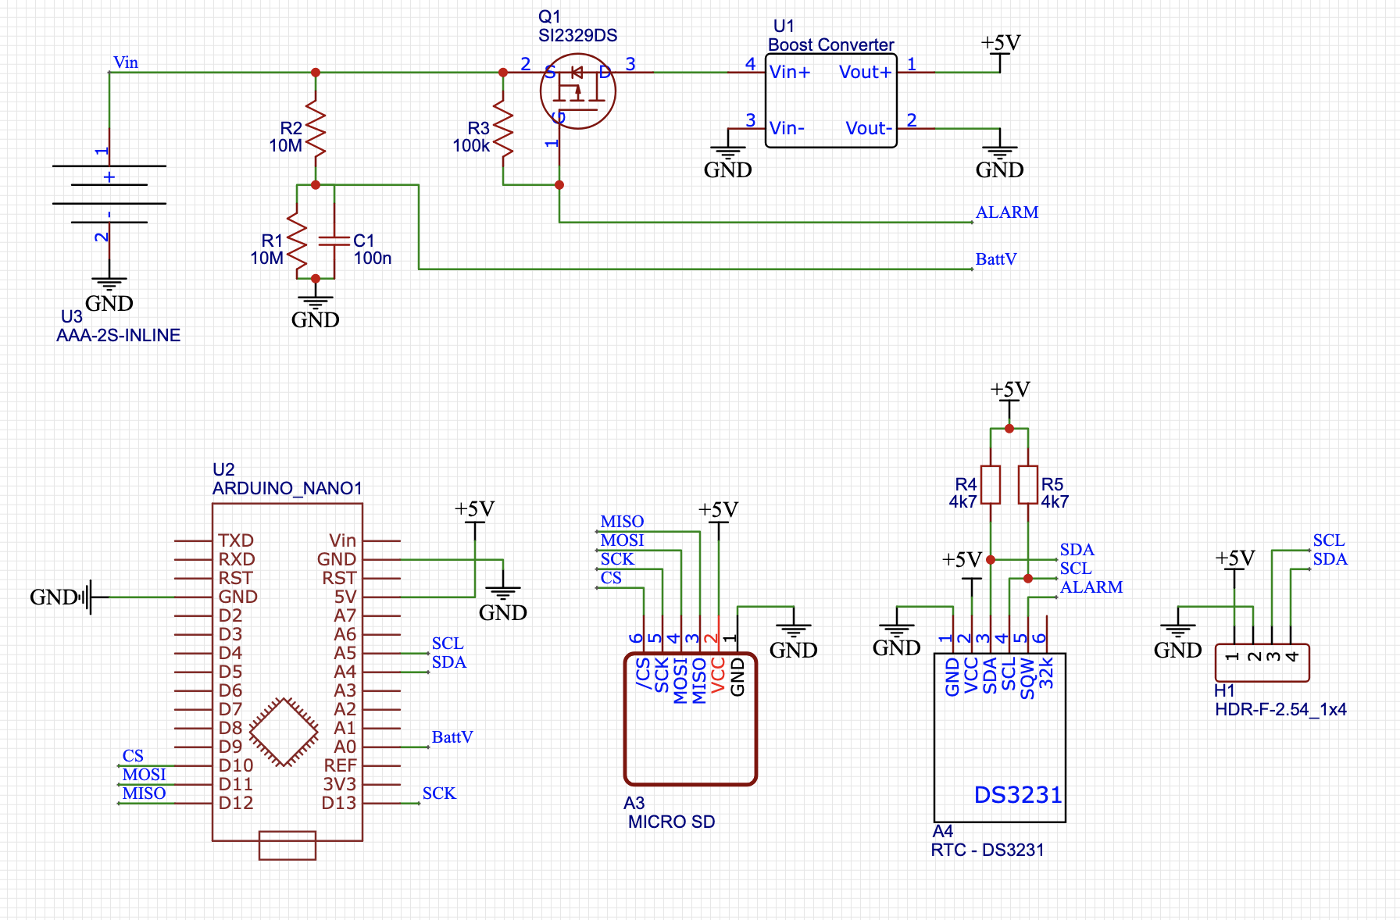
Figure S3: Educational version schematic

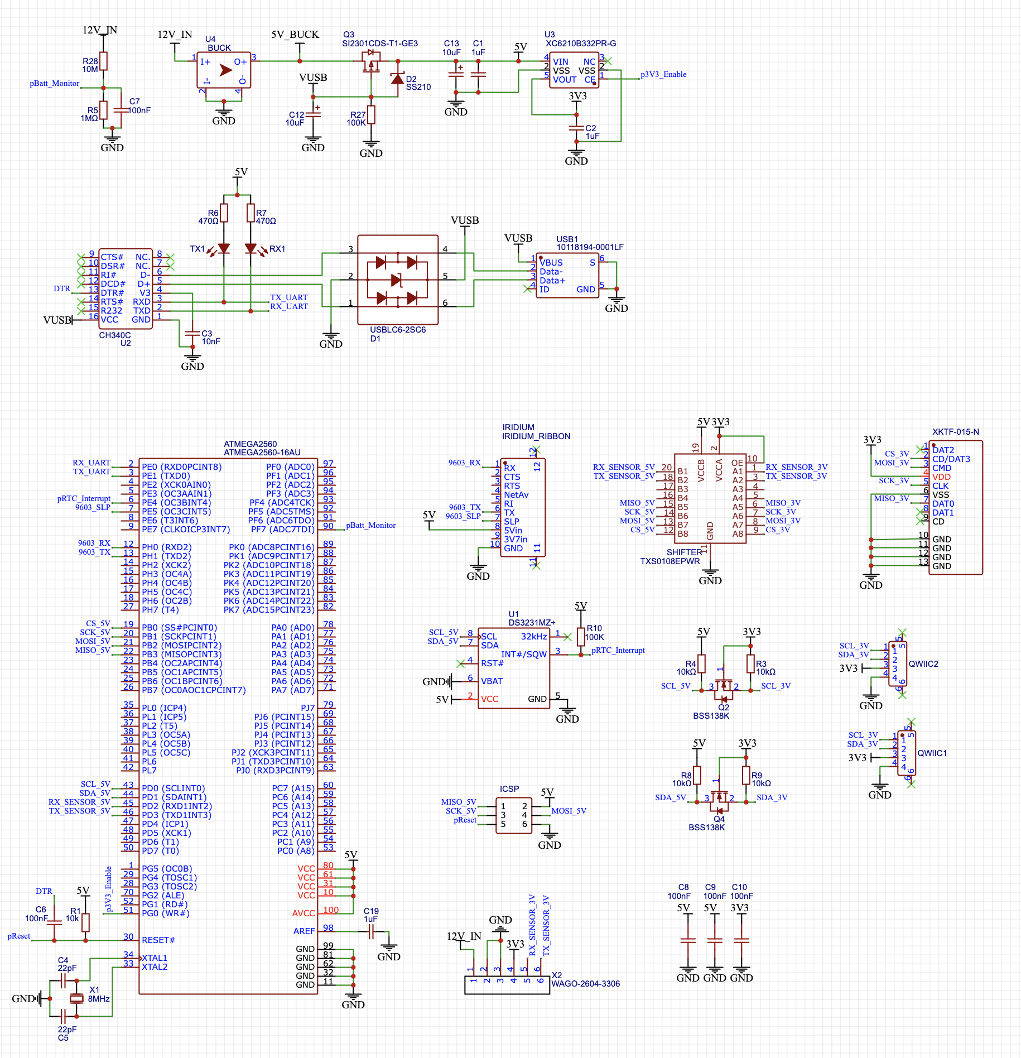
Figure S4: OpenOBS-Iridium logger schematic

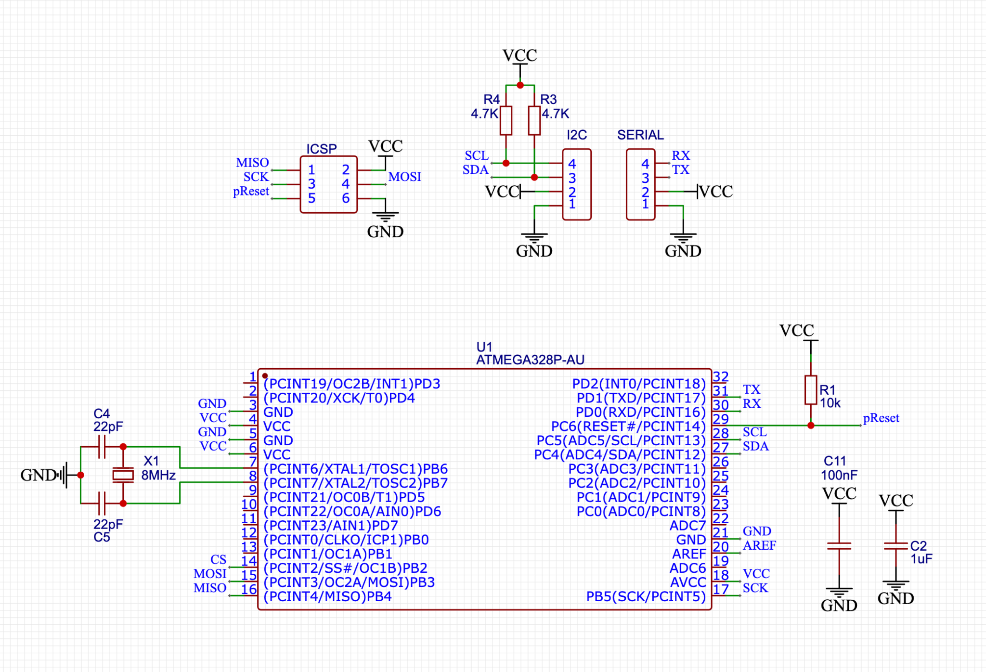
Figure S5: OpenOBS-Iridum sensor schematic

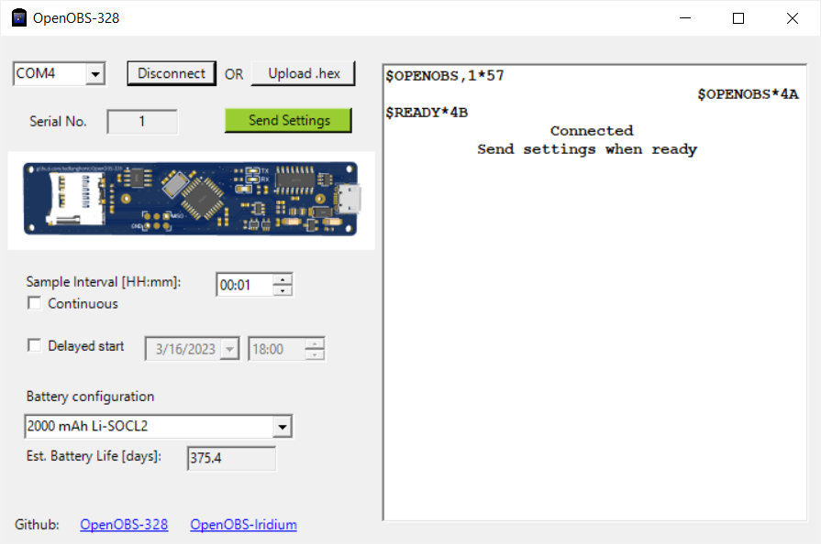
Figure S6: Graphical user interface for the OpenOBS-328. Once the sensor is built, this interface can be used to update firmware or configure a deployment without any code.

