Supplementary Material

Comparative Study and Characterization of Water-treated Bacterial Cellulose produced by Solid or Liquid inoculum of Komagateibacter sucrofermentans

Athanasios Drosos, Golfo G. Kordopati, Charalampos Anastasopoulos, John Zafeiropoulos, Athanasios A. Koutinas, Maria Kanellaki*

Author information
A. Drosos, G. G. Kordopati, C. Anastasopoulos, A. A. Koutinas, M. Kanellaki
Department of Chemistry, University of Patras, GR-26504 Patras, Greece

J. Zafeiropoulos,
School of Science and Technology, Hellenic Open University, Parodos Aristotelous 18, GR-26335 Patras, Greece

*Corresponding Author: Prof. Maria Kanellaki, Department of Chemistry, University of Patras, 26504 Patras, Greece. E-mail: m.kanellaki@upatras.gr

ORCID
A. Drosos: https://orcid.org/0009-0008-6046-5260
G. G. Kordopati: https://orcid.org/0000-0003-2427-6098

Table S1. Surface elemental (C, O, Na, K and Cl) analysis % (w/w) composition data of water-treated BCS₇ and BCL₇ from Energy Dispersive X-ray Spectroscopy (EDS) (H atoms are not observed in EDS)
 | Elemental mass percent (%, w/w)
BC samples | C | O | Na | K | Cl
BCL₇ | 55.29 | 42.01 | 0.64 | 1.20 | 0.86
BCS₇ | 56.29 | 40.26 | 0.72 | 2.09 | 0.64
Standard samples: C: CaCO₃; O: SiO₂; Na: Albite; K: MAD-10 Feldspar; Cl: KCl

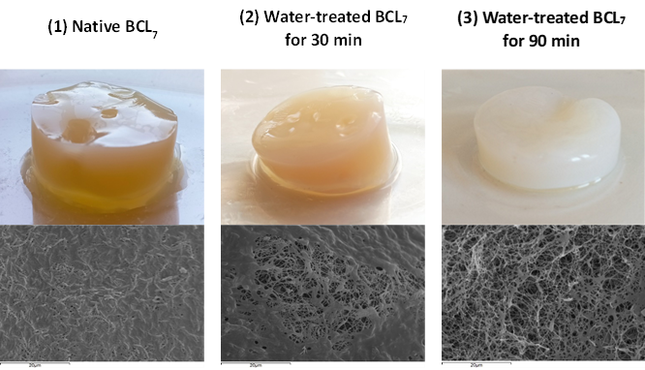
Fig. S1. Gradual depigmentation of the gelatinous pellicles of BCL₇ samples and corresponding surface SEM images: (1) before the water treatment (native BCL₇), (2) after the water treatment for 30 min, and (3) after the water treatment for 90 min, at magnification of 2000x and bar of 20 µm.

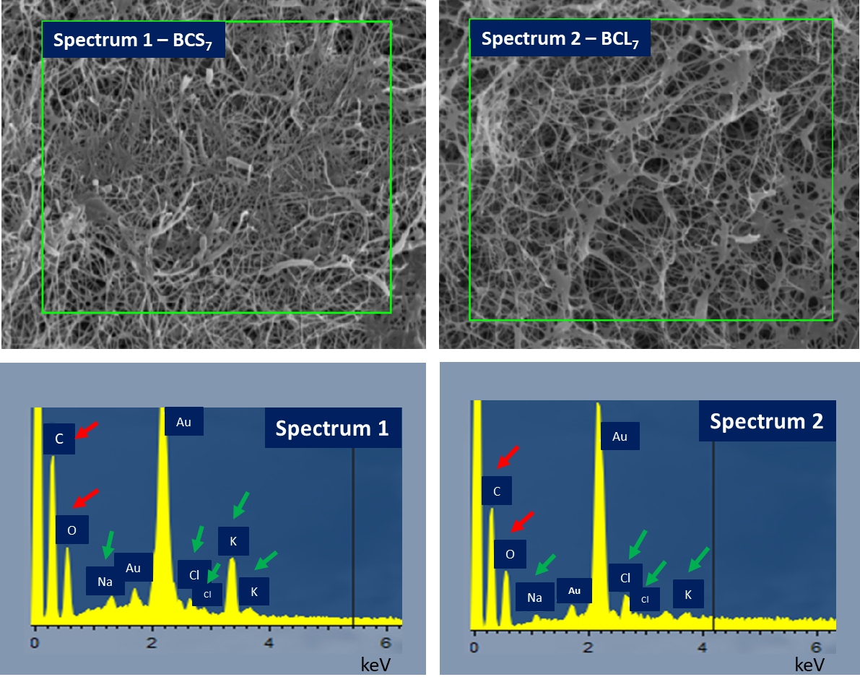
Fig. S2. Energy dispersive X-ray spectrometer (EDS) spectrum of water-treated BCS₇ and BCL₇. Red arrows indicate the main elemental peaks of cellulose (C and O) and green arrows indicate the elemental peaks of culture medium impurities in the spectrum (Na, K and Cl).

Water Retention Rate

Fig. S3. Water retention rate (WRR) of BCL₁₋₇^{20mL}, BCL₇^{100mL}, BCL₇^{400mL}, BCL₇^{1000mL}, BCS₇^{20mL}, BCS₇^{100mL}, BCS₇^{400mL}, and BCS₇^{1000mL} samples.

Rehydration Ratio

Fig. S4. Rehydration ratio (RR) of BCL₁₋₇^{20mL}, BCL₇^{100mL}, BCL₇^{400mL}, BCL₇^{1000mL}, BCS₇^{20mL}, BCS₇^{100mL}, BCS₇^{400mL}, and BCS₇^{1000mL} samples.

Water Swelling Ability

Fig. S5. Water swelling ability (WSA) of BCL₁₋₇^{20mL}, BCL₇^{100mL}, BCL₇^{400mL}, BCL₇^{1000mL}, BCS₇^{20mL}, BCS₇^{100mL}, BCS₇^{400mL}, and BCS₇^{1000mL} samples.

Fig. S6. TG and DTG curves of BCL₁₋₇^{20mL} and BCS₇^{20mL} samples, separately.

