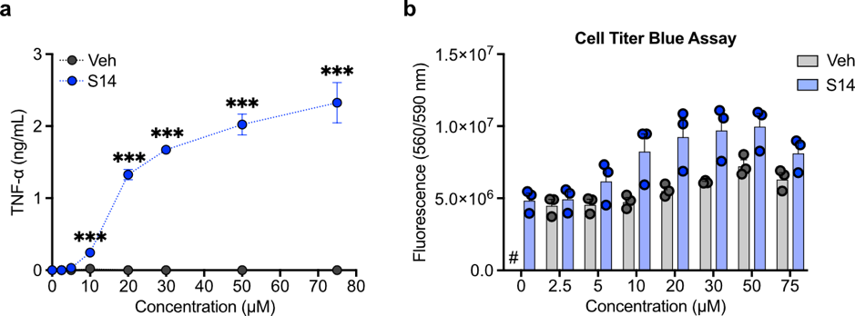
Extended Figure 1| Concentration Titration and Cell Cytotoxicity of Sphingomyelin 14:0
(a-b) WT BMDMs were stimulated for 18 h with indicated concentrations of vehicle control or S14 and (a) cytokine release as well as (b) cell viability by CellTiter-Blue Assay were assessed. Data is presented as mean with SEM of n=3 biological replicates. # indicates no data points (not assessed). Data was analysed by multiple unpaired two-tailed t-tests. P-values adjusted for multiple testing against the control group are presented: *p < 0.05, **p < 0.01, ***p < 0.001.
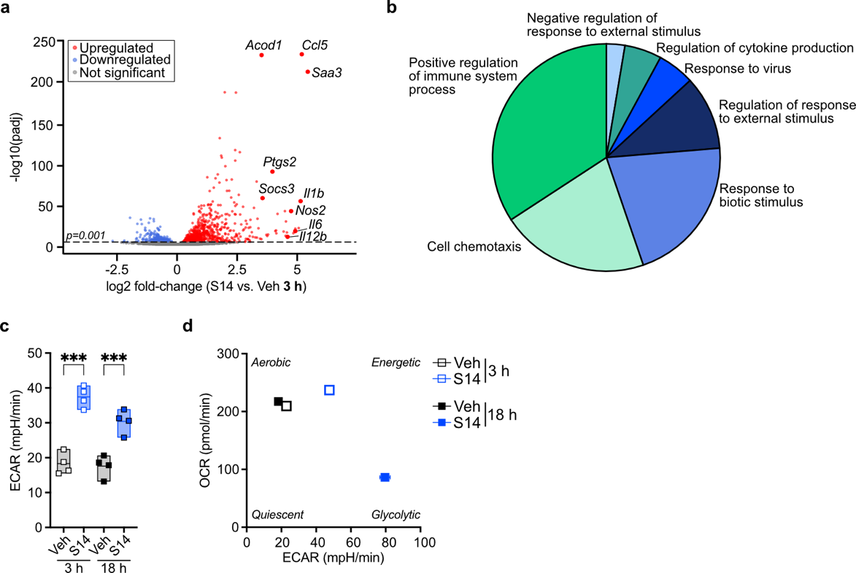
Extended Figure 2| Sphingomyelin 14:0 alters the mouse macrophage transcriptome
(a) Volcano plot of RNA-seq transcriptomic analysis displaying patterns of gene expression for 3 h S14-treated BMDMs (n=4) relative to vehicle control. Significantly differentially expressed genes (adjusted p value < 0.001) are indicated in blue (downregulated) or red (upregulated), and selected highly upregulated genes (log2 fold-change > 2.5) are highlighted. (b) ClueGO analysis of the top 200 upregulated genes from (a), shown as an overview chart of functional groups annotated with the major GO pathway term per group (p < 0.05). (c) Extracellular Acidification Rate (ECAR) as a measure of glycolysis of WT BMDMs stimulated with vehicle control or 30 µM S14 for indicated times; n=4. (d) Overview of Extracellular Flux Analysis Data of BMDMs stimulated for 3 or 18 h with vehicle control or 30 µM S14 summarized in an energy map, displaying basal oxygen consumption rate against basal glycolysis; n=4. Where applicable, data was analysed by one-way ANOVA with Bonferroni post hoc analysis. P-values adjusted for multiple testing against the control group are presented: *p < 0.05, **p < 0.01, ***p < 0.001.
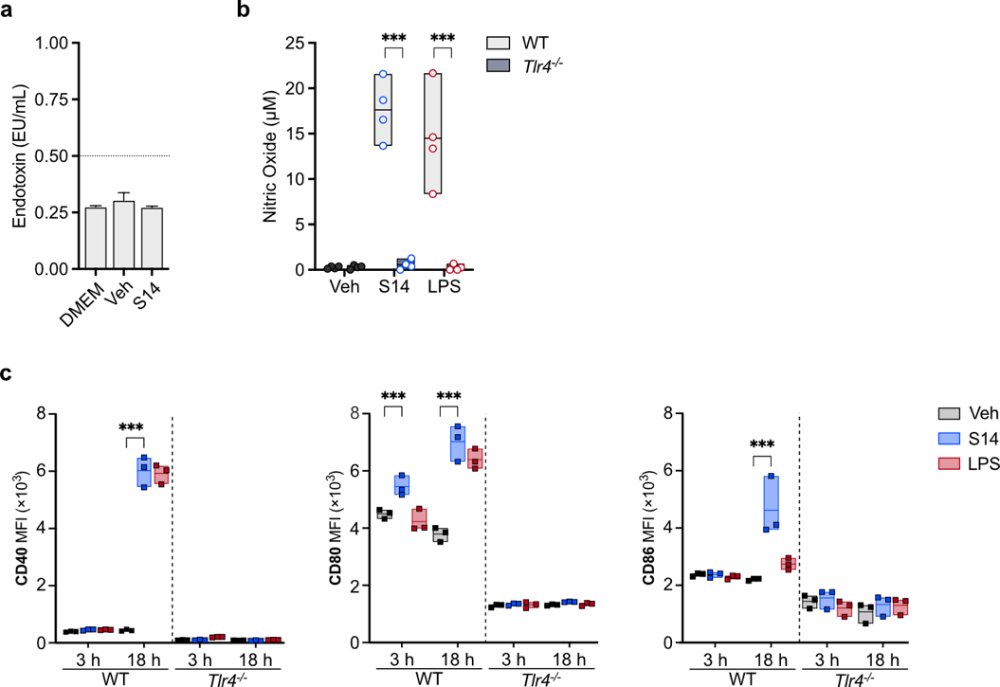
Extended Figure 3| S14 rewires macrophage metabolism and upregulates activation markers in a TLR4-dependent manner
(a) Conventional culture medium (DMEM, Life Technologies), vehicle control and Sphingomyelin (S14) were tested for the presence of gram-negative bacterial endotoxin contamination using the Pierce LAL Chromogenic Endotoxin Quantitation Kit. Mean with SEM; n=3. (b) Griess Assay of WT or Tlr4-/- BMDMs stimulated for 18 h with vehicle control, 30 µM S14 or 100 ng/mL LPS; n=4. (c) WT or Tlr4-/- BMDMs were stimulated for 3 or 18 h with vehicle control, 30 µM S14 or 100 ng/mL LPS before assessing surface expression of co-stimulatory molecules by flow cytometry; n=3. All data, if not stated otherwise, is presented as box plots with indicated mean and individual replicate data points. Where applicable, data was analysed by two-way ANOVA with Bonferroni post hoc analysis. P-values adjusted for multiple testing against the control group are presented: *p < 0.05, **p < 0.01, ***p < 0.001.
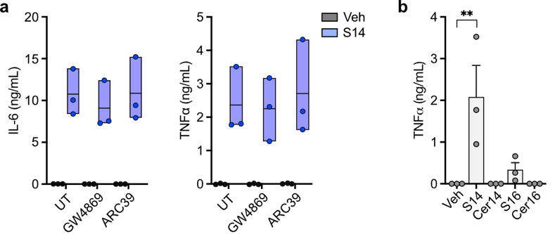
Extended Figure 4| Sphingomyelin but not its downstream catabolites activate TLR4 signalling
(a) WT BMDMs were pre-treated for 30 min with either 10 µM GW4869 or 5 µM ARC39 to inhibit sphingomyelinase activity, before stimulating for 18 h with vehicle control or 30 µM S14 and assessing cytokine release in supernatants. Data is presented as box plots with indicated mean and individual replicate data points; n=3. (b) WT BMDMs were incubated for 18 h with vehicle, 30 µM Sphingomyelin (S14 or S16) or 30 µM Ceramide (Cer) of indicated fatty acid chain length and cytokine release was assessed in culture supernatants; mean with SEM; n=3. Data was analysed by one-way ANOVA with Bonferroni post hoc analysis. P-values adjusted for multiple testing against the control group are presented: *p < 0.05, **p < 0.01, ***p < 0.001.

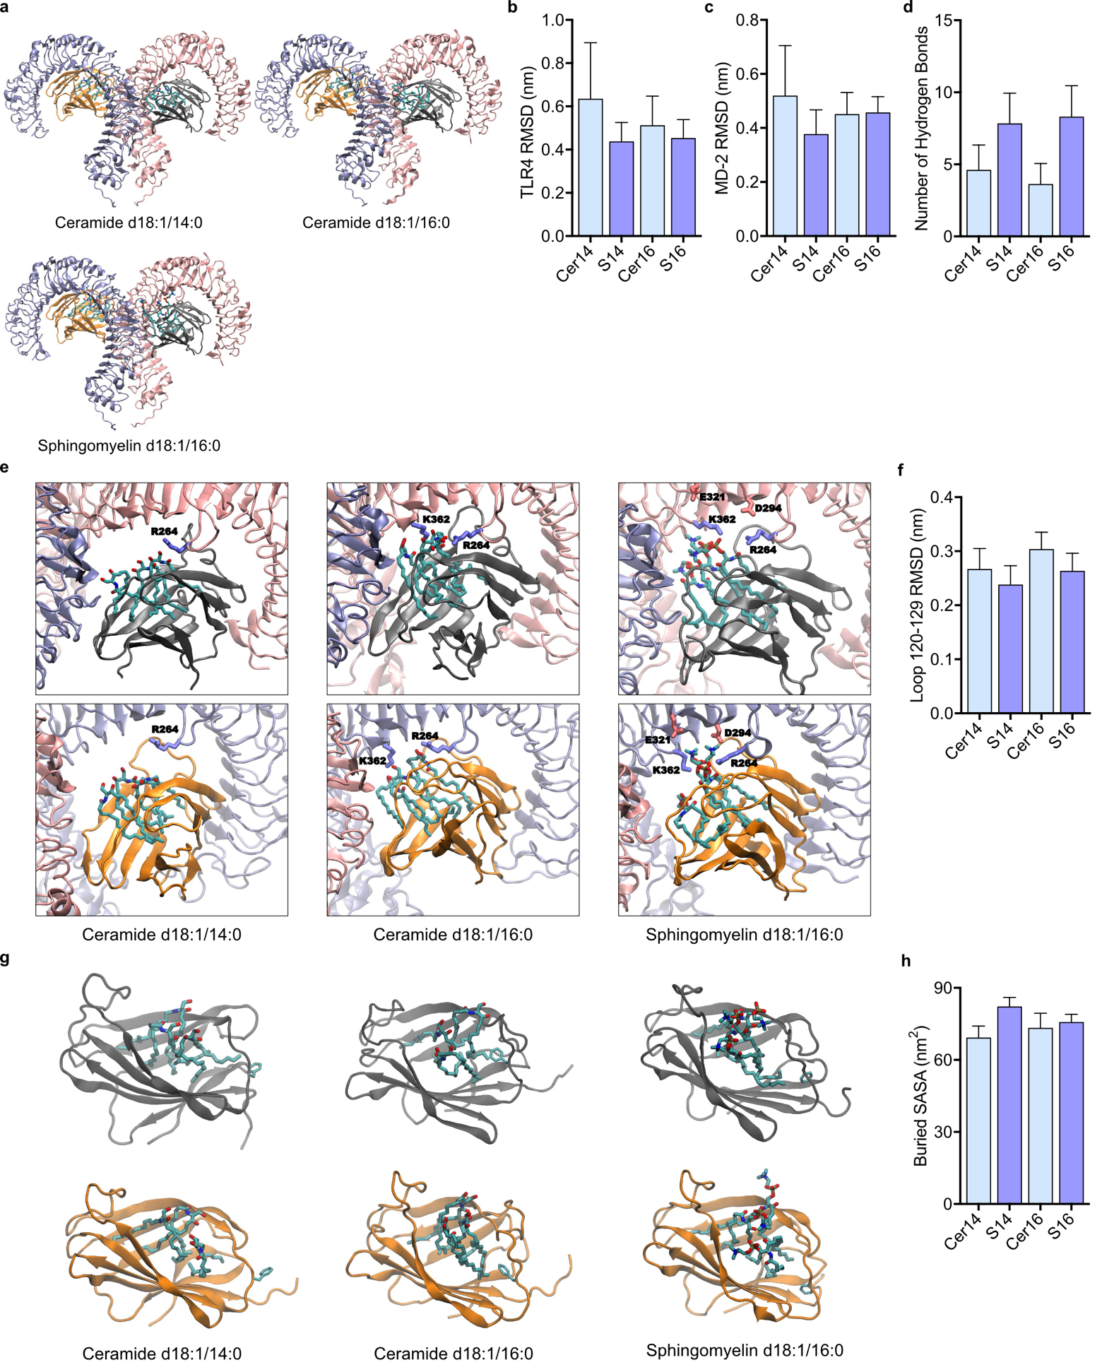
Extended Figure 5| Molecular Dynamic Simulations modelling interactions between TLR4/MD-2 and different sphingolipids
(a-h) MD Simulations for sphingomyelins and ceramides. Individual protein chains are shown in cartoon representation and color-coded, whereas the sphingolipid and amino acid residues are indicated in CPK licorice format. (a) Initial simulation snapshots of the (TLR4/MD-2)2 complex bound to either Ceramide or Sphingomyelin of indicated fatty acid chain length (Cer14, Cer16, S16). (b-d) Assessment of (TLR4/MD-2)2 complex stability during simulation when bound to different lipids with (b) backbone RMSD of dimer of TLR4 proteins with respect to X-ray structure, (c) backbone RMSD of each MD-2 protein and (d) number of hydrogen bonds formed between lipid per monomer. (e) Final zoomed simulation snapshots of each side of the (TLR4/MD-2)2 complex, bound to the indicated lipid. Labeled ionizable amino acid residues (encompassing D294, E321, R264, K362) observed to make significant hydrogen-bonding interactions with each lipid during each trajectory are shown in licorice format, colored in red or blue for acidic or basic, respectively. (f) Backbone RMSD of each MD-2 loop containing F126 compared to X-ray structure, after first aligning on MD-2. (g) Final zoomed snapshots of each MD-2 of the (TLR4/MD-2)₂ complex, bound to the indicated lipid. Each MD-2 protein chain is shown in cartoon format and color-coded with the lipid and F126 shown in CPK licorice format. (h) Buried SASA between each MD-2/lipid complex and dimer of TLR4 ectodomains. Means and standard deviations for all data were calculated over the final 200 ns of pairs of replicate trajectories for each system, and for (b, c, d, f, h) averaged over the two sets of data calculated for each side of the (TLR4/MD-2)₂ complex.

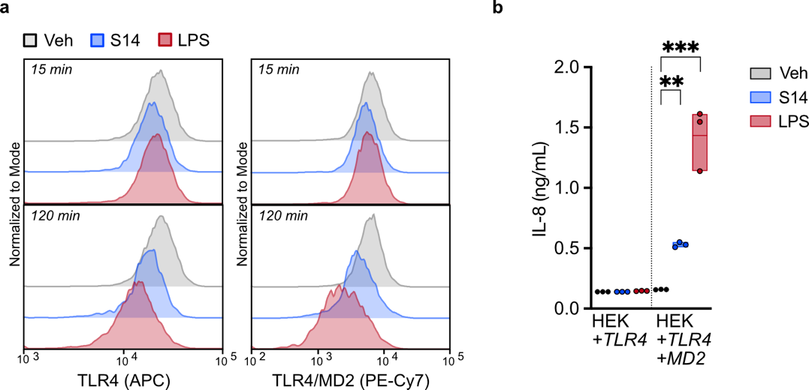
Extended Figure 6| Sphingomyelin 14:0 induces TLR4/MD-2 dimerization and endocytosis
(a) WT BMDMs were stimulated with either vehicle control, 100 ng/mL LPS or 30 µM S14 for the indicated duration and TLR4 surface abundance using two distinct antibodies was assessed by flow cytometry. Shown are representative histograms of one out of n=3 biological replicates. (b) HEK293T cells expressing either human TLR4 alone or both human TLR4 and MD-2 were stimulated for 18 h with vehicle, 30 µM S14 or 10 ng/mL LPS before analysing IL-8 release. Data is shown as box plots with indicated mean and individual data points of n=3 biological replicates and was analysed by two-way ANOVA with Bonferroni post hoc analysis. P-values adjusted for multiple testing against the control group are presented: *p < 0.05, **p < 0.01, ***p < 0.001.
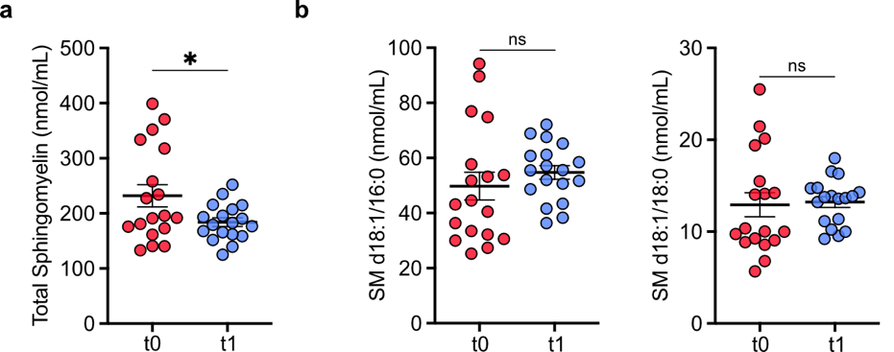
Extended Figure 7| Weight loss in T2D alters the circulating sphingomyelin pool
(a-b) Lipidomic analysis of serum samples from clinical trial NCT05295160 (unpublished data), in which type 2 diabetic patients (n=18) were exposed to a very low-caloric diet (VLCD) for 12 weeks or until a reduction of body weight by 15 kg. Displayed are (a) the total concentration of all sphingomyelin species detected and (b) the concentration of S16 and S18; n=18. Data is presented as mean with SEM and individual biological replicate data points. Data was analysed by either paired two-tailed t-test. P-values are presented: *p < 0.05, **p < 0.01, ***p < 0.001.
SUPPLEMENTARY DATA
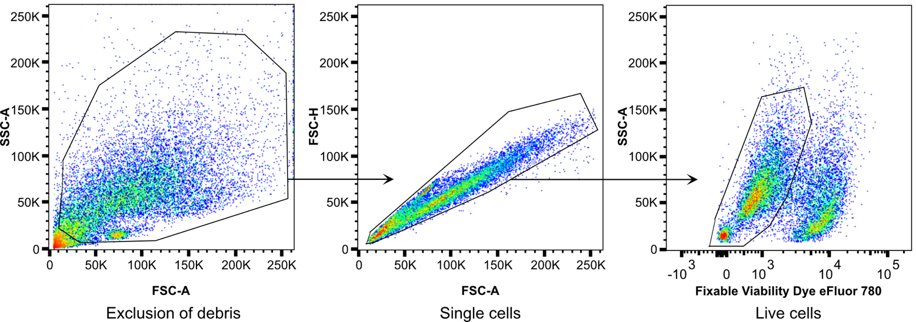
Supplementary Data 1| Gating Strategy Flow Cytometry
For all flow cytometric experiments assessing surface marker expression, the pool of all cells identified in a forward (FSC-A) – sideward (SSC-A) scatter plot was initially separated from cellular debris (left panel). This population was further gated to identify only singlets (middle panel). From the singlet population, all live cells were subsequently identified as those cells that were negative for fixable viability dye (right panel). The resulting population was used to analyse expression of various surface markers.

