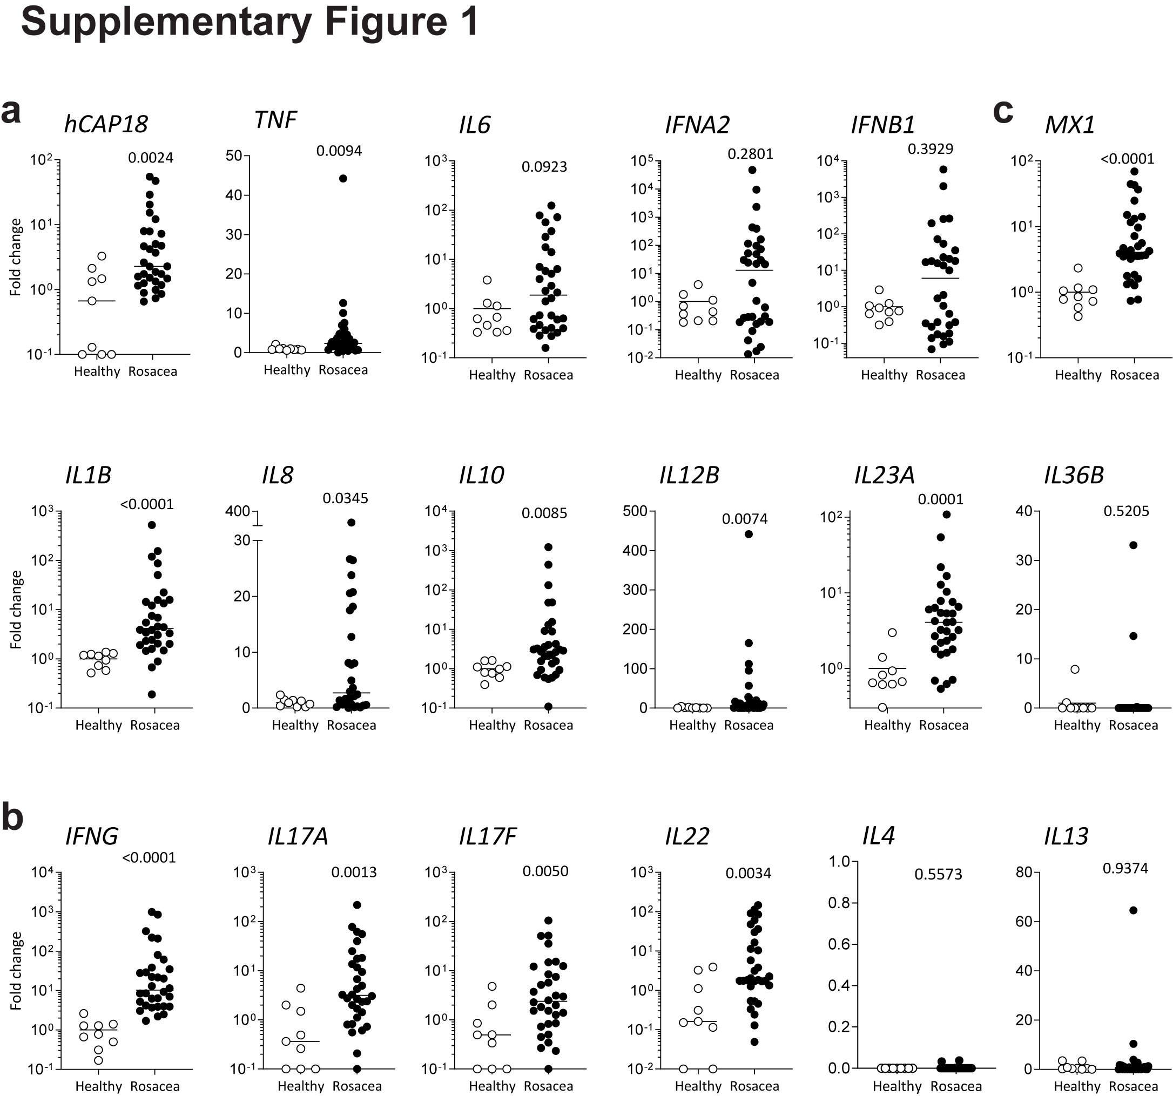

Fig. S1: Inflammatory cytokine profile in lesions of rosacea. (a) Gene expression of innate and (b) adaptive inflammatory genes from biopsies of lesions of rosacea (black, n=32) as compared to healthy skin (white, n=9). (c) MX1 expression comparison between healthy skin and rosacea lesions. P-values of two-tailed Mann-Whitney nonparametric unpaired t-test are depicted.

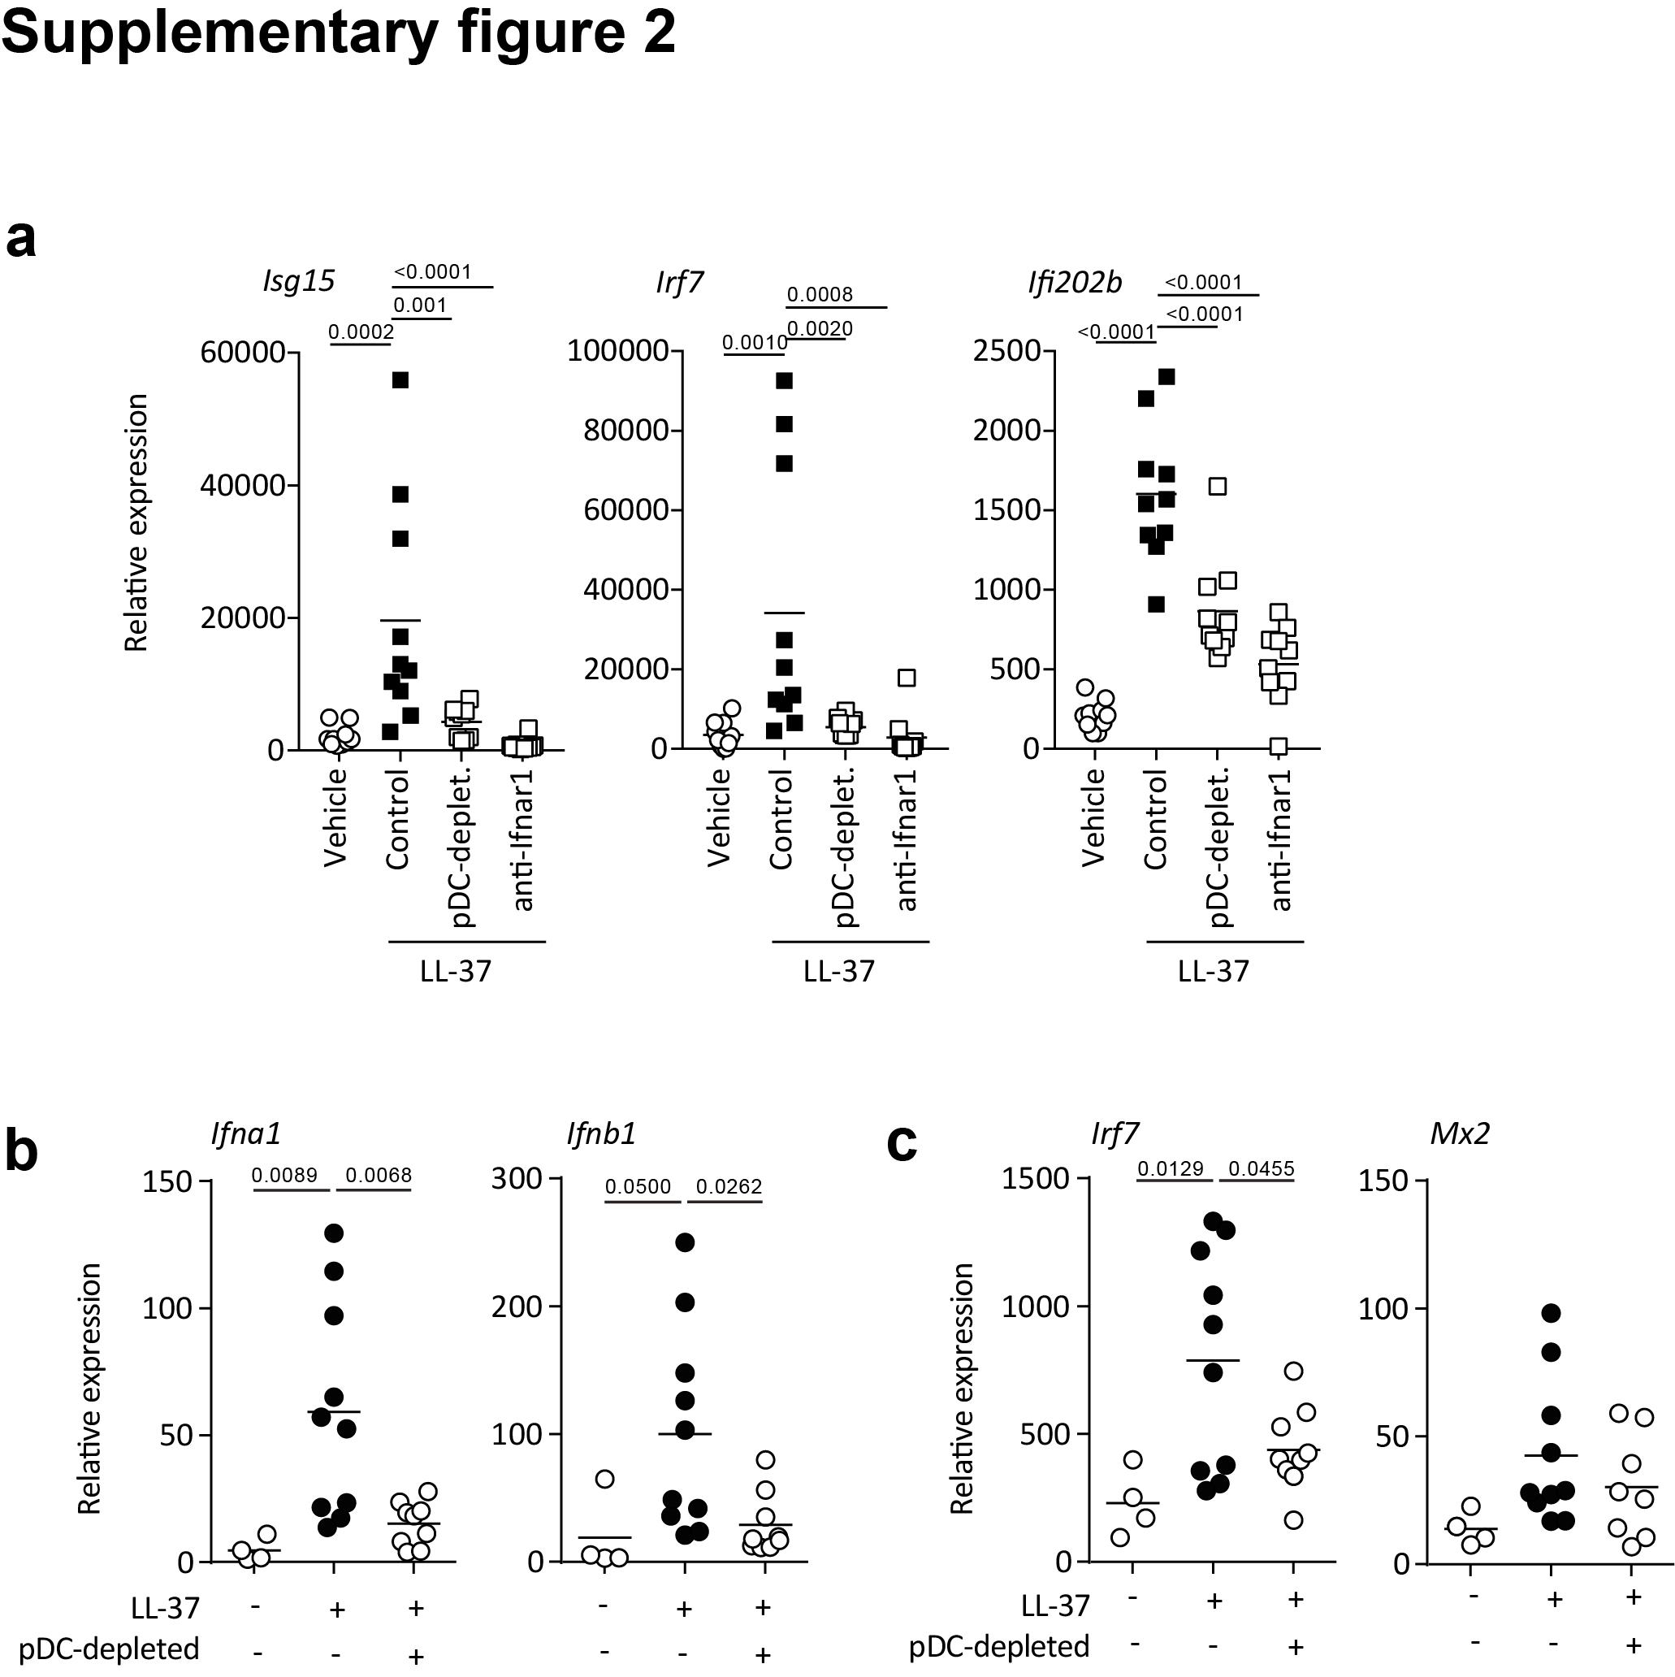

Fig. S2 Antimicrobial peptide LL-37 induces pDC-dependent interferon responses in situ. Gene expression from biopsies following LL-37 intradermal injection in mice (a) depleted of pDCs via antibody-mediated targeting or blockaded of type I interferon signalling, (b) or depleted of pDCs via diptheria toxin injection in BDCA2-DTR transgenic mice. Results depicted of two pooled experiments. Multiplicity adjusted P-values of one-way ANOVA are depicted.

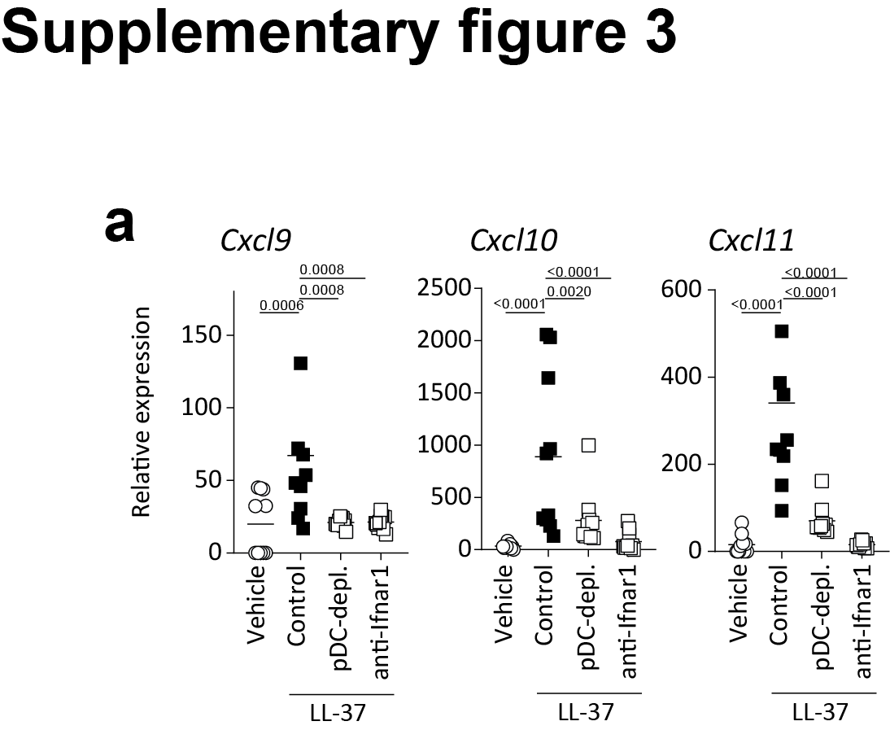

Fig. S3: Type I interferon and pDC contribute to Cxcr3-family chemokine expression. (a) Cxcr3-family chemokine expression in biopsies obtained from intradermally injected mice with corresponding pre-treatments as in Fig. 4). Multiplicity adjusted P-values of one-way ANOVA are depicted.

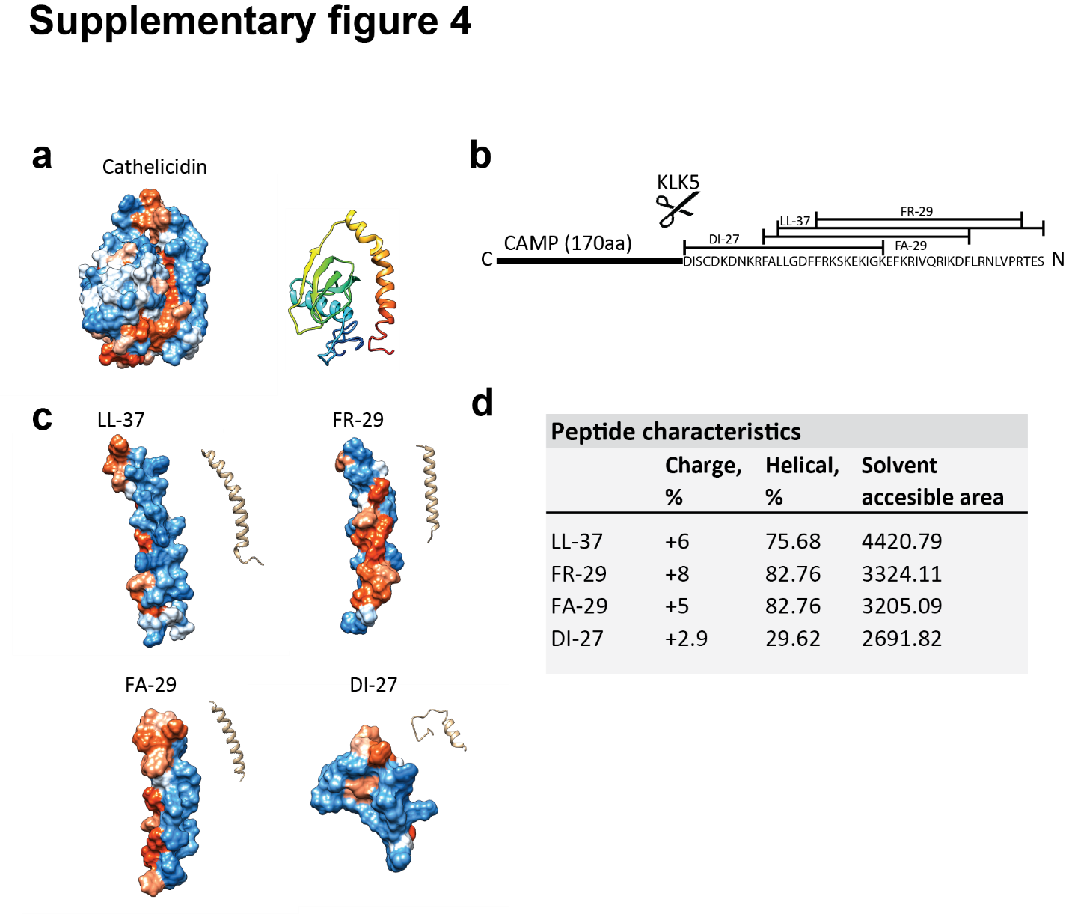

Fig. S4: Cathelicidin peptides described in rosacea. (a) Cathelicidin structure prediction with hydrophobicity colouring of residues depicted (phobic to philic: red to blue). Ribbon representation coloured N- (blue) to C-terminus (red). (b) Cathelicidin Antimicrobial Peptide (CAMP) processing by Kallikrein 5 (KLK5) yields different sized antimicrobial peptides DI-27, FA-29, LL-37, and FR-29 as described elsewhere.¹³ (c) Structure prediction and ribbon representation of cathelicidin antimicrobial peptides, and (d) their accompanying characteristics. Predictions obtained using I-TASSER.^{67,68}

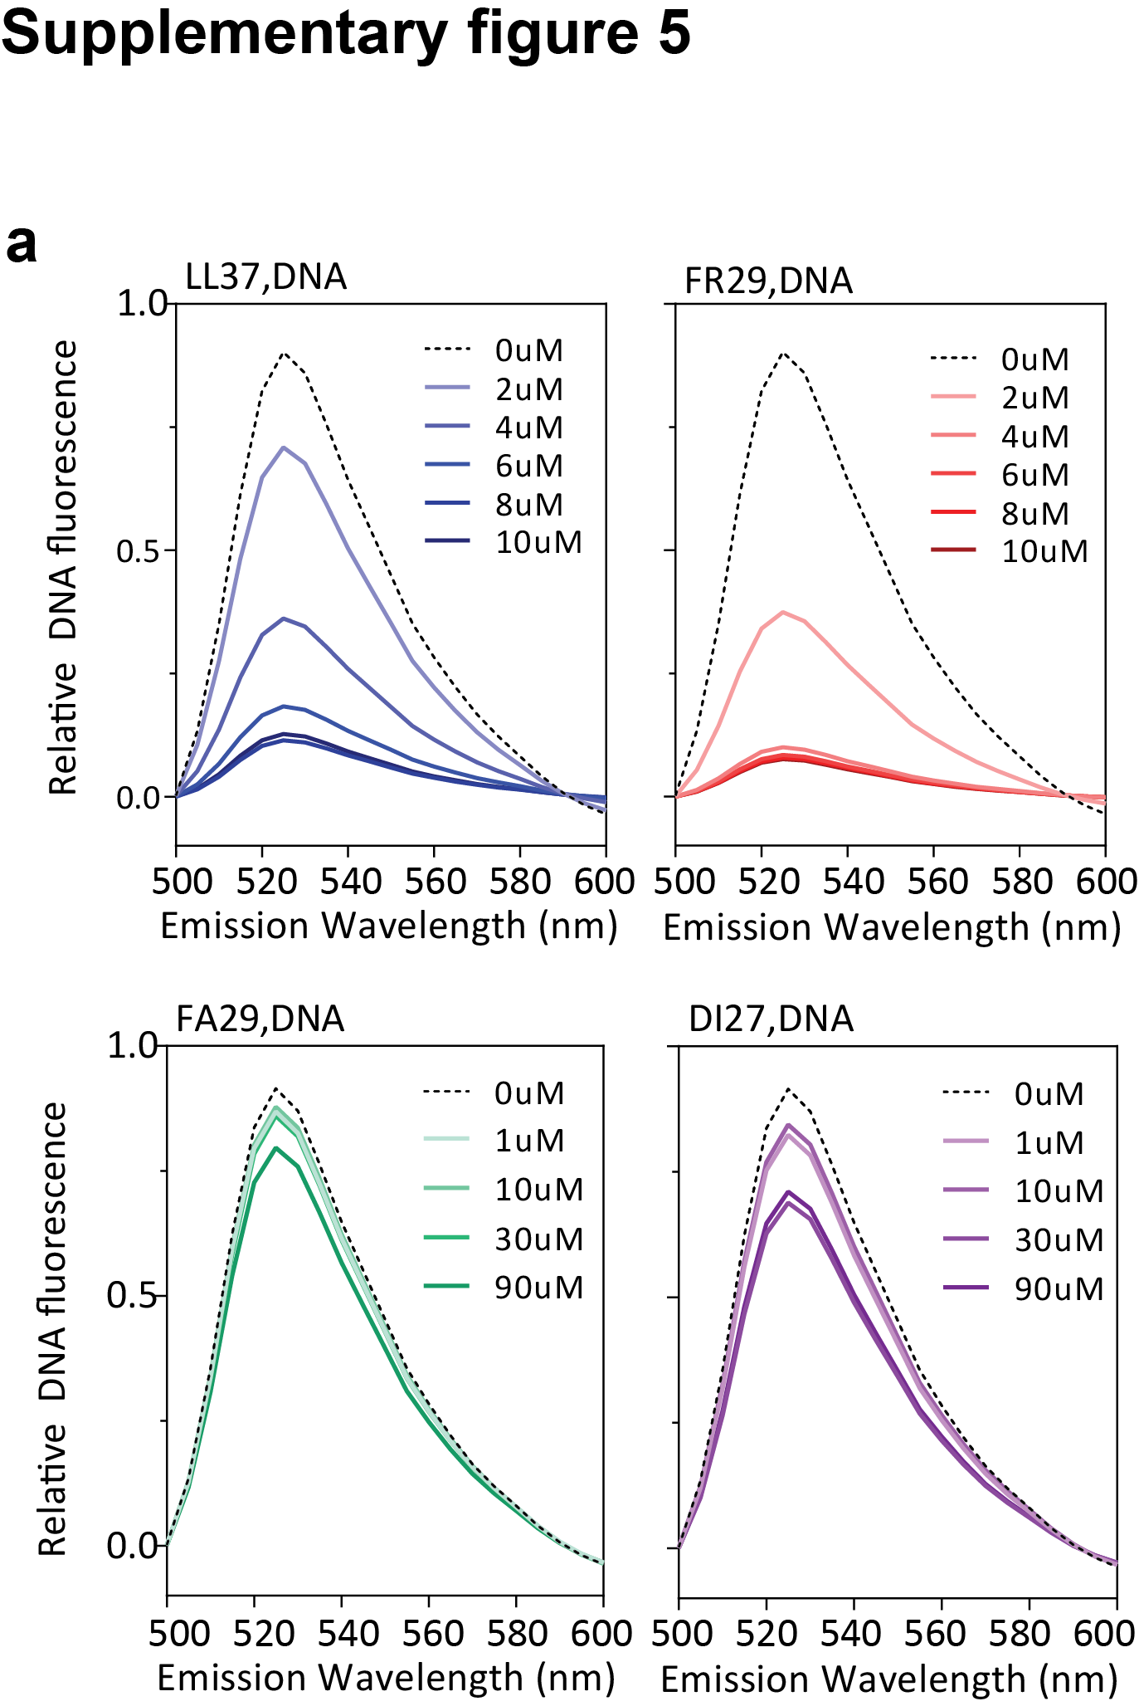

Fig. S5: Differential DNA binding capacities of cathelicidin antimicrobial peptides described in rosacea skin lesions. (a) Human DNA (2µg) was incubated with varying molar concentrations of the indicated cathelicidin peptides, and unbound free DNA was quantified by picogreen dye.

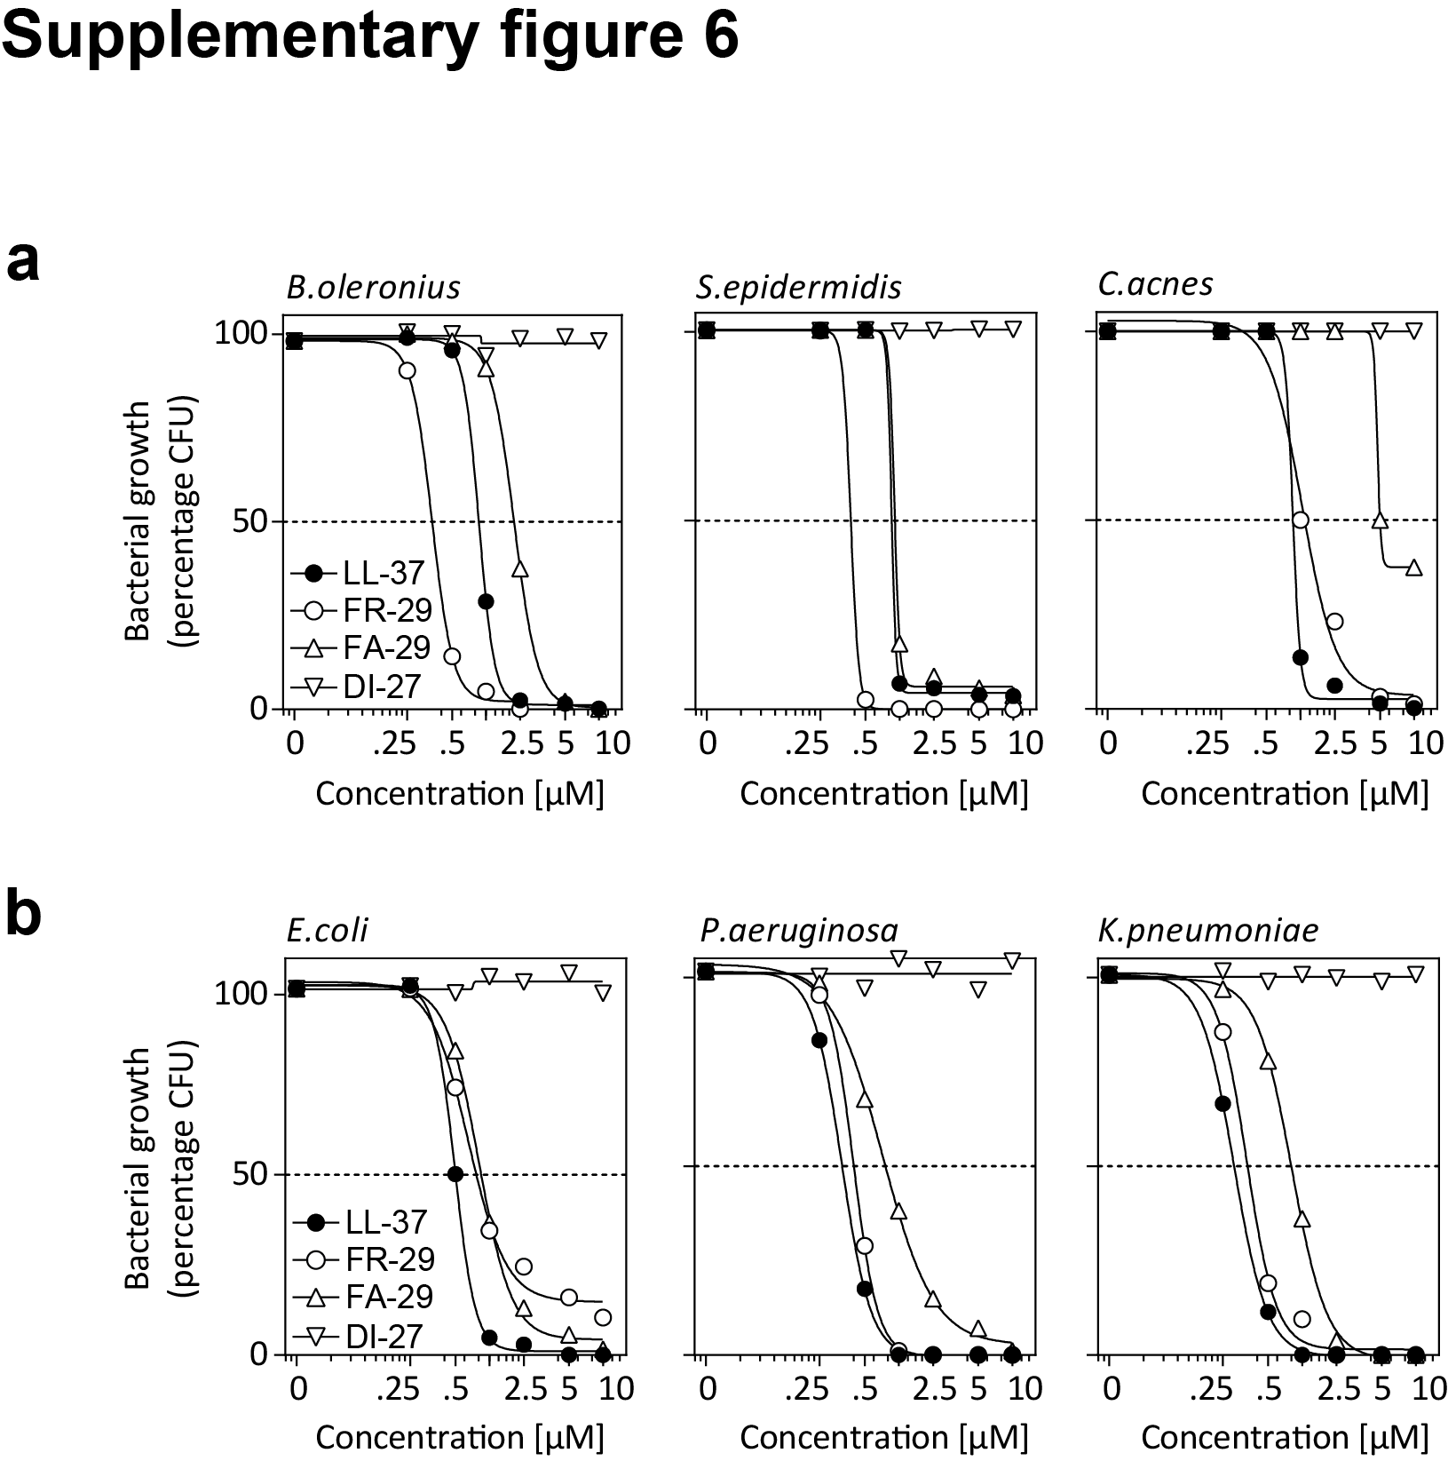

Fig. S6: Comparison of bacterial killing efficacy of different rosacea-associated cathelicidin peptides. (a) Skin- and (b) gut- and respiratory tract-associated bacterial killing assay by indicated cathelicidins. Bacteria CFU counts were determined after 18h culture in their appropriate culture conditions and the corresponding 10⁵ CFUs were incubated with the indicated peptides at the indicated concentration for 2h, followed by plating and culturing for 18h. CFUs were counted and calculated as relative percentage of control cultures.

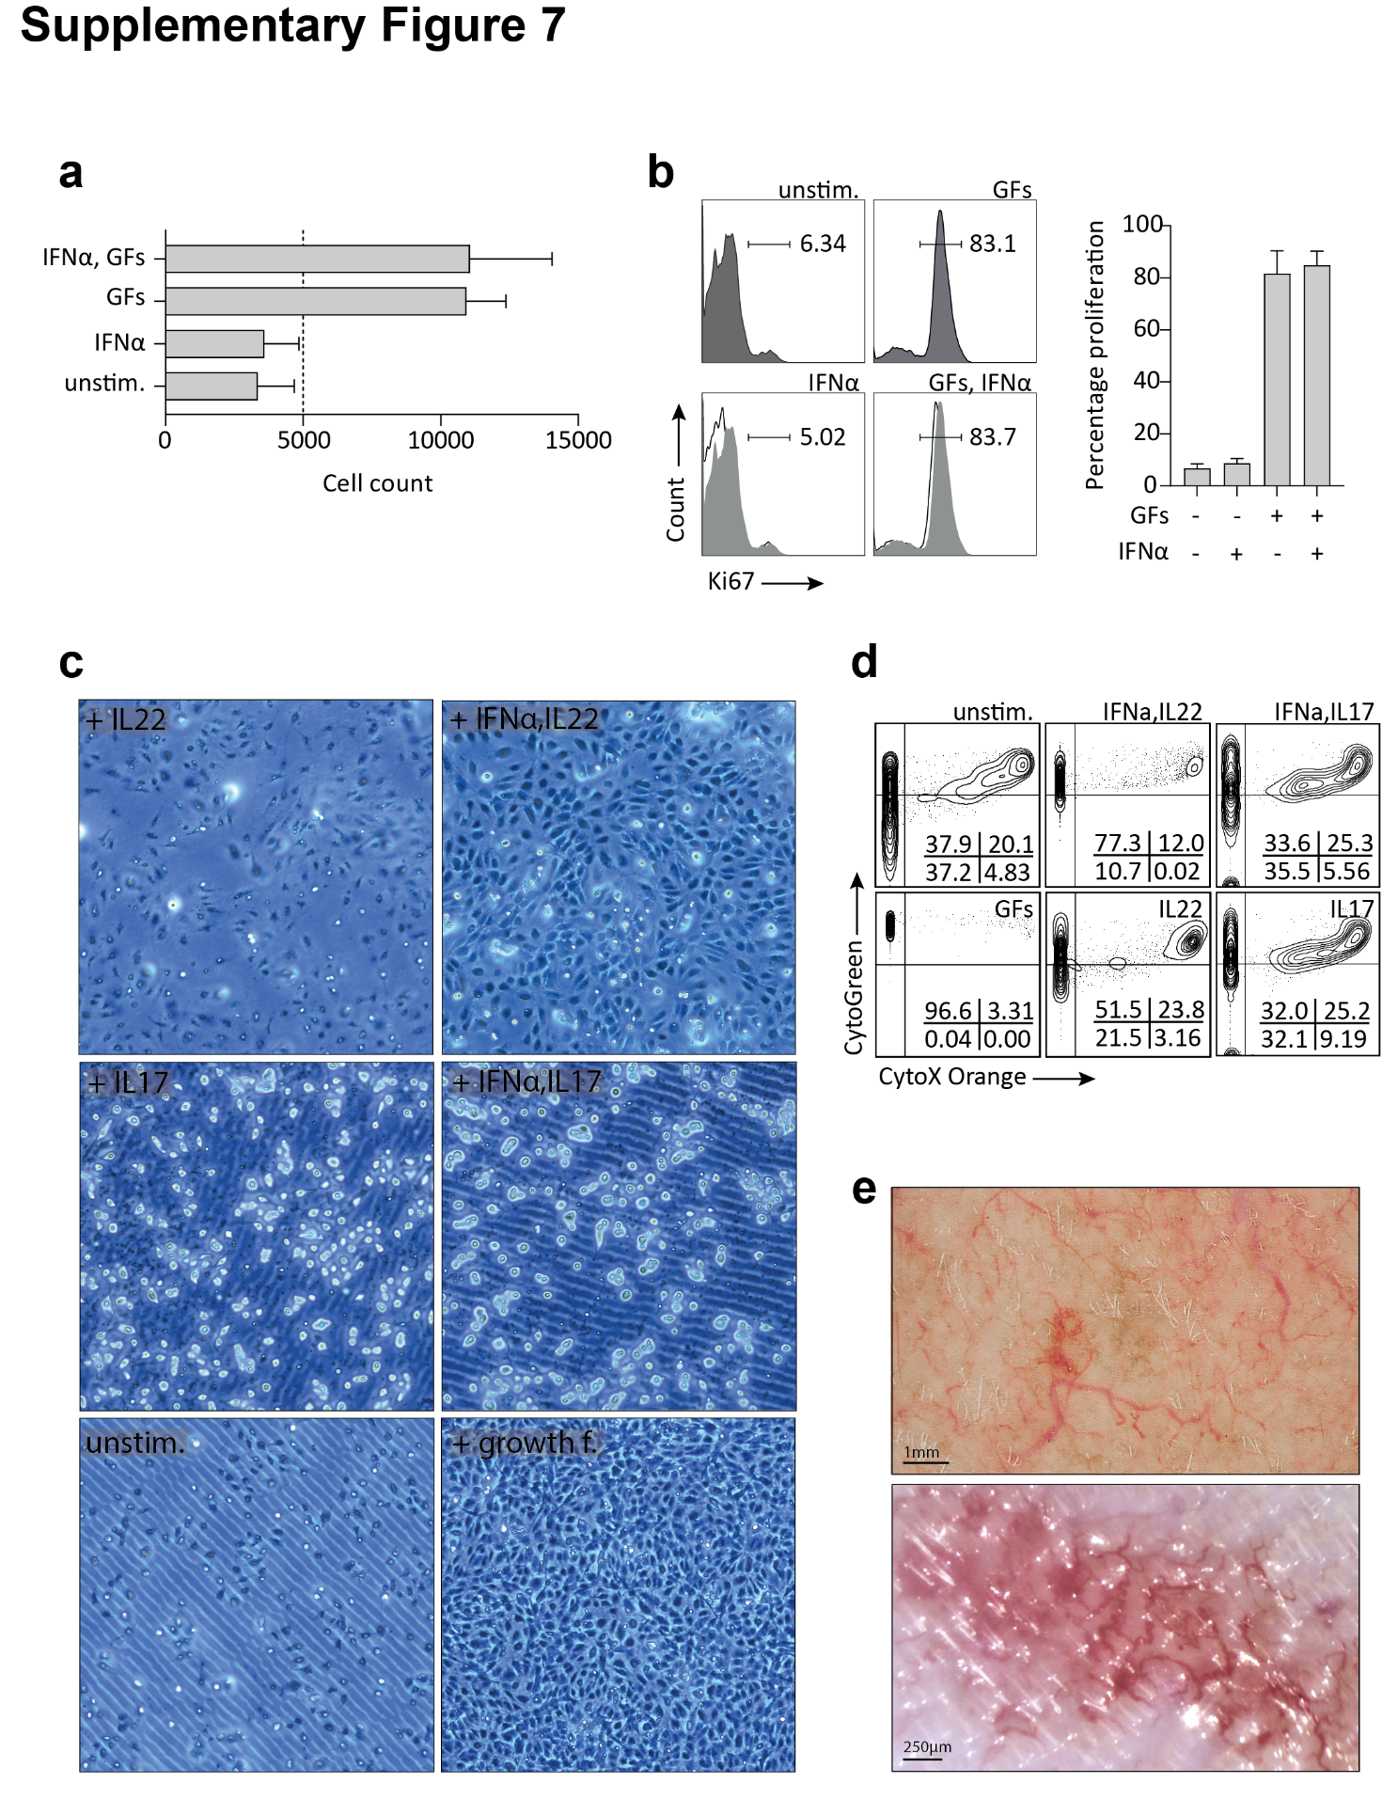

Fig. S7: IFNα does not directly induce Huvec proliferation or survival, despite participating in the observed angiogenesis in vivo. (a) Cell survival of Huvec stimulated with or without IFNα, in the presence or absence of growth factors (GFs). (b) Huvec proliferation determined by KI67 staining of cells stimulated as in (a). (c) Huvec stimulated with indicated cytokines, left unstimulated, or with the growth factor cocktail, and visualised by light microscopy. (d) Huvec were stimulated with the indicated conditions as in (c) and survival assessed by SYTO®13 Green and SYTOX® Orange staining. (e) Representative images of rosacea skin taken with fotofinder (upper panel) and videocapillaroscopy images of LL-37 injection site (bottom panel).

