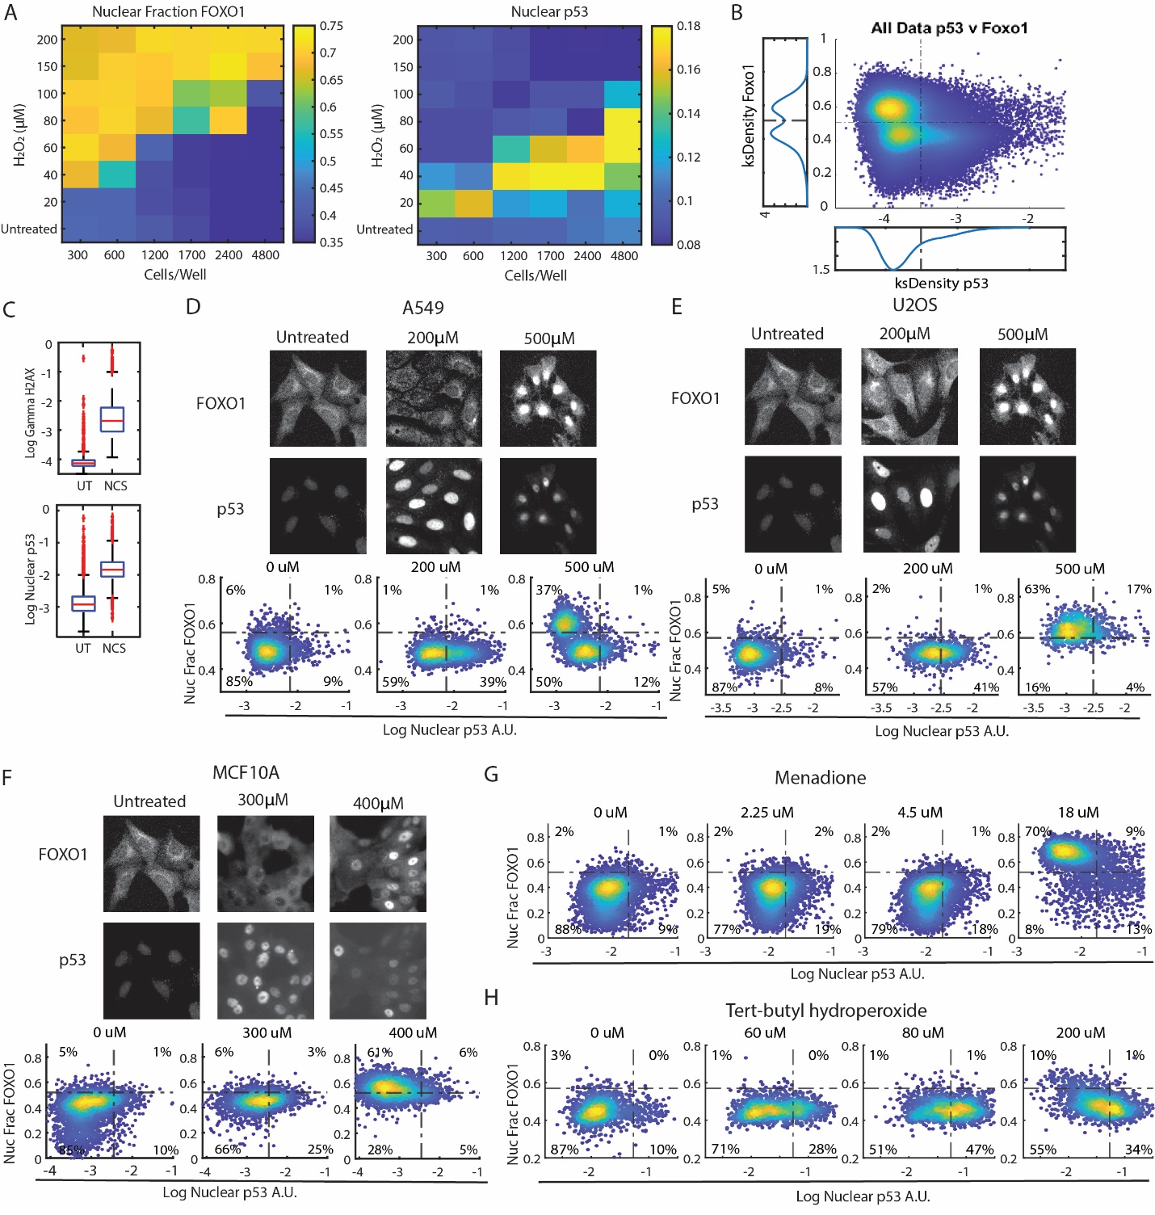
Supplemental Figure 1: Other cell lines show mutually exclusive activity of FOXO1 and p53. (A) Heat maps showing the nuclear fraction of FOXO1 and nuclear p53 levels of cells plated at specified cell numbers (bottom) and indicated concentrations of H₂O₂ (left). (B) Density colored scatter plot of all cells used in Figure 2B to determine thresholds for the fraction of FOXO1 and nuclear levels of p53. Population density plots of nuclear fraction of FOXO1 (left side) and nuclear p53 (below) used for thresholding of the density plots shown in Figure 1B. (C) Bar and whisker plots of nuclear γH2AX and nuclear p53 levels after 3 hours of treatment with 400ng/ml of Neocarzinostatin (NCS). The central line indicates the median and the bottom and top edges of the box indicate the 25th and 75th percentiles respectively. The whiskers indicate the extreme data points not considered as outliers and outliers are indicated by ‘+’. (D-F) Immunofluorescence images and density colored scatter plots of nuclear fraction of FOXO1 and nuclear p53 at the indicated concentrations of H₂O₂ for 5 hours for (D) A549 (E) U2OS and (F) MCF10A cell lines. (G and H) Density colored scatter of cells treated with indicated concentrations of Menadione and tert-butyl hydroperoxide (TBHP) for 5 hours.
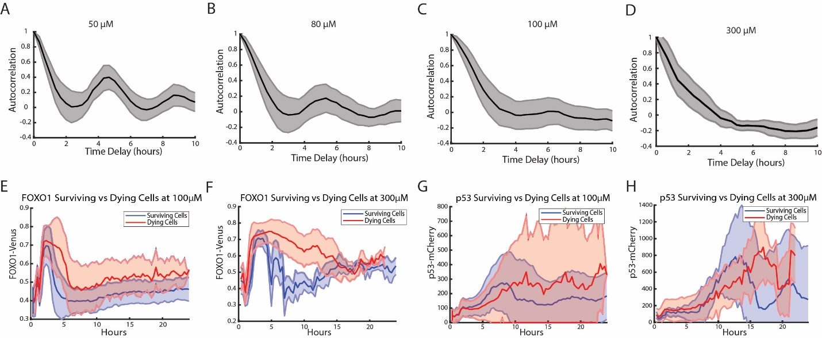
Supplemental Fig 2: p53 dynamics in response to H₂O₂ stress. (A) Autocorrelation of p53 trajectories of cells treated with 50µM of H₂O₂ from Figure 2B. (B) Autocorrelation of p53 trajectories after FOXO1 phase of cells treated with 80µM of H₂O₂ from Figure 2C (C) Autocorrelation of p53 trajectories after FOXO1 phase of cells treated with 100µM of H₂O₂ from Figure 2D. (D) Autocorrelation of p53 trajectories after FOXO1 phase of cells treated with 300µM of H₂O₂ from Figure 2E. (E) FOXO1-mVenus levels in surviving (blue) and dead (red) cells treated with 100µM of H₂O₂ over 24 hours. (F) FOXO1-mVenus levels in surviving (blue) and dead (red) cells treated with 300µM of H₂O₂ over 24 hours. (G) p53-mCherry levels in surviving (blue) and dead (red) cells treated with 100µM of H₂O₂ over 24 hours. (H) p53-mCherry levels in surviving (blue) and dead (red) cells treated with 100µM of H₂O₂ over 24 hours.

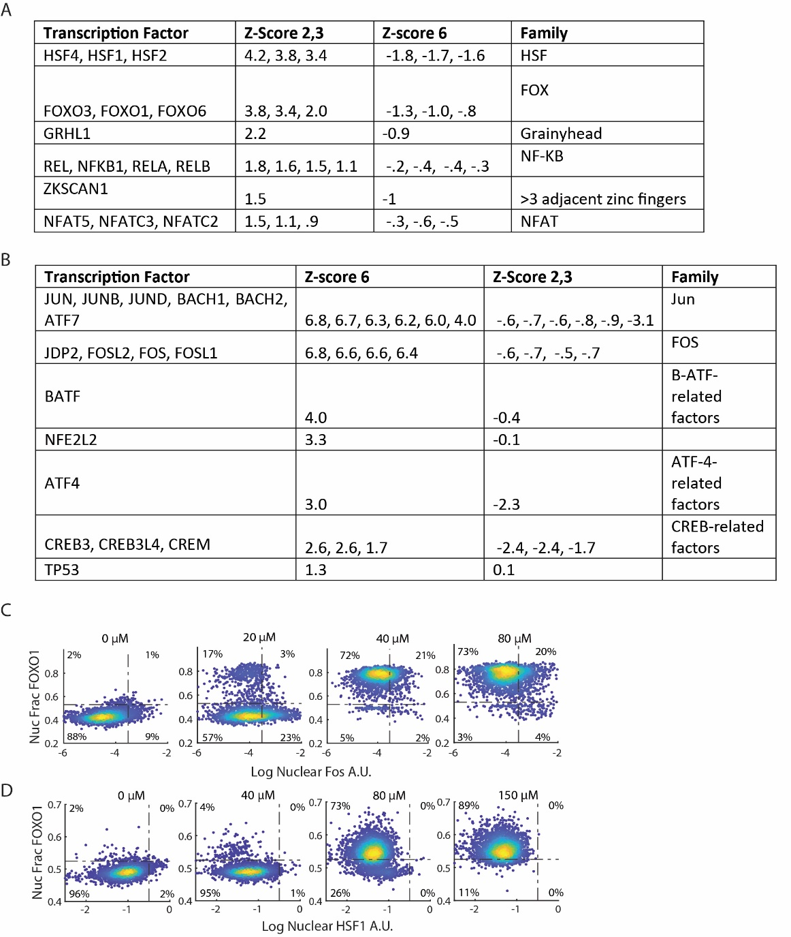
Supplemental Fig 3: Other Transcription factors are activated with FOXO1 and p53 in response to oxidative stress. (A) TF binding motifs enriched in clusters 2 and 3 of single-cell ATAC data. Motifs of TFs not expressed in gene expression data (>.1 counts per cell) were omitted. (B) TF binding motifs enriched in cluster 6 of single-cell ATAC data. Motifs of TFs not expressed in gene expression data (>.1 counts per cell) were omitted. (C) Density colored scatter plots of nuclear fraction of FOXO1 and log of nuclear levels of FOA for cells treated at indicated concentrations of H₂O₂ for 5 hours. (D) Density colored scatter plots of nuclear fraction of FOXO1 and nuclear fraction of HSF1 for cells treated with indicated concentrations of H₂O₂ for 5 hours.

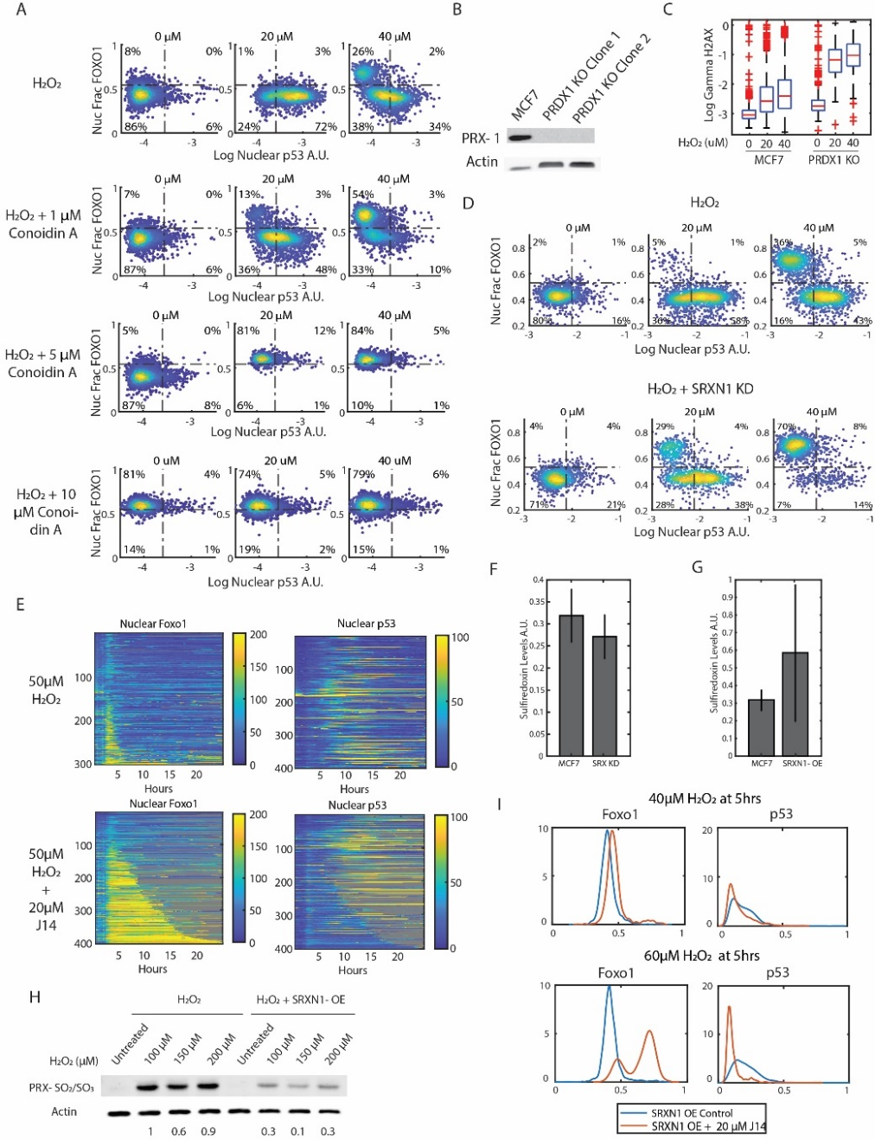
Supplemental Figure 4: Overexpression/Inhibition of Sulfiredoxin controls the activation of FOXO1 and p53. (A) Density colored scatter plots representing the nuclear fraction of FOXO1 and nuclear p53 levels of cells treated with H₂O₂ alone (top) or with 1 µM (2nd from top), 5µM (3rd from top) and 10 µM (4th from top) of Conoidin A at indicated concentrations of H₂O₂ for 5 hours. (B) Western Blot stained with PRDX1 antibody to validate PRDX1 knockout in MCF7 cells. (C) Bar and whisker plots of gamma H2AX levels in MCF7 cells and PRDX1 knockout cells treated with 20µM of H₂O₂ for 3 hours. The central line indicates the median and the bottom and top edges of the box indicate the 25th and 75th percentiles respectively. The whiskers indicate the extreme data points not considered as outliers and outliers are indicated by ‘+’. (D) Density scatter plots of cells treated with H₂O₂ as a control for cells with a SRXN1 knockdown treated with indicated concentrations of H₂O₂ for 3 hours. (E) Heatmaps of single cell traces of the nuclear fraction of FOXO1-mVenus (left) and nuclear p53-mCherry (right) in cells treated with 50µM H₂O₂ (top, n=306, 13% cell death) and 50µM H₂O₂ + 20µM J14 (n=406, 70% cell death) for 24 hours. Each row of the heat maps is a single cell over time. Both FOXO1 and p53 heat maps were sorted by the duration that FOXO1-mVenus remained in the nucleus. Gray indicates cell death. (F) Bar graphs of mean Sulfiredoxin levels and standard deviation (error bars) in cells with the shRNA knockdown compared to the MCF7 control. (G) Bar graphs of mean levels of Sulfiredoxin and standard deviation (error bars) in cells with SRXN1 overexpression compared to MCF7 cells using immunofluorescence. (H) Western blot of MCF7 cells and Sulfiredoxin (SRXN1) overexpressing cells treated with indicated concentrations of H₂O₂ for 3 hours and stained for hyperoxidized (SO₂/SO₃) PRDX1/2 and Actin. (I) Population density plots of nuclear fraction of FOXO1 and nuclear p53 levels in cells overexpressing Sulfiredoxin (SRXN1-OE) after treatment with H₂O₂ and the same cells treated with 20µM of J14 at indicated concentrations of H₂O₂. Blue line indicates cells with overexpression of Sulfiredoxin and the red line indicates cells overexpressing Sulfiredoxin treated with 20µM J14.
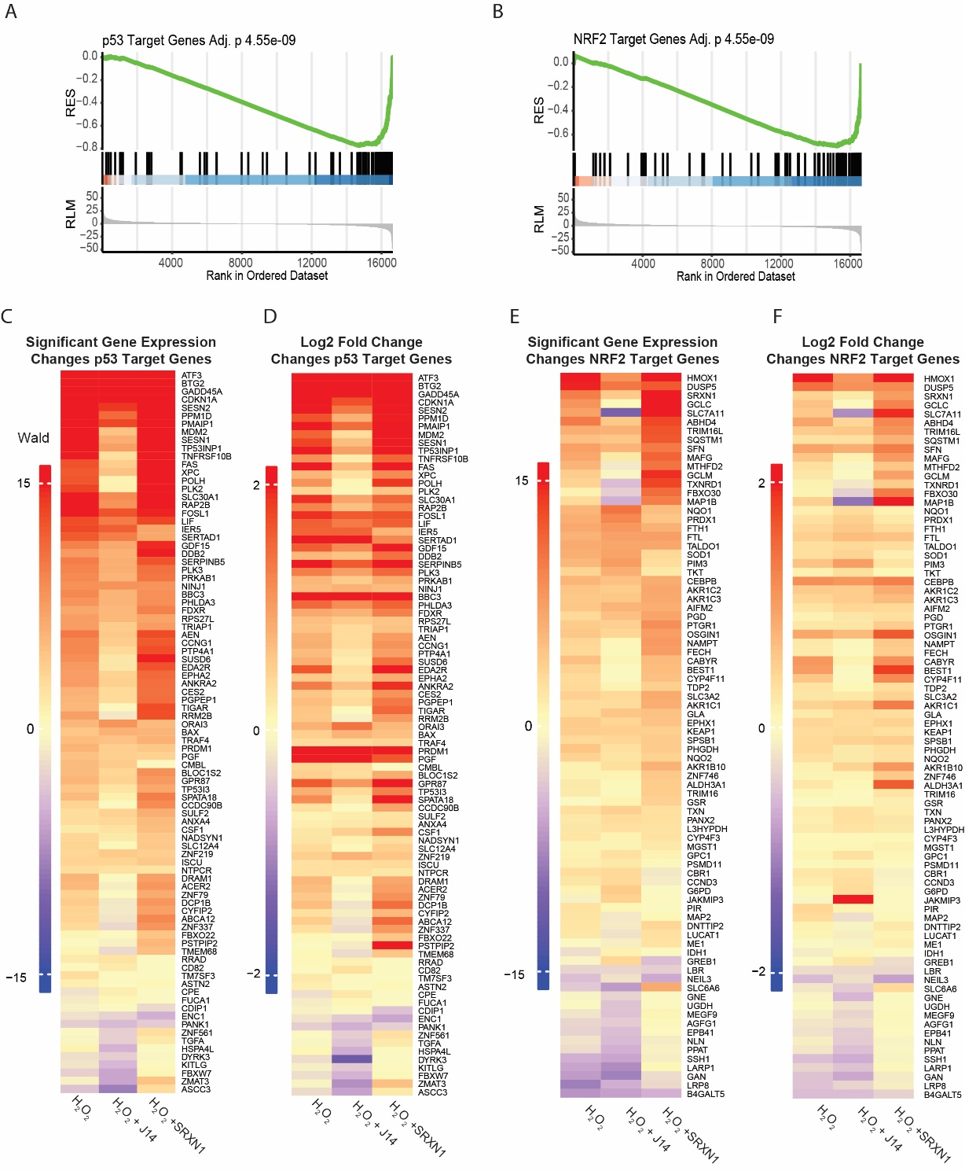
Supplemental Figure 5. Differential gene expression analysis of p53 and NRF2 target genes. (A) GSEA of p53 target genes in J14 + H₂O₂ samples as compared to SRXN1-OE + H₂O₂ samples (B) GSEA of NRF2 target genes in J14 + H₂O₂ samples as compared to SRXN1-OE + H₂O₂ samples. (C) Wald statistic and (D) log₂ fold changes of p53 target genes in H₂O₂ treated cells vs. PBS controls, H₂O₂ + J14 treated cells vs J14 treated controls and H₂O₂ treated SRXN1-OE cells vs. SRXN1-OE PBS controls. (E) Wald statistic and (F) log₂ fold changes of NRF2 target genes in H₂O₂ treated cells vs. PBS controls, H₂O₂ + J14 treated cells vs J14 treated controls and H₂O₂ treated SRXN1-OE cells vs. SRXN1-OE PBS controls. H₂O₂ concentration is 50μM, J14 20μM.

Supplemental Movie 1: Example movie showing FOXO1-mVenus and p53-mCherry activity after treatment with 50µM of H₂O₂ in MCF7 cells for a period of 24hrs.H₂O₂ was added at the 20-minute timepoint.
Supplemental Movie 2: Example movie showing FOXO1-mVenus and p53-mCherry activity after treatment with 80µM of H₂O₂ in MCF7 cells for a period of 24hrs.H₂O₂ was added at the 20-minute timepoint.
Supplemental Movie 3: Example movie showing FOXO1-mVenus and p53-mCherry activity after treatment with 100µM of H₂O₂ in MCF7 cells for a period of 24hrs.H₂O₂ was added at the 20-minute timepoint.
Supplemental Movie 4: Example movie showing FOXO1-mVenus and p53-mCherry activity after treatment with 300µM of H₂O₂ in MCF7 cells for a period of 24hrs.H₂O₂ was added at the 20-minute timepoint.

