Supplementary Information
Supplementary Table 1. Alpha diversity between obese and non-obese groups. Alpha diversity estimated by Shannon, Observed ASVs and Faith’s PD (Phylogenetic Diversity) between obese and non-obese in each country. Statistical significance padj. < 0.05 (FDR-corrected). n= 1764 samples. FDR= False Discovery Rate
Country | non-Obese | Obese | Observed ASVs | Shannon | Faith's PD
Country | non-Obese | Obese | P.adj | P.adj | P.adj
Ghana | 243 | 89 | 0.0439 | 0.268 | 0.0393
South Africa | 233 | 141 | 0.0488 | 0.0686 | 0.12
Jamaica | 208 | 179 | 0.338 | 0.494 | 0.239
Seychelles | 217 | 147 | 0.206 | 0.752 | 0.186
USA | 112 | 195 | 0.759 | 0.246 | 0.901

Supplementary Table 2. Gut microbiota (Weighted UniFrac Distance). Adjusted multivariable analysis in the entire cohort (overall) and by each country. Statistical significance from permutational multivariate analysis of variance (PERMANOVA) test, padj. < 0.05. n= 1764 samples. All p-values are generated based on 999 permutations.
 | Overall |  | Ghana |  | South Africa |  |  | Jamaica |  |  |  | Seychelles |  |  |  | US
 | R² | P | R² | P | R² | P |  | R² |  | P |  | R² |  | P |  | R² |  | P
Obese | 0.001 | 0.031 | 0.004 | 0.208 | 0.003 | 0.415 |  | 0.002 |  | 0.732 |  | 0.001 |  | 0.903 |  | 0.007 |  | 0.043
Sex | 0.003 | 0.001 | 0.002 | 0.549 | 0.004 | 0.19 |  | 0.009 |  | 0.009 |  | 0.023 |  | 0.001 |  | 0.011 |  | 0.004
Age | 0.002 | 0.001 | 0.101 | 0.815 | 0.08 | 0.737 |  | 0.102 |  | 0.062 |  | 0.053 |  | 0.894 |  | 0.098 |  | 0.283
Country | 0.118 | 0.001

Supplementary Table 3. Gut microbiota (Unweighted UniFrac Distance). Adjusted Multivariate Analysis for the entire cohort and by each country. Statistical significance from permutational multivariate analysis of variance (PERMANOVA) test, padj. < 0.05. n= 1764 samples. All p-values are generated based on 999 permutations.

 | Overall |  | Ghana |  | South Africa |  | Jamaica |  | Seychelles |  | US
 | R² | P | R² | P | R² | P | R² | P | R² | P | R² | P
Obese | 0.003 | 0.001 | 0.004 | 0.032 | 0.007 | 0.002 | 0.002 | 0.732 | 0.003 | 0.279 | 0.004 | 0.154
Sex | 0.003 | 0.001 | 0.005 | 0.018 | 0.007 | 0.002 | 0.009 | 0.009 | 0.01 | 0.001 | 0.01 | 0.001
Age | 0.001 | 0.135 | 0.113 | 0.471 | 0.083 | 0.708 | 0.102 | 0.062 | 0.063 | 0.576 | 0.094 | 0.252
Country | 0.083 | 0.001

Supplementary Table 4 – Description of study participants by microbial enterotypes. Data are presented as median (interquartile range) for continuous variables and percentages (%) for categorical variables. n= 1686 samples. Statistical significance, p adj. < 0.05. BMI = Body Mass Index, SCFA = short chain fatty acids
 | Bacteroides type | Prevotella type | p-value | q-value
N | 820 | 866
BMI | 29(25,35) | 28(23,34) | 0.003 | 0.004
Country |  |  | <0.001 | <0.001
Ghana | 61 (7.4%) | 265(31%)
Jamaica | 243(30%) | 117(14%)
Seychelles | 149(18%) | 176(20%)
South Africa | 142(17%) | 232(27%)
US | 225(27%) | 76(8.8%)
Sex | 564(69%) | 503(58%) | <0.001 | <0.001
Age | 44(38,50) | 42(36,48) | 0.032 | 0.032
Obese | 370(45%) | 346(40%) | <0.001 | <0.001
Total SCFA | 3547(2325,4891) | 5300(3591,7672) | <0.001 | <0.001
Bacteroides | 1299(315,7521) | 92(18,526) | <0.001 | <0.001
Prevotella | 98(25,319) | 1246(198,10382) | <0.001 | <0.001
Median(IQR), n (%)
p-value: Wilcoxon rank run test, Pearson's Chi-squared test
q-value: False discovery rate correction multiple testing

Supplementary Table 5. Weight adjusted fecal SCFA levels by country. Data are presented as mean + standard deviation.
Women
 | Ghana | South Africa | Jamaica | Seychelles | US
 | n=254 | n=228 | n=263 | n=196 | n=213
Propionate (ug/g) | 30.4 ± 18.0 | 11.6 ± 6.9 | 11.5 ± 8.5 | 14.5 ± 8.5 | 9.1 ± 6.0
Butyrate (ug/g) | 22.1 ± 11.8 | 10.6 ± 6.6 | 8.5 ± 6.8 | 7.0 ± 5.4 | 9.0 ± 6.5
Acetate (ug/g) | 61.3 ± 22.8 | 15.6 ± 7.4 | 24.4 ± 13.3 | 40.9 ± 25.4 | 16.8 ± 11.1
Total SCFA (ug/g) | 115.5 ± 45.0 | 39.5 ± 19.0 | 46.0 ± 26.3 | 63.8 ± 35.1 | 36.4 ± 21.5
MEN
 | Ghana | South Africa | Jamaica | Seychelles | US
 | n=117 | n=171 | n=133 | n=164 | n=107
Propionate (ug/g) | 34.3 ± 15.9 | 18.6 ± 13.1 | 18.3 ± 13.2 | 21.0 ± 13.9 | 13.1 ± 9.9
Butyrate (ug/g) | 23.1 ± 14.2 | 14.5 ± 9.0 | 13.2 ± 10.1 | 8.6 ± 4.7 | 11.3 ± 6.8
Acetate (ug/g) | 68.9 ± 22.5 | 22.1 ± 9.3 | 27.0 ± 13.3 | 42.2 ± 17.2 | 22.3 ± 13.7
Total SCFA (ug/g) | 128.0 ± 44.2 | 57.3 ± 27.9 | 60.3 ± 30.1 | 72.8 ± 32.0 | 48.4 ± 27.3

Supplementary Table 6. Total fecal SCFA by adiposity status; non-obese vs. obese. Data are presented as mean + standard deviation.
Non-obese
 | Ghana |  | South Africa |  | Jamaica |  | Seychelles |  | US
 | n=254 |  | n=228 |  | n=263 |  | n=196 |  | n=213
Propionate (ug/g) | 34.1 ± 18.3 |  | 16.8 ± 11.8 |  | 16.6 ± 13.0 |  | 19.2 ± 13.2 |  | 12.7 ± 9.6
Butyrate (ug/g) | 23.8 ± 13.2 |  | 14.3 ± 8.6 |  | 12.2 ± 9.7 |  | 8.4 ± 5.9 |  | 11.1 ± 7.4
Acetate (ug/g) | 69.3 ± 22.4 |  | 21.4 ± 9.2 |  | 28.3 ± 15.3 |  | 45.9 ± 24.1 |  | 23.1 ± 14.2
Total scfa (ug/g) | 129.1 ± 45.0 |  | 54.6 ± 26.3 |  | 59.0 ± 32.6 |  | 74.8 ± 37.6 |  | 48.9 ± 28.4
OBESE
 | Ghana |  | South Africa |  | Jamaica |  | Seychelles |  | US
 | n=89 |  | n=141 |  | n=178 |  | n=132 |  | n=201
Propionate (ug/g) | 24.9 ± 12.4 |  | 10.7 ± 6.3 |  | 10.3 ± 5.9 |  | 14.6 ± 8.1 |  | 9.1 ± 6.1
Butyrate (ug/g) | 18.7 ± 10.2 |  | 8.7 ± 5.0 |  | 7.7 ± 5.6 |  | 6.6 ± 3.3 |  | 9.0 ± 6.1
Acetate (ug/g) | 48.7 ± 16.9 |  | 13.2 ± 4.9 |  | 21.6 ± 9.5 |  | 34.9 ± 16.8 |  | 16.0 ± 10.1
Total scfa (ug/g) | 93.9 ± 33.9 |  | 34.1 ± 14.5 |  | 40.9 ± 18.0 |  | 57.1 ± 24.0 |  | 35.4 ± 19.9

Supplementary Fig 1. Differentially abundant taxa among countries (a-d) adjusted for BMI, age, and sex using ANCOM-BC. Bars represent ANCOM-BC estimated log fold change between compared groups (effect size) and error bars, with the 95% confidence interval. ASVs with log fold change >1.4 are shown for country. FDR-adjusted (p < 0.05) effect sizes are indicated by *, ** and ***, corresponding to p < 0.05, <0.01 and <0.001 respectively. n= 1694 samples. FDR= False Discovery Rate

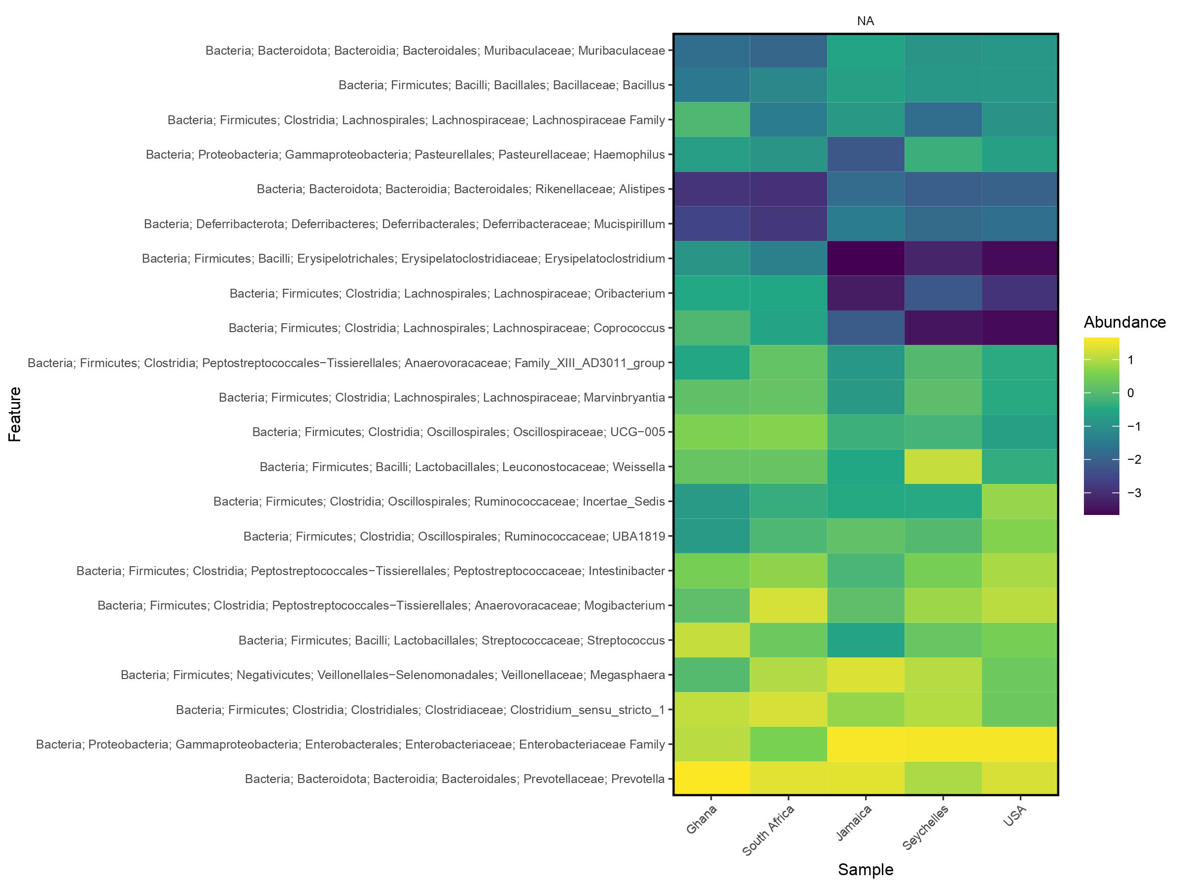
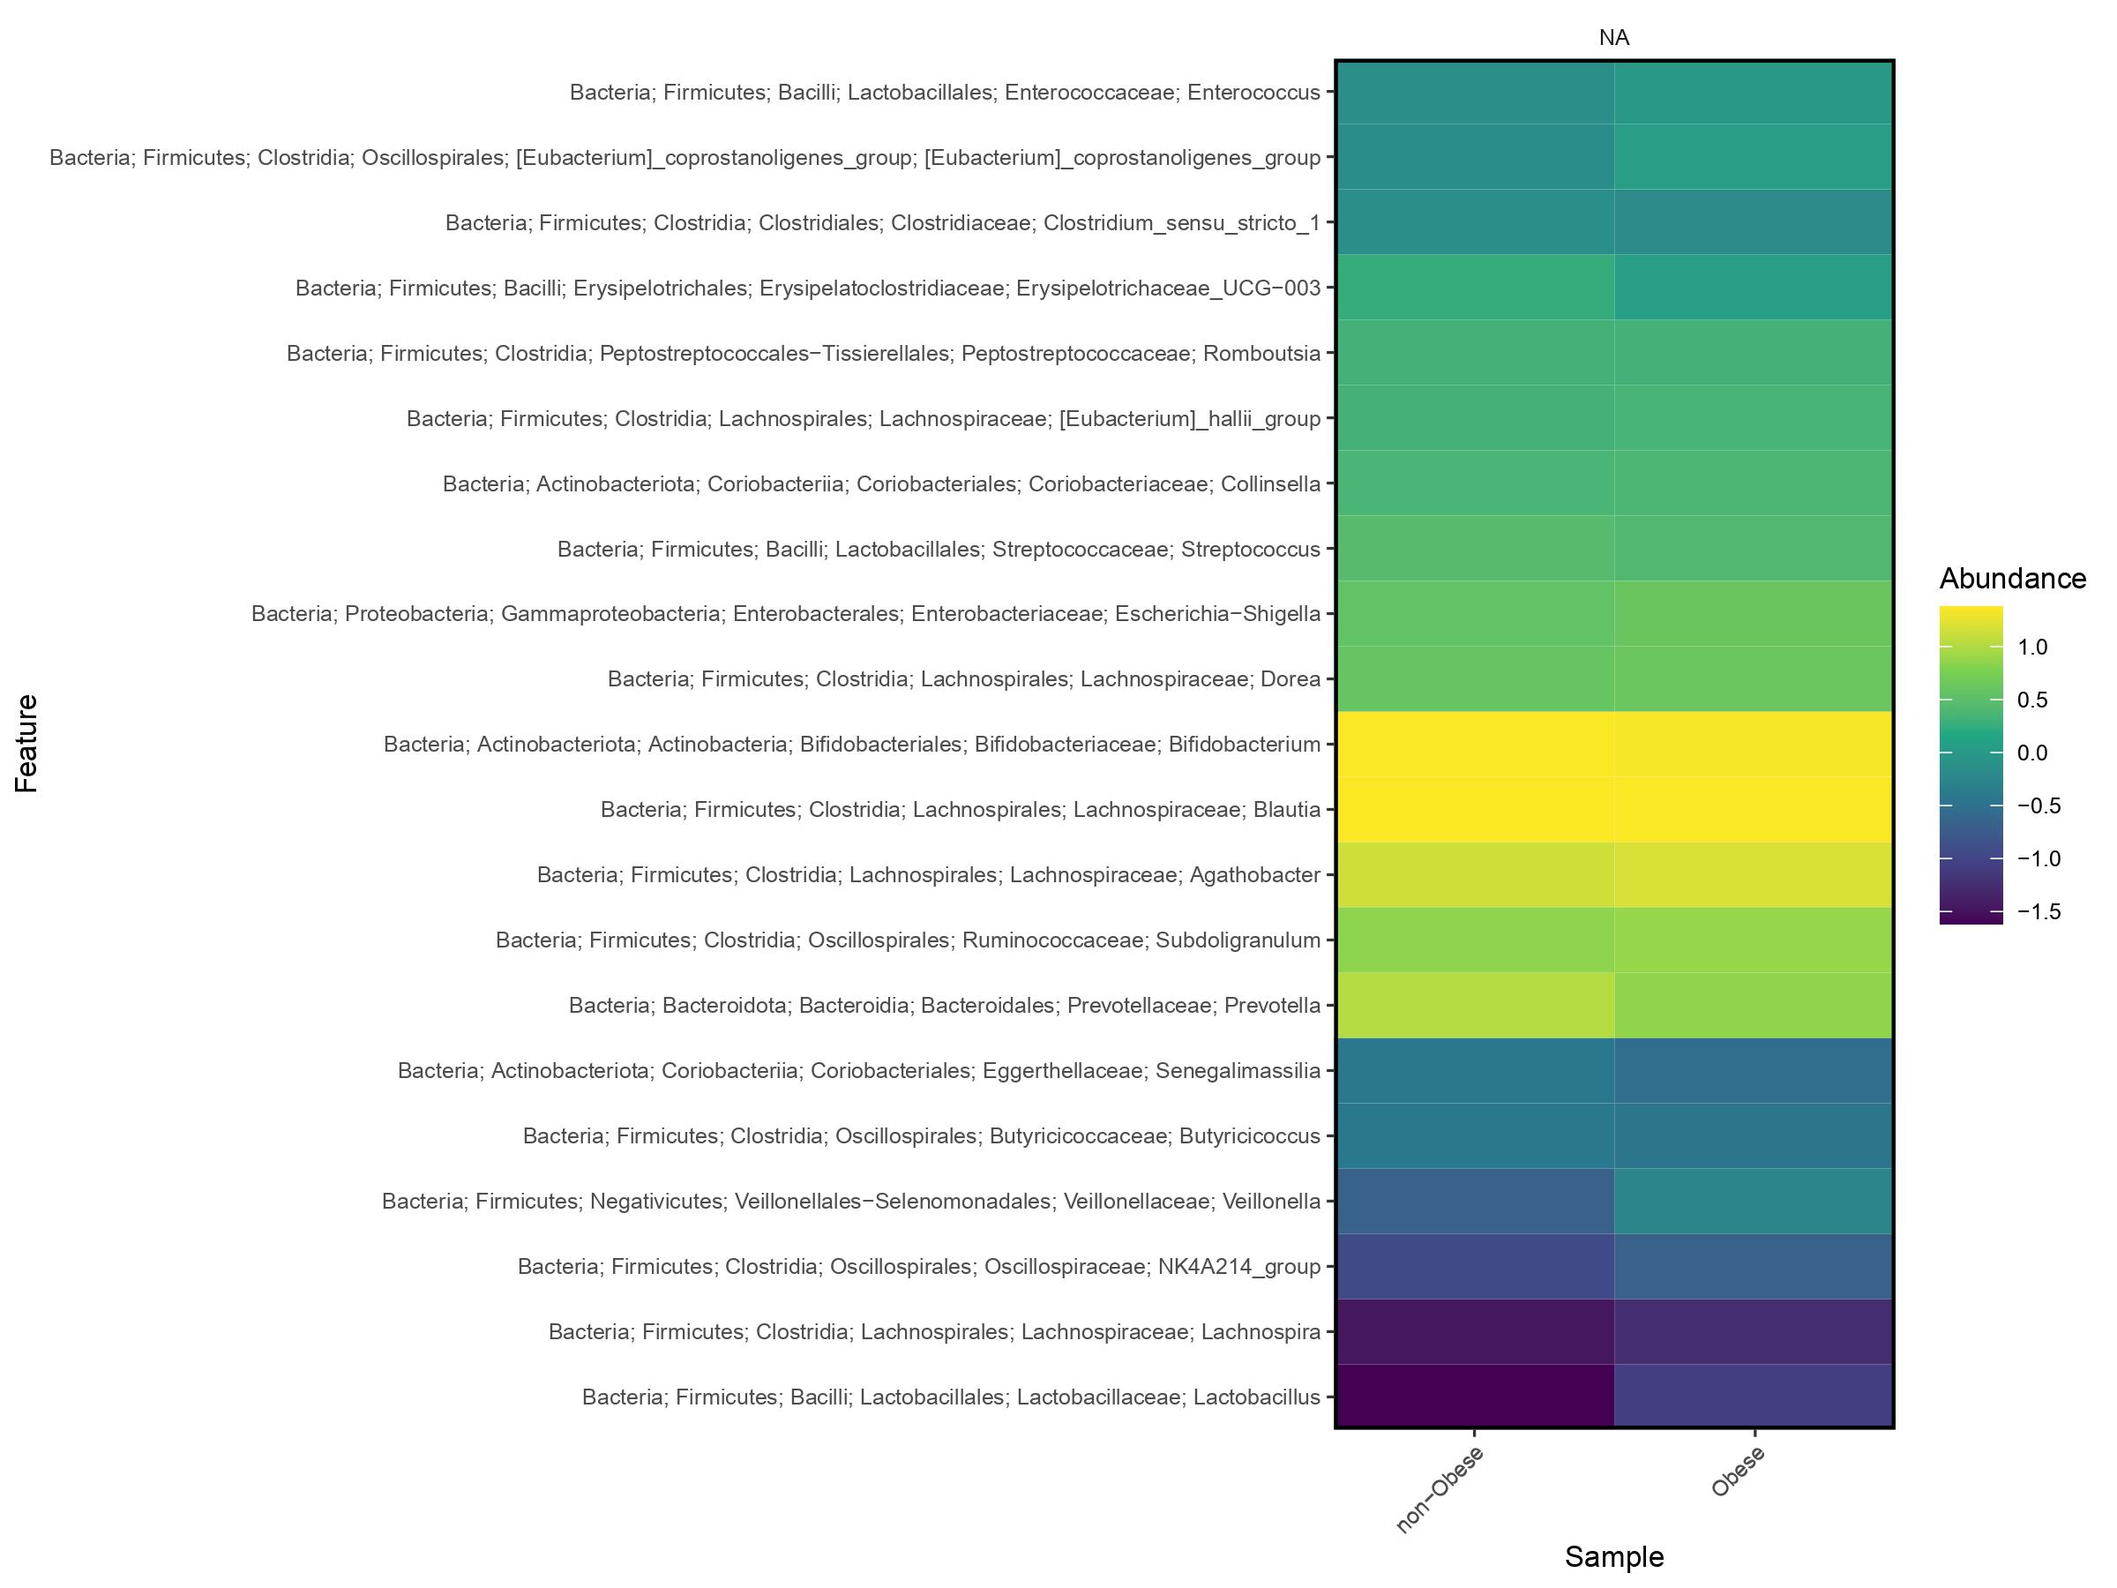
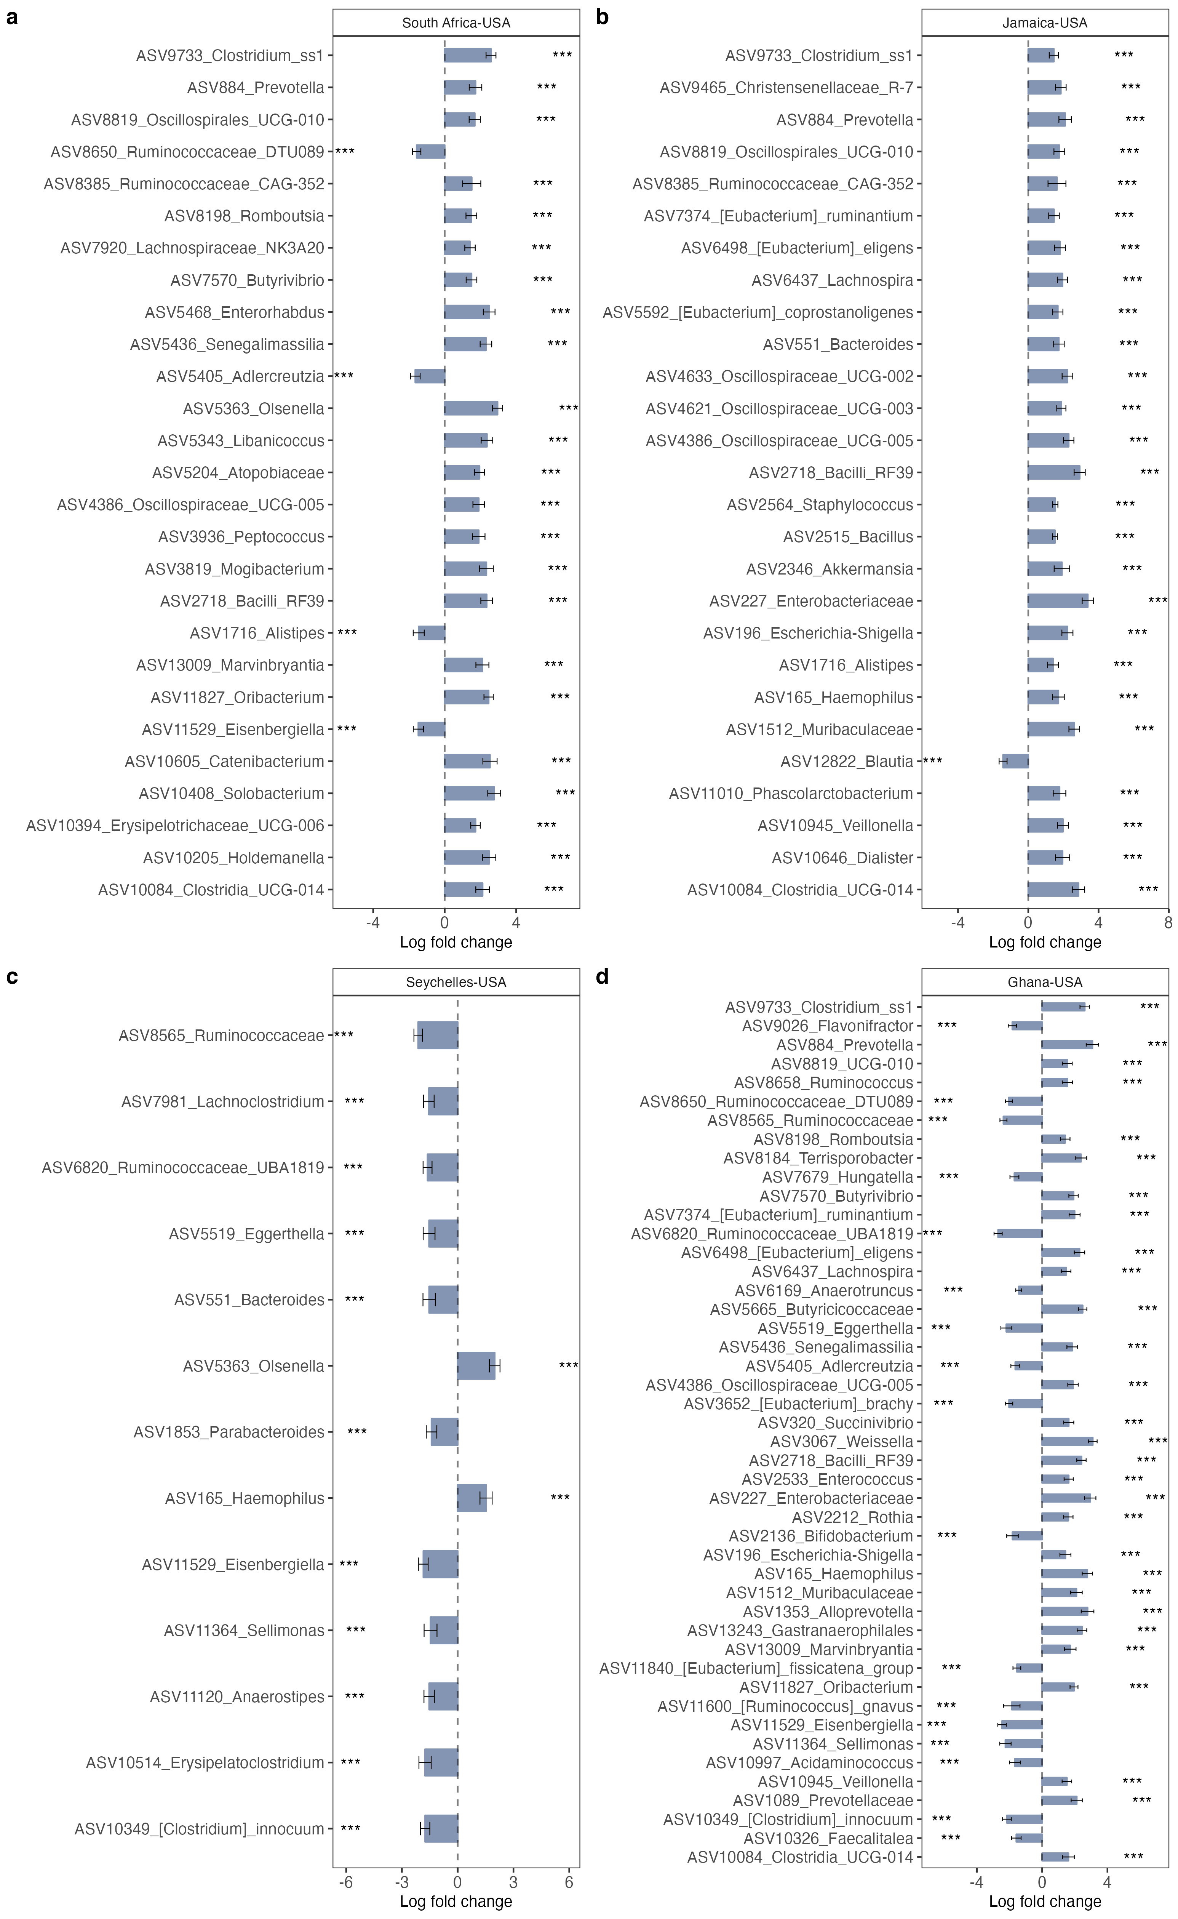Supplementary Fig. 2. Heatmap representations of the 30 most predictive microbial features (in rows) identified by Random Forest analysis for classification of samples into the various (a) countries and into obese and (b) non-obese groups. n= 1694 samples
a
b

Supplementary Fig. 3. Receiver operating characteristic curves showing the classification accuracy of gut microbiota in a Random Forest model. Classification accuracy for estimating obesity status in (a). Ghana; (b) South Africa, (c). Jamaica; (d). Seychelles; (e). US are presented. n= 1694 samples. AUC= area under the curve

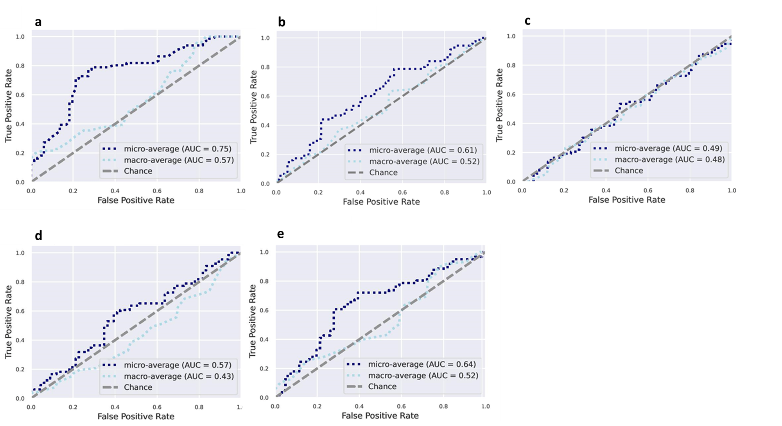

Supplementary Fig. 4. Differentially abundant predicted PICRUSt2 MetaCyc pathways among countries (a) and obese group (b) adjusted for BMI, age, sex and country using ANCOM-BC. Bars represent the ANCOM-BC estimated log fold change between compared groups (effect size) and error bars, with the 95% confidence interval. Representative predicted pathways with log fold change >1.4 in at least one group are shown for country. FDR-adjusted (p < 0.05) effect sizes are indicated by *, ** and ***, corresponding to p < 0.05, <0.01 and <0.001 respectively. n= 1694 samples. n = 1694 samples. FDR= False Discovery Rate

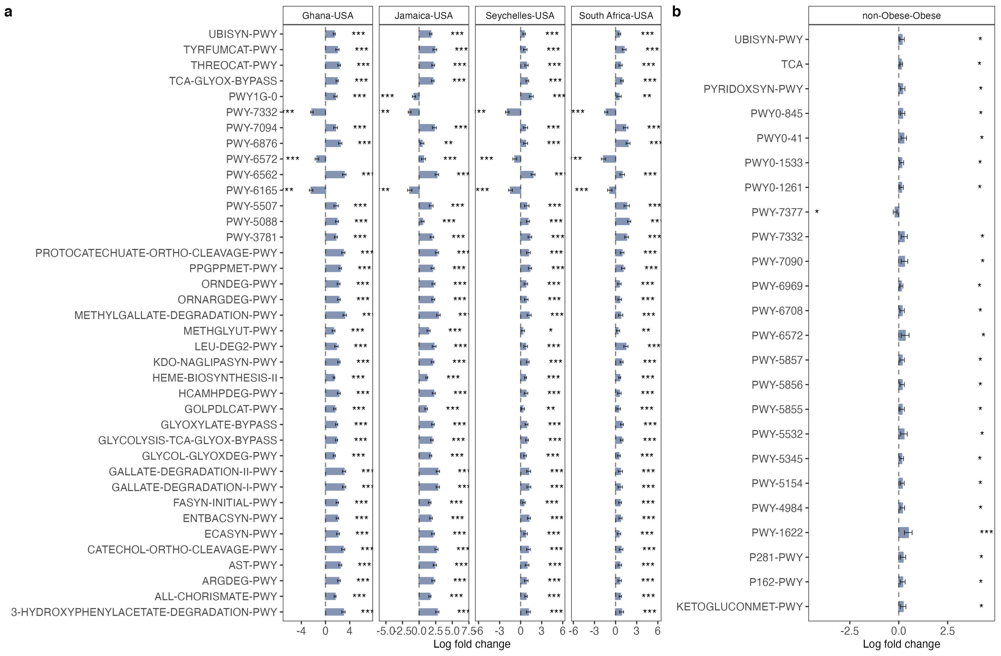

Supplementary Fig. 5. Differentially abundant predicted PICRUSt2 KEGG orthology (KO) in butanoate metabolism pathway among countries (A) and obese group (B) adjusted for BMI, age, sex and country using ANCOM-BC. Bars represent the ANCOM-BC estimated log fold change between compared groups (effect size) and error bars, with the 95% confidence interval. Representative predicted pathways with log fold change >1.4 in at least one group are shown for country. FDR-adjusted (p < 0.05) effect sizes are indicated by *, ** and ***, corresponding to p < 0.05, <0.01 and <0.001 respectively. n = 1694 samples. FDR= False Discovery Rate

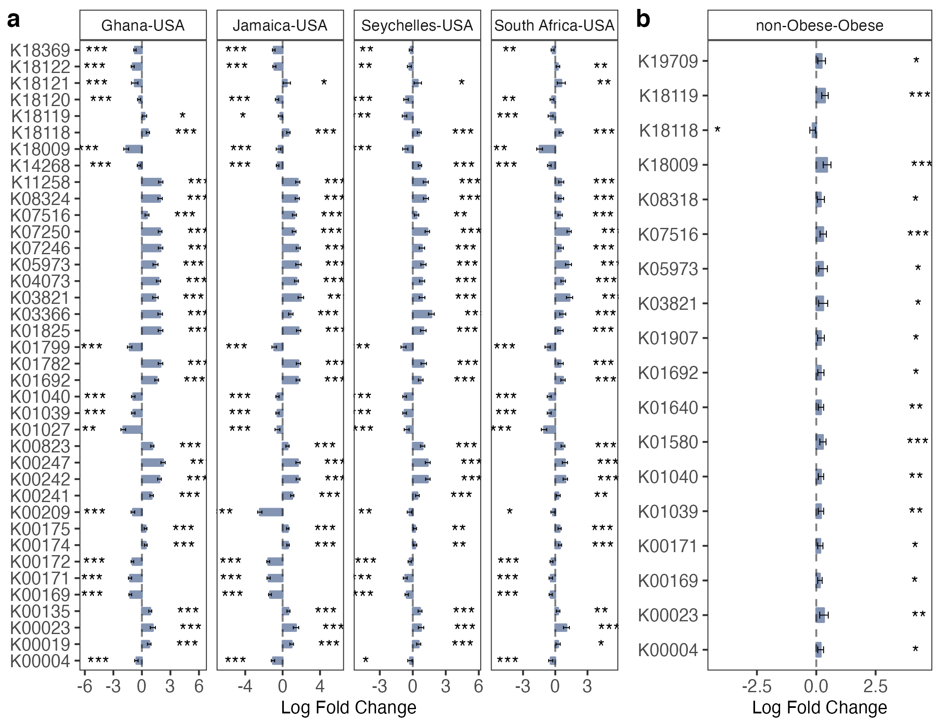

Supplementary Fig. 6. Differentially abundant predicted PICRUSt2 KEGG orthology (KO) in LPS biosynthesis pathway among countries (a) and obese group (b) adjusted for BMI, age, sex and country using ANCOM-BC. Bars represent the ANCOM-BC estimated log fold change between compared groups (effect size) and error bars, with the 95% confidence interval. Representative predicted pathways are shown for country. FDR-adjusted (p < 0.05) effect sizes are indicated by *, ** and ***, corresponding to p < 0.05, <0.01 and <0.001 respectively. n= 1694 samples. FDR= False Discovery Rate.

