Supplemental information:

Transmission of Alzheimer's Disease-Associated Microbiota Dysbiosis and its Impact on Cognitive Function: Evidence from Mouse Models and Human Patients

Yiying Zhang, Yuan Shen, Ning Liufu, Ling Liu, Wei Li, Zhongyong Shi, Hailin Zheng, Xinchun Mei, Chih-Yu Chen, Zhangliang Jiang, Shabnam Abtahi, Yuanlin Dong, Feng Liang,Yujiang Shi, Leo Cheng, Guang Yang, Jing X. Kang,Jeremy E. Wilkinson, and Zhongcong Xie

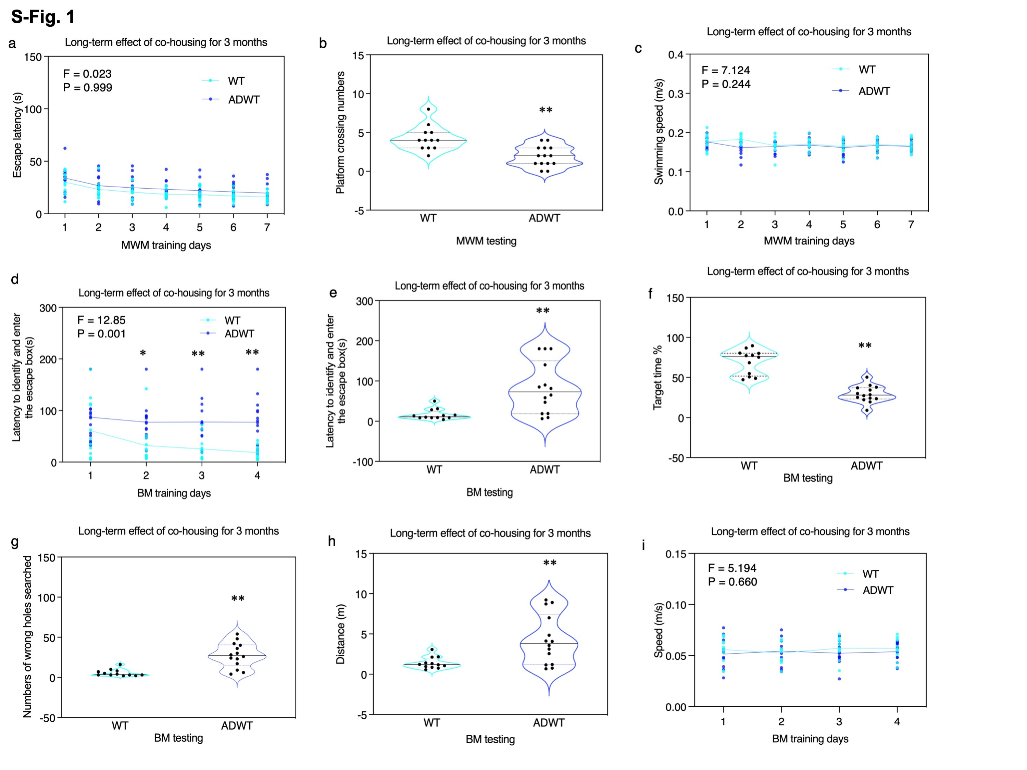
S-Fig. 1. Long-term effects of co-housing for on cognitive function of ADWT mice at 8 months old in MWM and BM test. The cognitive impairment in ADWT mice was sustained for at least 3 months after the end of the co-housing at 8 months old, as demonstrated in MWM training (a), MWM testing (b), but no significant changes in swimming speed in MWM (c); BM training (d), and BM testing (e), BM target time (f), wrong holes searched in BM (g), distance in BM (h), but no significant changes in speed in BM (i) compared to the WT mice. Data are mean ± standard deviation or medians (with interquartile ranges), N = 12– 14 mice in each experimental group. The P values refer to the differences of variables between the groups (WT versus ADWT), * P < 0.05; ## P < 0.01. Two-way ANOVA with repeated measurement and Bonferroni test was used to analyze the data presented in a, c, d, and i. The P values refer to the interaction of group (WT versus ADWT) in MWM and BM training days. Mann–Whitney U test was used to analyze the data presented in b, e, f, g, and h. AD, Alzheimer’s disease; WT, wild-type; Tg, transgenic; MWM, Morris water maze; BM, Barnes maze.

S-Fig. 2. WT mice did not develop cognitive impairment after 1 months co-housing with AD Tg mice. After co-housing with AD Tg mice for 1 month, the ADWT mice
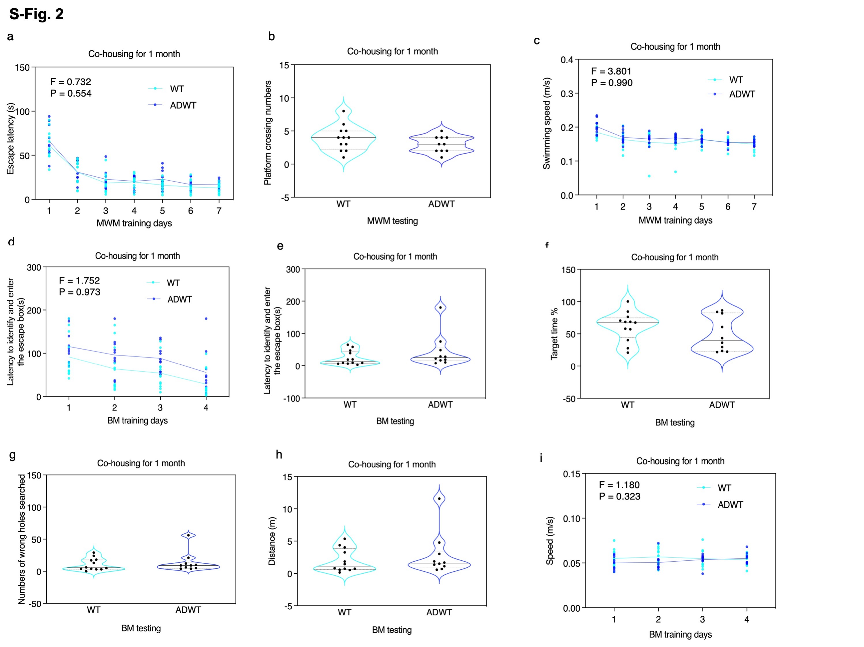
had no significant changes in MWM (a, b, and c) and BM (d, e, f, g, h, and i) compared to the WT mice. N = 10 – 12 mice in each experimental group. * P < 0.05; ## P < 0.01. Two-way ANOVA with repeated measurement and Bonferroni test was used to analyze the data presented in a, c, d, and i. Mann–Whitney U test was used to analyze the data presented in b, e, f, g, and h. The P values refer to the differences of variables between the groups (WT versus ADWT). AD, Alzheimer’s disease; WT, wild-type; Tg, transgenic; MWM, Morris water maze; BM, Barnes maze.

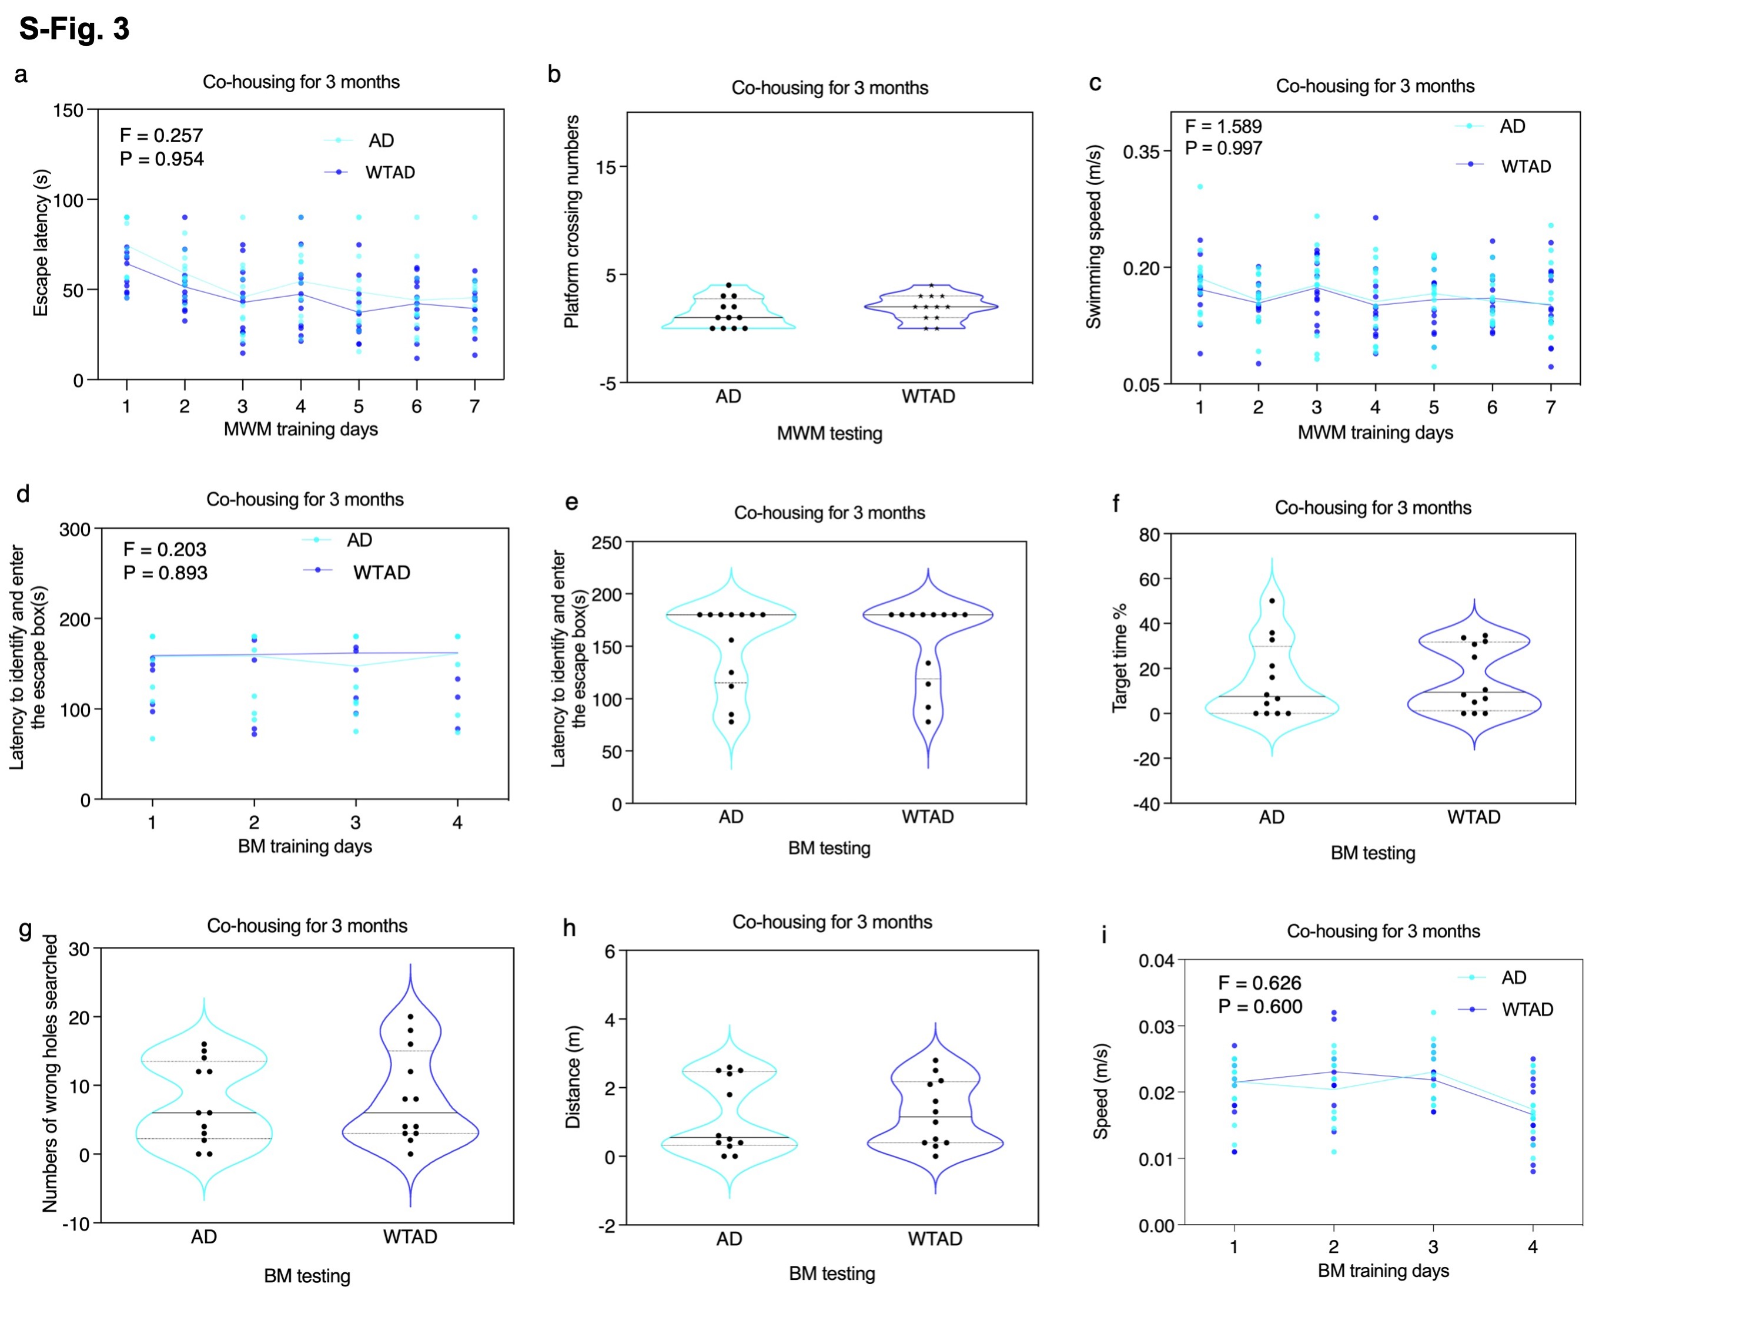

S-Fig. 3. AD Tg mice did not show improvement in cognitive function after 3 months co-housing with WT mice. After co-housing with WT mice for 3 months, the WTAD mice (AD Tg mice co-housed with WT mice) had no significant changes in MWM (a, b, and c) and BM (d, e, f, g, h, and i) compared to the AD Tg mice without co-housing with WT mice. N = 12 mice in each experimental group. Two-way ANOVA with repeated measurement and Bonferroni test was used to analyze the data presented in a, c, d, and i. Mann–Whitney U test was used to analyze the data presented in b, e, f, g, and h.
The P values refer to the differences of variables between the groups (WT versus WTAD), * P < 0.05; ## P < 0.01. AD, Alzheimer’s disease; WT, wild-type; Tg, transgenic; MWM, Morris water maze; BM, Barnes maze.

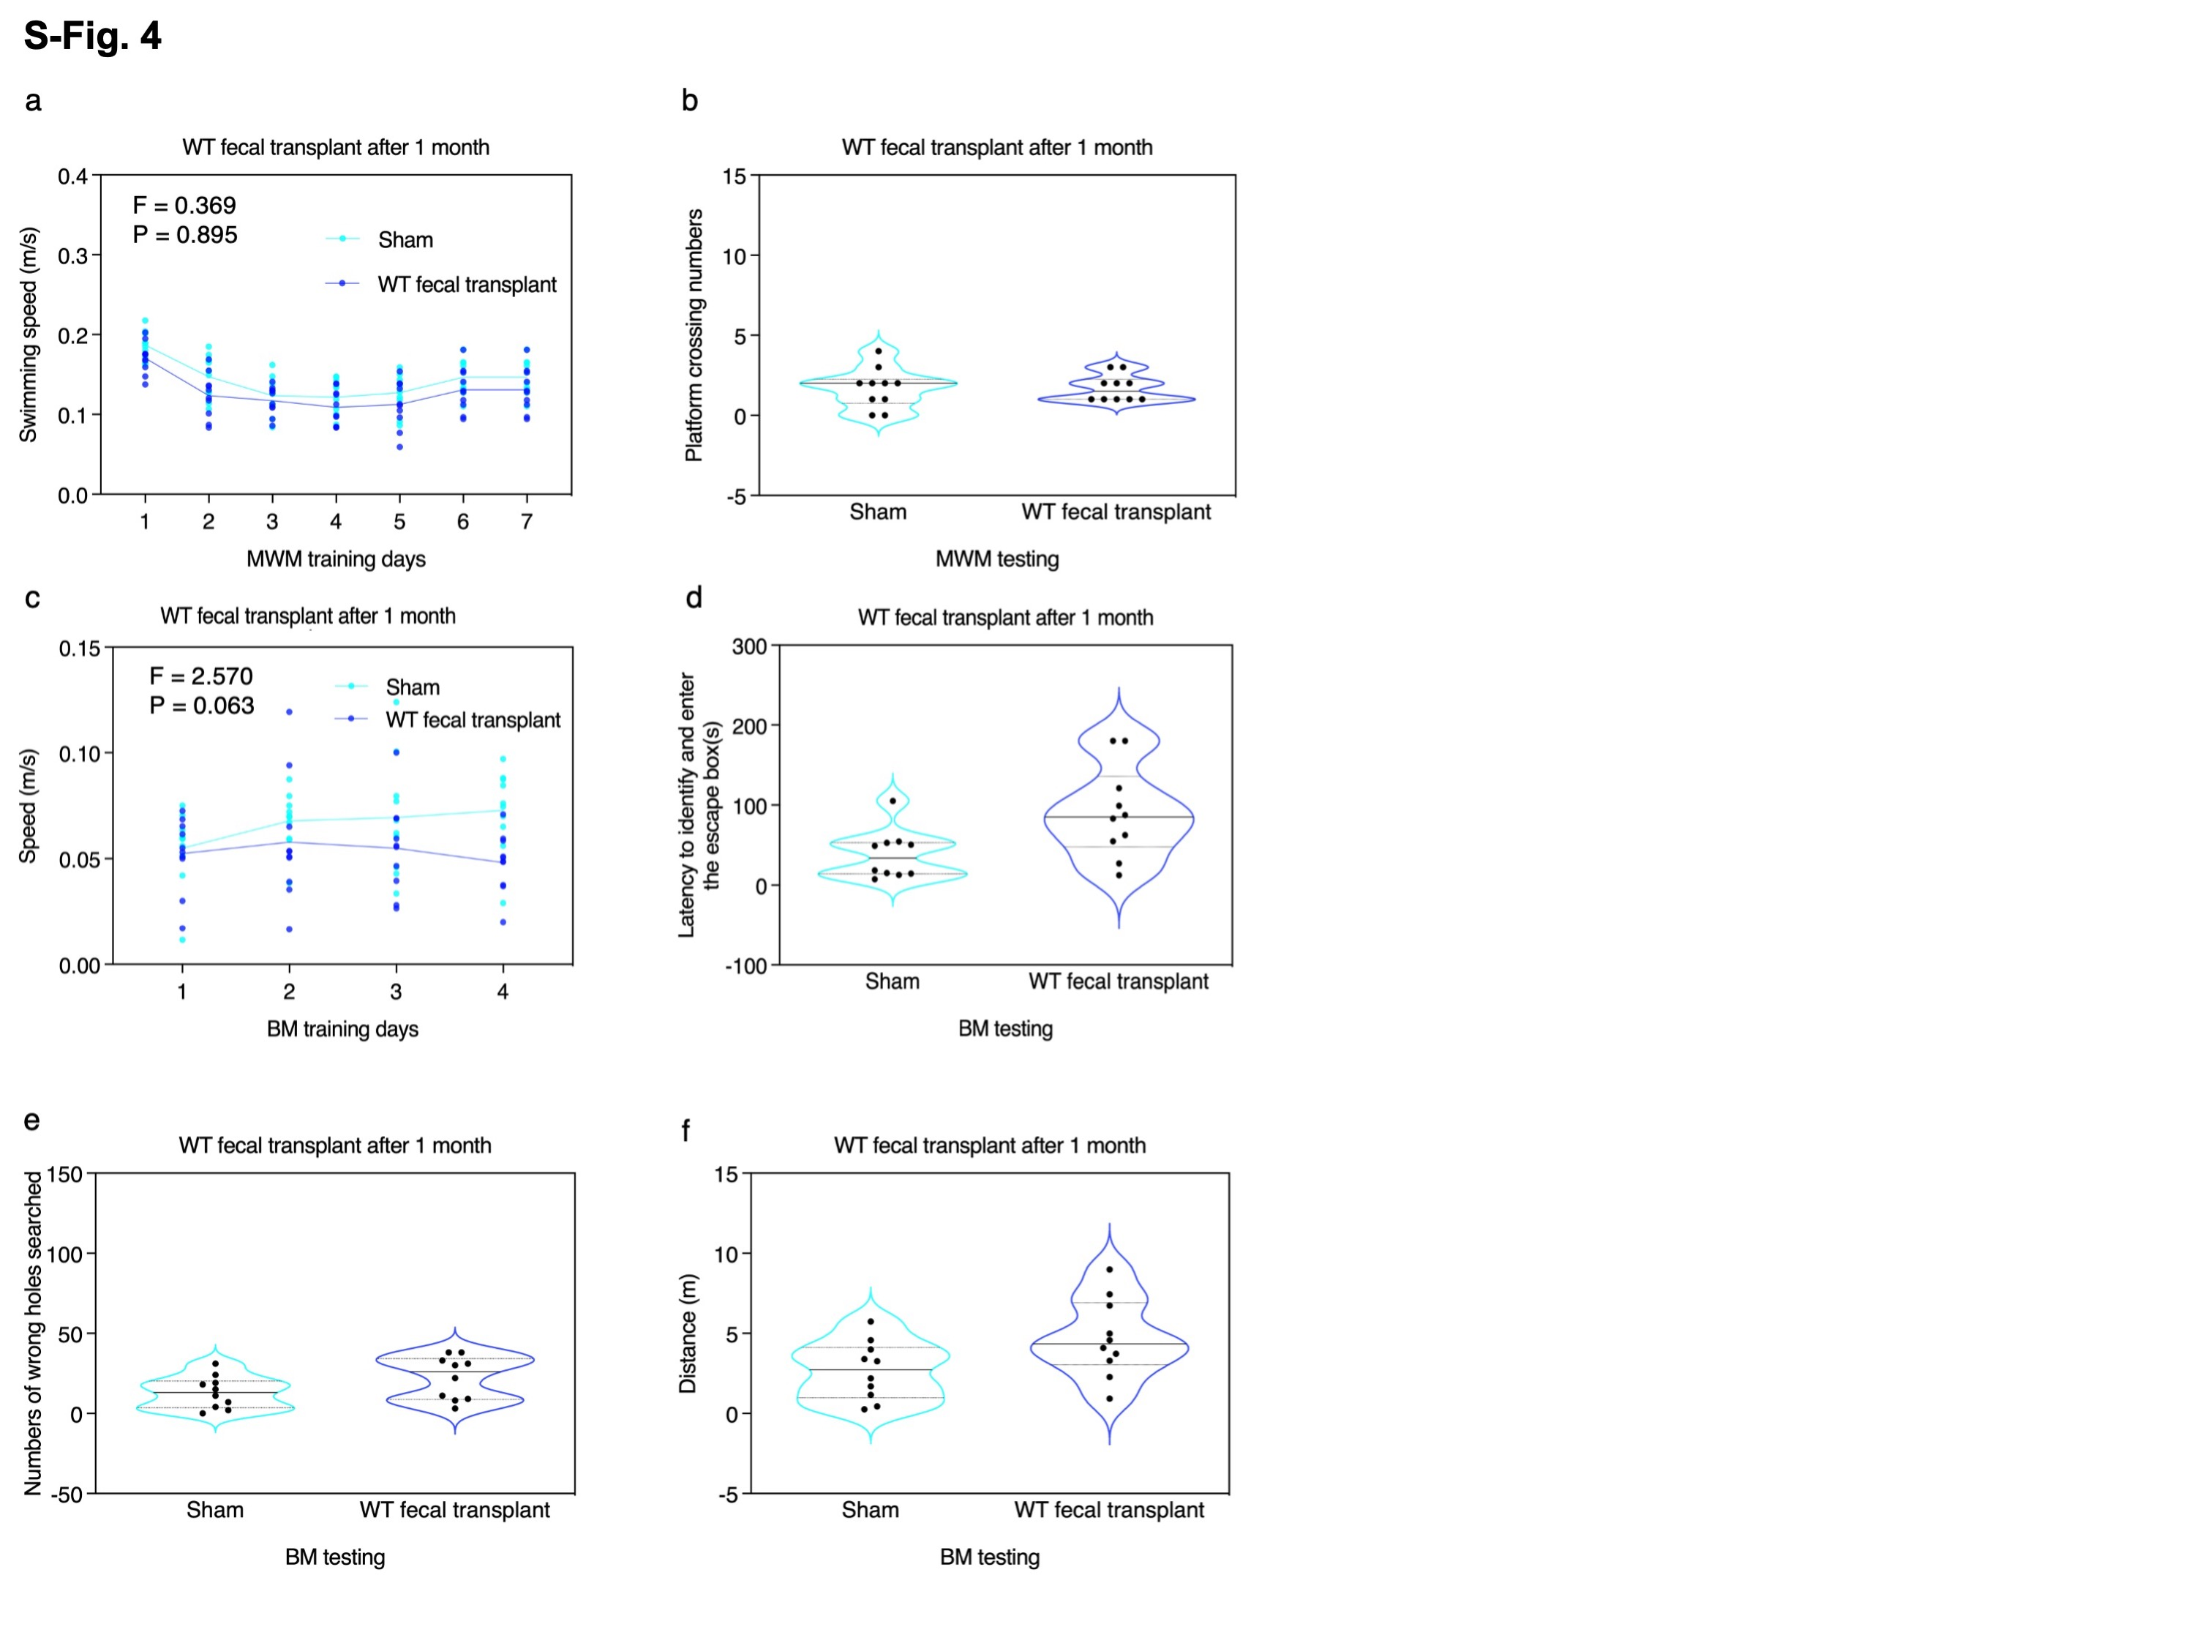

S-Fig. 6. The

S-Fig. 4. WT mice did not develop cognitive impairment after receiving feces of WT mice. The 2 months old WT mice received gavage of feces from another group of WT mice for 7 days did not develop cognitive impairment at 3 months old compared to the WT mice without treatment of feces, as evidenced by no significant changes on swimming speed on MWM (a), platform crossing number on MWM (b), speed (c), latency to identify and enter the escape box (d), number of wrong hole searched (e), and distance (f) on BM. N = 10 mice in each experimental group. Two-way ANOVA with repeated measurement and Bonferroni test was used to analyze the data presented in a and c. Mann–Whitney U test was used to analyze the data presented in b, d, e, and f.
The P values refer to the difference between treatments (sham versus WT fecal transplant). AD, Alzheimer’s disease; WT, wild-type; MWM, Morris water maze; and BM, Barnes maze.

S-Fig. 5. Effects of air exchange for 3 months on cognitive function of mice in MWM and BM test. WT mice with air exchange, but not co-housing, with AD Tg mice did not show significant difference compared to WT mice without air exchange in the MWM and BM test on escape latency (a), planform crossing number (b), swimming speed (c) of MWM, latency to identify and enter the escape box of BM training (d), latency to identify and enter the escape box (e), number of wrong holes searched (f), target time (g), distance (h) and speed (i) of BM testing. Data are mean ± standard deviation or medians (with interquartile ranges), N = 12 mice in each experimental group. Two-way ANOVA was used to analyze the data presented in a, c, d and i. Mann–Whitney U test was used to analyze the data presented in b, e, f, g, and h.
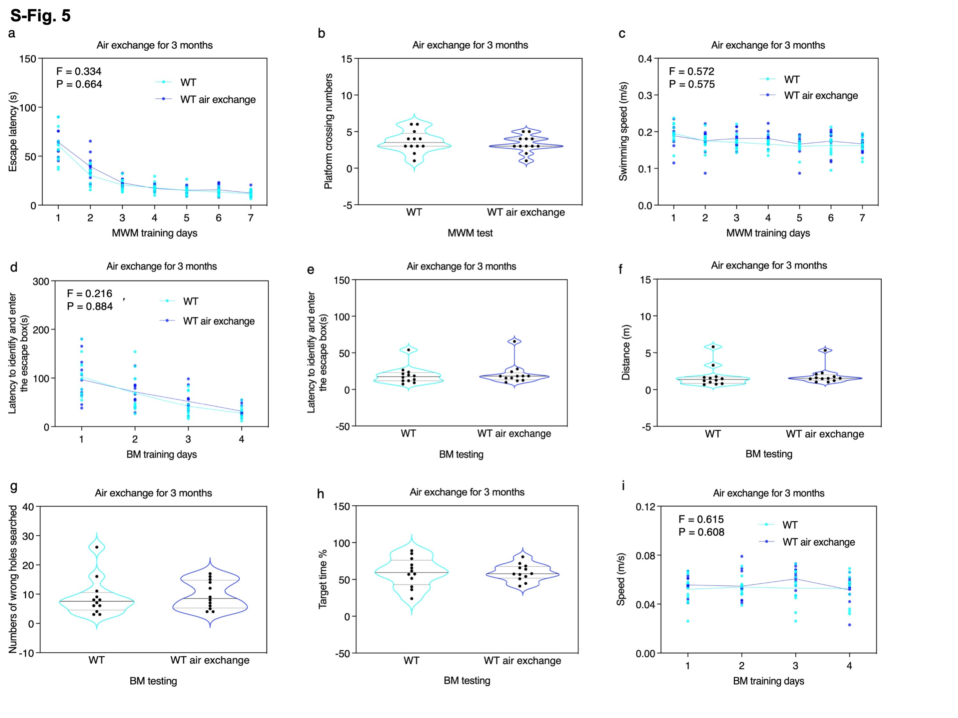
AD, Alzheimer’s disease; WT, wild-type; MWM, Morris water maze; BM, Barnes maze.

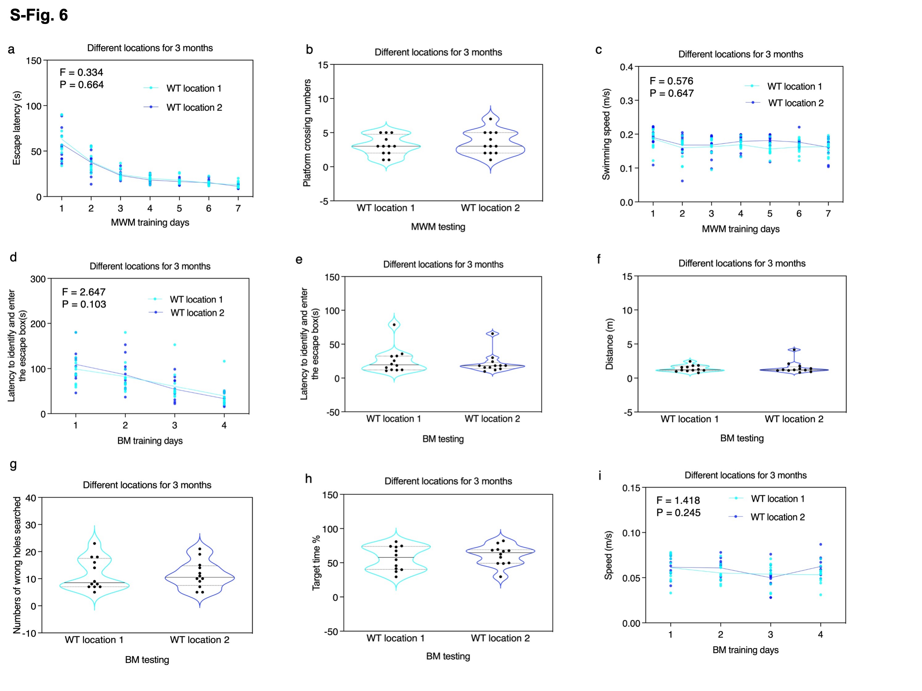
S-Fig. 6. Effects of different location for 3 months on cognitive function of mice in MWM and BM test. WT mice in location 1 did not show significant difference as compared to WT mice in location 2 in the MWM and BM test on escape latency (a), planform crossing number (b), swimming speed (c) of MWM, latency to identify and enter the escape box of BM training (d), latency to identify and enter the escape box (e), number of wrong holes searched (f), target time (g), distance (h) and speed (i) of BM testing. Data are mean ± standard deviation or medians (with interquartile ranges), N = 12 mice in each experimental group. Two-way ANOVA was used to analyze the data presented in a, c, d and i. Mann–Whitney U test was used to analyze the data presented in b, e, f, g, and h. WT, wild-type; MWM, Morris water maze; BM, Barnes maze.

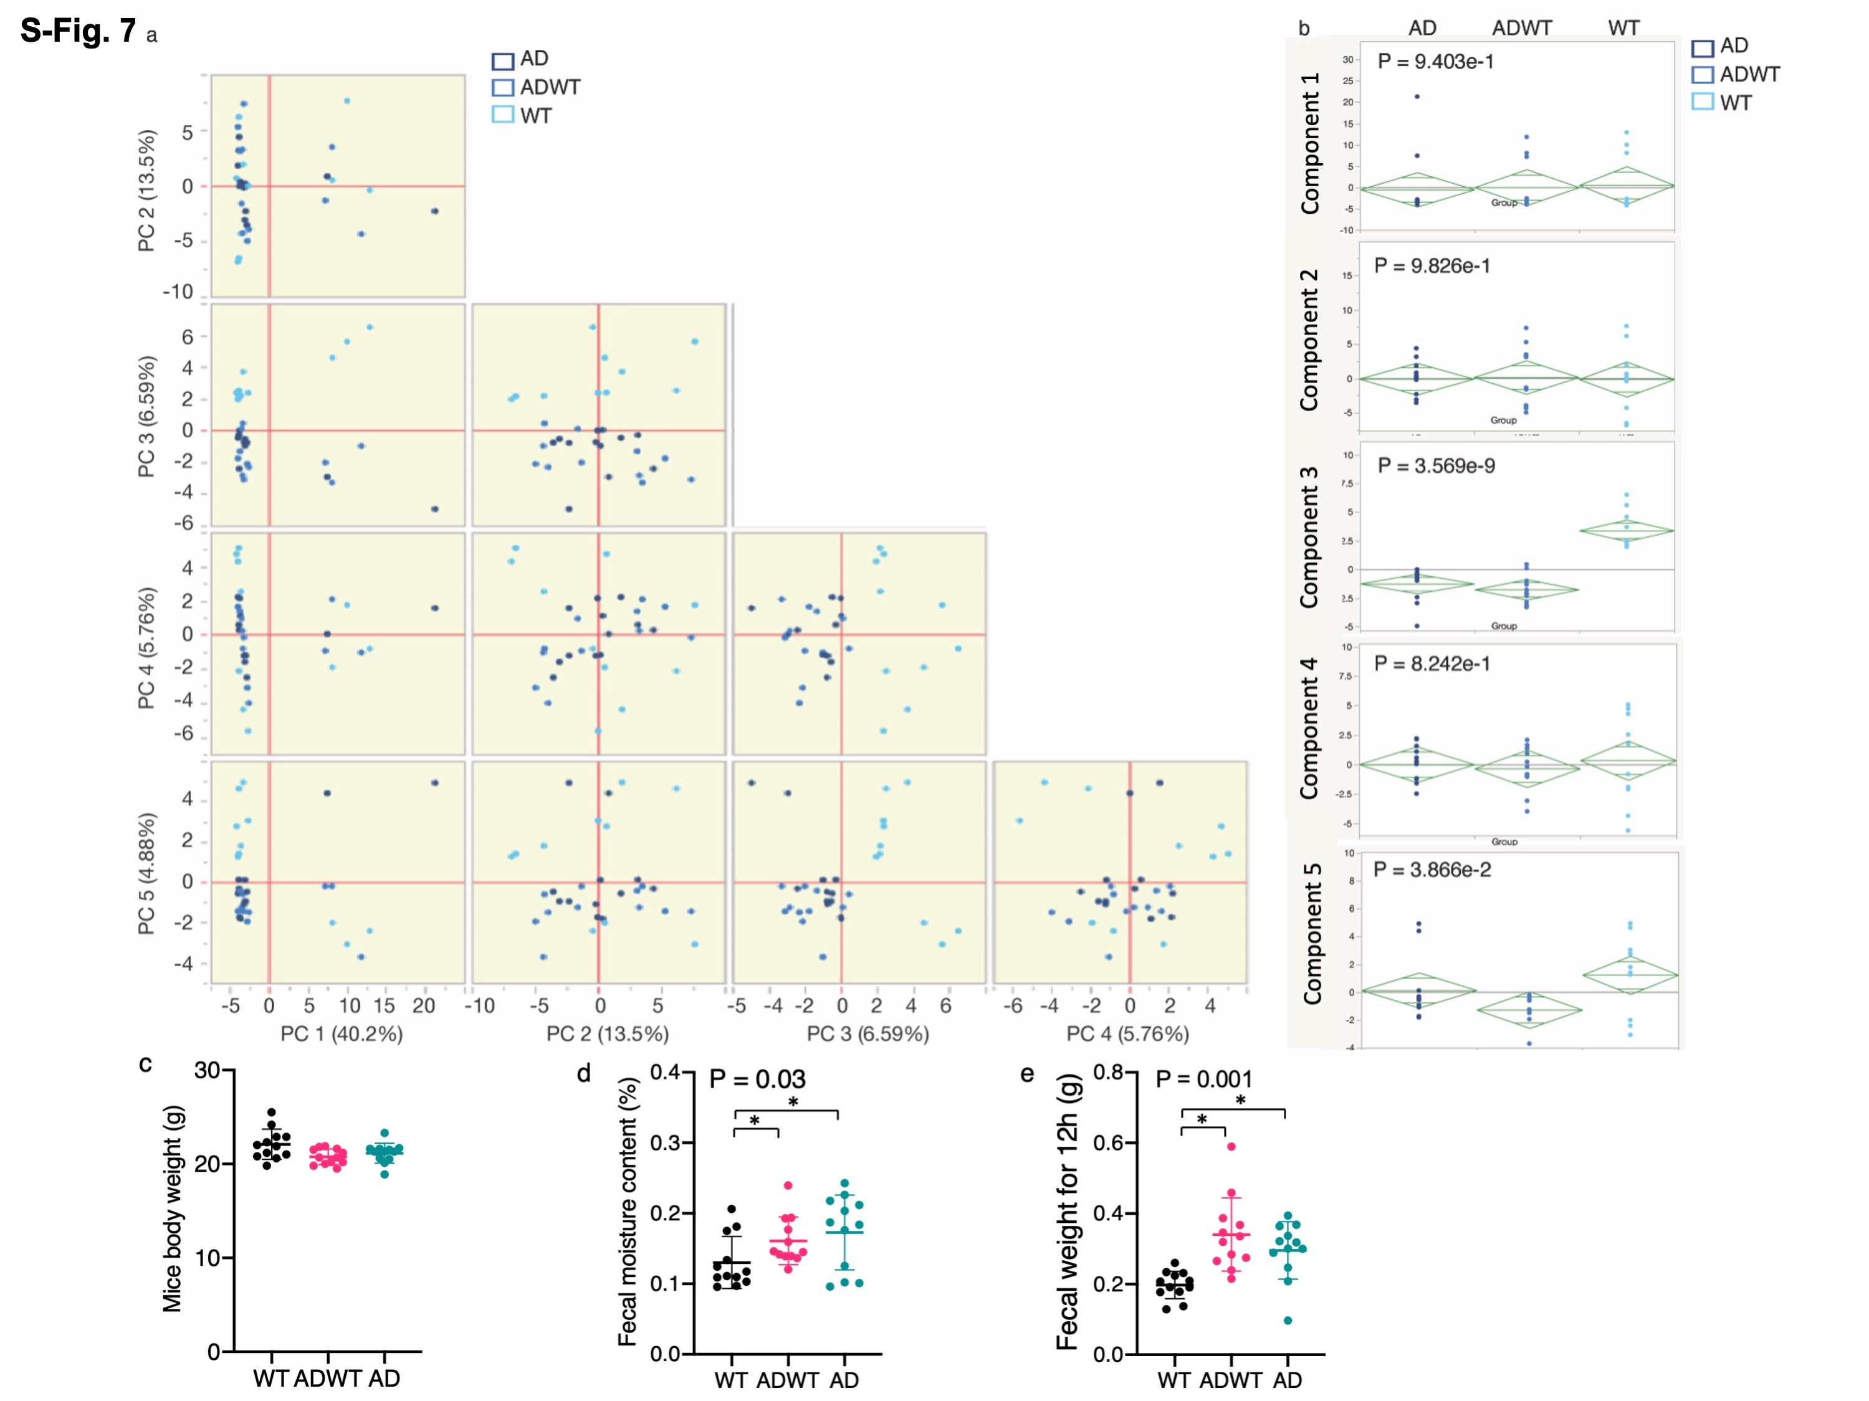

S-Fig. 7. Principal component analysis (PCA) using the Bray–Curtis dissimilarity metric among fecal samples of WT, ADWT and AD Tg mice. a. Each dot represents an individual mouse. PC1, PC2, PC3, PC4 and PC5 represent percentage of variance explained by each coordinate. b. Principal component analysis showed the significant difference in PC3 or PC5 among the fecal samples of WT, ADWT and AD Tg mice, suggesting that there were significant differences in the principal component of bacteria in fecal samples among the WT, ADWT and AD Tg mice. c. There were no significant differences in body weight among WT, ADWT and AT Tg mice after 3 months of co-housing. d. The feces of AD Tg and ADWT mice had increased moisture content compared to WT mice after 3 months of co-housing. e. The feces collected during a 12-hour period of AD Tg and ADWT mice had increased weight compared to those of WT mice after 3 months of co-housing. N = 12 - 14 biologically independent samples in each group. One-way ANOVA and post-hoc Bonferroni test was used to analyze the data presented in b, c, d, and e; the P values refer to the differences among the AD Tg, ADWT and WT mice. * or # P < 0.05; ** P < 0.01. AD, Alzheimer’s disease; WT, wild-type; PCA, principal component analysis.

S-Fig. 8. There were no significant differences in the expression of tight junction proteins in gut between WT and AD Tg mice. a. There are no significant differences in expressions of E-cadherin,Claudin-2, Claudin-4,Occludin and ZO-1 in the small intestine between the WT and AD Tg mice. b. There are no significant differences in the expression of E-cadherin,Claudin-2，Claudin-4,Occludin and ZO-1in the Colon between the WT and AD Tg mice. N = 6-7 biologically independent samples in each group. The Kruskal-Wallis and Dunn’s tests was used to analyze the data presented in the figure A and B; the p values refer to the differences of protein expressions between AD Tg and WT mice. * or # P < 0.05; ** P < 0.01. Error bar indicates standard deviation. AD, Alzheimer’s disease; WT, wild-type.

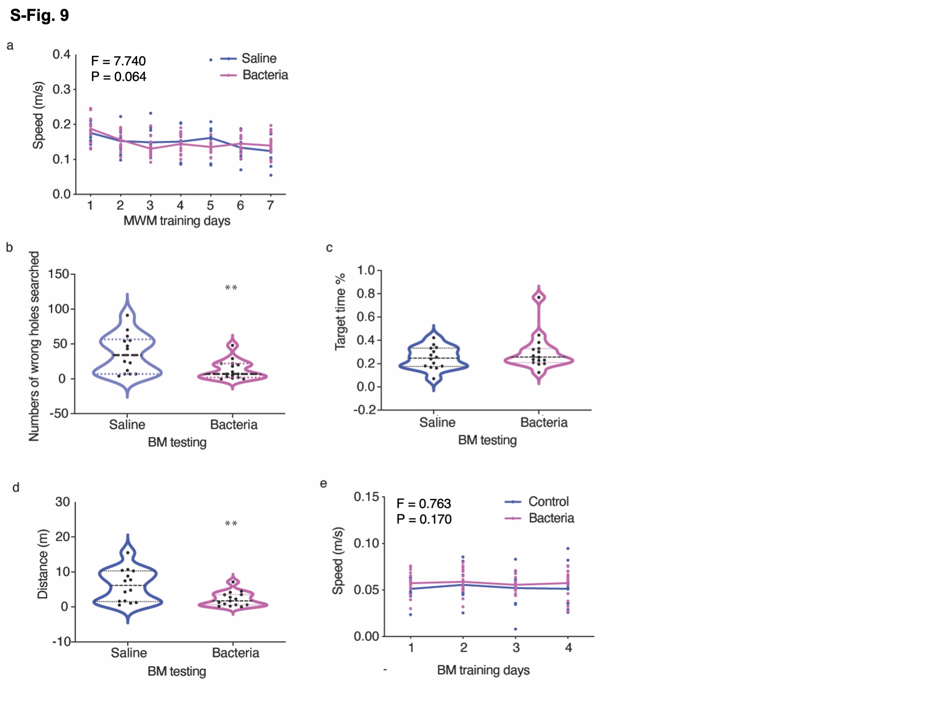

S-Fig. 9. Treatment with Lactobacillus and Bifidobacterium restored the behavioral and cellular changes in ADWT mice.
The gavage with Lactobacillus and Bifidobacterium in mice for 10 days did not significantly alter the swimming speed in MWM (a), but improved the cognitive function in BM testing (b, c and d) without significantly changing the speed in BM training (e). Data are mean ± standard deviation or medians (with interquartile ranges). N = 10 – 12 mice in each experimental group. Two-way ANOVA with repeated measurement and post-hoc Bonferroni test were used to analyze the data presented in a and e. Mann–Whitney U test was used to analyze the data presented in b, c, and d. The P values refer to the differences between saline and bacteria. ** P < 0.01. AD, Alzheimer’s disease; WT, wild-type; BM, Barnes maze.

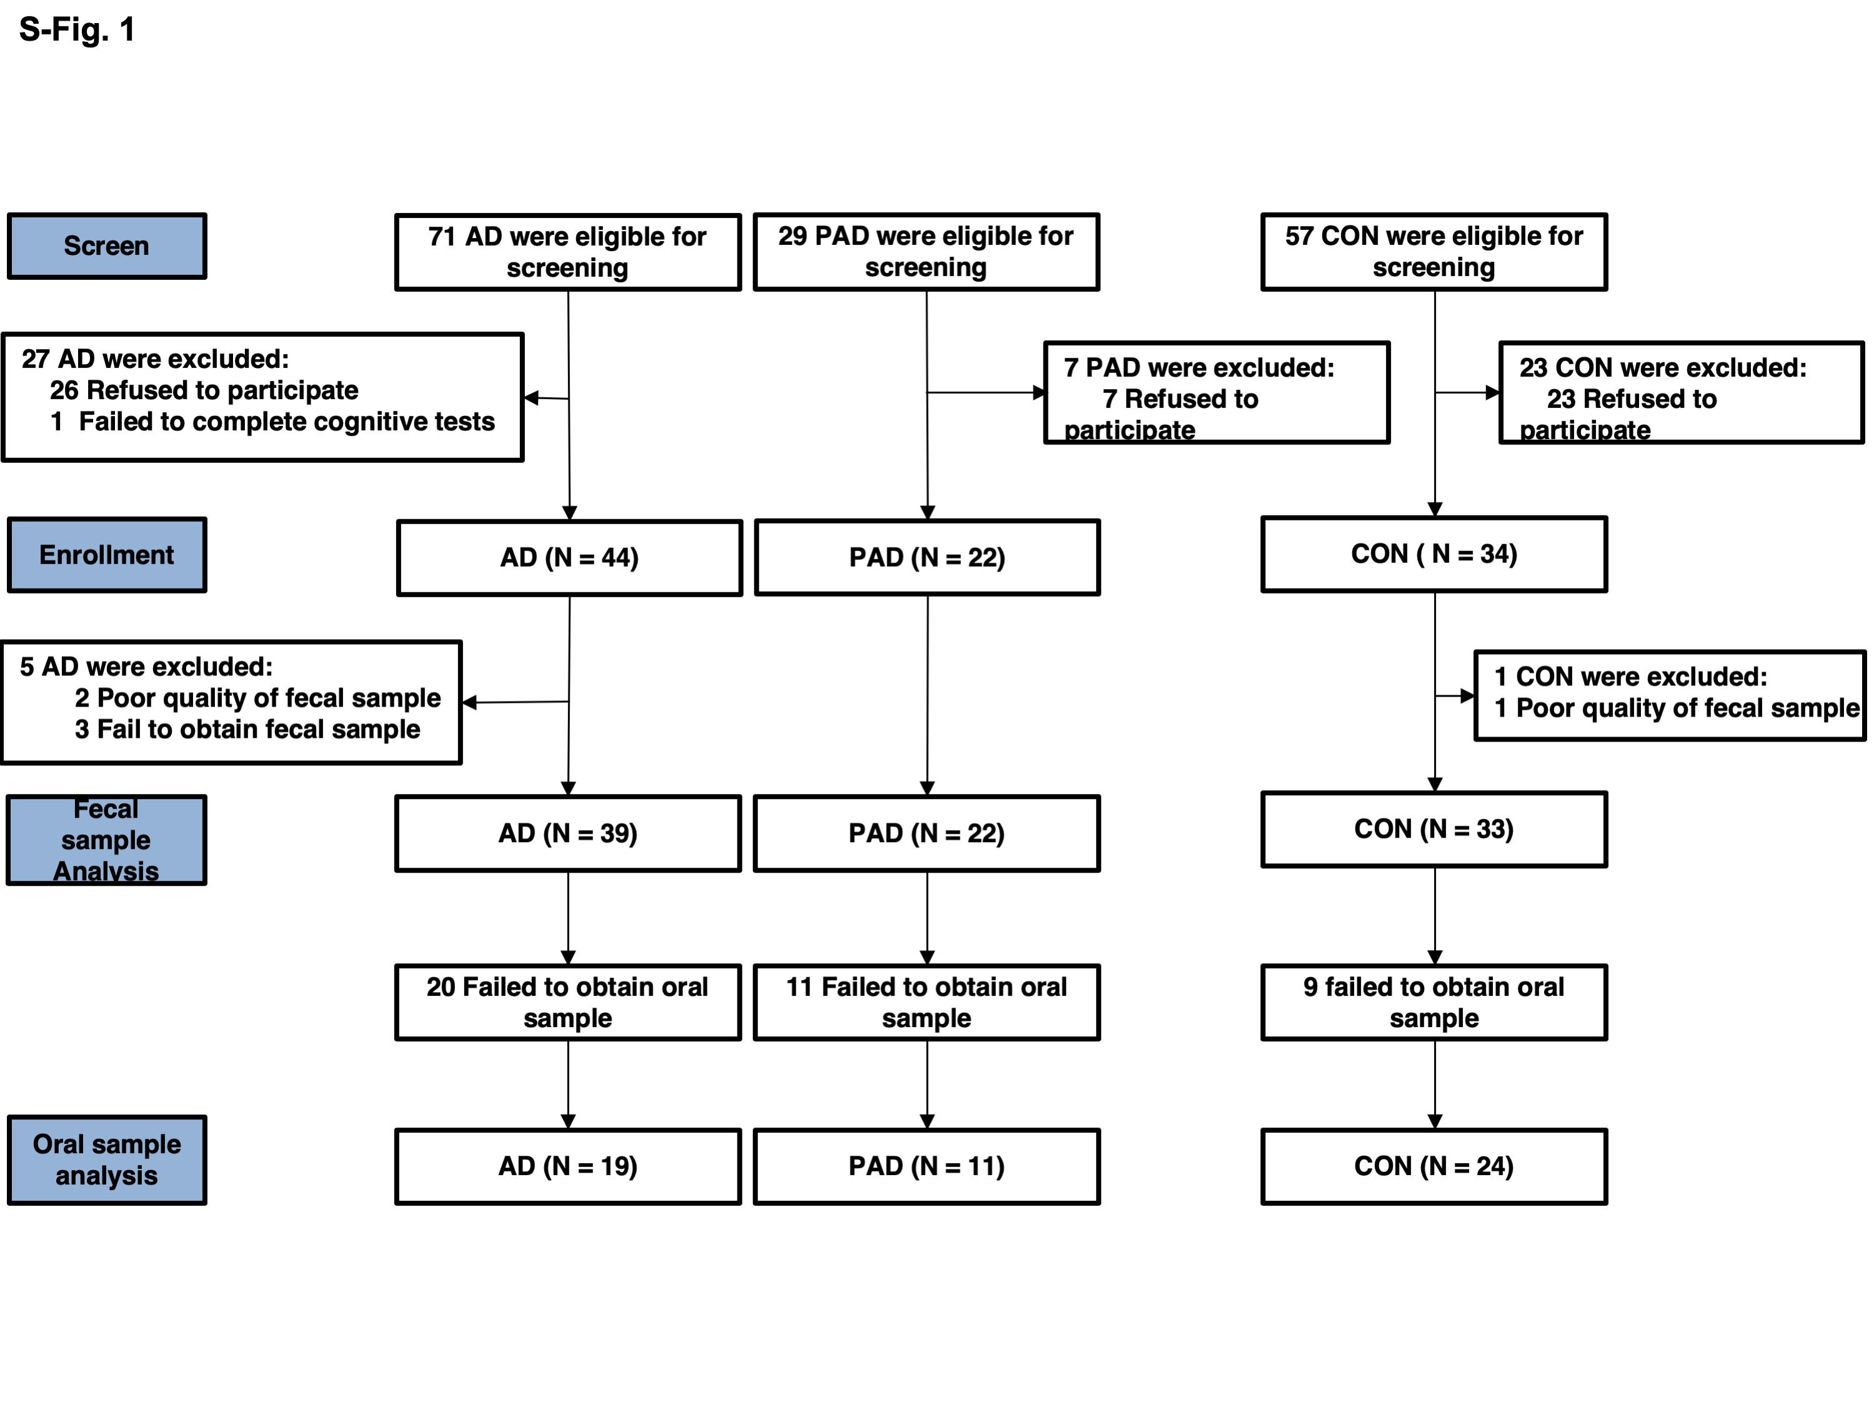

S-Fig. 10. Flow diagram of the clinical study. Participants (N = 157) were initially screened, and 108 participants were included in the final data analysis. Among them, 94 (AD = 39; PAD = 22; CON = 33) participants provided good quality fecal samples and 54 (AD = 19; PAD = 11; CON = 24) provided good quality oral samples. AD, Alzheimer’s disease; PAD, partners of AD; CON, control.

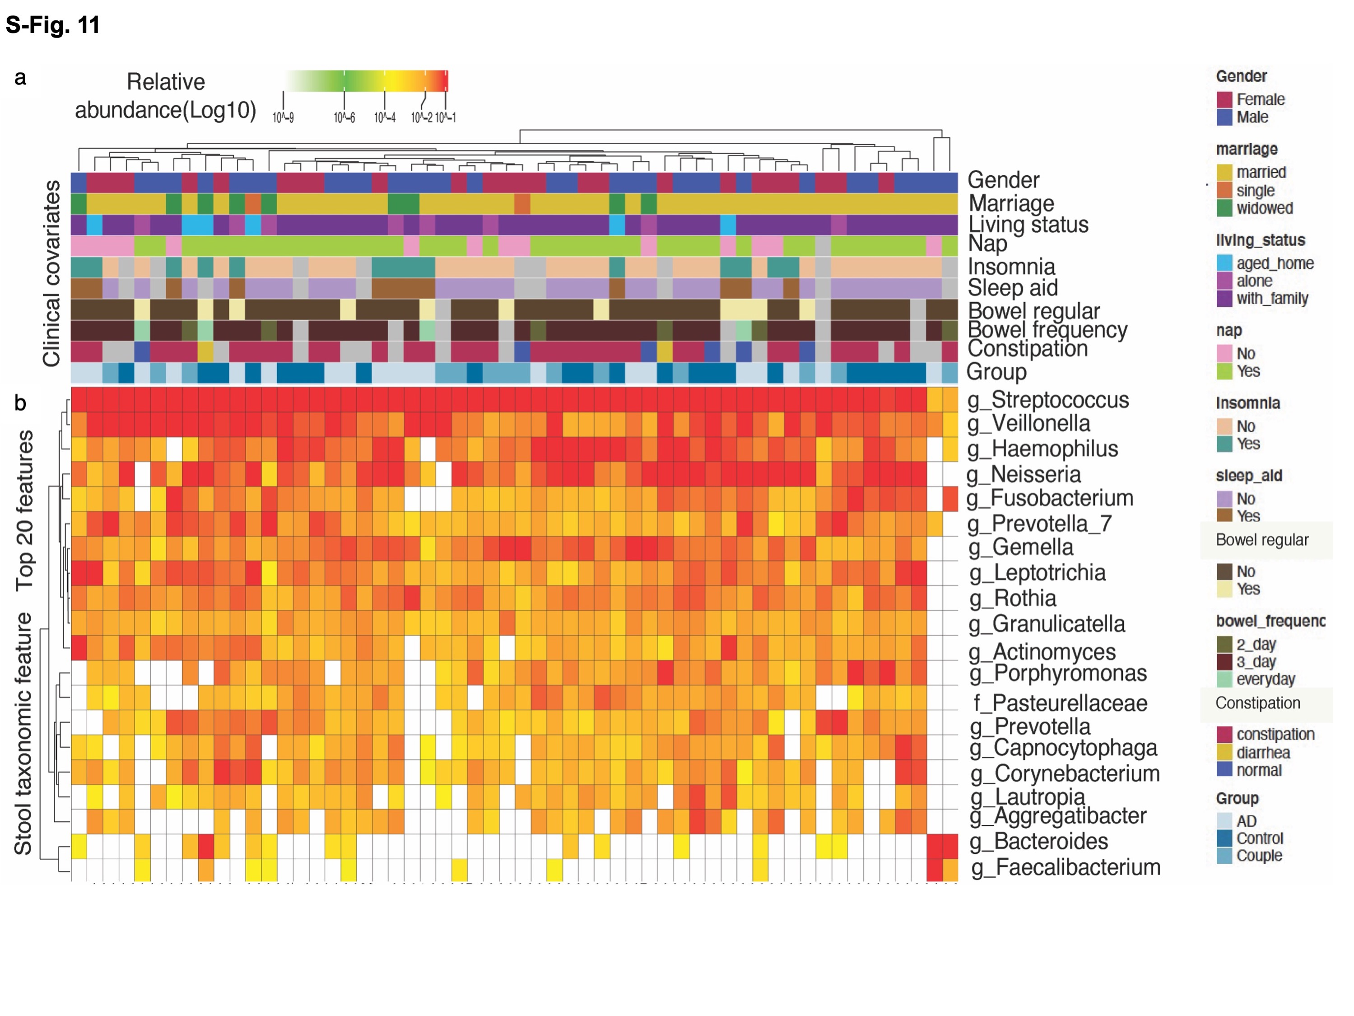

S-Fig. 11. Microbiota in oral samples of Alzheimer’s disease (AD) patients, partners of AD patients (PAD), and control (CON) individuals. Taxonomic features of the gut microbiome with AD, PAD, and CON in clinical covariates (a) and stool taxonomic feature (b) for all cohort samples, with the most abundant (average) 20 genera in oral samples. There were the following biologically independent samples in each group of fecal samples: AD (N = 19), PAD (N = 11), CON (N = 24). AD, Alzheimer’s disease; PAD, partners of AD; and CON, control.

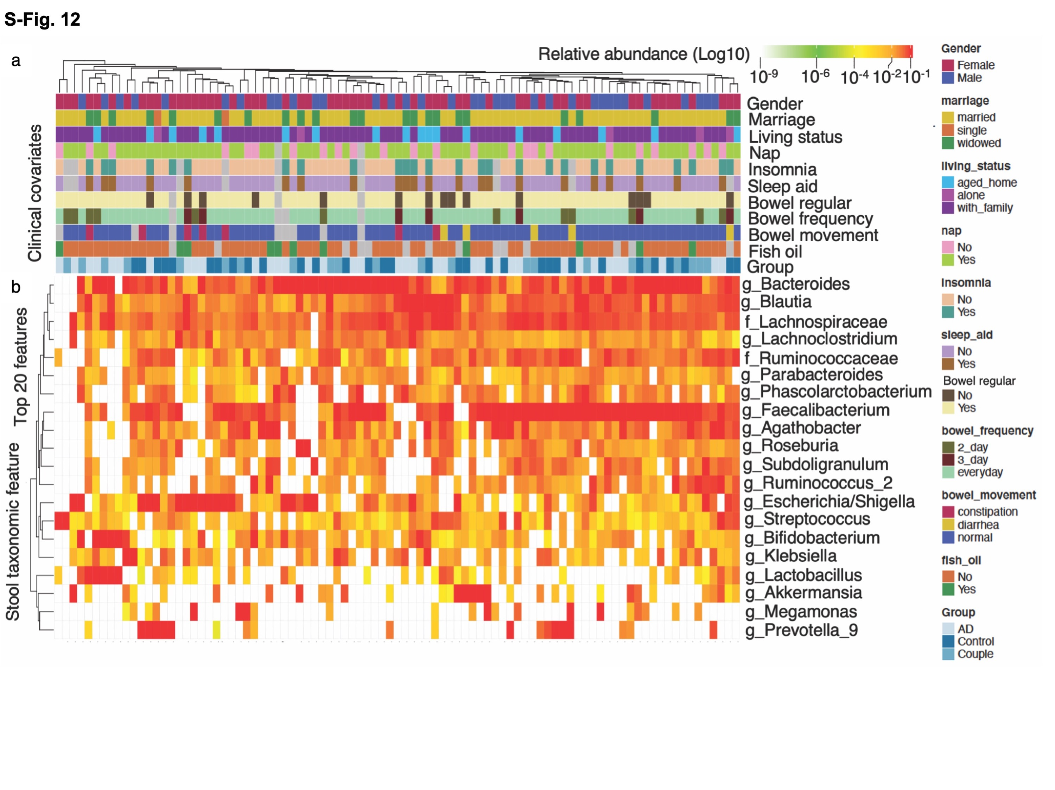

S-Fig. 12. Microbiota in fecal samples of Alzheimer’s disease (AD) patients, partners of AD patients (PAD), and control (CON) individuals. Taxonomic features of the gut microbiome with AD, PAD, and CON in clinical covariates (a) and stool taxonomic feature (b) for all cohort samples, with the most abundant (average) 20 genera in fecal samples. There were the following biologically independent samples in each group of fecal samples: AD (N = 39), PAD (N = 22), CON (N = 33). AD, Alzheimer’s disease; PAD, partners of AD; and CON, control.

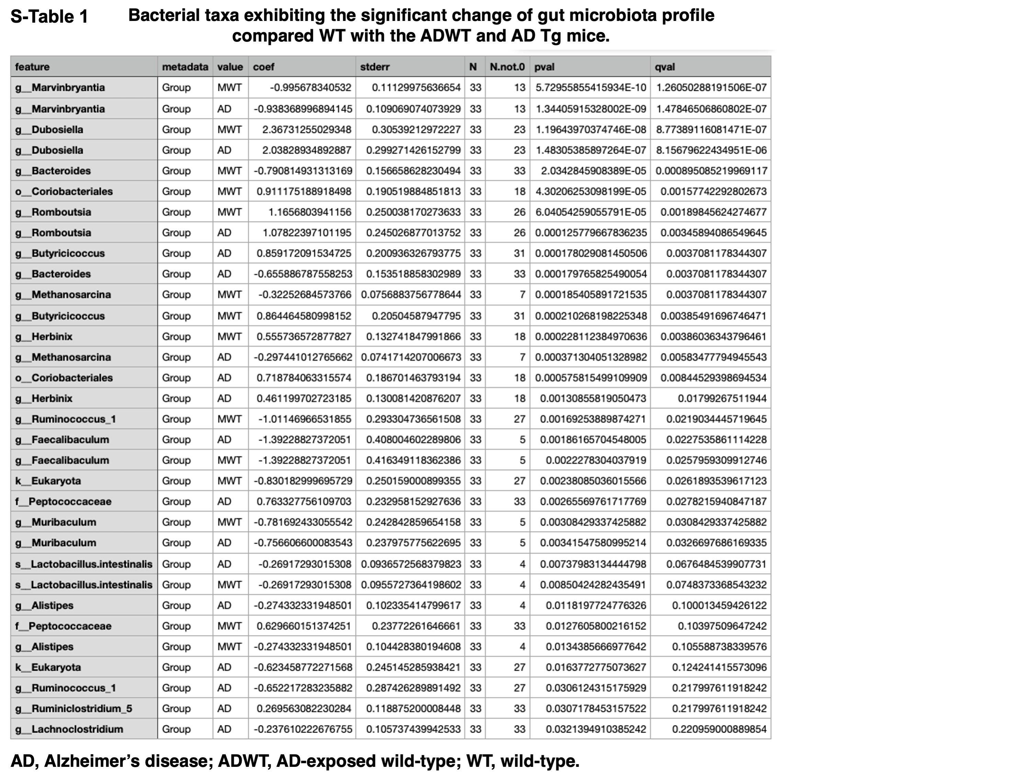

S-Table 1. Bacterial taxa of gut bacteria in fecal samples of WT, ADWT and AD Tg mice.

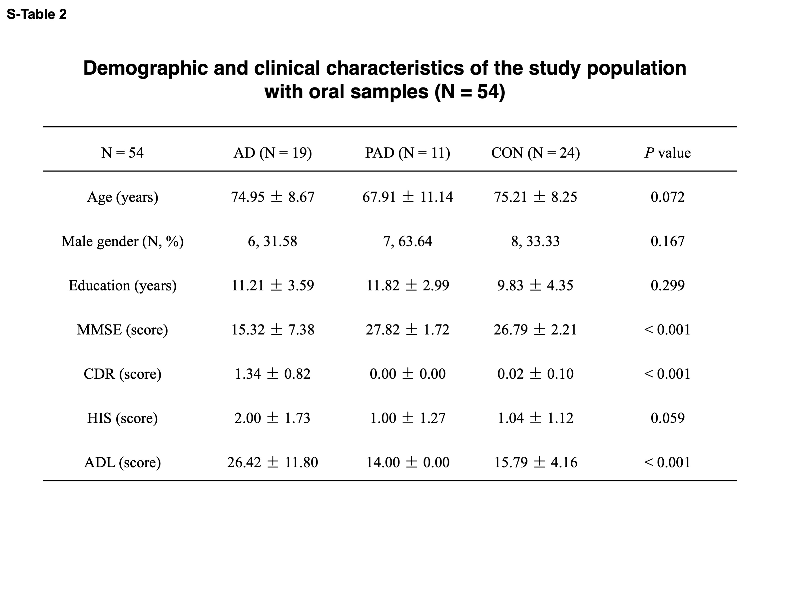
S-Table 2. The demographic and clinical characteristics of AD, PAD, and Con participant who provided oral samples (N = 54).
Average + SD age, sex, education, MMSE score, CDR score, HIS score, and ADL score of each patient cohort is presented. There were significant differences in CDR, MMSE, HIS, and ADL score among AD, PAD, and control participants. Note that oral samples of these participants were collected. AD, Alzheimer’s disease; PAD, partners of AD; CON, control; MMSE, Mini-mental state examination; CDR, clinical dementia rating; HIS, Hachinski ischemia index; ADL, activities of daily living. One-way ANOVA with post-hoc analysis of Bonferroni test and Chi square test were used for data analysis.

S-Table 3. The demographic and clinical characteristics of AD, PAD, and Con participant who provided fecal samples (N = 94)
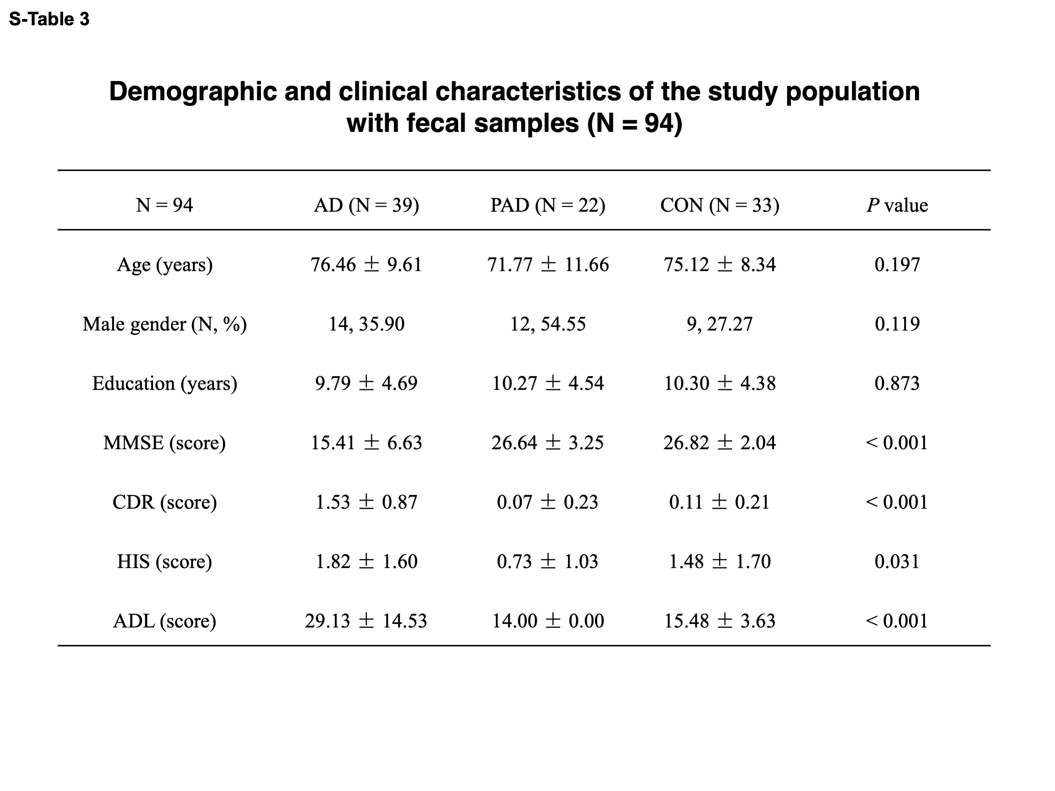
Average + SD age, sex, education, MMSE score, CDR score, HIS score, and ADL score of each patient cohort is presented. There were significant differences in CDR, MMSE, HIS and ADL scores among AD, PAD, and control participants. Note, the fecal samples of these participants were collected from the participants. AD, Alzheimer’s disease; PAD, partners of AD; CON, control; MMSE, Mini-mental state examination; CDR, clinical dementia rating; HIS, Hachinski ischemia index; ADL, activities of daily living. One-way ANOVA with post-hoc analysis of Bonferroni test and Chi square tests were used for data analysis.

STAR+METHODS

Key Resource table

Antigen | Host | Source | Catalog  Clone | RRID | Concentration
Claudin-2 | Rabbit | Turner Lab | Rb188-1 | AB_2916077 | 1 µg/ml
Claudin-4 | Rabbit | Abcam | ab210796 | AB_2732879 | 0.1 µg/ml
E-cadherin | Mouse | Abcam | MAB1388 | AB_1671631 | 1 µg/ml
Occludin | Rat | Cell Signaling | 68534  clone 6B8A3 | AB_2819194 | 1 µg/ml
ZO-1 | Rat | Cell Signaling | R40.76 | AB_628459 | 0.5 mg/ml
AF488-anti Mouse IgG F(ab′)2 | Donkey | Jackson ImmunoResearch | 715-546-151 | AB_2340850 | 1 mg/ml
AF594-anti Rabbit IgG F(ab′)2 | Donkey | Jackson ImmunoResearch | 711-586-152 | AB_2340622 | 1 mg/ml
AF647-anti Rat IgG F(ab′)2 | Donkey | Jackson ImmunoResearch | 712-606-153 | AB_2340696 | 1 mg/ml
Tau-pS202/T205 | Rabbit | ThermoFisher Scientific | MN1020B | AB_223648 | 0.1 mg/ml
Tau-pT181 | Rabbit | ThermoFisher Scientific | 701530 | AB_2532491 | 0.5 mg/ml
Tau-pT217 | Rabbit | ThermoFisher Scientific | 44744 | AB_2533741 | n/a
Tau | Mouse | ThermoFisher Scientific | AHB0042 | AB_2536235 | 0.5 mg/ml
GSK 3α/β | Rabbit | Cell Signaling | 5676 | AB_10547140 | n/a
GSK3β-S9 | Rabbit | Cell Signaling | 9336 | AB_331405 | n/a
GAPDH | Rabbit | Cell Signaling | 5174 | AB_10622025 | n/a

RESOURCE AVAILABILITY

Lead contact Further information and requests for resources and reagents should be directed to and will be fulfilled by the lead contact, Yiying Zhang (yzhang37@mgh.harvard.edu), Zhongcong Xie (zxie@mgh.harvard.edu)

Materials availability

All unique plasmids and transgenic mice generated in this study are available from the lead contact upon completion of the Material Transfer Agreement.

Data and code availability

This study does not report original codes. d Any additional information required to reanalyze the data reported in this paper is available from the lead contact upon request.

EXPERIMENTAL MODEL AND SUBJECT DETAILS

Mice stains

AD Tg mice [B6SJL-Tg (APPSwFlLon, PSEN1M146LL286V) 6799Vas/Mmjax, Stock No. 34848-JAX, Jackson Lab, Bar Harbor, ME]

WT mice (C57BL/6J, Jackson Lab)

Bacterial strains

Lactobacillus reuteri [ATCC, Manassas, VA, Dsm 20016 Lactobacillus reuteri (53609)]

Bifidobacterium pseudolongum (ATCC, Manassas, VA, Catalog 25526)

Cell strains

HEK293T cell (Cat# CRL-3216; ATCC, RRID: CVCL_0063)

Methods

Mice Co-housing condition
I. Co-housing of AD Tg mice with WT mice to generate the ADWT mice.
To generate ADWT mice, female AD Tg mice were co-housed with age-matched female WT mice, in accordance with the approved animal protocol (Protocol number: 2006N000219) of the Massachusetts General Brigham (Boston, Massachusetts) Standing Committee on the Use of Animals in Research and Teaching, and the National Institutes of Health guidelines and regulations. Only female mice were used in the current study. The mice were maintained in a non-germ-free facility with a 12:12 hour light: dark cycle (lights on at 7:00 am), and ad libitum access to food and water, mimicking real-world conditions. Each cage housed two AD Tg mice [B6SJL-Tg (APPSwFlLon, PSEN1M146LL286V) 6799Vas/Mmjax, Stock No. 34848-JAX, Jackson Lab, Bar Harbor, ME] and two WT mice (C57BL/6J, Jackson Lab) aged 2 months, and were co-housed for either 1 or 3 months. After separation, four ADWT mice were housed in one cage for subsequent studies. We followed the Animal Research: Reporting of In Vivo Experiments (ARRIVE) guidelines in writing this manuscript. We bred and maintained the AD Tg mice in our own animal facilities, typically using male AD Tg mice with female WT mice.
II. Air exchange between AD Tg mice and WT mice.
To investigate whether cognitive changes were specifically due to co-housing and not air exchange, we conducted an experiment where a cage containing four AD Tg mice and another cage containing four WT mice were placed side-by-side to allow air exchange between the two cages without physical contact between the AD Tg mice and the WT mice. This experiment was designed to separate the effects of co-housing from potential confounding factors such as differences in air quality. We monitored the cognitive performance of the mice in both cages and compared the results to those obtained from the co-housed ADWT mice.
III. Different locations of cages.
To evaluate the effect of the environment on cognitive function in WT mice, we conducted an experiment where cages containing four WT mice each were placed in a different room. This was done to rule out any potential environmental confounds that may affect the cognitive performance of the mice. We monitored the cognitive performance of the mice in these cages and compared the results to those obtained from the co-housed ADWT mice and the side-by-side cage experiment.
Microbiota transplantation.
Female wild-type mice at 2 months of age were randomly assigned to two groups (ten mice in each group), and received a cocktail of four antibiotics (ampicillin, vancomycin, neomycin, and metronidazole) in their drinking water for one week. After the antibiotic treatment, each mouse was orally gavaged with 0.2 mL of a suspension of fecal material obtained from either 2-month-old AD transgenic mice or age-matched wild-type mice. Fecal samples were prepared as described previously^{1,2}, and each mouse received daily treatment for ten days. Control mice received only saline for the same duration. One month after the last gavage, cognitive function was assessed using the Morris water maze and Barnes maze.
Animal behaviors tests
I. Morris water maze.
The Morris water maze (MWM) test was conducted following previously established protocols ³. Briefly, mice were subjected to four trials per day for seven consecutive days in the MWM starting one day after co-housing. Escape latency, the time taken to reach the platform, was recorded in each trial to assess learning function, and the average escape latency from the four trials was calculated and analyzed each day. On the final day, the platform was removed, and the number of platform crossings was counted to measure memory function. Swimming speed was also recorded and analyzed. Mice were kept warm using a heating device throughout the experiment.
II. Barnes maze.
The same group of mice were tested in the Barnes maze (BM) one day after completing the MWM test, following previously established procedures ⁴. The BM training included two trials per day (3 minutes per trial with 15-minute intervals) for four consecutive days. During BM training, the latency to identify and enter the escape box was measured and recorded for each mouse. Five days after BM training, BM testing was conducted to record and measure the latency to identify and enter the escape box, the number of wrong holes searched, distance traveled, and time spent in the target zone. The testing was initiated by placing a mouse under a bucket in the center of the circular platform and using bright light (200 Watt) and noise (85 decibels) to stimulate escape behavior. If the mouse did not enter the escape box within three minutes of the stimulation, it was gently guided to the correct hole. The buzzer was turned off immediately when the mouse entered the tunnel connecting the hole and the escape box. Each mouse was allowed to remain in the escape box for one minute before being returned to the home cage. Latency to identify and enter the escape box and speed were recorded during BM training, while latency, target zone entrances, wrong holes searched, distance, and speed were measured during BM testing.
Gavage with Lactobacillus and Bifidobacterium in mice
Lactobacillus reuteri (ATCC, Catalog 53609) were cultured in ATCC Medium 78 at 37°C in an aerobic environment, composed of 20 g/L tryptone, 5 g/L tryptose, 5 g/L yeast extract, 200 ml/L tomato juice, 1 g/L liver extract concentrate, 0.05 g/L Tween 80, 3 g/L glucose, and 2 g/L lactose (pH 6.5). Bifidobacterium pseudolongum (ATCC, Catalog 25526) were cultured in ATCC Medium 2107 at 37°C in an anaerobic environment. The medium was composed of 10 g/L tryptose, 10 g/L beef extract, 3 g/L yeast extract, 5 g/L dextrose, 5 g/L NaCl, 1 g/L soluble starch, 0.5 g/L L-cysteine HCl, 3 g/L sodium acetate, and 4 ml/L resazurin (0.025%) (pH 6.8). For the first 10 days of each month during the 3-month co-housing with the AD Tg mice, each ADWT mouse received either 10⁹ CFU Lactobacillus reuteri plus Bifidobacterium pseudolongum (10⁹ CFU in 200 µL of saline) or saline only by intragastric administration once per day.
Harvest of mice brain tissues and collection of mice feces. At the end of co-housing, fecal samples were collected from each mouse in the study (n = 6-12 in each group). Additionally, cortex and hippocampus tissue samples were harvested from each mouse at the end of the behavioral tests.
DNA extraction and 16S rRNA Gene Sequencing
The researchers collected fecal and oral samples from the mice and human participants and stored them at -80°C until being shipped for analysis. The 16S rRNA gene sequencing was performed by BGI America (for mouse samples) or Shanghai, P.R. China (for human samples) using the manufacturer's protocol, following previously established procedures ⁴. In brief, mouse feces were placed in 1.5 ml tubes, snap-frozen on dry ice, and stored at −80°C until being shipped on dry ice for analysis. In human studies, participants were asked to provide a fecal and oral sample whenever they were ready. Samples were taken in fecal and oral collection containers, then transferred on ice and stored at –80°C in tubes supplied with OmniGene Gut kits (OMR-200, DNA Genotek, Ora Sure Technologies) until DNA extraction.
SCFAs detection
I. Quantification of fecal SCFAs. Quantification of fecal SCFAs was performed as previously described ⁵. Briefly, fecal samples were homogenized, and their dry weight (DW) was determined. The homogenates were then diluted and stored at -80°C. To quantify SCFAs, an aliquot of the homogenate was centrifuged, and the clear supernatant was collected. The pH of the supernatant was adjusted to 2-3 using 5 M HCl, and the suspension was centrifuged again. The clear supernatant was transferred to a new tube, and an internal standard (2-ethylbutyric acid) was added. SCFA quantification was performed by gas chromatography using a Shimadzu GC-2014 system with a fused-silica capillary column and a free fatty acid phase. The flow rates for hydrogen, air, and nitrogen were 30, 300, and 20 mL/min, respectively, and the injected sample volume was 1 μL. The authors quantified eight SCFAs: acetic, propionic, butyric, isobutyric acid, valeric acid, isovaleric acid, hexanoic acid, and TEBA (internal standard).
II. Quantification of brain SCFAs
Quantification of fecal SCFAs was performed as previously described ⁶. Briefly, the method involves homogenizing 0.1 g of the tissue in 500 µl of aqueous acetonitrile and extracting the supernatant with 8 ml of extraction buffer (hexane: diethyl ether = 1:1). After centrifugation, 7.5 ml of the supernatant is collected and mixed with 93 µl of 20 mM KOH in methanol, and then dried at 40 °C under nitrogen gas. The dried residue is reconstituted in 50 µl of 2.5% 18-Crown-6 in acetonitrile and is further derivatized with 9-chloromethylanthracene in acetonitrile with the addition of tetramethylammonium hydroxide. The derivatized sample is loaded onto an Acclaim C18 column (3 µm, 4.6 × 100 mm, Thermo Scientific) and separated using an Ultimate 3000 high-performance liquid chromatograph (HPLC, Thermo Scientific) equipped with a UV-visible detector. 2-Ethylbutyric acid (2-EA) is added as an internal reference control, and the peak area of SCFAs is measured in mAU*min. The peak area of each sample is normalized with that of 2-EA in the sample, and the results are presented as ratios of SCFAs in the treatment group to the control (NS) group.
Enzyme-linked immunosorbent assays (ELISA)
The immunoassay kits used to detect IL-6, Aβ42, Aβ40, and Tau-pS199 in mouse brain tissue were as follows: Mouse IL-6 immunoassay kit (Catalog number: M6000B, R&D Systems, Minneapolis, MN); Mouse Aβ42 ELISA kit (Catalog number: KHB3441, Invitrogen, Waltham, MA); Mouse Aβ40 ELISA kit (Catalog number: KHB3481, Invitrogen, Waltham, MA), and mouse Tau (Phospho) [Tau-pS199] ELISA Kit (Catalog number: KMB7041, Invitrogen, Waltham, MA). The manufacturer's instructions were followed for each kit to determine the amount of IL-6, Aβ42, Aβ40, and Tau-pS199 in mouse brain tissue. The optical density of each well was measured at 450 nm and corrected at 570 nm, as described in a previous study ⁷.
Western blot analysis
Western blot analysis as previously described ⁸. We used the following antibodies: AT8 (55 kDa, 1:1,000, Invitrogen, Carlsbad, CA) to detect Tau phosphorylated at serine 202 (Tau-pS202) and threonine 205 (Tau-pT205); anti-Tau (phospho S262) (55 kDa, 1:1,000, Abcam, Boston, MA, ab131354) to detect Tau phosphorylated at serine 262 (Tau-pS262); Tau antibody (ab254256, Abcam, 1:1,000) to detect total Tau; GSK-3a/b (1:1,000, 52 kDa, Cell Signaling Technology, Danvers, MA) to detect total GSK3; and phospho-GSK-3b Ser9 (1:1,000, 52 kDa, Cell Signaling Technology, Danvers, MA) to detect GSK3b phosphorylated at serine 9. β-Actin antibody (1:5,000, 42 kDa, Sigma, St. Louis, MO) and GAPDH (1:5,000, 36 kDa, Cell Signaling Technology, Danvers, MA) were used as loading controls for β-actin and GAPDH, respectively. The signal intensity was analyzed using a Bio-Rad (Hercules, CA) image program, and the changes in protein amounts were presented as a percentage of those in control mice, where a protein level of 100% indicates control levels.
Cell culture and butyric acid treatment

HEK293T cells (CRL-3216, ATCC) were cultured in Dulbecco's modified Eagle's medium (DMEM) with high glucose, supplemented with 5% heat-inactivated fetal calf serum, 100 U/ml penicillin, 100 ug/ml streptomycin, and 2 mM L-glutamine. One million cells were seeded in 100x20 mm dishes with 10 ml of cell culture media and incubated overnight. The sodium butyrate (Sigma) was prepared as a 1 M stock solution in ultrapure deionized water and freshly diluted with culture medium to final treatment concentrations of 0, 5, 10, or 20 mM. The cells were then treated with 10 μM LY2090314 (LY, Millipore Sigma, SML1438), an inhibitor of GSK3, and incubated for an additional 24 hours. The cells were then used for further Western blot or mass spectrometry studies.
Mass spectrometry (MS) studies
The HEK293T cells were harvested for protein analysis using immunoprecipitation (IP) and mass spectrometry (MS). First, the cells were washed with ice-cold DPBS buffer and lysed using ice-cold IP lysis buffer containing protease and phosphatase inhibitors. The lysate was centrifuged to remove cell debris, and the supernatant was mixed with protein A/G beads for pre-cleaning. The pre-cleared lysate was then incubated with specific antibodies and fresh beads overnight at 4 °C. The antibody-bound beads were washed with IP buffer and the mixture of beads and SDS sample buffer were heated at 95 °C for 10 minutes. The protein samples were separated by SDS-PAGE, and the desired protein bands were excised from the gel. The gel pieces were destained using 100 mM ammonium bicarbonate (pH 8.9) in 50% acetonitrile, and the protein content was analyzed using mass spectrometry at the Taplin Mass Spectrometry Facility at Harvard Medical School as previously described ⁹.
Plasmid constructs and transfection
The mammalian expression plasmid for GSK3beta wild-type in pcDNA3 (Plasmid # 14753) was obtained from Addgene, while site-directed mutants were created using the GeneArt® Site-Directed Mutagenesis System (A13282, Thermo Fisher Scientific) and standard molecular biology techniques. All constructs were confirmed by Sanger sequencing, and a complete list of primers was provided, including 15R (sense-5’cctttgcggagagctgcaggccggtgcagcagcctt3’; anti-sense-5’aaggctgctgcaccggcctgcagctctccgcaaagg3’), 11K/15R (sense-5’agaaccacctcctttaaggagagctgcaggccggtg3’; anti-sense-5’caccggcctgcagctctccttaaaggaggtggttct3’), and 13K/15R (sense-5’acctcctttgcggagaagtgcaggccggtgcagcag3’; anti-sense-5’ctgctgcaccggcctgcacttctccgcaaaggaggt3). The plasmids were then transiently transfected into HEK293T cells (CRL-3216, ATCC) using Lipofectamine 3000 reagents (Invitrogen) following the manufacturer's instructions.
Immune staining and Morphometry
Formalin-fixed paraffin-embedded (FFPE) analysis as previously described ^{10,11}. Briefly, the colon and small intestine samples were processed as swiss rolls and baked at 60°C overnight. To prepare the tissue sections for immunofluorescence staining, heat-assisted deparaffinization, rehydration, and antigen retrieval were carried out using TintoDeparaffinatior Citrate (BioSB, Santa Barbara, CA). To minimize tissue autofluorescence, the sections were then incubated for 2 hours in bleaching buffer under broad spectrum LED light. After blocking with Serum Free Protein Block (Agilent), the sections were incubated with primary antibodies and incubated for 8 hours at room temperature. Following washing, the sections were incubated with secondary antibodies and Hoechst 33342 (1 μg/ml), and then mounted with Slowfade (Fisher scientific; cat# S36963). The tissue samples were imaged using a DM4000 microscope with a 20X NA 0.7 HC PLAN APO objective (Leica), multichannel dichroic and single band emission filters (Semrock), Aura light engine (Lumencor), and ORCA-Flash 4.0 LT+ camera (Hamamatsu), controlled by Metamorph 7.8 (Molecular Devices). Hematoxylin and eosin (H & E) stained sections were also imaged using a transmitted white LED light source and MicroPublisher 5.0 camera (Q Imaging). Quantitative immunostain analyses were conducted using CellProfiler software developed by the Broad Institute. The nuclei labeled with Hoechst 33342 were used to identify the tissue, and the epithelial mask was generated based on the E-cadherin signal. The E-cadherin staining was also used to create masks that demarcated the basolateral membranes for the analysis of claudin-4. Tight junction masks generated based on ZO-1 labeling were used to analyze the expression of claudin-2, occludin, and ZO-1. Prior to the analysis, the consistency of E-cadherin staining across samples was validated, and E-cadherin was used to normalize the signal intensity.
Human study design and participants
We conducted a cross-sectional cohort study in Shanghai, China from October 2017 to December 2019. A total of 157 participants were initially screened for the study, including AD patients, partners of AD patients, and controls. To be eligible, participants had to be at least 50 years old, have five or more years of education, speak Chinese Mandarin, and have normal vision and hearing. Exclusion criteria included prior neurologic or gastrointestinal disease, mental disorders, recent use of antibiotics, and unwillingness to comply with cognitive assessments. AD patients were defined based on clinical diagnosis, MMSE score, CDR, ADL score, and Hachinski Ischemia scale score¹². Participants in the control group had MMSE scores of at least 24 and CDRs of zero. Of the 157 participants screened, 49 were excluded for various reasons, and 108 participants were included in the data analysis, with fecal samples collected from 94 of them. The collection of fecal samples was not possible for every participant due to technical reasons and/or willingness. The study protocol was approved by the Human Research Ethics Committee of the Shanghai Tenth People's Hospital and Tongji University, and all participants or family members provided written informed consent before enrollment. The study was registered on ClinicalTrials.gov (NCT03827733).
Study size estimation. The objective of the present study was to assess potential differences in the fecal microbiota of PAD and control individuals. Based on prior experience, we aimed to recruit at least 20 participants in AD, PAD, or control groups in this exploratory study.
Clinical study outcomes. The primary outcome was the microbiota of fecal and oral samples collected from participants.
Statistics. Data are expressed as means ± standard deviations (SD) or medians and interquartile ranges (25% to 75%). Data were first tested for normality for behavioral and biochemical studies using the Shapiro-Wilk test. Data with normal distributions were analyzed by Student’s t-test, one-way ANOVA, or two-way ANOVA with post hoc analyses (Bonferroni comparison). The Mann–Whitney U test analyzed data with abnormal distributions or the Friedman test. The analyses in this paper were run in part by the Harvard Chan Microbiome Analysis Core at the Harvard Chan Microbiome in Public Health Center (Boston, MA) ran the human and mice gut microbiota data analyses in this paper. MaAsLin 2 implementation were used for testing in microbiome profiles taxonomic result. Univariate statistical tests included Student's t-test (for normally distributed data according to the Shapiro-Wilk W test) or Mann-Whitney-Wilcoxon test (MWW, for non-normal distributions) for binary comparisons; analysis of variance (ANOVA, for normal distributions), or Kruskal-Wallis-Wilcoxon (KWW, for non-normal distributions) for ternary comparisons. Multivariate analyses included principal component analysis and partial least squares discriminator analysis. Outliers, determined by Jackknife distance analysis, were removed from further analysis. P values of <0.05 were considered statistically significant. We used prism 9 software (Graph Pad Software) and JMP Pro 14 (Cary, NC) to analyze the data.

Reference:

1. Kaliannan, K., Wang, B., Li, X.Y., Kim, K.J. & Kang, J.X. A host-microbiome interaction mediates the opposing effects of omega-6 and omega-3 fatty acids on metabolic endotoxemia. Scientific reports 5, 11276 (2015).
2. Prizont, R. & Konigsberg, N. Identification of bacterial glycosidases in rat cecal contents. Dig Dis Sci 26, 773-777 (1981).
3. Zhang, Y., et al. The mitochondrial pathway of anesthetic isoflurane-induced apoptosis. J Biol Chem 285, 4025-4037 (2010).
4. Liufu, N., et al. Anesthesia and surgery induce age-dependent changes in behaviors and microbiota. Aging (Albany NY) 12, 1965-1986 (2020).
5. Zhao, G., Nyman, M. & Jonsson, J.A. Rapid determination of short-chain fatty acids in colonic contents and faeces of humans and rats by acidified water-extraction and direct-injection gas chromatography. Biomed Chromatogr 20, 674-682 (2006).
6. Lai, Z., et al. Appropriate exercise level attenuates gut dysbiosis and valeric acid increase to improve neuroplasticity and cognitive function after surgery in mice. Mol Psychiatry 26, 7167-7187 (2021).
7. Yang, S., Gu, C., Mandeville, Dong, Y., Esposito, E., Zhang, Y., Yang, G., Shen, Y., Fu, X., Eng, H. and Xie, Z. Aneshethesia and surgery impair blood-brain barrier and cogntive function in mice. Frontiers in Immunology 8(2017).
8. Zhang, Y., et al. Anesthetics isoflurane and desflurane differently affect mitochondrial function, learning, and memory. Ann Neurol 71, 687-698 (2012).
9. Aebersold, R. & Goodlett, D.R. Mass spectrometry in proteomics. Chem Rev 101, 269-295 (2001).
10. Inczefi, O., et al. Targeted Intestinal Tight Junction Hyperpermeability Alters the Microbiome, Behavior, and Visceromotor Responses. Cell Mol Gastroenterol Hepatol 10, 206-208 e203 (2020).
11. Abraham, C., Abreu, M.T. & Turner, J.R. Pattern Recognition Receptor Signaling and Cytokine Networks in Microbial Defenses and Regulation of Intestinal Barriers: Implications for Inflammatory Bowel Disease. Gastroenterology 162, 1602-1616 e1606 (2022).
12. Li, H., Jia, J. & Yang, Z. Mini-Mental State Examination in Elderly Chinese: A Population-Based Normative Study. J Alzheimers Dis 53, 487-496 (2016).

