Author Biography

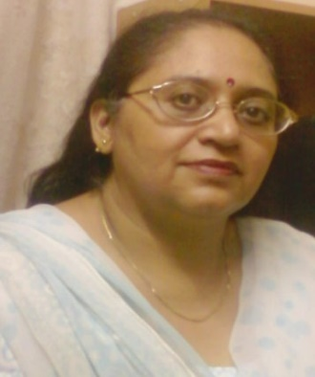 | Vasundhara Arora received Ph.D. in Botany from Department of Botany, Ch. Charan Singh University, Meerut, Uttar Pradesh, India. She has published papers in leading Biotechnology Journals and has presented Papers in various International and National Conferences. She is graduated in BSc and Post Graduated in MSc Botany Vasundhara.arora66@gmail.com
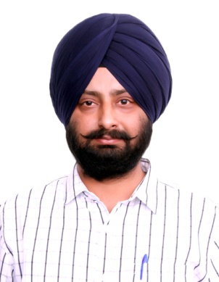 | Dr. Bikram Jit Singh is working as a Professor in Mechanical Engineering Department at Maharishi Markandeshwar Deemed to be University, Mullana, Ambala, India. He had done Masters of Engineering with distinction in Industrial Engineering from Thapar University, Patiala and PhD in Mechanical Engineering from National Institute of Technology, Kurukshetra. He had a three year Industrial Experience as a Production Engineer in Light Alloy Foundry at Goetze India Limited (A German MNC). He had around 14 years of vast teaching and research experience. He wrote about 39 research papers in reputed International Journals and published 6 books. He can be contacted at chann461@gmail.com or dr_bikramjit@mmumullana.org
 | Navneet Bithel is a Professor in the Department of Botany and Microbiology Gurukul Kangri University Haridwar, India. He earned M.Sc. and M.Phil. Degree in 1985 and 1987 respectively and Ph.D. in 1991 from Kurukshetra University, Kurukshetra. He joined Gurukul Kangri University Haridwar as Lecturer in 1992. He has been the Head of the Department of Botany and Microbiology from July 2013 to June 2016. He has guided 18 Ph.D. students and is supervising 5 research students on varied aspects of microbiology. He had been the Dean Student Welfare and Coordinator, National Service Scheme of Gurukul Kangri University. He has published over 100 research papers and reviews in National and International journals. Dr. Navneet is a Fellow of the Indian Botanical Society, Fellow of Indian Phytopathological Society and a life member of several academic societies. navneetbithel@gmail.com
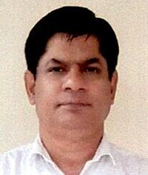 | Dr. Tapan Kumar Mukherjee is working as Professor at the Amity Institute of Biotechnology (AIB), Amity University, Noida, UP, India. He has a Ph.D. in Human Physiology from Bose Institute India. Prof. Mukherjee completed his post-doctoral training from the Centre for Cellular and Molecular Biology (CCMB), Hyderabad, India, and the Department of Molecular and Medical Pharmacology, University of California, Los Angeles (UCLA), USA. As a visiting scientist Professor Mukherjee has visited University of Utah, USA, National University of Singapore (NUS) Singapore and Korean Institute of Bioscience and Biotechnology (KRIBB), South Korea. On the research front, his primary interest is deciphering the cell signaling molecules involved in the complication of cancer and cardiovascular diseases. He has trained numerous research project students and Ph.D. candidates.
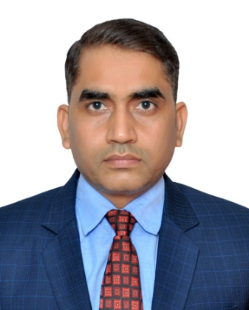 | Dr. Sushil Kumar Upadhyay is Associate Professor in Bio-Sciences and Technology at M. M. (Deemed to be University), Mullana-Ambala, India. He had done Doctorate from University of Allahabad. He has 14+ years of rich teaching-cum-research experience and received above 3 dozens of awards 2 dozens Fellowships including FLS (London) in yesteryears. His research skill is excellent, published 9 patents, 43 books and 165 research articles in high impact journals Dr. Upadhyay is an ideal teacher and his hard work inspires students to achieve their goal be ‘SMART’ [S=Specific, M=Meaningful, A=Achievable, R=Relevant, T=Time-bound]. He can be contacted at upadhyay.k.sushil@gmail.com or sushil.upadhyay@mmumullana.org
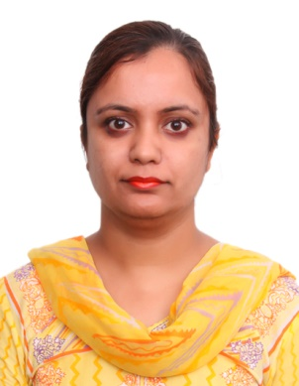 | Rippin is working as a Research Scholar in the Department of Biotechnology, Maharishi Markandeshwar (Deemed to be University), Mullana-Ambala, 133207, Haryana, India. She has published papers in leading Biotechnology Journals and has presented Papers in various International and National Conferences. She is graduated in BSc Medical and Post Graduated in MSc Micro-Biology from Punjab Agriculture University, Ludhiana Punjab. She has submitted her Doctorate Thesis recently on the rising research area of Tannins in various food extracts. She can be contacted at rippin.622@gmail.com
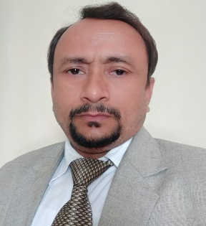 | Dr. Raj Singh is a Professor (Botany) in the Department of Bio-Sciences and Technology, Maharishi Markandeshwar (Deemed to be University), Mullana- Ambala, Haryana, India. He holds Doctor of Philosophy (Ph.D.) in Botany, specializing in Mycology as lingo-cellulosic crop residues and its application in livelihood and sustainability, from Ch. Charan Singh University, Meerut, Uttar Pradesh, India. During his yesteryears career Dr. Singh published 22 books, 12 book chapters, 09 patents more than 140 research and review papers in different peer reviewed and indexed National and International journals. He is recipient of honors in the field of Botany and Agri-Biotechnology by Esteemed Organizations and Universities of International repute.

