Supplementary Appendix
Supplementary Appendix for: Artificial Intelligence Predictive Model for Hormone Therapy Use in Localized Prostate Cancer

Table Of Contents
Supplementary Appendix 1
NRG Prostate Cancer AI Consortium Members 3
Clinical Risk Group Defined by NCCN Guidelines Prostate Cancer V.1.2022 4
Methods for Multimodal Deep Learning Model Development 4
Supplementary Figures and Tables 9
Figure S1. Multimodal deep learning architecture and distribution of delta for development and validation set. 9
Figure S2. Model feature weights and their associated feature importance. 11
Figure S3. Forest plots for all endpoints in positive and negative biomarker groups of NRG/RTOG 9408 (validation set) for the subgroup of NCCN low-intermediate-risk patients. 12
Figure S4. Forest plots for exploratory endpoints in positive and negative biomarker groups of NRG/RTOG 9408 (validation set) for all patients. 13
Table S1. Trials included in meta-analyses. 14
Table S2. Study summary and patient baseline characteristics for all NRG/RTOG trials used for model development and validation. 16
Table S3. Representativeness of patient cohort 18
Table S4. Patient baseline characteristics for the development cohort. 19
Table S5. Patient baseline characteristics by biomarker group in NRG/RTOG 9408. 20
Table S6. Prognostic evaluation of the biomarker in NRG/RTOG 9408 22
References 23

NRG Prostate Cancer AI Consortium Members
The following authors were critical to the accrual of the trials used in this study:
Michael Kucharczyk, Luis Souhami, Leslie Ballas, Christopher A. Peters, Sandy Liu, Alexander G. Balogh, Pamela D. Randolph-Jackson, David L. Schwartz, Michael R. Girvigian, Naoyuki G. Saito, Adam Raben, Rachel A. Rabinovitch & Khalil Katato

Clinical Risk Group Defined by NCCN Guidelines Prostate Cancer V.1.2022
Patients were considered to be in the high- risk group if they had any of the following: a PSA > 20ng/mL, Gleason score of 8 to 10, clinical stage T3 or higher; in the intermediate-risk group if they had Gleason score of 7 or a Gleason score of 6 or less with a PSA 10-20 ng/mL or a clinical stage T2b and not high-risk; and in the low-risk group if they had a Gleason score of 6 or less, a PSA < 10 ng/mL, and a clinical T-stage of T2a or lower.

Methods for Multimodal Deep Learning Model Development
Clinical Data Preprocessing
Categorical clinical variables (T-stage, Gleason score and primary/secondary Gleason pattern) and binary treatment type (0 for radiotherapy [RT] alone, 1 for RT with ST-ADT) were fed through neural network embedding layers to generate continuous vector embeddings. Groupings are as follows: Gleason total (≤6, 7, 8, and ≥9), both primary and secondary Gleason patterns (≤3, 4, and 5), T-stage (Tx, T0, T1a, T1b, T1c or T1, T2a, T2b, T2c or T2, T3a, T3b, T3c or T3, T4a, T4b, T4) . Continuous clinical variables (age, baseline PSA) were standardized based on the mean and standard deviation of the training data. In the development set, missing continuous clinical variables (age and PSA) were imputed using sklearn SimpleImputer with the default mean strategy; missing categorical clinical variables (T stage and Gleason information) were treated as separate “N/A” category by the encoder. In the validation set, NRG/RTOG 9408, missing clinical variables (age, Gleason total, T stage, and PSA) were considered numeric and imputed using sklearn KNNImputer with the default parameters (average of 5 nearest neighbors)1. Missing Gleason primary or secondary patterns were imputed based on the most frequent patterns of their non-missing Gleason combination.
Image Feature Extraction Model Development
For each patch from a patient’s histopathology images, a 128-dimensional feature vector was extracted using the self-supervised pre-trained Resnet-50 image feature extraction model and was standardized based on the mean and standard deviation of the training data. All the patch-level feature vectors from the same patient were stacked to form an image feature tensor, which was fed to the downstream predictive model.

Inverse Probability Treatment Weighting
As the development set comprised two phase III randomized trials (NRG/RTOG 9910 and 0126), inverse probability of treatment weighting (IPTW) was used to ensure that patients in two treatment types had comparable clinical baseline characteristics². Propensity score was calculated using a logistic regression model with elastic net penalty, where treatment types were regressed against patients’ age, baseline PSA, Gleason score, Gleason primary/secondary patterns, and T-stage variables. To mitigate the high variability introduced by large weights, IPTW weights were trimmed based on the 1st and 99th percentiles^{3,4}.

Downstream Predictive Model Development
The downstream predictive model took the image feature tensor, preprocessed clinical data, and treatment type (rx) as input for each patient. An attention multiple instance learning network was employed to learn a weight for each patch from the patient⁵. A single 128-dimensional image vector was generated from the image feature tensor for each patient by taking the weighted sum of the image vectors of all patches from the same patient, where the weights were learned by the attention mechanism. A concatenation of this single 128-dimensional image vector, preprocessed clinical data, and treatment type was further processed through the joint fusion pipeline to effectively learn predictive feature encodings of differential treatment benefit from the addition of ST-ADT to RT.
The multimodal predictive model was trained in a multitask manner. The first task was to predict the relative risk of DM using the factual rx (“Task 1” in Supplementary Figure 1A). The image, clinical, and factual rx vectors were concatenated and fed through a few layers of fully connected neural networks to produce a continuous score for each patient that estimates the relative risk of DM (referred to as “factual model prediction score” hereafter). The negative log-partial likelihood was used as the training objective for the first task and the factual model prediction scores were the estimated log relative hazards⁶.
The negative log-partial likelihood loss was parameterized by the model weights and formulated as follows:
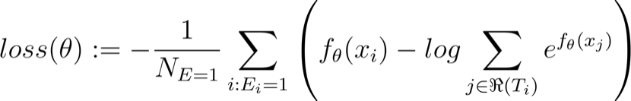,
where the values , , and are the respective event time or time of last follow-up, an indicator variable for whether the event is observed, and the model input for the 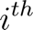 observation. The function represents the factual branch of the multimodal model, and 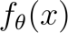 is the estimated log relative hazard given an input . The value represents the number of patients with an observable event. The set of patients with an observable event is represented as . The risk set 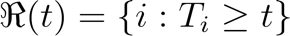 is the set of patients still at risk of failure at time . We used Breslow’s approximation for handling tied event times⁷.

Based on the estimated relative risk on the first task, the second task was to predict the delta score, defined as the difference in factual model prediction score and counterfactual model prediction score (“Task 2” in Supplementary Figure 1A). To this end, a counterfactual rx variable was created by toggling the patient’s factual rx (RT for patients who received RT with short-term ADT, and vice versa). The counterfactual rx variable was fed through the same rx embedding layer and concatenated with the image and clinical vectors. Then, the concatenated vectors were fed through the same fully connected neural network layers yielding another continuous score (referred to as “counterfactual model prediction score” hereafter). For patients who received RT alone, delta would be the factual model prediction score minus the counterfactual prediction score; whereas for patients with RT+ST-ADT treatment, delta would be the counterfactual prediction score minus the factual model prediction score. The delta indicates the magnitude of therapeutic benefit for each patient, where a larger delta suggests a larger benefit from additional ST-ADT, and vice versa.

For this predictive task, the delta loss was designed and used as the training objective. Essentially, the delta loss was the deviation between the predicted delta scores and the expected delta scores. The expected delta scores were dependent on patients falling into one of four subgroups based on their treatment types and DM outcomes as follows: (a) Subgroup A consisted of metastasis-free patients who received RT alone; (b) Subgroup B consisted of patients who received RT alone and had DM; (c) Subgroup C comprised of metastasis-free patients who received RT with ST-ADT; (d) Subgroup D consisted of patients who received RT with ST-ADT and had DM. For Subgroup A, the delta should be close to 0 as the patients had no DM when receiving RT alone treatment and additional ST-ADT would not affect their risk of DM; for Subgroup B, the delta should be greater than or equal to 0 since the patients may benefit from additional ST-ADT treatment; for Subgroup C, the delta should be greater than 0 since the patients were free of DM when receiving additional ST-ADT; finally, Subgroup D’s delta should be close to 0 as the patients had DM even if they received additional ST-ADT treatment. During training, the model was penalized when the delta scores did not fall in the expected range described above. The training objective for the predictive task was defined using the softplus function⁸.

During training, we approximated the weighted sum of both losses from the prognostic task and the predictive task, and each data point was weighted by its IPTW weight. Once the model was trained, a cutoff was selected at the 67th percentile of the delta scores in the development set such that all patients in the validation set with a delta score greater than the cutoff were considered to be biomarker positive, with predicted benefit of additional ST-ADT, and those with a delta score less than the cutoff were considered to be biomarker negative. The final model was chosen based on the lowest ratio of IPTW-weighted hazard ratios of biomarker positive and negative subgroups on the tuning set.

Supplementary Figures and Tables
A
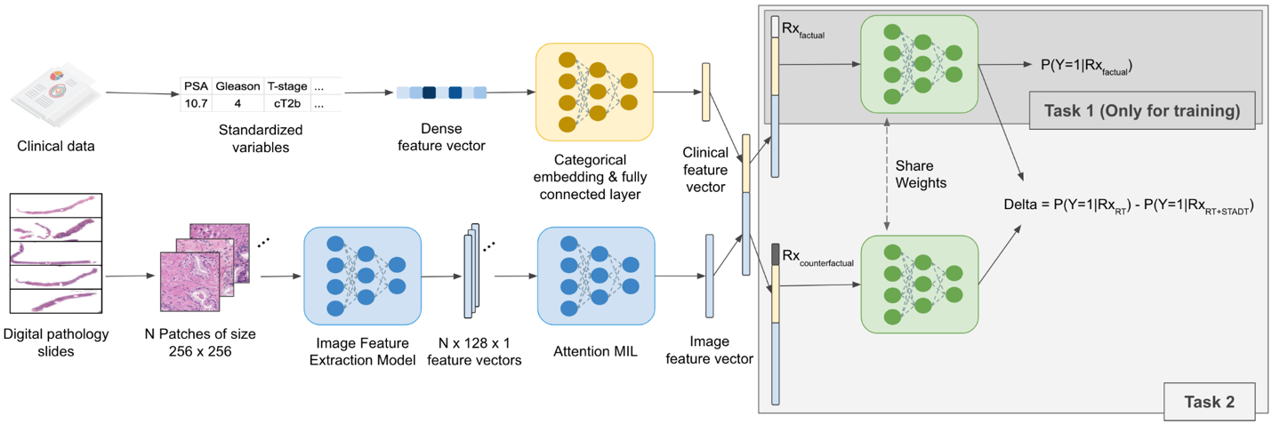
B
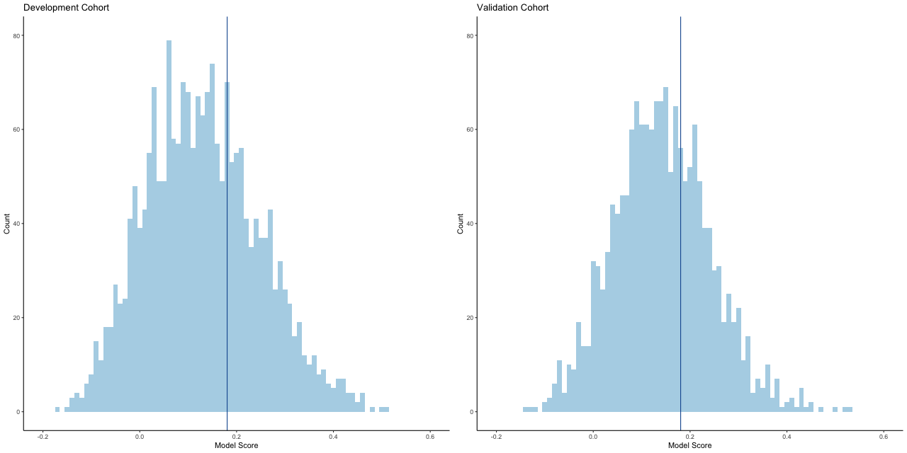

Figure S1. Multimodal deep learning architecture and distribution of delta for development and validation set.
(A) The multimodal architecture accepts both clinical data and histopathology image data and outputs a delta score that captures the magnitude of therapeutic benefit. (B) The 67th percentile of the delta scores in the development set was selected as the cutoff threshold such that biomarker positive patients had a delta greater than the cutoff, and biomarker negative patients had a delta less than the cutoff.
PSA = prostate-specific antigen; Rx = treatment type; P = probability; Y = outcome; RT = radiotherapy; ST-ADT = short-term androgen-deprivation therapy; N = number; MIL = multiple instance learning.

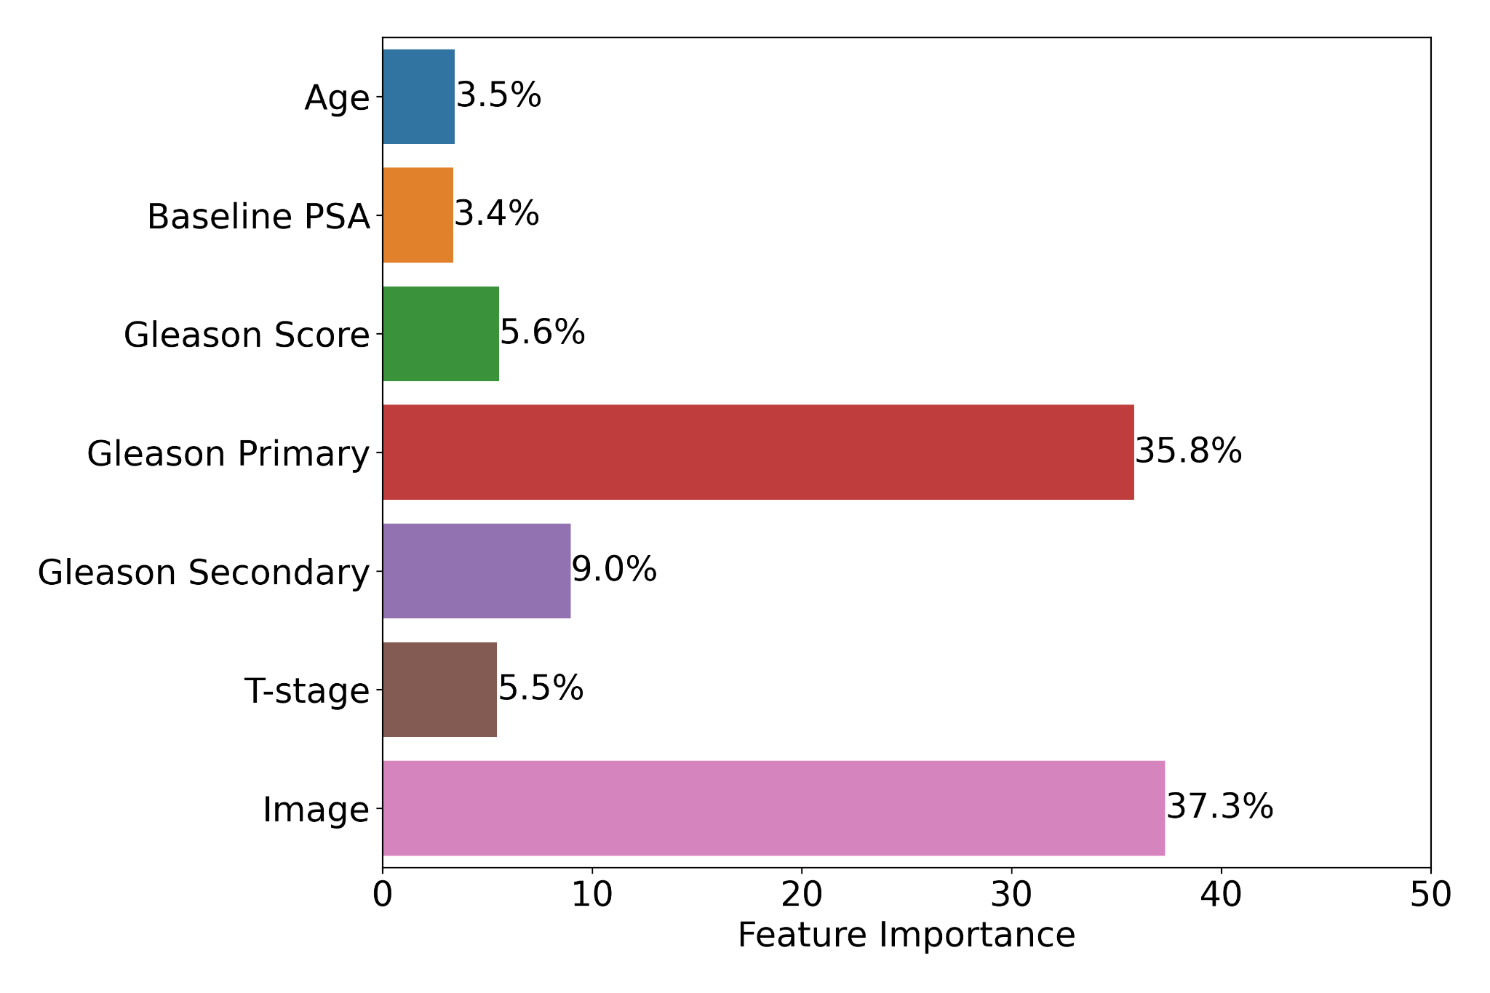

Figure S2. Model feature weights and their associated feature importance.
The greater the feature importance, the more contribution the individual clinical (e.g. baseline PSA) or histopathology-derived feature has to the downstream predictive model prediction. The feature importance is calculated based on the absolute Shapley value for each variable, averaged over the patients in the validation set (NRG/RTOG 9408) to obtain a global measure of feature importance, and is normalized across the features for visualization purposes⁹. Histopathology-derived features–including Gleason score and imaging features–contributed the most to the AI-derived predictive biomarker. Of note, the downstream predictive model has a capacity to jointly learn complex interactions between image and clinical features, and the Shapley value provides a combined contribution of main and interaction effects. Note that some percentages may not add up to a hundred percent due to rounding.
PSA = prostate-specific antigen.

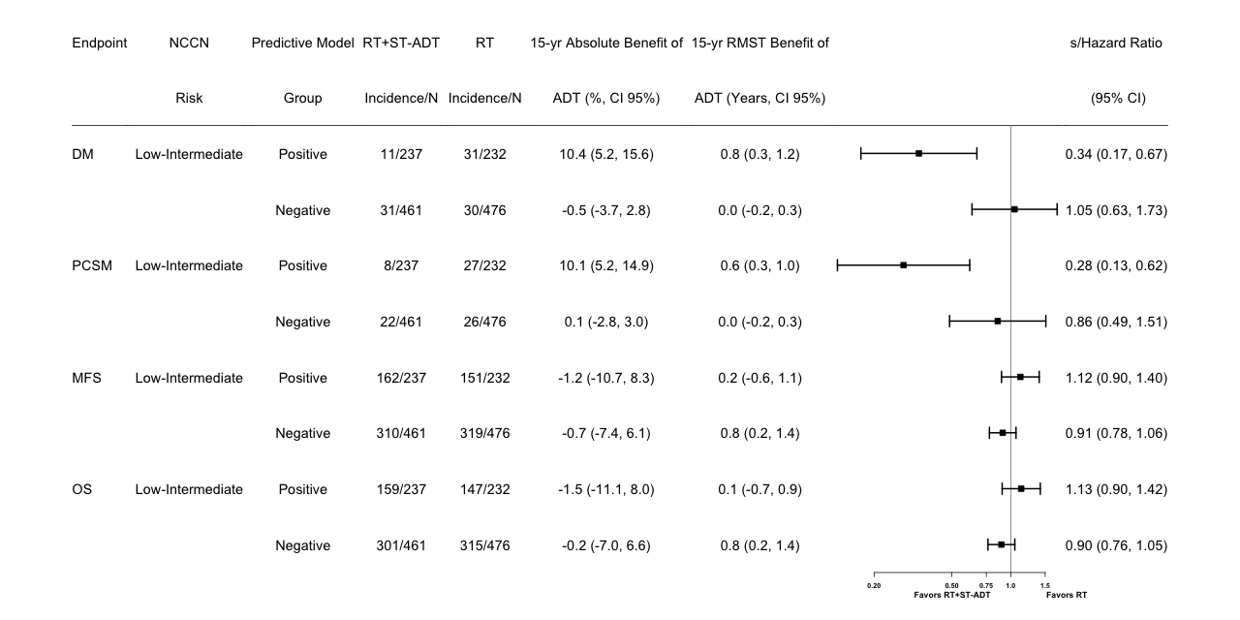

Figure S3. Forest plots for all endpoints in positive and negative biomarker groups of NRG/RTOG 9408 (validation set) for the subgroup of NCCN low-intermediate-risk patients.
NCCN = National Comprehensive Cancer Network; RT = radiotherapy; ST-ADT = short-term androgen-deprivation therapy; yr = year; RMST = restricted mean survival time; s/HR = subdistribution hazard ratio or hazard ratio; CI = confidence interval; N = number of patients; DM = distant metastasis; PCSM = prostate cancer-specific mortality; MFS = distant metastasis-free survival; OS = overall survival.
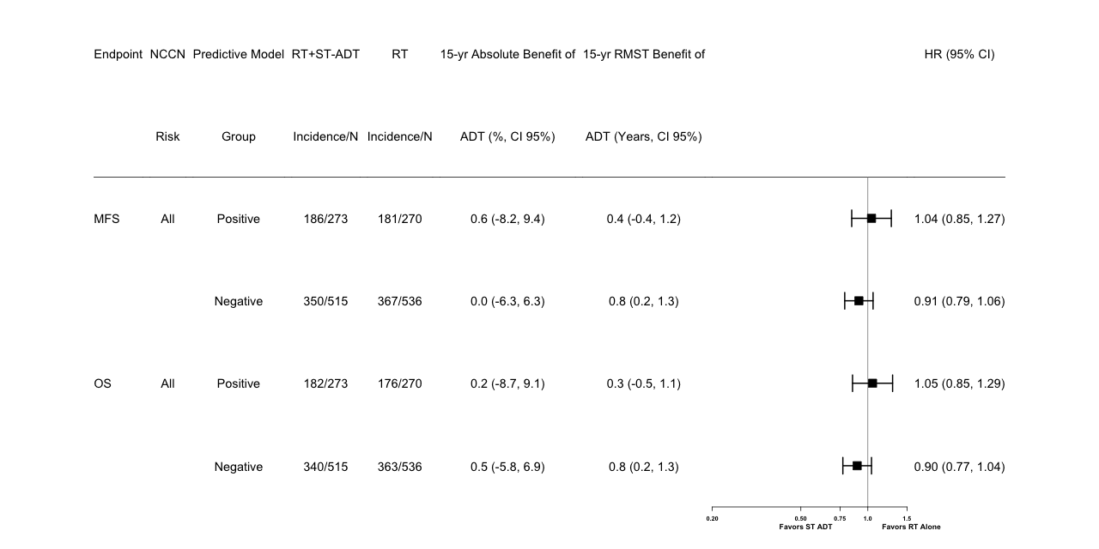

Figure S4. Forest plots for exploratory endpoints in positive and negative biomarker groups of NRG/RTOG 9408 (validation set) for all patients.
NCCN = National Comprehensive Cancer Network; RT = radiation therapy; ST-ADT = short-term androgen-deprivation therapy; yr = year; RMST = restricted mean survival time; HR = hazard ratio; CI = confidence interval; N = number of patients; MFS = distant metastasis-free survival; OS = overall survival.

Table S1. Trials included in meta-analyses.
 | Population | Dates | Experimental Arm | Control Arm | Patients in Experimental Arm | Patients in Control Arm | Primary Endpoint | Primary Endpoint Result | Secondary Efficacy Endpoints
NRG/RTOG 9408 | T1b-T2b and PSA ≤20 | 1994-2001 | RT + 4 mo ADT | RT alone | 987 | 992 | OS | Negative¹ | DSM  BF  DM
NRG/RTOG 9413 | >15% LN risk by Roach AND PSA <100;  T2c-T4 tumors and Gleason >=6 were allowed regardless of LN risk | 1995-1999 | 2x2 factorial:  4 mo neoadjuvant/concurrent vs adjuvant ADT  Prostate only RT vs whole pelvis RT |  | 1323 total |  | PFS | Positive² | BF  OS  LP  DM  RF  PCSF
NRG/RTOG 9910 | T1b-T4 GS2-6 PSA>10 ≤100  T1b-T4 GS 7 PSA<20  T1b-c GS 8-10 PSA <20 | 2000-2004 | RT + 36 weeks ADT | RT + 4 mo ADT | 737 | 752 | DSS | Negative³ | OS  DFS  LRP  DM  BF
NRG/RTOG 9202 | T2c-T4 AND PSA<150 | 1992-1995 | RT + 28 mo ADT | RT + 4 mo ADT | 758 | 762 | DFS | Positive⁴ | LP  DM  BF  DSS  OS
NRG/RTOG 0126 | cT1b-T2b, GS 2-6, and PSA 10-20;  or GS 7 and PSA <15 | 2002-2008 | 79.2 Gy RT alone | 70.2 Gy RT alone | 748 | 751 | OS | Negative⁵ | BF  DSS  LP  DM
¹Jones et al., IJROBP 2021; ²Roach et al., Lancet Oncol 2018; ³Pisansky et al., JCO 2015; ⁴Lawton et al., IJROBP 2017; ⁵Michalski et al., JAMA Oncol 2018
OS = overall survival; DSM = disease-specific mortality; BF = biochemical failure; DM = distant metastasis; PFS = progression-free survival; LP = local progression; RF = regional failure; PCSF = prostate cancer-specific failure; DSS = disease-specific survival; DFS = disease-free survival; LRP = locoregional progression

Table S2. Study summary and patient baseline characteristics for all NRG/RTOG trials used for model development and validation.
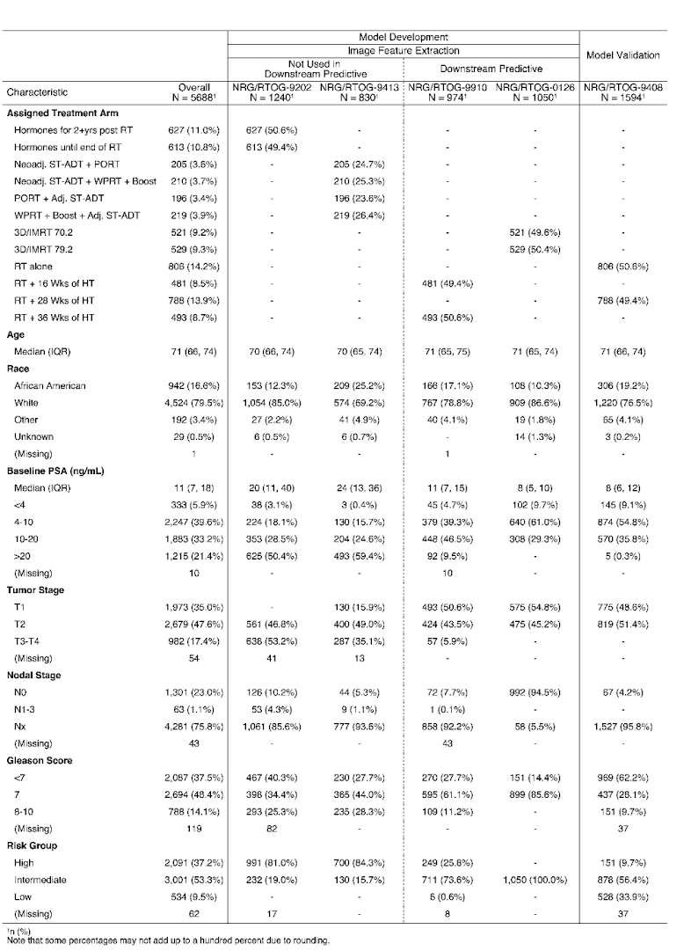
3D/IMRT = intensity-modulated radiotherapy; Wks = weeks; RT = radiotherapy; HT = hormone therapy; IQR = interquartile range; PSA = prostate-specific antigen; ng/mL = nanograms per milliliter.

Table S3. Representativeness of patient cohort
Disease under investigation | Localized Prostate cancer
Race or ethnic group | Prostate cancer disproportionately affects African American men in the United States
Age | Incidence and mortality rates are strongly related to age with the highest incidence being seen in elderly men (> 65 years of age)
Geography | Incidence and mortality rates for prostate cancer vary worldwide, with the greatest incidence in North America and highest mortality rate in Asia.
Overall representativeness of study | The study population included patients from North America. Prostate cancer patients are younger outside North America thus, the age distribution in the current study population differs from that in some countries. In the RTOG-9408 validation set of 1,594 patients, there were 306 (19.2%) Black, 1,220 (76.5%) White, 68 (4.3%) Other/Unknown men. In the US, 488,375 men were diagnosed with localized prostate cancer from 2015-2019¹⁰. Of these men, there were 76,374 Black (15.6%) and 253,697 White (52%) men.

Table S4. Patient baseline characteristics for the development cohort.
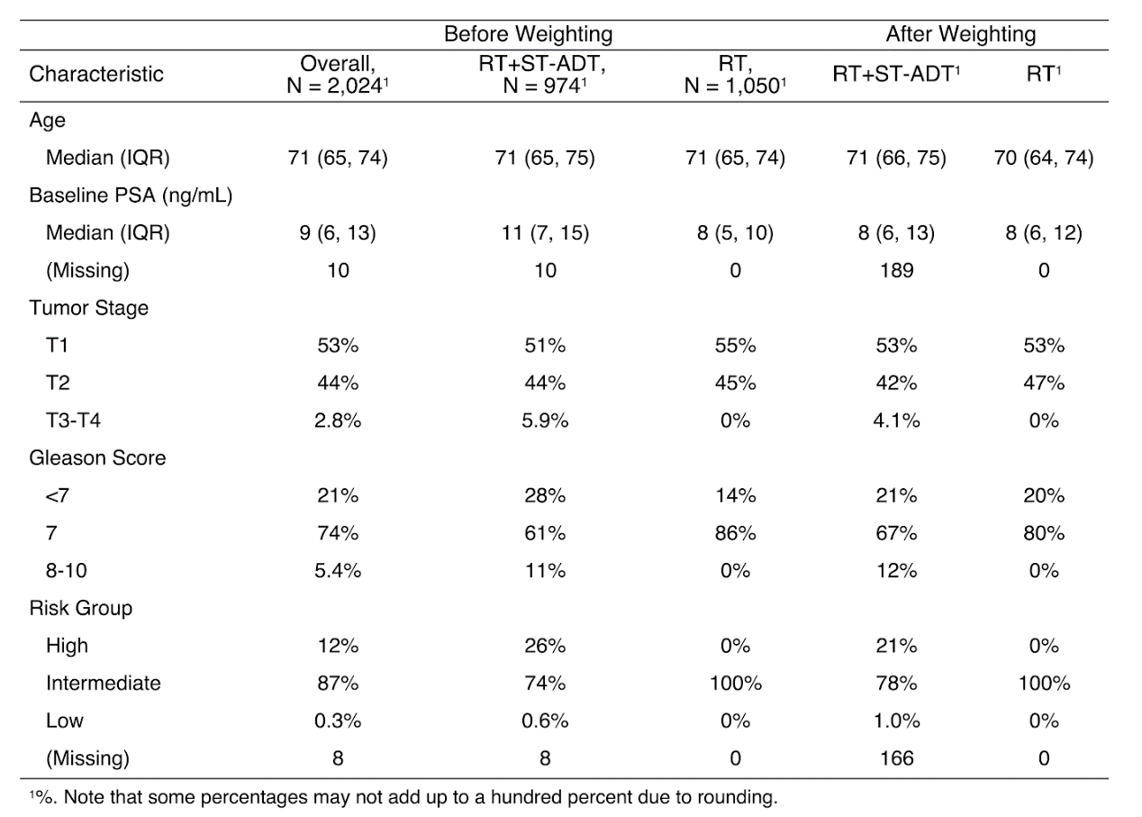
RT = radiation therapy; ADT = androgen-deprivation therapy; IQR = interquartile range; PSA = prostate-specific antigen; ng/mL = nanograms per milliliter.

Table S5. Patient baseline characteristics by predictive model group in NRG/RTOG 9408.
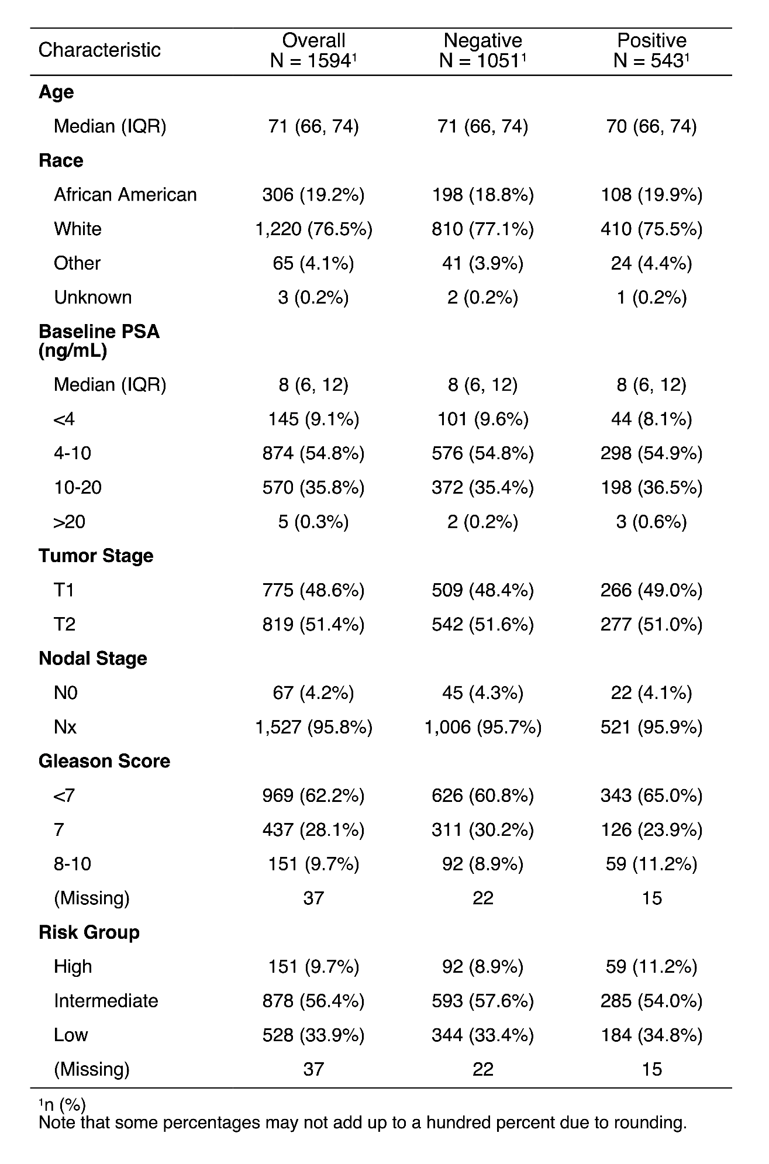
IQR = interquartile range; PSA = prostate-specific antigen; ng/mL = nanograms per milliliter.
DM = distant metastasis; PCSM = prostate cancer-specific mortality; RT = radiation therapy; ST-ADT = short-term androgen-deprivation therapy; sHR = subdistribution hazard ratio; CI = confidence interval.

Table S6. Prognostic evaluation of the biomarker in NRG/RTOG 9408
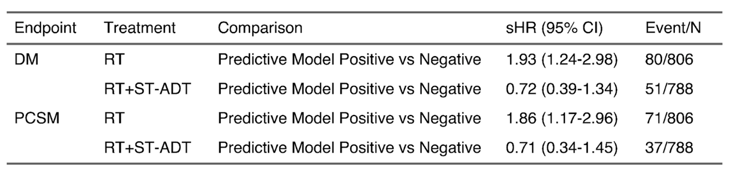
DM = distant metastasis; PCSM = prostate cancer-specific mortality; RT = radiation therapy; ST-ADT = short-term androgen-deprivation therapy; sHR = subdistribution hazard ratio; CI = confidence interval; N = number of patients.

References
1. Mucherino A, Papajorgji PJ, Pardalos PM. k-Nearest Neighbor Classification [Internet]. Data Mining in Agriculture. 2009;83–106. Available from: http://dx.doi.org/10.1007/978-0-387-88615-2_4
2. Austin PC, Stuart EA. Moving towards best practice when using inverse probability of treatment weighting (IPTW) using the propensity score to estimate causal treatment effects in observational studies. Stat Med 2015;34(28):3661–79.
3. Cole SR, Hernán MA. Constructing inverse probability weights for marginal structural models. Am J Epidemiol 2008;168(6):656–64.
4. Lee BK, Lessler J, Stuart EA. Weight Trimming and Propensity Score Weighting [Internet]. PLoS ONE. 2011;6(3):e18174. Available from: http://dx.doi.org/10.1371/journal.pone.0018174
5. Ilse M, Tomczak J, Welling M. Attention-based Deep Multiple Instance Learning. In: Dy J, Krause A, editors. Proceedings of the 35th International Conference on Machine Learning. PMLR; 10--15 Jul 2018. p. 2127–36.
6. Katzman JL, Shaham U, Cloninger A, Bates J, Jiang T, Kluger Y. DeepSurv: personalized treatment recommender system using a Cox proportional hazards deep neural network. BMC Med Res Methodol 2018;18(1):24.
7. Breslow N. Covariance analysis of censored survival data. Biometrics 1974;30(1):89–99.
8. Leen TK, Dietterich TG, Tresp V. Advances in Neural Information Processing Systems 13: Proceedings of the 2000 Conference. MIT Press; 2001.
9. Shapley LS. 17. A Value for n-Person Games. In: Kuhn HW, Tucker AW, editors. Contributions to the Theory of Games (AM-28), Volume II. Princeton: Princeton University Press; 1953. p. 307–18.
10. Cancer of the Prostate - Cancer Stat Facts [Internet]. SEER. [cited 2023 Apr 10];Available from: https://seer.cancer.gov/statfacts/html/prost.html

