Supplementary Materials

The Impact of Protein Corona Formation on PEGylated NT3-BDNF Nanoparticles - Distribution, Protein Release, and Cytotoxicity in Human Retinal Pigmented Epithelial Cell Model
Maria Dąbkowska^{1*†}, Alicja Kosiorowska^{1,2†}and Bogusław Machaliński²

¹ Independent Laboratory of Pharmacokinetic and Clinical Pharmacy, Rybacka 1, 70-204 Szczecin, Poland
² Department of General Pathology, Pomeranian Medical University, Rybacka 1, 70-204 Szczecin, Poland
† These authors contributed equally to this work.
* Correspondence: maria.dabkowska@pum.edu.pl

Determining the size and nanoparticle concentration.

Part 1

Part 2

A)
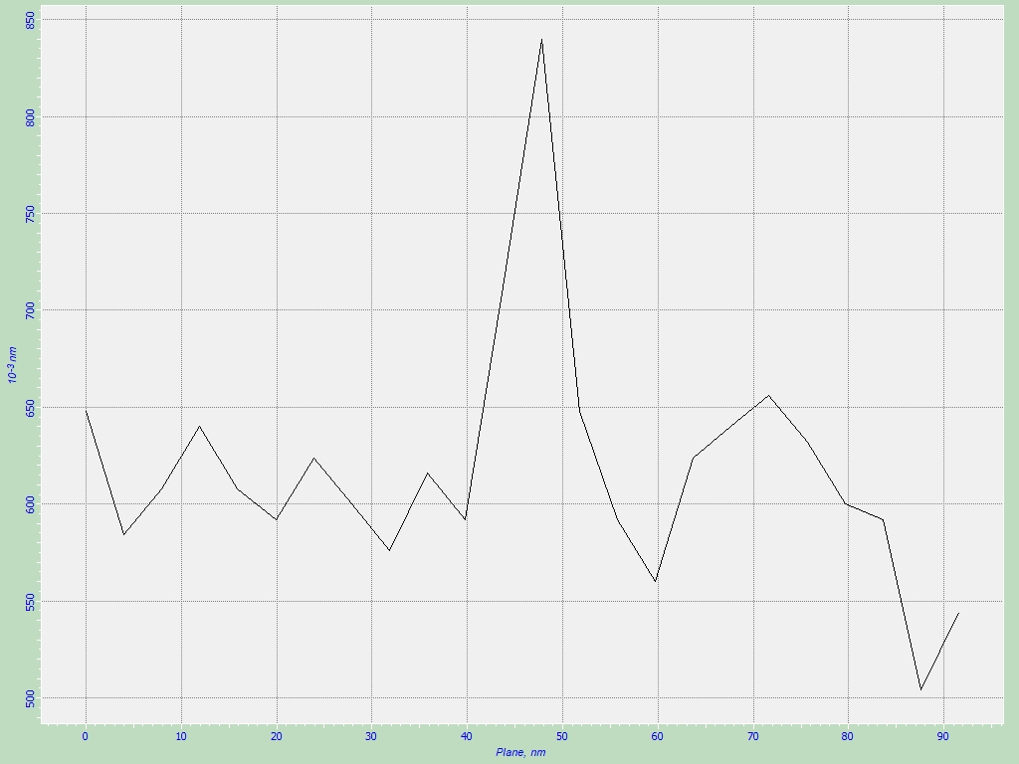
B)
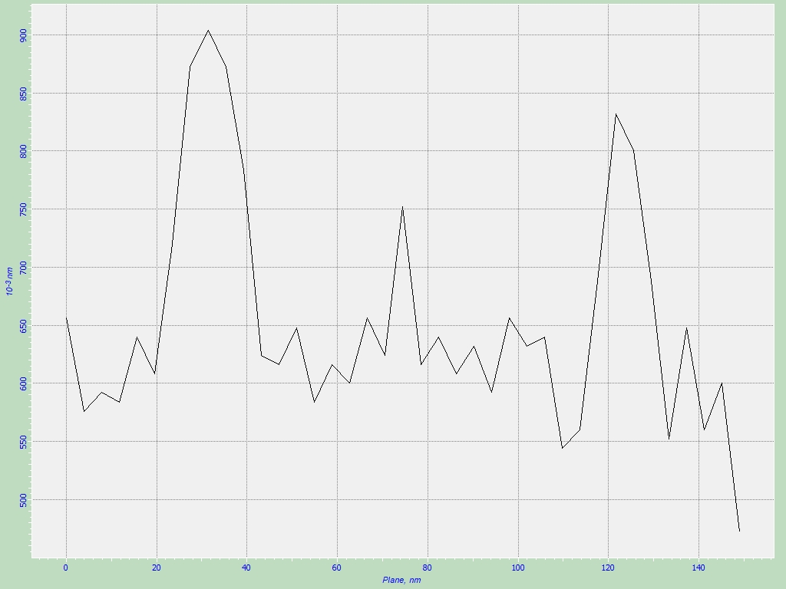

C)

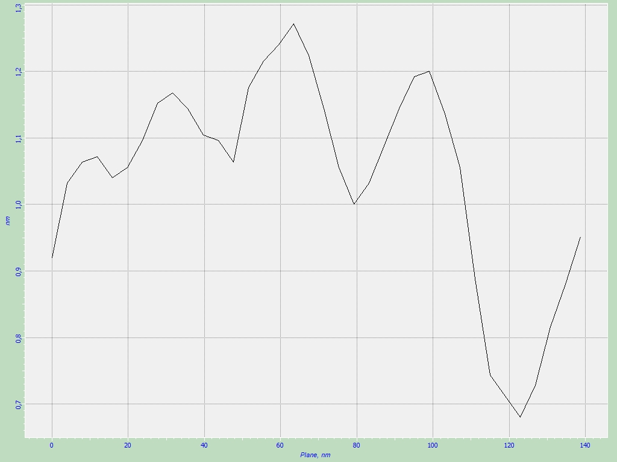

Figure S1. (Part 1) SEM images of PEGylated NT3-BDNF nanoparticles deposited from 0.15M, pH 7.4: PBS, containing various concentration of recombinant neurotrophins: 1 mgL⁻¹ NT3 and 1 mgL⁻¹ BDNF (Figure S1.1.A), 5 mgL⁻¹ NT3 and 5 mgL⁻¹ BDNF (Figure S1.1.B). The images on the left and right side corresponds to a 100 000 magnification. Scale bar is 100 nm. (Part 2) AFM images of PEGylated NT3-BDNF nanoparticles deposited onto the mica surface at 0.15M, pH 7.4 in PBS for various concentrations of recombinant neurotrophins. The structures of PEGylated NT3-BDNF nanoparticles after cross-section: 0.1 mgL⁻¹ (part A), 1mgL⁻¹ (part B), 5mgL⁻¹ (part C).

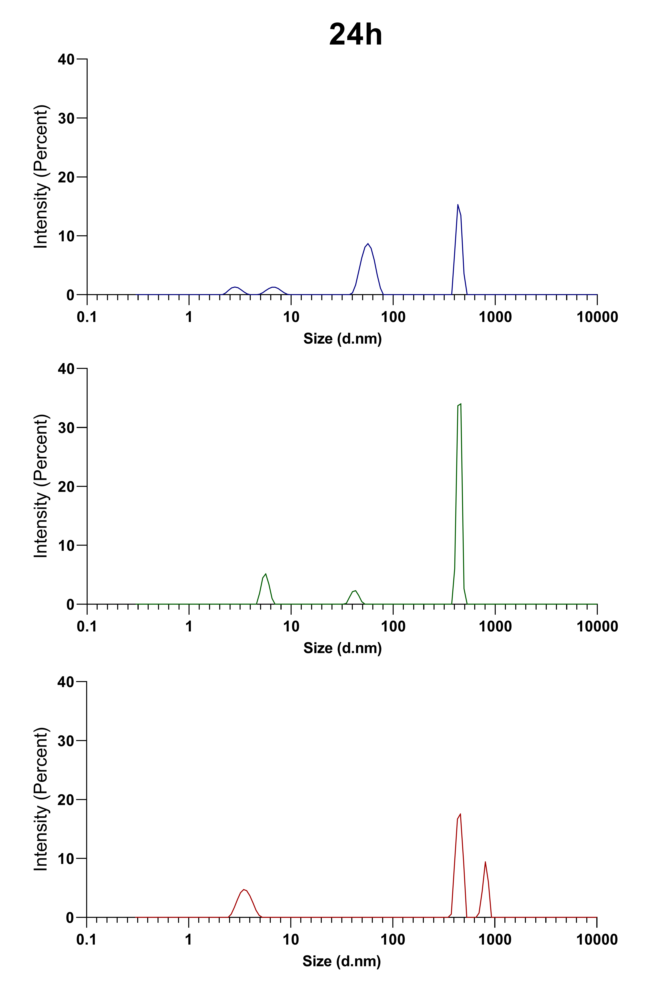
Figure S2. Size distribution by MADLS, of PEGylated NT3-BDNF nanoparticles with different neurotrophin concentrations: 0.1 mgL⁻¹ (blue curve), 1mgL⁻¹ (green curve), 5mgL⁻¹ (red curve) over 24h after formulation. The intensity (percent) indicates the sizes of the frequency of the most common particles.

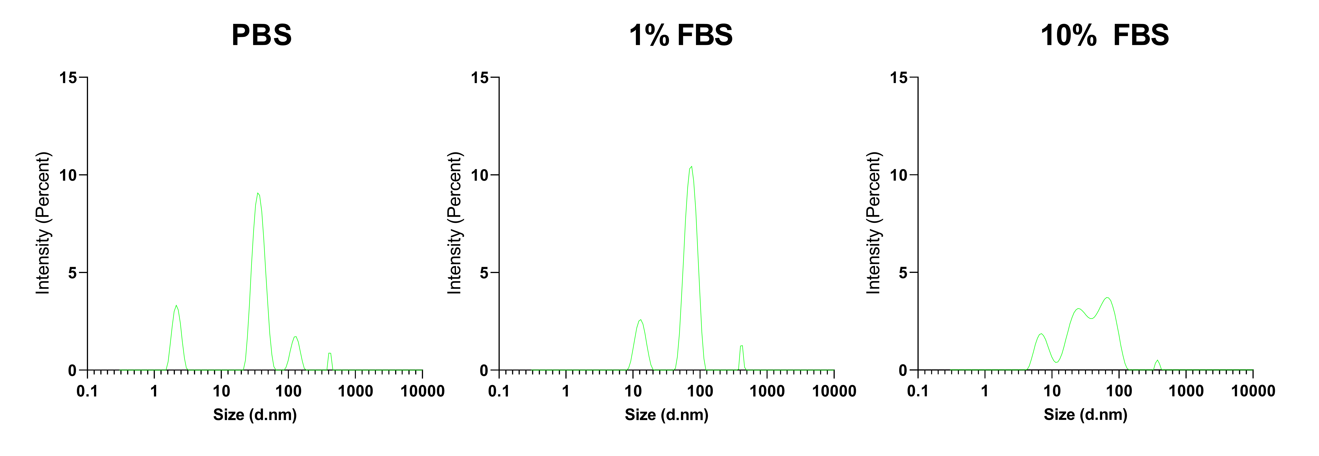
Figure S3. Dependence of NPs aggregation on various bulk conditions (PBS, PBS supplemented with 1% FBS, and PBS supplemented with 10% FBS) was shown at 72 hours. PEGylated NT3-BDNF nanoparticles aggregation triggered by FBS supplementation showed variable dynamics depending on neurotrophins concentration: 1mgL⁻¹ (green curve).

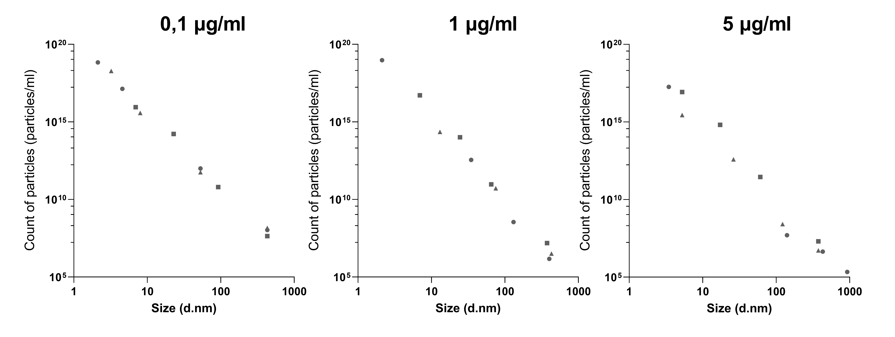

Figure S4. Dependences of PEGylated BDNF-NT3 nanoparticles concentration on various bulk conditions: PBS (circle), PBS supplemented with 1% FBS (triangle), and PBS supplemented with 10% FBS (square) were shown at 72 hours cells treatment. The concentration of nanoparticles is expressed in the unit [the number of particles/ml].

NPs concentration  [particle ml-¹]  PEGylated  NT3-BDNF NPs  [mgL⁻¹] | 2h |  |  |  | 24h |  |  | 72h
 | Peak 1 | Peak 2 | Peak 3 | Peak 4 | Peak 1 | Peak 2 | Peak 3 | Peak 1 | Peak 2 | Peak 3 | Peak 4
 | x 10¹⁶ | x10⁹ | x10⁶ | x10⁵ | x10¹⁷ | x10¹⁰ | x10⁷ | x10¹⁹ | x10¹⁸ | x10¹¹ | x10⁸
0.1 | 6.31 | 4.52 | 8.66 | - | 3.32 | 7.49 | 2.08 | 7.04 | 6.9 | 9.96 | 1.08
1 | 8.45 | 0.009 | 10.5 | - | 0.3 | 0.68 | 6.38 | 0.96 | - | 0.004 | 0.02
5 | 18.3 | 0.05 | 4.39 | 2.17 | 1.48 | 0.001 | 0.6 | 0.04 | - | 0.001 | 0.01

Table S1. The correlations between concentration of PEGylated BDNF-NT3 nanoparticles as a function of various neurotrophin concentrations, bulk conditions: PBS, and time points.

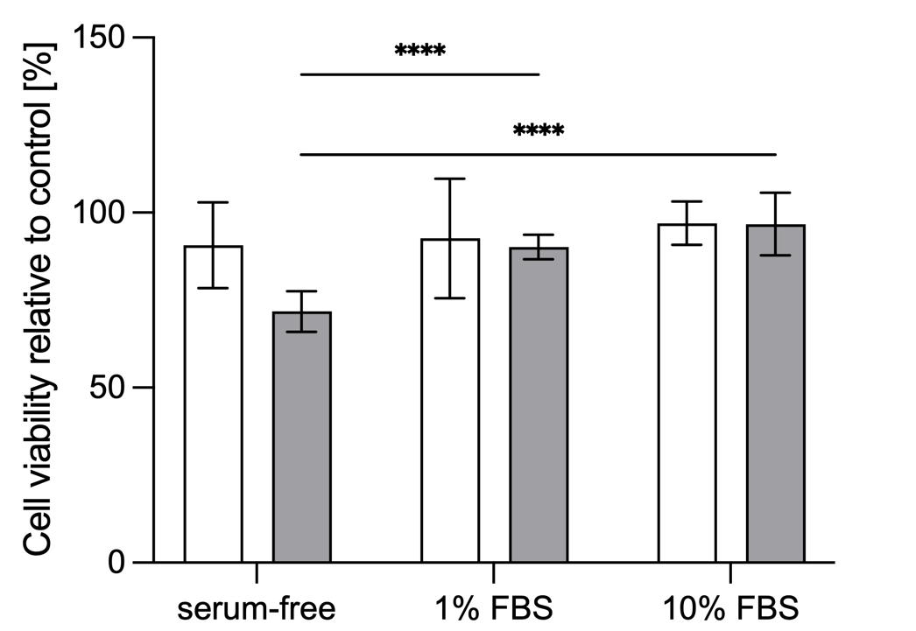

Figure S5. ARPE-19 cell viability. Effect of serum concentration (serum-free, 1% FBS and 10% FBS) and PEG-ylated nanoparticles NT3-BDNF on ARPE-19 cell viability over 72 hours as measured with alamarBlue® assay. ARPE-19 cell line was exposed for up to 72 hours to increasing concentrations of BDNF-NT3 released from PEGylated nanoparticles at 1mgL⁻¹ (n=12); Data was analysed using repeated measures ANOVA with Tukey’s post-test; ****p <0.0001.

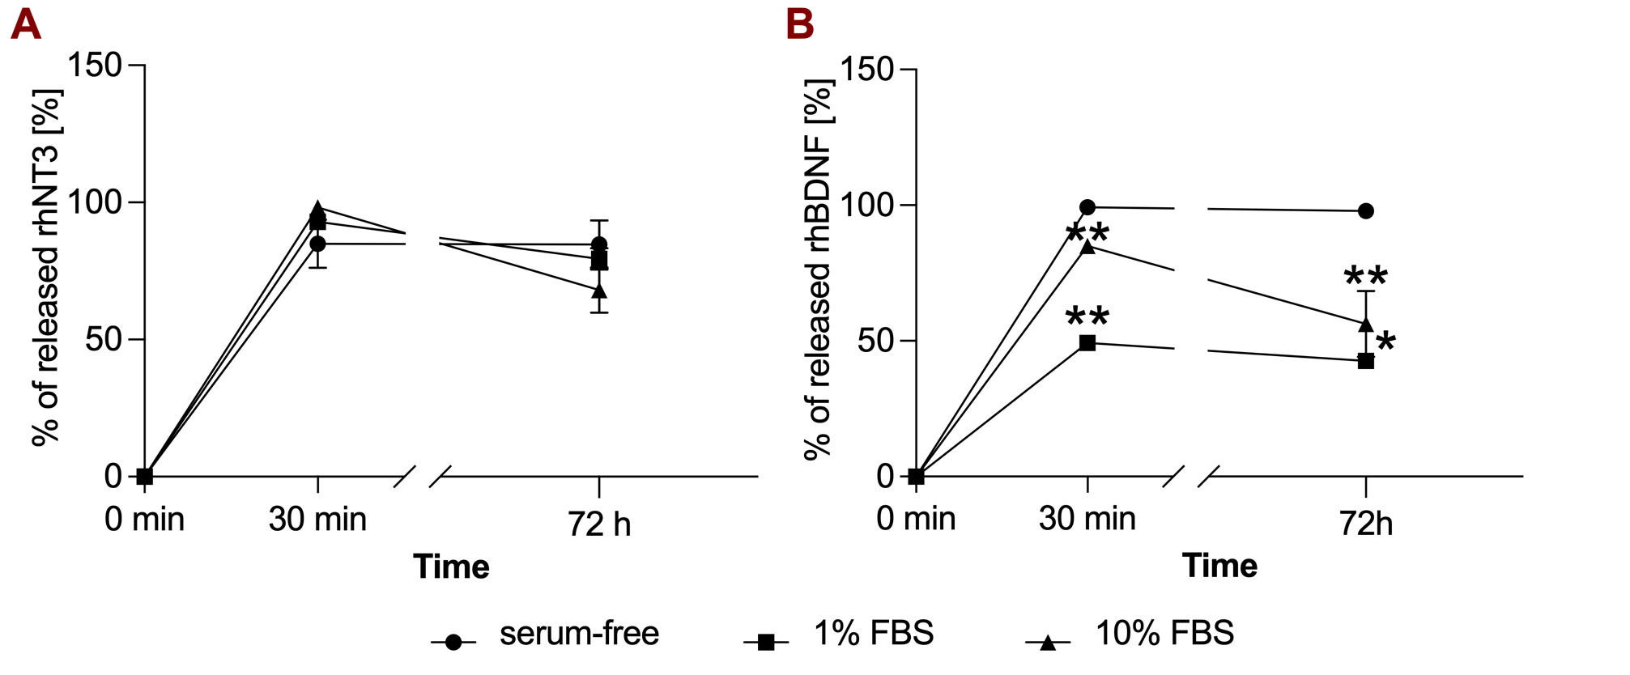

Figure S6. Release of rhNT3 (A) and rhBDNF (B) from PEGylated NT3-BDNF nanoparticles in a cell free system.
PEGylated NT3-BDNF nanoparticles (1 mgL⁻¹) were incubated in serum-free, 1% and 10% FBS for up to 72 hours with constant mixing. After each time point a sample was removed and released rhBDNF and NT3 were separated by ultracentrifugation. Released levels were measured with ELISA. Data was analysed using repeated measures ANOVA with Tukey’s post-test comparing protein release profile in serum-free DMEM F-12 and DMEM F-12 + 1% FBS, *p < 0.05, **p < 0.005.

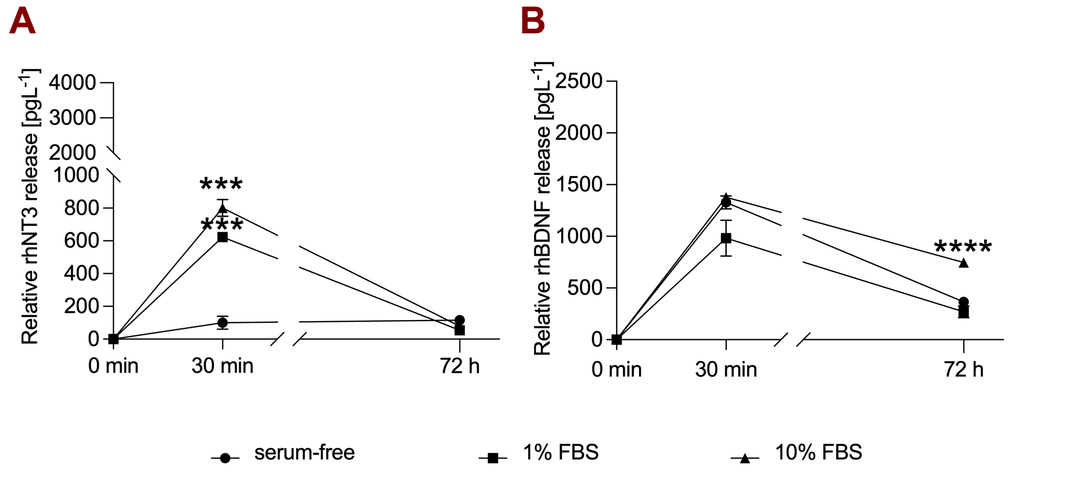

Figure S7. PEGylated NT3-BDNF NPs release profile in vitro.
NT3-BDNF PEGylated NPs (1 mgL⁻¹) show time-dependent release over 72h period for rhNT3 (a) and rhBDNF (b). Results are mean ± SD of three replicates. Data was analysed using repeated measures ANOVA with Tukey’s post-test comparing protein release profile in serum-free DMEM F-12 and DMEM F-12 + 1% FBS, ***p < 0.005, ****p < 0.001.

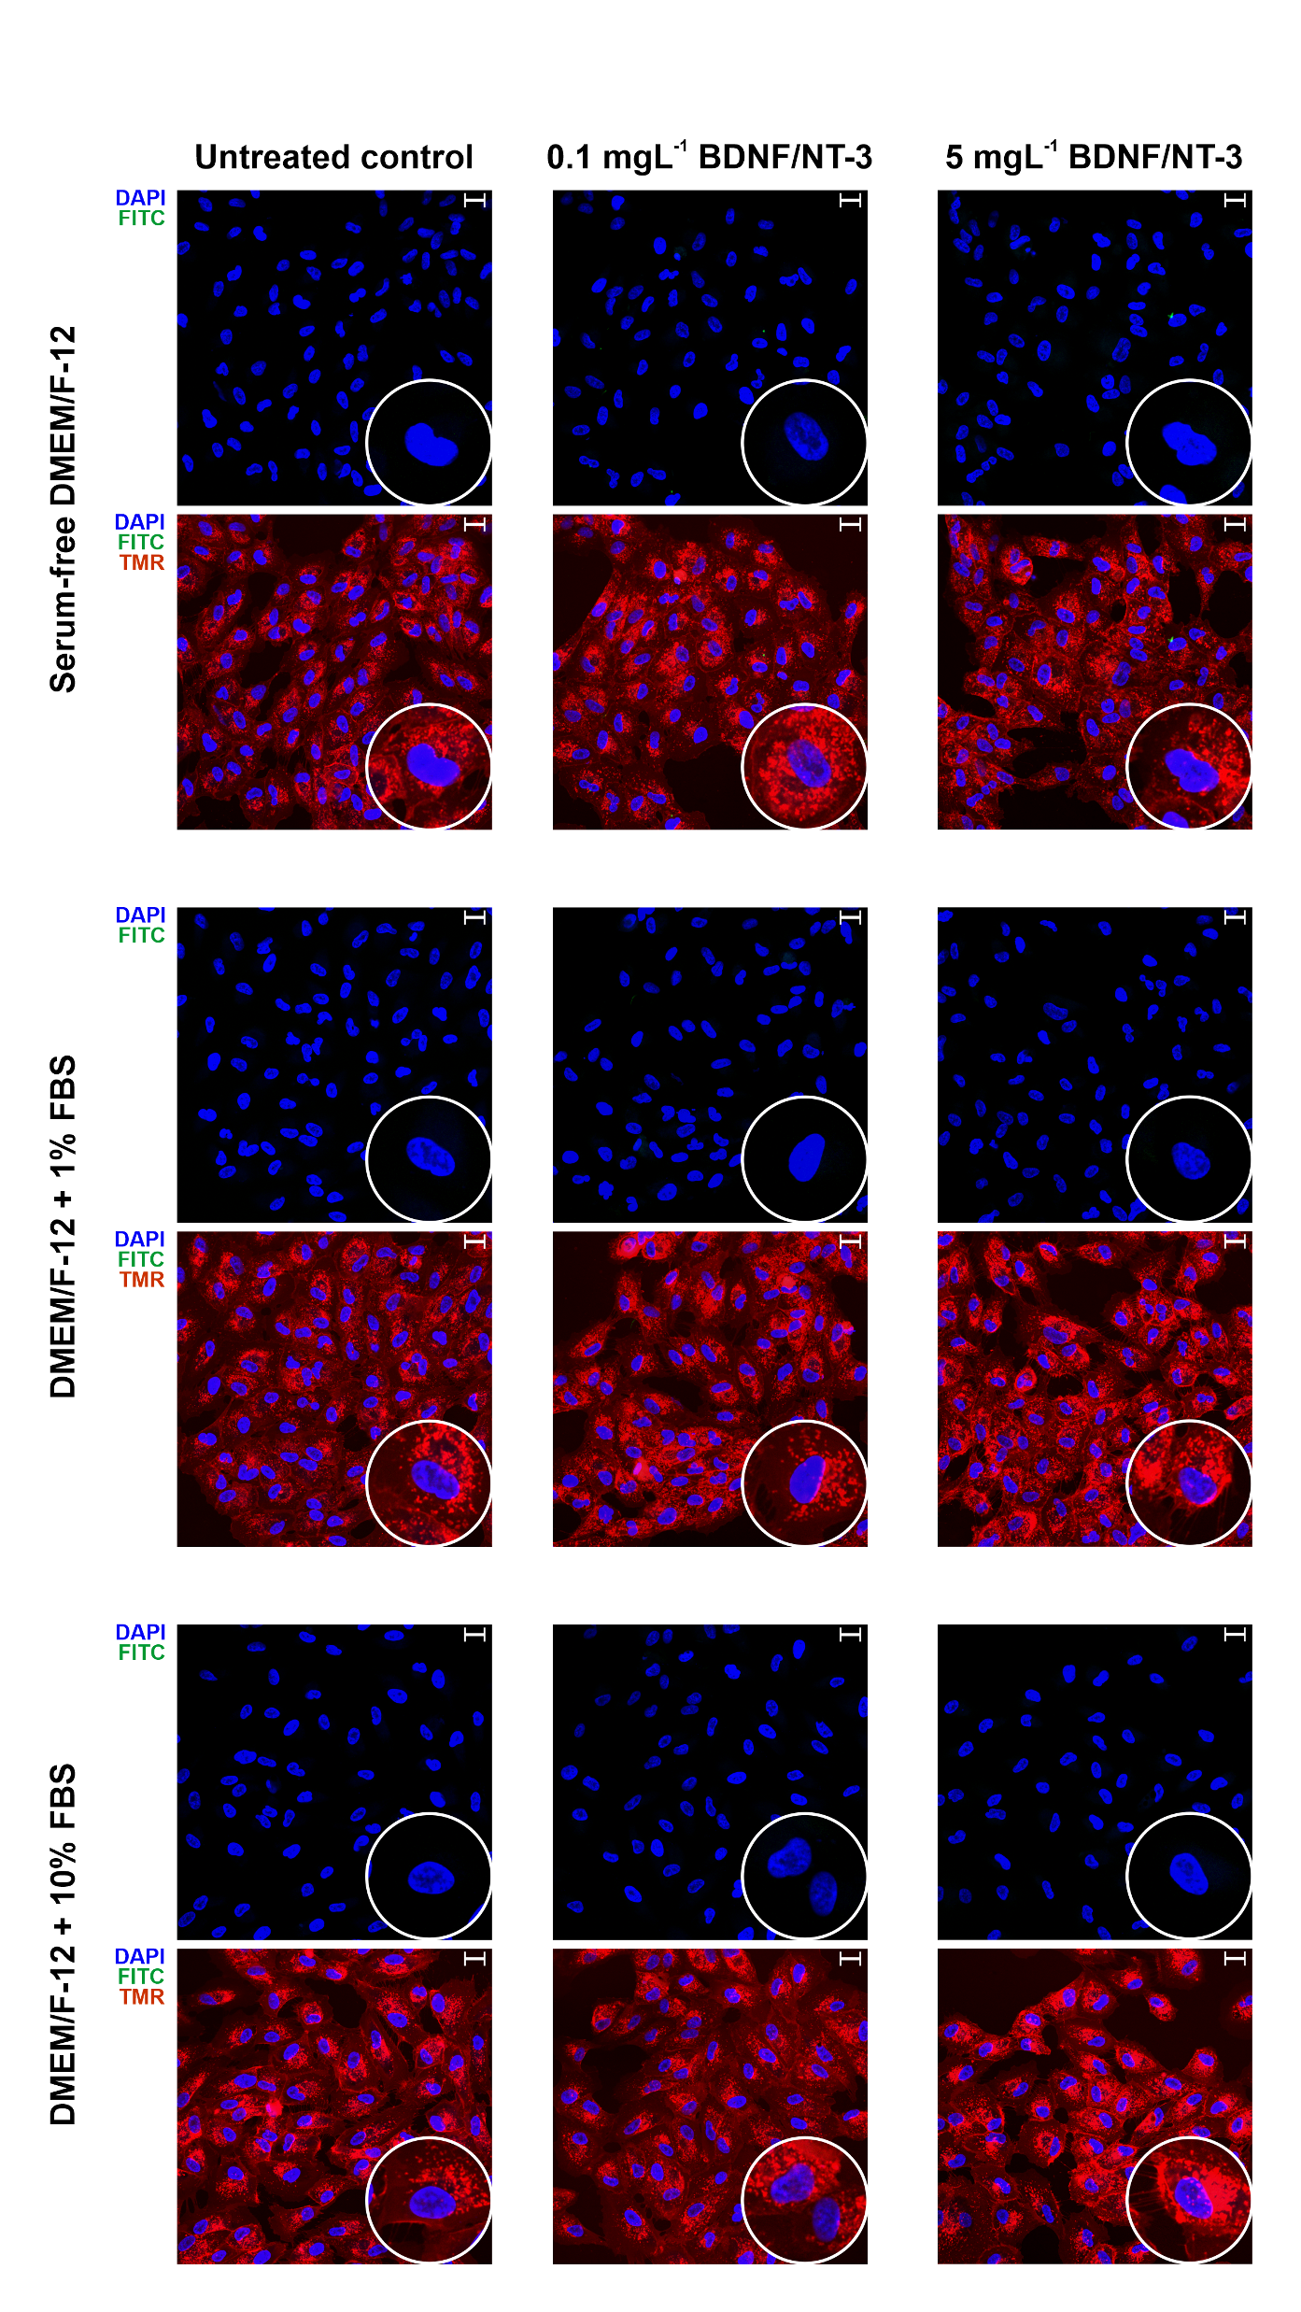
Figure S8. Cellular internalisation of PEG-ylated BDNF/NT-3 nanoparticles after 30 minutes.
The ARPE-19 cells cultured in different DMEM/F-12 media conditions: serum-free, complemented with 1% of FBS and 10% FBS, were incubated for 30 minutes with PEGylated NT3-BDNF NPs (0.1 mgL⁻¹ or 5 mgL⁻¹). Green fluorescence (FITC) represents nanoparticles, blue (DAPI) – cell nuclei, red (tetramethylrhodamine) – surface glycoproteins. The scale bar is 20 μm. All images include inserts with 3x magnification.

