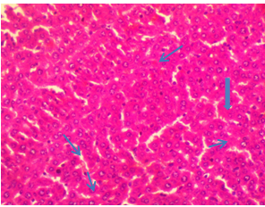
Plate 1: Photomicrograph of histological sections of liver of Control wistar rats (400x magnification)
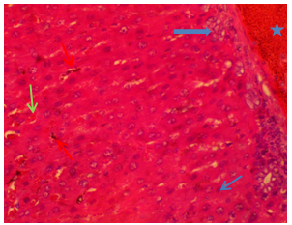
Plate 2: Photomicrograph of histological sections of liver of 235ng/l AFM₁ rats at 12 weeks (400x magnification) Red arrow: Kupffer cell hyperplasia Black arrow: Hepatocellular necrosis Blue arrow: Bile duct hyperplasia Green arrow: hepatic sinusoids Star: congested blood vessels
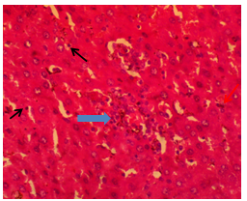
Plate 3: Photomicrograph of histological sections of liver of 456ng/l AFM₁ rats at 4 weeks (400xmagnification) Blue arrow: Inflammatory cells ,Black arrow: Hepatocellular necrosis Red arrow: Kupffer hyperplasia (KCH) laden with black pigments

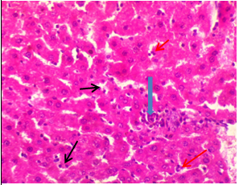
Plate 4: Photomicrograph of histological sections of liver of 456ng/l AFM₁ rats at 8 weeks (400 x magnifications)
Blue arrow: Aggregatemononuclear cells in portal tracts
Black arrow: Hepatocellular necrosis
Red arrow: Moderate kupffer cell hyperplasia
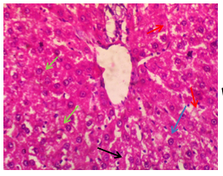

Plate 5: Photomicrograph of histological sections of liver of 456ng/l AFM₁ rats at 12 weeks (400x magnification)
Blue arrow: Hepatic sinusoids ,Black arrow: Hepatocellular necrosis , Red arrow: Marked kupffer cell hyperplasia , Green arrow: Vacuolar change of the hepatocytes.

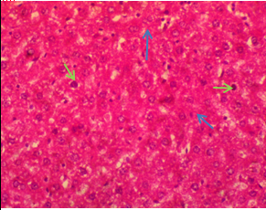
Plate 6: photomicrograph of histological sections of liver of 456ng/l AFM₁+black seed oil rats at 12 weeks (400x magnification) Blue arrow: closely packed hepatocytes Green arrow: very mild megalocytes

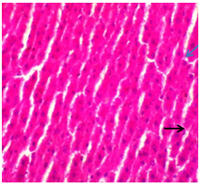
Plate 7: Photomicrograph of histological sections of liver of 456ng/l AFM₁+ Vitamin C rats at 12 weeks
Blue arrow: Fairly closely packed hepatic cord, Black arrow: Few hepatocellular necrosis

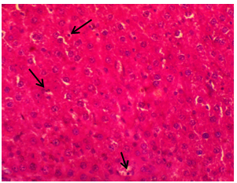

Plate 8: Photomicrograph of histological sections of liver of 456ng/l AFM₁+ Vitamin E rats at 12 weeks (400x magnification) Black arrow: Closely packed hepatic cord with single cell hepatocellular necrosis

