Accuracy and generalizability of machine learning models for adolescent suicide prediction with longitudinal clinical records

Chengxi Zang^{1,*}, Yu Hou^{1,*}, Jun Jin², Shane Sacco², Kun Chen^{2,#}, Robert Aseltine^{3,#}, Fei Wang^{1,#}

¹Department of Population Health Sciences, Weill Cornell Medicine. Cornell University.
²Department of Statistics, University of Connecticut.
³University of Connecticut Health Center.

*Equal Contributions
#Corresponding Authors

Supplementary Materials

Supplementary Table S1. Diagnostic codes for suicide attempt identification
Code Type | ICD-9 codes
Suicide Attempt | E950-E958 (intentional self-harm)
Suicide V-Code | V62.84 (suicide ideation)
Suicide V-Code | ---AND SAME VISIT---
Suicide V-Code | 870-899, 960-989
Suicide Algorithm | 881, 960-979, 980-989, 994.7
Suicide Algorithm | ---AND SAME VISIT---
Suicide Algorithm | 290.8-290.9, 293.83, 295, 296.00-296.06, 296.1-296.14, 296.20-296.36, 296.40-296.99, 297, 298.0-298.9, 299, 300.4, 301, 309.0-309.9, 311, 780.1

Supplementary Table S2. Local and transported performance of gradient boosting machine across three datasets.
 |  |  | 90%-Specificity |  | 95%-Specificity
Training Dataset | Transferred Dataset | AUC (95% CI) | Sensitivity (95% CI) | PPV  (95% CI) | Sensitivity (95% CI) | PPV (95% CI)
APCD | - | 0.887  (0.884, 0.890) | 0.671  (0.664, 0.677) | 0.087  (0.085, 0.089) | 0.540  (0.530, 0.550) | 0.133  (0.129, 0.136)
HIDD | APCD | 0.770 (  0.763, 0.777) | 0.460  (0.444, 0.476) | 0.061  (0.059, 0.063) | 0.292  (0.280, 0.305) | 0.076  (0.073, 0.080)
KHIN | APCD | 0.820  (0.815, 0.825) | 0.522  (0.510, 0.534) | 0.068  (0.066, 0.071) | 0.356  (0.346, 0.367) | 0.091  (0.087, 0.095)
HIDD | - | 0.827  (0.818, 0.837) | 0.451  (0.427, 0.476) | 0.064  (0.061, 0.068) | 0.258  (0.238, 0.277) | 0.073  (0.068, 0.078)
APCD | HIDD | 0.805  (0.794, 0.815) | 0.458  (0.447, 0.470) | 0.065  (0.062, 0.069) | 0.290  (0.270, 0.309) | 0.081  (0.075, 0.087)
KHIN | HIDD | 0.824  (0.819, 0.829) | 0.402  (0.380, 0.424) | 0.057  (0.053, 0.060) | 0.254  (0.233, 0.275) | 0.071  (0.065, 0.077)
KHIN | - | 0.793  (0.788, 0.799) | 0.485  (0.470, 0.499) | 0.042  (0.040, 0.043) | 0.360  (0.347, 0.372) | 0.061  (0.058, 0.063)
APCD | KHIN | 0.747  (0.740, 0.754) | 0.420  (0.406, 0.437) | 0.036  (0.035, 0.037) | 0.241  (0.229, 0.252) | 0.041  (0.039, 0.043)
HIDD | KHIN | 0.717  (0.709, 0.725) | 0.389  (0.373, 0.403) | 0.033  (0.032, 0.034) | 0.241  (0.230, 0.253) | 0.041  (0.039, 0.043)

Supplementary Table S3. Local and transported performance of LSTM across three datasets.
 |  |  | 90%-Specificity |  | 95%-Specificity
Training Dataset | Transferred Dataset | AUC  (95% CI) | Sensitivity  (95% CI) | PPV  (95% CI) | Sensitivity  (95% CI) | PPV  (95% CI)
APCD | - | 0.901  (0.896, 0.905) | 0.721  (0.707, 0.734) | 0.093  (0.091, 0.095) | 0.597  (0.584, 0.609) | 0.145  (0.142, 0.148)
HIDD | APCD | 0.654  (0.641, 0.668) | 0.308  (0.281, 0.338) | 0.042  (0.039, 0.046) | 0.198  (0.178, 0.221) | 0.053  (0.049, 0.058)
KHIN | APCD | 0.800  (0.793, 0.807) | 0.504  (0.490, 0.515) | 0.067  (0.064, 0.069) | 0.333  (0.321, 0.345) | 0.087  (0.083, 0.089)
HIDD | - | 0.811  (0.799, 0.824) | 0.425  (0.391, 0.462) | 0.061  (0.057, 0.066) | 0.279  (0.251, 0.308) | 0.079  (0.073, 0.084)
APCD | HIDD | 0.827  (0.808, 0.844) | 0.476  (0.433, 0.521) | 0.069  (0.062, 0.076) | 0.281  (0.248, 0.317) | 0.079  (0.070, 0.089)
KHIN | HIDD | 0.773  (0.758, 0.788) | 0.356  (0.310, 0.403) | 0.052  (0.045, 0.059) | 0.171  (0.135, 0.210) | 0.049  (0.039, 0.059)
KHIN | - | 0.759  (0.745, 0.771) | 0.446  (0.427, 0.461) | 0.039  (0.037, 0.040) | 0.318  (0.298, 0.336) | 0.054  (0.052, 0.056)
APCD | KHIN | 0.709  (0.702, 0.717) | 0.327  (0.310, 0.343) | 0.028  (0.026, 0.030) | 0.184  (0.166, 0.201) | 0.031  (0.028, 0.034)
HIDD | KHIN | 0.595  (0.572, 0.616) | 0.218  (0.197, 0.241) | 0.020  (0.018, 0.022) | 0.142  (0.129, 0.156) | 0.026  (0.023, 0.029)

Supplementary Table S4. Top 30 Diagnostic codes (ICD-9 codes) associated with increased risk of suicide attempt in three datasets.
APCD | HIDD | KHIN
296, Episodic mood disorders | 296, Episodic mood disorders | 296, Episodic mood disorders
300, Anxiety, dissociative and somatoform disorders | 311, Depressive disorder, not elsewhere classified | V62, Other psychosocial circumstances
Sex Female | V62, Other psychosocial circumstances | 305, Nondependent abuse of drugs
311, Depressive disorder, not elsewhere classified | 301, Personality disorders | Sex Female
309, Adjustment reaction | Sex Female | 300, Anxiety, dissociative and somatoform disorders
305, Nondependent abuse of drugs | 304, Drug dependence | 787, Symptoms involving digestive system
V62, Other psychosocial circumstances | 300, Anxiety, dissociative and somatoform disorders | 789, Other symptoms involving abdomen and pelvis
298, Other nonorganic psychoses | 305, Nondependent abuse of drugs | 965, Poisoning by analgesics, antipyretics, and antirheumatics
304, Drug dependence | 314, Hyperkinetic syndrome of childhood | 625, Pain and other symptoms associated with female genital organs
299, Pervasive developmental disorders | 309, Adjustment reaction | 277, Other and unspecified disorders of metabolism
995, Certain adverse effects not elsewhere classified | 965, Poisoning by analgesics, antipyretics, and antirheumatics | 307, Special symptoms or syndromes, not elsewhere classified
293, Transient mental disorders due to conditions classified elsewhere | 724, Other and unspecified disorders of back | 301, Personality disorders
319, Unspecified intellectual disabilities | 303, Alcohol dependence syndrome | 311, Depressive disorder, not elsewhere classified
312, Disturbance of conduct, not elsewhere classified | V60, Housing, household, and economic circumstances | 729, Other disorders of soft tissues
295, Schizophrenic disorders | E939, Psychotropic agents | 295, Schizophrenic disorders
310, Specific nonpsychotic mental disorders due to brain damage | 307, Special symptoms or syndromes, not elsewhere classified | 536, Disorders of function of stomach
599, Other disorders of urethra and urinary tract | 298, Other nonorganic psychoses | 969, Poisoning by psychotropic agents
794, Nonspecific abnormal results of function studies | 728, Disorders of muscle, ligament, and fascia | E006, Activities involving other sports and athletics played individually
250, Diabetes mellitus | 368, Visual disturbances | 780, General symptoms
V71, Observation and evaluation for suspected conditions not found | 308, Acute reaction to stress | 308, Acute reaction to stress
620, Noninflammatory disorders of ovary, fallopian tube, and broad ligament | 788, Symptoms involving urinary system | 796, Other nonspecific abnormal findings
E000, External cause status | Age15-19 | 923, Contusion of upper limb
920, Contusion of face, scalp, and neck except eye(s) | V61, Other family circumstances | 401, Essential hypertension
314, Hyperkinetic syndrome of childhood | 295, Schizophrenic disorders | 338, Pain, not elsewhere classified
493, Asthma | 473, Chronic sinusitis | 599, Other disorders of urethra and urinary tract
965, Poisoning by analgesics, antipyretics, and antirheumatics | 881, Open wound of elbow, forearm, and wrist | 784, Symptoms involving head and neck
307, Special symptoms or syndromes, not elsewhere classified | 277, Other and unspecified disorders of metabolism | V15, Other personal history presenting hazards to health
E960, Fight, brawl, rape | 253, Disorders of the pituitary gland and its hypothalamic control | V69, Problems related to lifestyle
112, Candidiasis | V12, Personal history of certain other diseases | V60, Housing, household, and economic circumstances
682, Other cellulitis and abscess | E850, Accidental poisoning by analgesics, antipyretics, and antirheumatics | V64, Persons encountering health services for specific procedures, not carried out
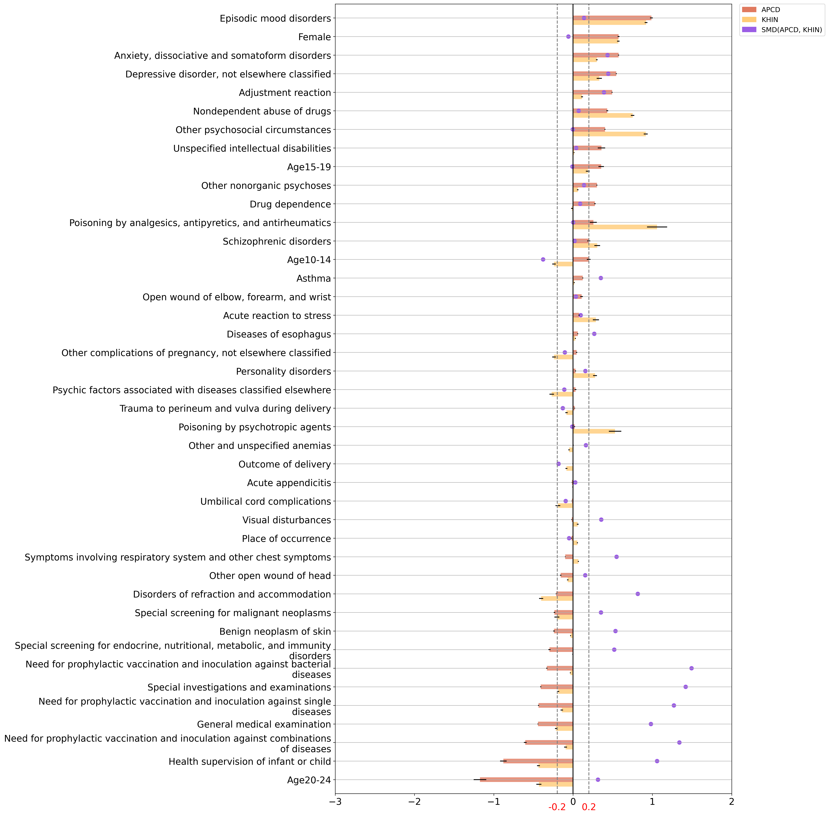

Supplementary Figure S1. Predictor importance and difference across the APCD and KHIN. The feature importances of the local APCD model and HIDD model were presented by bar plots with 95% CI as error bars. standardized mean differences of feature prevalence were shown in the dots. The regularized logistic regression models were used for learning feature importance. We showcased the top 30 features with top learned importance. The difference in the prevalence of features between datasets was measured by standardized mean difference (SMD), and the dashed lines $±0.2$ were guidelines for eyes, implying significant data difference if the absolute value of SMD is beyond 0.2.

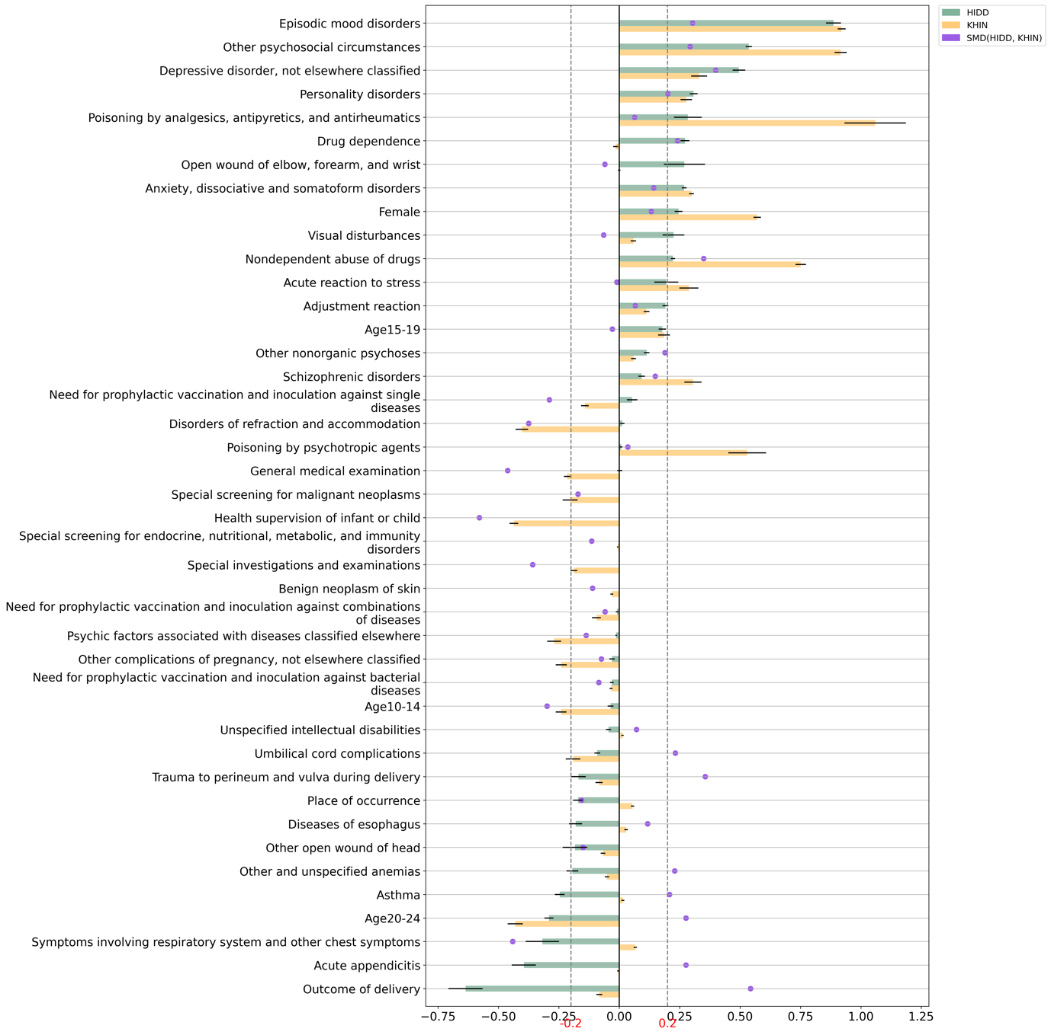

Supplementary Figure S2. Predictor importance and difference across the HIDD and KHIN. The feature importance of the local APCD model and HIDD model were presented by bar plots with 95% CI as error bars. standardized mean differences of feature prevalence were shown in the dots. The regularized logistic regression models were used for learning feature importance. We showcased the top 30 features with top learned importance. The difference in the prevalence of features between datasets was measured by standardized mean difference (SMD), and the dashed lines $±0.2$ were guidelines for eyes, implying significant data difference if the absolute value of SMD is beyond 0.2.

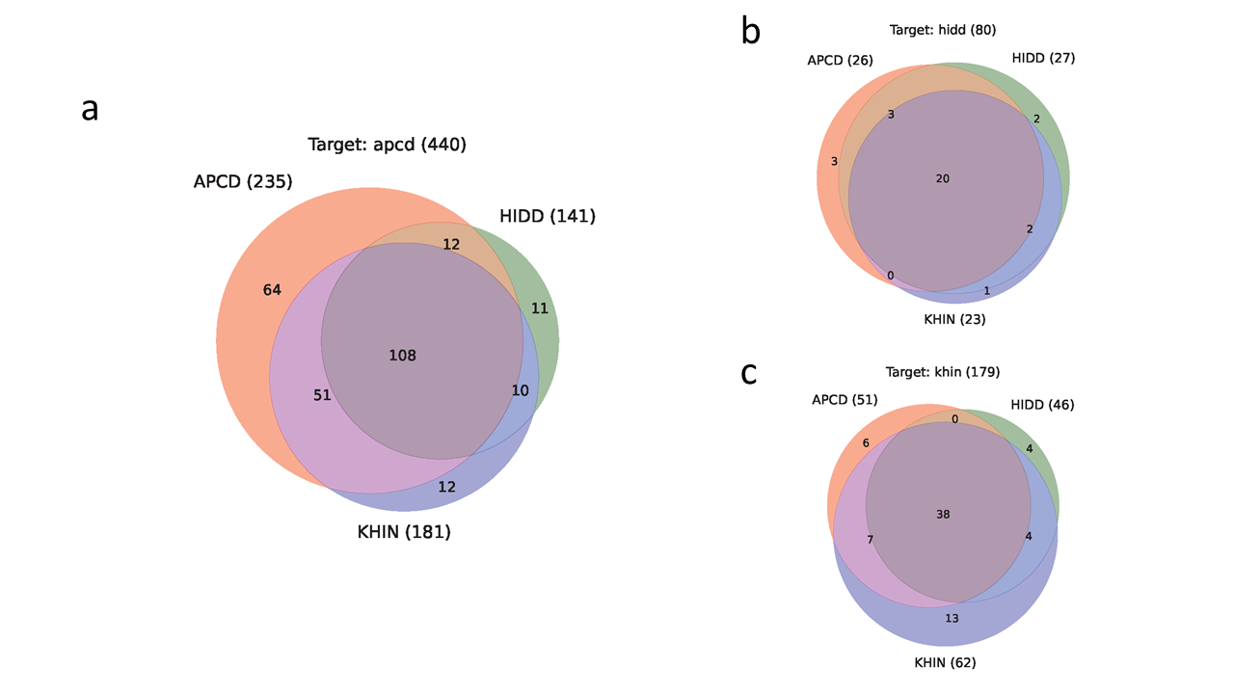

Supplementary Figure S3. Venn diagrams of different models in identifying positive patients. a) using the APCD model, HIDD model, and KHIN model on the APCD testing data. b) on the HIDD testing data, and c) Predictor importance and difference across the HIDD and KHIN data.

