Supplementary information
Quantum size effects in ultra-thin YBa₂Cu₃O_{7-x} films
M. Lyatti^{1,2*}, I. Gundareva^{1,2}, T. Röper^{1,2}, Z. Popovic³,D. Grützmacher¹, T. Schäpers^{1,2}
¹ Peter Grünberg Institut (PGI-9), Forschungszentrum Jülich, 52425 Jülich, Germany
² JARA-Fundamentals of Future Information Technology, Jülich-Aachen Research Alliance, Forschungszentrum Jülich and RWTH Aachen University, Germany
³ University of Belgrade, Faculty of Physics, Studentski trg. 12, 11001 Belgrade, Serbia

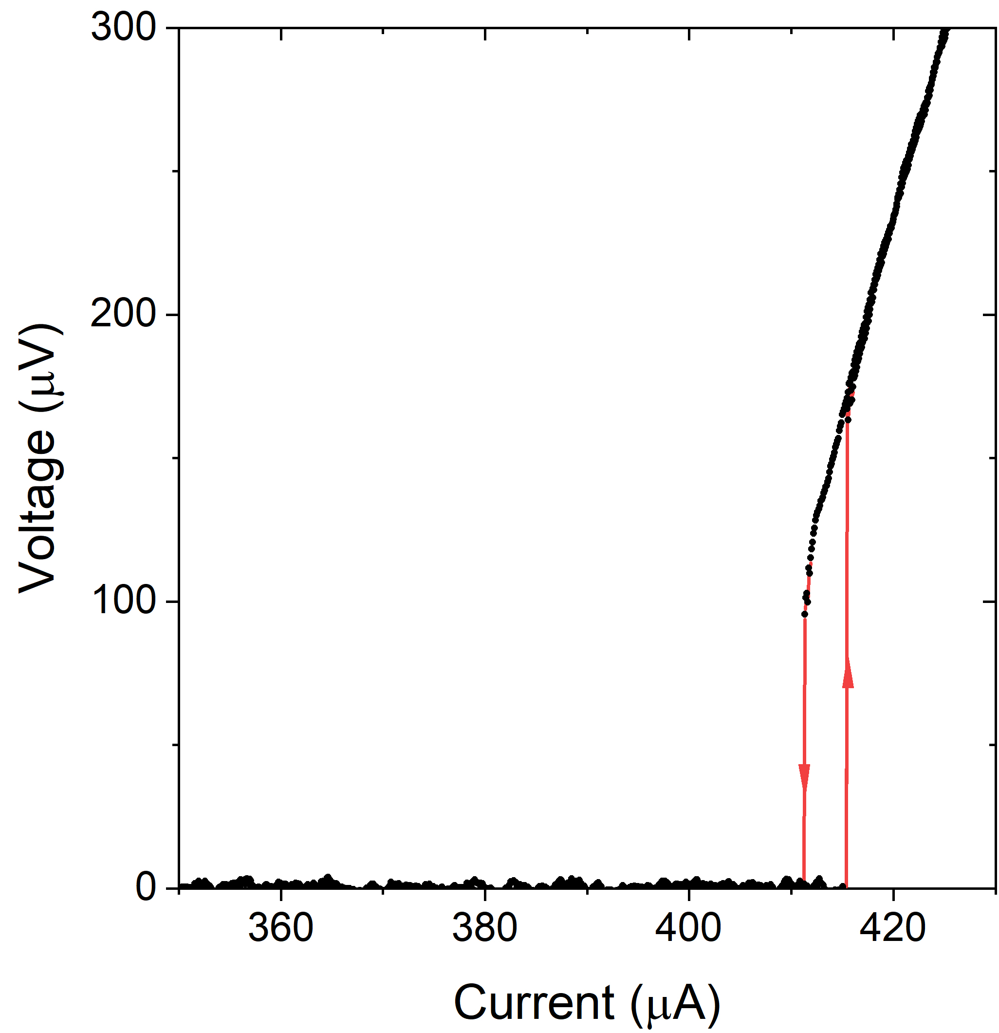 | 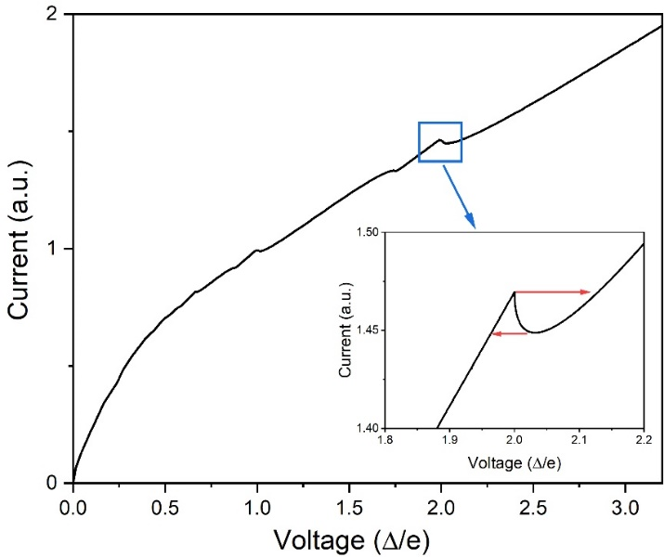
Figure S1| IV curve of 76-nm-wide and 9-u.c.-thick Au-YBCO nanowire at T = 4.2 K. | Figure S2| Numerically simulated current-voltage characteristic of the voltage-biased SNS junction. Inset. Zoomed current-voltage characteristic. Red arrows show the voltage switching in the current-bias regime.

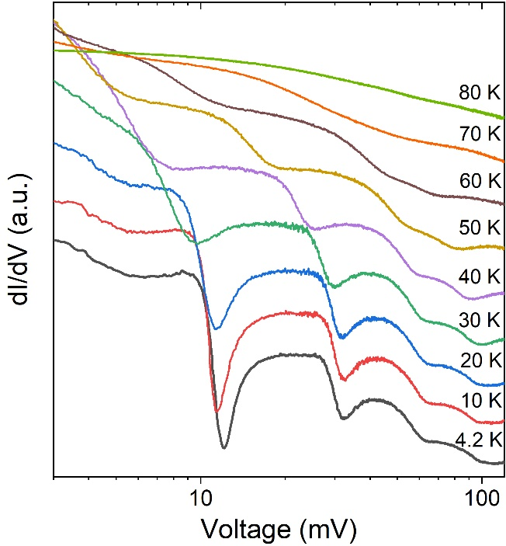 | 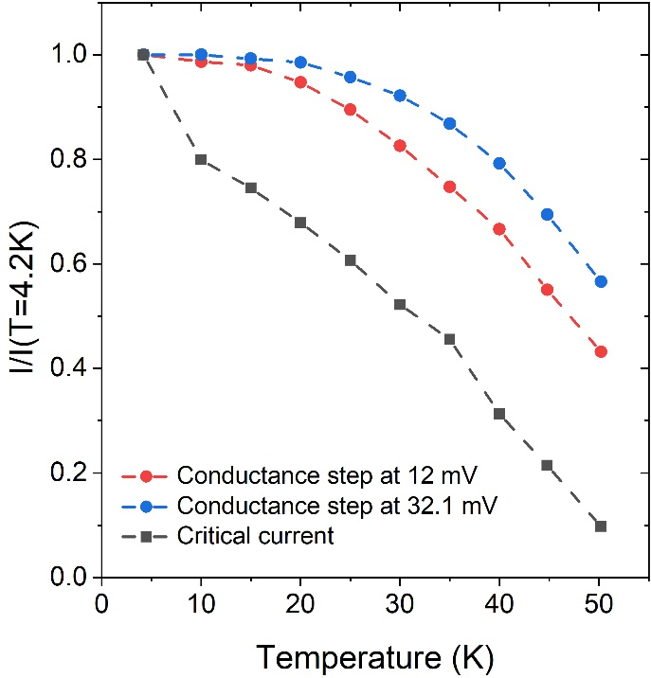
Figure S3| Differential conductance of the ultra-narrow YBCO nanoconstriction at various temperatures. Curves are shifted along the Y-axis for convenience of their representation. | Figure S4| Temperature dependences of critical current and current position of the conductance steps at 12 mV and 32.2 mV of the ultra-narrow YBCO nanoconstriction.

