Supplemental Figures
Figure S1. FACS analysis of stage-specific embryonic antigen-3 (SSEA-3) (+)-Muse cells isolated by magnetic-activated cell sorting (MACS). Gate P1 showed 5.0±0.9% of human bone marrow mesenchymal stem cells (BM-MSCs) were SSEA-3(+)-Muse cells. Gate P2 was SSEA-3(-)-non-Muse MSCs in human BM-MSCs. SSC-A, side scatter area; FITC-A, fluorescein isothiocyanate area. MACS isolated-Muse cells were shown to contain 76.5±6.0%of SSEA-3(+)-Muse cells by FACS.

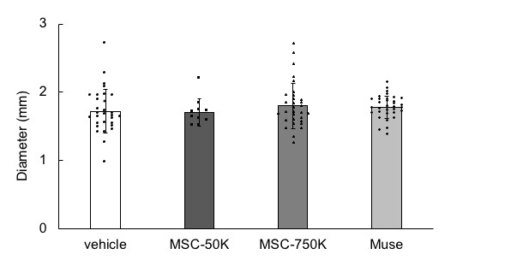
Figure 2. Diameter of dissected aorta at 0 day after Stanford B acute aortic dissection (AAD) onset measured by contrast-enhanced CT imaging. There were no significant differences among the vehicle group (AAD mice administered with no cells) (n=30), MSC-50K group (AAD mice administered with 50,000 mesenchymal stem cells) (n=10), MSC-750K group (AAD mice administered with 750,000 mesenchymal stem cells) (n=31) and Muse group (AAD mice administered with 50,000 Muse cells) (n=34) (P > 0.05) (Steel-Dwass test).

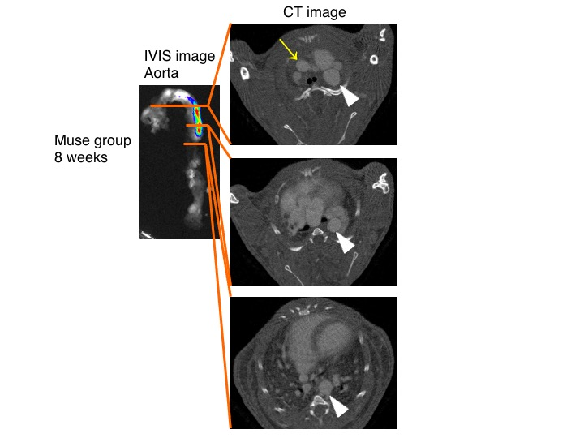
Figure S3. Correspondence between the IVIS Spectrum CT image and contrast-enhanced CT. CT was performed before IVIS imaging to confirm the site of Stanford B acute aortic dissection (AAD) at 8 weeks after cell administration. The distribution of Muse cells was shown to be concentrated on the dissected aorta and not on the intact aorta. Muse group: AAD mice administered with Venus-Akaluc GFP-labeled 50,000 Muse cells. Yellow arrow: the ascending aorta without aneurysm. White arrowhead: the dissected and dilated descending thoracic aorta.

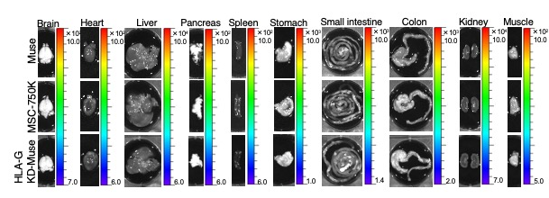Figure S4. IVIS Spectrum CT images of each organ at 1 week after cell administration in the Muse group (AAD mice administered with Venus-Akaluc GFP-labeled 50,000 Muse cells), MSC-750K group (AAD mice administered with Venus-Akaluc GFP-labeled 750,000 mesenchymal stem cells) and HLA-G KD-Muse group (AAD mice administered with Venus-Akaluc GFP-labeled HLA-G gene knockdown-50,000 Muse cells). Signals in the brain, heart, liver, pancreas, spleen stomach, small intestine, colon, kidney, and thigh muscle were under the detection limit in all the groups. The same trend was observed at 4 and 8 weeks after cell administration (not shown).

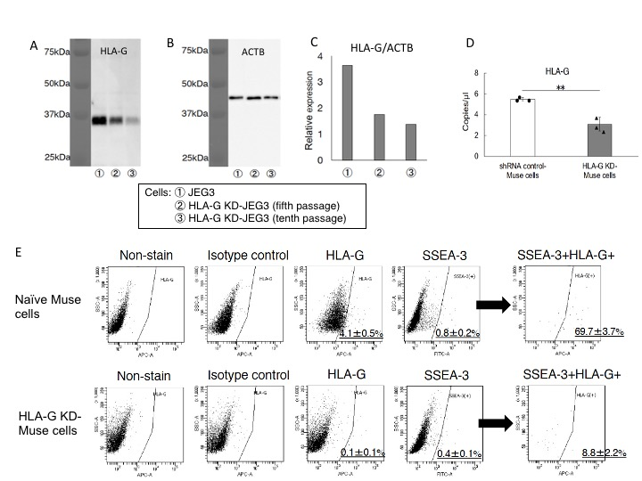

Figure S5. (A-C) We examined whether HLA-G shRNA functioned in JEG3 cell line that is guaranteed to express HLA-G. Western blotting of naïve JEG3 (line 1) and HLA-G KD-JEG3 (HLA-G gene was knocked down by HLA-G shRNA induction) fifth passage (line 2) and tenth passage (line 3) showed suppression of HLA-G in HLA-G KD-JEG3 (lines 2 and 3). A, Western blot of HLA-G (39-41kDa). B, Western blot of ACTB (β-actin) (46kDa). C, Relative expression of HLA-G normalized by ACTB. D, HLA-G gene expression level in control vector-introduced Akaluc-Muse cells (shRNA control-Muse cells) and HLA-G shRNA-introduced Akaluc-Muse cells (HLA-G KD-Muse cells), both at eleventh passage, in digital droplet PCR. **P < 0.01; by t-test. E, HLA-G expression in naïve Muse and HLA-G KD-Muse cells (HLA-G gene was knocked down by HLA-G shRNA induction) by FACS. HLA-G(+) ratio was 69.7±3.7% in stage-specific embryonic antigen-3 (SSEA-3) (+) naïve Muse cells (corresponded to 0.8±0.2% of total MSCs). HLA-G(+) ratio was reduced to 8.8±2.2% in SSEA-3(+) HLA-G KD-Muse cells (corresponded to 0.4±0.1% of total MSCs). SSC-A, side scatter area; FITC-A, fluorescein isothiocyanate area.

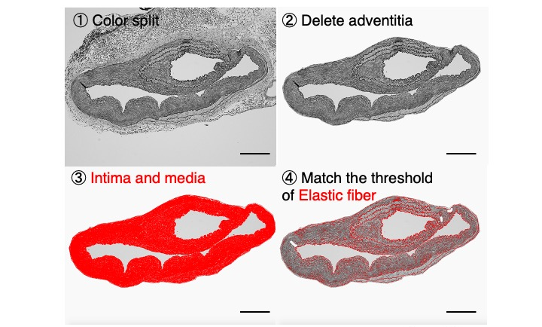
Figure S6. Method of measureing elastic fiber areas in the neointima and media of dissected aorta. Upper left (1): An image obtained from color splitting Elastica-Masson staining converted to monochrome. Upper right (2): An image after exclusion of the adventitia. Lower left (3): The remaining part was the neointima and media (red). Lower right (4): An image showing elastic fibers (red) by matching the color tone of the image. ((4) red area) / ((3) red area) × 100 is the ratio of the elastic fiber area to the total area of the neointima and media (elastin area (%)). Scale bar: 200 μm.

