Additional file

Additional methods

Volume averaged FiO2 calculation
The volume averaged FiO₂ estimates if there is a match between the peak inspiratory flow and the actual delivered FiO₂. Volume averaged FiO₂ represents the effective FiO₂ delivered inside the lungs. The oxygen flow passing through the trachea over time is calculated by multiplying the patient’s inspiratory flow (Q_{patient}(t)) by the measured FiO₂ at the same time point [Equation 1].
Equation 1: $oxygen flow in the trachea=Q_{patient}\left(t\right).F{iO}_{2}(t)$
The start and end of the patient’s inspiratory time were identified when the patient’s flow rate crossed 0 L/s. The oxygen flow needs to be integrated over time to determine the actual volume of oxygen during inspiration. [Equation 2].
Equation 2: $inspired volume of oxygen=\int_{Ti0}^{Ti}{Q_{patient}\left(t\right).F{iO}_{2}\left(t\right)dt}$
Volume-averaged FiO₂ is finally obtained by calculating the ratio of inspired volume of oxygen divided by tidal volume (3).
Equation 3:
$Volume averaged FiO_{2 }=\frac{\int_{Ti0 }^{Ti}{Q_{patient}\left(t\right).FiO_{2}\left(t\right)dt}}{Vt} with Vt=\int_{TiO}^{Ti}{Q_{patient}\left(t\right)dt}$

Supplementary Figure 1. Schematic description of the volume averaged FiO₂ calculation criteria in two illustrative situations
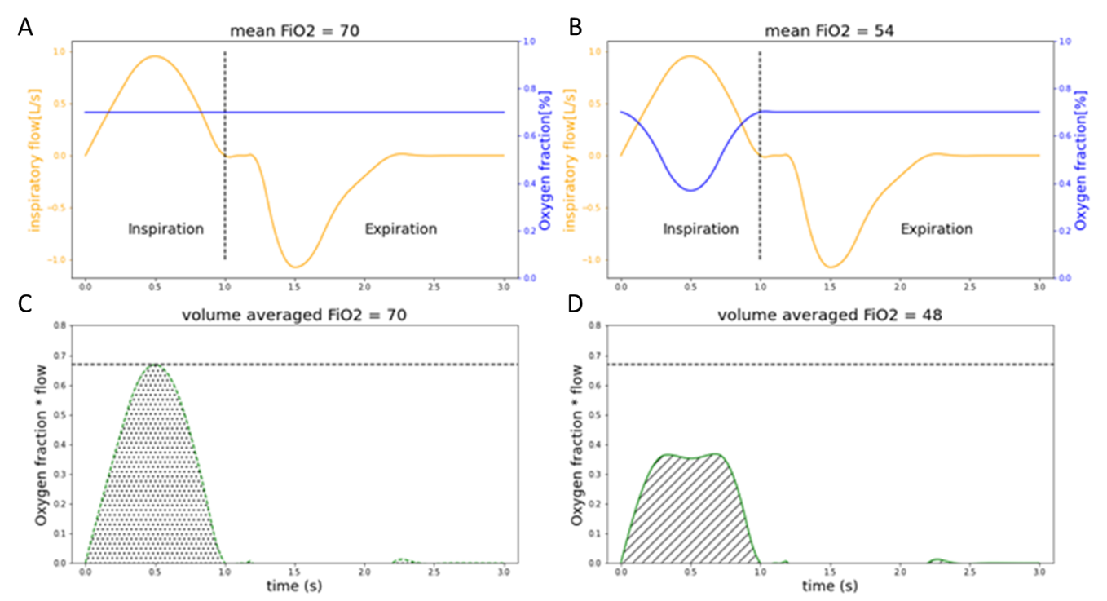
Panels A and B represent flow and inspired fraction of oxygen (FiO₂) during a single breathe. On these panels yellow curves represent the patient spontaneous respiratory flow during one breathe whereas blue ones illustrates the FiO₂ measured in the mask of the patient during the same breathe. Panels C and D present a visualization of the respiratory flow multiplied by the FiO₂ according to the time. The area under the curve is proportional to the volume averaged FiO₂. Focusing on the B and D panels, the FiO₂ rate drops when the patient inspiratory flow increases (e.g. open valves CPAP devices behavior). It leads to a global diminution of the oxygen molecule rate received by the patient during the inspiratory time. This method takes into account the patient flow/FiO₂ relative behavior in the volume averaged FiO₂.

Additional Results
Supplementary Figure 2. FiO₂ recorded on the bench with different tested devices at moderate and high FiO₂ targets
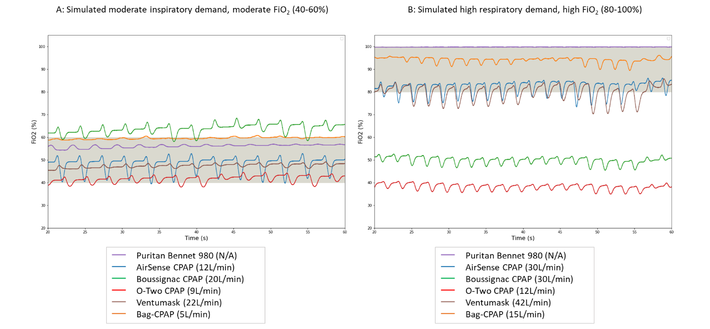
FiO₂ actually delivered by each device was assessed at two FiO₂ target ranges corresponding to two clinical scenario: 40% to 60% while the test lung simulated a moderate respiratory demand (panel A) and 80% to 100% while the test lung simulated a high respiratory demand (panel B). Oxygen flow rates were adjusted on each device according to manufacturer’s recommendations to reach those two target ranges with the constraint of delivering a PEEP level between 5 and 10 cm H₂O.
The grey areas represent the two FiO₂ target ranges.
Supplementary Figure 3. Pressure volume curves obtained on the bench to compare resistive work induced by the increase of oxygen flow in the Bag-CPAP device.
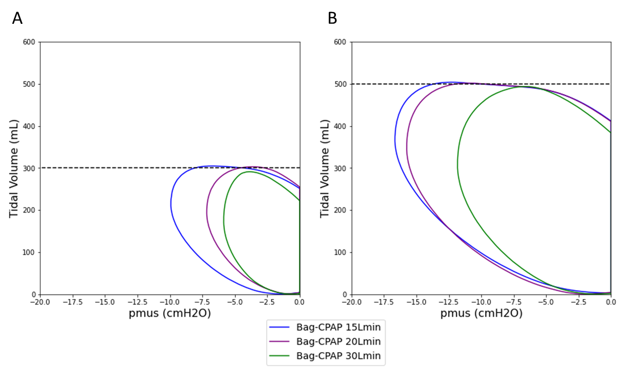
The figure represents dynamic simulated muscle pressure (Pmus)/volume loops recorded with the Bag-CPAP device. The pressure/volume loops were obtained by adjusting the simulated patient’s effort to reach a tidal volume of 300 mL (Panel A) or 500 mL (Panel B). The work of breathing (WOB) was defined as the trapezoidal numerical integration of the pressure/volume curve, which corresponds to the area under the curve. The difference in the areas represents the relative change in WOB imposed by the device to keep the tidal volume constant. The smaller is the area under the curve, the lower is the WOB imposed by the device: the increase of oxygen flow in the Bag-CPAP decreases the WOB.

Supplementary Tables
Supplementary Table 1. General characteristics of the devices
 | Puritan Bennett 980 | AirSense  10Autoset | Boussignac CPAP | O-Two CPAP | StarMed Ventumask | Bag-CPAP
Manufacturer | Covidien | Resmed | Vygon | O-Two | Intersurgical | Air Liquide Medical Systems
Gaz mixture | Pneumatic | Turbine | Open valve | Open valve | Venturi | Venturi
PEEP range (cmH₂O) | 0-45 | 4-20 | 5-10 | 5-25 | 5-12.5 | 7.5-10
FiO₂ range (%) | 21-100 | N/A | >50% | 54-77 | 40-100 | 50 or >90
Oxygen flow rate (L/min) | 0-200 | N/A | 20-30 | 8-25 | 12-42 | 5-20
NIV interface used | Respireo Hospital¹ | AirFit F10² | Respireo Hospital | Respireo Hospital | Ventumask³ | Respireo Hospital

Abbreviations: PEEP: positive end expiratory pressure, FiO₂: inspired fraction of oxygen, NIV: noninvasive ventilation
¹ Air Liquide Medical Systems, Brescia, Italy; ² Resmed, Saint Priest, France; ³ Intersurgical, Wokingham, United Kingdom
Supplementary Table 2. Calculation of the ∆WOB patient (%) according to two simulated inspiratory demands
 | Moderate inspiratory demand with Vt target of 300ml | High inspiratory demand with Vt target of 500ml
 | ∆WOB patient (%) | ∆WOB patient (%)
PB 980 | 0 | 0
AirSense CPAP | -2 | -11
Boussignac CPAP | +35 | +26
O-Two CPAP | +50 | +38
Ventumask CPAP | +68 | +96
Bag-CPAP | +37 | +66

∆WOB patient represents the relative variation of the simulated patient’s work of breathing needed to maintain the tidal volume obtained with the ICU ventilator (PB 980). See figure 3 as well.
The AirSense CPAP required lower WOB than the PB980 ventilator to achieve the target tidal volume (either 300 or 500 mL), resulting in a negative ΔWOB. The ΔWOB was positive for other tested CPAP, with lower values with virtual valve CPAPs (Boussignac, O-two) than with Venturi type CPAP, Ventumask or Bag-CPAP.

