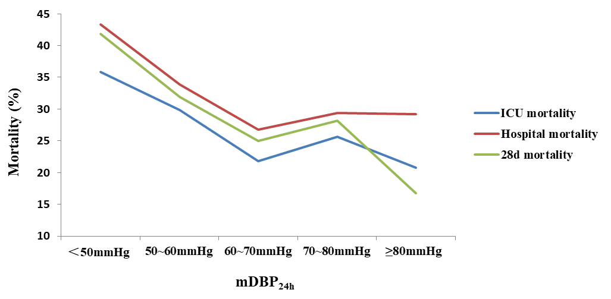
Supplemental figure 1 mortality of septic shock patients

