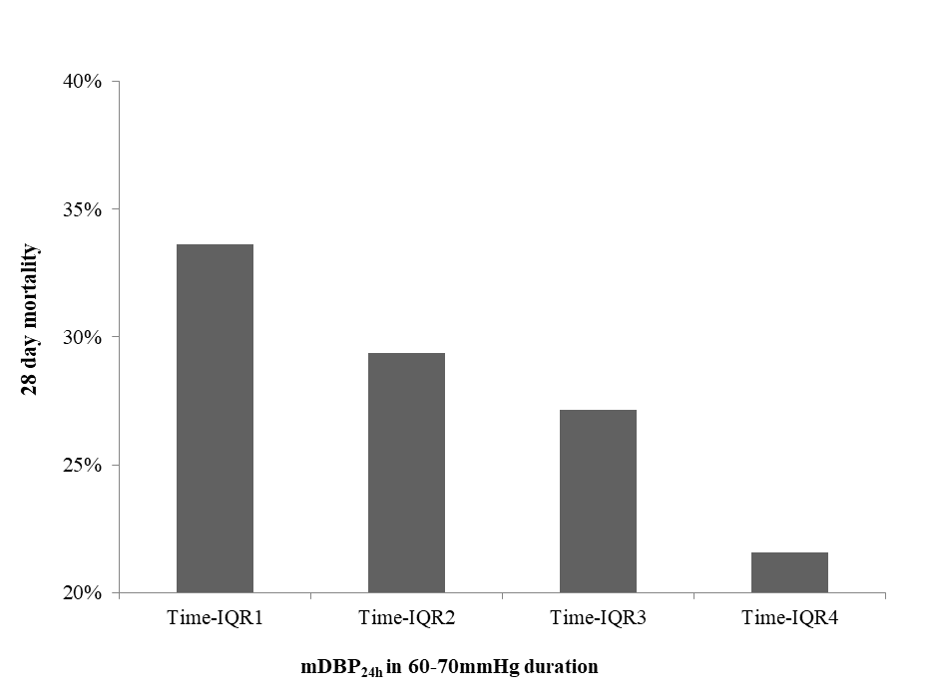
Supplemental Figure 2. 28 day mortality of different interquartile intervals with mDBP_{24h} in 60-70mmHg duration (Time-IQR1: ≤4 hours, Time-IQR2: 4-8hours, Time-IQR3: 8-11hours, Time-IQR4: ≥11hours ); IQR: interquartile range.

