Supplementary information
Title: Regulation of myogenesis and adipogenesis by the electromagnetic perceptive gene

Jangsun Hwang^{ad†}, Haewoon Jung^{b†}, Kyung Min Kim^{c}, Daun Jeong^{ad}, Jinhyuck Lee^{ad}, Jeong-Ho Hong^{c}, and Woo Young Jang^{ad*}

ªDepartment of Orthopedic Surgery, College of Medicine, Korea University, 73 Korea-ro, Seongbuk-gu, Seoul 02841, Republic of Korea
^{b}Department of Pediatrics, Kyung Hee University Medical Center, Seoul, Korea
^{c}Department of Life Sciences, School of Life Sciences and Biotechnology, Korea University, Seoul 02841, Korea
^{d}Institute of Nano, Regeneration, Reconstruction, College of Medicine, Korea University, 73 Korea-ro, Seongbuk-gu, Seoul 02841, Republic of Korea
†These authors contributed equally.

*Correspondence to opmanse@korea.ac.kr

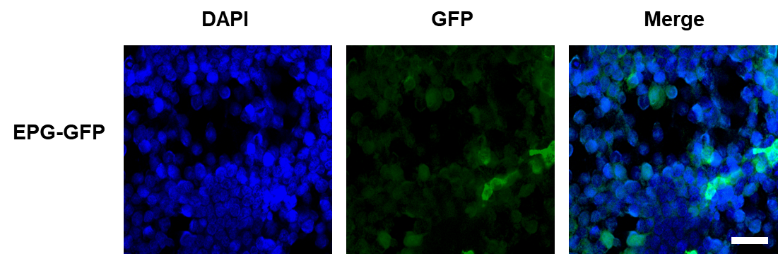
Supporting Figure 1. Fluorescent images of EPG-GFP transfected HEK 293T cells (scale bar =50 µm, DAPI: 358⁄461 nm, GFP: 475/510 nm).

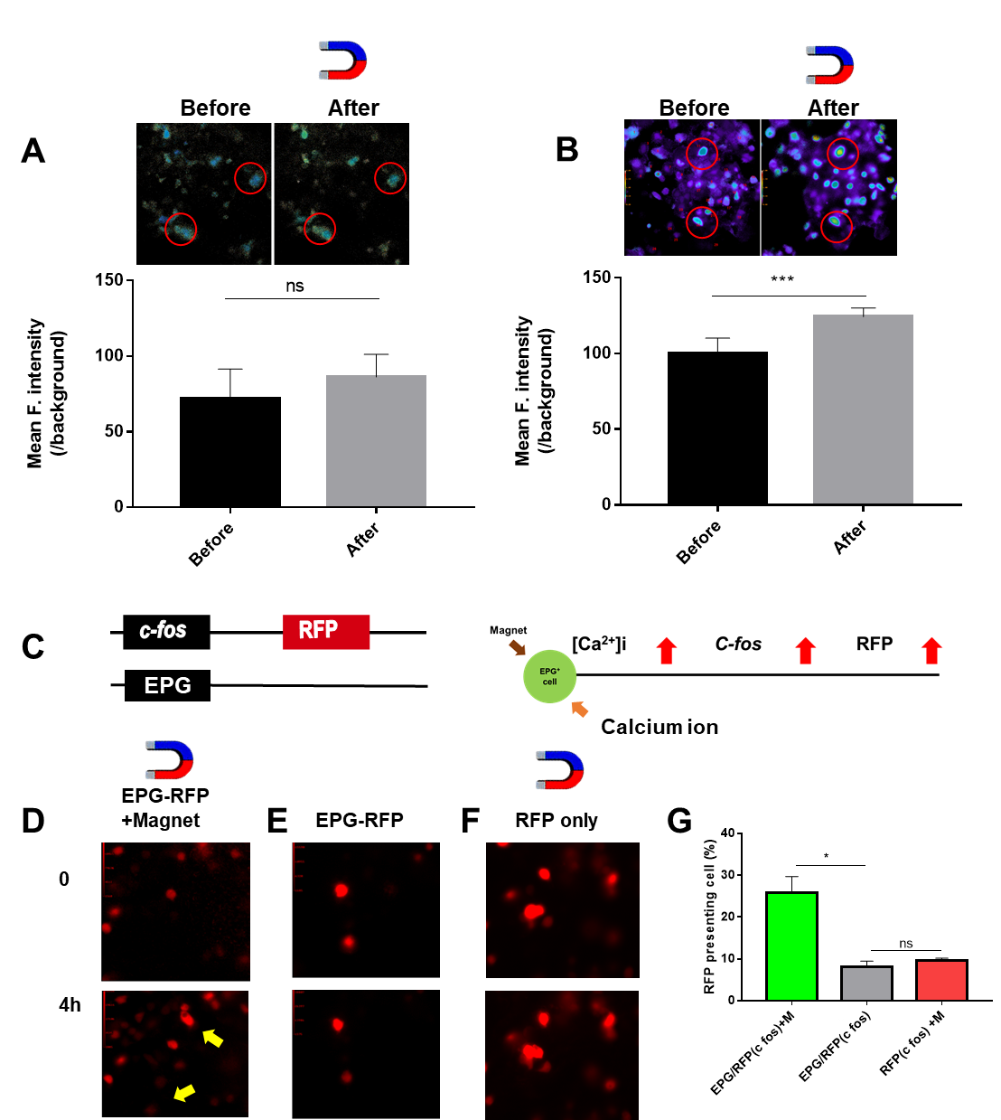
Supporting Figure 2. Regulation of RFP expression by EPG with Calcium ion sensitive promotor on HEK 293T cells. (A) Calcium ion mapping on HEK 293T cells without magnet. (B) EPG-GFP transfected HEK 293T cells with Magnet (Magnetic field=50mT, 1s). (C) Illustration of target gene regulation on EPG-GFP and c-fos-RFP co transfected HEK 293T cell. (D) Fluoresce images of EPG, c-fos-RFP co transfected HEK 293T cell without magnet. (E) Fluoresce images of c-fos-RFP transfected HEK 293T cell with magnet. (F) RFP transfected HEK 293T cell with magnet. (D) Quantification of RFP expression from D-F (cells were observed and countered after 4h in the presence of magnet, 50 mT).

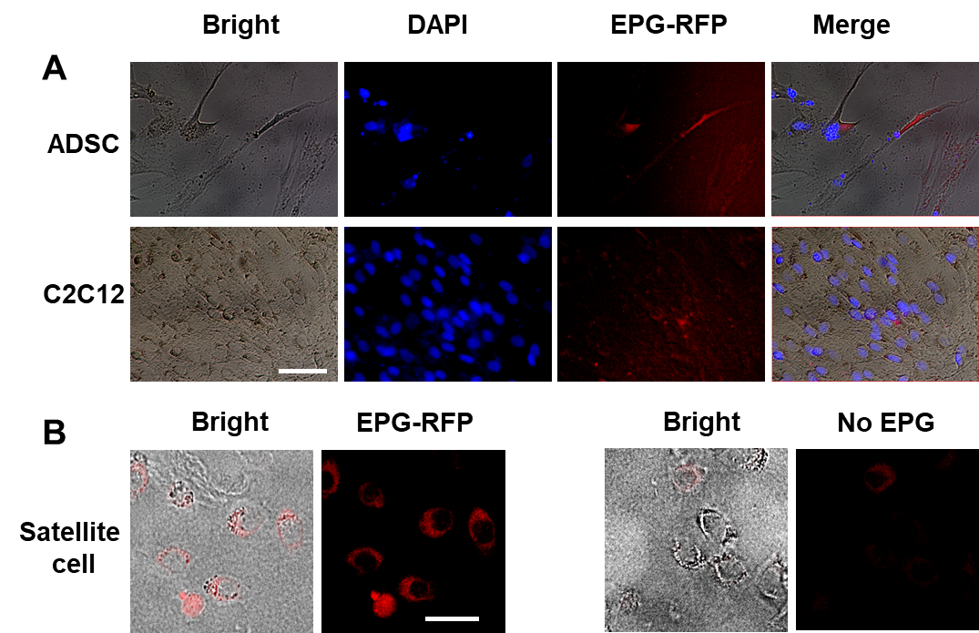
Supporting Figure 3. Fluorescent images of EPG transfected (A) ADSC, C2C12 cells, and (B) satellite cells (scale bar =20 or 50 µm, DAPI: 358⁄461 nm, EPG-RFP: 540/585 nm).

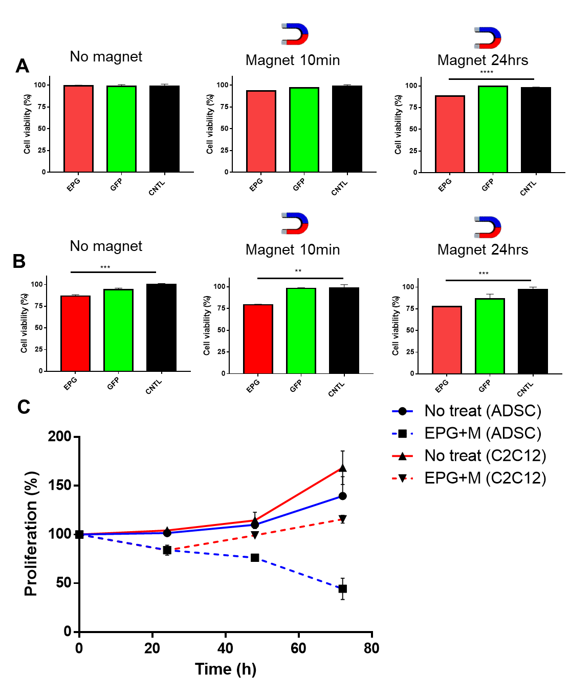
Supporting Figure 4. Proliferation test of EPG on ADSCs and C2C12. (A) EPG transfected ADSCs without magnet stimulation, magnet for 10 min, and 24h (left to right). (B) EPG transfected C2C12 cells without magnet stimulation, magnet for 10 min, and 24h (left to right). (C) Cell viability (magnet= ~196mT, CNTL=no treat, n=3, 5x 10⁴/mL cells were used and cultured for 24-72 h, CCK-8 assay).

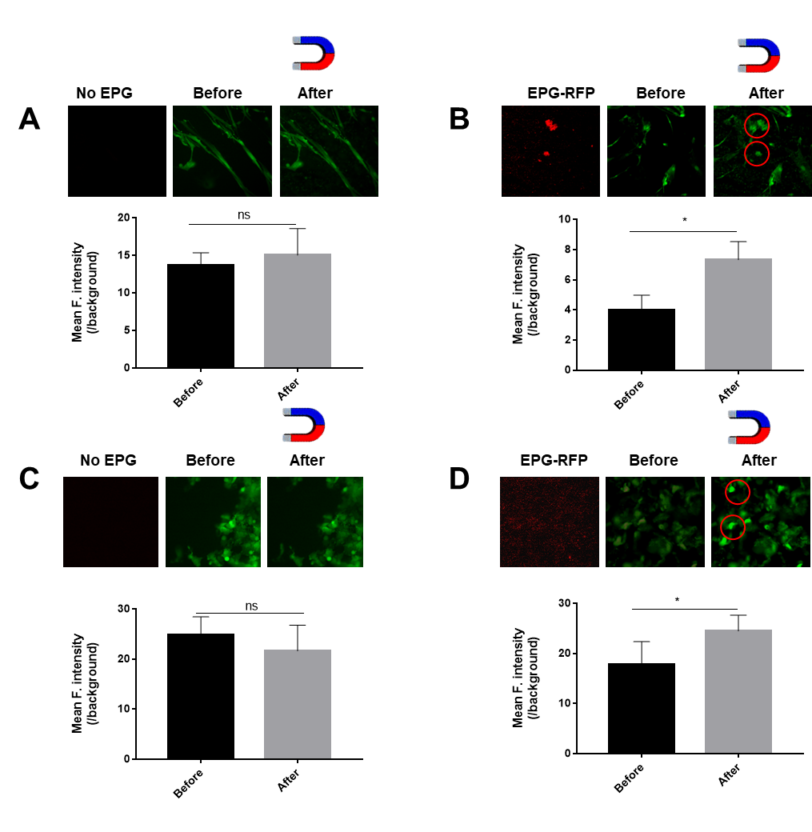
Supporting Figure 5. Calcium ion mapping. (A) [Ca2+]i images on ADSC without EPG activation. (B) [Ca2+]i images on hADSC with EPG with magnetic activation. (C) [Ca2+]i images on C2C12 without EPG activation. (D) [Ca2+]i images on C2C12 with EPG with magnetic activation (EPG-RFP=red, magnetic bead = ~196mT, Green=Fura -4AM, red circle= Ca²⁺ increased cell, n=3).
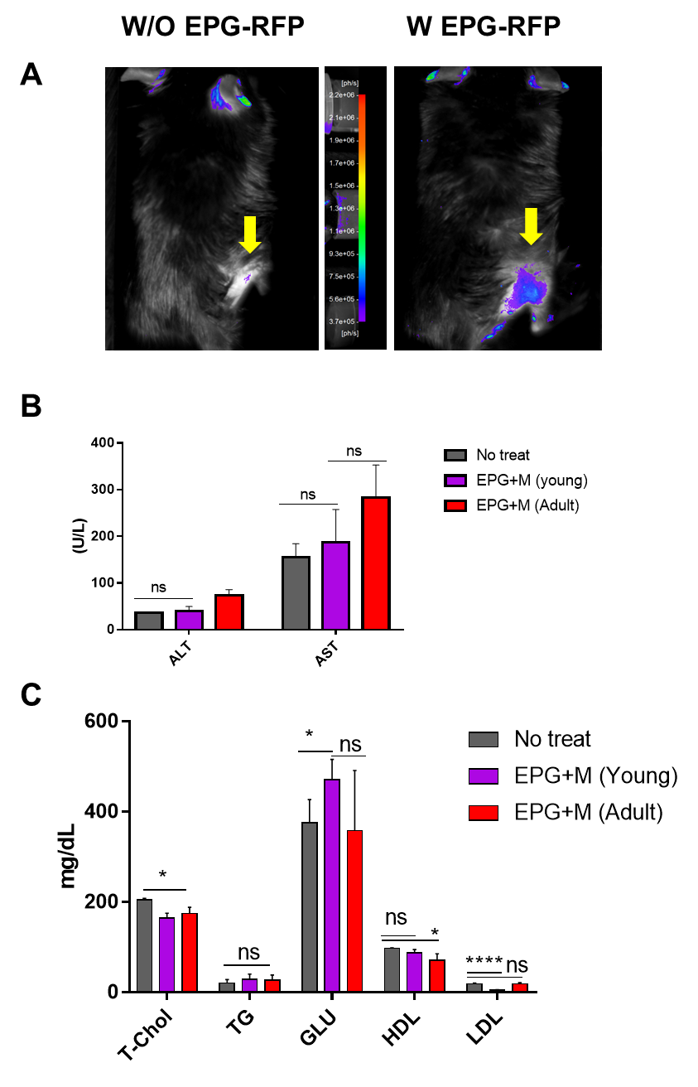
Supplementary Figure 6. Evaluation of EPG in mouse. (A) IVIS image of EPG-RFP expression on a mouse. (B) ALT and AST. (C) Lipid profile test (all mice were treated MF with customized cage, AAV6-EPG-RFP= 3x10¹⁰ Pa, magnetic field ~196mT, 30 min for 5 days, n=3).

Table 1. Primer pairs
Protein | Gene | Forward | Reverse
Murine MyoD | MyoD | 5’ GCCGGTGTGCATTCCAA 3’ | 5’ CACTCCGGAACCCCAACAG 3’
Murine MyoG | MyoG | GACCTGATGGAGCTGTATGAG | CTGAAGGTGGACAGGAAGG
Murine Myomaker | MYMK | CTGAGCTCCCAAGACATGAG | CCAATCTCTCCTTCCTCTGG
Murine MCK | MCK | CACCTCCACAGCACAGACAG | ACCTTGGCCATGTGATTGTT
Murine GAPDH | GAPDH | GTTGTCTCCTGCGACTTCA | GGTGGTCCAGGGTTTCTTA
Human PPARγ2 | PPARγ2 | CTATTGACCCAGAAAGCGAT | CGTAATGTGGAGTAGAAATGC
Human GLUT4 | GLUT4 | AGGATCGGTTCTTTCATCTTCGC | GTTCCCCATCTTCGGAGCCTA
Human CasR | CasR | TCTCAAATCAAGGCCGGAGT | GCTGTTTATCTCCTCTATGGCAA
Human Beta actin | ATP5PB | TCGAGTCGCGTCCACC | GGGAGCATCGTCGCCC

