Supplementary data
Figure 1a. Original image showing full length membranes, with membrane edges visible of agarose gel showing the migration of DNA extracted from human lymphocytes
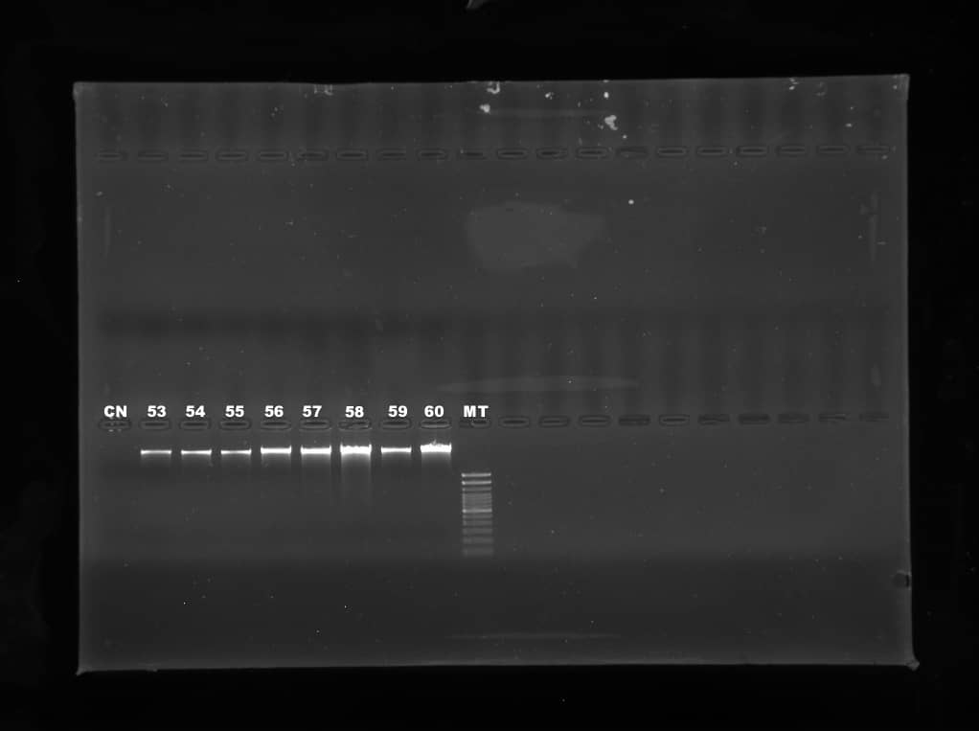

Figure 1b. Original image showing full length membranes, with membrane edges visible of PCR products showing the amplifications of the two regions of the human genome extracted from human lymphocytes
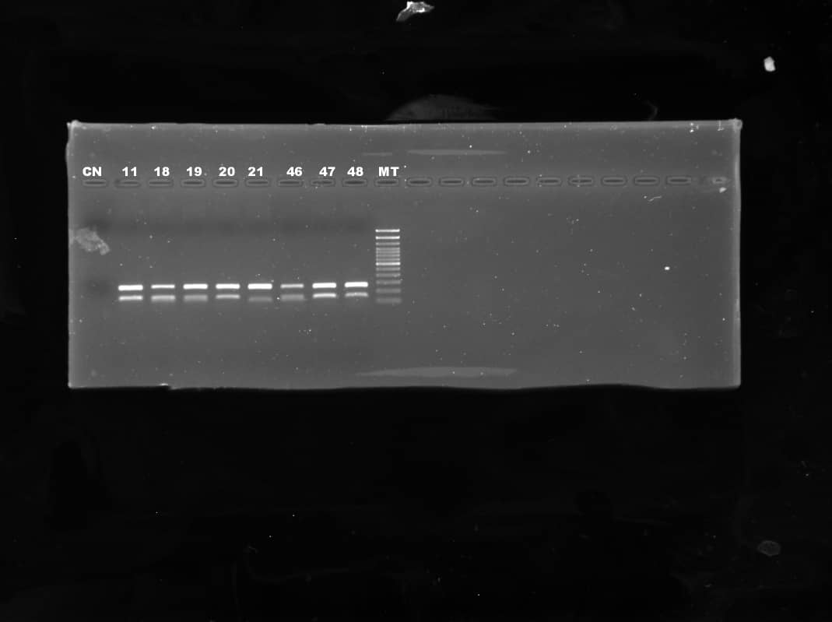

Legends of Original image of Figure 1
Figure 1 : Original image of agarose gel showing migration of DNA extracted and amplified of some participants.
a: Original image showing full length membranes, with membrane edges visible of Agarose gel showing the migration of DNA extracted from human lymphocytes . The gel was prepared from 1g of agarose powder and 100 ml of TBE (Tris-borate buffer), all supplemented with 2.5 ul of BET (Ethidium bromide). The size of amplification product is 3000 000 kbp.
B: Original image showing full length membranes, with membrane edges visible of PCR products showing the amplifications of the two regions of the human genome extracted from human lymphocytes. PCR A with primers A and PCR B with primers B. The gel was prepared from 2.5 g of agarose powder and 100 ml of TBE, all supplemented with 2.5 ul of BET. The sizes of the different amplification products are 252 bp and 248 bp.
CN=Negative control, MT= DNA ladder

