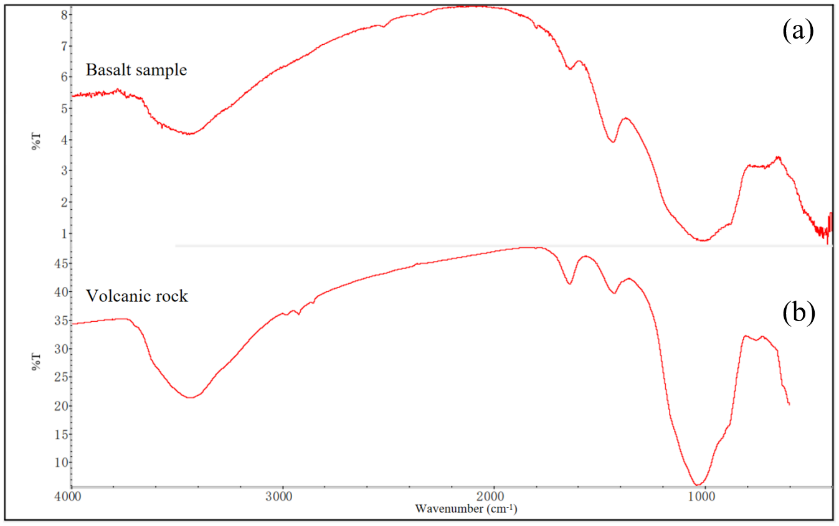
Fig.S.1 Infrared spectrum of basalt sample (a) and matching diagram (b)

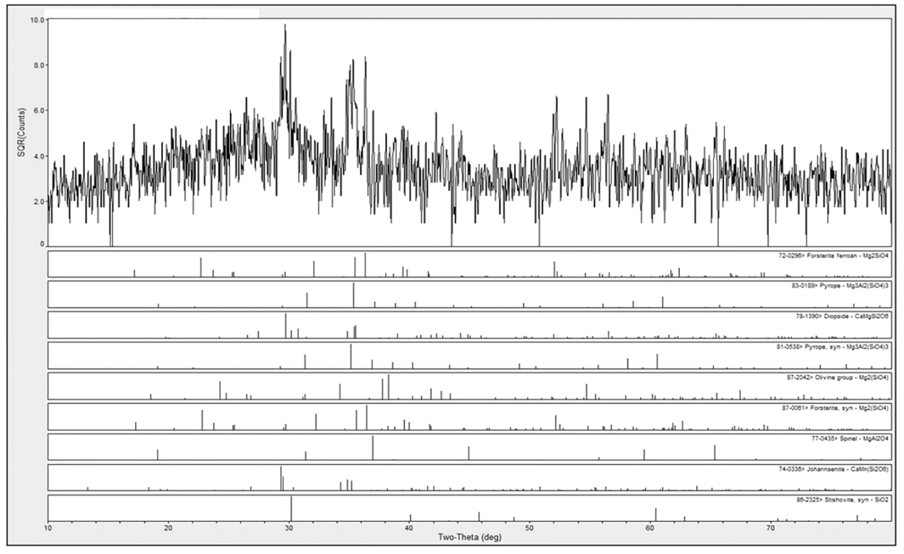

Fig.S.3

Fig.S.2 XRD spectrum of basalt sample

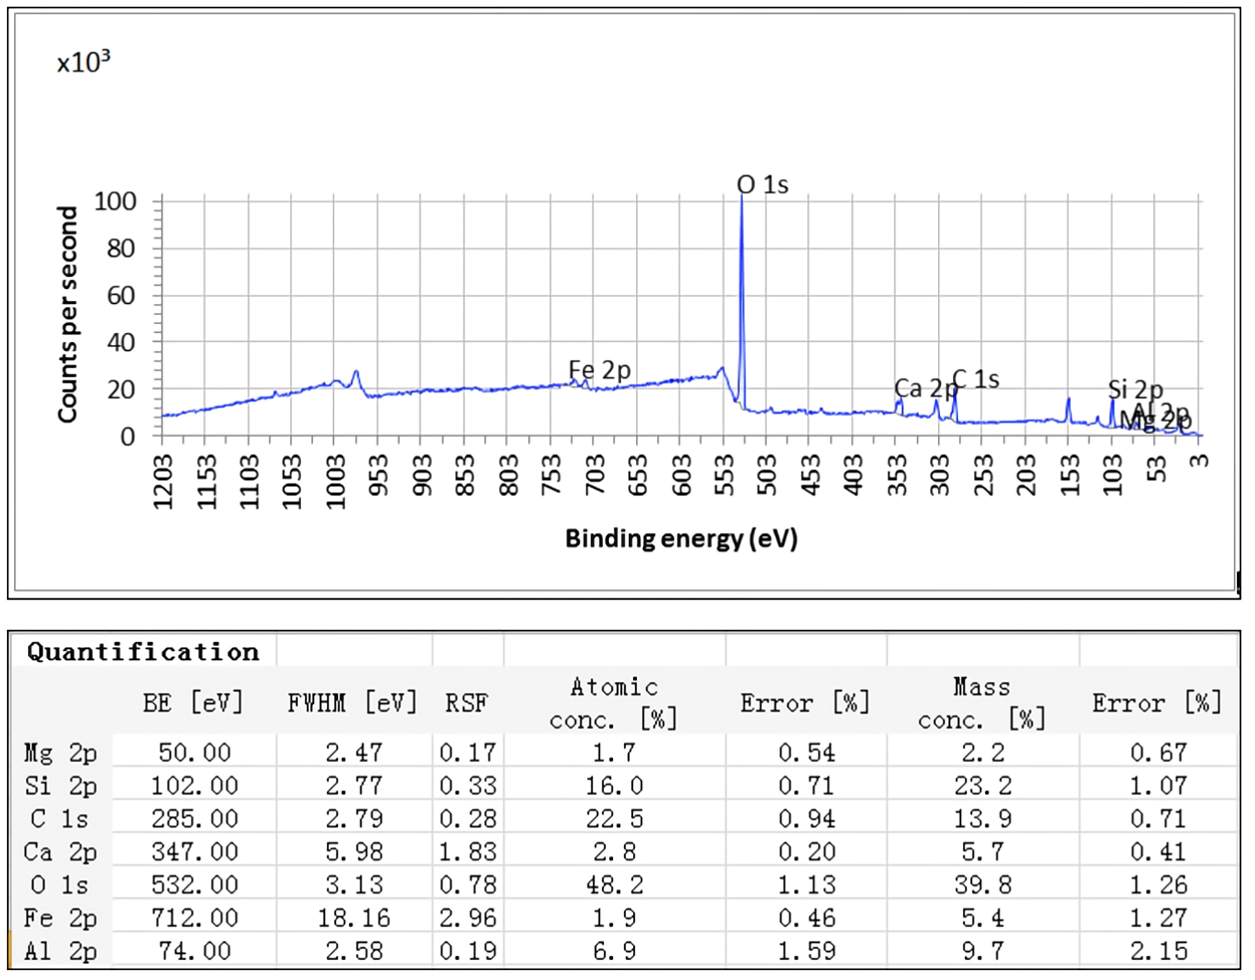
Fig.S.3 XPS test data diagram of basalt sample

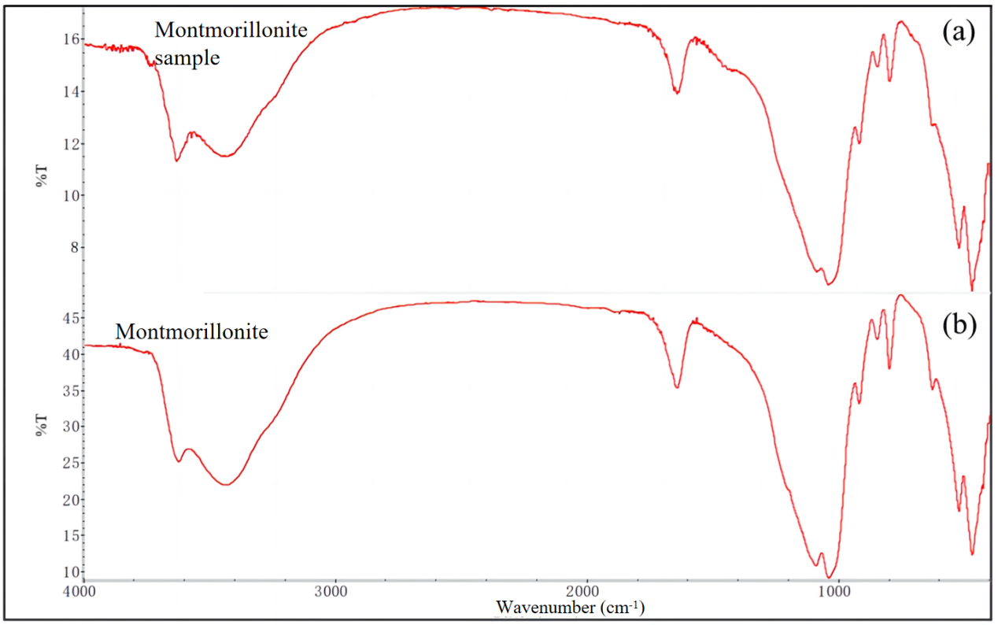

Fig.S.4 Infrared spectrum of montmorillonite sample (a) and matching diagram (b)

Fig.S.5

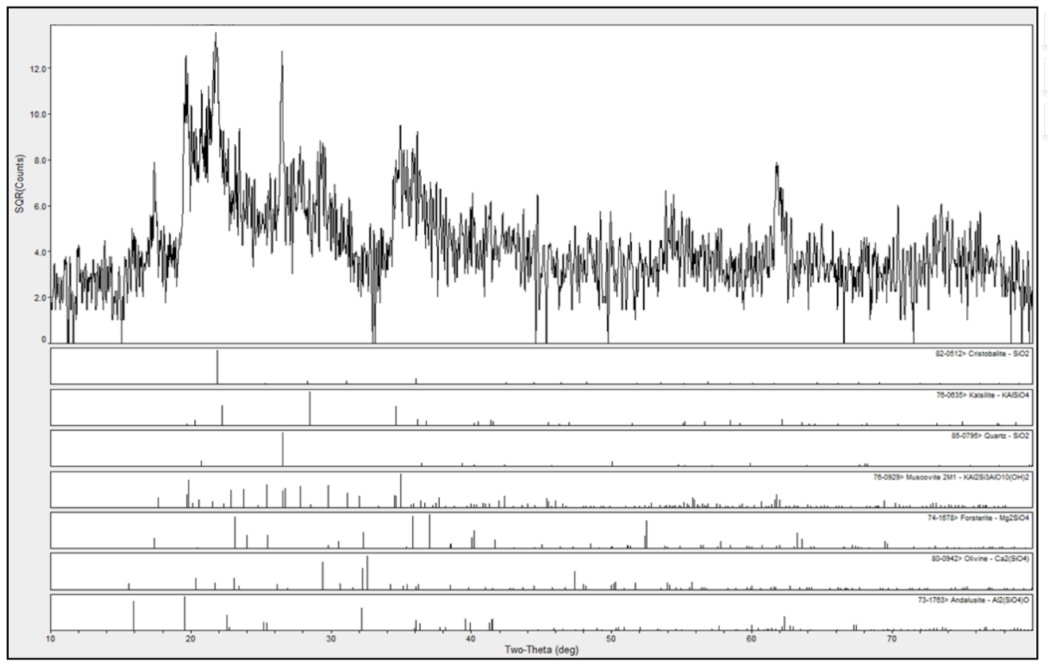
Fig.S.5 XRD spectrum of montmorillonite sample

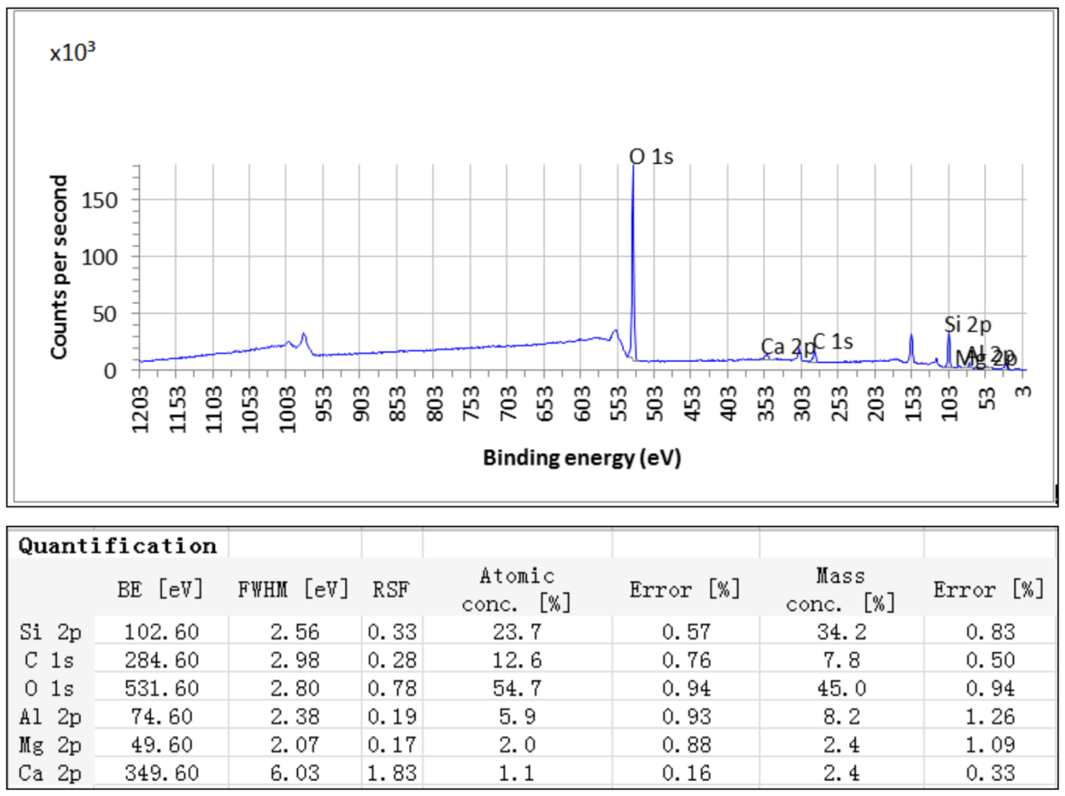

Fig.S.6 XPS test data diagram of montmorillonite sample

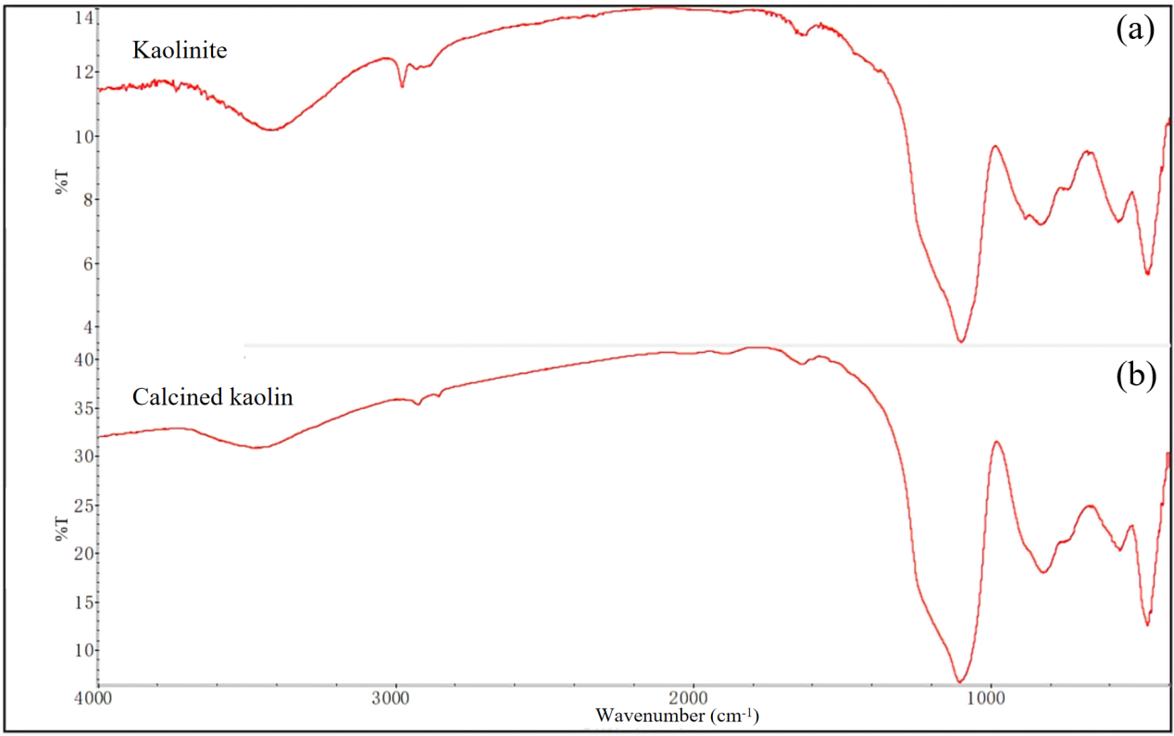

Fig.S.7 Infrared spectrum of kaolinite sample (a) and matching diagram (b).

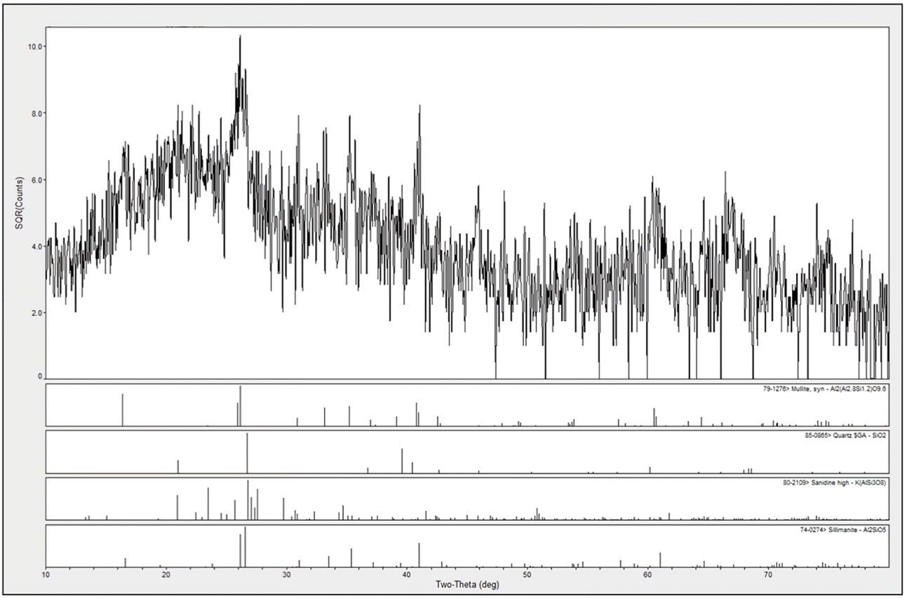
Fig.S.8 XRD spectrum of kaolinite sample

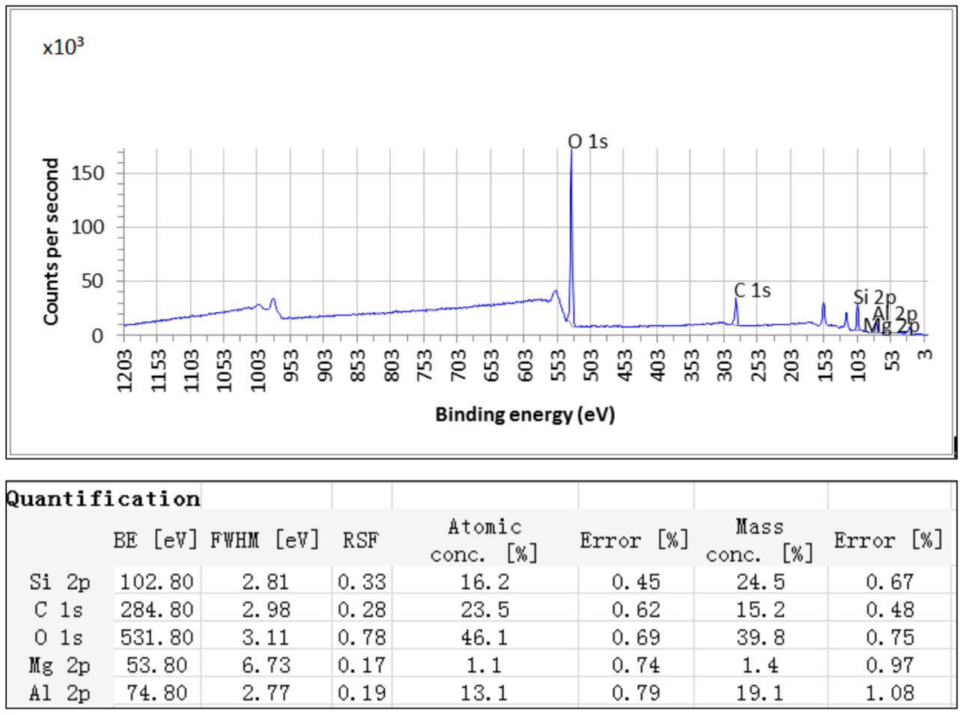
Fig.S.9 XPS test data diagram of kaolinite sample

