Supplementary information
A comparative proteomics study revealing impact of growing region and cultivar on protein expression in the leaves of Nicotiana tabacum plant
Yongxu Hu¹², Min Chen¹, Gang Li¹, Da Wu^{1*}, Xiangmin Zhang^{2*}
¹Technology R&D Center, Shanghai Tobacco Group Co., Ltd., Shanghai 201315, China; ²Department of Chemistry and Institutes of Biomedical Sciences, Fudan University, Shanghai 200433, China

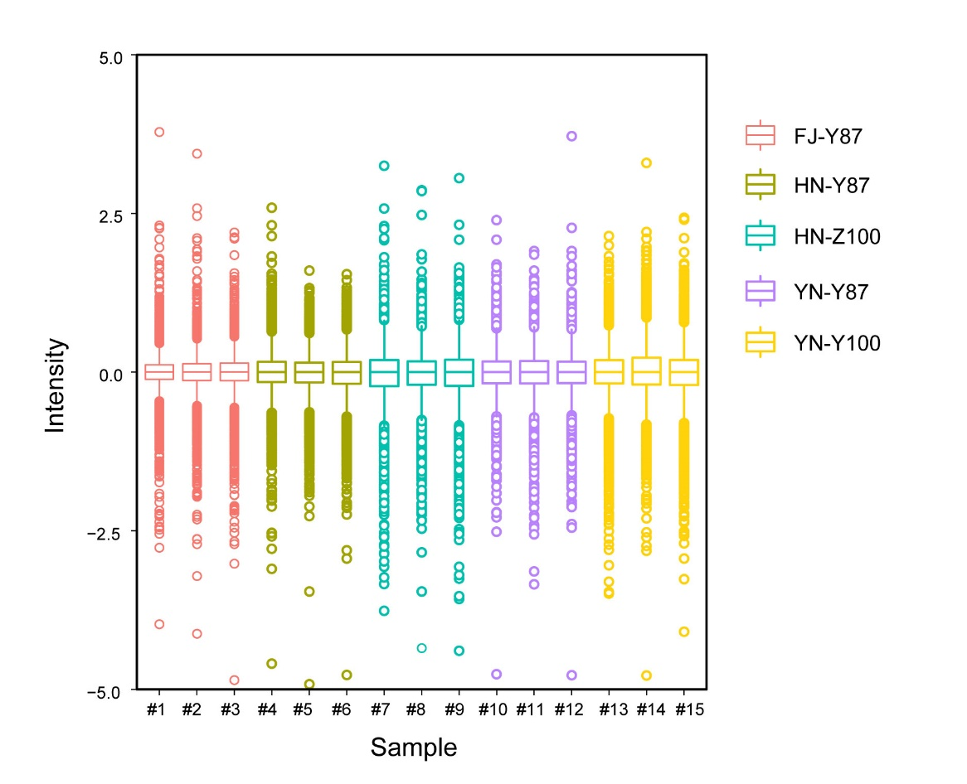
Figure S1 The box plot of protein intensity of five tobacco samples.
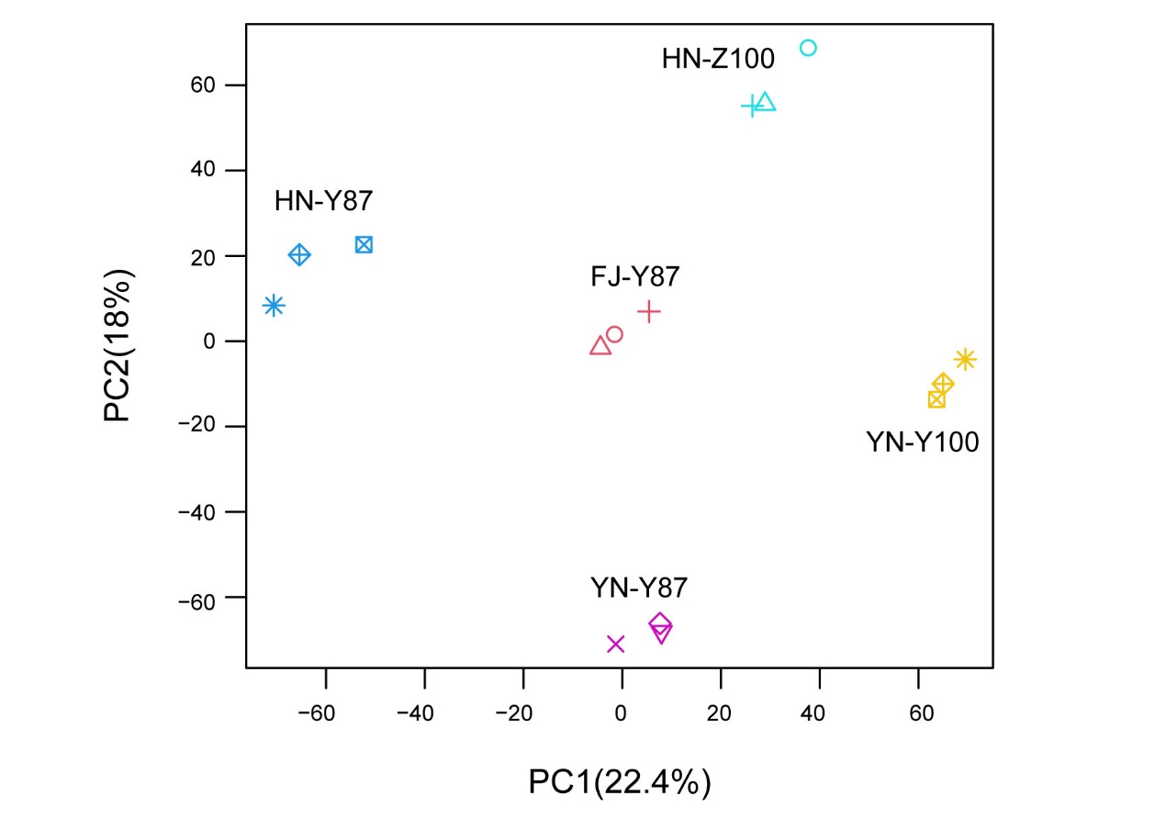
Figure S2 PCA score plots of five tobacco leave samples.

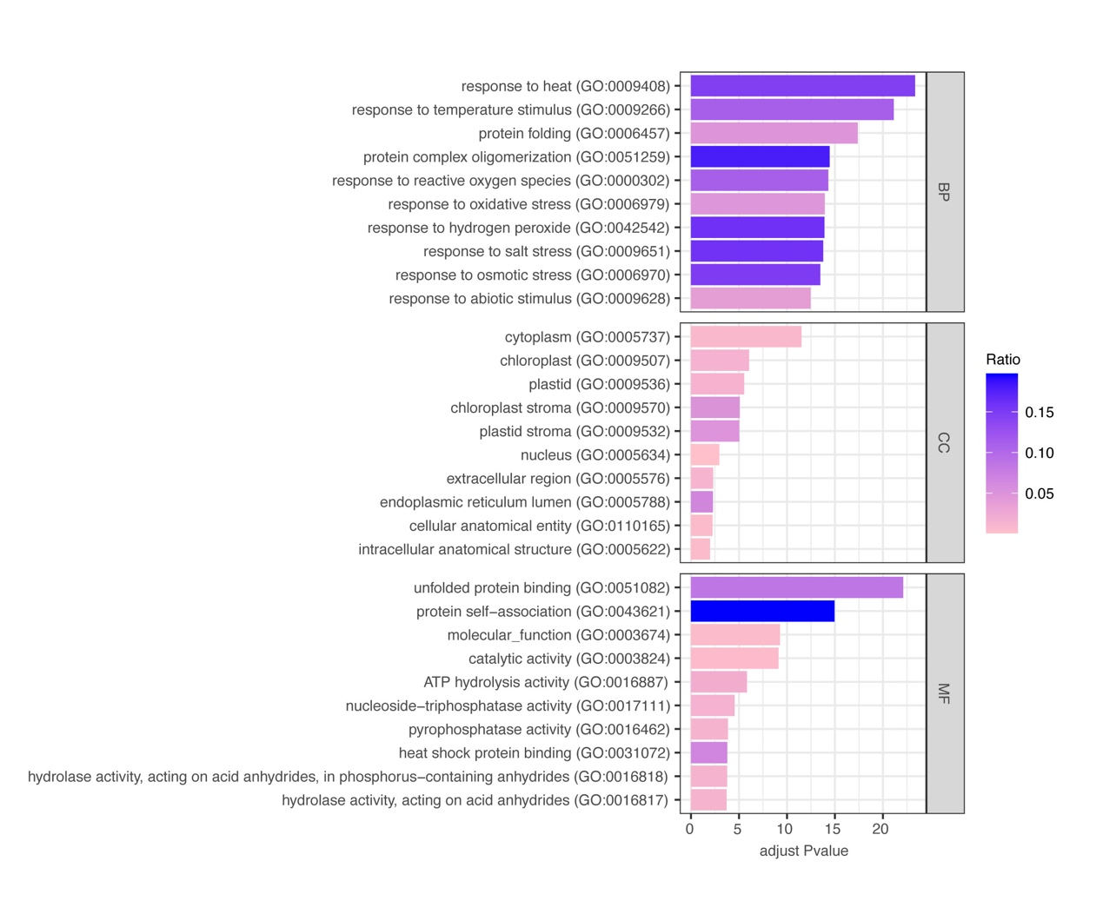
Figure S3 Go enrichment of all DAPs in terms of biological process, cellular component and molecular function.
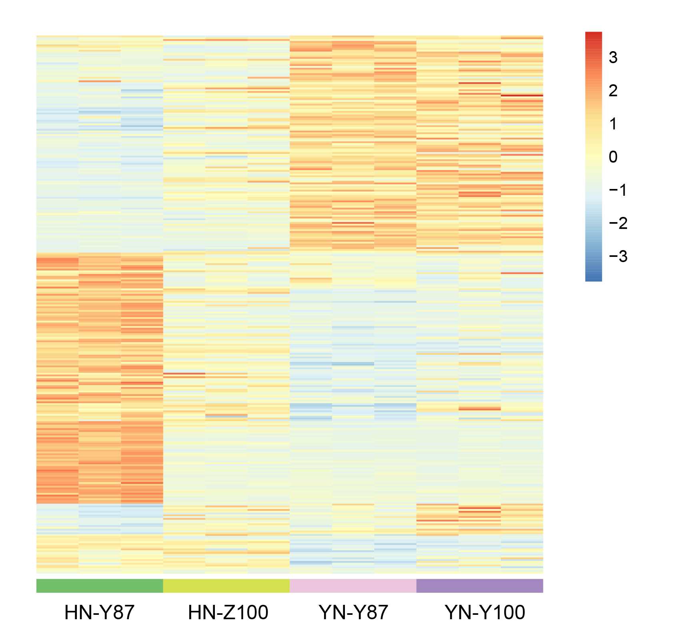
Figure S4 Expression of 214 DAPs related with environmental change in two cultivals from Yunnan and Henan region.
Table S1 Detailed information of samples collected from different geographical Origins.
Sample | Sampling date | Growing area | Sampling position
YN-Y87 | 21.8.19 | Qujing. Yunnan | Middle leaf（9-11）
YN-Y100 | 21.8.19 | Qujing, Yunnan | Middle leaf（9-11）
HN-Y87 | 21.7.20 | Nanyang, Henan | Middle leaf（9-11）
HN-Y100 | 21.8.16 | Linying, Henan | Middle leaf（9-11）
FJ-Y87 | 21.6.1 | Longyan, Fujian | Middle leaf（9-11）

Table S2 Number of up-regulated and down regulated protein in different comparison
Compared sample | Up regulated | Down regulated | Total DAPs
YN-Y87 vs HN-Y87 | 114 | 136 | 250
YN-Y87 vs FJ-Y87 | 53 | 31 | 84
FJ-Y87 vs HN-Y87 | 24 | 68 | 92
YN-Y100 vs YN-Y87 | 83 | 69 | 152
HN-Z100 vs HN-Y87 | 134 | 190 | 324

Table S2 list of candidate DAPs of tobacco leave in response to changing environments.
Protein ID | Protein name | Fold Change  (YN vs HN) | Fold Change (YN vs FJ) | Fold Change (FJ vs HN)
Starch and sucrose metabolism
A0A1S4B6F7 | UGP1 | 10.91 | 9.777 | 1.116
A0A1S4BNA9 | UGP1 | 2.415 | 2.250 | 1.075
A0A1S3ZPV3 | Sucrose synthase | 2.303 | 1.859 | 1.238
A0A1S3Z5I9 | Sucrose synthase | 2.376 | 2.224 | 1.068
Galactose metabolism
A0A1S4AK24 | ATP-dependent 6-phosphofructokinase | 2.455 | 1.781 | 1.379
Glycolysis / Gluconeogenesis
A0A1S3Y5S6 | pyruvate decarboxylase | 2.416 | 1.924 | 1.256
A0A1S3ZSC9 | pyruvate decarboxylase | 3.741 | 3.589 | 1.042
A0A1S3YSN4 | pyruvate decarboxylase | 3.363 | 2.471 | 1.36
A0A1S4A0T5 | Glucose-6-phosphate 1-epimerase | 2.125 | 1.824 | 1.165
A0A1S4DJ24 | Alcohol dehydrogenase 1 | 4.686 | 4.077 | 1.149
Q6IVK8 | Alcohol dehydrogenase | 5.542 | 3.724 | 1.488
A0A1S4D555 | Acetyl-CoA carboxytransferase | 0.480 | 0.769 | 0.625
A0A1S4AXH8 | PDH | 0.495 | 0.712 | 0.696
Amino acid metabolism
A0A1S4D3Y8 | Aspartate aminotransferase | 2.330 | 1.953 | 1.193
A0A1S4ASM7 | Aspartate aminotransferase | 2.012 | 1.925 | 1.045
A0A1S3YQG6 | Aspartate aminotransferase | 2.386 | 2.098 | 1.137
Protein processing in endoplasmic reticulum
A0A1S3ZBZ1 | 17.6 kDa class I heat shock protein 3-like | 0.119 | 0.515 | 0.232
A0A1S4BQU5 | class I heat shock protein-like | 0.138 | 0.788 | 0.175
A0A1S4BPP5 | 17.6 kDa class I heat shock protein-like | 0.167 | 0.528 | 0.316
E1AWP1 | 17.8 kDa class I heat shock protein-like | 0.167 | 0.864 | 0.194
A0A1S3ZYC0 | 22.0 kDa class IV heat shock protein-like | 0.187 | 0.894 | 0.209
A0A1S3ZRR0 | 22.0 kDa class IV heat shock protein-like | 0.190 | 0.969 | 0.198
Protein processing in endoplasmic reticulum& Endocytosis& Spliceosome
A0A1S3YV22 | stromal 70 kDa heat shock-related protein, chloroplastic-like | 0.232 | 0.581 | 0.400
A0A1S4D4H6 | heat shock 70 kDa protein-like | 0.236 | 0.713 | 0.330
A0A1S4AE85 | heat shock 70 kDa protein | 0.259 | 0.714 | 0.362
A0A1S4B2J0 | stromal 70 kDa heat shock-related protein, chloroplastic-like | 0.279 | 0.601 | 0.465
A0A1S3X8Z6 | heat shock cognate 70 kDa protein 2-like | 0.412 | 0.765 | 0.539
Phenylpropanoid biosynthesis
P45733 | Phenylalanine ammonia-lyase | 0.382 | 0.626 | 0.609
P25872 | Phenylalanine ammonia-lyase | 0.297 | 0.564 | 0.526
A0A1S4D6Z4 | Caffeoyl-CoA O-methyltransferase | 0.495 | 0.536 | 0.926
Porphyrin and chlorophyll metabolism
Q9FES7 | Mg-protoporphyrin IX chelatase | 0.461 | 0.806 | 0.572
A0A1S3YNG0 | Magnesium-protoporphyrin IX monomethyl ester (oxidative) cyclase | 0.481 | 1.029 | 0.467
Terpenoid backbone biosynthesis
A0A1S3X709 | geranylgeranyl pyrophosphate synthase, chloroplastic-like | 0.446 | 0.735 | 0.606
D3W9H9 | Geranylgeranyl diphosphate synthase | 0.295 | 0.875 | 0.337

