Fig.1

FPN1
GPX4
FTL
TFR1

Fig.2

GPX4
FPN1
FTL
TFR1

Fig.3

FPN1
TFR1
FTL
GPX4

Fig.4
TREM1
GPX4
FPN1
TREM1

TFR1
FTL

Fig.5

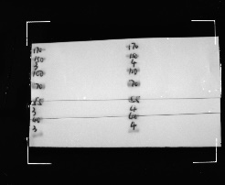
BIP
P-PERK
ATF6
P-IRE

CHOP
ATF4
P-eIF2αα

Fig.6

TREM1
TREM1

Fig.7

GPX4
TFR1
FPN1

Fig.S1
GPX4
FPN1
FTL
TFR1

Fig.S2

TREM1
FTL
FPN1
TREM1

GPX4
TFR1

