Figure S1 Unweighted PH assumption for RATIONALE 302, tislelizumab relative to the chemotherapy group
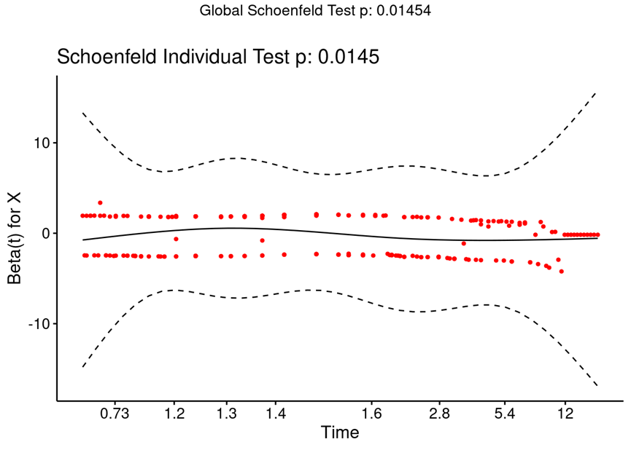

Figure S2 Weighted PH assumption for RATIONALE 302, tislelizumab relative to the chemotherapy group
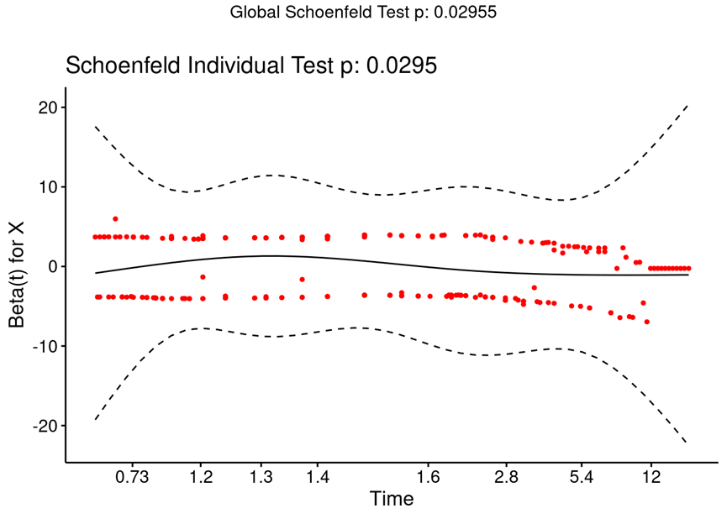

Table S1 Statistical testing of tislelizumab/camrelizumab monotherapy OS and PFS
Statistical testing | Weibull | gamma | exponential | log-logistic | log-normal | Gompertz
OS data of tislelizumab monotherapy
AIC | 539.7 | 539.5 | 538.6 | 542.3 | 542.5 | 539.8
BIC | 545.8 | 545.6 | 541.6 | 548.4 | 548.6 | 545.9
Parameter | shape=1.1002  scale=14.1609 | shape=1.1670  rate=0.0849 | rate=0.0713 | shape=1.4638  scale=9.2488 | meanlog=2.1832  sdlog=1.1903 | shape=0.0146  rate=0.0623
PFS data of tislelizumab monotherapy
AIC | 394.0 | 396.1 | 394.5 | 373.4 | 370.9 | 384.9
BIC | 400.1 | 402.2 | 397.5 | 379.5 | 377.0 | 391.0
Parameter | shape=0.8755  scale=5.1761 | shape=0.9153  rate=0.1677 | rate=0.1853 | shape=1.4948  scale=2.6255 | meanlog=1.0745  sdlog=1.1338 | shape=-0.0901  rate=0.2767
OS data of camrelizumab monotherapy
AIC | 1182.0 | 1177.9 | 1191.1 | 1169.5 | 1168.2 | 1191.6
BIC | 1188.9 | 1184.7 | 1194.5 | 1176.3 | 1175.1 | 1198.5
Parameter | shape=1.2512  scale=11.8067 | shape=1.4929  rate=0.1350 | rate=0.0840 | shape=1.7145  scale=8.0690 | meanlog=2.0846  sdlog=1.0030 | shape=0.0189  rate=0.0743
PFS data of camrelizumab monotherapy
AIC | 950.3 | 942.8 | 950.7 | 891.3 | 894.8 | 947.6
BIC | 957.1 | 949.7 | 954.1 | 898.2 | 901.6 | 954.5
Parameter | shape=1.0877  scale=4.6829 | shape=1.3423  rate=0.3010 | rate=0.2180 | shape=1.9470  scale=2.7334 | meanlog=1.0795  sdlog=0.9120 | shape=-0.0441  rate=0.2563

