Bile acid derivatives from gut microbiota promote GBPs-mediated activation of caspase-4/11 by LPS through lncRNA57RIK
Yunhuan Gao^{1,2,3}, Jianmei Yue^{1,2,3}, Fushuang Ha⁴, Ya Wang³, Rong Wang³, Xiaorong Yang³, Junqi Zhang⁵, Xinqi Liu⁵, Yuan Zhang³, Tao Han⁶ and Rongcun Yang ^{1,2,3*}

Supplementary Figures

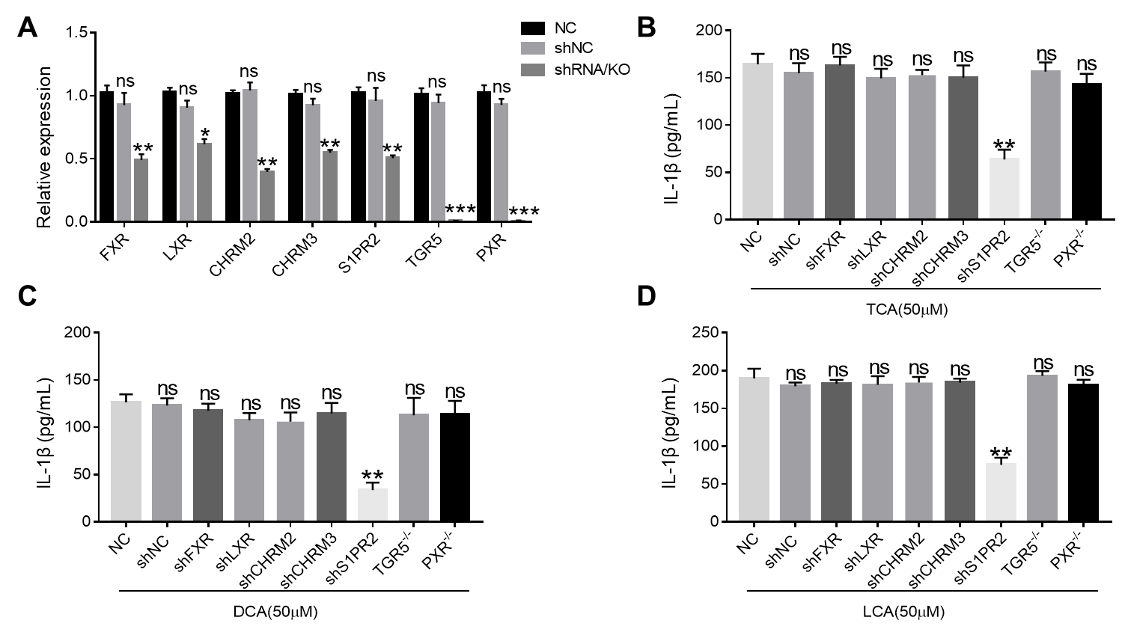
Fig. S1 S1PR2 is involved in BAs mediated production of mIL-1β. A qRT-PCR of FXR, LXR, CHRM2, CHRM3, S1PR2 TGR5 and PXR in the macrophages after silencing FXR, LXR, CHRM2, CHRM3 and S1PR2 by siRNA or knocking out TGR5 and PXR respectively. B ELISA of IL-1β in the supernatant of the macrophages after silencing FXR, LXR, CHRM2, CHRM3 or S1PR2 by siRNA or knocking out TGR5 and PXR respectively after exposure to TCA. C ELISA of IL-1β in the supernatant of the macrophages after silencing FXR, LXR, CHRM2, CHRM3 or S1PR2 by siRNA or knocking out TGR5 and PXR after exposure to DCA. D ELISA of IL-1β in the supernatant of the macrophages after silencing FXR, LXR, CHRM2, CHRM3 or S1PR2 by siRNA or knocking out TGR5 and PXR after exposure to LCA. The macrophages in B, C and D were pretreated with TCA, DCA or LCA respectively and stimulated by caspase 4 ligands (LPS with Dotap). ONE-way ANOVA Bonferroni’s Multiple Comparison Tests. *P < 0.05, **P < 0.01, ***P < 0.001, NS, not significant.
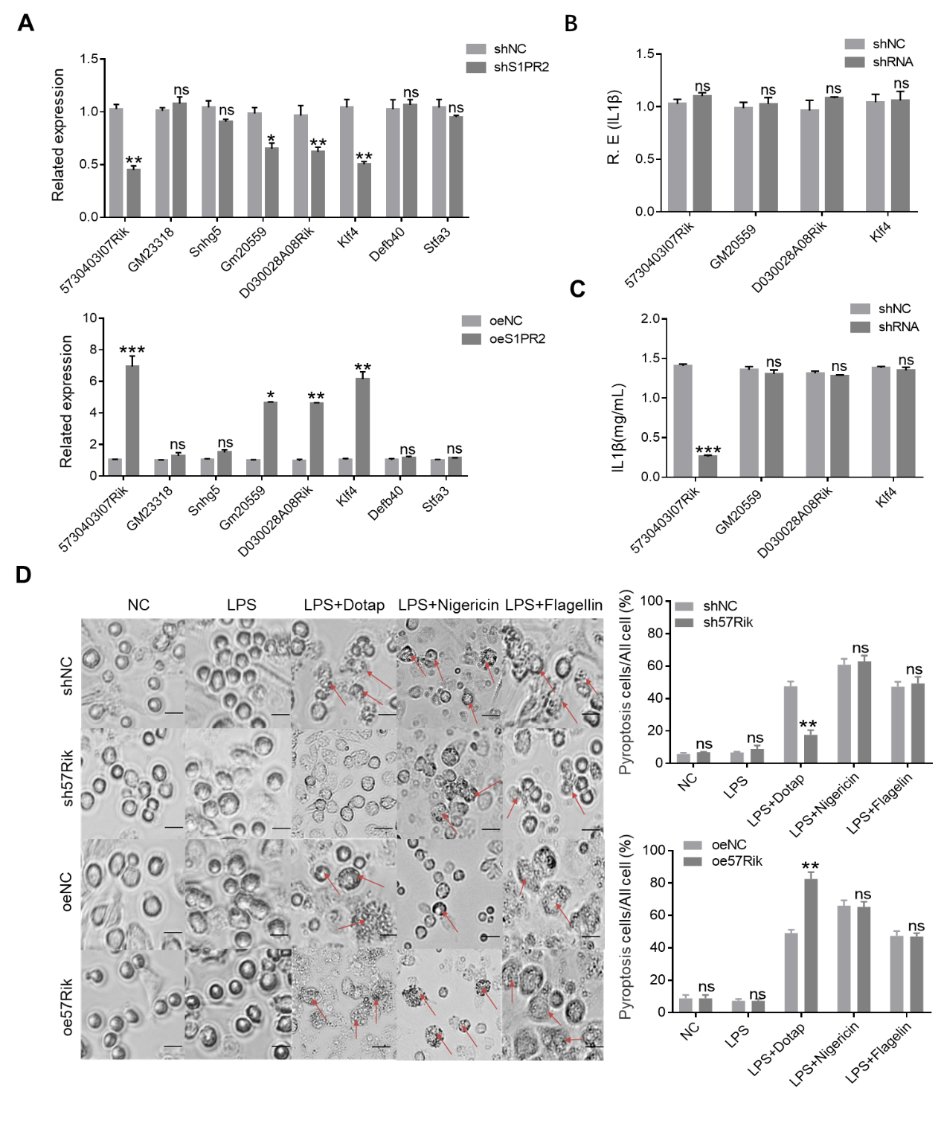 Fig. S2 LncRNA57RIK is involved in BAs mediated production of mIL-1β. A qRT-PCR of the genes in the macrophages of wt mice, S1PR2 shRNA or exogenous S1PR2 transfected macrophages after exposure to DCA. B qRT-PCR of IL-1β in the macrophages after siRNA silencing S1PR2 relative genes. C ELISA of IL-1β in the supernatants of the macrophages after silencing S1PR2 relative genes. The treated macrophages were pretreated with LPS+DCA and stimulated by caspase 4 ligands (LPS with Dotap). D Pyroptotic cells and statistics of the lncRNA57RIK shRNA (sh57Rik) and exogenous lncRNA57RIK (oe57Rik) transfected macrophages under light microscopy after stimulated by LPS plus nigericin, LPS plus flagellin and LPS with Dotap. Scale bar, 5 μM. The arrows indicate pyroptotic cells. Student’s t-tests. *P < 0.05, **P < 0.01, ***P < 0.001, NS, not significant.
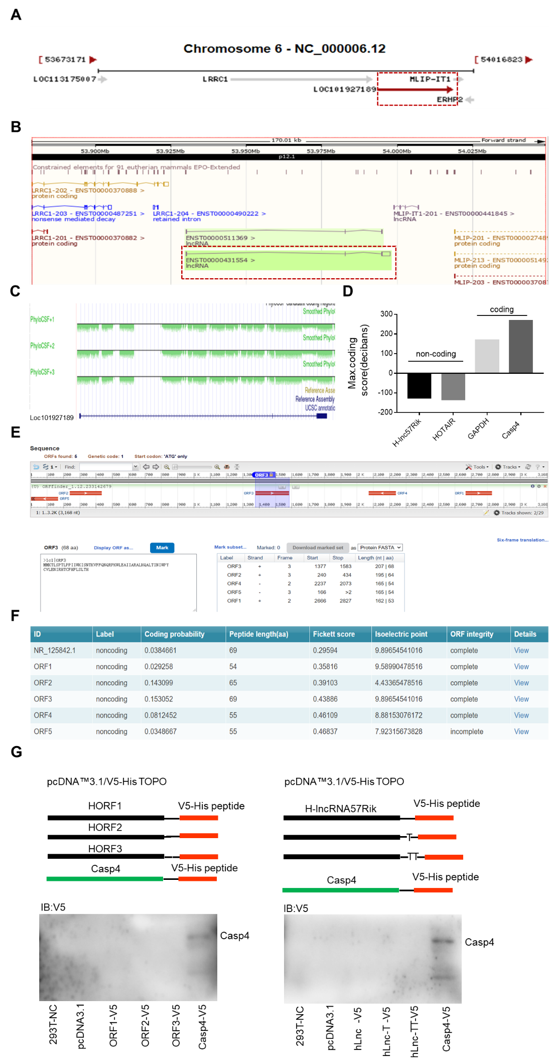
Fig. S3 Characterization of lncRNA57RIK. A, B The location of lncRNA57 in chromosome. The NCBI database(https://www.ncbi.nlm.nih.gov/) and UCSC database(https://genome.ucsc.edu/) shows the chromosomal location of HulncRNA57RIK. C, D Coding potency of HulncRNA57RIK sequence was analyzed using PhyloCSF. Hotair, a control non-coding gene. GAPDH and caspase4, control coding genes. Scores above 0 suggested there had a coding potential, whereas scores below 0 represented no coding potential. E Open reading frame on hulncRNA57RIK by ORFfinder (https://www.ncbi.nlm.nih.gov/orffinder/). F Encoding capability of hulncRNA57RIK and open reading frame by CPC2 (Coding Potential Calculator2, http://cpc2.gao-lab.org/). G Immunoblotting of V5-tagged HulncRNA57RIK ORF transfected HEK293T cells. Different fragments of hulncRNA57RIK were cloned into pCDNA 3.1 plasmids and then transfected HEK293T cells. Immunoblotting was detected via anti-V5 antibody.

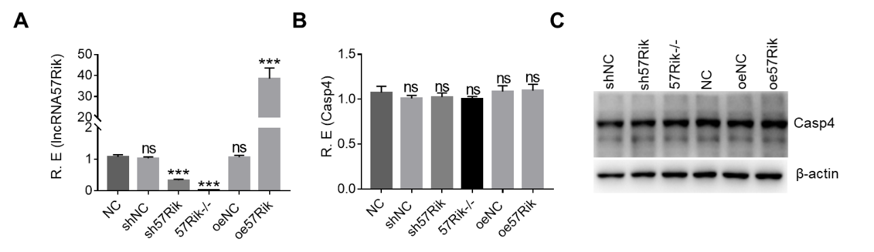

Fig. S4 LncRNA57RIK does not affect the levels of caspase 4 mRNA and protein. A qRT-PCR of lncRNA57 in lncRNA57 shRNA or exogenous lncRNA57 transfected macrophages or lncRNA57 KO macrophages. B QRT-PCR of caspase 4 in lncRNA57 shRNA or exogenous lncRNA57 transfected macrophages or lncRNA57 KO macrophages. C Immunoblotting of caspase 4 in lncRNA57 shRNA or exogenous lncRNA57 transfected macrophages or lncRNA57 KO macrophages. shNC, shRNA control; sh57Rik, lncRNA57RIK shRNA; oeNC, exogenous lncRNA57RIK control; oe57Rik, exogenous lncRNA57RIK; 57Rik-/-, lncRNA57RIK knockout. ONE-way ANOVA Bonferroni’s Multiple Comparison Tests. ***P < 0.001, NS, not significant.
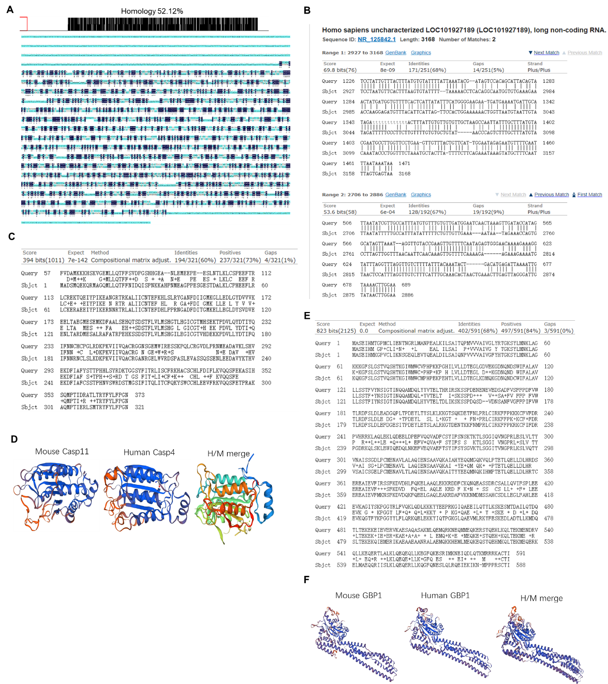

Fig. S5 Higher conservation in lncRNA57Rik, caspase 4 and GBP1 between human and mice. A, B Comparison of lncRNA57Rik nucleic acid sequences in mice and humans use DNAMAN software(A) and NCBI database(https://blast.ncbi.nlm.nih.gov/Blast.cgi)(b). C Comparison of caspase4/11 nucleic acid sequences in mice and humans use NCBI database(https://blast.ncbi. nlm.nih.gov/Blast.cgi). D Crystal structure of mouse and human caspase 4/11 in the auto-inhibited conformation. We used SWISS-MODEL software to model the protein crystal structure of human caspase4/11 and compare the homology (https://swissmodel.expasy.org). E Comparison of GBP1 nucleic acid sequences in mice and humans use NCBI database (https://blast.ncbi.nlm. nih.gov/Blast.cgi). F Crystal structure of mouse and human GBP1 in the auto-inhibited conformation. We used SWISS-MODEL software to model the protein crystal structure of human GBP1 and compare the homology (https://swissmodel.expasy.org). H/M, human/mice.

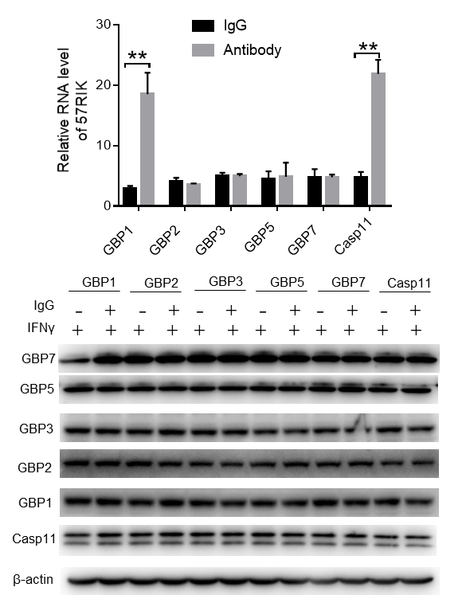
Fig. S6 MlncRNA57RIK potentially binding with GBP1. RIP in the BMDMs after exposed to LPS/Dotap. Cell lysates were incubated with normal rabbit IgG and GBP-1/2/3/5/7 antibodies respectively. The immunoprecipitates were analyzed by QRT-PCR to exam enrichment efﬁciency of mlncRNA57RIK. Student’s t-test; **P < 0.01.

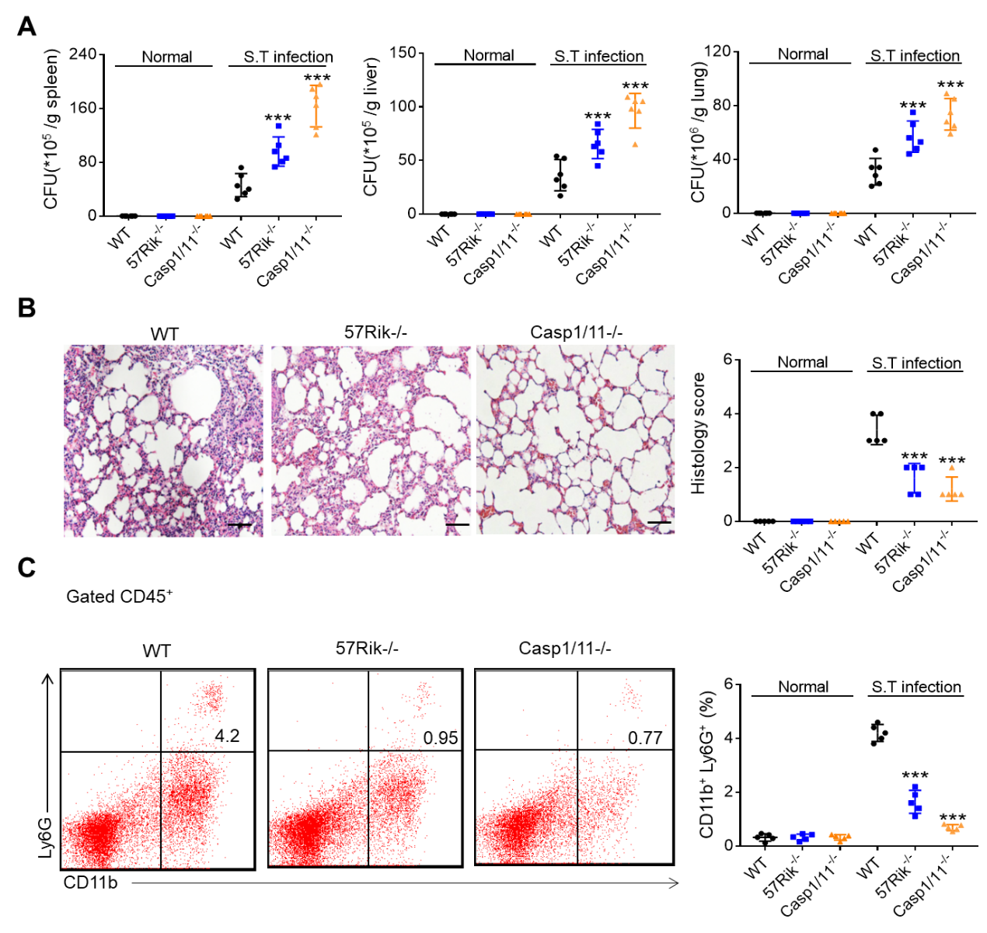
Fig. S7 There are stronger inflammatory responses in WT mice than lncRNA57RIK KO or caspase 1/11 KO mice after S.T infection. A CFUs of S. T bacteria in the spleen, liver and lung of wt, lncRNA57RIK-/- and caspase-1/11-/- mice after S. T infection. Mice were from Fig. 7J. B H&E staining and histological score of lung sections from the mice. C Flow cytometry of neutrophils (CD11b⁺Ly6G⁺) from the intestinal lamina propria of mice in the Fig. 7J. ONE-way ANOVA Bonferroni’s Multiple Comparison Tests. ***P < 0.001.

Table S1．Reagents and oligoes used in this study.
REAGENT or RESOURCE | SOURCE | IDENTIFIER
Antibodies
β-Actin Antibody | Santa Cruz | Cat:sc-47778 RRID: AB_626632
Anti-Caspase 4 Antibody | Thermo Fisher Scientific | Cat: PA5-21286 RRID: AB_11153341
Anti-caspase-4 (4B9) Antibody | Santa Cruz Biotechnology | Cat: sc-56056, RRID: AB_781828
V5 Tag Monoclonal Antibody | Thermo Fisher Scientific | Cat:MA5-15253 RRID: AB_10977225
Anti-Caspase11 antibody | Cell Signaling Technology | Cat: 14340 RRID: AB_2728693
Anti-GBP1 antibody | Thermo Fisher Scientific | Cat: PA5-75381, RRID: AB_2719109
Anti-GBP2 antibody | Novus | Cat: NBP1-47774, RRID: AB_10010744
GBP3 Antibody | Affinity Biosciences | Cat: DF4114 RRID: AB_2836479
GBP5 Polyclonal antibody | Proteintech | Cat: 13220-1-AP RRID: AB_2109348
GBP7 Polyclonal Antibody | Thermo Fisher Scientific | Cat: PA5-24834 RRID: AB_2542334
Anti -IL1β antibody | Proteintech | Cat: 16806-1-AP RRID: AB_10646432
Anti-Histone H3 (tri methyl K4) antibody | Abcam | Cat: ab8580 RRID: AB_306649
Anti- Cleaved Caspase-1 antibody | Cell Signaling Technology | Cat：67314 RRID: AB_2714037
F4/80 (6A545) antibody | Santa Cruz | Cat:sc-71085 RRID: AB_1122717
APC-CD45 30-F11 | Biolegend | Cat:103112 RRID: AB_312977
FITC-CD11b M1/70 | eBioscience | Cat:11-0112-86 RRID: AB_464937
PE-Ly6G 1A8 | Biolegend | Cat: 127607 RRID: AB_1186104
Bacterial and Virus Strains
BL21 Chemically Competent cell | TransGen Biotech | Cat:CD901-01
DH5αChemically Competent cell | Tiangen Biotech | Cat:CD101-03
S. Typhimurium | ATCC | Cat: 14028
Chemicals, Peptides, and Recombinant Proteins
Recombinant Murine GM-CSF | PeproTech | Cat:315-03
Recombinant Murine M-CSF | PeproTech | Cat:315-02
Recombinant Human M-CSF | PeproTech | Cat: 300-25
Recombinant Human IFN-γ | PeproTech | Cat: 300-02
Recombinant Murine IFN-γ | PeproTech | Cat: 315-05
HiPerFect Transfection Reagent | QIAGEN | Cat:301705
Advanced DNA RNA Transfection Reagent | ZETA LIFE | Cat: AD600100
Chenodeoxycholic Acid (CDCA) | MCE | Cat: HY-76847
Taurocholic acid (TCA) | MCE | Cat: HY-B1788
Deoxycholic acid (DCA) | Selleck | Cat: S4689
Lithocholic acid (LCA) | MCE | Cat: HY-B0172
DOTAP chloride | Selleck | Cat: S6908
LPS (0111:B4) | Sigma | Cat: L2630
Nigericin | MedChemExpress | Cat: 28380-24-7
Flagellin | AdipoGen Life Sciences | Cat: AG-40B-0095
Phorbol 12-myristate 13-acetate (PMA) | selleck | Cat: S7791
Polybrene | Millipore | Cat:sc-134220
Lipofectamine™ 3000 Transfection Reagent | Thermo Fisher Scientific | Cat:11668027
Trizol | Life technologies | Cat:15596018
FXR antagonist 1 | MCE | Cat: HY-151481
TEI-9648(VDR inhibitor) | MCE | Cat: HY-12398A
RORγt/DHODH-IN-3(RORγt inhibitor) | MCE | Cat: HY-142847
Larsucosterol (LXR inhibitor) | MCE | Cat: HY-139576
Resveratrol (PXR inhibitor) | MCE | Cat: HY-16561
SBI-115(TGR5 inhibitor) | MCE | Cat: HY-111534
CINPA1(CAR inhibitor) | MCE | Cat: HY-110249
JET-013(S1PR2 inhibitor) | Selleck | Cat: S7182
MRGPRX4 modulator-1(MRGPRX4 inhibitor) | MCE | Cat: HY-14599
Experimental Models: Cell Lines
HEK 293T | ATCC | N/A
THP-1 | ATCC | N/A
U937 | ATCC | N/A
Oligonucleotides for clone genes
Murine lncRNA57Rik FW | BGI | 5’-GTGACACAGGAGATCCCCAGA -3’
Murine lncRNA57Rik REV | BGI | 5’-TCTGTTTCATTTATATTTATTGT-3’
Human ORF1 FW | BGI | 5’- ATGATGAAAACATTGTCTCCT -3’
Human ORF1 REV | BGI | 5’- TCAGTGAGTCAGGCTCAGAAA -3’
Human ORF2 FW | BGI | 5’- ATGTCGACTCCCTCCCCAAC -3’
Human ORF2 REV | BGI | 5’- TCACACCATTGCACTCCAGC -3’
Human ORF3 FW | BGI | 5’- ATGCTTTTTACTCAGCTATG -3’
Human ORF3 REV | BGI | 5’- CTAAATGGAGTTACATTTTC -3’
Human lncRNA57Rik FW | BGI | 5’- TTGCTCTTGGTTTTAATCCTT -3’
Human lncRNA57Rik REV | BGI | 5’-TTACTCACTAAATTGAAAGCAT-3’
Murine Caspase 11 FW | BGI | 5’- ATGGCTGAAAACAAACACCC -3’
Murine Caspase 11 REV | BGI | 5’- GTTGCCAGGAAAGAGGTAGA-3’
Human Caspase 4 FW | BGI | 5’- ATGGCAGACTCTATGCAAGA-3’
Human Caspase 4 REV | BGI | 5’- ATTGCCAGGAAAGAGGTAGAA-3’
Murine GBP1 FW | BGI | 5’- ATGGCCTCAGAAATCCACAT-3’
Murine GBP1 REV | BGI | 5’- AAGTATGGTGCATGATCGAG-3’
Human GBP1 FW | BGI | 5’- ATGGCATCAGAGATCCACAT-3’
Human GBP1 REV | BGI | 5’- GCTTATGGTACATGCCTTTC-3’
Human Caspase 4(CARD) FW | BGI | 5’- ATGGCAGACTCTATGCAAGA -3’
Human Caspase 4(CARD) REV | BGI | 5’- GCGTGTGCGGTTGTTTCTCT -3’
Human Caspase 4(LS) FW | BGI | 5’-ATGCTGGCTCTCATCATATGCA-3’
Human Caspase 4(LS) REV | BGI | 5’- GAGTTGTGTGATGAAGATAG -3’
Human Caspase 4(SS) FW | BGI | 5’- ATGATCACATGCTTCCAGAAATA -3’
Human Caspase 4(SS) REV | BGI | 5’- ATTGCCAGGAAAGAGGTAGAA -3’
Murine Caspase11 (CARD) FW | BGI | 5’- ATGGCTGAAAACAAACACCC -3’
Murine Caspase11 (CARD) REV | BGI | 5’- GTCCACACTGAAGAATGTCT -3’
Murine Caspase11(LS) FW | BGI | 5’-ATGCCAGGCAGCCACCATGGT-3’
Murine Caspase11(LS) REV | BGI | 5’- CTCTCTGATCCACATTTCTC-3’
Murine Caspase11(SS) FW | BGI | 5’-ATGTCTTCAAAACCCCAGTTG-3’
Murine Caspase11(SS) REV | BGI | 5’- GTTGCCAGGAAAGAGGTAGA-3’
Human GBP1(GTPase) FW | BGI | 5’- ATGGCATCAGAGATCCACAT-3’
Human GBP1(GTPase) REV | BGI | 5’- GCACGGCAGATCCCCACTGC-3’
Human GBP1(ΔGTPase) FW | BGI | 5’- ATGGAGAACGCAGTCCTGGC-3’
Human GBP1(ΔGTPase) REV | BGI | 5’- GCTTATGGTACATGCCTTTC-3’
Human GBP1 (ΔCaax) FW | BGI | 5’- ATGGCATCAGAGATCCACAT-3’
Human GBP1(ΔCaax) REV | BGI | 5’- ACATGCCTTTCGTCGTCTCA-3’
Human S1PR2 FW | BGI | 5’-ATGGGCAGCTTGTACTCGGAG-3’
Human S1PR2 REV | BGI | 5’- GACCACCGTGTTGCCCTCCAGA-3’
Murine GBP1(GTPase) FW | BGI | 5’- ATGGCCTCAGAAATCCACAT -3’
Murine GBP1(GTPase) REV | BGI | 5’- GGGTAGTTCTCCACTGCAGAT -3’
Murine GBP1(ΔGTPase) FW | BGI | 5’- ATGTGTATGGAGAACGCAGTC -3’
Murine GBP1(ΔGTPase) REV | BGI | 5’- AAGTATGGTGCATGATCGAG -3’
Oligonucleotides for qRT-PCR
Murine GAPDH FW | BGI | 5’-TCAACGGCACAGTCAAGG-3’
Murine GAPDH REV | BGI | 5’-TACTCAGCACCGGCCTCA-3’
Murine lncRNA57Rik FW | BGI | 5’- ATGTCTTTCCCCACCCTTCT -3’
Murine lncRNA57Rik REV | BGI | 5’- ACCTTTCTTTTGTTCCCACT -3’
Murine Caspase11 FW | BGI | 5’- GAGAAATGTGGATCAGAGAG-3’
Murine Caspase11 REV | BGI | 5’- GATGTGGGGTTGTAGAGTAG-3’
Murine IL1β FW | BGI | 5’-TCGCAGCAGCACATCAACAAG-3’
Murine IL1β REV | BGI | 5’-GAAGGTCCACGGGAAAGACAC-3’
Murine GBP1 FW | BGI | 5’- ATAGGAACCATCAACCAGCA-3’
Murine GBP1 REV | BGI | 5’- ATCCCTCAGAGTCCACACAA-3’
Human GAPDH FW | BGI | 5’- TCAAGAAGGTGGTGAAGCAGG-3’
Human GAPDH REV | BGI | 5’- AGCGTCAAAGGTGGAGGAGTG-3’
Human lncRNA57Rik FW | BGI | 5’- GCCTGTCTTCGTCTTGATGC -3’
Human lncRNA57Rik REV | BGI | 5’- TACTGGGAGGTGGAGGTTGC -3’
Human Caspase4 FW | BGI | 5’- AGAGGTGCAAACCGTGGGGAA -3’
Human Caspase4 REV | BGI | 5’- CGTTGTGTGGCGTTGAAGAGC -3’
Human IL1β FW | BGI | 5’- GGCAATGAGGATGACTTGTTC-3’
Human IL1β REV | BGI | 5’- TGCTGTAGTGGTGGTCGGAGA-3’
Human GBP1 FW | BGI | 5’- TCTGGATGTGGTGTGTGCCC -3’
Human GBP1 REV | BGI | 5’- AGCCTGCTGGTTGATGGTTC -3’
Human FXR FW | BGI | 5’- GCTGTGTGTTGTTTGTGGAG -3’
Human FXR REV | BGI | 5’- GCGTTTTTGGTAATGCTTCT -3’
Human VDR FW | BGI | 5’- CATCCCATTGCCCTGGTTATAT -3’
Human VDR REV | BGI | 5’- TGTTTTTGTCTGTTTTTCCTCC -3’
Human RORg FW | BGI | 5’- GCAGCAACAGGAACCAGTGG -3’
Human RORg REV | BGI | 5’- CAGGCAGGTCAGGCGAGGAG -3’
Human CAR FW | BGI | 5’- AATACCACTTTCTGTCTCCAAA -3’
Human CAR REV | BGI | 5’- AGCTGATCAATCTCATCTCTCT -3’
Human MRGPRX4 FW | BGI | 5’- GCCAACCCCATCATTTACTT -3’
Human MRGPRX4 REV | BGI | 5’- CCCTTCACCTTTATCCACCT-3’
Human S1PR2 FW | BGI | 5’- TGCCTGTCCCGTCCACTCCT -3’
Human S1PR2 REV | BGI | 5’- TCCGTCCTTGCACCCCCACC -3’
Human LXRa FW | BGI | 5’-TCTGGAGACATCTCGGAGGT-3’
Human LXRa REV | BGI | 5’-GATAGCAATGAGCAAGGCAA-3’
Human CHRM2 FW | BGI | 5’-TCCATTAAAGTCAACCGCCA-3’
Human CHRM2 REV | BGI | 5’-TCACACACCACAGGTCCCAA-3’
Human CHRM3 FW | BGI | 5’- CTAGAGTCAGCCGTGGACAC -3’
Human CHRM3 REV | BGI | 5’- TGATGAAGGCAAGCAAGATC-3’
GM23318 FW | BGI | 5’- TCGCTTCGGTAGCAAATATACT -3’
GM23318 REV | BGI | 5’- TTATTTAGTCCCCCCTCCCAG -3’
Snhg5 FW | BGI | 5’- TTACGACGGAGCCTAAGATAT -3’
Snhg5 REV | BGI | 5’- TTAGTACGAATCTCACTGGGGC -3’
GM20559 FW | BGI | 5’- CTATGGCCTATCAAGTCAATAT -3’
GM20559 REV | BGI | 5’- TAATTCGATAGACCTGTACTT -3’
D030028A08Rik FW | BGI | 5’- GTATGGCTGTGAAGTGGC -3’
D030028A08Rik REV | BGI | 5’- AGTTGTCCTGGGTAAAGG -3’
Klf4 FW | BGI | 5’- CACCTCCCACGGCCCCCTTCA -3’
Klf4 REV | BGI | 5’- TCAGAGACGCCTTCAGCACAA -3’
Defb40 FW | BGI | 5’- TCCTGCTTTCTACTGATGATCT -3’
Defb40 REV | BGI | 5’- TTTCTGAATGTGACAGTTGTTG -3’
Stfa3 FW | BGI | 5’- AGATAGATGTAGGGAATGGTT -3’
Stfa3 REV | BGI | 5’- AGTCTTGGTTTTGTTAGTCTG -3’
Oligonucleotides used in Northern blot
T7- Human lncRNA57Rik -F | BGI | 5’- CAAGACTGAGGTGACTCTGAG-3’
T7- Human lncRNA57Rik -R | BGI | 5’-TAATACGACTCACTATAGGGCAGCACACAAAACAAGAAGGGAAAA -3’
T7-U6 RNA-F | BGI | 5’-GTGCTCGCTTCGGCAGCACATATAC-3’
T7-U6 RNA-R | BGI | 5’-TAATACGACTCACTATAGGGAAAAATATGGAACGCTTCACGAATT-3’
Probes used in the RNA-FISH
Murine lncRNA57Rik -FAM | BGI | 5’-FAM-AATACCTTTCTTTTGTTCCCACTCT -3’
Human lncRNA57Rik -FAM | BGI | 5’-FAM-CAGATAATAGGAGGCAGTGTAGGAG -3’
NC-FAM | BGI | 5’-FAM-CGGGAGCCTAGGAAGTGCATCTTTC-3’
crRNAs used in this study
Caspase 4 | BGI | 5’-AGGGATTCCAACACCTTAAG-3’
GBP1 | BGI | 5’-GAACACTAATGGGCGACTGA -3’
shRNAs used in this study
Murine lncRNA57Rik | Ribobio | 5’-CCAGTCAGTGAAGCCTGCAATCACA-3’
Human lncRNA57Rik | Ribobio | 5’-CAGGAGCGTTGCCATTGATGGCTAT-3’
Human FXR | Ribobio | 5’-GACAGAGCCTCTGGATACCACTATA-3’
Human VDR | Ribobio | 5’- CCACTGGCTTTCACTTCAATGCTAT -3’
Human CAR | Ribobio | 5’-GACCAAGCCACAGGCTACCACTTTA -3’
Human S1PR2 | Ribobio | 5’-TGGCCATTGCCAAGGTCAAGCTGTA-3’
Human RORg | Ribobio | 5’-CCAGCATGTGGAAAGGCTGCAGATC-3’
Human LXRa | Ribobio | 5’-GGGCCATGAATGAGCTGCAACTCAA-3’
Human CHRM2 | Ribobio | 5’-CCTCAGTTATGAATCTGCTCATCAT-3’
Human CHRM3 | Ribobio | 5’-CCCGTGTGCTATGCTCTGTGCAACA-3’
Human MRGPRX4 | Ribobio | 5’-CCCTTCGGCATTCTGGGGGCCCTAA-3’
Murine GBP1 | Ribobio | 5’-ACTGGACATCCTGTCTGCTATCCAA -3’
Gm20559 | Ribobio | 5’-CCCATCTTTGCATACACCAATGTTT -3’
D030028A08Rik | Ribobio | 5’-GGGAATGGAGCAGTTTGACTCCCAT -3’
Klf4 | Ribobio | 5’-AGCAGCCCTTCGGTCATCAGTGTTA-3’
Oligonucleotides used in CHIP-PCR
P1 FW | BGI | 5’-CATAGCAAGAAACCAGGCTTGT-3’
P1 REV | BGI | 5’-GGCAAGCTACTTTTTTAAAGCA-3’
P2 FW | BGI | 5’-GAGTGTCTGGCGTTCATGTTCC-3’
P2 REV | BGI | 5’-AGAACATTCAATGCCCAGACAA-3’
Other
Ampicillin | Sigma | Cat: BP021
Vancomycine | Sigma | Cat: V2002
Neomycin sulfate | Sigma | Cat: N6386
Metronidazole | Sigma | Cat: M3761
DMEM | Gibco | Cat:11965118
FBS | Gibco | Cat:10099141
HBSS | Gibco | Cat:14170161
Percoll | Solarbio | Cat: P8370
pcDNA™3.1/V5-His TOPO® TA  Expression Kit | Invitrogen | Cat: K4800-40
Pierce™ Magnetic RNA-Protein  Pull-Down Kit | Thermo Fisher Scientific | Cat:20164
DIG Northern Starter Kit | Roche | Cat:12039672910
Pierce™ Protein G Agarose | Thermo Fisher Scientific | Cat: 20397
LDH Assay Kit | Abcam | Cat: ab102526

Table S2. The predicting protein that bind with the hu/mlncRNA57RIK conservative sequence.
Protein | Bioinformatic software programs | Predicted results
Caspase11 | catRAPID，RPISeq，RNAInter | +++
Caspase4 | catRAPID，RPISeq，RNAInter | +++
Hu-GBP1 | catRAPID，RPISeq， | ++
M-GBP1 | catRAPID，RNAInter | ++
+, indicates a potential binding of protein with lncRNA.

Table S3. The predicting protein binding sites in the hu/mlncRNA57RIK conservative sequence.
Bioinformatic software | Number of caspase4  binding sites | Position | Matrix sequence
catRAPID | Three binding sites | 2732bp-2746bp  2826bp-2837bp  2851bp-2870bp | CTGTTGTTGAAAAAT  AGGTTGTCTTTC  AACTGAAACTTGAGTTAGGG
RPISeq | Three binding sites | 2717bp-2729bp  2812bp-2827bp  2846bp-2858bp | GCCATTTATATTT  ATGTAACTCCATTTAG  ACACTAACTGAAA
RNAInter | Two binding sites | 2780bp-2793bp  2857bp-2871bp | TCAACAAAGTTGTT  AACTTGAGTTAGGGA
Bioinformatic software | Number of caspase11  binding sites | Position | Matrix sequence
catRAPID | Three binding sites | 515bp-530bp  600bp-611bp  630bp-649bp | TTGCCATTTATGTGTT  AATAGAGTGGGA  GGTTTAGGTTGTCTTTTATT
RPISeq | Two binding sites | 523bp-536bp  656bp-666bp | TATGTGTTTGTGTT  TACTGACATGA
RNAInter | Two binding sites | 554bp-574bp  617bp-629bp | TTGATACCATAGGCATAGTTA  AGAAAGGTATTTA
Bioinformatic software | Number of Hu-GBP1  binding sites | Position | Matrix sequence
catRAPID | Three binding sites | 2966bp-2980bp  3033bp-3045bp  3077bp-3097bp | AGGCAATGGTGTGAA  ATGTAATTGTATA  AACCCAGTCTTTGCTTTATGT
RPISeq | Two binding sites | 3082bp-3102bp  3144bp-3156bp | AGTCTTTGCTTTATGTACAAA  AGTATGCTTTCAA
Bioinformatic software | Number of M-GBP1  binding sites | Position | Matrix sequence
catRAPID | Three binding sites | 1259bp-1274bp  1380bp-1395bp  1438bp-1452bp | TACGATAGTCCACAGC  AAGCCAATTATTTGCT  TTGGAATAGAGAATG
RNAInter | Two binding sites | 1325bp-1340bp  1406bp-1421bp | ATGATGAAAATGATTG  ATGCCTTGGTTCCTGA

