Supplementary Materials
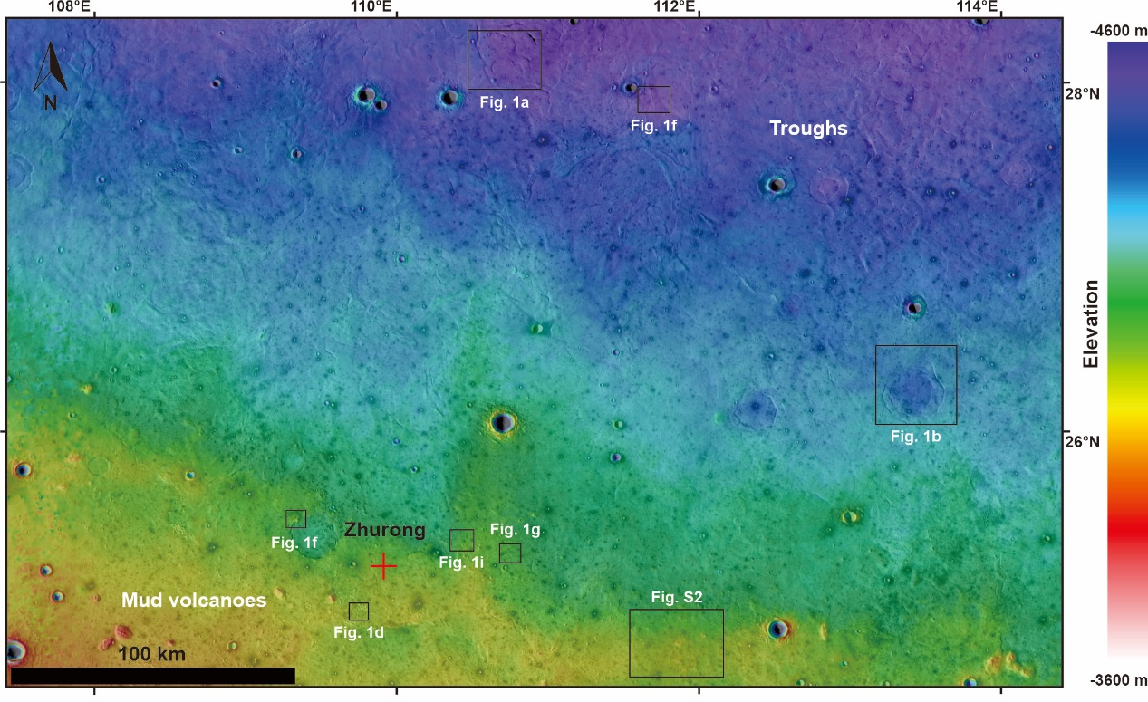
Figure S1. The landing region of the Zhurong rover in Color-coded HRSC MOLA topographic context. Troughs are mainly distributed in the northern part of the Zhurong landing region, whereas mud volcanoes are mainly distributed in the southern part.

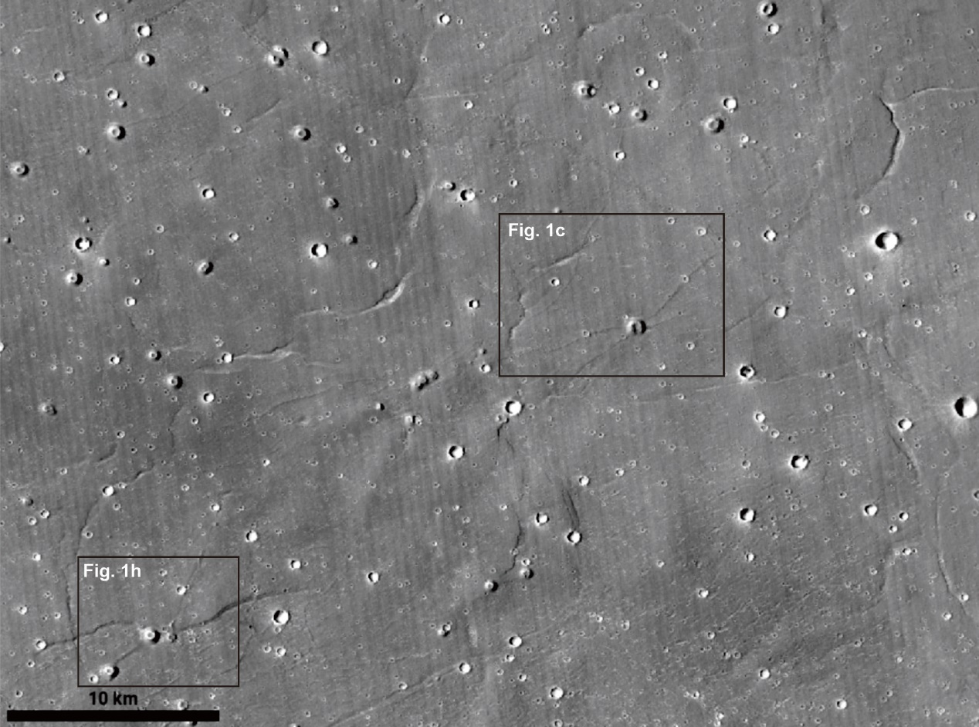
Figure S2. Mud volcanoes, troughs, and dikes in the eastern part of the Zhurong landing region.

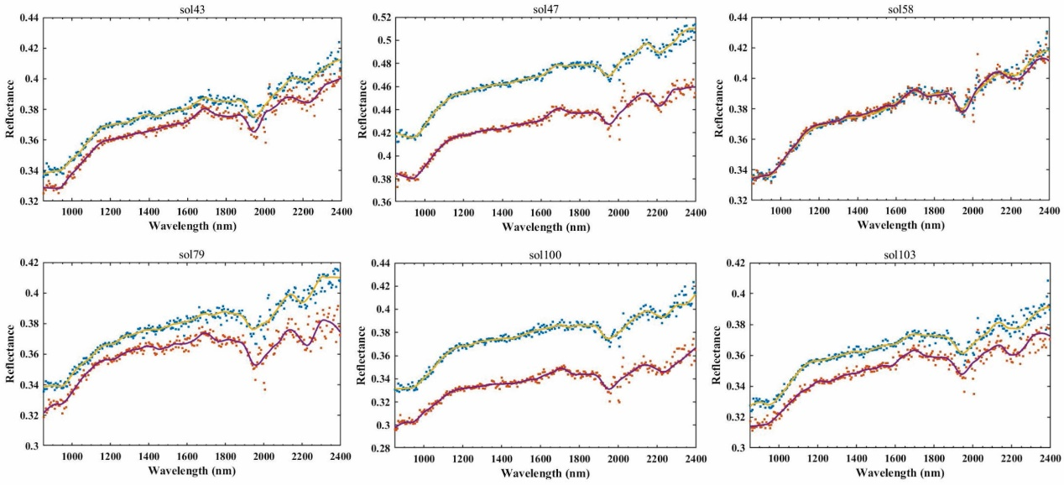
Figure S3. Smoothed MarSCoDe spectra showing similar broad absorptions around 1950 and 2220 nm. These features suggest that the rocks are composed of sulfate and/or silica. The spectral absorptions around 1400 and 1900 nm may also be influenced by the martian atmosphere.

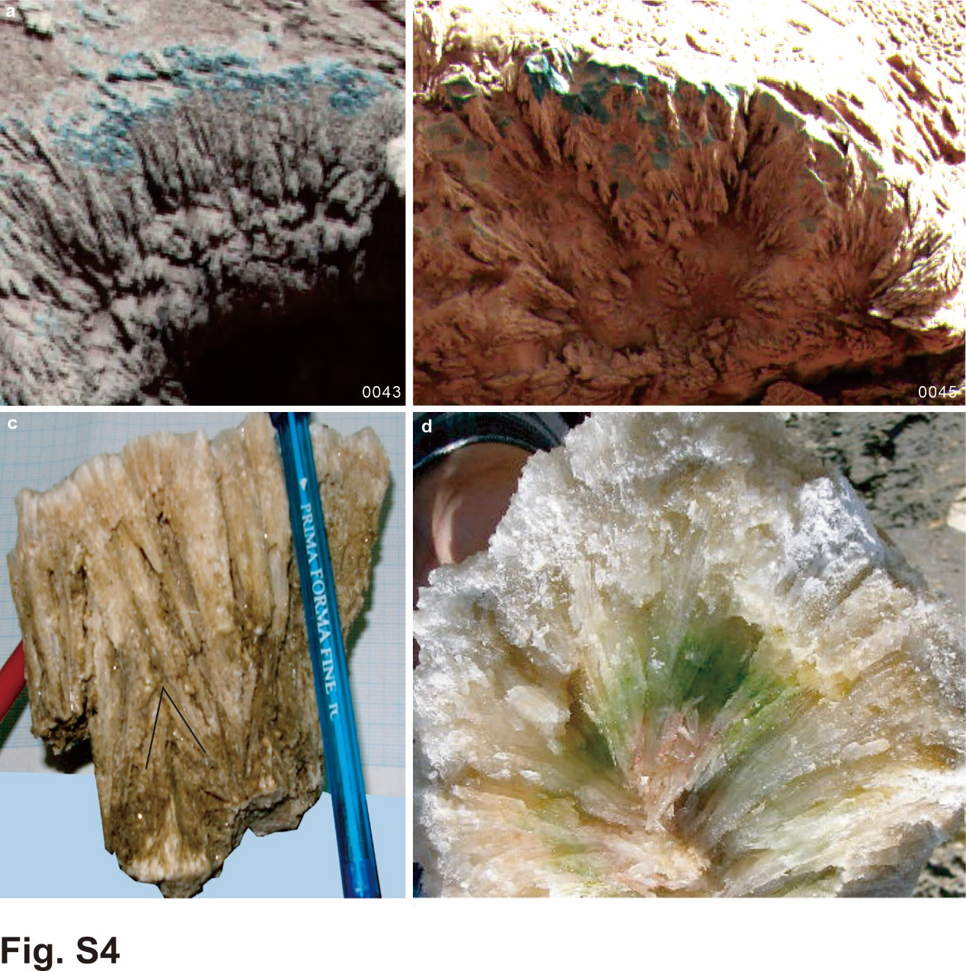
Figure S4. Comparison between the crystal cluster pictured by Zhurong (a, b) with the selenite cluster formed in a shallow, non-marine, evaporite basin (c-d)³². (a, c) Single and twinned selenite crystals with growth fabric patterns. (b, d) Palmate patterns of upward-grown selenite crystals.

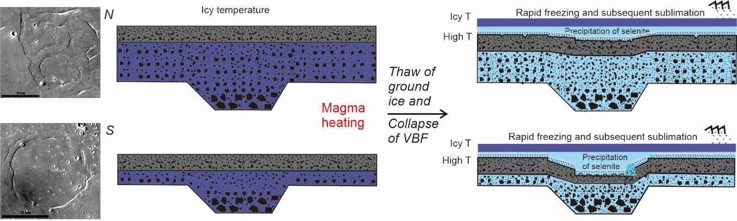
Figure S5. Collapse owing to the thawing of ground ice that led to the formation of grabens and troughs defining the ghost craters with doubled rings. The doubled rings correspond to the outer and inner circles of craters. It is noteworthy that the VBF formation is thicker at the center of Utopia Planitia (north, N) than that at the southern part of Utopia Planitia southern (S).

