Supplementary Materials for
Identification of Key Extracellular Proteins and miRNAs for Use as Diagnostic Biomarkers of Temporomandibular Joint Osteoarthritis

TABLE S1 | Top 4 compounds with the highest scores in the CMap analysis
CMap name | Dose | Cell line | Enrichment | Description
GW-501516 | 10 uM | SKB | -0.8434 | PPAR receptor agonist
pifithrin-mu  CS-1657 | 10 uM  10 uM | SKB  HA1E | -0.831  -0.8299 | p53 inhibitor  PARP inhibitor
PD-198306 | 10 uM | SKB | -0.8148 | MAP kinase inhibitor

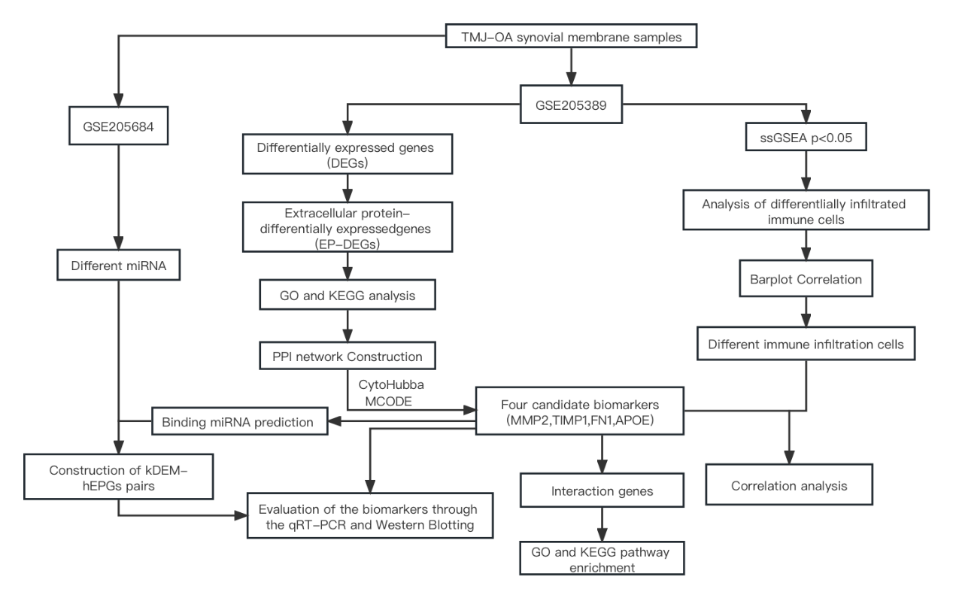
Figure.S1 | Workflow of the entire study.

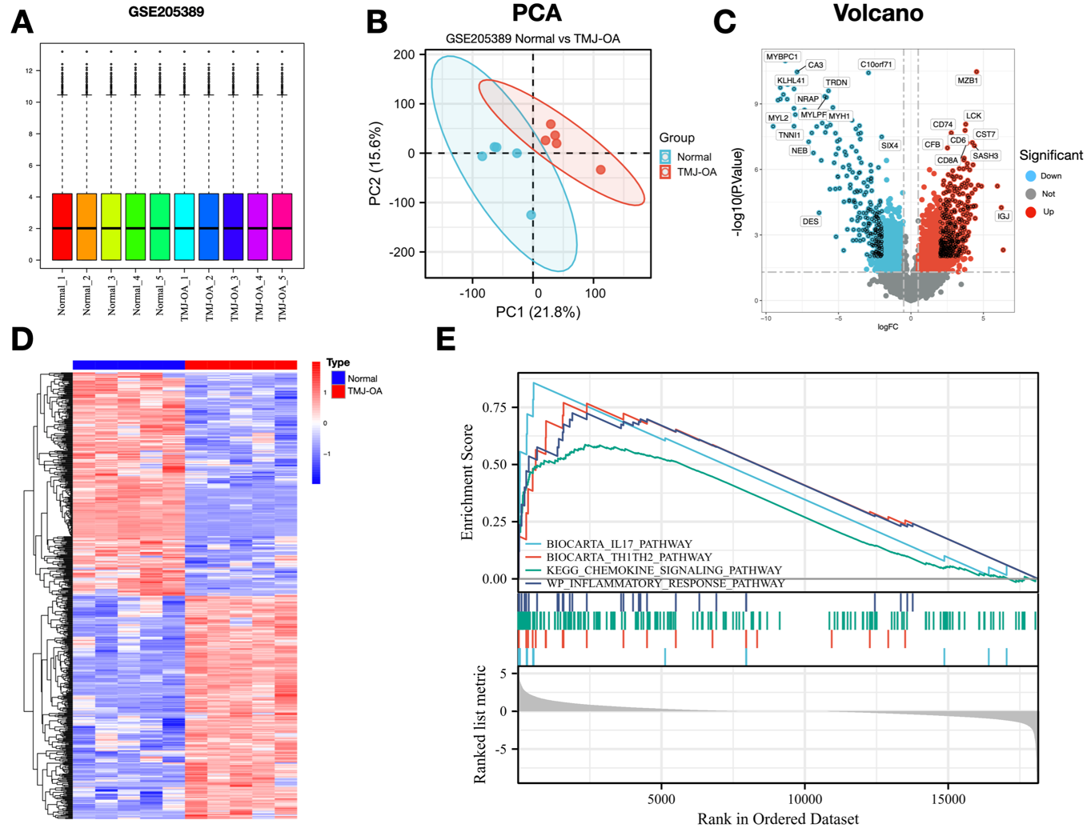
Figure. S2 | Analysis of differential gene expression between the TMJ-OA group and the normal group. (A) Boxplot of gene probe expression levels among samples showing no significant difference between median and upper and lower quartiles. There was no significant difference in the median and the upper and lower quartiles. (B) PCA principal-component analysis. (C) Volcano plot showing the top 10 upregulated DEGs and downregulated DEGs with the smallest p values in the TMJ-OA group and the normal group. (D) Heatmap for all DEGs in the TMJ-OA group and normal group in the mRNA datasets. (E) GSEA enrichment results for all the groups.

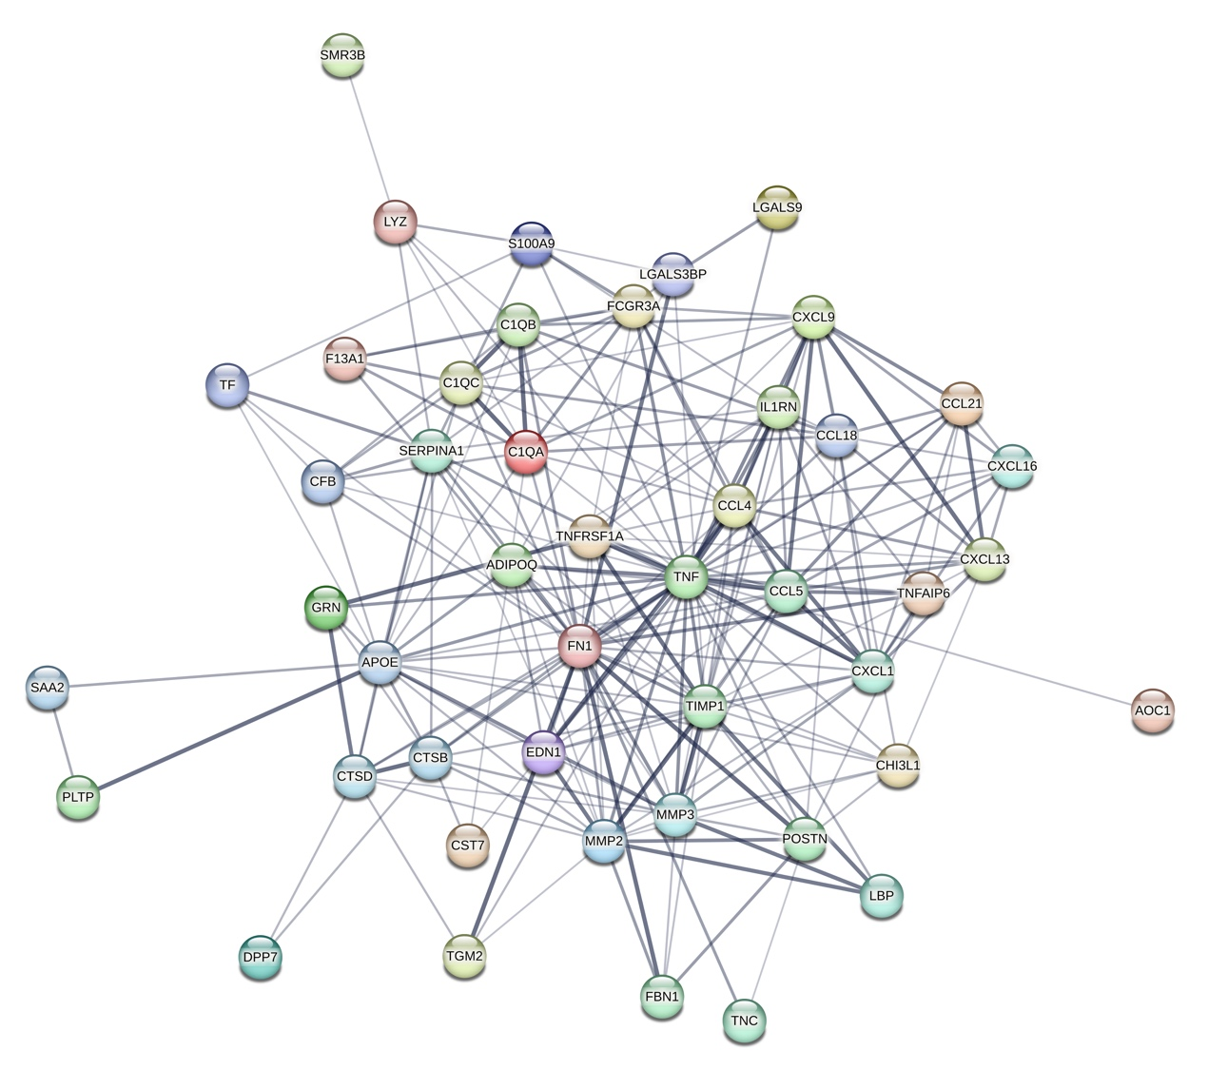
Figure. S3 PPI network of EPGs

Figure. S4 | Chemical structures of small molecule compound candidates for the treatment of TMJ-OA. The expression profiles observed after treatment with GW-501516 (A), CS-1657 (B), PD-198306 (C) and pifithrin-mu (D) showed a significant negative correlation with EPGs.

This image shows the western blot membrane of β-actin+APOE in chondrocytes.

This image shows the western blot membrane of β-actin+FN 1in chondrocytes.
These images show the western blot membrane of β-actin+TIMP+MMP2 in chondrocytes. The left panel shows a bright-field image of the entire membrane after splicing the cropped Western blot membranes together, while the right panel shows the membranes exposed separately after cropping.
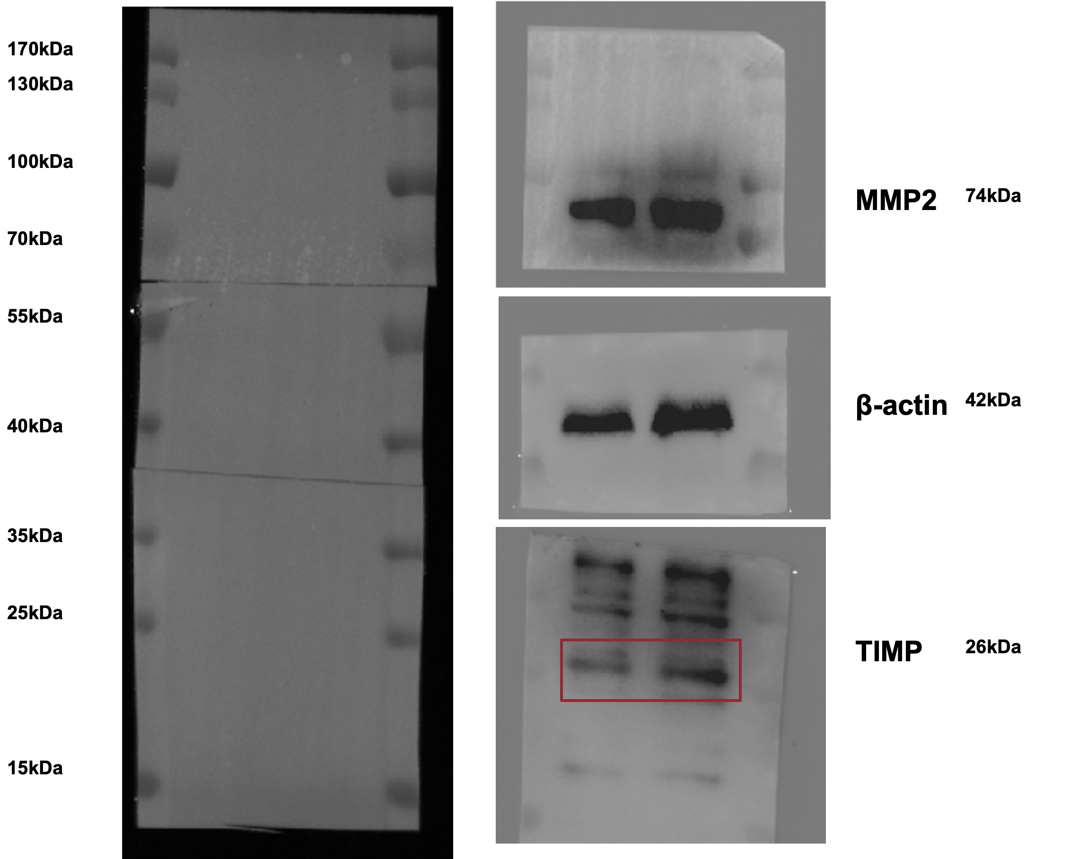

This image shows the western blot membrane of β-actin+FN1 in SW982.
These images show the western blot membrane of β-actin+ MMP2+ AOPE + TIMP in SW982. The left panel shows a bright-field image of the entire membrane after splicing the cropped Western blot membranes together, while the right panel shows the membranes exposed separately after cropping. APOE, β-actin, and TIMP belong to the same band, which was stripped and re-exposed using Stripping Buffer.

