Elaborate Design and Mechanism Insight of Monodispersed AuCuPt Alloy Nanozyme with Promoted Antitumor Activity
Jing Liu, Shuming Dong, Shili Gai, Yushan Dong, Bin Liu, Zhiyu Zhao, Chenghao Yu, Ying Xie, Piaoping Yang, and Jun Lin

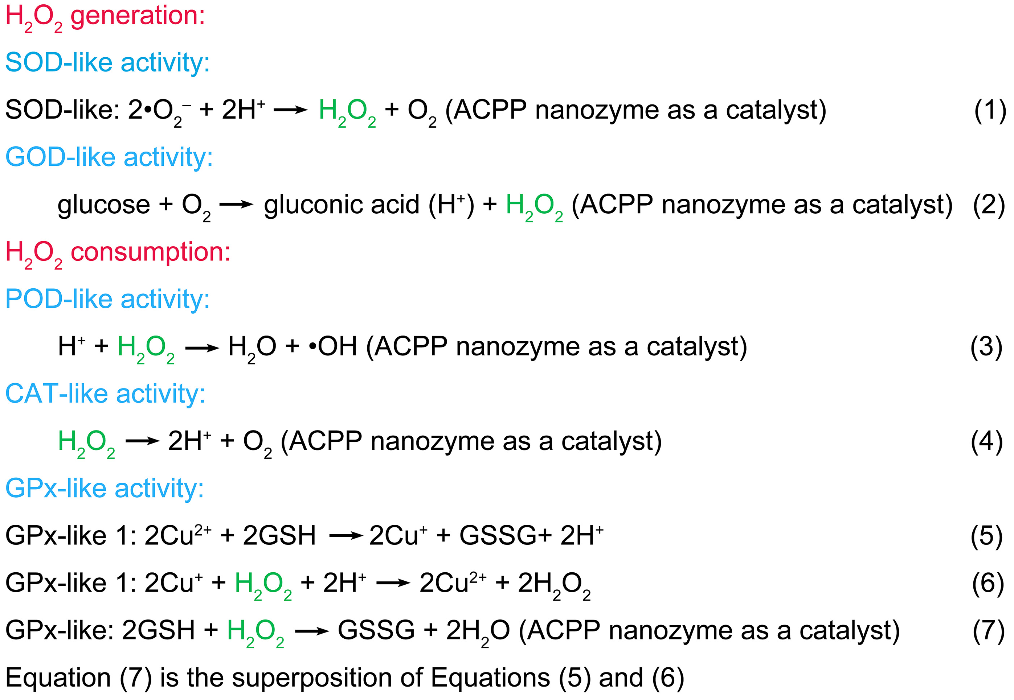
Supplementary Figure 1. Cascade reactions enabled by ACPP nanozymes.

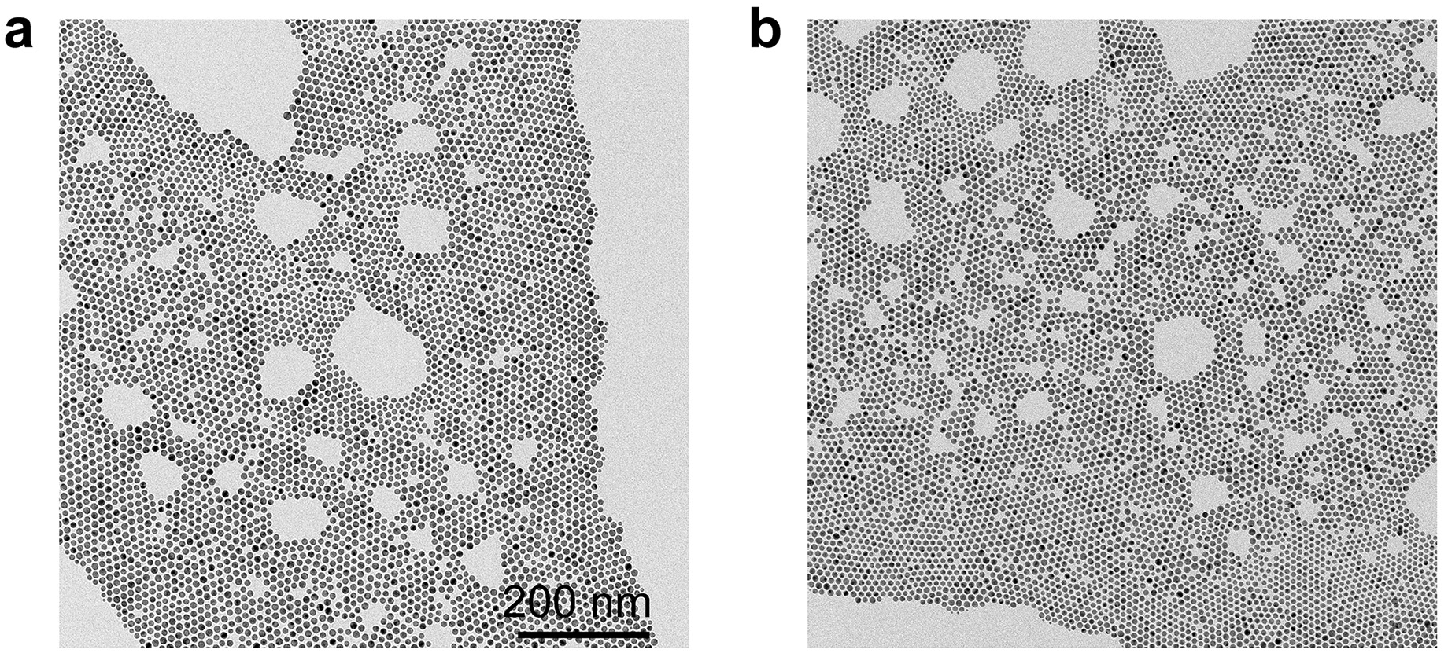
Supplementary Figure 2. TEM images of (a) Au and (b) AuCu nanozymes.

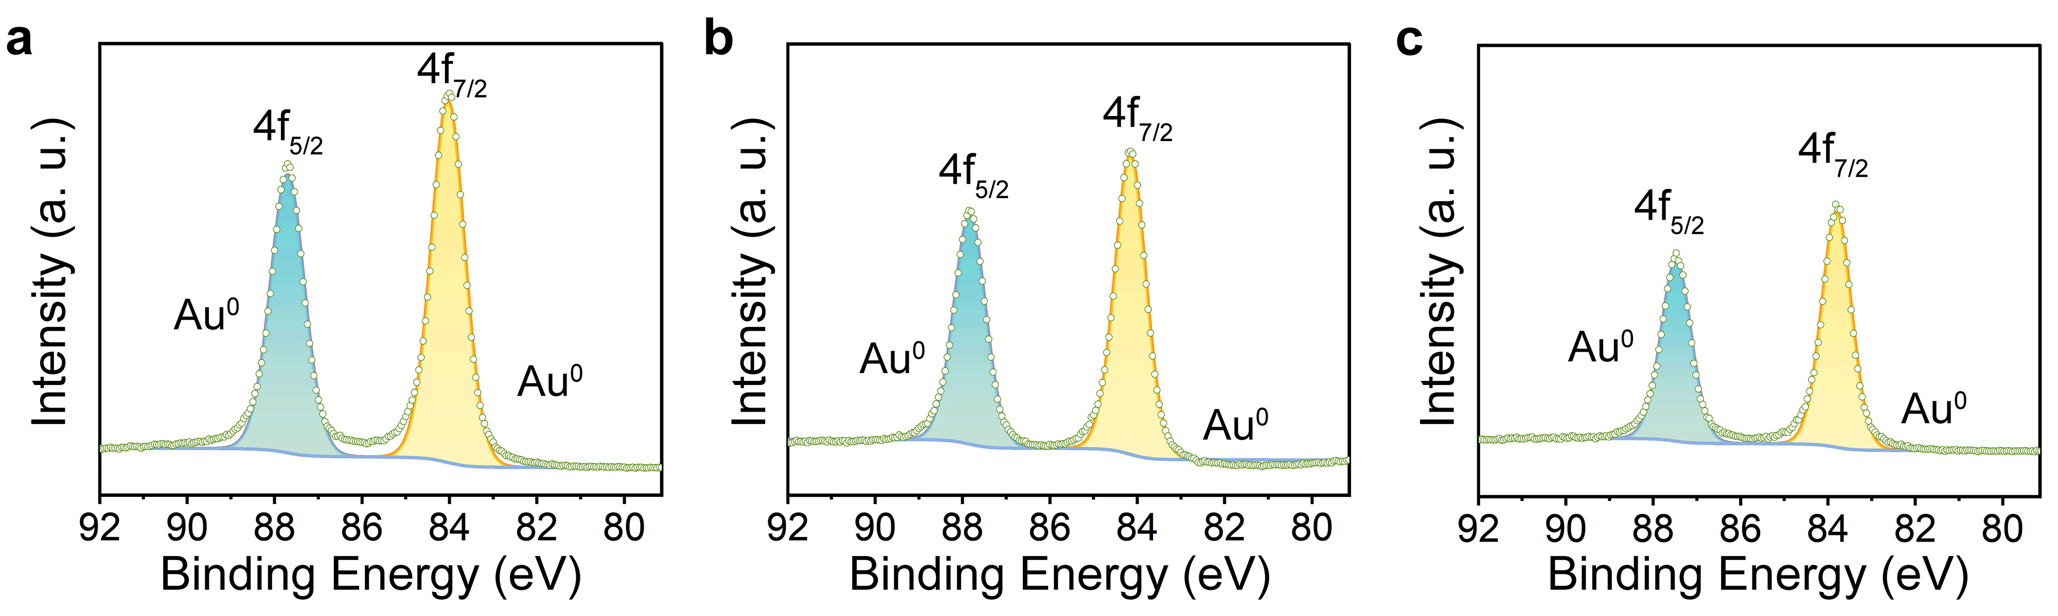
Supplementary Figure 3. High-resolution Au 4f spectrum of (a) Au, (b) AuCu, and (c) AuCuPt nanozymes.
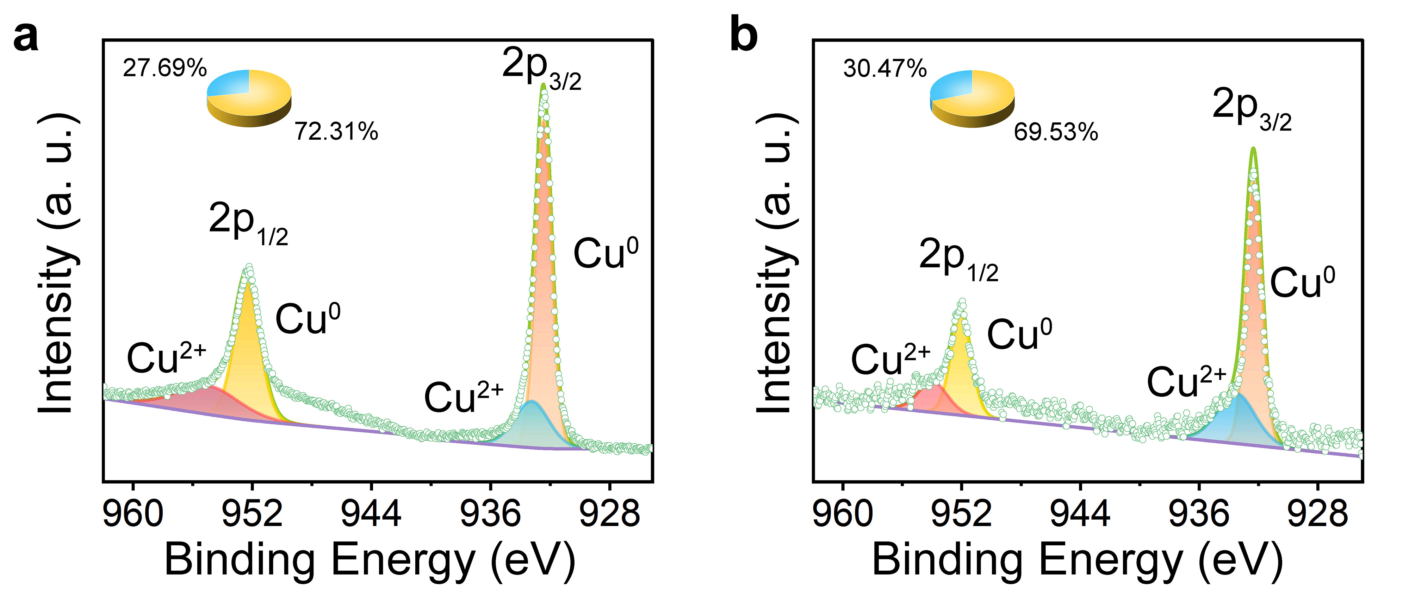
Supplementary Figure 4. High-resolution Cu 2p spectrum of (a) AuCu and (b) AuCuPt nanozymes.
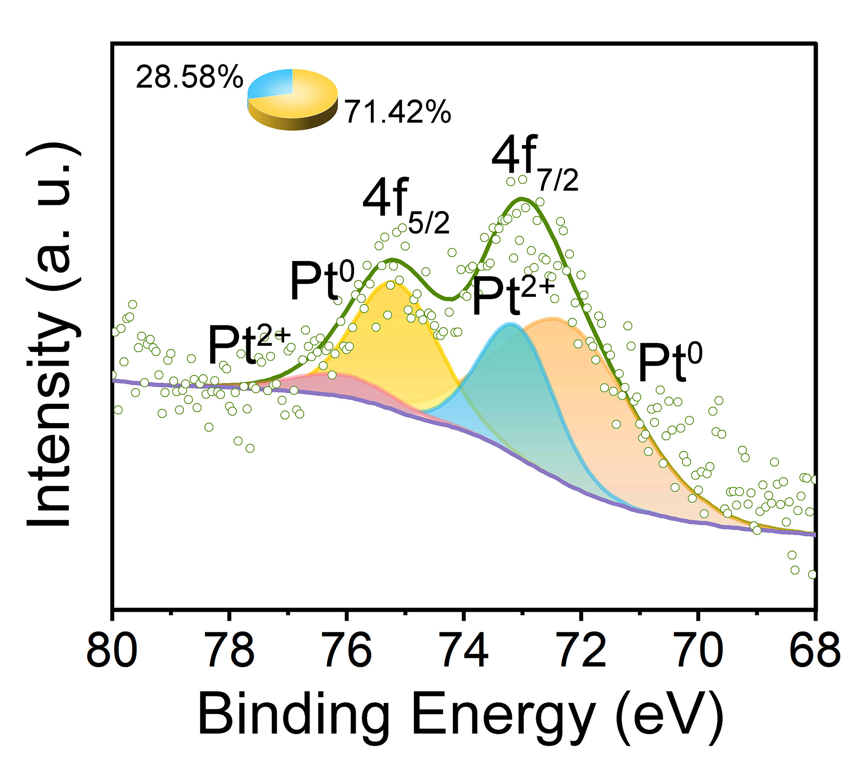
Supplementary Figure 5. High-resolution Pt 4f spectrum of AuCuPt nanozymes.

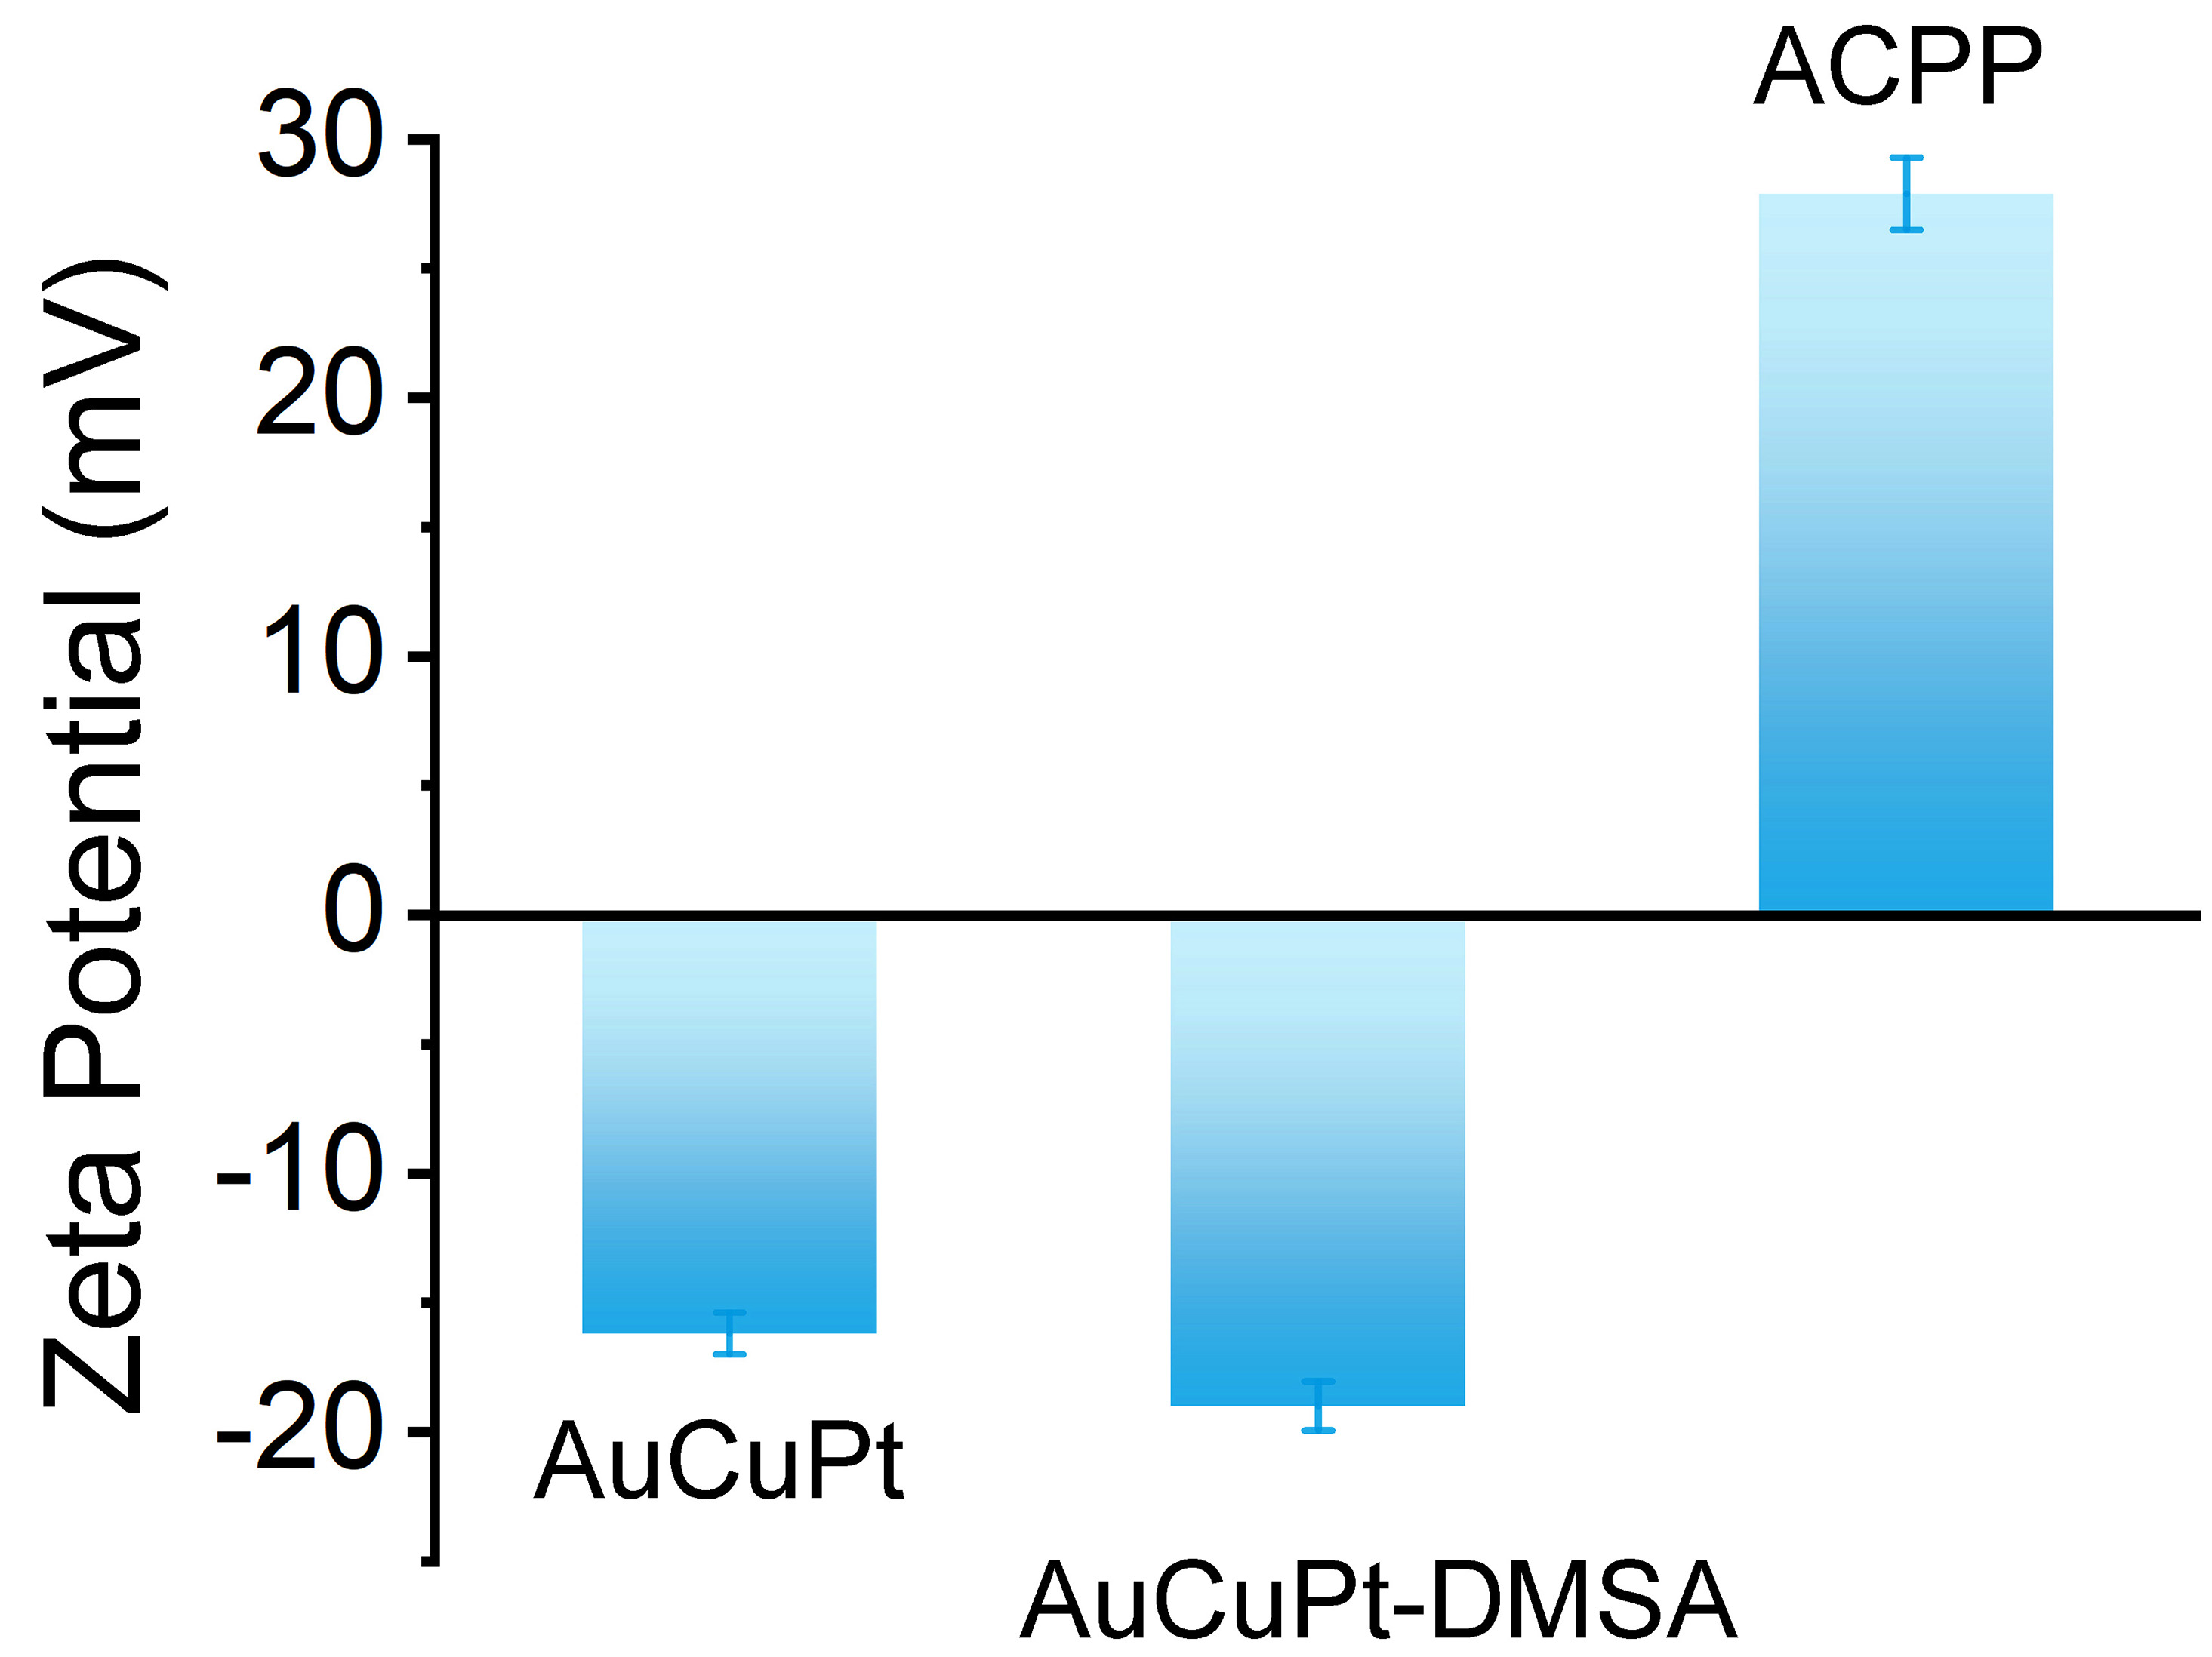
Supplementary Figure 6. Zeta potentials of different synthetic steps.

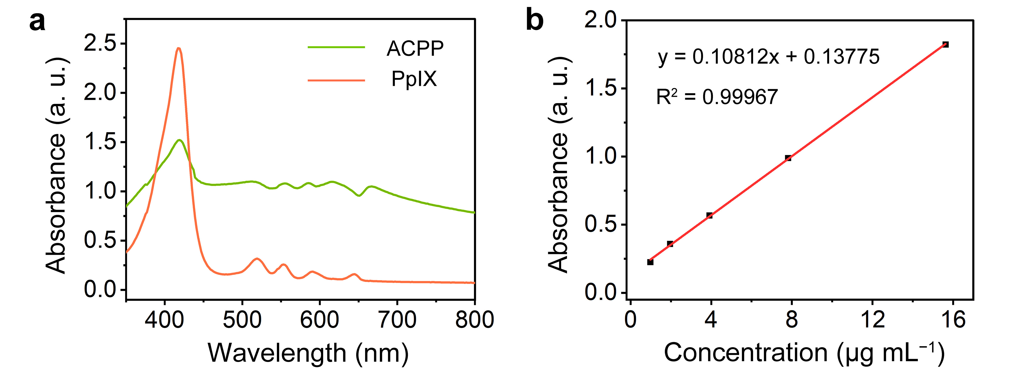
Supplementary Figure 7. (a) The UV–vis absorbance spectrum of free PpIX standard solution and ACPP nanozymes solution. (b) The fitted linear standard curve of the absorption and mass concentration of free PpIX.

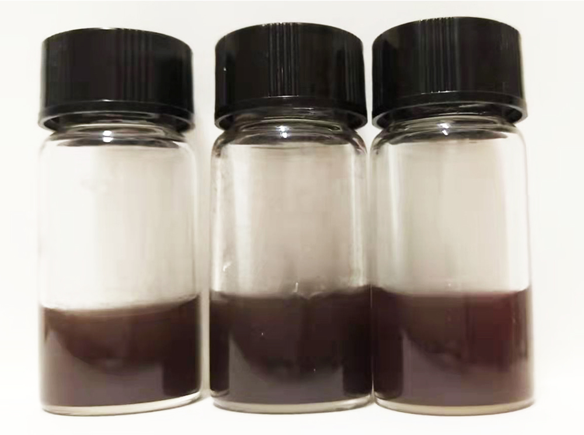
Supplementary Figure 8. Digital images of ACPP nanozymes dispersed in saline, PBS, and DMEM for 7 d.

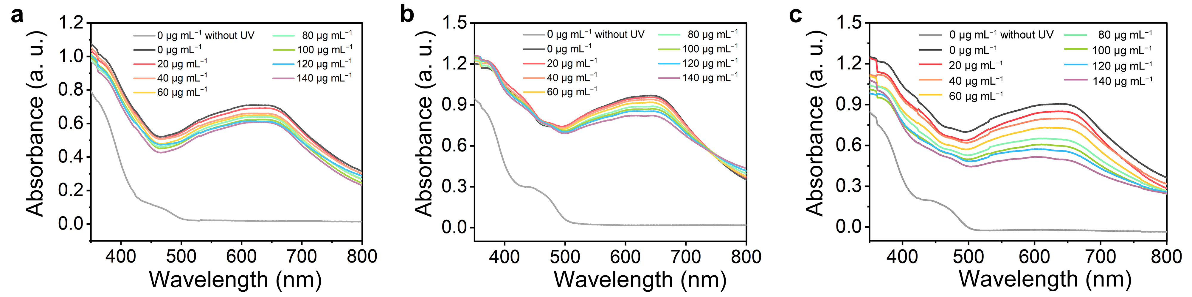
Supplementary Figure 9. Catalytic conversion of ·O₂⁻ by (a) AP, (b) ACP, and (c) ACPP nanozymes.

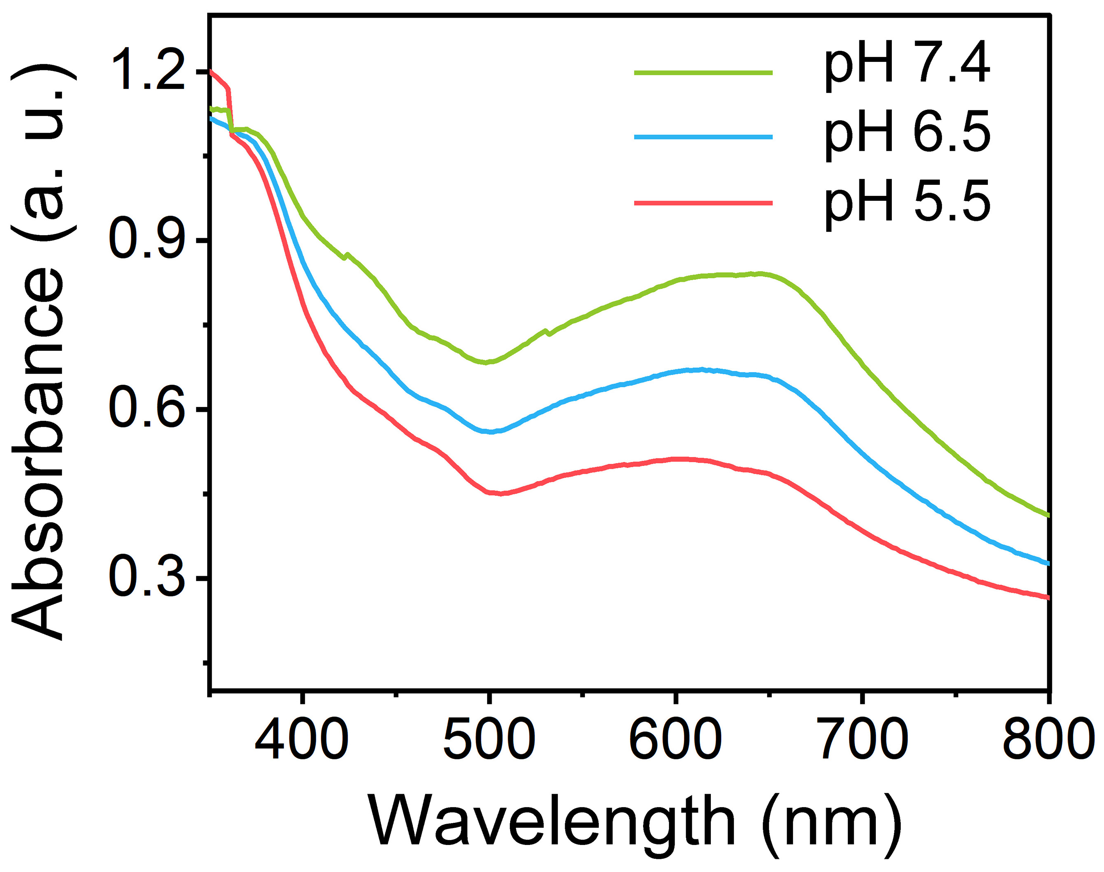
Supplementary Figure 10. The UV-vis absorbance spectrum of catalytic conversion of ·O₂⁻ at the pH = 5.5, 6.5, and 7.4.

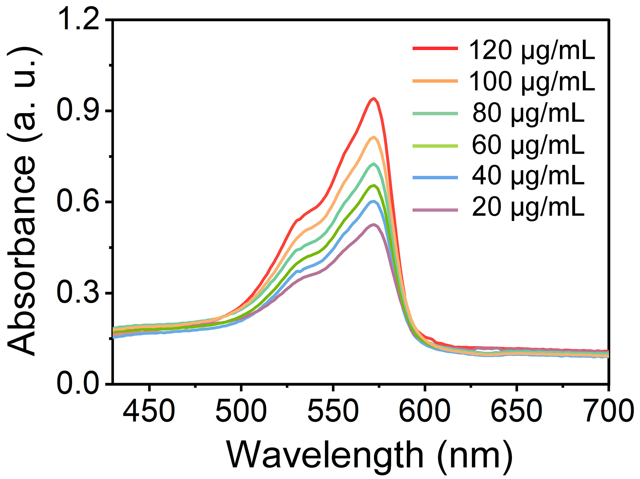
Supplementary Figure 11. H₂O₂ generation in the SOD-like reaction process catalyzed by ACPP nanozymes.
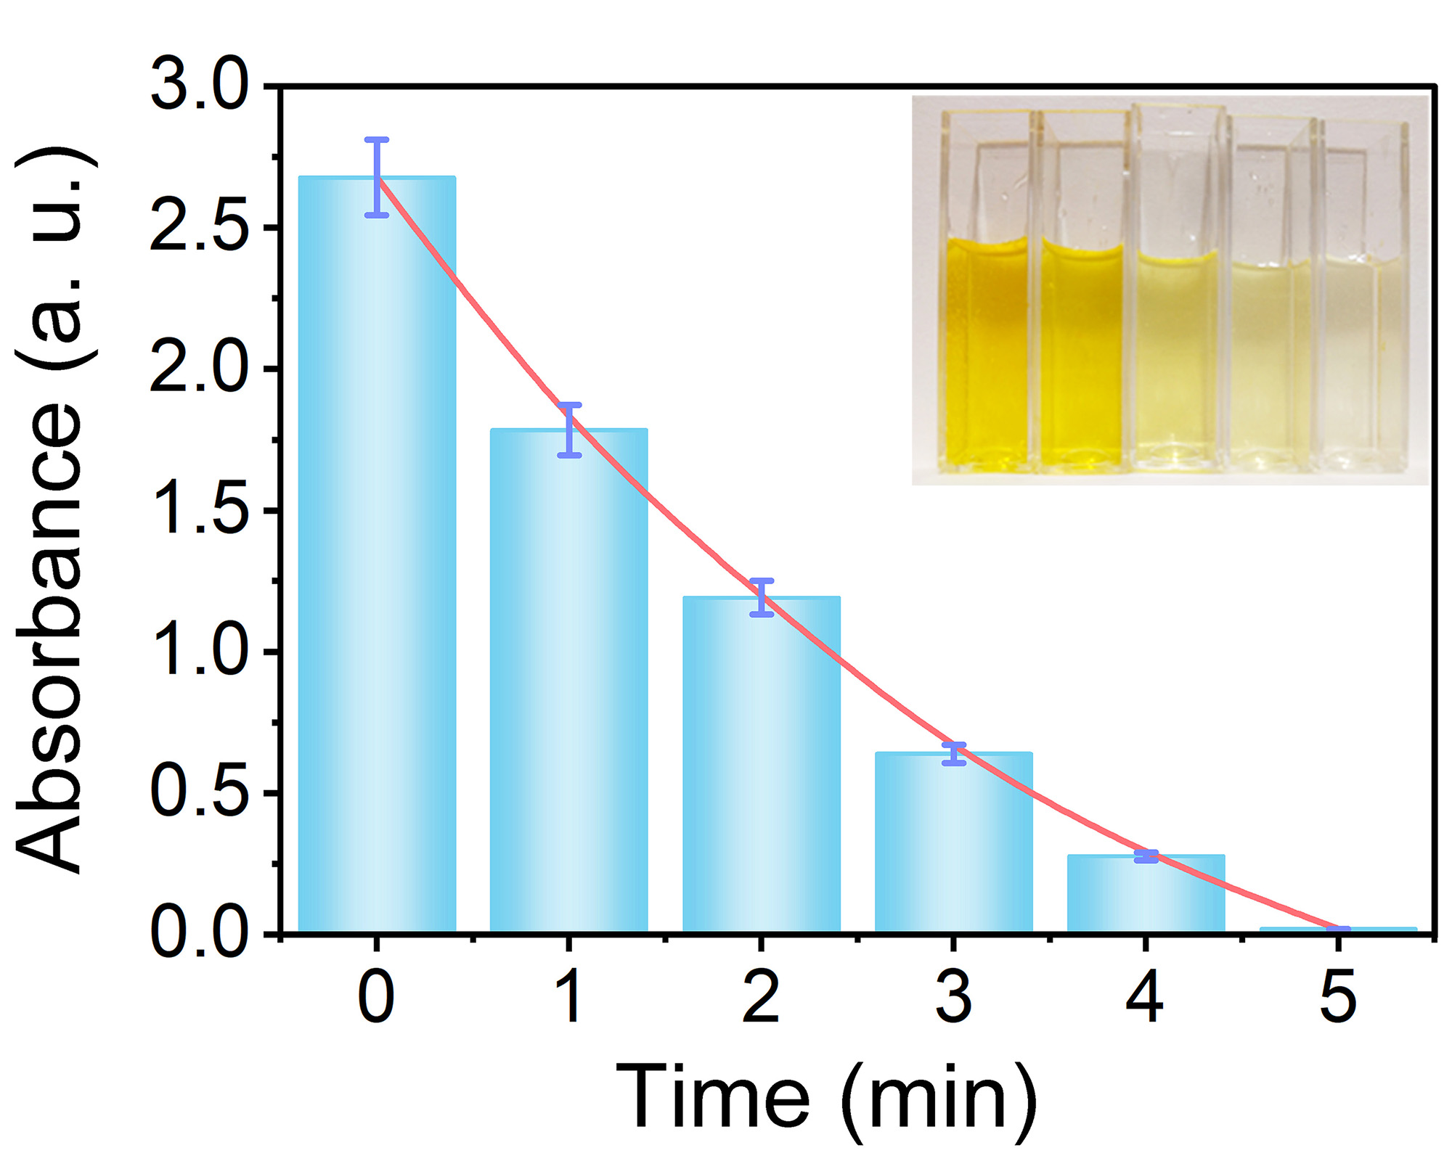
Supplementary Figure 12. Absorbance at different reaction times detected at 412 nm and the corresponding photographs of solutions at the fixed time interval (inset).

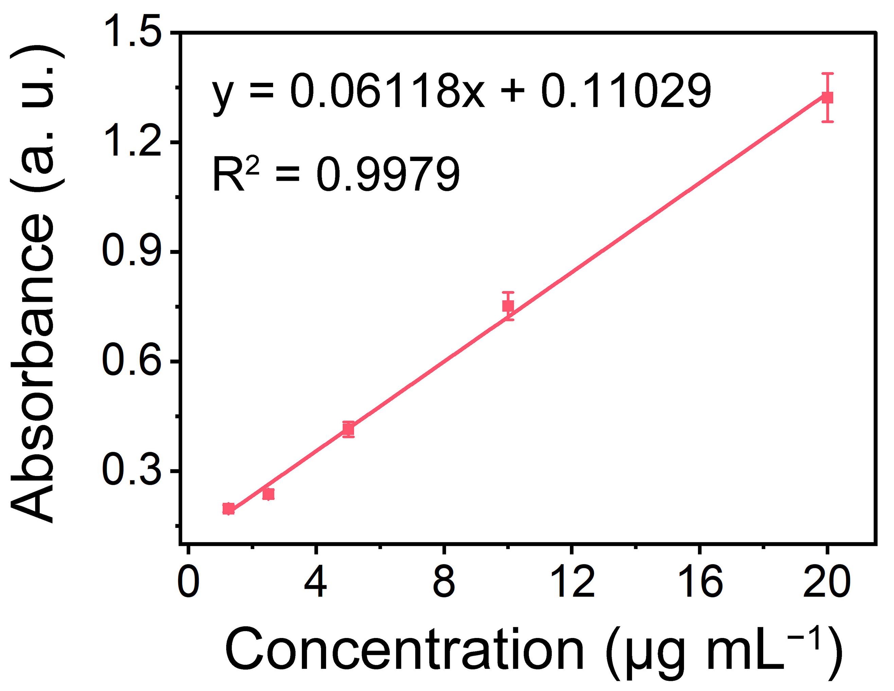
Supplementary Figure 13. The fitted linear standard curve of the TNB versus GSH concentrations detected at 412 nm.

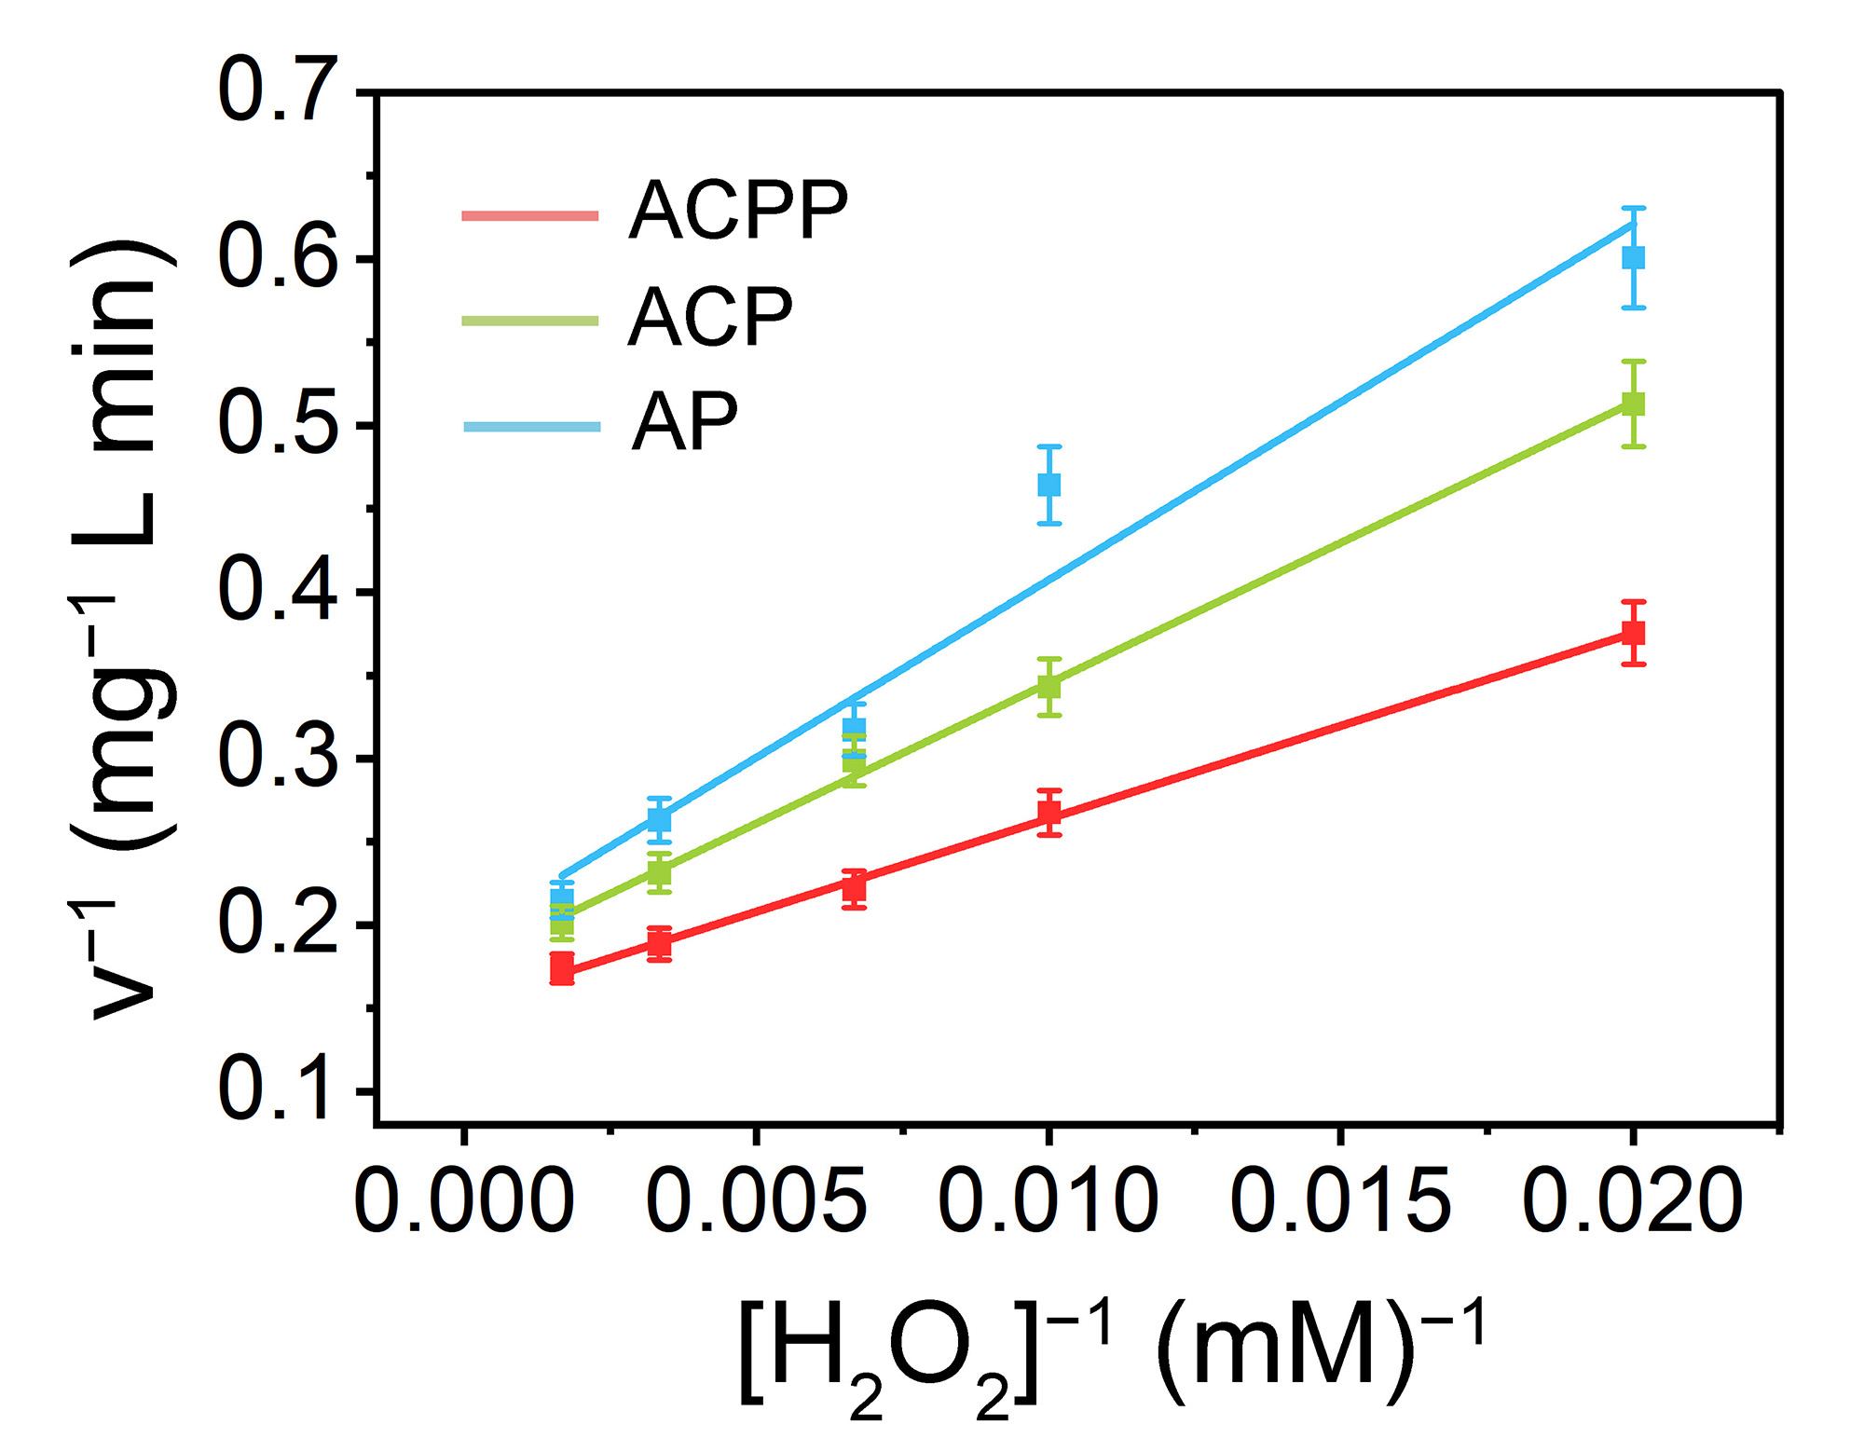
Supplementary Figure 14. Lineweaver–Burk curves for determining CAT-like activity.

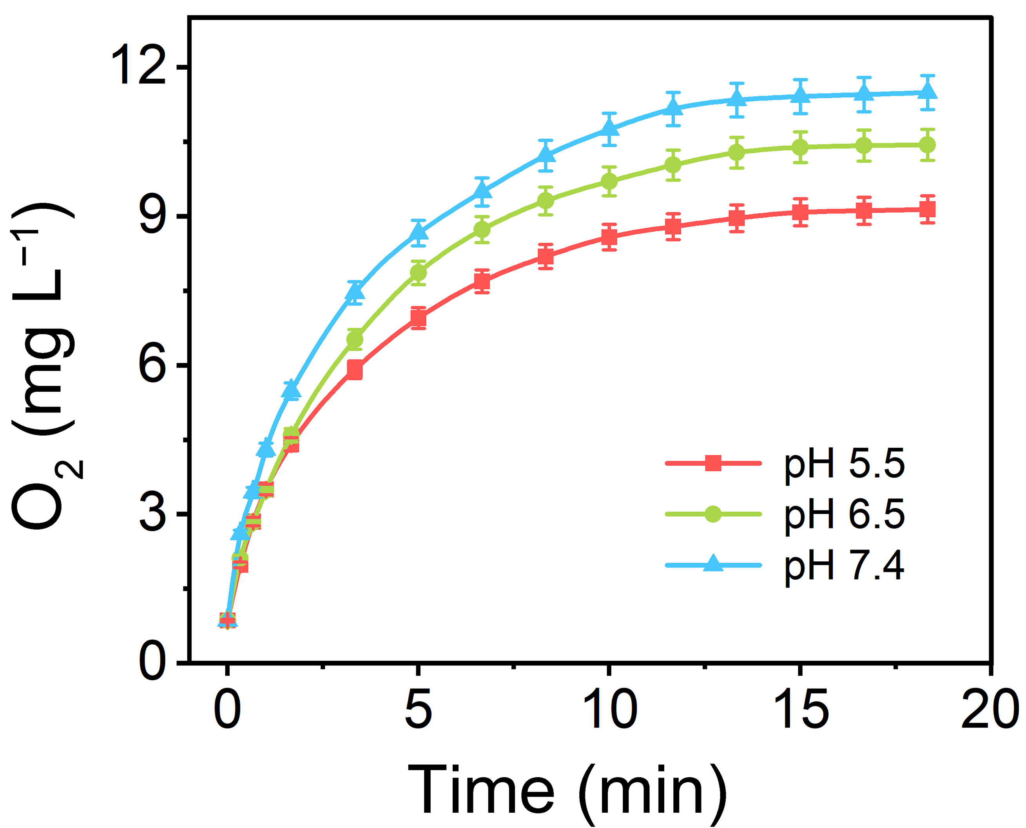
Supplementary Figure 15. The production of O₂ catalyzed by ACPP nanozymes (20 g mL^{–1}) with H₂O₂ (150 mM) at the pH = 5.5, 6.5, and 7.4.

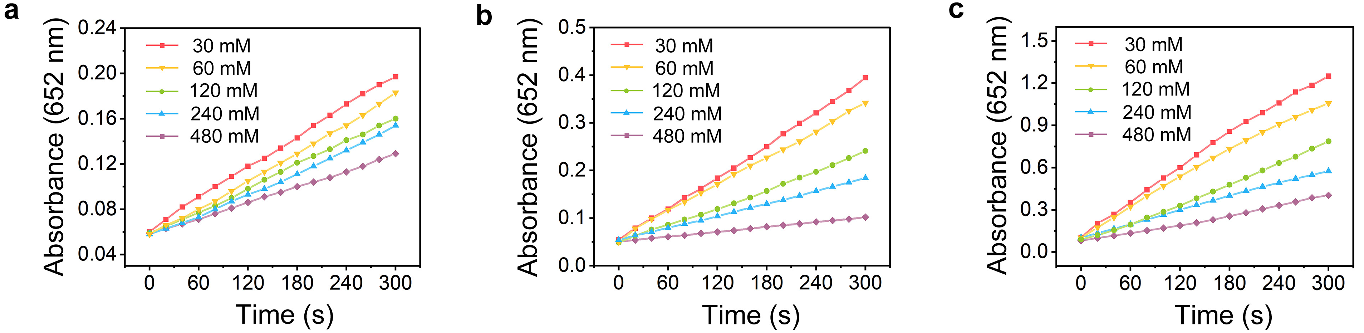
Supplementary Figure 16. Absorbance change in the first 300 s of AP, ACP, and ACPP nanozymes, respectively.

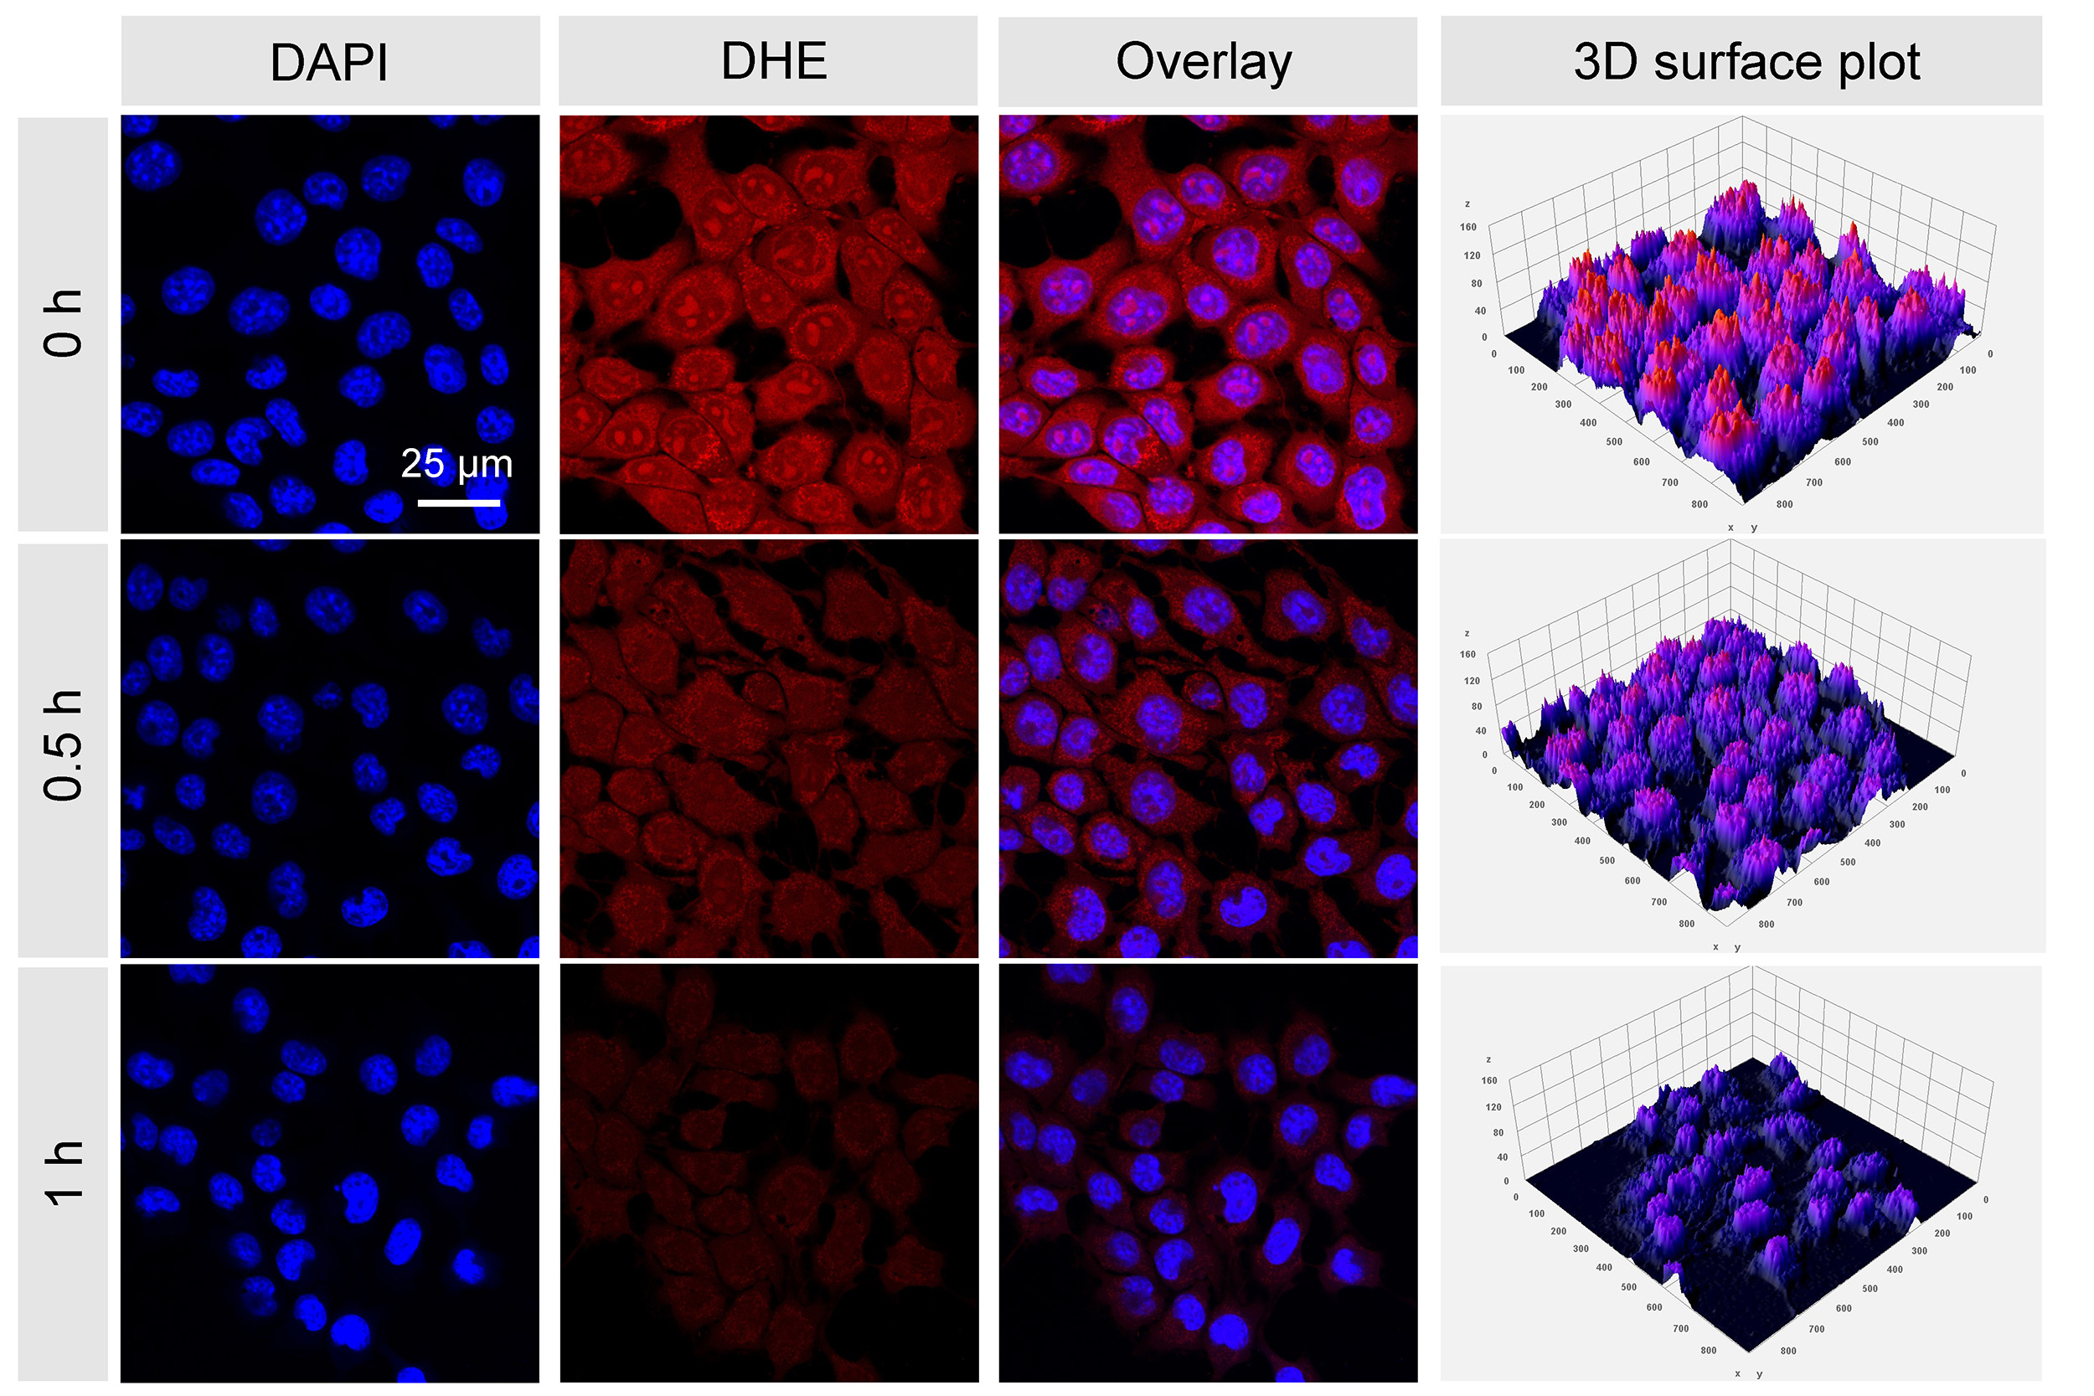
Supplementary Figure 17. CLSM images of intracellular ·O₂⁻ level stained by DHE after incubating with ACPP nanozymes for different time intervals.

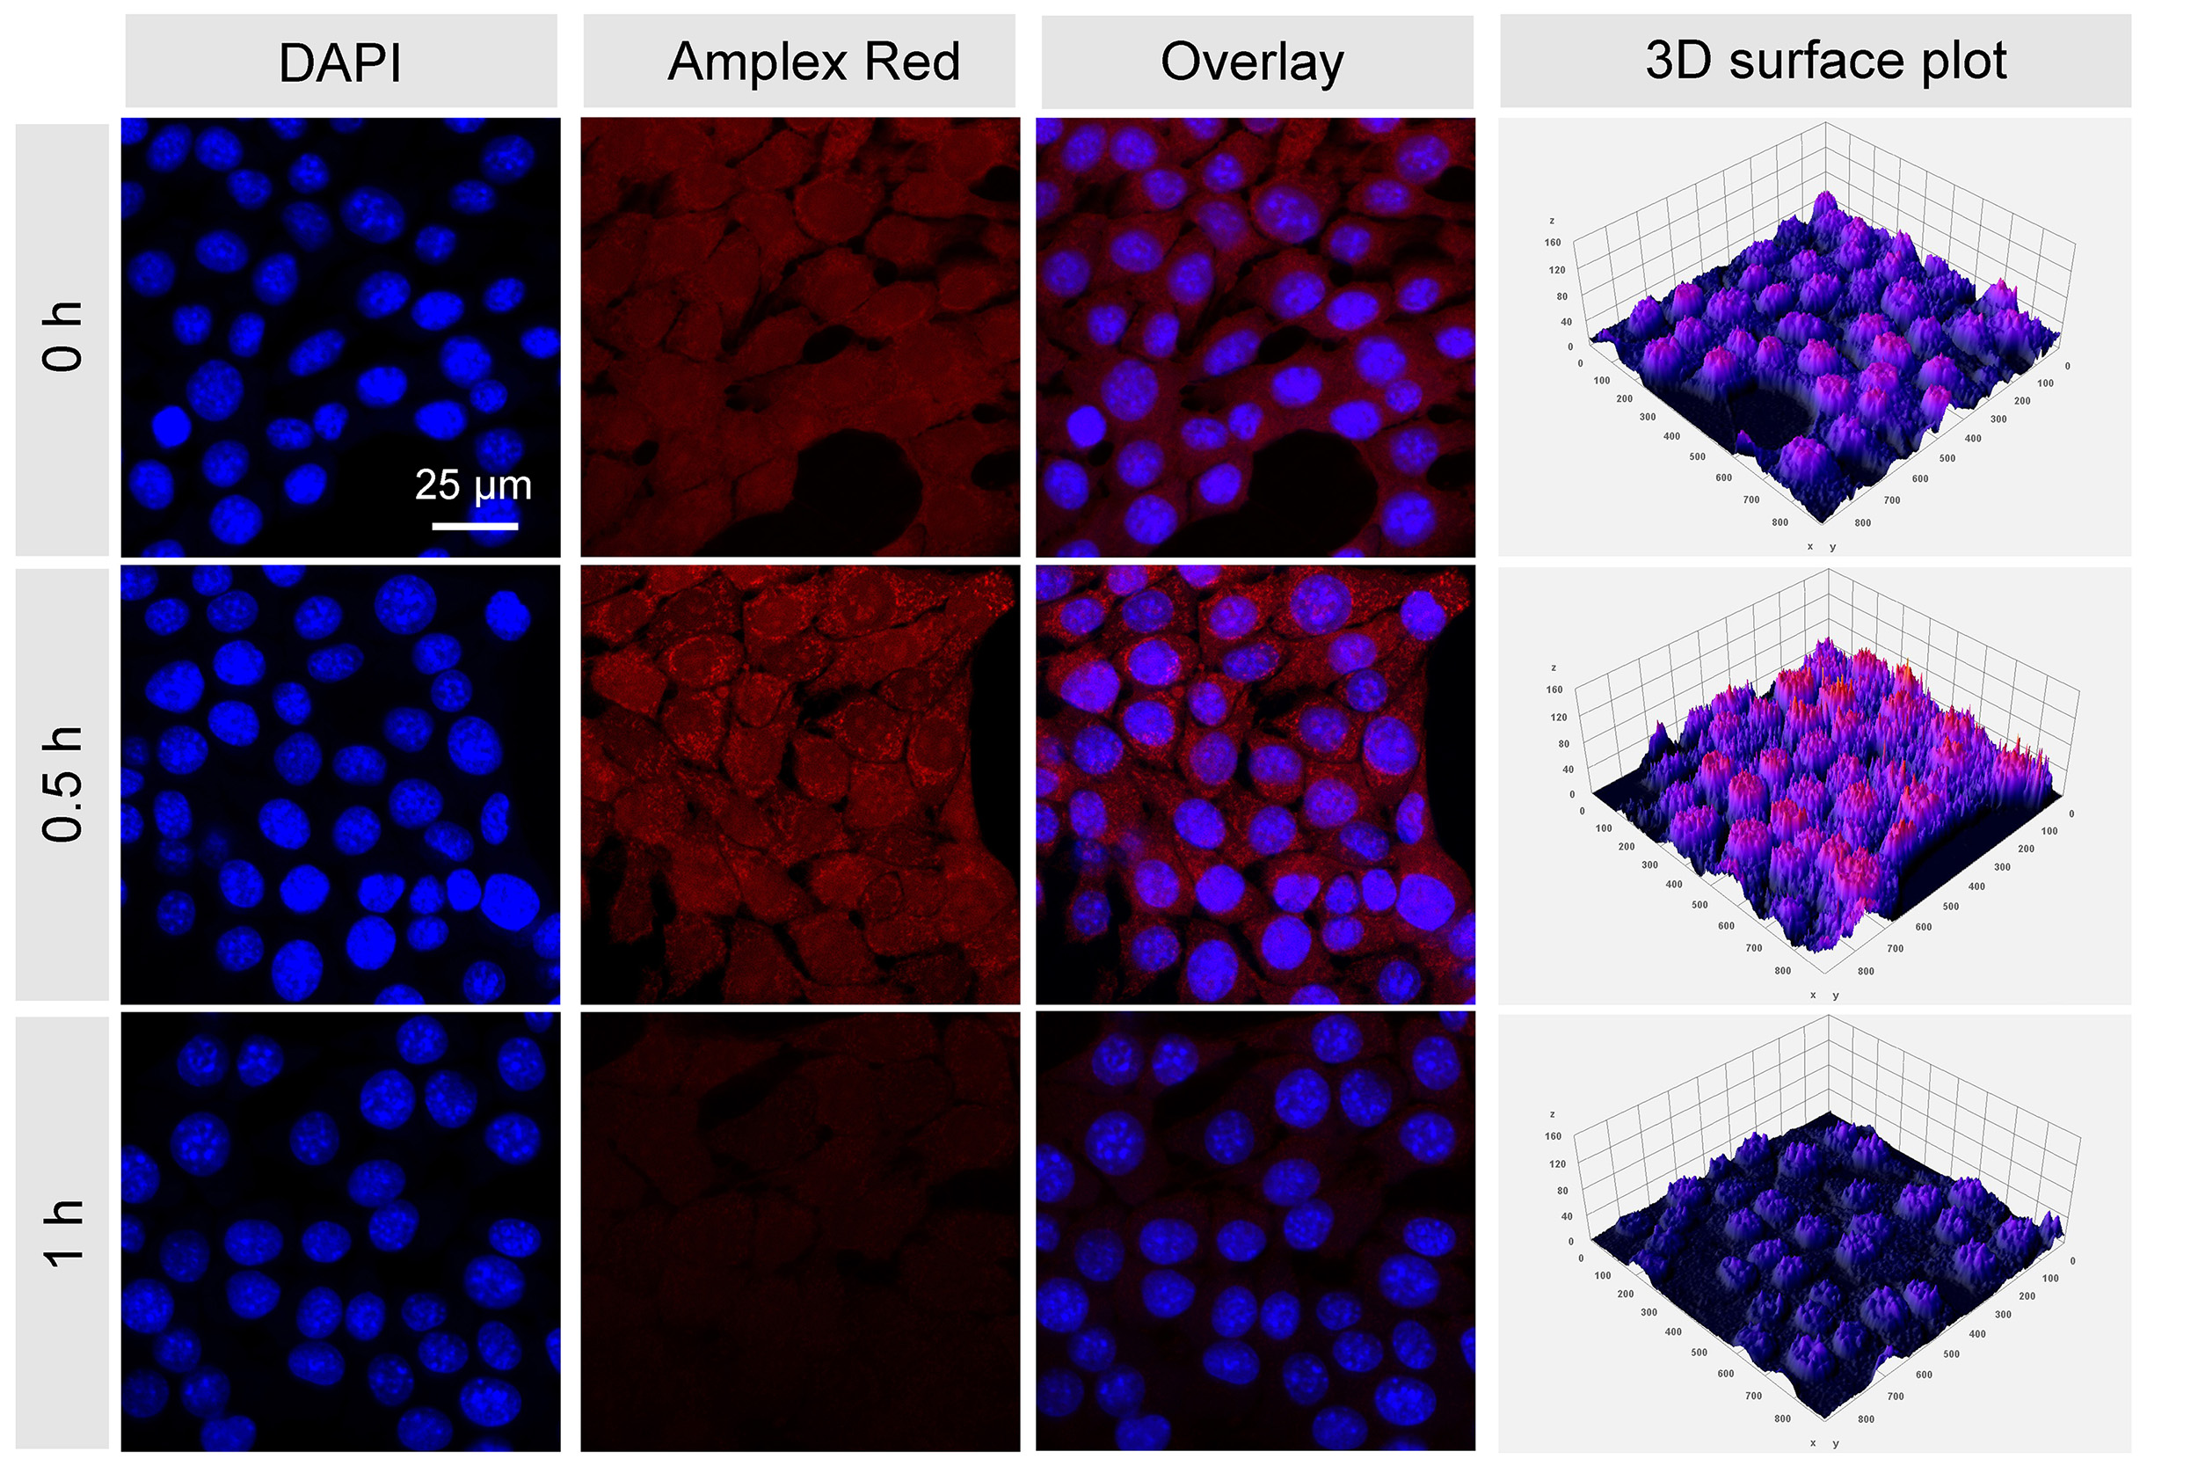
Supplementary Figure 18. CLSM images of intracellular ·O₂⁻ level stained by DHE after incubating with ACPP nanozymes for different time intervals.

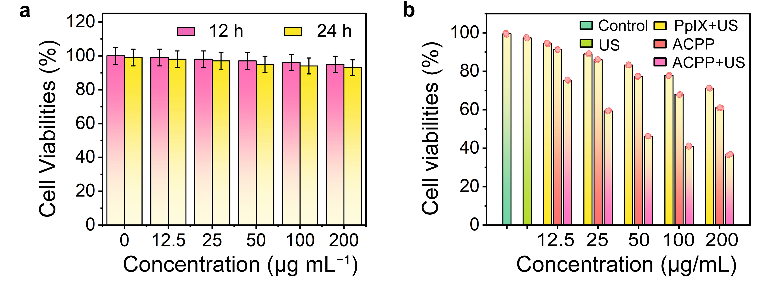
Supplementary Figure 19. (a) The cytotoxicity of L929 cells after incubation for 12 and 24 h at the presence of ACPP nanozymes at varied concentrations (0, 12.5, 25, 50, 100, and 200 g mL⁻¹). (b) Cytotoxicity assays of 4T1 cells with various treatments of ACPP nanozymes at varied concentrations (12.5, 25, 50, 100, and 200 g mL⁻¹).

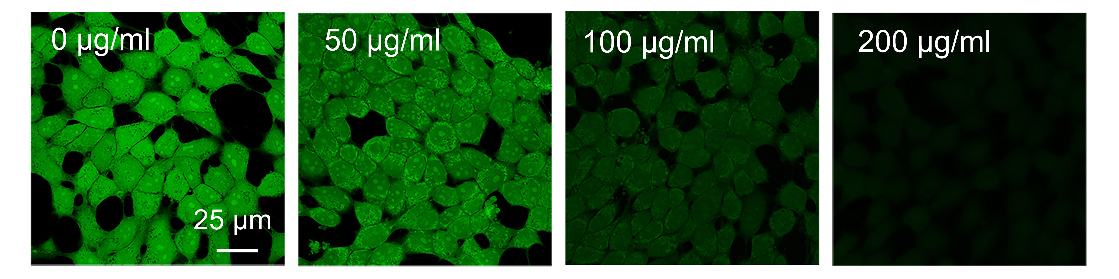
Supplementary Figure 20. CLSM images of intracellular GSH level stained by Thiol Tracker Violet incubated with different amount of ACPP nanozymes (0, 50, 100, and 200 μg mL⁻¹).

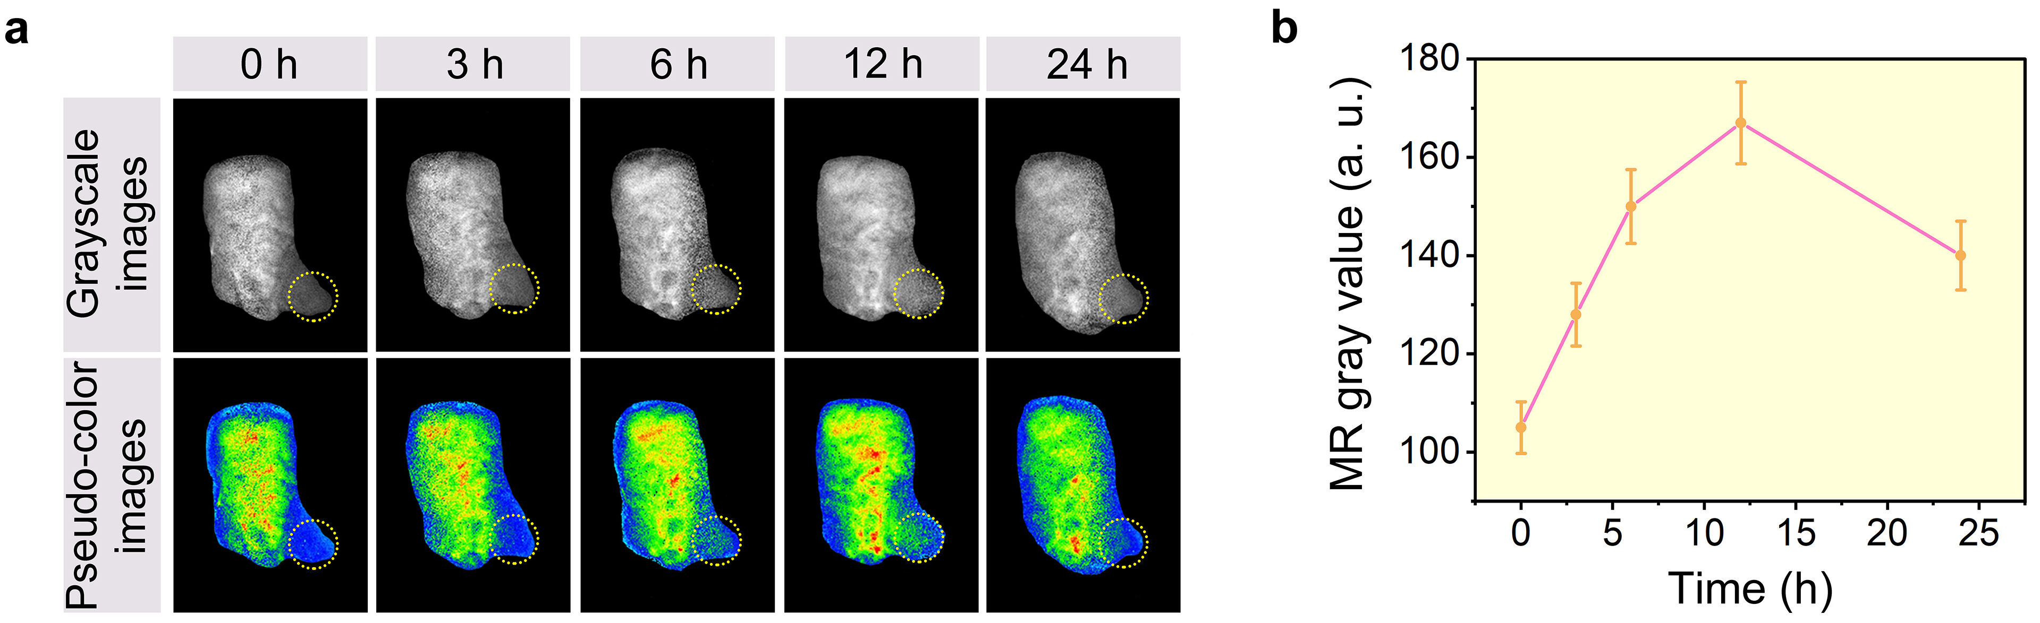
Supplementary Figure 21. (a) Time-dependent MR imaging of mice bearing 4T1 tumors post ACPP nanozymes intravenous injection. (b) MR signal values of the tumor area at different times.

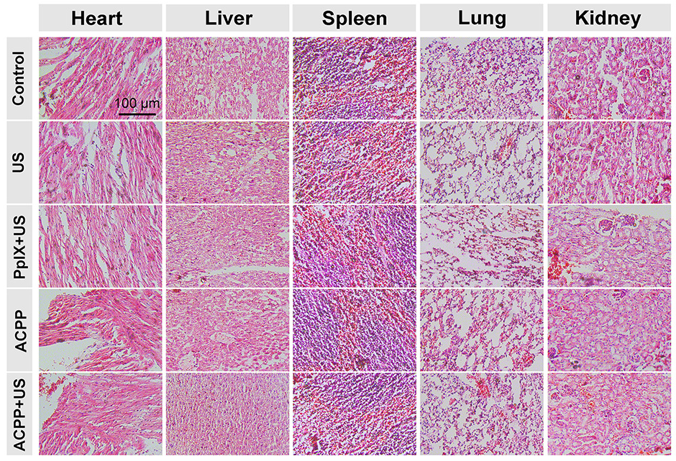
Supplementary Figure 22. Histological examination of major organs obtained from different groups after 20-day treatment: (1) control, (2) US, (3) PpIX + US, (4) ACPP, and (5) ACPP + US.

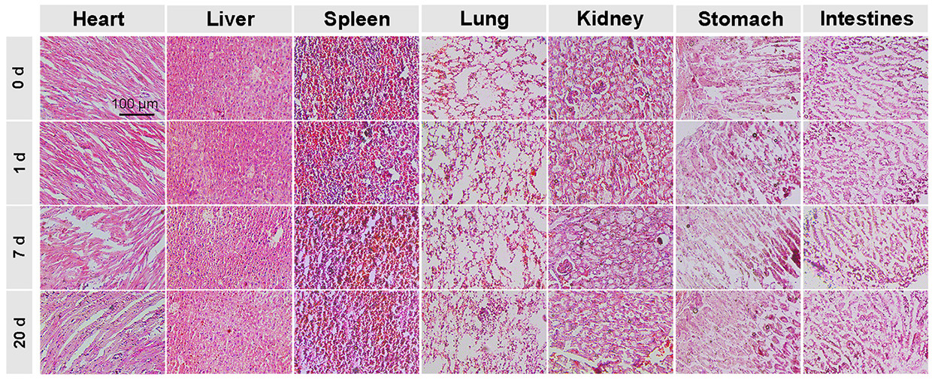
Supplementary Figure 23. H&E staining images of the main organs (heart, liver, spleen, lungs, kidney, stomach, and intestines) of the mice before and post i.v. injection of ACPP nanozymes at 0, 1, 7, and 20 days.

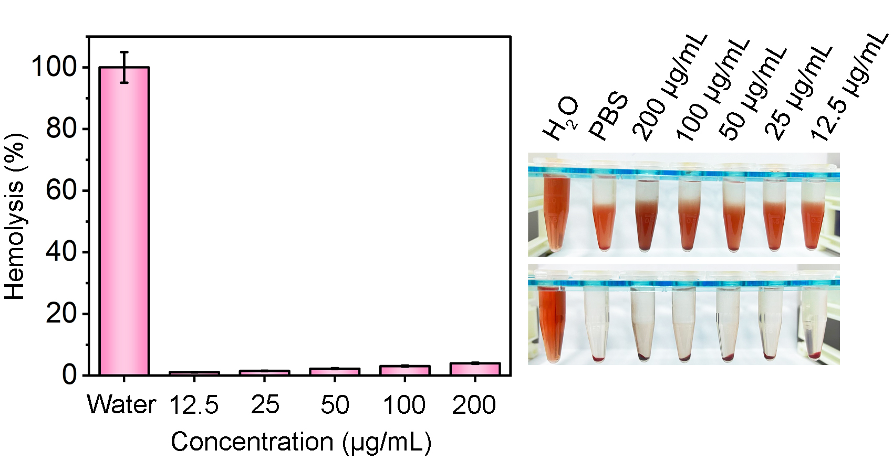
Supplementary Figure 24. Hemolysis analysis and corresponding digital photograph of blood incubated with water and different concentrations of ACPP nanozymes.

