Supplementary material for: Proteomics and machine learning identify a distinct biomarker panel to detect prodromal and early Parkinson’s disease

Supplementary Table S1. Demographics for the samples analysed in the targeted assay. OND consists of subjects with Vascular Parkinsonism (10), Essential Tremor (7), Progressive Supranuclear Palsy; PSP (7),Multiple System Atrophy; MSA (3), Corticobasal Syndrome; CBS (2), Dementia with Lewy Bodies; DLB (2), Drug-induced Tremor (2), Dystonic Tremor (2), Restless Legs Syndrome (1), Hemifacial spasm (1), Motoneuron Disease (1), Amyotrophic Shoulder Neuralgia (1), Alzheimer’s Disease (1),
 | De novo PD | Healthy  controls | Other neuro-logical disorders (OND) | REM sleep behaviour disorder (iRBD) | p-value  (compared to healthy controls)
 |  |  |  |  | De novo PD | iRBD | OND
Number of subjects | 99 | 36 | 41 | 18
Sex (M/F) | 49/50 | 20/15 | 29/12 | 10/8
M/F% | 49/51 | 57/43 | 71/29 | 56/44
Age (mean ± SD) | 67.1 ± 10.6 | 63.7 ± 6.5 | 70 ± 8.9 | 67.3 ± 8.3 | > 0.05 | > 0.05 | < 0.01
Range | 41 - 87 | 52 - 77 | 49 - 82 | 51 - 77
UPDRS I (mean ± SD) | 1.8 ± 1.8 | 0.5 ± 0.9 | N/A | 2.9 ± 2.5 | < 0.001 | < 0.001 | N/A
Range | 0 - 8 | 0 - 4 | N/A | 0 - 9
UPDRS II (mean ± SD) | 8.7 ± 6.6 | 0.03 ± 0.2 | N/A | 3.1 ± 3.7 | < 0.001 | < 0.001 | N/A
Range | 0 - 29 | 0 - 1 | N/A | 0 - 11
UPDRS III (mean ± SD) | 24.8 ± 13.9 | 0.3 ± 0.7 | 21.2 ± 13.3 | 2.6 ± 2.7 | < 0.001 | < 0.001 | >0.001
Range | 5 - 69 | 0 - 3 | 3 - 51 | 0 - 10
UPDRS total score (mean ± SD) | 35.2 ± 18.3 | 0.7 ± 1.3 | N/A | 8.5 ± 7.2 | < 0.001 | < 0.001 | N/A
Range | 6 - 86 | 0 - 6 | N/A | 1 - 26
MMSE total score (mean ± SD) | 28 ± 2.2 | 28.9 ± 1.4 | 26.6 ± 2.6 | 28.5 ± 1.8 | < 0.05 | > 0.05 | < 0.05
Range | 25 - 30 | 26- 30 | 19 - 30 | 25 - 30

Supplementary Table S2. Spearman correlation p-values (Benjamini-Hochberg adjusted, false discovery rate (FDR) = 5%) followed by correlation coefficients in parenthesis for correlations between clinical scores and proteins measured by targeted mass spectrometry in PD subjects and healthy controls. The p-values are denoted by **** p < 0.0001, *** p < 0.001, ** p < 0.01, and * p < 0.05.
BH adjusted p- values | MMSE | Hoehn & Yahr Stage | UPDRS I | UPDRS II | UPDRS III | UPDRS total score
MMSE |  | * (-0.23) |  |  | ** (-0.31) | ** (-0.29)
Hoehn & Yahr |  |  | **** (0.61) | **** (0.88) | **** (0.69) | **** (0.77)
UPDRS I |  | **** (0.61) |  | **** (0.7) | **** (0.44) | **** (0.59)
UPDRS II |  | **** (0.88) | **** (0.7) |  | **** (0.64) | **** (0.78)
UPDRS III | * (-0.31) | **** (0.69) | **** (0.44) | **** (0.64) |  | **** (0.97)
UPDRS total score | * (-0.29) | **** (0.77) | **** (0.59) | **** (0.78) | **** (0.97)
A2M | * (-0.32) |  |  |  | **** (0.44) | **** (0.37)
ADIPOQ |  | **** (0.37) | * (0.25) | **** (0.4) | *** (0.34) | **** (0.37)
C3 | ** (-0.35) | ** (0.3) |  | ** (0.28) | *** (0.34) | *** (0.34)
CST3 |  |  |  |  | ** (0.28) | ** (0.26)
DKK3 |  | *** (-0.32) | * (-0.24) | **** (-0.38) | **** (-0.38) | **** (-0.4)
FABP5 | * (-0.32) |  |  |  | * (0.22) | * (0.19)
GRN |  | **** (-0.45) |  | **** (-0.45) | **** (-0.49) | **** (-0.48)
HPX | * (-0.25) | *** (0.32) |  | *** (0.34) | *** (0.34) | **** (0.36)
HSPA1L |  | * (0.19) |  | * (0.2) | ** (0.28) | ** (0.28)
HSPA5 |  | * (0.21) |  | * (0.2) | ** (0.3) | ** (0.29)
ITIH2 |  | * (0.21)
MASP2 |  | * (-0.21) |  | * (-0.25) | * (-0.22) | * (-0.2)
PGK1 |  |  |  |  | ** (0.25) | ** (0.24)
PPP3CB |  | *** (-0.34) |  | **** (-0.42) | ** (-0.28) | *** (-0.32)
PRG4 | * (-0.27)
PTGDS | * (-0.26) | * (0.2) |  |  | ** (0.28) | ** (0.24)
SELE |  | * (-0.24) | * (-0.23) | *** (-0.35) | ** (-0.3) | *** (-0.32)
SERPINA3 | * (-0.26) | *** (0.33) |  | *** (0.31) | *** (0.35) | *** (0.35)
SERPINF2 | * (-0.27) | *** (0.34) |  | *** (0.33) | ** (0.3) | ** (0.3)
SERPING1 |  | ** (0.26) |  | * (0.2) | ** (0.29) | ** (0.26)
SPP2 |  | * (0.21) |  |  | * (0.19) | * (0.19)
TUBA4A |  |  |  | * (0.2) | * (0.22) | * (0.22)
VCAM1 |  |  |  |  | *** (0.31) | ** (0.28)

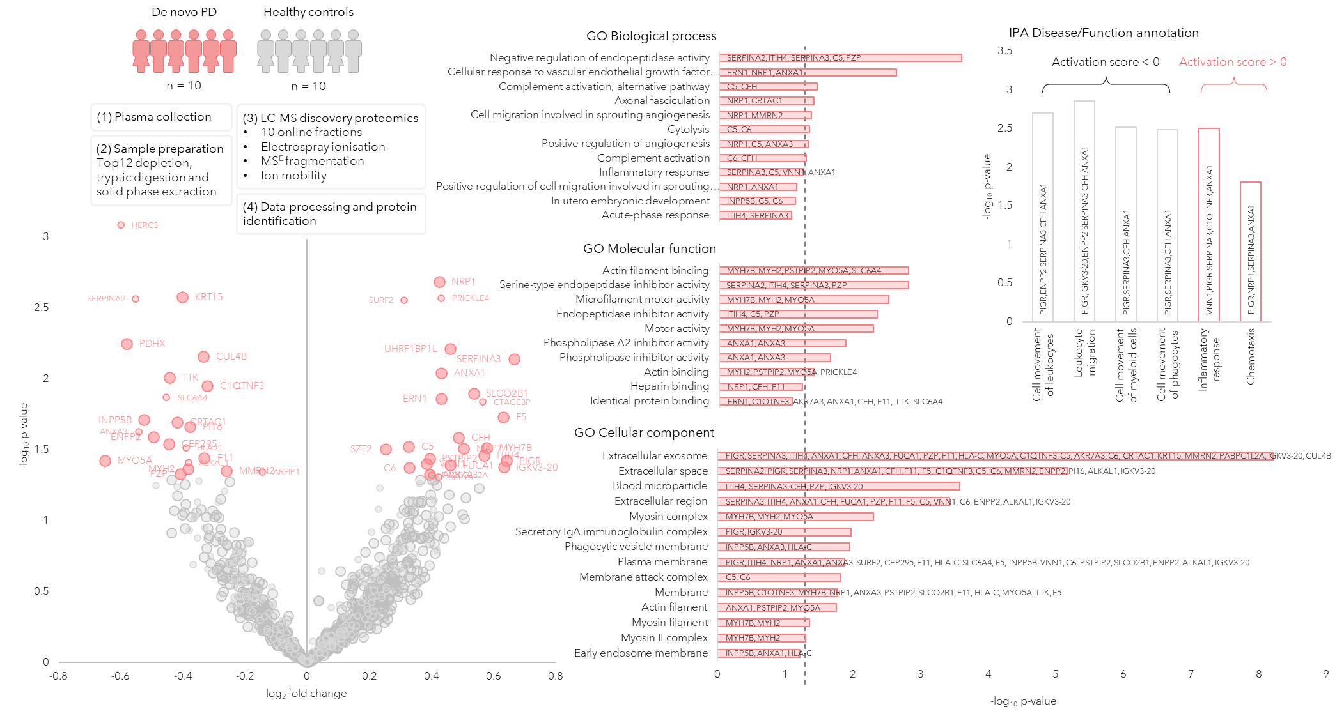
Supplementary Figure S1. Proteomic Discovery step in plasma samples of de novo PD and healthy controls represented by a Volcano plot showing the protein expression differences between PD and controls. The circle radii represent the identification certainty, where large radii represent proteins identified by at least two unique peptides and an identification score > 15, smaller radii are given for proteins identified by 2 or more unique peptides or a confidence score > 15. The horizontal axis shows log₂ of the average fold change and the vertical axis shows -log₁₀ of the p-values. The significantly different proteins are annotated by gene name. GO annotations for the significant proteins are shown, the dashed line represents p = 0.05. Disease and function annotations from IPA are shown, divided into annotations with a positive or negative activation score.

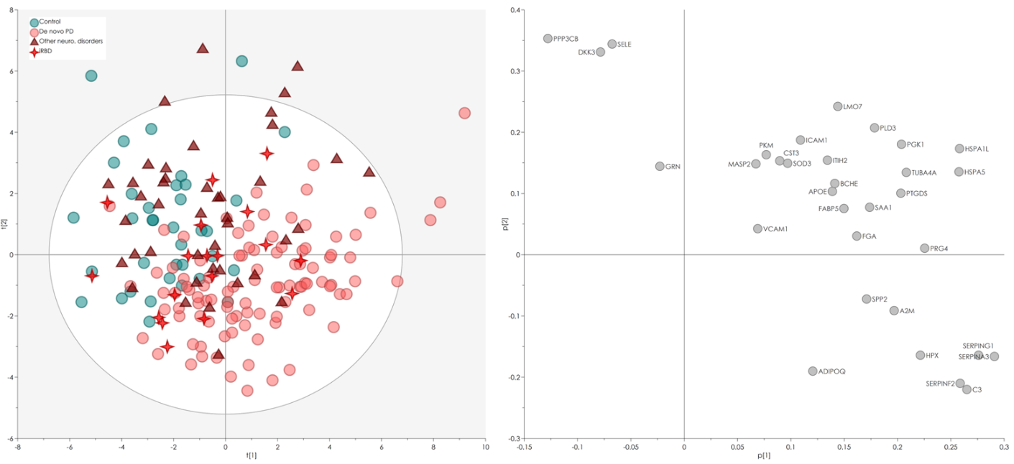
Supplementary Figure S2. Principal component analysis of the targeted proteomics data showing all groups.
(A) PC1 (23.5%) and PC2 (13.9%) show a separation between de novo PD and controls. The iRBD samples distribute between de novo PD and controls while other neurological disorders mainly cluster with controls, indicating that some iRBD patients could be developing the early hallmarks of motor disease (B) The loadings demonstrate that de novo PD are correlated with lower levels of PPP3CB, DKK3, SELE, and GRN.

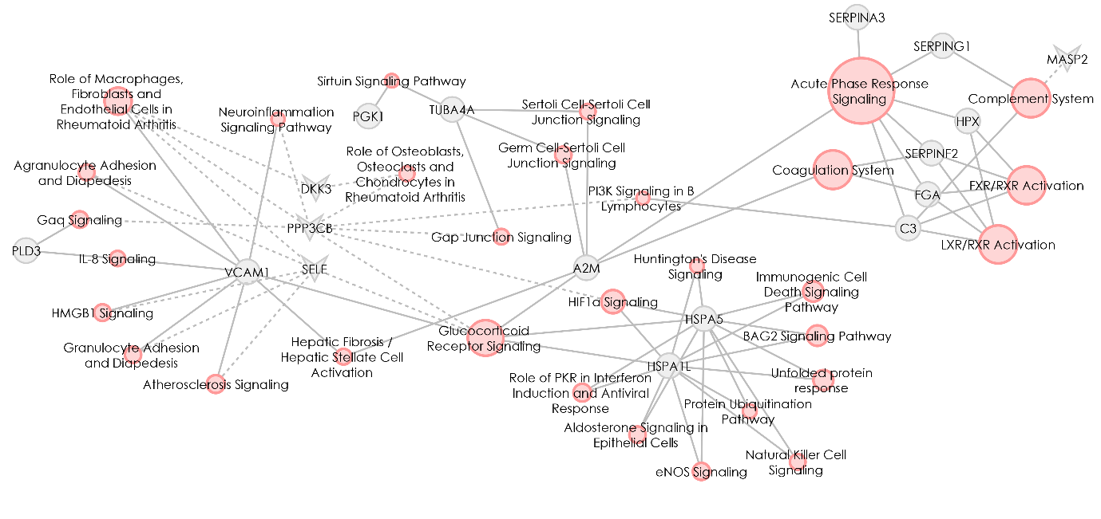
Pathway Enrichment
-log₁₀(p-value)
1.3
9.1
Protein
Pathway
Upregulated
Downregulated

Supplementary Figure S3. Pathway enrichment based on the expression of the proteins that were demonstrated as being significantly different between PD (n = 99) and controls (n = 36) from the targeted proteomic assay.
The analysis was performed in Ingenuity Pathway Analysis using the expression fold-change between the groups. Pathways with an enrichment p-value < 0.05 and at least two proteins were considered. Pathways are represented by pink nodes and proteins by grey nodes. Solid edges represent upregulation of a protein in the PD group compared to controls, while dotted edges represent downregulation. The pathways’ node sizes represent the significance of the enrichment p-values, larger being more significant. The proteins are annotated by gene names.

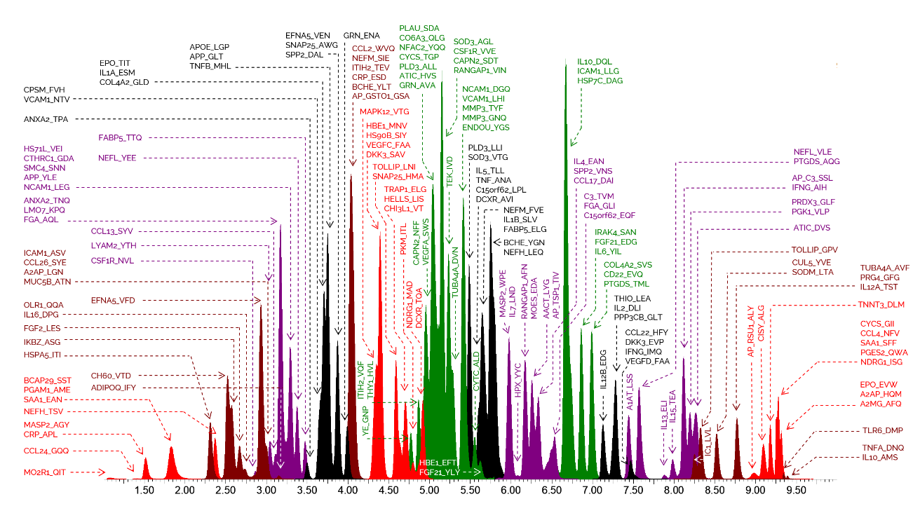
Supplementary Figure S4. Annotated chromatogram showing the elution profile in a sample of synthetic peptide standards from the targeted proteomic assay.
The peptides are annotated by gene name or Uniprot entry and followed by the first three amino acids.

