Supplementary Material

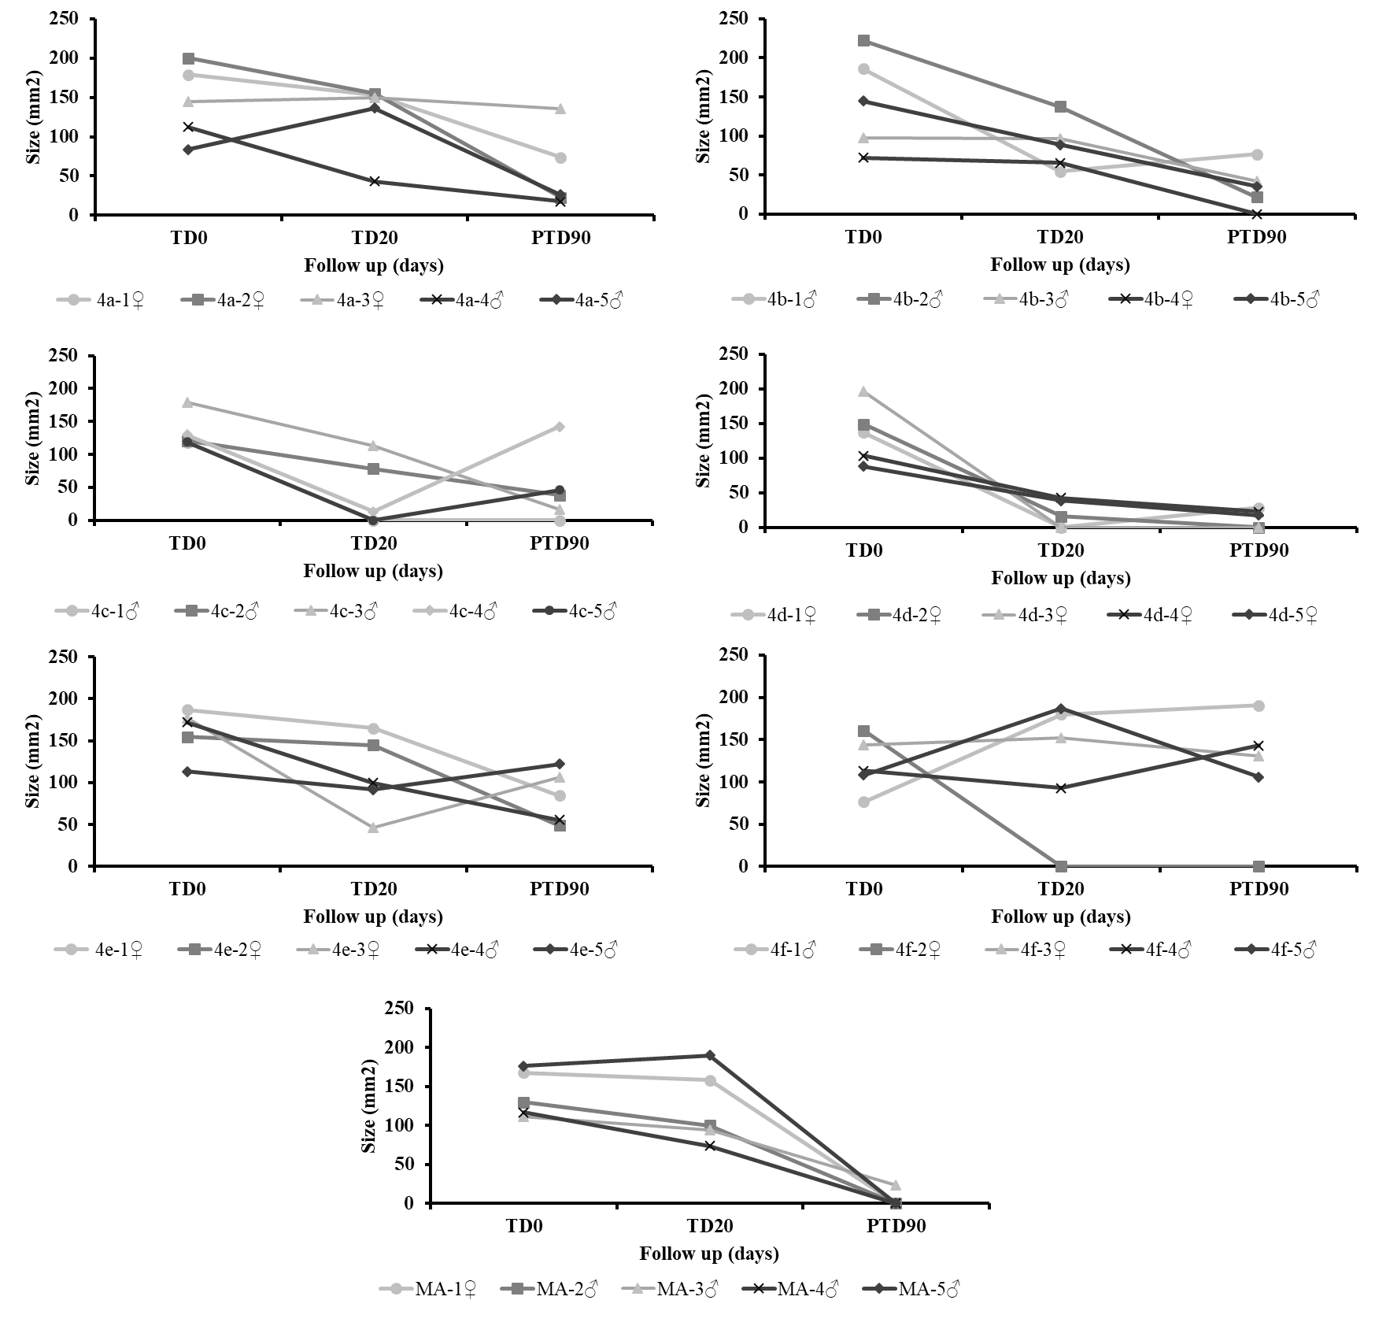
Figure S1. Therapeutic response of hamsters with Cutaneous Leishmaniasis (LC) to the treatment with (4a-4f) vs Meglumine Antimoniate. Response was evaluated in hamsters treated with 1% cream formulation of 4a-4f at dose of 40 mg/day (topic) vs. intralesional meglumine antimoniate (MA). Lines represent the evolution of lesion size in mm² before and after treatment follow up. TD0: Before treatment; TD20 last day of treatment; PTD30: day 30 after the end of treatment; PTD60: day 60 after treatment ended; PTD90: day 90 after the end of treatment.

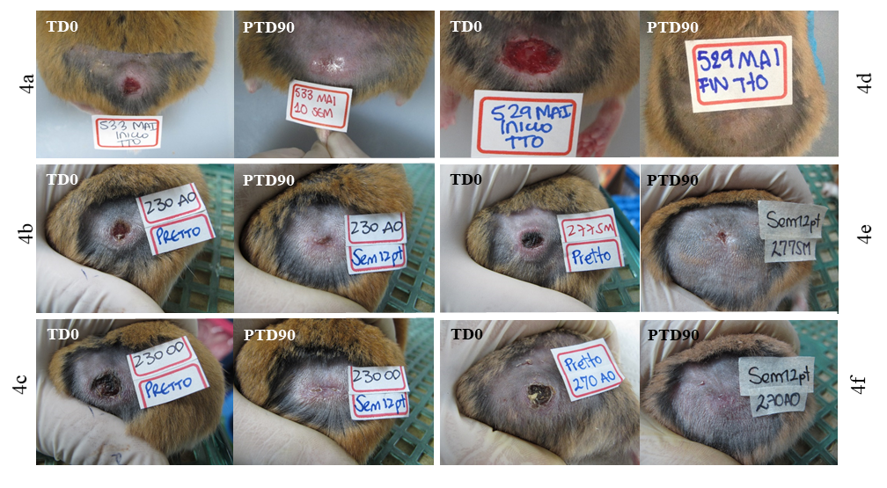
Figure S2. Treatment progress of cutaneous leishmaniasis (CL) caused by L. (V.) panamensis in hamsters treated with compounds 4a–f, before treatment (TD0) and on day 90 after the end of treatment (PTD90). Observe the decrease in the size of the lesion at three months after treatment, with respect to that at the beginning of the treatment

Figure S3. Changes in the weight of hamsters infected with L (V.) panamensis after treatment with 1% 4a-4f cream formulation. The x-axis corresponds to time points of study, while the y-axis shows the weight average of hamsters from before treatment until the end of the study. Data represents median of weight ± standard deviation. TD0: before treatment; TD20: last day of treatment; PTD30: day 30 after the end of treatment; PTD60: day 60 after treatment ended; PTD90: day 90 after the end of treatment.
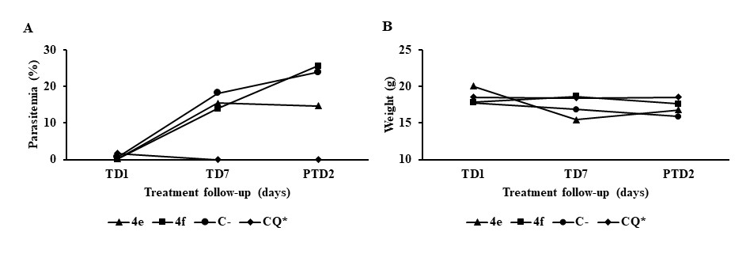
Figure S4. Efecto del tratamiento con 4e and 4f en la evolución de la infección por P. berghei en ratones Balb/c. La gráfica muestra la carga parasitaria (A) y el peso (B) al inicio del tratamiento (TD0), al final del tratamiento (TD7) y al final del estudio que correspondió al día 2 después de finalizado el tratamiento (PTD2). *El ultimo día de tratamiento con CQ fue el día 4.

Table S1. Canonical SMILES and formula of compounds designed as leishmaniasis inhibitors.
Molecule | Canonical SMILES | Formula
4a | CC(=O)Oc1ccccc1/C=C/c1ccc2c(n1)cccc2 | C₁₉H₁₅NO₂
4b | CC(=O)Oc1ccccc1/C=C/c1ccc2c(n1)c(O)ccc2 | C₁₉H₁₅NO₃
4c | COc1cccc(c1OC(=O)C)/C=C/c1ccc2c(n1)cccc2 | C₂₀H₁₇NO₃
4d | COc1cccc(c1OC(=O)C)/C=C/c1ccc2c(n1)c(O)ccc2 | C₂₀H₁₇NO₄
4e | CC(=O)Oc1ccc(cc1/C=C/c1ccc2c(n1)cccc2)Br | C₁₉H₁₄BrNO₂
4f | CCOc1cc(/C=C/c2ccc3c(n2)cccc3)ccc1OC(=O)C | C₂₁H₁₉NO₃

Table S2. Toxicological parameters measured in the in vivo assay (4a-f)
Compound | ALT (UI)  R.V: 22-128 |  | Creatinina (mg/dL)  R.V 0.3-1.0 |  | BUN (mg/dL)  R.V 25-55
Compound | TD0 | TD8 | TD0 | TD8 | TD0 | TD8
4a | 62.7+7.7 | 64.5+11.7 | 0.35+0.1 | 0.3+0.1 | 31.5+3.7 | 39.0+1.8
4b | 55.3+5.8 | 69.3+10.1 | 0.3+0 | 0.3+0 | 27.3+0.6 | 30.0+2.0
4c | 78.7+8.6 | 60.8+6.9 | 0.4+0.06 | 0.4+0.1 | 26.4+5.8 | 36.9+3.1
4d | 57.4+2.3 | 71.0+14.1 | 0.35+0.05 | 0.4+0.06 | 31.7+1.2 | 33.0+4.0
4e | 62.0+8.8 | 63.7+11.7 | 0.4+0.05 | 0.37+0.06 | 29.9+2.1 | 35.4+5.5
4f | 76.8+11.2 | 51.0+8.1 | 0.4+0.05 | 0.5+0.05 | 34.3+2.3 | 34.0+6.2
MA | 72.3+16.6 | 74.5+10.2 | 0.43+0.08 | 0.4+0.1 | 38.6+15.8 | 42.5+9.7
Data represent the mean values + SD. TD0: Before Treatment; TD8: 8 days of Treatment. MA: meglumine antimoniate
Table S3. Molecular docking results for 4a–f in the LmDHODH. The interacting residues within a radius of 3Å and the most relevant hydrogen bonds in the complexes are shown.
LmDHODH
Compound | H-bonds interaction | Residue interaction
4a | - | asn128, asn54, asn68, gly101, gly71, leu102, leu72, met70, ser100, ser103, ser130, ser69, val140
4b | - | asn128, asn195, asn68, gly101, gly71, leu102, leu129, leu72, lys44, met70, ser100, ser130, ser196, val140
4c | asn68 | asn128, asn195, asn68, gln139, gly101, gly220, leu102, leu72, lys44, met70, ser100, ser130, ser196, val140
4d | asn68 | asn128, asn68, gln139, gly101, gly220, leu102, leu129, leu72, lys44, met70, ser100, ser130, ser196, ser69, val140
4e | fmn | asn107, asn128, asn68, gln139, gly101, gly220, leu102, leu129, leu72, ser100, ser130, ser196, val140, fmn
4f | - | asn107, asn128, asn195, asn68, cys150, gly101, gly220, gly71, leu102, leu129, leu72, lys44, met70, ser100, ser103, ser130, ser196, ser69, val140

Table S4. Molecular docking results for 4a–f in the LmTXNPx. The interacting residues within a radius of 3Å and the most relevant hydrogen bonds in the complexes are shown.
LmTXNPx
Compound | H-bonds interaction | Residue interaction
4a | val172, leu46, met147, phe50 | arg128, arg140, cys52, glu167, leu46, met147, phe50, pro148, pro186, pro45, thr49, val166, val172, val51
4b | val172, leu46, met147, phe50 | arg128, arg140, cys52, leu46, met147, phe50, pro148, pro186, pro45, thr49, val166, val172, val51
4c | pro148, thr49 | arg128, arg140, asn9, asp146, leu46, met147, phe50, pro148, pro45, thr49, tyr127, val125, val166, val172, val51
4d | val172 | arg128, asn9, asp146, cys52, leu46, met147, phe50, pro148, pro186, pro45, thr49, val172, val51
4e | pro148, val125, phe50, met147 | arg128, cys52, glu171, gly170, leu46, met147, phe50, pro148, pro186, pro45, thr49, val125, val166, val172, val51
4f | met147, phe50 | arg128, asn9, cys52, gln123, glu120, leu46, met147, phe50, pro148, pro186, pro45, ser122, thr49, val125, val172, val51

Figure S5. Analysis of six physicochemical properties (lipophilicity, size, polarity, solubility, flexibility, and saturation) using bioavailability radar plot representations. The shaded area represents the range of properties to be considered drug-like. The black line represents the properties of the test molecules.
Figure S6. Predictive human intestinal absorption (HIA) model and blood–brain barrier permeation (BBB) method (boiled-egg plot) of the six considered compounds (4a–f).

Figure S7. Last snapshot (taken at 70 ns) of molecular dynamics simulations of LmDHODH in complex with FMN molecule and compounds 4a–f at BP1 site. LmDHODH is represented in white, FMN is coloured cyan, and 4a–f are coloured grey.

Figure S8. Distance (as a function of simulation time) between the centre of mass of the LmDHODH protein and centre of mass compounds 4a–f. BP1 and BP2 correspond to LmDHODH binding sites one and two, respectively.

Figure S9. Percentage rate of interaction between LmDHODH residues and compounds 4a–f.

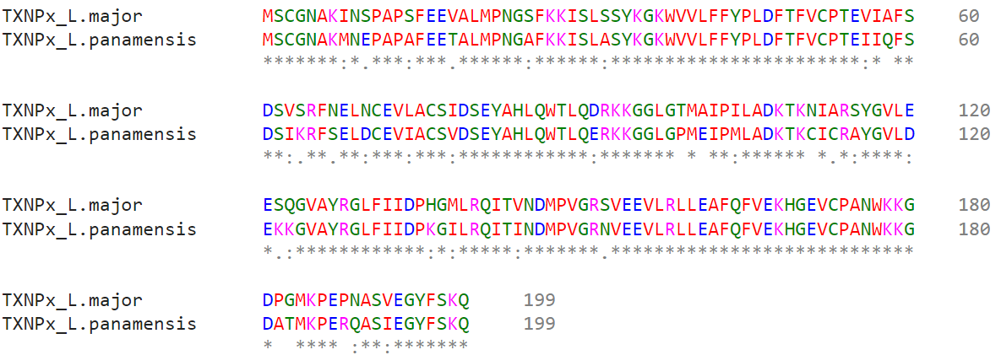

Figure S10. Alignment between LmTXNPx and LpTXNPx protein sequences.

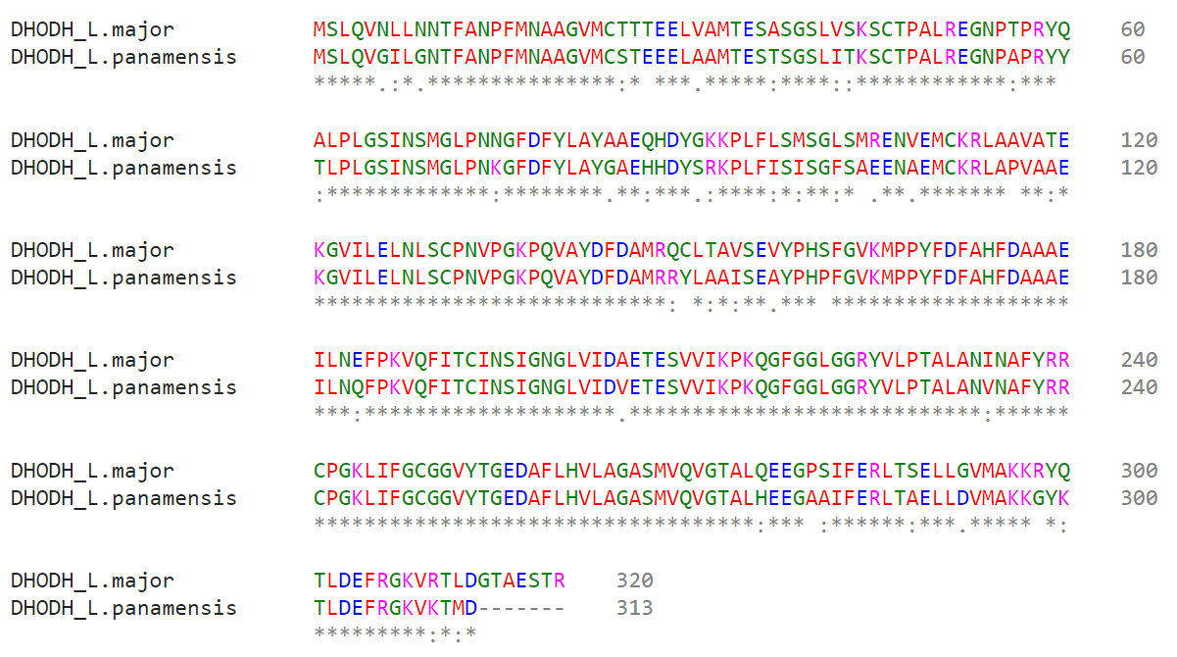
Figure S11. Alignment between LmDHODH and LpDHODH protein sequences.

