Photocatalytic degradation of Emtricitabine, Lamivudine, and Tenofovir in water using the UV/TiO₂/H₂O₂ hybrid system

Environmental Science and Pollution Research

*Caliphs Zvinowanda^{b}, Pauline Ncubeª, Freeman Ntuli^{a,c}
ªDepartment of Chemical Engineering, University of Johannesburg P. O box 17011, Doornfontein 2028, Johannesburg, South Africa
^{b}Department of Chemical Sciences, University of Johannesburg P. O box 17011, Doornfontein 2028, Johannesburg, South Africa
^{c}Department of Chemical, Materials and Metallurgical Engineering, Botswana International University of Science and Technology, Private Mail Bag 16, Palapye, Botswana
Corresponding author: czvinowanda@uj.ac.za

Supplementary information

S1 physicochemical properties of FTC, LVD, and NVP

Table S1 Physicochemical properties of FTC, LVD, and TFV (Cited from PubChem) (PubChem, n.d.)
Compound | Chemical structure | Water Solubility (mg/ml) | pka | Log K_{ow}
NRTI
FTC | 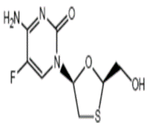  C₈H₁₀FN₃O₃S (247.25 g/mol) | 112 | 2.65 | -0.43
LVD | 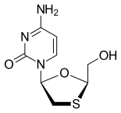  C₈H₁₀FN₃O₃S (247.25 g/mol) | 70 | 4.3 | -1.4
TFV | 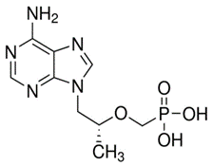  C₉H₁₄N₅O₄P (287.21g/mol) | 13.4 | 3.8, 6.7 | 1.06

Table S1 shows that FTC and LVD have high solubilities compared to TFV. This could be due to the presence of the terminal -OH on FTC and LVD, which is more electronegative than the H₂PO₄⁻ group. The pKa values indicate that all the compounds are weakly basic, while the log Kow suggests a high potential to persist in the aqueous matrix.
S2. LC-MS/MS analysis
The samples were analyzed using the Shimadzu LCMS-8040 spectrometer. The analytes were separated on a Waters Xbridge, reversed-phase C18 column (3.5 μm particle size, 150 mm length × 4.6 mm I.D), set at 40◦C. While mobile phase (B) was composed of 0.1% formic acid in 1:1(v/v) acetonitrile/methanol, mobile phase (A) contained 0.1% formic acid in water. The injection volume was 10 µl, and the flow rate was 0.2 ml/min. Gradient elution was run for 15 minutes to separate the pollutants, as shown in Table S2.
Table S2 Gradient elution for FTC, LVD and NVP
Time (min) Flow (ml/min) Solvent B (%)
1 | 0.0 | 0.2 | 50
2 | 0.5 | 0.2 | 50
3 | 8.5 | 0.2 | 95
4 | 10.0 | 0.2 | 50
5 | 11.0 | 0.2 | 50
6 | 15.0 | 0.2 | 50

The MS analysis was executed with positive electrospray ionization (ESI+) mode. The source parameters were, drying gas (Ar) temperature 250⁰C, source temperature 400⁰C, capillary voltage 4.5 KV, detector voltage 1.74 KV and collision-induced dissociation (CID) gas 230 KPa. The optimized MS/MS conditions for the target contaminants are shown in Table S3.

Table S3 Optimized MS/MS conditions for FTC, LVD and TFV degradations
Analyte | precursor m/z | Product m/z | RT (min) | Q1 Pre Bias (V) | CE | Q3 Pre (Bias)
FTC | 248.2 | 130.5 | 8.131 | -16 | -21 | -23
 | 248.2 | 113.5 | 7.928 | -14 | -44 | -23
LVD | 230.1 | 112.1 | 8.082 | -11 | -12 | -21
 | 230.1 | 31.1 | 7.948 | -25 | -50 | -12
 | 230.1 | 69.2 | 7.998 | -11 | -36 | -29
 | 230.1 | 226 | 8.324 | -15 | -35 | -15
 | 230.1 | 95.1 | 8.001 | -11 | -39 | -18
TFV | 288.1 | 176.1 | 7.454 | -14 | -25 | -19
 | 288.1 | 159.1 |  | -10 | -32 | -30
RT- Retention time

Table S4 Calibration data for FTC, LVD, and TFV
 | R² | slope
FTC | 0.99998 | 4.52855
LVD | 0.99999 | 3.28496
TFV | 0.99988 | 1.53500

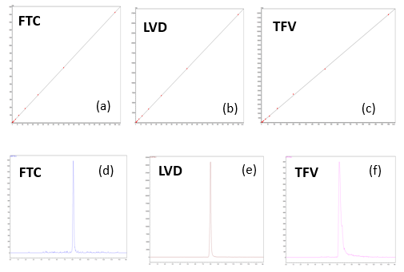
Fig. S1 Calibration curves (a- c) and corresponding total ion chromatograms (d-f) for FTC, LVD, and TFV.

S3. UV/Visible
In this work, it was essential for the TiO₂ (A/R) to be able to absorb UV/visible radiation because it supplied the photons needed for catalytic activation. Fig. S2 presents the UV/Visible spectra obtained.
Fig. S2 UV-Visible absorption spectra for FTC, LVD and TFV (100 mg/L) and TiO₂(10 mg/L)

S4 Optimization process
Table S5 and Table S6 give the CCD predicted experimental schedules.
Table S5 Experimental Schedule for the optimization of FTC and LVD degradation.
Run | pH | Concentration (μg/L | Catalyst (mg/L) |  | H₂O₂(%) | Time
1 | 10 | 5 | 0.2 | 2 |  | 5
2 | 6.5 | 27.5 | 0.7 | 10 |  | 32.5
3 | 3 | 50 | 1.2 | 2 |  | 60
4 | 10 | 50 | 0.2 | 10 |  | 5
5 | 3 | 50 | 0.2 | 10 |  | 60
6 | 10 | 50 | 0.2 | 2 |  | 60
7 | 6.5 | 27.5 | 0.2 | 6 |  | 32.5
8 | 6.5 | 27.5 | 0.7 | 6 |  | 32.5
9 | 6.5 | 50 | 0.7 | 6 |  | 32.5
10 | 6.5 | 27.5 | 0.7 | 6 |  | 32.5
11 | 6.5 | 27.5 | 0.7 | 6 |  | 32.5
12 | 10 | 50 | 1.2 | 2 |  | 5
13 | 10 | 50 | 1.2 | 10 |  | 60
14 | 3 | 50 | 1.2 | 10 |  | 5
15 | 3 | 5 | 0.2 | 2 |  | 60
16 | 10 | 5 | 0.2 | 10 |  | 60
17 | 6.5 | 27.5 | 0.7 | 6 |  | 5
18 | 6.5 | 27.5 | 0.7 | 6 |  | 32.5
19 | 6.5 | 27.5 | 0.7 | 6 |  | 32.5
20 | 3 | 5 | 1.2 | 2 |  | 5
21 | 6.5 | 27.5 | 1.2 | 6 |  | 32.5
22 | 6.5 | 27.5 | 0.7 | 2 |  | 32.5
23 | 6.5 | 27.5 | 0.7 | 6 |  | 60
24 | 3 | 27.5 | 0.7 | 6 |  | 32.5
25 | 10 | 5 | 1.2 | 10 |  | 5
26 | 3 | 5 | 1.2 | 10 |  | 60
27 | 6.5 | 5 | 0.7 | 6 |  | 32.5
28 | 6.5 | 27.5 | 0.7 | 6 |  | 32.5
29 | 10 | 27.5 | 0.7 | 6 |  | 32.5
30 | 10 | 5 | 1.2 | 2 |  | 60
31 | 3 | 50 | 0.2 | 2 |  | 5
32 | 3 | 5 | 0.2 | 10 |  | 5

Table S6 Experimental Schedule for the optimization of TFV degradation.
Run | pH | Concentration (mg/L) | catalyst (mg/L) | H₂O₂ (%) | time (min)
1 | 7 | 60 | 1.25 | 2 | 32.5
2 | 11 | 20 | 2 | 10 | 5
3 | 11 | 100 | 0.5 | 10 | 5
4 | 3 | 20 | 0.5 | 2 | 60
5 | 11 | 20 | 2 | 2 | 60
6 | 11 | 100 | 2 | 10 | 60
7 | 11 | 100 | 2 | 2 | 5
8 | 7 | 60 | 1.25 | 6 | 32.5
9 | 11 | 20 | 0.5 | 2 | 5
10 | 11 | 100 | 0.5 | 2 | 60
11 | 7 | 60 | 2 | 6 | 32.5
12 | 7 | 60 | 1.25 | 6 | 5
13 | 7 | 60 | 1.25 | 6 | 60
14 | 7 | 60 | 1.25 | 6 | 32.5
15 | 7 | 60 | 1.25 | 6 | 32.5
16 | 7 | 20 | 1.25 | 6 | 32.5
17 | 7 | 60 | 1.25 | 6 | 32.5
18 | 7 | 60 | 0.5 | 6 | 32.5
19 | 7 | 60 | 1.25 | 6 | 32.5
20 | 7 | 60 | 1.25 | 10 | 32.5
21 | 3 | 20 | 2 | 10 | 60
22 | 3 | 20 | 2 | 2 | 5
23 | 7 | 100 | 1.25 | 6 | 32.5
24 | 3 | 60 | 1.25 | 6 | 32.5
25 | 3 | 100 | 2 | 10 | 5
26 | 11 | 60 | 1.25 | 6 | 32.5
27 | 3 | 100 | 0.5 | 2 | 5
28 | 11 | 20 | 0.5 | 10 | 60
29 | 7 | 60 | 1.25 | 6 | 32.5
30 | 3 | 100 | 0.5 | 10 | 60
31 | 3 | 20 | 0.5 | 10 | 5
32 | 3 | 100 | 2 | 2 | 60

The empirical model representing the relationship between the experimental factors and the pollutant removals (without irrelevant variables) is given in Eq. (19)- (21).
FTC (%) = 87.05 - 15.84 A + 0.994 B + 49.24 C + 1.361 D + 0.253 E + 0.6543 A² - 0.01741 B² - 30.92 C - 0.01524AB + 1.146 AC + 0.2890 AD + 0.01112 AE + 0.4107 BC - 0.04017 BD - 0.004467 BE - 1.141 CD (4.4)

LVD (%) = -65.13 + 35.95 pH + 0.432 B + 17.1 C + 1.80 D - 0.714 E - 0.0314 AB + 1.671 AC - 0.2451 AD + 0.00580 BE (4.5)

% TFV = 41.95 + 9.98 A - 0.059 B - 27.51 C - 9.45 D + 1.293 E - 0.8351 A² + 0.003809 B² + 17.18 C² + 0.3282 D² - 0.01249 E² - 0.01954 AB - 0.763 AC + 0.2517 AD - 0.2365 BC + 1.460 CD + 0.03919 DE (4.6)

The effect of a particular factor is represented by its regression coefficient, whereas the interaction between elements is shown by a coefficient with more than one factor. A positive coefficient implies the synergistic effect of the variable, whereas a negative one suggests an antagonistic result. The Pareto chart displays the contributions of individual variables and their combinations to mark their significance (An et al., 2015). Fig. S3 illustrates the Pareto charts for FTC, LVD, and TFV, respectively.
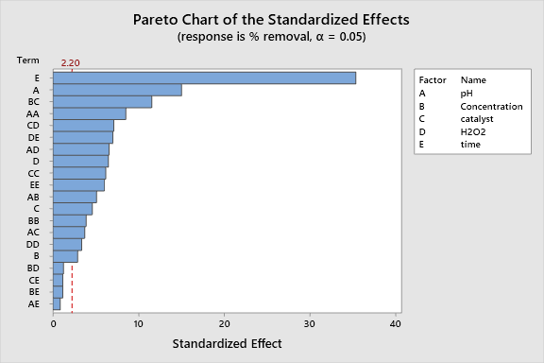
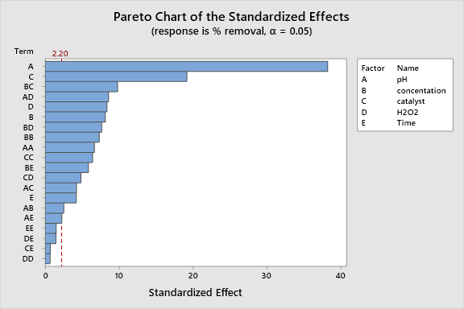
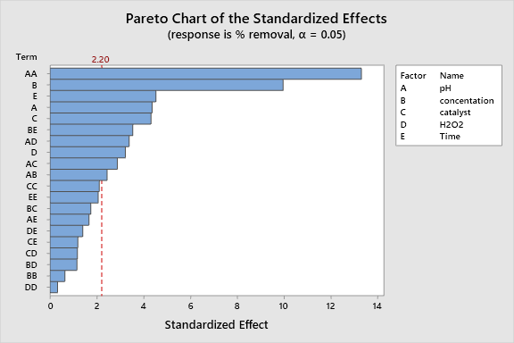
D, and NVP removals.
TFV
FTC
LVD

Fig. S3 Pareto chart of the standardized effects of variables on FTC, LVD, and TFV removals.

Table S7 ANOVA analysis of FTC and LVD experimental data
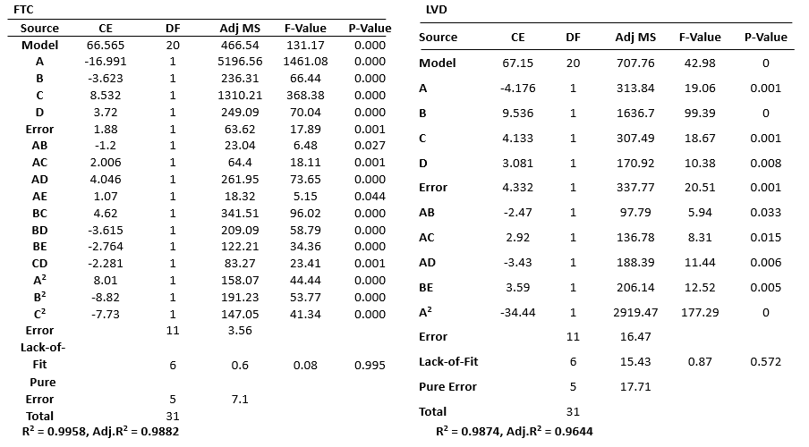
Table S8 ANOVA analysis of TFV degradation results
Source | CE | DF | Adj MS | F-Value | P-Value
Model | 53.21 | 20 | 608.48 | 100.72 | 0.000
A | -8.72 | 1 | 1367.31 | 226.34 | 0.000
B | -1.67 | 1 | 50.34 | 8.33 | 0.015
C | 2.67 | 1 | 128.01 | 21.19 | 0.001
D | -3.76 | 1 | 254.26 | 42.09 | 0.000
Error | 20.49 | 1 | 7559.76 | 1251.39 | 0.000
AB | -3.13 | 1 | 156.44 | 25.90 | 0.000
AC | -2.29 | 1 | 83.80 | 13.87 | 0.003
AD | 4.03 | 1 | 259.45 | 42.95 | 0.000
BC | -7.10 | 1 | 805.71 | 133.37 | 0.000
CD | 4.38 | 1 | 306.78 | 50.78 | 0.000
DE | 4.31 | 1 | 297.40 | 49.23 | 0.000
A² | -13.36 | 1 | 439.37 | 72.73 | 0.000
B² | 6.09 | 1 | 91.39 | 15.13 | 0.003
C² | 9.66 | 1 | 229.85 | 38.05 | 0.000
D² | 5.25 | 1 | 67.85 | 11.23 | 0.006
E² | -9.44 | 1 | 219.39 | 36.32 | 0.000
Error |  | 11 | 6.04
Lack-of-Fit |  | 6 | 6.07 | 1.01 | 0.506
Pure Error |  | 5 | 6.00
Total |  | 31

The P-value of the ANOVA test is used to determine each coefficient's significance or lack thereof, with values 0.05 implying significance. The model has a p-value of 0.000, indicating high model significance (Tables S7 and S8). The LOF tool measures residual error relative to pure error. A good model fit is represented by p(LOF) > 0.05, which agrees with Table S7 and S8. p(LOF) > 0.05 further illustrates adequate prediction of the model, while R² values ≈ 1 affirms the model’s capability to describe the degradations of FTC, LVD and TFV.

FTC
LVD
TFV

Fig. S4 Actual vs. predicted plots for FTC, LVD, and TFV removals.
The experimental data points are in close proximity to the straight line, demonstrating a high degree of agreement between the predicted and observed responses. This also proves the proposed model's suitability for modelling the experimental data.
The 3D surface and related 2-D contour plots provide a graphical representation of the regression equations, to examine the interaction effect of experimental conditions. The plots for the FTC, LVD, and TFV degradations are displayed in Fig. S5 - S7 (a)- (j)
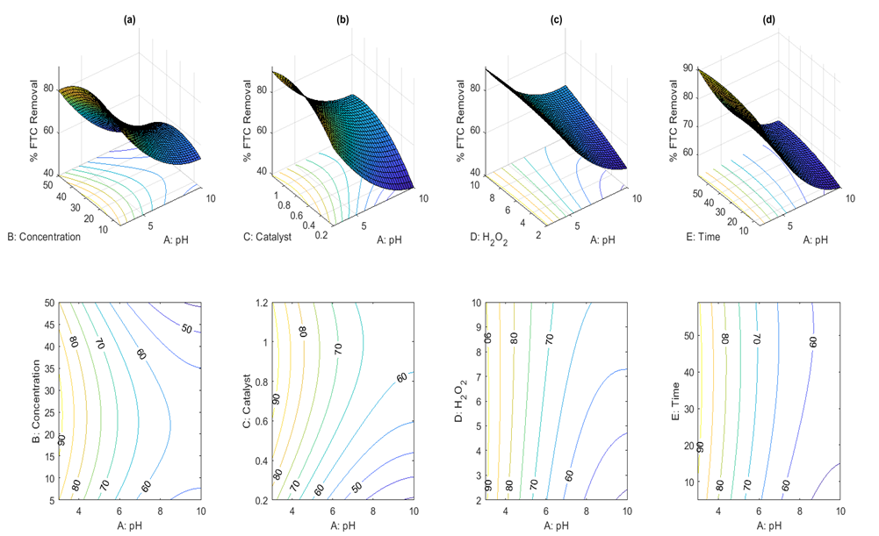
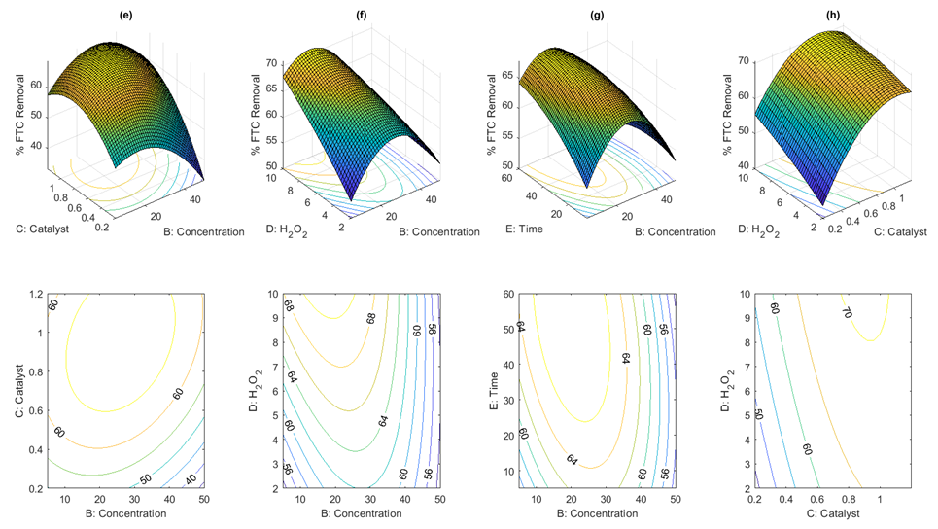

Fig. S5 3D surface and corresponding contour plots for FTC removal as a function of the interactions (a) pH/A-concentration/B(μg/L), (b) pH/A-catalyst/C (mg/L), (c) pH/A-H₂O₂/D (%), (d) pH/A-time/E (min), (e) concentration/B(μg/L)-catalyst/C(mg/L)-, (f) concentration/B (μg/L)-H₂O₂/D (%L), (g) catalyst/C (mg/L)-time/E (min)-, (h) catalyst/C (mg/L)-H₂O₂/D (%)
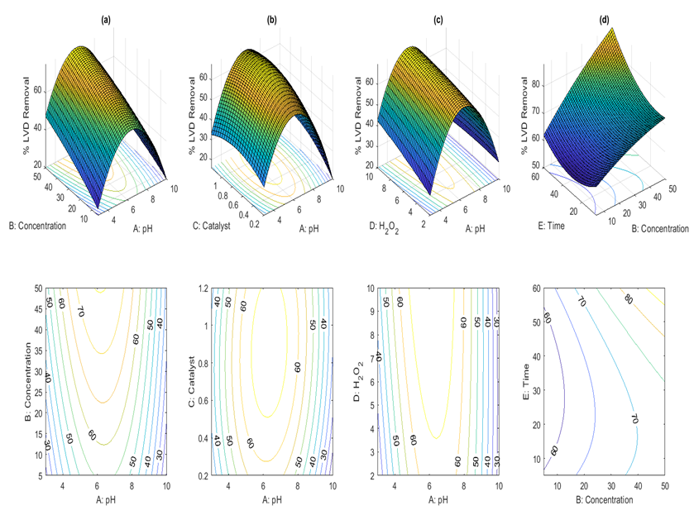
Fig. S6 3D surface and corresponding contour plots for LVD removal as a function of the interactions (a) pH/A-concentration/B (μg/L), (b) pH/A-catalyst/C (mg/L), (c) pH/A-H₂O₂/D (%), (d) Concentration/B (μg/L)-time/E (min)

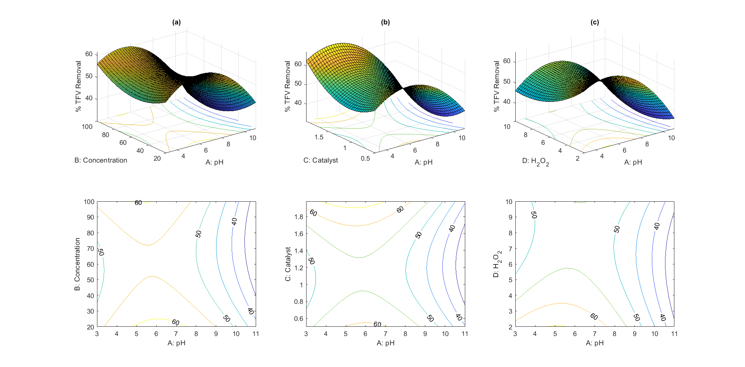
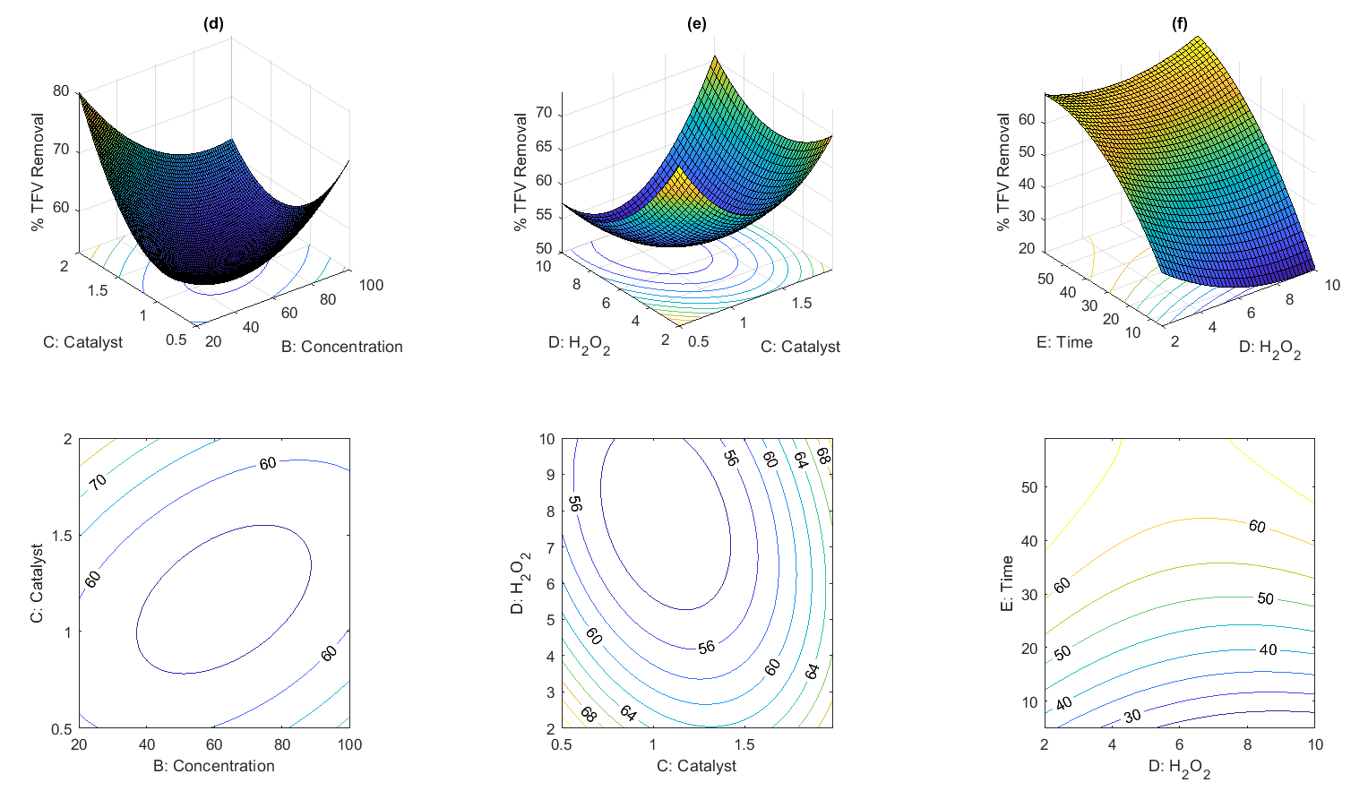
Fig. S7 3D surface and corresponding contour plots for TFV removal as a function of the interactions (a) pH/A-concentration/B (mg/L), (b) pH/A-catalyst/C (g/L), (c) pH/A-H₂O₂/D (%), (d) concentration/B(mg/L)-catalyst/C(g/L),(e) catalyst/C(g/L)-H₂O₂/D(%)-(f) H₂O₂/D (%)-time/E (min)

S5. Degradation kinetics
To determine the individual and combined contributions of different processes, preliminary studies were carried out under optimum conditions. Table S9 shows the results.
Table S9 Preliminary experimental results
Degradation Process |  | Removal (%)
 |  | FTC | LVD | TFV
TiO₂ only (dark) | Adsorption | 4.61 | 4.33 | 3.17
H₂O₂ only | Chemical Oxidation | 3.9 | 4.18 | 6.71
TiO₂/H₂O₂ | Catalytic Oxidation | 7.42 | 9.67 | 9.36
UV only | Photolysis | 33.38 | 31.54 | 30.44
UV/H₂O₂ | Photooxidation | 56.74 | 49.28 | 53.62
UV/TiO₂ | Photocatalysis | 79.28 | 71.93 | 77.39
UV/TiO₂/H₂O₂ | Photocatalysis | 92.56 | 91.67 | 94.83

Table S10 Anova: Two-Factor Without Replication for the preliminary results
SUMMARY | Count | Sum | Average | Variance
Row 1 | 3 | 12.11 | 4.036667 | 0.582933
Row 2 | 3 | 14.79 | 4.93 | 2.3959
Row 3 | 3 | 26.45 | 8.816667 | 1.487033
Row 4 | 3 | 95.36 | 31.78667 | 2.206533
Row 5 | 3 | 159.64 | 53.21333 | 14.03693
Row 6 | 3 | 228.6 | 76.2 | 14.5677
Row 7 | 3 | 279.06 | 93.02 | 2.6551
Column 1 | 7 | 277.89 | 39.69857 | 1374.334
Column 2 | 7 | 262.6 | 37.51429 | 1213.18
Column 3 | 7 | 275.52 | 39.36 | 1346.976
ANOVA
Source of Variation | SS | df | MS | F | P-value | F crit
Rows | 23550.43 | 6 | 3925.071 | 833.4172 | 5.25E-15 | 2.99612
Columns | 19.34892 | 2 | 9.674462 | 2.054195 | 0.170913 | 3.885294
Error | 56.51534 | 12 | 4.709612
Total | 23626.29 | 20
The analysis of the reaction kinetics was essential to understanding the mechanism of the degradation process. The best conditions for efficient pollutant deterioration were determined using the rate constant. R² ≈ 1 denoted an excellent fit of the experimental data to the L-H model. Table S11 displays the results.
Table S11 Effect of pH and H₂O₂ on the rate constant.
 | Effect of pH
 |  | FTC |  |  | LVD |  |  |  | TFV
 | pH 3 | pH 6 | pH 10 |  | pH 3 | pH 6 | pH 10 |  | pH 3 | pH 5.0 | pH 10
k₁ | 0.1077 | 0.061 | 0.0194 |  | 0.0089 | 0.0476 | 0.0247 |  | 0.011 | 0.0513 | 0.0244
R² | 0.9995 | 0.9985 | 0.9998 |  | 0.9991 | 0.9989 | 0.9999 |  | 0.9991 | 0.9996 | 0.9995
 |  | Effect of H₂O₂
 | 2% | 6% | 10% |  | 2% | 6% | 10% |  | 2% | 6% | 10%
k₁ | 0.1077 | 0.0582 | 0.0385 |  | 0.0103 | 0.0212 | 0.0476 |  | 0.0513 | 0.0271 | 0.0142
R² | 0.9999 | 0.9991 | 0.9998 |  | 0.9999 | 0.9998 | 0.9991 |  | 0.999 | 0.9986 | 0.999

S6 Scavengers investigations
According to several references in the literature, the production of reactive species like h+, e-, O₂•-, and •OH is what drives the photocatalytic destruction of organic contaminants in water. Scavenger studies were carried out under optimum conditions to further understand how these reactants affect the removal of FTC, LVD and TFV in wastewater.
As widely cited in the literature, the photocatalytic degradation of organic pollutants is driven by the generation of reactive species such as h⁺, e⁻, O₂•^{-,} and •OH. To better comprehend the influence of these reactants on the elimination of NVP, scavenger experiments were performed under optimized conditions.
Table S12 The contribution of various reactive species on degradation kinetics
 |  | FTC |  |  |  | LVD |  |  |  | TFV
 | R² | k₁ | % Inhibition |  | R² | k₁ | % Inhibition |  | R² | k₁ | % Inhibition
No scav | 0.9995 | 0.1077 | 0.00 |  | 0.9998 | 0.0476 | 0.00 |  | 0.9996 | 0.0513 | 0.00
ISO | 0.9997 | 0.0083 | 92.31 |  | 0.9996 | 0.0024 | 95.06 |  | 0.9996 | 0.0042 | 91.92
EDTA | 0.9997 | 0.0217 | 79.88 |  | 0.9982 | 0.0074 | 84.42 |  | 0.9986 | 0.0029 | 94.41
KBRO3 | 0.9998 | 0.0837 | 22.32 |  | 0.9990 | 0.0323 | 32.13 |  | 0.9994 | 0.0403 | 21.60
Benzo | 0.9992 | 0.0931 | 13.57 |  | 0.9990 | 0.0356 | 25.11 |  | 0.9996 | 0.0361 | 29.61

References
An, J., Li, G., An, T., Song, W., Feng, H., & Lu, Y. (2015). Photocatalytic degradation of three amantadine antiviral drugs as well as their eco-toxicity evolution. Catalysis Today, 258, 602–609.
PubChem. (n.d.). National Library of Medicine (US), National Center for Biotechnology Information, PubChem Compound Summary for CID. Retrieved April 7, 2021, from https://pubchem.ncbi.nlm.nih.gov/

