Supplementary Materials

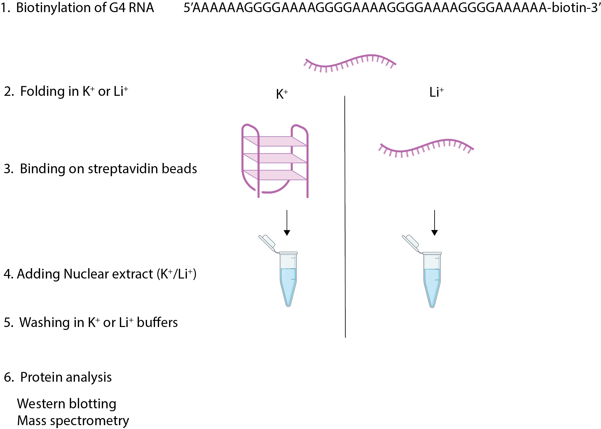

Supplementary Figure 1.
An overview of the experimental design for purification of proteins binding to G-quadruplex forming RNA oligo.

Supplementary Table 1.
catRAPID predictions of proteins binding to folded or linear G4A4. The first column contains gene name, second column corresponds to the Uniprot code, the third and fourth columns report the amino acids considered, fifth and sixth columns are the scores for the folded and linear G4A4, the seventh column is the average of the difference between columns sixth and seventh over all fragments of a protein, eight column is the maximal difference between columns sixth and seventh over all fragments of a protein.

Supplementary Table 2.
Detected proteins in all conditions in mass spectrometry.

Supplementary Table 3.
Proteins detected and differentially bound in mass spectrometry analysis, including QUADRatlas status.

Supplementary Table 4.
Chromatin RBPs from Conrad et al 2016 with prediction scores for binding to G4A4 in K⁺ and Li⁺ buffer.

Supplementary Table 5.
Secondary structure properties binding in presence of K⁺ and Li⁺ ions. First column is the AlphaFold name of the pdb. Second, third, fourth, fifth columns report the amount of Coil, Turn, Helix and Strand per protein. Sixth column is the protein length and seventh column the amount of structure normalized by length used in Figure 4d.

Supplementary Table 6.
Phase separation propensity of RBPs interacting with G4 in presence of K⁺ and Li⁺ ions.

Supplementary Table 7.
Condensation state of RBPs interacting with G4 in presence of K⁺ and Li⁺ ions.

Supplementary Table 8.
Proteome-wide chromatin-binding proteins with prediction scores for binding to G4A4 in K⁺ and Li⁺ buffer.

