Early gestural development in high-risk infants and its value on early detection of ASD
Appendix S1. Descriptive and inferential statistics for developmental age across HR and LR groups
 | 9–10 months |  |  |  | 12–13 months |  |  |  | 15–16 months |  |  |  | 18-19months
Subscales, M(R) | HR(nª=22) | LR(n=13) | Z | p | HR(n=29) | LR(n=19) | Z | p | HR(n=21) | LR(n=18) | Z | p | HR(n=14) | LR(n=10) | Z | P
Locomotor | 9.50(4.00) | 10.00(3.00) | -0.61 | 0.54 | 13.00(7.00) | 13.00(7.50) | -0.18 | 0.86 | 17.00(6.00) | 18.00(8.00) | -0.93 | 0.35 | 20.00(6.00) | 20.38(2.00) | 1.14 | 0.25
Personal-Social | 10.00(6.50) | 10.00(3.00) | -0.45 | 0.66 | 12.50(7.00) | 12.77(4.50) | -1.17 | 0.24 | 15.50(15.00) | 16.11(10.00) | -0.68 | 0.50 | 19.30(16.00) | 20.00(13.00) | 0.88 | 0.38
Language | 8.50(4.00) | 9.50(4.00) | -1.49 | 0.14 | 9.50(9.00) | 10.50(5.00) | -1.02 | 0.31 | 13.00(11.50) | 14.00(10.50) | -0.61 | 0.54 | 18.50(20.00) | 16.10(15.00) | -1.17 | 0.24
Eye-Hand Coordination | 10.50(5.50) | 10.50(3.50) | -0.02 | 1.00 | 14.00(7.00) | 14.00(2.00) | -0.66 | 0.51 | 17.00(7.50) | 16.00(9.00) | -0.55 | 0.58 | 20.50(5.00) | 18.75(10.00) | -0.67 | 0.50
Performance | 9.50(5.00) | 9.50(4.00) | -1.07 | 0.28 | 12.00(9.50) | 12.50(4.00) | -0.90 | 0.37 | 15.50(12.00) | 15.50(5.00) | -0.21 | 0.83 | 18.20(8.00) | 17.44(8.00) | -0.47 | 0.64
Note: M: Median, R: Range, a: Number of infants who completed certain follow-up node

Appendix S2. Descriptive and inferential statistics for developmental age across outcome groups
12–13 months（n=20） |  |  |  |  |  |  |  | 15–1 6 months(n=21) |  |  |  |  |  |  | 18-19months(n=21)
Subscales, M（R） |  | Group A  （nª=11） |  | Group N  (n=9) | Z | p |  | Group A（n=13） | Group N  (n=8) | Z |  | p |  |  | Group A  (n=15) | Group N  (n=6) |  | Z |  | p
Locomotor | 13.00(5.50) |  | 13.00(3.50) |  | -0.56 | 0.58 |  | 20.50(5.00) | 20.00(2.00) |  | -0.55 | 0.58 |  | 20.00(6.00) |  |  | 20.38(1.00) |  | -0.04 |  | 0.97
Personal-Social | 13.00(5.50) |  | 12.00(4.00) |  | -0.59 | 0.56 |  | 20.00(17.00) | 19.00(10.00) |  | -1.02 | 0.31 |  | 20.00(17.00) |  |  | 19.00(10.00) |  | -0.21 |  | 0.83
Language | 10.50(7.50) |  | 11.00(6.50) |  | -0.35 | 0. 73 |  | 19.00(16.00) | 16.00(14.00) |  | -0.71 | 0.48 |  | 18.50(20.00) |  |  | 18.00(14.00) |  | -0.29 |  | 0.77
Eye-Hand Coordination | 14.00(7.00) |  | 14.00(1.00) |  | -0.73 | 0.46 |  | 20.00(7.00) | 20.00(10.00) |  | -0.65 | 0.52 |  | 20.00(6.00) |  |  | 20.00(10.00) |  | -0.08 |  | 0.93
Performance | 12.50(9.50) |  | 12.50(7.30) |  | -0.31 | 0.76 |  | 18.00(8.00) | 20.00(5.00) |  | -1.33 | 0.19 |  | 16.50(8.00) |  |  | 20.00(4.00) |  | -1.55 |  | 0.12
Note: M: Median, R: Range, a: The number of people who completed GDS-C in Group A or Group N

Appendix S3. Tasks of Observation Procedure
- Free-play
Object(s): A toy plane
Have the child seated at the table (or on the caregiver's knees) turn on a toy plane that emits sound and light to attract the child's attention. Then, let the child operate the toy by himself (or herself) for about 1-5 minutes. The experimenter and caregiver can join in or respond to the child but must not dominate the play process.
- Wind-up toy
Object(s): A wind-up toy
Activate the wind-up toy and wait for the child to initiate a communication signal. If the child does not pick up the toy after the toy is deactivated, the experimenter hands the toy to the child and waits for 10 seconds. If the child does not have any communication behavior, use language to prompt the child, such as "I can help you"; if the child still does not have communication behavior, reach out to the child and use a language prompt again. If the child has initiated a communication behavior or the chances are used up, proceed to the next round. The toy is presented twice. In the process, the child can choose the person to communicate with.
- Blow bubbles
Object(s): A bottle of bubble water
Unscrew the bubble bottle, blow some bubbles, and let the child pop the bubbles. After blowing, tighten the bottle cap, put the bottle in front of the child, and wait for the child to send a communication signal. If the child does not touch the bubble bottle, the experimenter pushes the bottle to the child and stays for 10 seconds. If the child does not exhibit any communication behavior, use language to prompt the child, such as "I can help you"; if the child still does not have communication behavior, reach out to the child and use a language prompt again. If the child has initiated a communication behavior or the chances are used up, proceed to the next round. The bottle is presented twice. In the process, the child can choose whom to communicate with.
- Blow balloons

Object(s): Several balloons
Blow up a balloon and slowly deflate it, making a funny sound. Put the balloon in front of the child after deflation, and wait for the child to send a communication signal. If the child does not pick up the balloon, the experimenter hands the balloon to the child and stays for 10 seconds. If the child does not have any communication behavior, use language to prompt the child, such as "I can help you"; if the child still does not have communication behavior, reach out to the child and use the language prompt again. If the child has initiated a communication behavior or the chances are used up, proceed to the next round. The toy is presented twice. In the process, the child can choose whom to communicate with.
- Snack time
Object(s): Some snacks, transparent snack jars
Break snacks into small pieces and put them into the jars. Take a bit out, present it to the child, and encourage the child to eat it (the choice of snacks has been communicated with the parents beforehand). After the child has finished eating, tighten the jar and place it in front of the child. If the child does not touch the jar, push the jar to the child, and wait for 10 seconds. If the child does not have any communication behavior, use language to prompt the child, such as "I can help you"; if the child still does not have communication behavior, reach out to the child and use a language prompt again. If the child has initiated a communication behavior or the chances are used up, proceed to the next round. The snack is presented twice. In the process, the child can choose whom to communicate with.
- Gaze Following
Object(s): Two hanging toys
Before the assessment, hang two dolls on the left rear and right front of the child about 1.5 meters away. When the child does not notice the two dolls after a task, the experimenter points and looks at the hanging doll simultaneously without making any sound and waits for the child's response for a maximum of 10 seconds. There are two gazes following tasks in the entire evaluation process. Only one task is performed for each doll, and the two tasks are performed separately during different evaluation intervals. When the child follows, the experimenter should respond to him, such as saying, "Oh, there is a doll."
- Book Presentation
Object(s): Three books
First, show Book 1 in front of the child. This book offers several different pictures. Let the child read the book freely for up to 30 seconds. If the child spontaneously points to the picture, the experimenter should make a short and natural answer (for example, "Yes, I know"). After the process is over, the tester takes Book 1 away and displays Book 2, and the process is the same as above. After taking away Book 2, place Book 3 on a table, showing pictures of different animals and characters. The experimenter opens the book and points to a picture, asking "Where is XX?" and waits for the child's response. If the child does not respond, repeat the question. If the child points to the picture, no matter right or wrong, the experimenter should praise the child (for example, "Good!"). If the child still does not point after two chances, turn to a new page and ask about the following picture for a total of 4 pictures (the recommended order is: duck, dog, cat, pig).
- Recognize body parts
Object(s): NONE
At the beginning of the task, call the child's name, and let the child notice the experimenter. Then ask the child, "Where is your XX" (recommended order: hand, eyes, nose, ears, mouth). After an inquiry, if the child does not have a pointing action, ask again, up to two times. If a child points to a body part, whether right or wrong, praise should be given. Ask about four body parts in total.
- Identify other people
Object(s): NONE
At the beginning of the task, call the child's name, and let the child notice the experimenter. Then ask the child, "Where is your XX" (recommended order: the child's name, the caregiver, such as "dad," "mother," etc.). After an inquiry, if the child does not have a pointing action, ask again, up to two times. If a child points to some people, whether right or wrong, praise should be given.
- Symbolic game – taking care of the doll
Object(s): Feeding toy set (two cups, two bowls, two spoons, two baby bottles, a pot, a plate, a doll)
Give the child two cups, two spoons, two bowls, two baby bottles, and a doll, allowing the child to manipulate the toy set freely. If the child does not pretend to feed the doll, the experimenter demonstrates and then lets the child operate independently. This process takes about 1-2 minutes. Then, take away half of the items, leaving a cup, a bowl, a spoon, and a baby bottle on the table, while taking out a plate and a saucer. Reach out to the child and issue the instruction "Give me XX" (recommended order: bowl, cup, bottle, spoon). If the child does not respond, repeat the instruction. If the child responds to the instruction, whether right or wrong, praise should be given.
- Building blocks
Object(s): 6 blocks of the same size
The experimenter first piles up 6 blocks and knocks them down. Then, push the blocks to the child, encouraging the child to operate them by himself (or herself). If the child is not yet capable of stacking blocks, allow the child to manipulate the blocks in any way, and the experimenter or caregiver can follow the child's play. The process lasts about 2 minutes, then the experimenter takes away the blocks, and says goodbye to the child.

Appendix S4. Environment setting for an observational measure of gesture
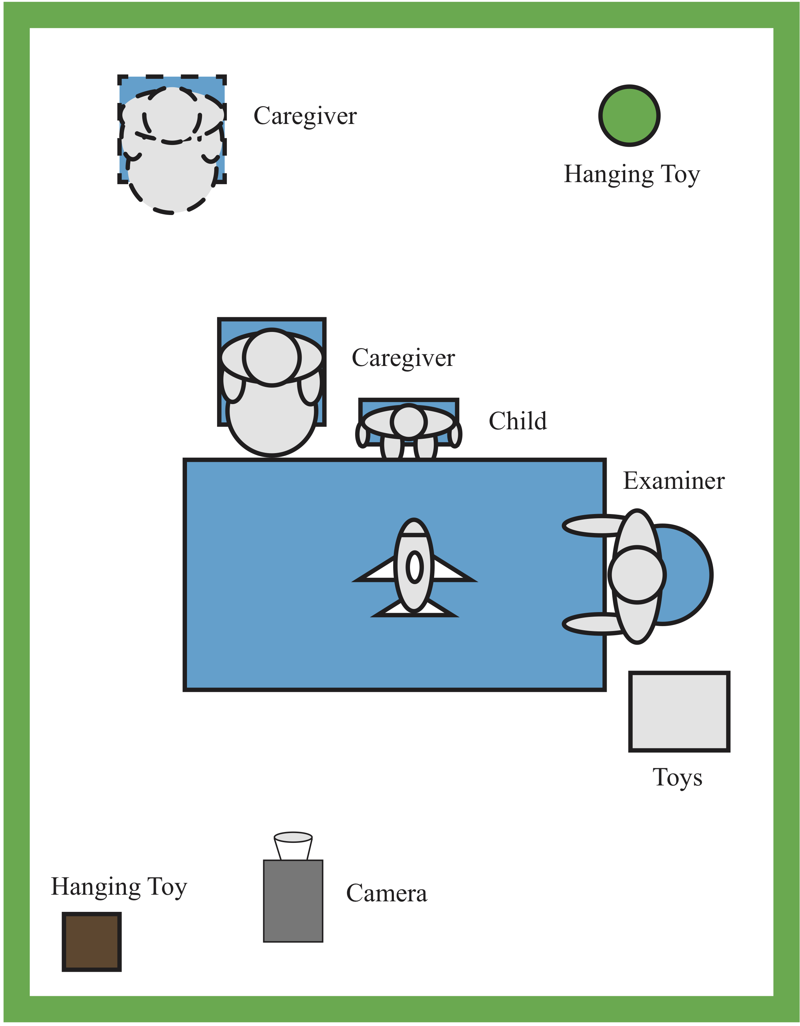

Appendix S5. Description of Gesture Classifications
Category | Description
Gesture | Communicative gestures are behaviors involving intentional movements that are interpreted by others as having a communicating intent. These need to meet the following three conditions:  (a) It is a gesture or an intentional movement(head nods and shakes are considered generalized gestures and satisfy this condition).  (b)The child was directing the behavior to another person.  (c) The behavior serves the communicative function of either SI, BR, or JA.
Overall gestures | The number of uses for all forms of motion that fit the definition of "gesture."
Communication function | BR gestures are used to control another person's behavior.  SI gestures are used to direct another person's attention to oneself.  JA gestures involve directing another person's attention to an event, object, or person solely to share an interest
Integrated gestures | G-E gesture： Gestures are only integrated with eye gaze. There must be a time overlap between the gesture and the eye gaze. That is, at a certain moment, the gesture and the eye gaze must appear simultaneously. Eye gaze and gestures are toward the same object. Eye gaze refers to gaze staying in the eye area of ​​others( the area formed between the furthest point of the left eye corner and the furthest point of the right eye corner in the horizontal direction, and between the lower edge of both eyebrows and the midpoint of the bridge of the nose in the vertical direction).  G-V gesture： Gestures are only integrated with non-word vocalizations （vocal utterances produced by the infants and do not contain words or speech sounds consistently used by the infants to refer to a specific object or event）:  ① The occurrence of gestures and non-word vocalizations must overlap in time. That is, at a certain moment, the gestures and non-word vocalizations must appear simultaneously.  ② non-word vocalizations must emphasize the semantics of gestures  G-W gesture： Gestures are only integrated with words（words consist of verbal utterances containing at least one "word" ）. Words must have precise semantics, and the following conditions must be satisfied simultaneously: ① Gestures and words must overlap in time. That is, at a certain moment, gestures and words must appear at the same time. ② words must carry any role in emphasizing, disambiguating, and complementing the semantics of gestures, that is, they must meet at least one of the following criteria:  -Gestures emphasize the semantic information of words, saying "biscuits!" while pointing at the biscuits  -Gestures disambiguate the semantic information of words, such as pointing to biscuits while saying "want this!".  -Gestures complement the semantic information of words, such as pointing at biscuits while saying "eat!".  G-M gesture： Gestures are only integrated with more than one of the above communication skills.  G-N gesture： Gestures are not integrated with any of the above communication skills.
Note: BR: Behavior Regulation, SI: Social Interaction, JA: Joint Attention, G-V: gesture integrated with non-word vocalizations, G-W: gesture integrated with words, G-E: gesture integrated with eye contact, G-M: gesture integrated with any two communication skills, G-N: Gestures integrated with none of the above communication skills

Appendix S6. Participants' follow-up details
 | HR（n=46） | LR(n=27)
9-10 months | 22 | 13
12-13 months | 29 | 19
15-16 months | 21 | 18
18-19 months | 14 | 10
ADOS | 15 | 11
Group A | 10 | 7
Group N | 5 | 4
ADOS score，m(SD) | 9.13（3.79） | 8.55（4.00）
Note: m=mean, SD=Standard deviation

Appendix S7. PRESS corresponding to the number of different components at three-time points
 |  | (Intercept) | 1 component | 2 components | 3 components | 4 components | 5 components | 6 components
TIME2  （n=20） | CV | 1.03 | 0.94 | 0.96 | 0.99 | 1.00 | 1.05 | 1.10
TIME2  （n=20） | adjCV | 1.03 | 0.93 | 0.96 | 0.99 | 0.99 | 1.04 | 1.09
TIME3  （n=21） | CV | 1.03 | 0.91 | 1.06 | 1.11 | 1.19 | 1.29 | 1.35
TIME3  （n=21） | adjCV | 1.03 | 0.90 | 1.05 | 1.10 | 1.17 | 1.27 | 1.33
TIME4  （n=21） | CV | 1.03 | 0.93 | 0.92 | 0.97 | 1.03 | 1.15 | 1.21
TIME4  （n=21） | adjCV | 1.03 | 0.93 | 0.92 | 0.97 | 1.02 | 1.13 | 1.19
Note：TIME2:12-13 months,TIME3:15-16 months,TIME4:18-19 months,CV:PRESS,adjCV:adjusted PRESS

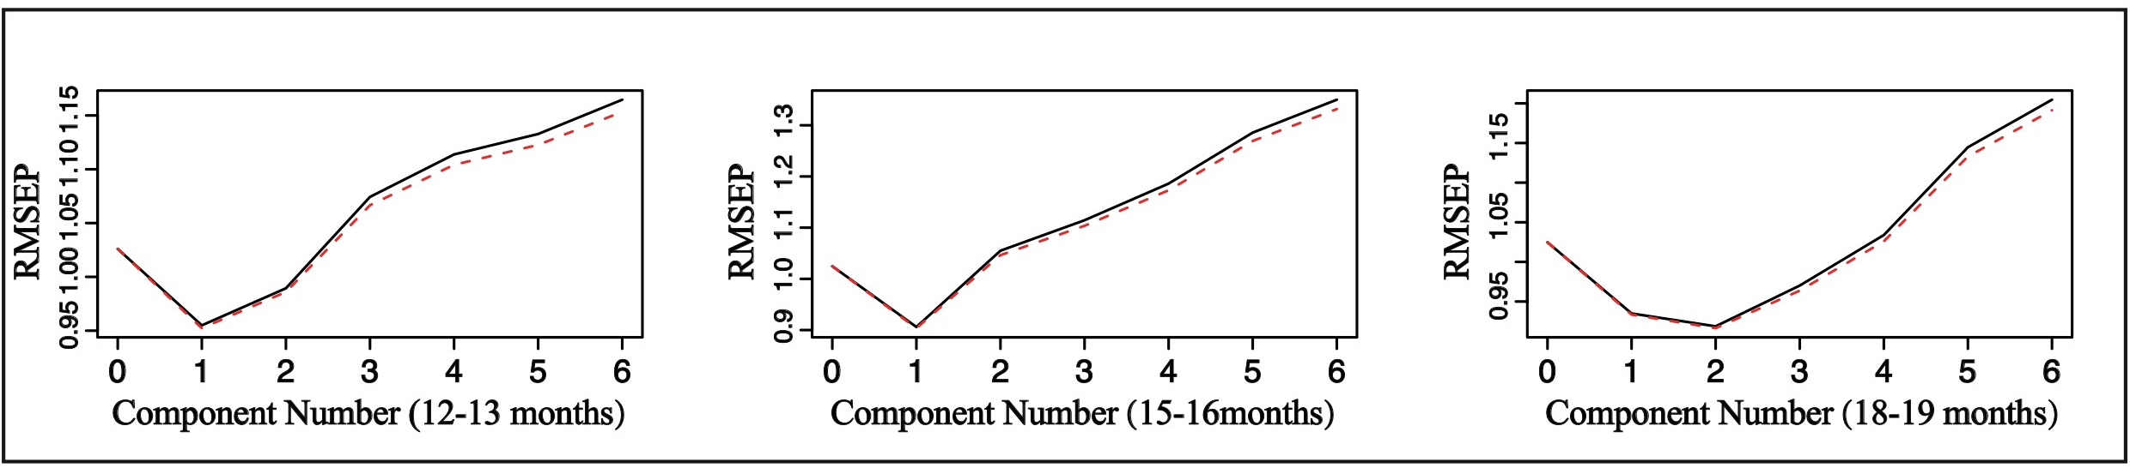

Appendix S8. Mean square error graph corresponding to different component numbers

Appendix S9. Descriptive statistics: number of gestures per 30 Mins. for LR and HR groups
 |  | 9–10 months |  | 12–13 months |  |  | 15–16 months |  | 18-19months
 | Gesture, M(R) | HR(n=22) | LR(n=13) | HR(n=29) | LR(n=19) |  | HR(n=21) | LR(n=18) | HR(n=14) | LR(n=10)
 | Overall gestures | 1.60(22.00) | 1.98(11.58) | 27.75(82.55) | 30.61(87.83) |  | 29.89(75.68) | 50.74(74.89) | 21.20(33.70) | 27.12(85.02)
 | BR gesture | 1.35(19.13) | 1.94(6.44) | 18.78(51.21) | 21.23(55.91) |  | 18.80(46.82) | 38.31(51.33) | 15.91(20.27) | 19.59(10.88)
 | SI gesture | 0.00(6.40) | 0.00(6.12) | 2.00(11.21) | 1.29(7.73) |  | 2.75(11.21) | 3.22(7.73) | 4.31(5.10) | 3.89(6.79)
 | JA gesture | 0.00(4.50) | 0.00(2.62) | 3.25(18.32) | 3.54(32.21) |  | 5.20(18.32) | 7.39(32.21) | 7.26(16.40) | 11.69(37.34)
 | G-V gesture | 0.00(6.70) | 0.00(1.29) | 5.63(38.06) | 9.84(38.60) |  | 7.59(37.04) | 18.87(35.60) | 2.98(7.98) | 7.20(29.88)
 | G-W gesture | 0.00(0.00) | 0.00(0.00) | 0.00(20.15) | 0.00(11.07) |  | 0.00(20.15) | 0.00(11.07) | 2.11(8.68) | 2.00(2.00)
 | G-E gesture | 0.00(11.25) | 1.20(6.12) | 5.66(26.90) |  | 5.94(21.46) | 5.81(25.87) | 8.56(21.46) | 4.79(14.52) | 8.92(13.82)
 | G-M gesture | 0.00(5.10) | 0.00(1.14) | 3.98(37.91) |  | 5.75(44.43) | 4.12(37.91) | 6.33(24.04) | 2.46(11.55) | 3.12(9.60)
 | G-N gesture | 0.90(9.56) | 0.00(9.01) | 8.67(25.49) |  | 10.30(36.36) | 10.57(23.78) | 11.12(34.90) | 12.09(24.01) | 15.21(19.28)
Note: M: Median, R: Range, BR: Behavior Regulation, SI: Social Interaction, JA: Joint Attention, G-V: gesture integrated with non-word vocalizations, G-W: gesture integrated with words, G-E: gesture integrated with eye contact, G-M: gesture integrated with any two communication skills, G-N: Gestures integrated with none of the above communication skills.

Appendix S10. Caregivers' concerns when they were enrolled for group comparison
 | HR(Nª=36) | LR（N=25） Male |  | X₁²/X₂² | P₁/P₂
Caregivers' concerns, N (%) | 27(0.75) | 13(0.52) 29 |  | 3.45/2.46 | 0.10/0.15
Eye-gaze, N^{b} | 3 | 4
Gesture | 3 | 0
Language | 7 | 4
Facial expression | 1 | 1
Introversion | 2 | 0
Social aspirations | 4 | 4
Parents' concerns about ASD | 6 | 2
Attachment | 1 | 1
Repetitive behavior | 3 | 2
Attention deficit and hyperactivity | 4 | 1
Emotion | 3 | 2
Locomotor | 6 | 0
Cognition and Intelligence | 6 | 1
Sleep problems | 1 | 1
Physical disease | 1 | 0
Note, a: The number of infants who filled out the overall issues section of ASQ-3, b: The number of infants whose caregivers expressed certain concerns about their children (for example, lack of eye-gaze). One caregiver in this study may express multiple concerns.X₁²: Chi-square test of different groups. X₂²: Chi-square test of different genders. P₁:P value for comparison of different groups. P₂:P value for different genders

Appendix S11. Specific reasons for the loss to follow-up
ID | Group | Reasons for loss to follow-up
37 | HR | Withdraw
12 | HR | Withdraw
27 | HR | Withdraw
16 | HR | Anti-epidemic measures^{b}
46 | HR | Anti-epidemic measures
11 | HR | Anti-epidemic measures
45 | HR | Distance^{c}
35 | HR | Distance
17 | HR | Distance
61 | HR | Distance
73 | HR | Distance
24 | LR | Withdraw
42 | LR | Withdraw
54 | LR | Withdraw
57 | LR | Withdraw
66 | LR | Withdraw
40 | LR | Withdraw
10 | LR | Withdraw
20 | LR | Sickness
26 | LR | Sickness
29 | LR | Withdraw
30 | LR | Withdraw
Note, a: Withdraw from the study for unknown reasons, b: Unable to follow up because of anti-epidemic measures of Anti-epidemic measures, c: Unable to follow up because of the distance, d: Unable to follow up due to sickness

Appendix S12. GAMM Model of Gesture Developmental Trajectory
 |  | coefficients | p
Overall gestures | Group（β7） | -41.11 | 0.44
Overall gestures | Age（β5） | 24.09 | <0.01*
Overall gestures | Age²（β6） | -0.68 | <0.01*
Overall gestures | Group ×Age（β8） | 7.25 | 0.36
Overall gestures | Group ×Age²（β9） | -0.32 | 0.25
BR gesture | Group（β7） | -12.65 | 0.70
BR gesture | Age（β5） | 19.52 | <0.01*
BR gesture | Age²（β6） | -0.58 | <0.01*
BR gesture | Group ×Age（β8） | 2.87 | 0.56
BR gesture | Group ×Age²（β9） | -0.15 | 0.38
JA gesture | Group（β2） | 9.99 | 0.01*
JA gesture | Age（β1） | 1.62 | <0.01*
JA gesture | Group ×Age（β3） | -0.88 | <0.01*
G-E gesture | Group（β7） | 1.64 | 0.89
G-E gesture | Age（β5） | 4.84 | <0.01*
G-E gesture | Age²（β6） | -0.14 | <0.01*
G-E gesture | Group ×Age（β8） | -0.21 | 0.90
G-E gesture | Group ×Age²（β9） | -0.01 | 0.96
G-V gesture | Group（β7） | 2.73 | 0.89
G-V gesture | Age（β5） | 6.81 | <0.01*
G-V gesture | Age²（β6） | -0.19 | 0.02*
G-V gesture | Group× Age（β8） | 0.20 | 0.94
G-V gesture | Group×Age²（β9） | -0.04 | 0.67
G-M gesture | Group（β7） | -5.38 | 0.78
G-M gesture | Age（β5） | 6.47 | <0.01*
G-M gesture | Age²（β6） | -0.21 | 0.01*
G-M gesture | Group× Age（β8） | 0.85 | 0.76
G-M gesture | Group×Age²（β9） | -0.04 | 0.71
G-N gesture | Group（β7） | 18.79 | 0.33
G-N gesture | Age（β5） | 9.34 | <0.01*
G-N gesture | Age²（β6） | -0.27 | <0.01*
G-N gesture | Group× Age（β8） | -2.45 | 0.39
G-N gesture | Group×Age²（β9） | 0.07 | 0.51

Appendix S13. Statistical description for gestures across HR and LR groups
 | 9–10 months |  | 12–13 months |  | 15–16 months |  | 18–19 months
Gestures M(R) | HR(nª=22) | LR(n=13) | HR(n=29) | LR(n=19) | HR(n=21) | LR(n=18) | HR(n=14) | LR(n=10)
Total gestures | 1.59(13.85) | 1.98(11.59) | 23.47(50.55) | 24.37(87.83) | 29.89(75.68) | 50.74(74.89) | 25.02(39.50) | 27.12(85.02)
BR gestures | 1.34(12.31) | 1.94(6.43) | 18.76(40.69) | 20.00(21.89) | 18.80(46.82) | 38.31(51.33) | 15.26(24.74) | 17.59(40.73)
JA gestures | 0.00(2.87) | 0.00(2.61) | 2.26(11.25) | 3.00(9.53) | 5.19(15.76) | 7.38(32.21) | 6.26(16.40) | 9.69(37.34)
SI gestures | 0.00(2.87) | 0.00(6.11) | 1.92(7.60) | 1.28(4.47) | 2.74(11.21) | 3.21(7.72) | 3.31(5.09) | 1.94(11.93)
G-W gestures | 0.00(0.00) | 0.00(0.00) | 0.00(0.37) | 0.00(0.00) | 0.00(5.19) | 0.00(11.07) | 1.11(8.68) | 0.00(14.31)
G-V gestures | 0.00(0.86) | 0.00(1.28) | 5.23(14.29) | 3.53(14.94) | 7.59(16.59) | 13.87(38.60) | 1.97(13.04) | 5.19(29.88)
G-E gestures | 0.00(4.78) | 1.20(6.11) | 4.32(14.39) | 5.46(20.19) | 5.80(14.48) | 8.56(21.46) | 3.79(14.53) | 6.92(13.82)
G-M gestures | 0.00(5.10) | 0.00(1.13) | 3.92(17.15) | 3.00(44.43) | 4.12(24.30) | 6.33(24.00) | 1.46(5.01) | 1.11(22.66)
G-N gestures | 0.00(5.80) | 0.00(2.27) | 6.12(20.28) | 8.25(19.74) | 10.57(23.78) | 11.12(34.90) | 11.09(24.01) | 13.21(19.28)
Note: M: Median, R: Range, BR: Behavior Regulation, SI: Social Interaction, JA: Joint Attention, G-V: gesture integrated with non-word vocalizations, G-W: gesture integrated with words, G-E: gesture integrated with eye contact, G-M: gesture integrated with any two communication skills, G-N: Gestures integrated with none of the above communication skills, a: The number of people who completed follow-up at this point.

