Supplemental Material files

SM1 Materials
SM2 Fig. 1-8: Ortep plots. Thermal ellipsoids are shown at 50 % probability.
SM3 Tab. 1-4: Crystallographic data, details of data collection and structure refinement parameters.
SM4 Table 5-14. Intramolecular interactions. Hirshfeld fingerprint plots
SM5 References.
SM1
2.1 Materials
N-tert-Butyl-N-methylamine, N-tert-butylaniline, di-tert-butylamine, 4-tert-butylbenzoyl chloride and Lawesson’s reagent (LR) are commercially available. The thioamides were prepared either by method A (thionation of the corresponding amides with P₄S₁₀ [13] or LR [14]) or by method B (one-pot procedure [15] of the corresponding acid chlorides, amines and P₄S₁₀ in dry pyridine).

2.2 Abbreviations
CC = column chromatography, TLC = thin layer chromatography, PE = petroleum ether

2.3 Syntheses

N-tert-Butyl-N-methylbenzamide (3a) was prepared according to the literature procedure [73]. M. p. 80-81°C (lit. [73] 80-82°C).
¹H NMR (600 MHz, CDCl₃, 300 K): 1.51 [s, 9 H, C(CH₃)₃], 2.86 (s, 3 H, NCH₃), 7.36-7.37 (m, 3 H, 3/4/5-H), 7.41-7.43 (m, 2 H, 2/6-H), in agreement with lit. [73, 74].
¹³C NMR (150.9 MHz, CDCl₃, 300 K): 27.9 [C(CH₃)₃], 35.4 (NCH₃), 56.6 [C(CH₃)₃], 127.4 (2 CH), 128.4 (2 CH), 129.5 (C4), 139.2 (C1), 173.3 (C=O).

N-tert-Butyl-N-methyl-thiobenzamide (3). The amide 3a (1.91 g, 10 mmol) and LR (2.22 g, 5.5 mmol) were dissolved in 100 mL dry toluene and stirred at 60°C for 4 h. Precipitates, which separated after cooling to room temperature, were filtered off. The toluene was removed in a vacuum. The crude product mixture was separated by CC (PE/EtOAc 5:1). The combined first two fractions were crystallized from PE to yield 190 mg (0.92 mmol, 9%) pure 3 as pale-yellow crystals, m. p. 57-58°C.
¹H NMR (400 MHz, CDCl₃, 223 K): E-Isomer: 1.24 [s, 9 H, C(CH₃)₃], 3.61 (s, 3 H, NCH₃), 7.30 (m, 5 H, H_{ar}). Z-Isomer: 1.79 [s, 9 H, C(CH₃)₃], 3.05 (s, 3 H, NCH₃), 7.30 (m, 5 H, H_{ar}). Diastereoisomeric ratio E:Z ≈ 3:2.
¹H NMR (600 MHz, CDCl₃, 298 K): 1.45 [bs, 9 H, C(CH₃)₃], 3.21 (bs, 3 H, NCH₃), 7.17 (t, 3 H, J = 7 Hz, 3/4/5-H), 7.18 (d, 2 H, J = 7 Hz, 2/6-H).
¹H NMR (400 MHz, DMSO-d₆, 296 K): 1.49 [bs, 9 H, C(CH₃)₃], 3.17 (bs, 3 H, NCH₃), 7.18 (d, 2 H, J = 7 Hz, 2/6-H), 7.25 (t, 2 H, J = 7 Hz, 3/5-H), 7.32 (t, 1 H, J = 7 Hz, 4-H).
¹H NMR (400 MHz, DMSO-d₆, 373 K): 1.52 [s, 9 H, C(CH₃)₃], 3.19 (s, 3 H, NCH₃), 7.18 (d, 2 H, J = 7 Hz, 2/6-H), 7.25 (t, 2 H, J = 7 Hz, 3/5-H), 7.32 (t, 1 H, J = 7 Hz, 4-H).
¹³C NMR (100.6 MHz, CDCl₃, 223 K, E/Z): 27.17/30.66 [C(CH₃)₃], 42.18/42.22 (NCH₃), 62.41/ 64.80 [C(CH₃)₃], 125.33/125.57 (C4), 127.74/128.15, 128.31/128.36, 146.01/146.87 (C1), 203.02/203.21 (C=S).
¹³C NMR (150.9 MHz, CDCl₃, 298 K): 29.15 [bs, C(CH₃)₃], 41.75 (NCH₃), 63.32 [bs, C(CH₃)₃], 125.85 (C4), 128.02 (C2/6), 128.13 (C3/5), 147.20 (C1), 204.14 (C=S).
¹³C NMR (100.6 MHz, DMSO-d₆, 373 K): 28.40 [C(CH₃)₃], 41.24 (NCH₃), 62.92 [s, C(CH₃)₃], 125.54 (C4), 127.67 (4 CH_{ar}), 147.03 (C1), 202.63 (C=S).
Calcd. for C₁₂H₁₇NS (207.34) C 69.52, H 8.26, N 6.76, S 15.46%; found: C 69.36, H 8.47, N 6.71, S 15.19%.
Further fractions consisted of unreacted 3a (1.30 g, 65%, m. p. 80-81°C) and de-tert-butylated N-methyl-thiobenzamide 18 (110 mg, 6%, m. p. 75-76°C; lit. [75] m. p. 77-78°C).

N-tert-Butyl-N-methyl-4-tert-butylbenzamide (4a). 4-tert-Butylbenzoyl chloride (1.97 g, 10 mmol) and N-tert-butyl-N-methylamine (0.87 g, 10 mmol) were dissolved in 12.5 mL dry pyridine and refluxed for 30 min. After cooling, the mixture was poured into dil. aqu. HCl. The solution (pH = 7) was extracted with diethyl ether. The extract was washed with dil. HCl, water, finally with satd. NaHCO₃ solution, and dried over Na₂SO₄. The solid residue obtained after removal of the solvent was recrystallized from PE to yield 1.98 g (84%) colorless crystals of 4a, m. p. 123-124°C.
¹H NMR (600 MHz, CDCl₃, 300 K): 1.32 [s, 9 H, CC(CH₃)₃], 1.50 [s, 9 H, NC(CH₃)₃], 2.89 (s, 3 H, NCH₃), 7.37 (bs, 4 H, H_{ar}).
¹³C NMR (150.9 MHz, CDCl₃, 300 K): 27.9 [NC(CH₃)₃], 31.4 [CC(CH₃)] 34.9, [CC(CH₃)₃], 35.5 (NCH₃), 56.5 [NC(CH₃)₃], 125.3 (2 CH), 127.4 (2 CH), 136.2 (C1), 152.8 (C4), 173.5 (C=O).
Calcd. for C₁₆H₂₅NO (247.38) C 77.68, H 10.19, N 5.66%; found: C 77.98, H 10.33, N 5.68%.

N-tert-Butyl-N-methyl-4-tert-butyl-thiobenzamide (4). The amide 4a (1.90 g, 8.08 mmol) and LR (1.80 g, 4.44 mmol) were heated to 60°C in 80 mL dry toluene for 4 h. Work-up was performed as described for 3. CC (2×, PE/EtOAc 4:1) gave 0.18 g (0.68 mmol, 9%) 4 as yellow crystals, m. p. 71-72°C (PE) besides 1.50 g (79%) of unreacted amide 4a.
Calcd. for C₁₆H₂₅NS (263.45) C 72.95, H 9.56, N 5.32, S 12.17%; found: C 72.66, H 9.62, N 5.33, S 12.08%.
N-Methyl-4-tert-butyl-thiobenzamide (4b) was formed as by-product by de-tert-butylation, pale-yellow crystals, m. p. 84-85°C (PE).
¹H NMR (300 MHz, CDCl₃, 296 K): 1.30 [s, 9 H, C(CH₃)₃], 3.27 (d, 3 H, ³J_{MeNH} = 2 Hz, NCH₃), 7.34 (d, 2 H, ³J = 7 Hz, 3/5-H), 7.66 (d, 2 H, ³J = 7 Hz, 2/6-H), 7.95 (bs, 1 H, NH).
¹³C NMR (75 MHz, CDCl₃, 296 K): 31.17 [C(CH₃)₃], 33.66 [C(CH₃)₃], 34.87 (NCH₃), 125.40 (2 CH), 126.52 (2 CH), 138.67 (C1), 154.61 (C4), 199.74 (C=S).
Calcd. for C₁₂H₁₇NS (207.34): C 69.51, H 8.26, N 6.76, S 15.47%; found: C 69.53, H 8.59. N 6.71, S. 15.34%.

N,N-Dibenzyl-thiobenzamide (6) was prepared by the one-pot procedure [15, 30] from benzoyl chloride, dibenzylamine and P₄S₁₀ in pyridine. Yellow crystals, m. p. 102°C (PE), lit. [41]: m. p. 95-97°C.
¹H NMR (600 MHz, CDCl₃, 298 K): 4.60 (s, 2 H, CH₂), 5.40 (s, 2 H, CH₂), 7.095 (d, 2 H, ³J = 7.1 Hz), 7.09-7.39 (m, 13 H), in agreement with lit. [41].
¹³C NMR (150.9 MHz, CDCl₃, 298 K): 53.0 (CH₂), 55.4 (CH₂), 125.5 (2 C_{ar}H) 127.3 (2 C_{ar}H), 128.0 (C_{ar}H), 128.1 (C_{ar}H), 128.2 (2 C_{ar}H), 128.5 (C_{ar}H), 128.6 (2 C_{ar}H), 128.95 (C_{ar}H), 129.05 (C_{ar}H), 129.0 (2 C_{ar}H), 135.2 (C_{q}, C1′), 135.5 (C_{q}, C1′′), 143.5 (C_{q}, C1), 203.6 (C=S).

3,5-Dideutero-N,N-diisopropyl-thiobenzamide (7) [13] was prepared by the one-pot procedure [15] from 3,5-dideuterobenzoyl chloride [13], diisopropylamine and P₄S₁₀ as described for the preparation of unlabeled N,N-diisopropylthiobenzamide [13, 36]. Pale-yellow crystals, m. p. 100.0-101.5°C.
¹H NMR (400 MHz, CDCl₃, 223 K): 1.195 (d, 6 H, ³J = 6.7 Hz, CH₃-E), 1.858 (d, 6 H, ³J = 7.0 Hz, CH₃-Z), 4.013 (sept, 1 H, ³J = 7.0 Hz, CH-E), 4.116 (sept, 1 H, ³J = 6.7 Hz, CH-Z), 7.157 (d, 2 H, ⁴J = 1.0 Hz, 2/6-H), 7.29 (bs, 1 H, 4-H), in agreement with the predominating conformer A in lit. [36].
¹H NMR (400 MHz, DMSO-d₆, 298 K): 1.12 (d, 6 H, ³J = 7 Hz, CH₃-E), 1.68 (bs, 6 H, CH₃-Z), 3.98 (sept, 2 H, ³J = 7 Hz, CH), 7.11 (bs, 2 H, 2/6-H), 7.28 (bs, 1 H, 4-H), in agreement with the predominating conformer A in lit. [36].
¹H NMR (400 MHz, DMSO-d₆, 398 K): 1.42 (bs, 12 H, 4 CH₃), 4.32 (bs, 2 H, 2 CH), 7.12 (s, 2 H, 2/6-H), 7.27 (s, 1 H, 4-H).
¹³C NMR (100.6 MHz, CDCl₃, 223 K): 19.11 (2 CH₃), 20.10 (2 CH₃), 50.91 (CH), 57.88 (CH), 123.60 (C2/6), 127.51 (C4), 129.07 (C3/5), 145.72 (C1), 198.90 (C=S).
¹³C NMR (100.6 MHz, DMSO-d₆, 398 K): δ 19.0 (4 CH₃), 39.5 (2 NCH), 124.0 (C2/6), 126.9 (C4), 127.0 (C3/5), 145.7 (C1); due to the low S/N ratio, the C=S signal was not detected.
HRMS Calcd. for [C₁₃H₁₇D₂NS+H]⁺: 224.1437, found: 224.1438.

3,5-Di-tert-butyl-N,N-diisopropyl-thiobenzamide (8) [76]. M. p. 122-123°C.
¹H NMR (400 MHz, DMSO-d₆, 298 K): 1.107 (d, 6 H, ³J = 6.6 Hz, CHCH₃), 1.286 [s, 18 H, C(CH₃)₃], 1.68 (bs, 6 H, CHCH₃), 3.32 [bs, 1 H, CH(CH₃)₂], 3.91 [sept, 1 H, ³J = 7.0 Hz (determined at 318 K), CH(CH₃)₃], 6.911 (d, 2 H, ⁴J = 1.7 Hz, 2/6-H), 7.313 (t, 1 H, ⁴J = 1.7 Hz, 4-H).
¹H NMR (400 MHz, DMSO-d₆, 398 K): 1.31 [s, 12 H, CH(CH₃)₂], 1.40 [bs, 18 H, C(CH₃)₃], 4.29 [bs, 1 H, CH(CH₃)₂], 4.32 [bs, 1 H, CH(CH₃)₂], 6.935 (d, 2 H, ⁴J = 1.8 Hz, 2/6-H), 7.34 (bt, 1 H, ⁴J = 1.8 Hz, 4-H).
¹³C NMR (100.6 MHz, DMSO-d₆, 298 K): 19.53 [CH(CH₃)₂], 31.62 [C(CH₃)₃], 35.03 [C(CH₃)₃], 39.5 (2 NCH), 119.97 (C2/6), 121.06 (C4), 145.45 (C1), 150.45 (C3/5); due to the low S/N ratio, the C=S signal was not detected.

N,N-Dicyclohexyl-thiobenzamide (9) [77]. M. p. 139-141°C.
¹H NMR (400 MHz, CDCl₃, 223 K): 0.75-2.20 (m, 20 H, CH₂), 3.53 (bs, 1 H, NCH), 3.63 (t, 1 H, ³J = 12 Hz, NCH), 7.14 (d, 2 H, ³J = 7 Hz, 2/6-H), 7.27-7.43 (m, 3 H, 3/4/5-H).
¹H NMR (400 MHz, CDCl₃, 298 K): 0.8-2.1 (m, 20 H, CH₂), 3.61-3.67 (m, 2 H, NCH), 7.13 (d, 2 H, ³J = 7.0 Hz, 2/6-H), 7.23-7.32 (m, 3 H, 3/4/5-H).
¹³C NMR (100.6 MHz, CDCl₃, 223 K): 24.7 (CH₂), 25.0 (CH₂), 26.4 (CH₂), 27.5 (CH₂), 29.8 (CH₂), 61.3 (NCH), 66.4 (NCH), 123.3 (CH), 127.6 (CH), 128.9 (CH), 145.7 (C1), 199.4 (C=S).

N-tert-Butylbenzanilide (10a). Benzoyl chloride (2,00 g, 14.2 mmol), N-tert-butylaniline (2.04 g, 13.7 mmol) and triethyl amine (1.73 g, 17.1 mmol) were dissolved in 20 mL dry diethyl ether. The reaction mixture was left standing at room temperature for 30 h. The precipitated triethylammonium chloride was filtered off. The organic solution was washed with H₂O (3×), 2N HCl (2×), H₂O, satd. NaHCO₃ solution (2×), H₂O and dried over Na₂SO₄. Evaporation gave 2.20 g (63%) crystalline raw product which was purified by re-crystallization from PE to yield 1.05 g (30%) of pure, colorless 10a, m. p. 89-90°C (decomp.).
¹H NMR (600 MHz, CDCl₃, 298 K): 1.50 (s, 9 H, CH₃), 7.01-7.17 (m, 10 H_{ar}).
¹³C NMR (150.9 MHz, CDCl₃, 298 K): 29.3 (CH₃), 58.8 [C(CH₃)₃], 127.4 (C4'), 127.5 (2 CH), 127.7 (2 CH), 128.4 (4 CH), 131.6 (C4), 139.5 (C1), 142.1 (C1'), 172.2 (C=O).
Calcd. for C₁₇H₁₉NO (253.34) C 80.60, H 7.56, N 5.53%; found: C 80.96, H 7.63, N 5.61%.
An attempt to perform the reaction in dry pyridine failed and led to benzanilide under elimination of isobutene.

N-tert-Butyl-thiobenzanilide (10). The amide 10a (2.53 g, 10 mmol) and LR (2.22 g, 5.5 mmol) were refluxed in 50 mL dry toluene for 5 h. Work-up was performed as described for 3. CC (PE/EtOAc 4:1) gave 0.62 g (2.30 mmol, 23%) 10 as pale-yellow crystals, m. p. 111-112°C (PE).
¹H NMR (400 MHz, CDCl₃, 298 K): 1.73 (s, 9 H, CH₃), 6.89-6.95 (m, 7 H_{ar}), 7.04-7.12 (m, 3 H_{ar}).
¹³C NMR (100.6 MHz, CDCl₃, 298 K): 29.1 (CH₃), 64.3 [C(CH₃)₃], 126.2 (2 CH), 126.6 (CH), 127.4 (2 CH), 127.8 (CH), 128.3 (2 CH), 129.8 (2 CH), 144.4 (C1), 148.0 (C1'), 204.4 (C=S).
¹³C NMR (100.6 MHz, CDCl₃, 238 K): 28.8 (CH₃), 65.3 [C(CH₃)₃], 126.1 (2 CH), 127.1 (CH), 128.1 (2 CH), 128.4 (CH), 129.0 (2 CH), 129.8 (2 CH), 144.0 (C1), 147.9 (C1'), 204.0 (C=S).
Calcd. for C₁₇H₁₉NS (269.41) C 75.79, H 7.11, N 5.20, S 11.90%; found: C 75.79, H 7.10, N 5.17, S 12.19%.

N-tert-Butyl-3,5-di-tert-butylbenzanilide (11a) was obtained from 3,5-di-tert-butylbenzoyl chloride [78] (6.63 g, 26.2 mmol), N-tert-butylaniline (3.73 g, 25.0 mmol) and triethyl amine (2.52 g, 24.9 mmol) as described for the preparation of 10a. 3,5-Di-tert-butylbenzanilide 11b (1.32 g, 14%), formed as by-product by de-tert-butylation, separated from the crude yellowish oil (8.5 g) as colorless crystals, m. p. 186-187°C (EtOAc), lit. [79] m. p. 203-204°C (EtOH). Flash chromatography (CCl₄/CHCl₃/MeOH) of the remaining oil gave 2.22 g (23%) 11a, m. p. 79-80°C (PE).
Calcd. for C₂₁H₂₇NO (309.43) C 81.51, H 8.79, N 4.53%; found: C 81.52, H 8.96, N 4.56%.
11b:
¹H NMR (400 MHz, CDCl₃, 298 K): 1.15 [s, 18 H, C(CH₃)₃], 1.51 [s, 9 H, NC(CH₃)₃], 6.99 (d, 2 H, ⁴J = 1.7 Hz, 2/6-H), 7.00 (t, 1 H, ⁴J = 1.7 Hz, 4-H), 7.04-7.12 (m, 5 H, H_{ar}).
¹³C NMR (100.6 MHz, CDCl₃, 298 K): 29.35/29.45 [NC(CH₃)₃], 31.3/31.4 [CC(CH₃)₃], 34.8 [CC(CH₃)₃], 58.7 [NC(CH₃)₃], 122.0/122.1 (CH), 122.4/122.5 (2 CH), 127.0 (2 CH), 128.2 (2 CH), 131.6 (2 CH), 138.3 (C1), 142.5 (C1'), 149.6 (C3/5), 173.1 (C=O).
Calcd. for C₂₅H₃₅NO (365.56) C 82.14, H 9.65, N 3.83%; found: C 82.43, H 9.82, N 3.70%.

N-tert-Butyl-3,5-di-tert-butyl-thiobenzanilide (11). The amide 11a (0.50 g, 1.4 mmol) and LR (0.31 g, 0.77 mmol) were refluxed in 50 mL dry toluene for 5 h. Work-up was performed as described for the preparation of 3. Preparative TLC (PE/EtOAc 4:1) led to 0.28 g (0.74 mmol, 54%) 11. Recrystallization from PE gave analytically pure, yellow crystals, m. p. 86-87°C (PE).
¹H NMR (400 MHz, CDCl₃, 300 K): 1.14 [s, 18 H, CC(CH₃)₃], 1.76 [s, 9 H, NC(CH₃)₃], 6.735 (d, 2 H, ⁴J = 1.5 Hz, 2/6-H), 6.891, (t, 2 H, ³J = 6.8 Hz, 3'/5'-H), 6.894 (t, 1 H, ³J = 6.8 Hz, 4'-H), 6.99-7.05 (m, 3 H, 4/2'/6'-H).
¹³C NMR (100.6 MHz, CDCl₃, 300 K): 29.2 [NC(CH₃)₃], 31.2/31.3 [CC(CH₃)₃], 34.7 [NC(CH₃)₃], 64.1 [C(CH₃)₃], 120.1/120.2 (CH), 120.6 (2 CH), 127.2 (C4), 127.9 (CH), 129.8 (2 CH), 144.5 (C1), 147.1 (C1'), 149.3 (C3/5), 205.9 (C=S).
Calcd. for C₂₅H₃₅NS (381.62) C 78.68, H 9.24, N 3.67, S 8.40%; found: C 78.52, H 9.20, N 3.73, S 8.46%.

4-Deutero-N,N-diphenyl-thiobenzamide (13) [80] was prepared from 4-deuterobenzoyl chloride [13] as described for the preparation of N,N-diphenyl-thiobenzamide (12) in lit. [15, 30]. Yellow crystals, m. p. 154-155°C (EtOH).
HRMS Calcd. for [C₁₉H₁₄DNS+H]⁺: 291.1061, found: 291.1053.

3,5-Di-tert-butyl-N,N-diphenyl-benzamide [80] (14a). Diphenylamine (1.69 g, 10 mmol) and 3,5-di-tert-butylbenzoyl chloride [78] (2,52 g, 10.0 mmol) were refluxed in 25 mL dry pyridine for 2 h under exclusion of moisture. After cooling, the reaction mixture was poured into excess dil. HCl. After 2 h, the precipitated amide was filtered off, washed with dil. HCl and finally with H₂O. The crude product was dried in a desiccator and purified by recrystallization. Yield: 2.81 g (7.30 mmol, 73%), colorless crystals, m. p. 137-138.5°C (EtOH/H₂O).
¹H NMR (600 MHz, CDCl₃, 300 K): 1.16 (s, 18 H, CH₃), 7.14-7.17 (m, 6 H, H_{ar}), 7.25-7.31 (m, 7 H_{ar}).
¹³C NMR (150.9 MHz, CDCl₃, 298 K): 31.37 (6 CH₃), 34.89 (2 CCH₃), 124.17 (4 CH), 126.24 (2 CH), 127.69 (CH), 129.16 (6 CH), 134.80 (2 CN), 144.47 (C1), 150.33 (C3/5), 171.48 (C=O).
Calcd. for C₂₇H₃₁NO (385.55) C 84.11, H 8.10, N 3.63%; found: C 84.12, H 8.12, N 3.76%.

3,5-Di-tert-butyl-N,N-diphenyl-thiobenzamide (14) [80]. The amide 14a (1.15 g, 3.86 mmol) and P₄S₁₀ (1.15 g, 2.59 mmol) were refluxed in 25 mL dry pyridine for 2 h under exclusion of moisture. The reaction mixture was cooled and poured into excess dil. HCl. After 10 h, the precipitated thioamide was filtered off, washed with dil. HCl and finally with H₂O. The crude 14 was dried in a desiccator and purified by recrystallization. Yield: 0.98 g (2.46 mmol, 82%) bright yellow crystals, m. p. 142-144°C (PE).
¹H NMR (400 MHz, CDCl₃, 223 K): 1.17 (s, 18 H, CH₃), 6.96 (d, 2 H, ³J = 7.8 Hz, 2'/6'-H), 7.04 (t, 1 H, ³J = 7.3 Hz,4'-H), 7.13 (t, 2 H, ³J = 7.3 Hz, 3'/5'-H), 7.17 (s, 1H, 4-H), 7.27 (s, 2 H, 2/6-H), 7.39 (t, 1 H, ³J = 7.0 Hz, 4''-H), 7.47 (d, 2 H, ³J = 7.7 Hz, 2''/6''-H), 7.52 (t, 2 H, ³J = 7.3 Hz, 3''/5''-H).
¹H NMR (400 MHz, CDCl₃, 298 K): 1.17 (s, 18 H, CH₃), 7.21 (t 1 H, ⁴J = 1.7 Hz, 4-H), 7.29 (d, 2 H, ⁴J = 1.7 Hz, 3/5-H), 7.1-7.4 (m, 10 H_{ar}).
¹³C NMR (100.6 MHz, CDCl₃, 238 K): 31.3 (6 CH₃), 34.8 (2 CCH₃), 123.4 (C4), 123.5 (C2/6), 126.4 (CH), 127.0 (2 CH), 127.7 2 (CH), 127.8 (CH), 129.0 (2 CH), 129.9 (2 CH), 141.9 (C1), 146.4 (CN), 147.3 (CN), 149.8 (C3/5), 206.2 (C=S).
¹³C NMR (100.6 MHz, CDCl₃, 300 K): 31.4 (6 CH₃), 34.9 (CCH₃), 123.3 (C2/6), 123.6 (2 CH), 124.2 (CH), 126.3 (CH), 127.6 (2 CH), 127.7 (2 CH), 129.2 (CH), 129.3 (CH), 129.4 (CH), 129.5 (2 CN), 142.8 (C1), 150.2 (C3/5), 206.8 (C=S).
¹³C NMR (100.6 MHz, DMSO-d₆, 368 K): 30.4 (6 CH₃), 33.8 (2 CCH₃), 121.3 (C4), 122.0 (C2/6), 126.3 (2 CH), 127.0 (4 CH), 128.5 (4 CH), 142.5 (C1), 146.3 (2 CN), 149.0 (C3/5), 204.9 (C=S).
Calcd. for C₂₇H₃₁NS (401.61) C 80.75, H 7.78, N 3.49, S 7.98%; found: C 80.61, H 7.85, N 3.56, S 8.04%.

N,N,2,4,6-Pentamethyl-thiobenzamide (15). N,N,2,4,6-Pentamethylbenzamide [43] (1.91 g, 10.0 mmol) and LR (5.00 g, 12.4 mmol) were refluxed in 50 mL dry xylene for 4 h. After cooling to r.t., the mixture was diluted with 500 mL PE. The precipitate was filtered off and the solvents were distilled off in a vacuum to yield 2.90 g of raw product. CC (SiO₂, CH₂Cl₂) gave 1.04 g (50%) pure 15 as pale-yellow needles, m. p. 68-68.5°C (PE), lit [37]: 69-70°C. ¹H and ¹³C NMR spectra in agreement with lit. [37].

SM2

Fig. 1-8: Ortep plots. Thermal ellipsoids are shown at 50 % probability.

Fig. 1. Ortep diagrams of the thioamides 3 and 4 (left) and of the amides 3a and 4a (right)

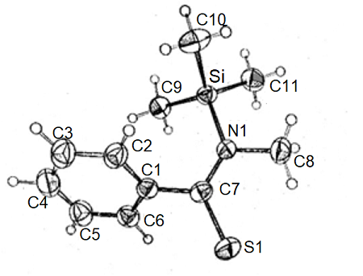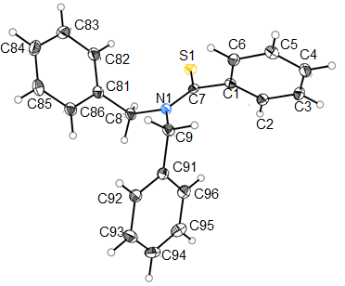
Fig. 2. Ortep diagrams of the thioamides 5 (left, taken from [29]) and 6 (right)

Fig. 3. Ortep diagrams of the thioamides 7 (left), 8 (middle) and 9 (right)

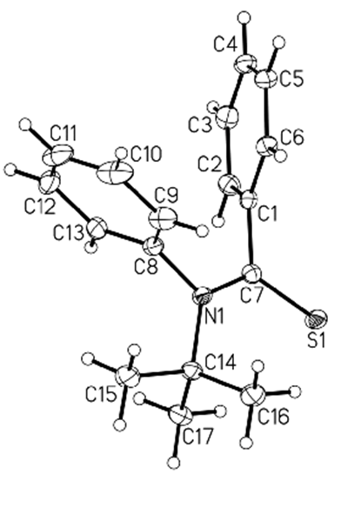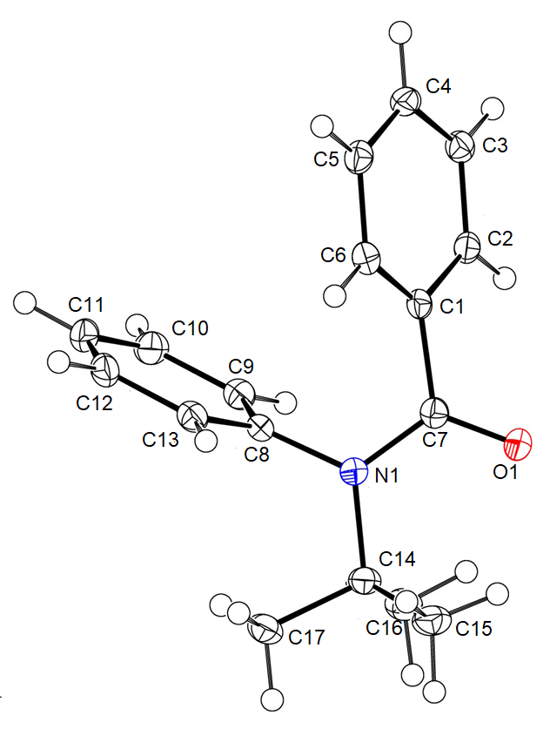
Fig. 4. Ortep diagrams of the thioamide 10 (left) and the amide 10a (right)
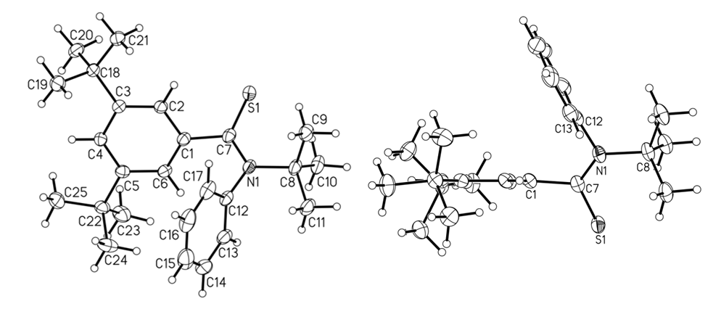
Fig. 5. Ortep diagrams of the thioamide 11; normal view (upper left), and side view (upper right) demonstrating the orthogonal arrangement of the planes of the arene ring and the thioamide group, and of the amide 11b (below)

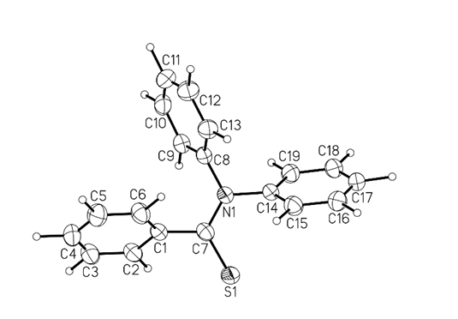
Fig. 6. Ortep diagram of the thioamide 12

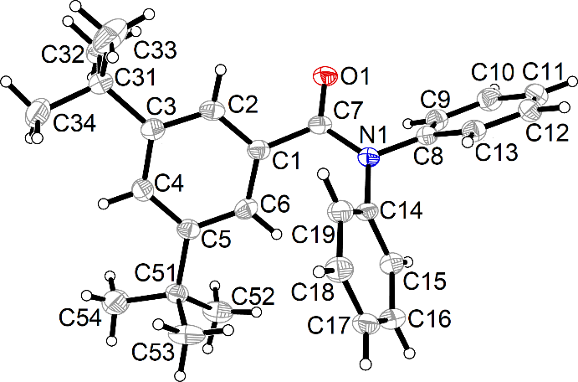
Fig. 7. Ortep diagrams of the thioamides 13 (left) and 14 (right) and of the amide 14a (below)

Fig. 8. Ortep diagrams of the thioamide 15; normal view (left) and side view (right) demonstrating the orthogonal arrangement of the planes of the arene ring and the thioamide group.

SM3

Tab. 1-4: Crystallographic data, details of data collection and structure refinement parameters

Table 1
Crystallographic data, details of data collection and structure refinement parameters for the thioamides 3, 4 and the amides 3a, 4a.
 | 3 | 3a | 4 | 4a
Empirical formula | C₁₂H₁₇NS | C₁₂H₁₇NO | C₁₆H₂₅NS | C₁₆H₂₅NO
Formula weight | 207.33 | 191.26 | 263.43 | 247.37
Temperature [K]  Color, shape | 100  yellow, needle | 100  colorless, plate | 100  yellow, block | 100  colorless, plate
Crystal size, [mm³] | 0.28×0.02×0.02 | 0.25×0.18×0.08 | 0.37×0.35×0.33 | 0.25×0.15×0.04
Crystal system | monoclinic | monoclinic | monoclinic | triclinic
Space group | P2₁/c | P2₁/c | P2₁/n | P₁̄
a [Å] | 15.8003(2) | 17.6476(4) | 18.8081(1) | 11.1964(2)
b [Å] | 5.8193(1) | 6.23902(13) | 10.5304(1) | 11.3280(3)
c [Å] | 24.9761(4) | 10.0630(2) | 24.3340(1) | 12.2051(2)
α [°] | 90.00 | 90.00 | 90.00 | 79.1157(16)
β [°] | 93.132(1) | 104.514(2) | 101.819(1) | 76.4111(17)
γ [°] | 90.00 | 90.00 | 90.00 | 89.6096(19)
V [Å³] | 2293.04(6) | 1072.61/4) | 4717.34(6) | 1476.46(5)
Z, d_{c} [g cm^{–3}] | 8, 1.201 | 4, 1.184 | 12, 1.113 | 4, 1.113
F(000) | 896 | 416 | 1728 | 544
Θ_{min}, Θ_{max} [°] | 3.54, 76.33 | 5.18/76.35 | 3.54, 76.42 | 3.80/76.28
μ(Cu K_{α}), mm^{–1} | 2.175 | 0.584 | 1.678 | 0.523
hkl range | -19<h<19  -7<k<7  -28<l<31 | -22<h<22  -7<k<7  -12<l<12 | -23<h<23  -13<k<13  -30<l<30 | -14<h<14  -12<k<14  -15<l<15
Refl. collected/unique [I > 2σ(I)] | 4786/4316 | 2244/2127 | 9857/8928 | 6120/5538
Parameters refined | 262 | 131 | 508 | 339
R₁ [I > 2σ(I)] | 0.0390 | 0.0340 | 0.0434 | 0.0362
wR₂ [a] | 0.0818 | 0.0875 | 0.1096 | 0.0949
R₁ (all data) | 0.0449 | 0.0358 | 0.0481 | 0.0398
wR₂ (all data) | 0.0830 | 0.0890 | 0.1123 | 0.0980
Weighing scheme | w = 1/[σ²(F_{o}²) + (0.0216P)² + 1.7641P].  P = (F_{o}²+2F_{c}²)/3 | w = 1/[σ²(F_{o}²) + (0.0439P)² + 0.3255P].  P = (F_{o}²+2F_{c}²)/3 | w = 1/[σ²(F_{o}²) + (0.0567P)² + 2.1238P].  P = (F_{o}²+2F_{c}²)/3 | w = 1/[σ²(F_{o}²) + (0.0481P)² + 0.3954P].  P = (F_{o}²+2F_{c}²)/3
GoF [a] | 1.132 | 1.057 | 1.040 | 1.042
Largest diff. peak/ hole [eÅ^{–3}] | 0.252/-0.254 | 0.321/-0.206 | 0.350/-0.290 | 0.291/-0.178
[a] Refine special details: Refinement of F² against all reflections. The weighted R-factor wR and goodness of fit GoF are based on F², conventional R-factors R are based on F, with F set to zero for negative F². The threshold expression of F² > 2σ(F²) is used only for calculating R-factors etc. and is not relevant to the choice of reflections for refinement. R-Factors based on F² are statistically about twice as large as those based on F, and R-factors based on all data will be even larger.

Table 2
Crystallographic data, details of data collection and structure refinement parameters for the thioamides 5-8.
 | 5[a] | 6 | 7 | 8
Empirical formula | C₁₁H₁₇NSSi | C₂₁H₁₉NS | C₁₃H₁₇D₂NS | C₂₁H₃₅NS
Formula weight | 223.41 | 317.43 | 223.36 | 321.55
Temperature [K]  Color, shape | 298  pale yellow, block | 100  pale yellow, needle | 100  pale yellow, plate | 100  yellow, plate
Crystal size, [mm³] | [b] | 0.32×0.06×0.04 | 0.20×0.16×0.02 | 0.34×0.22×0.08
Crystal system | orthorhombic | orthorhombic | orthorhombic | monoclinic
Space group | Pna/2₁ | P2₁2₁2₁ | P2₁2₁2₁ | P2₁/n
a [Å] | 8.737(1) | 15.26349(14) | 7.4593(2) | 11.1491(1)
b [Å] | 21.639(3) | 18.77106(15) | 11.9142(5) | 16.4469(1)
c [Å] | 6.792(1) | 5.82724(5) | 14.5063(4) | 11.8572(1)
α [°] | 90.00 | 90.00 | 90.00 | 90.00
β [°] | 90.00 | 90.00 | 90.00 | 104.742(1)
γ [°] | 90.00 | 90.00 | 90.00 | 90.00
V [Å³] | 1284.10(2) | 1669.57(2) | 1289.20(7) | 2105.22(3)
Z, d_{c} [g cm^{–3}] | 4, 1.162 | 4, 1.263 [c] | 4, 1.151 | 4, 1.015
F(000) | 480 | 672 | 480 | 712
Θ_{min}, Θ_{max} [°] | [b] | 3.73, 76.07 | 4.80, 76.38 | 4.70, 74.98
μ(Cu K_{α}), mm^{–1} | 2.742 | 1.687 | 1.962 | 1.323
hkl range | [b] | -7<h<7  -19<k<18  -23<l<23 | -9<h<9  -14<k<14  -18<l<18 | -13<h<13  -20<k<20  -14<l<14
Refl. collected/unique [I > 2σ(I)] | [b] | 3481/3420 | 2706/2532 | 4325/4065
Parameters refined | [b] | 208 | 140 | 218
R₁ [I > 2σ(I)] | 0.047 | 0.0221 | 0.0438 | 0.0475
wR₂ [d] | [b] | 0.0542 | 0.1092 | 0.1237
R₁ (all data) | [b] | 0.0226 | 0.0472 | 0.0498
wR₂ (all data) | [b] | 0.0546 | 0.1114 | 0.1260
Weighing scheme | [b] | w = 1/[σ²(F_{o}²) + (0.0215P)² + 0.4406P].  P = (F_{o}²+2F_{c}²)/3 | w = 1/[σ²(F_{o}²) + (0.0860P)²].  P = (F_{o}²+2F_{c}²)/3 | w = 1/[σ²(F_{o}²) + (0.0572P)² + 1.5626P].  P = (F_{o}²+2F_{c}²)/3
GoF [d] | [b] | 1.070 | 1.075 | 1.081
Largest diff. peak/ hole [eÅ^{–3}] | [b] | 0.172/-0.150 | 0.208/-0.342 | 1.211/-0.775
[a] Data taken from lit. [29]. [b] Not reported in lit. [29]. [c] d_{c} (exp.) = 1.18 g cm^{–3}. [d] Refine special details: Refinement of F² against all reflections. The weighted R-factor wR and goodness of fit GoF are based on F², conventional R-factors R are based on F, with F set to zero for negative F². The threshold expression of F² > 2σ(F²) is used only for calculating R-factors etc. and is not relevant to the choice of reflections for refinement. R-Factors based on F² are statistically about twice as large as those based on F, and R-factors based on all data will be even larger.

Table 3
Crystallographic data, details of data collection and structure refinement parameters for the thioamides 9, 10, 11 and the amides 10a, 11b.
 | 9 | 10 | 10a | 11 | 11b
Empirical formula | C₁₉H₂₇NS | C₁₇H₁₉NS | C₁₇H₁₉NO | C₂₅H₃₅NS | C₂₁H₂₇NO
Formula weight | 301.47 | 269.39 | 253.33 | 381.60 | 309.43
Temperature [K]  Color, shape | 100  yellow, block | 100  pale yellow, plate | 100  colorless, plate | 100  yellow, block | 100  colorless, plate
Crystal size, [mm³] | 0.28×0.22×0.10 | 0.70×0.60×0.04 | 0.32×0.23×0.07 | 0.26×0.20×0.15 | 0.32×0.18×0.08
Crystal system | monoclinic | monoclinic | monoclinic | triclinic | monoclinic
Space group | P2₁ | P2₁/n | P2₁/c | P₁̄ | P2₁/c
a [Å] | 9.1766(3) | 16.0774(1) | 10.3397(2) | 11.5115(2) | 7.8954(1)
b [Å] | 9.5448(2) | 8.6050(1) | 12.2657(2) | 17.4977(3) | 24.8058(4)
c [Å] | 10.3200(3) | 22.2174(2) | 11.3677(3) | 18.8004(3) | 9.4079(2)
α [°] | 90.00 | 90.00 | 90.00 | 108.2150(10) | 90.00
β [°] | 111.048(3) | 107.6060(1) | 104.757(2) | 100.2970(10) | 100.909(2)
γ [°] | 90.00 | 90.00 | 90.00 | 90.5950(10) | 90.00
V [Å³] | 843.61(4) | 2929.71(5) | 1404.23(5) | 3530.27(11) | 1809.26(5)
Z, d_{c} [g cm^{–3}] | 2, 1.187 | 8, 1.122 | 4/1.200 | 6, 1.077 | 4, 1.136
F(000) | 328 | 1152 | 544 | 1248 | 672
Θ_{min}, Θ_{max} [°] | 4.59, 74.93 | 4.04, 76.65 | 4.40, 76.18 | 3.88, 76.30 | 3.56, 76.13
μ [mm^{–1}] | 1.628 | 1.825 (CuK_{α}) | 0.576 (CuK_{α}) | 1.26 | 0.527 (CuK_{α})
hkl range | -11<h<11  -11<k<11  -12<l<12 | -20<h<20  -10<k<10  -27<l<27 | -13<h<12  -15<k<13  -14<l<14 | -14<h<14  -22<k<22  -23<l<23 | -9<h<9  -30<k<31  -10<l<11
Refl. collected/unique [I > 2σ(I)] | 3450/3415 | 6121/5958 | 2923/2697 | 14701/13380 | 3753/3514
Parameters refined | 191 | 350 | 175 | 758 | 217
R₁ [I > 2σ(I)] | 0.0637 | 0.0310 | 0.0353 | 0.0432 | 0.0363
wR₂ [a] | 0.2016 | 0.0838 | 0.0906 | 0.1025 | 0.0888
R₁ (all data) | 0.0643 | 0.0319 | 0.0379 | 0.0478 | 0.0386
wR₂ (all data) | 0.2019 | 0.0846 | 0.0927 | 0.1060 | 0.0910
Weighing scheme | w = 1/[σ²(F_{o}²) + (0.1097P)² + 1.9422P].  P = (F_{o}²+2F_{c}²)/3 | w = 1/[σ²(F_{o}²) + (0.0421P)² + 1.2342 P].  P = (F_{o}²+2F_{c}²)/3 | w = 1/[σ²(F_{o}²) + (0.0435P)² + 0.4488 P].  P = (F_{o}²+2F_{c}²)/3 | w = 1/[σ²(F_{o}²) + (0.0395P)² + 2.217P].  P = (F_{o}²+2F_{c}²)/3 | w = 1/[σ²(F_{o}²) + (0.0400P)² + 0.6194P].  P = (F_{o}²+2F_{c}²)/3
GoF [a] | 1.101 | 1.051 | 1.075 | 1.048 | 1.053
Largest diff. peak/hole [eÅ^{–3}] | 1.243/-0.339 | 0.326/-0.252 | 0.216/-0.220 | 1.216/-1.246 | 0.221/-0.206
[a] Refine special details: Refinement of F² against all reflections. The weighted R-factor wR and goodness of fit (GoF) are based on F², conventional R-factors R are based on F, with F set to zero for negative F². The threshold expression of F² > 2σ(F²) is used only for calculating R-factors etc. and is not relevant to the choice of reflections for refinement. R-Factors based on F² are statistically about twice as large as those based on F, and R-factors based on all data will be even larger.

Table 4
Crystallographic data, details of data collection and structure refinement parameters for the thioamides 12-15 and the amide 14a.
 | 12 | 13 | 14 | 14a | 15
Empirical formula | C₁₉H₁₅NS | C₁₉H₁₄DNS | C₂₇H₃₁NS | C₂₇H₃₁NO | C₁₂H₁₇NS
Formula weight | 289.40 | 290.39 | 401.59 | 385.53 | 207.32
Temperature [K]  Color, shape | 298  yellow, block | 100  yellow, plate | 100  yellow, plate | 100  colorless, plate | 100  colorless, plate
Crystal size, [mm³] | 0.30×0.30×0.20 | 0.22×0.12×0.06 | 0.20×0.16×0.07 | 0.20×0.15×0.05 | 0.22×0.18×0.04
Crystal system | triclinic | triclinic | triclinic | monoclinic | monoclinic
Space group | P₁̄ | P₁̄ | P₁̄ | C2/c | P2₁/c
a [Å] | 8.380(1) | 8.2491(3) | 10.225(3) | 27.7139(8) | 14.9670(6)
b [Å] | 9.389(1) | 9.3385(3) | 10.994(3) | 9.3478(4) | 11.9907(4)
c [Å] | 9.945(1) | 9.7874(4) | 11.861(3) | 17.6806(6) | 13.5472(5)
α [°] | 99.57(1) | 99.1867(4) | 77.543(3) | 90.00 | 90.00
β [°] | 94.97(1) | 95.3272(4) | 80.808(3) | 97.860(3) | 104.714(4)
γ [°] | 94.19(1) | 94.3297(4) | 65.127(3) | 90.00 | 90.00
V [Å³] | 763.36 | 737.94(5) | 1172.2(5) | 4537.4(3) | 2351.51(16)
Z, d_{c} [g cm^{–3}] | 2, 1.255 [a] | 2, 1.307 | 2, 1.138 | 8/1.129 | 8, 1.176
F(000) | 304 | 304 | 432 | 1640 | 896
Θ_{min}, Θ_{max} [°] | [b], 71.12 | 2.12, 27.50 | 1.76, 28.90 | 3.22, 61.75 | 4.71, 76.02
μ [mm^{–1}] | 1.323 (CuK_{α}) | 0.211 (MoK_{α}) | 0.150 (MoK_{α}) | 0.516 (CuK_{α}) | 2.120 (CuK_{α})
hkl range | [b]  [b]  [b] | -10<h<10  -12<k<12  -12<l<12 | -13<h<13  -14<k<14  -15<l<15 | -31<h<31  -10<k<10  -20<l<20 | -18<h<18  -14<k<14  -17<l<17
Refl. collected/unique [I > 2σ(I)] | 2943/2600 | 3351/3265 | 5582/5070 | 3401/2378 | 4915/4138
Parameters refined | 268 | 190 | 268 | 268 | 263
R₁ [I > 2σ(I)] | 0.0456 | 0.0297 | 0.0338 | 0.0531 | 0.0505
wR₂ [c] | [b] | 0.0731 | 0.0868 | 0.1332 | 0.1334
R₁ (all data) | [b] | 0.0305 | 0.0377 | 0.0863 | 0.0598
wR₂ (all data) | [b] | 0.0738 | 0.0897 | 0.1561 | 0.1445
Weighing scheme | [b] | w = 1/[σ²(F_{o}²) + (0.0266P)² + 0.4561P].  P = (F_{o}²+2F_{c}²)/3 | w = 1/[σ²(F_{o}²) + (0.0380P)² + 0.6053P].  P = (F_{o}²+2F_{c}²)/3 | w = 1/[σ²(F_{o}²) + (0.0819P)² + 1.1721P].  P = (F_{o}²+2F_{c}²)/3 | w = 1/[σ²(F_{o}²) + (0.0763P)² + 1.2147P].  P = (F_{o}²+2F_{c}²)/3
GoF [c] | [b] | 1.058 | 1.047 | 1.014 | 1.053
Largest diff. peak/hole [eÅ^{–3}] | [b] | 0.311/-0.227 | 0.357/-0.251 | 0.240/-0.254 | 0.383/-0.367
[a] d_{exp} = 1.25 [g cm^{–3}]. [b] Not reported in lit. [30]. [c] Refine special details: Refinement of F² against all reflections. The weighted R-factor wR and goodness of fit (GoF) are based on F², conventional R-factors R are based on F, with F set to zero for negative F². The threshold expression of F² > 2σ(F²) is used only for calculating R-factors etc. and is not relevant to the choice of reflections for refinement. R-Factors based on F² are statistically about twice as large as those based on F, and R-factors based on all data will be even larger.

SM 4

Table 5 - 14. Intramolecular interactions [53, 54, 55, 56]. Hirshfeld fingerprint plots

Table 5: Thiobenzamide 3
Inside Atom | Outside Atom
Inside Atom | S |  | N |  | C |  | H |  | ∑
C | 0,00 |  | 0,00 |  | 0,00 |  | 7,60 |  | 7,60
H | 6,10 |  | 0,10 |  | 6,20 |  | 68,00 |  | 80,40
N | 0,00 |  | 0,00 |  | 0,00 |  | 0,20 |  | 0,20
S | 0,00 |  | 0,00 |  | 0,00 |  | 11,80 |  | 11,80
∑ | 6,10 |  | 0,10 |  | 6,20 |  | 87,50 |  | 100,00
Table 6: Thiobenzamide 4
Inside Atom | Outside Atom
Inside Atom | S |  | N |  | C |  | H |  | ∑
C | 0,00 |  | 0,00 |  | 0,00 |  | 5,20 |  | 5,20
H | 4,80 |  | 0,00 |  | 4,50 |  | 79,30 |  | 88,60
N | 0,00 |  | 0,00 |  | 0,00 |  | 0,00 |  | 0,00
S | 0,00 |  | 0,00 |  | 0,00 |  | 6,20 |  | 6,20
∑ | 4,80 |  | 0,00 |  | 4,50 |  | 90,70 |  | 100,00
Table 7: Thiobenzamide 6
Inside Atom | Outside Atom
Inside Atom | S |  | N |  | C |  | H |  | ∑
C | 0,20 |  | 0,00 |  | 0,10 |  | 16,80 |  | 17,20
H | 4,10 |  | 0,00 |  | 12,80 |  | 59,00 |  | 75,80
N | 0,00 |  | 0,00 |  | 0,00 |  | 0,00 |  | 0,00
S | 0,00 |  | 0,00 |  | 0,30 |  | 6,80 |  | 7,00
∑ | 4,30 |  | 0,00 |  | 13,20 |  | 82,60 |  | 100,00
Table 8: Thiobenzamide 7
Inside Atom |  | Outside Atom
 |  | S |  | N |  | C |  | H |  | ∑
C |  | 0,00 |  | 0,00 |  | 0,00 |  | 7,40 |  | 7,40
H |  | 5,20 |  | 0,00 |  | 6,00 |  | 72,50 |  | 83,80
N |  | 0,00 |  | 0,00 |  | 0,00 |  | 0,00 |  | 0,00
S |  | 0,00 |  | 0,00 |  | 0,00 |  | 8,90 |  | 8,90
∑ |  | 5,20 |  | 0,00 |  | 6,00 |  | 88,70 |  | 100,10

Table 9: Thiobenzamide 8
Inside Atom |  | Outside Atom
 |  | S |  | N |  | S |  | H |  | ∑
C |  | 0,00 |  | 0,00 |  | 0,00 |  | 2,60 |  | 2,60
H |  | 3,70 |  | 0,00 |  | 2,60 |  | 85,10 |  | 91,30
N |  | 0,00 |  | 0,00 |  | 0,00 |  | 0,00 |  | 0,00
S |  | 0,00 |  | 0,00 |  | 0,00 |  | 6,10 |  | 6,10
∑ |  | 3,70 |  | 0,00 |  | 2,60 |  | 93,70 |  | 100,00
Table 10: Thiobenzamide 9
Inside Atom |  | Outside Atom
 |  | S |  | N |  | C |  | H |  | ∑
C |  | 0,00 |  | 0,00 |  | 0,00 |  | 6,50 |  | 6,50
H |  | 3,80 |  | 0,10 |  | 5,70 |  | 77,70 |  | 87,20
N |  | 0,00 |  | 0,00 |  | 0,00 |  | 0,10 |  | 0,10
S |  | 0,00 |  | 0,00 |  | 0,00 |  | 6,30 |  | 6,30
∑ |  | 3,80 |  | 0,10 |  | 5,70 |  | 90,50 |  | 100,10
Table 11: Thiobenzamide 10
Inside Atom | Outside Atom
Inside Atom | S |  | N |  | C |  | H |  | ∑
C | 0,00 |  | 0,00 |  | 2,60 |  | 8,00 |  | 10,50
H | 3,50 |  | 0,00 |  | 6,20 |  | 72,20 |  | 81,90
N | 0,00 |  | 0,00 |  | 0,00 |  | 0,00 |  | 0,00
S | 0,00 |  | 0,00 |  | 0,00 |  | 7,60 |  | 7,60
∑ | 3,50 |  | 0,00 |  | 8,80 |  | 87,70 |  | 100,00
Table 12: Thiobenzamide 11
Inside Atom | Outside Atom
Inside Atom | S |  | N |  | C |  | H |  | ∑
C | 0,00 |  | 0,00 |  | 0,00 |  | 4,60 |  | 4,6
H | 3,50 |  | 0,00 |  | 3,80 |  | 83,20 |  | 90,5
N | 0,00 |  | 0,00 |  | 0,00 |  | 0,00 |  | 0
S | 0,00 |  | 0,00 |  | 0,00 |  | 4,90 |  | 4,9
∑ | 3,50 |  | 0,00 |  | 3,90 |  | 92,70 |  | 100,00

Table 13: Thiobenzamide 13
Inside Atom | Outside Atom
Inside Atom | S | N | C | H
C | 0,70 | 0,00 | 0,50 | 18,50 | 19,7
H | 5,40 | 0,00 | 14,40 | 51,10 | 70,9
N | 0,00 | 0,00 | 0,00 | 0,00 | 0
S | 0,00 | 0,00 | 0,80 | 8,60 | 9,3
∑ | 6,10 | 0,00 | 15,60 | 78,20 | 99,9
Table 14: Thiobenzamide 14
Inside Atom | Outside Atom
Inside Atom | S | N | C | H
C | 0,00 | 0,00 | 0,20 | 9,00 | 9,20
H | 4,20 | 0,00 | 7,60 | 72,40 | 84,30
N | 0,00 | 0,00 | 0,00 | 0,00 | 0,00
S | 0,00 | 0,00 | 0,00 | 6,50 | 6,50
∑ | 4,20 | 0,00 | 7,90 | 87,90 | 100,00

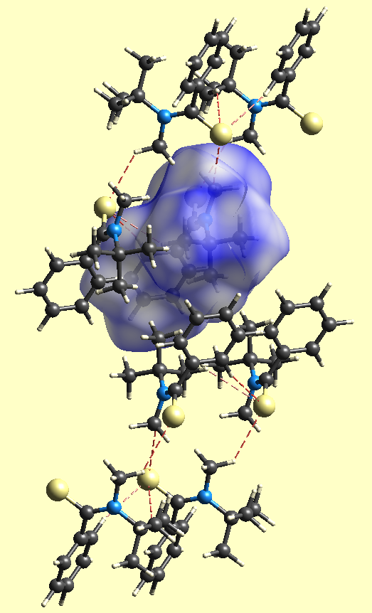
Figure SM 4-1: Thiobenzamide 3, B3LYP 6-31G**; H-bonding, S-H close contacts, isosurface 0.5
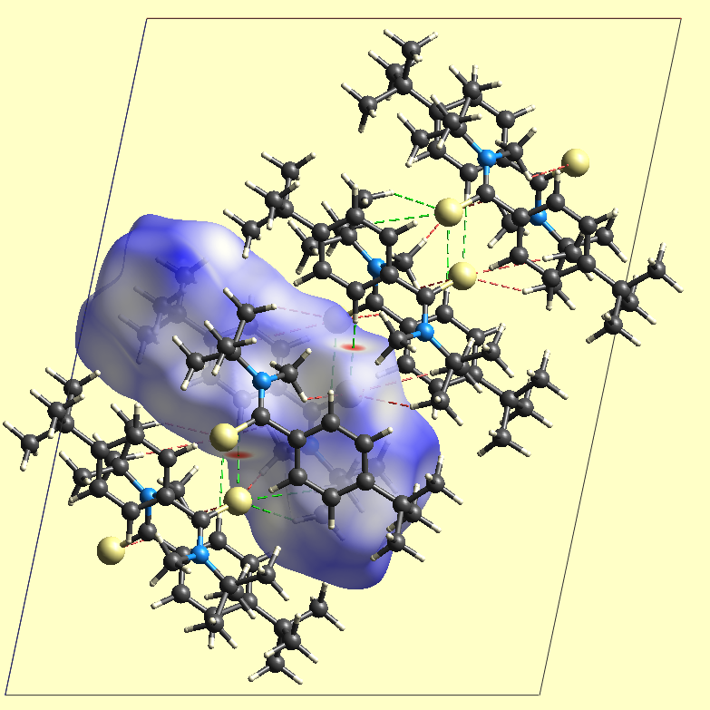
Figure SM 4-2: Thiobenzamide 4, B3LYP 6-31G**; H-bonding, S-H close contacts, isosurface 0.5

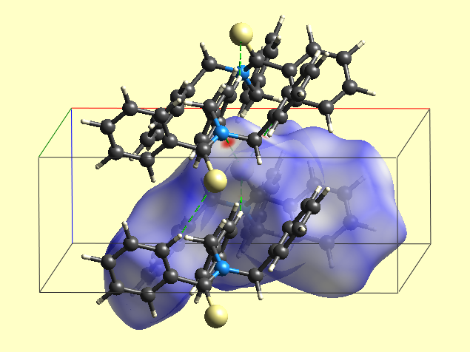
Figure SM 4-3: Thiobenzamide 6, B3LYP 6-31G**; H-bonding, S-H close contacts, isosurface 0.5

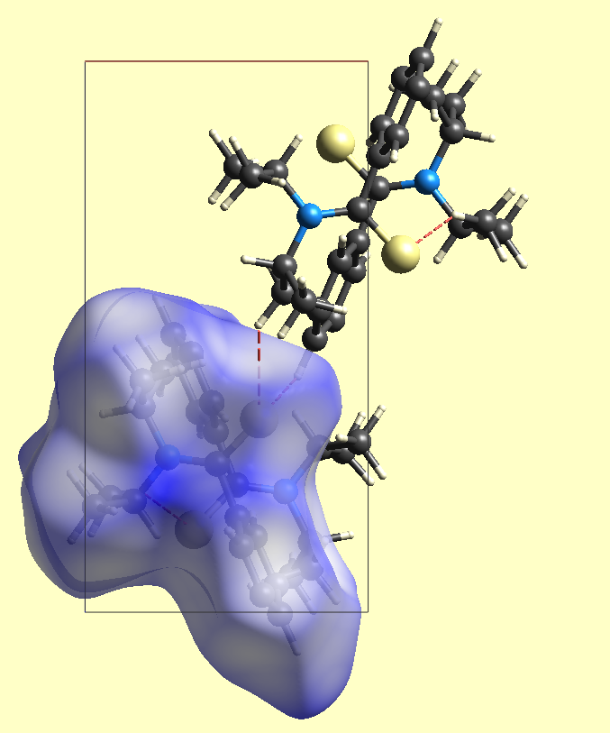
Figure SM 4-4: Thiobenzamide 7, B3LYP 6-31G**; H-bonding, S-H close contacts, isosurface 0.5
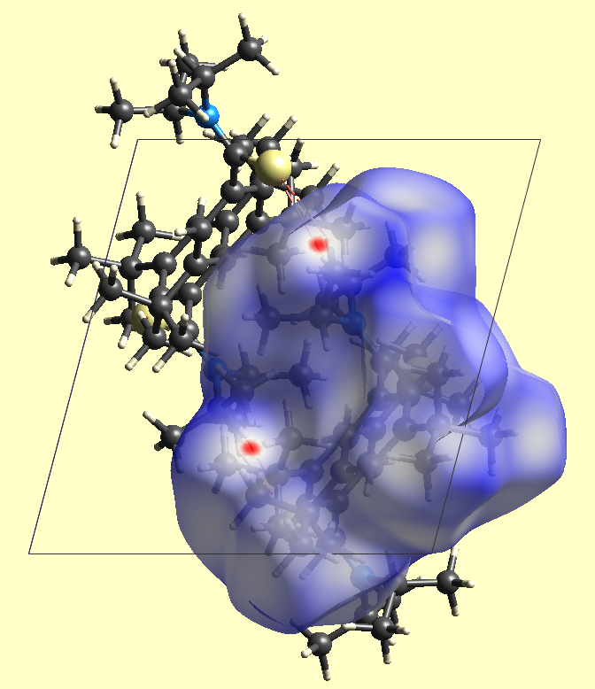
Figure SM 4-5: Thiobenzamide 8, B3LYP 6-31G**; H-bonding, S-H close contacts, isosurface 0.5

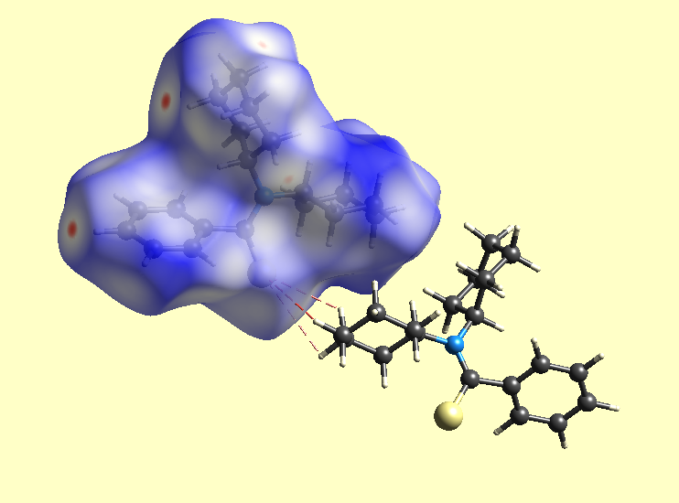
Figure SM 4-6: Thiobenzamide 9, B3LYP 6-31G**; H-bonding, S-H close contacts, isosurface 0.5

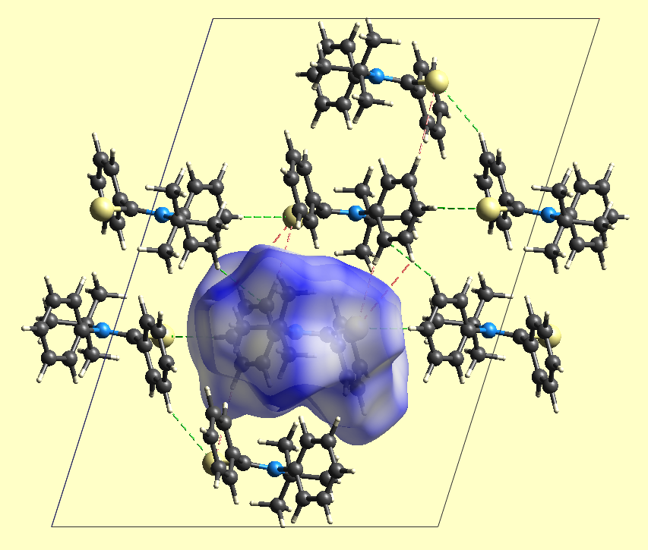
Figure SM 4-7: Thiobenzamide 10, B3LYP 6-31G**; H-bonding, S-H close contacts, isosurface 0.5

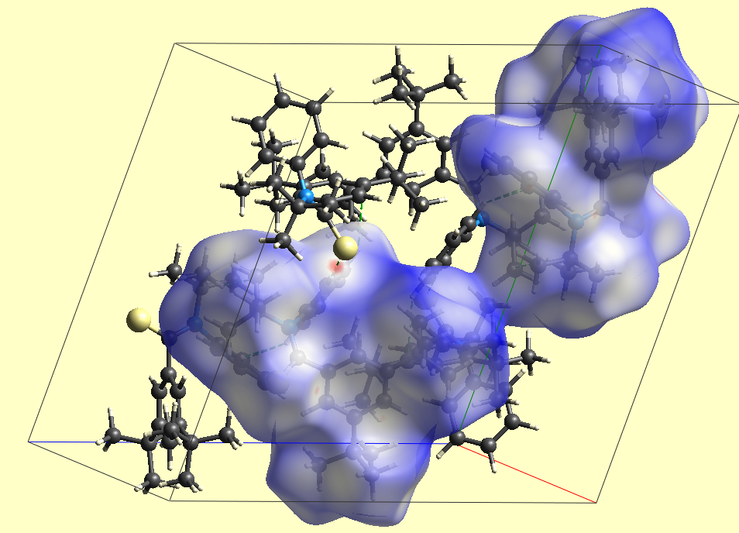
Figure SM 4-8: Thiobenzamide 11, B3LYP 6-31G**; H-bonding, S-H close contacts, isosurface 0.5

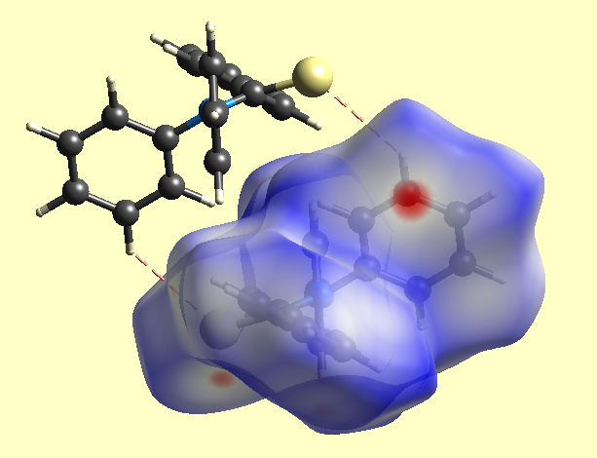
Figure SM 4-9: Thiobenzamide 13, B3LYP 6-31G**; H-bonding, S-H close contacts, isosurface 0.5

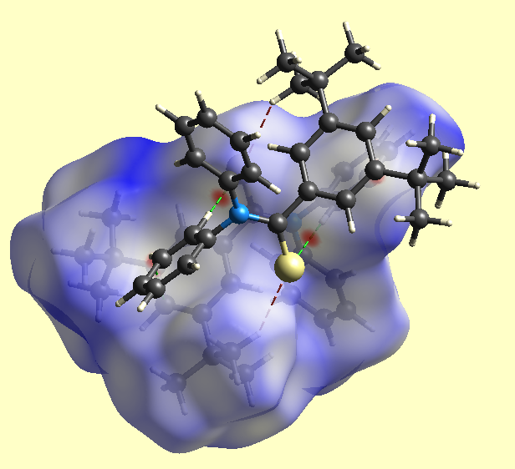
Figure SM 4-10: Thiobenzamide 14, B3LYP 6-31G**; H-bonding, S-H close contacts, isosurface 0.5

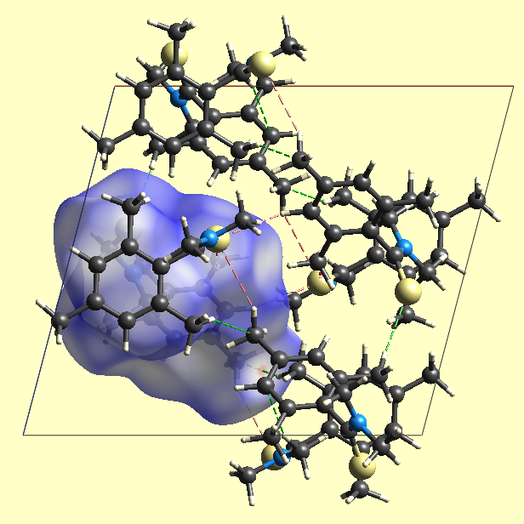
Figure SM 4-11: Thiobenzamide 15, B3LYP 6-31G**; H-bonding, S-H close contacts, isosurface 0.5
SM5
References

The following citations [13] – [56] are identic with the corresponding references in the main text of the publication. References [73] – [80] are new follow-up numbers.

[13] Voss J, Walter W (1970) EPR-Untersuchungen an Thioamiden, II. N,N-Dialkyl-thiobenzamid-Radikal-Anionen. Liebigs Ann Chem 734:1-12.
[14] Voss J (1995) 2,4-Bis(4-methoxyphenyl)-1,3,2,4-dithiadiphosphetane 2,4-Disulfide In: Paquette LA, Burke SD (eds) Encyclopedia of Reagents for Organic Synthesis, 1st edn vol. 1. John Wiley & Sons Ltd., Chichester, 530-534. Voss J (2006) 2,4-Bis(4-methoxyphenyl)-1,3,2,4-dithiadiphosphetane 2,4-Disulfide In: Electronic Encyclopedia of Reagents for Organic Synthesis. Paquette LA, Crich D eds), 2nd edn vol. 1, John Wiley & Sons Ltd., Chichester, 1-16. ISBN: 978-0-470-84289-8. http://www.mrw.interscience.wiley.com/eros/articles/rb170/sect0.html.
[15] Voss J, Walter W (1968) Direkte Darstellung von Thioamiden aus Säurechloriden und Aminen. Liebigs Ann Chem 716:209-211.
[29] Lüke H-W (1978) Silylthioamide Eigenschaften und Reaktionen, PhD thesis, Univ. Hamburg, Germany.
[30] Harto S (1976), Röntgenstrukturanalyse von Carbonyl- und Thiocarbonyl-Verbindungen mit sp²- und sp-hybridisiertem Kohlenstoff, PhD thesis, Univ. Hamburg, Germany.
[36] Berg U, Pettersson I (1985) Conformational Equilibria and Torsional Barriers of the Isopropyl Groups in N,N-Diisopropylbenzamide and its Thio and Seleno Analogues. Magn Reson Chem 23:536-539. DOI: 10.1002/mrc.1260230711.
[37] Holík M, Mannschreck A (1979) Application of NMR spectroscopy of Chiral Association Complexes. 8. Rotation about the C(sp₂)-C(aryl) Bond in 2,6-Disubstituted Benzamides. Org Magn Reson 12:223-228. DOI: 10.1002/mrc.1270120411.
[41] Khatri CK, Mali AS, Chaturbhuj GU (2017) Sulfated Polyborate Catalyzed Kindler Reaction: A Rapid, Efficient, and Green Protocol. Monatsh Chem 148:1463-1468. DOI: 10.1007/s00706-017-1944-6.
[43] Mannschreck A, Mattheus A, Rissmann G (1967) Comparison of kinetic results obtained by NMR line shape and equilibration methods. J Mol Spectrosc 23:15-31. DOI: 10.1016/0022-2852(67)90044-6.
[53] Spackman MA, Jayatilaka D (2009) Hirshfeld Surface Analysis. Cryst Eng Commun 11:19-32. DOI: 10.1039/b818330a.
[54] Spackman MA, McKinnon JJ (2002) Fingerprinting intermolecular interactions in molecular crystals. Cryst Eng Commun 4:378-392. DOI: 10.1039/b203191b.
[55] McKinnon JJ, Jayatilaka D, Spackman MA (2007) Towards Quantitative Analysis of Intermolecular Interactions with Hirshfeld Surfaces. Chem Commun 3814-3816. DOI: 10.1039/b704980c.
[56] Hirshfeld FL (1977) Bonded-atom fragments for describing molecular charge densities. Theoret Chim Acta 44:129-138. https://doi.org/10.1007/BF00549096.
[73] Deyrup JA, Szabo WA (1975) Deprotonation of Ternary Iminium Salts, J. Org. Chem. 40:2048-2052. DOI: 10.1021/jo00902a008.
[74] Aitken RA, Raut SV (1996) Base-induced Cycloreversion of Nitrile Oxide Cycloadducts: Conversion of Imines into Secondary and Tertiary Amides and Aromatic Aldehydes into Acids without a Conventional Oxidising Agent, J. Chem. Soc., Perkin Trans. 1 747-751. DOI: org/10.1039/P19960000747.
[75] Spychała J (2006), Convenient Synthesis of N-Methylthioamides: A Migration of the H₂S Molecule in the Thioamide-Nitrile System, J. Sulfur Chem. 27:203-212. DOI: 10.1080/17415990600654599.
[76] Voss J, Bruhn F-R (1979) ESR Studies in the Thioamide Series. VI. - Radical Anions of N,N-Dialkylbenzamides, -thiobenzamides, and -selenobenzamides, Liebigs Ann. Chem. 1931-1944.
[77] Walter W, Curts J, Pawelzik H (1961) Über die Oxidationsprodukte von Thiocarbonsäureamiden. IV Oxidationsprodukte sekundärer und tertiärer Thioamide, Liebigs Ann. Chem. 643:29-38.
[78] Beets MGB, Meerburg W, van Essen H (1959) Structure and Musk Odor. II Benzene Derivatives, Rec. Trav. Chim. P.-B. 78: 570-585.
[79] Bondarenko AV, Farberov MI, Karakuleva GI, Komoleva GA, Tikhvinskaya MYu (1962), Di-tert-butylbenzoic acid, Uch. Zap. Yaroslavsk. Tekhnol. Inst. 1(8):91-99. (1964) Chem. Abstr. 61:604g.
[80] Voss J (1972) EPR-Spektroskopische Untersuchungen an den Radikalanionen von Carbonsäurederivaten. Habilitation thesis, Univ Hamburg, Germany.

