Extended Data

Mapping the planet's critical areas for biodiversity and people

Rachel A. Neugarten, Rebecca Chaplin-Kramer, Richard P. Sharp, Richard Schuster, Matthew Strimas-Mackey, Patrick R. Roehrdanz, Mark Mulligan, Arnout van Soesbergen, David Hole, Christina M. Kennedy, James R. Oakleaf, Justin A. Johnson, Joseph Kiesecker, Stephen Polasky, Jeffrey O. Hanson, Amanda D. Rodewald

Correspondence to: ran63@cornell.edu

This file includes:

Supplementary Text
Extended data Figs. S1 to S9
Extended data Tables S1 to S6

Other Extended data for this manuscript include the following:

Extended data Tables S7 and S8 (separate files)

Supplementary Text

Spatial overlap of prioritized areas for NCP and prioritized areas for species
When prioritized separately, prioritized areas NCP are not sufficient for achieving species representation targets, particularly in arid regions (Fig. S1). This is because areas providing high levels of NCP tend to be more geographically concentrated in regions with dense vegetation and in areas accessible to, or upstream of, human populations, while areas prioritized to achieve species targets occur across all habitat types and in geographically remote areas.
Spatial resolution
The spatial resolution of input data, as well as the method used for converting data between spatial resolutions (resampling), is known to influence results of spatial prioritizations. To test the effect of spatial resolution on our results, we conducted prioritizations for NCP at four different resolutions: 2km, 3km, 5km, and 10km. At coarser resolutions, more land area is required to achieve NCP targets (Fig. S6, Table S5), consistent with previous studies⁶¹. Due to the large number of species (26,709), prioritizations at finer spatial resolutions for both NCP and species were beyond the scope of this analysis, which relied on traditional computational resources. To address this issue, and to bring our results in line with previous work¹⁰, we masked the 10 km prioritization results to natural and semi-natural habitat data at a finer spatial resolution (2 km), which more precisely identifies the 2 km habitat grid cells which provide NCP within each 10 km grid cell.
Urban Pressure Index
We created the Urban Pressure Index (UPI) based on global urban growth probabilities for 31 years at approximately the same resolution as the Development Potential Indices (DPIs) (30 arc-seconds, ~1-km) and was based on the SLEUTH urban growth model, which accounts for slope, land cover, excluded regions (i.e., protected areas, water bodies), urban land cover, transportation, and hill shade and calibrated based on the historical distribution of global population from LandScan⁶².
To produce an UPI similar to the DPIs, we removed all currently designated urban areas⁵⁷ and existing (non-urban) built-up areas⁶³. We then summed urban growth probability values across the 31-year time interval, resulting in values ranging from 1 (1% probability of expansion in 2050) to 3100 (100% probability of expansion for all 31 years). Given the right-skewed distribution of these data (skewness = 4.3619), we log transformed all urban cell values and scaled the data to 0-1 values using min-max normalization.
Because UPI was derived from urban expansion probabilities based on population growth projections, which were more restrictive than the DPIs (e.g., excluded suitable areas like flat land, near roads and existing urban areas once demand was met), we binned the range of values represented in the UPI into either “high” or “very high” categories.
Development Pressure
We used the Development Potential Indices (DPIs) to create our development pressure index, because they provide the most globally consistent and detailed data on the relative suitability of lands for future development expansion by agriculture, mining, oil and gas, and renewable energy sectors. For a more complete discussion of the assumptions and limitations of the DPIs, see¹⁶. The high and very high DPI classes used in our study were validated as having a higher likelihood of development expansion over other DPI classes¹⁶, as well as to reflect general patterns of potential expansion under business-as-usual growth projections¹⁹. Accurately predicting locations of future development expansion, however, requires a number of assumptions and a level of precision that are not currently available with global data. For example, governmental actions (e.g., environmental regulations, incentives, tax breaks), market changes and technological advancements were not accounted for in the DPI, again because of a lack of consistent global data. Given the frequency of policy and market changes, variations across administrative units, and the effort required to maintain such a database, incorporating all feasibility factors was beyond the scope of this analysis, but as these data become more available globally, doing so will improve future work.
Comparison to previous work
The spatial optimizations included here differ from previous work¹⁰ in several key ways. First, because of the inclusion of biodiversity targets, the optimizations were run globally, rather than for each country, as it is more efficient (in terms of land area required) to achieve species representation targets at a global scale rather than within countries. In order to be consistent with data on terrestrial species, the current analysis focuses on the ten NCP that are relevant for terrestrial habitats, including water-related NCP provided by terrestrial systems (flood regulation, water quality regulation), the onshore component of coastal protection, and nearshore mangrove carbon storage (within 10km of the coast). Offshore marine NCP (marine fish catch, coral reef tourism, the offshore component of coastal protection) were not included, in contrast to¹⁰. Because the focus of the current analysis is on achieving global biodiversity and climate targets simultaneously, vulnerable ecosystem carbon storage (an NCP with global benefits) was included in all optimization scenarios, rather than in a parallel analysis as was done in¹⁰. Due to the large number of species and constraints from using traditional computational resources, the spatial resolution of the optimization in the current analysis is 10 km, rather than 2 km as in¹⁰. This coarser resolution resulted in larger land areas to achieve targets (see Table S5); the difference in resolution was addressed by masking prioritization results to natural and semi-natural habitat data at 2 km⁵⁵.

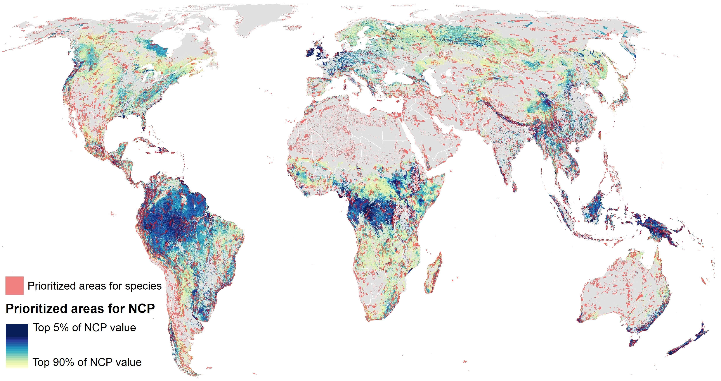

Fig. S1 Prioritized areas for NCP overlaid with prioritized areas for species
Prioritized areas for NCP (5%-90% of current levels, dark blue to light yellow) overlaid with areas required to achieve minimum species representation targets (in red), optimized separately.
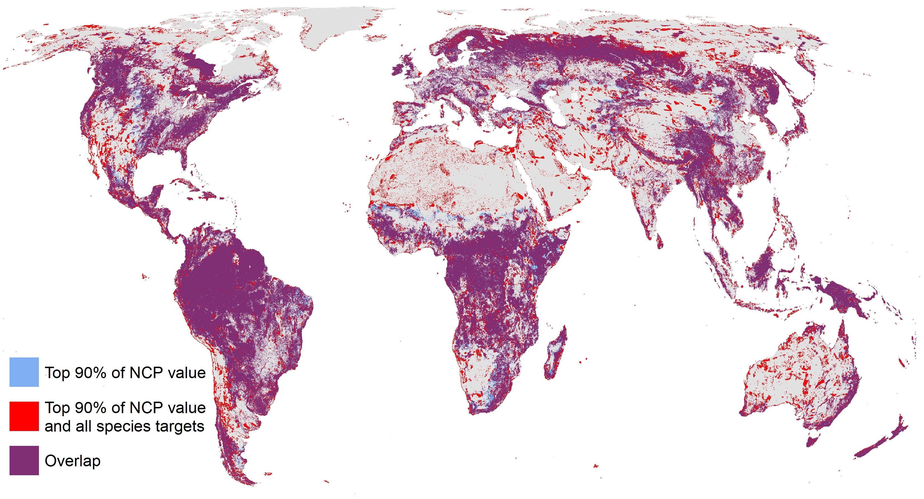

Fig S2. Overlap between prioritized areas for NCP only, and NCP and species
Prioritized areas for NCP only (90% of current levels of NCP, in blue), NCP (90%) and species (red), and overlap (purple). Prioritized areas overlap over 33% of global land area (representing 94% of areas prioritized for NCP alone, or 75% of areas prioritized for NCP and species).

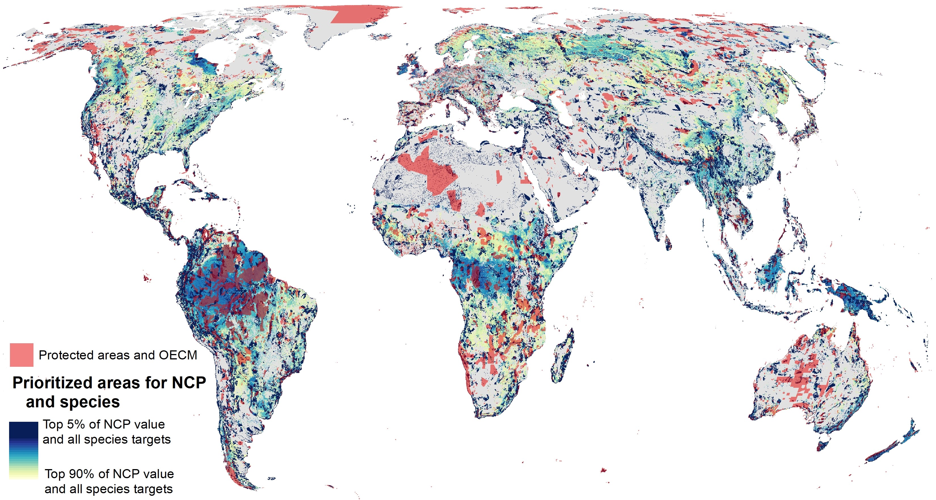

Fig. S3 Prioritized areas for NCP and species overlaid with terrestrial protected areas and Other Effective area-based Conservation Measures (OECM)
Protected areas and OECM based on the World Database of Protected Areas, March 2021 (in red).
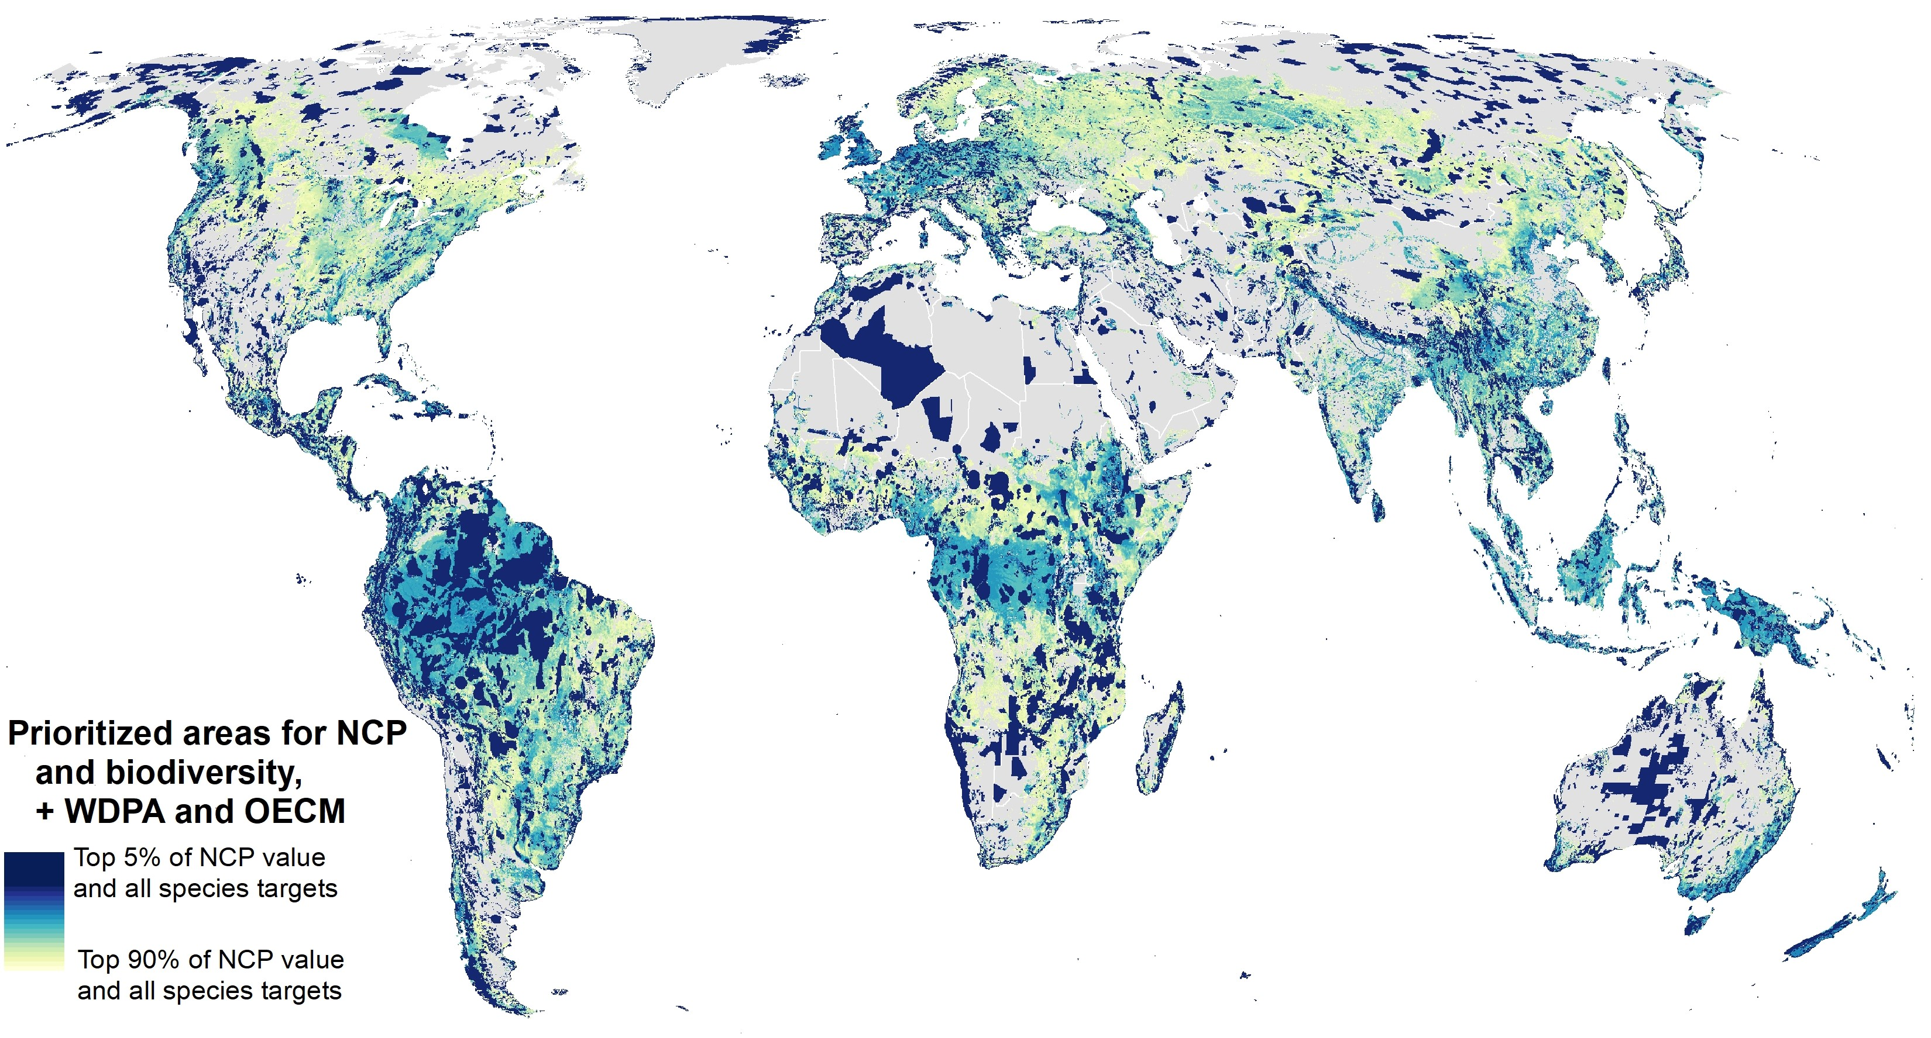

Fig. S4 Prioritized areas for NCP and biodiversity with protected and OECM areas “locked in” to the spatial optimization
Prioritized areas for NCP and species, with protected areas “locked in”, shown in light yellow (areas providing 90% of current levels of NCP and meeting minimum species representation targets) to dark blue (5% of current levels of NCP and all species targets). Dark blue areas represent the highest value places for NCP, that also achieve minimum species targets, in the least amount of land area, with WDPA and OECM areas “locked in”.
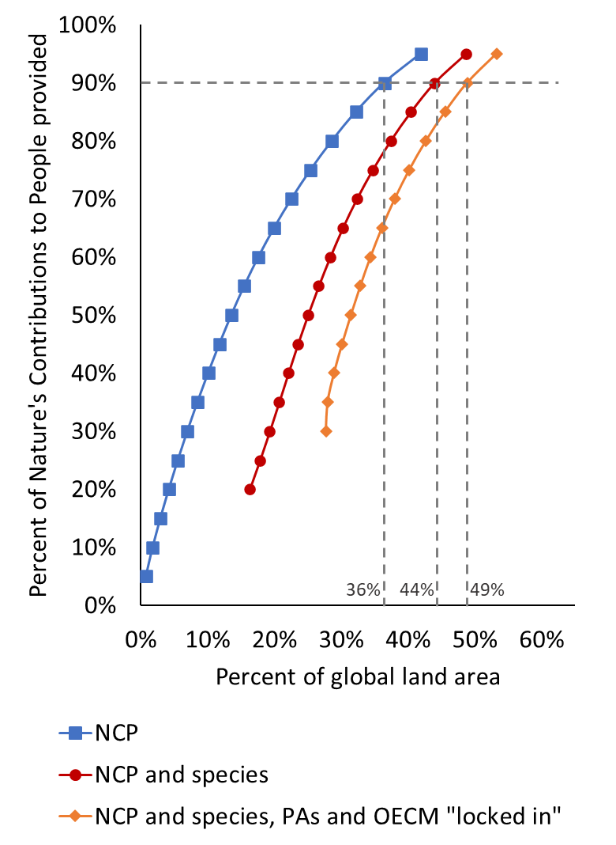

Fig. S5 Percent of land area required to achieve targets with protected areas and OECM “locked in”
NCP (blue squares), NCP and minimum species representation targets (red circles), NCP and species targets with PAs and OECM areas locked in (orange diamonds). Providing 90% of NCP (without species targets) requires 36% of global land area. Dashed lines: achieving all species representation targets as well as 90% of NCP requires 44% of global land area, achieving the same targets after “locking in” existing protected and OECM areas adds 5% (49% of global land area).

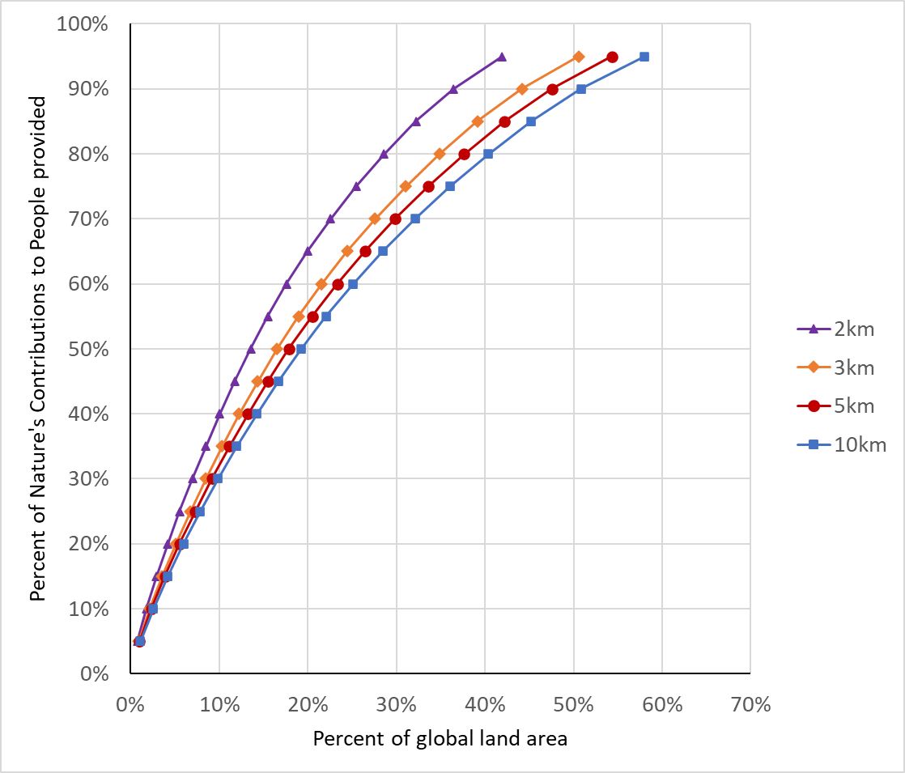

Fig. S6 Percent of land area required to provide different levels of NCP at different spatial resolutions
Results of prioritization scenarios for NCP (only) with targets ranging from 5% to 95% across all ten NCP. Different symbols represent solutions at different spatial resolutions: 10 km (blue squares), 5 km (red circles), 3 km (orange diamonds), and 2km (purple triangles.)

A)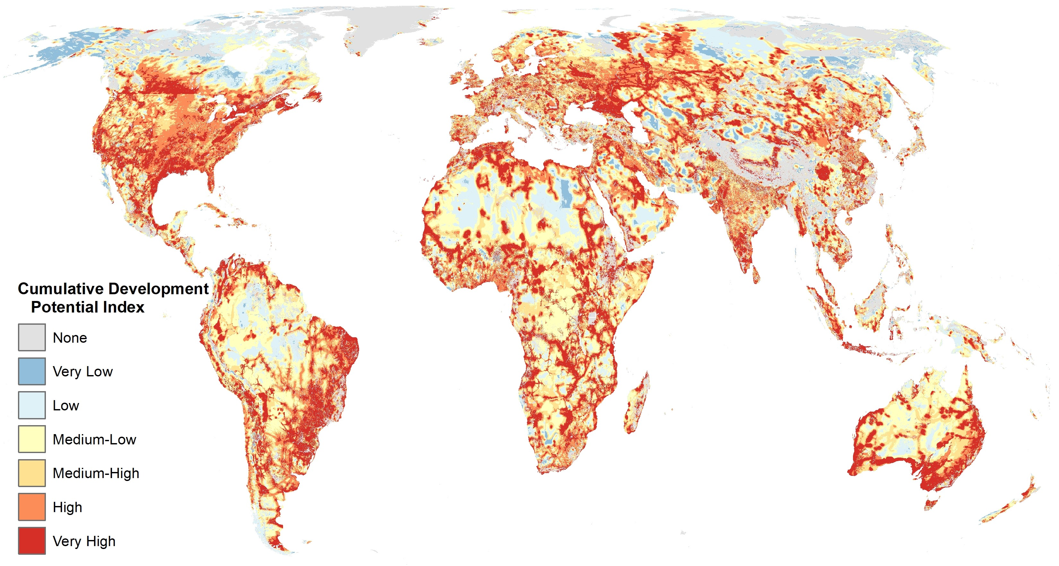
B)
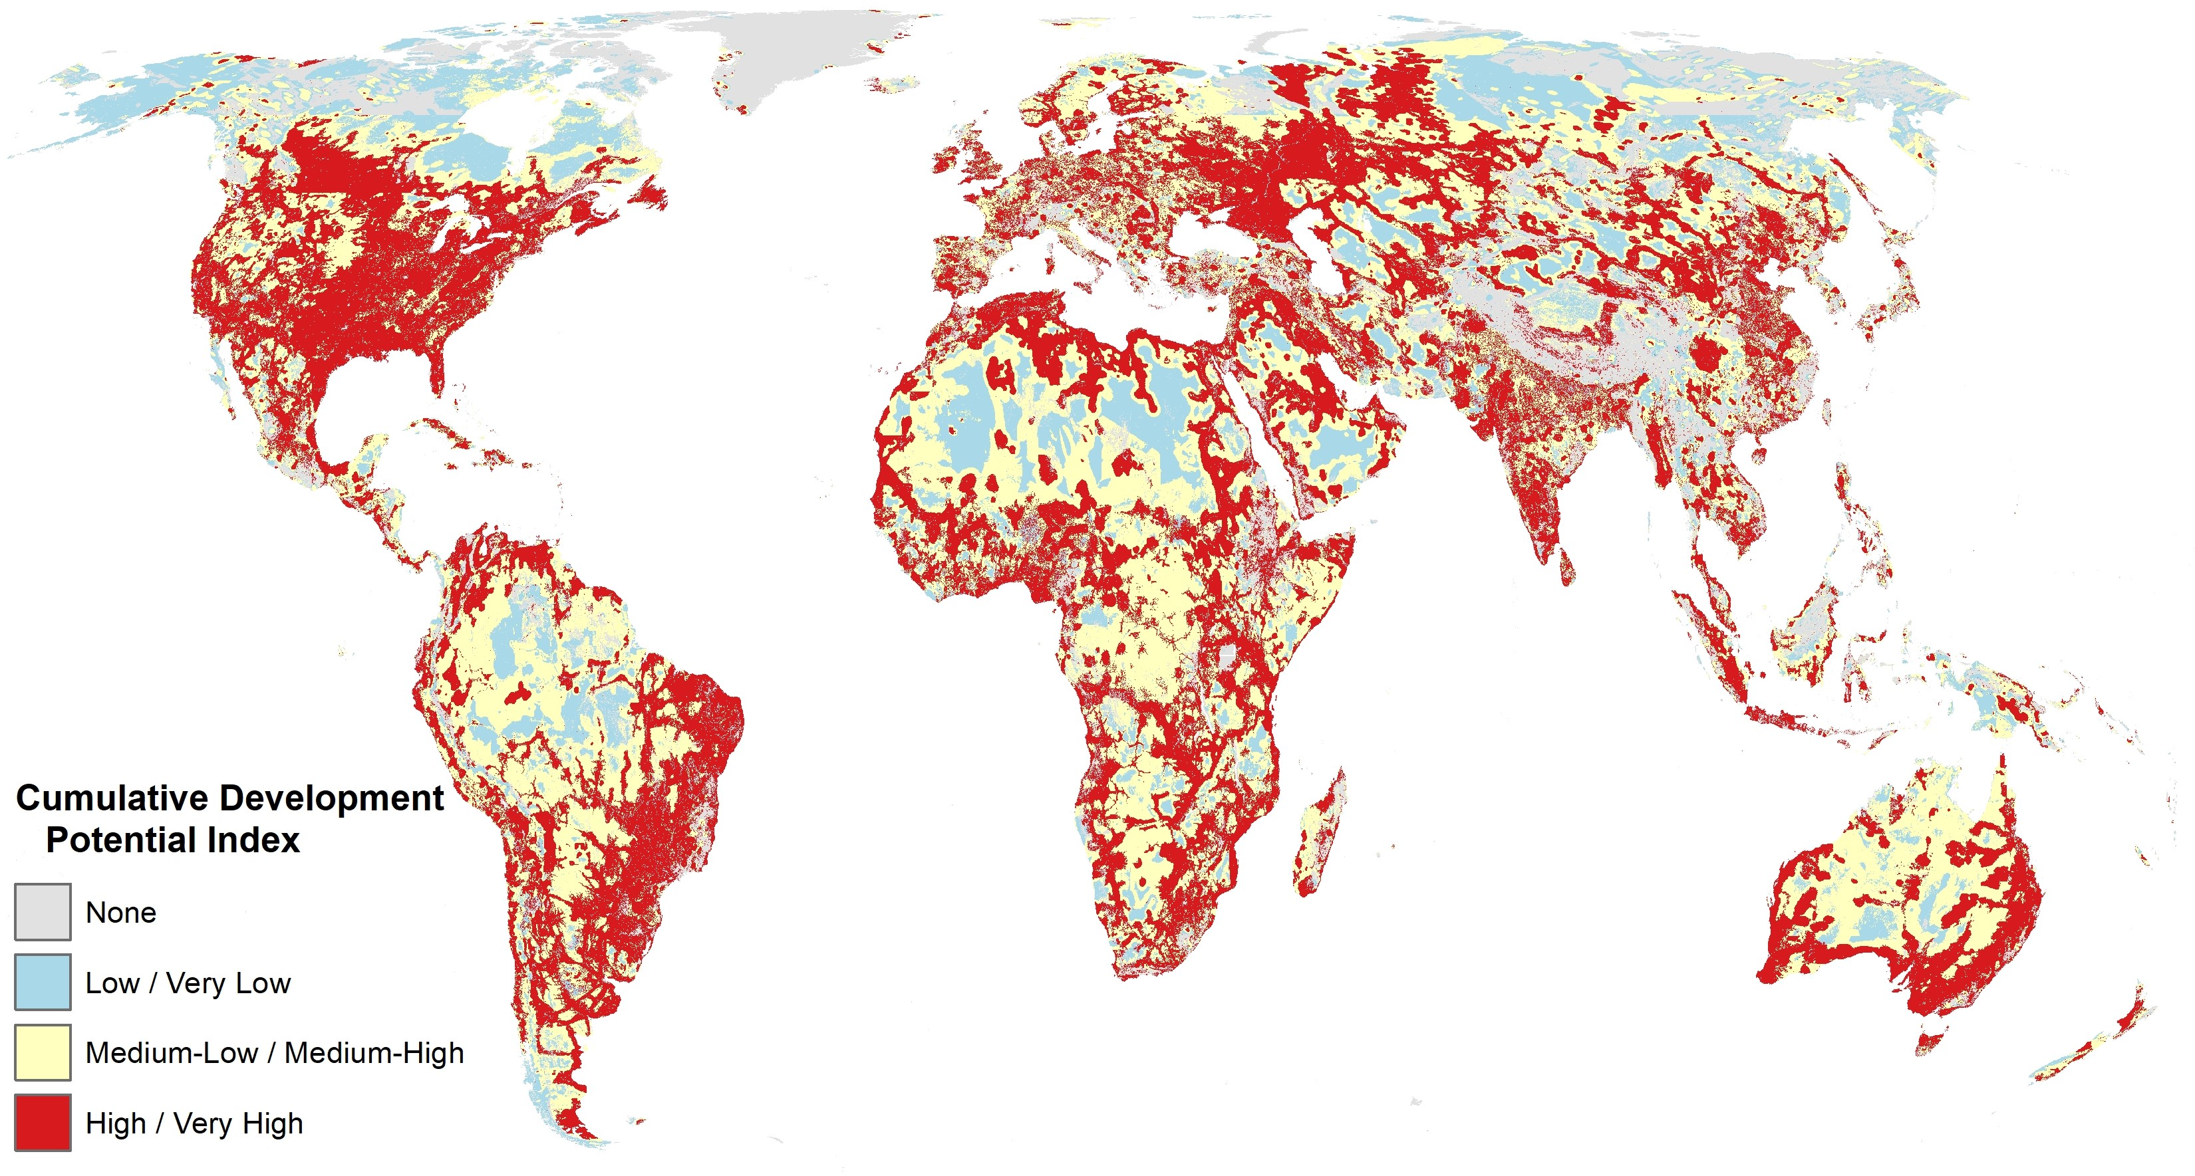

Fig. S7 Development Potential Map
Global development potential for renewable energy, oil and gas, mining, agriculture, and urban sectors (A) grouped into low, medium, and high development potential (B). Source: Oakleaf et al.¹⁶ Areas with no or low development potential (blue), areas with medium-low or medium-high development potential (yellow), and areas with high or very high development potential (red). Data available from: https://tnc.box.com/s/cyu1w0c14h8fhl1ln3s01rbj8ickas0t
(A)
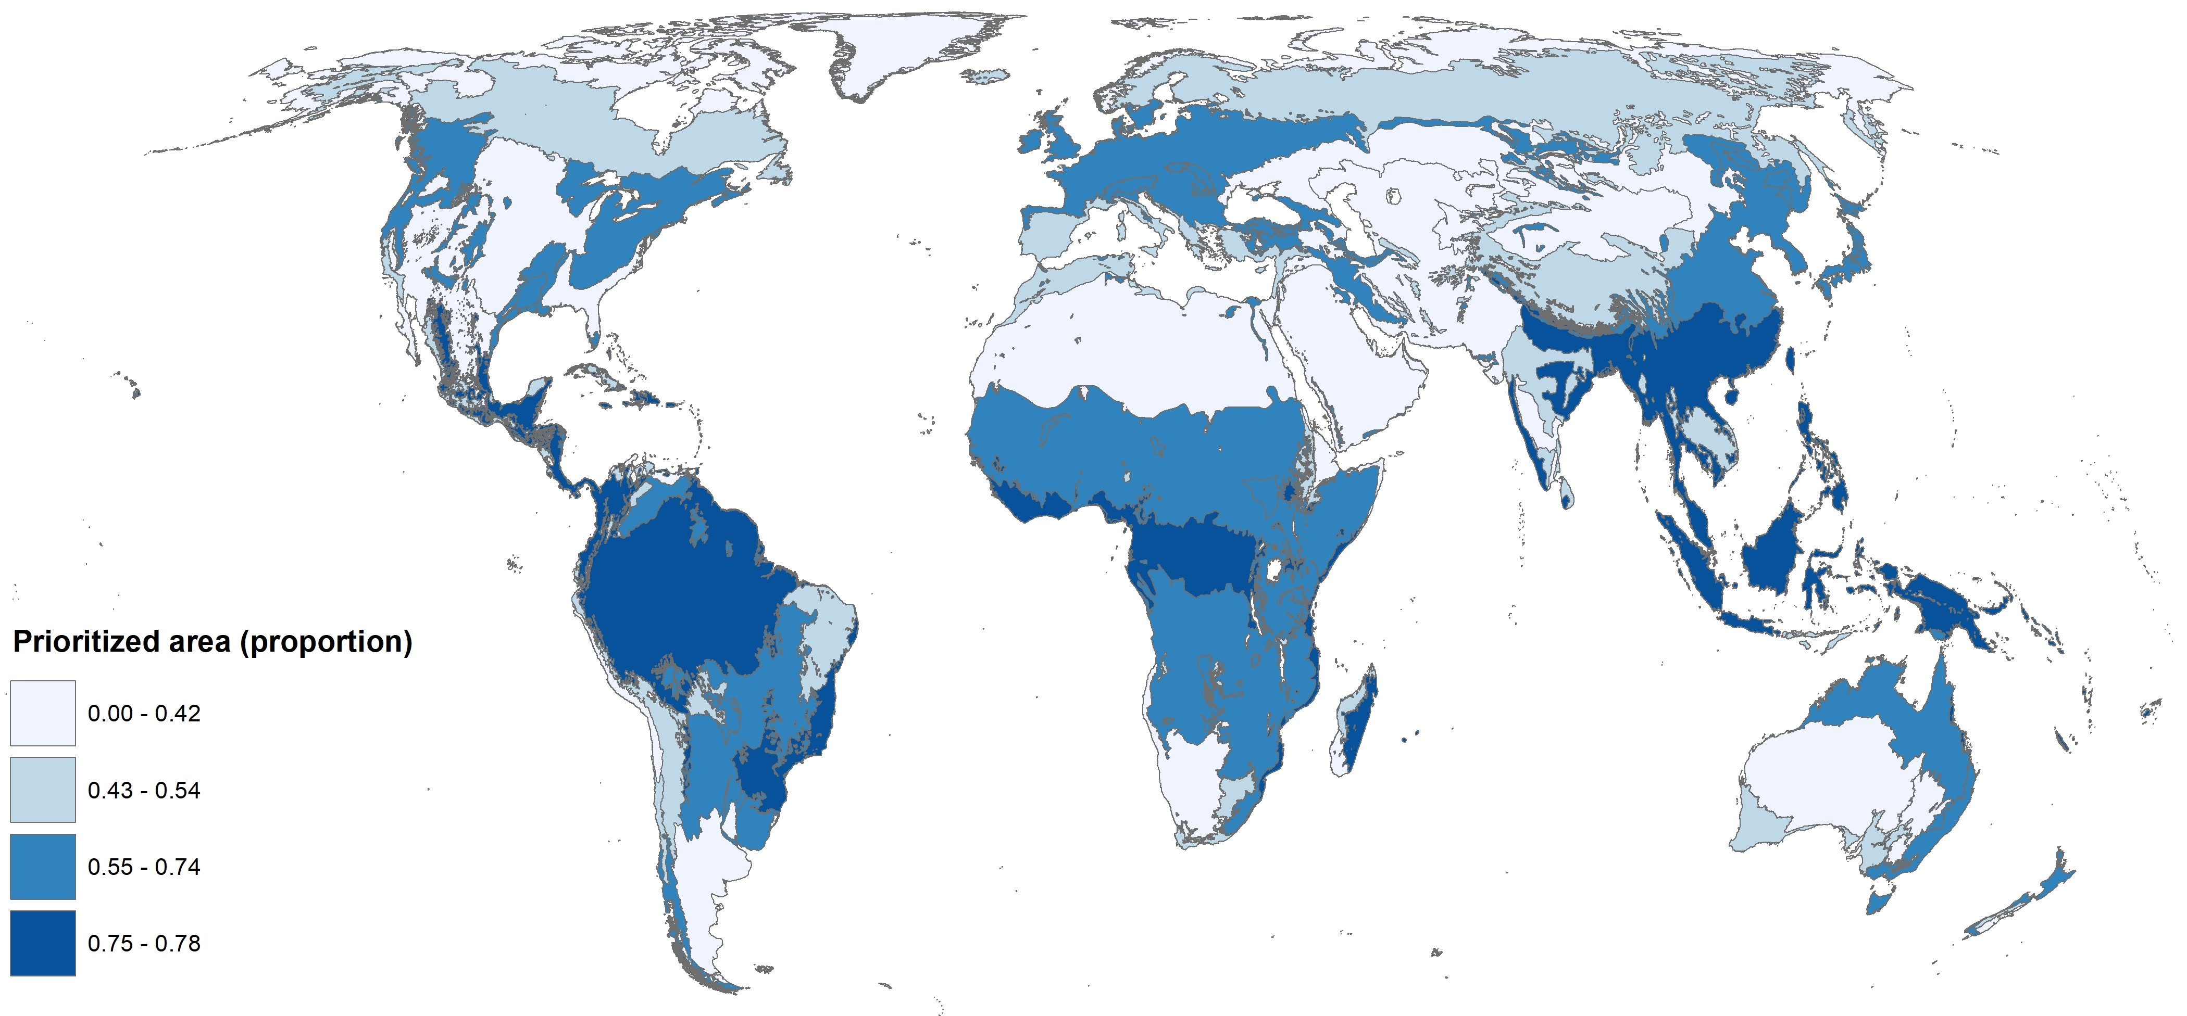
(B)
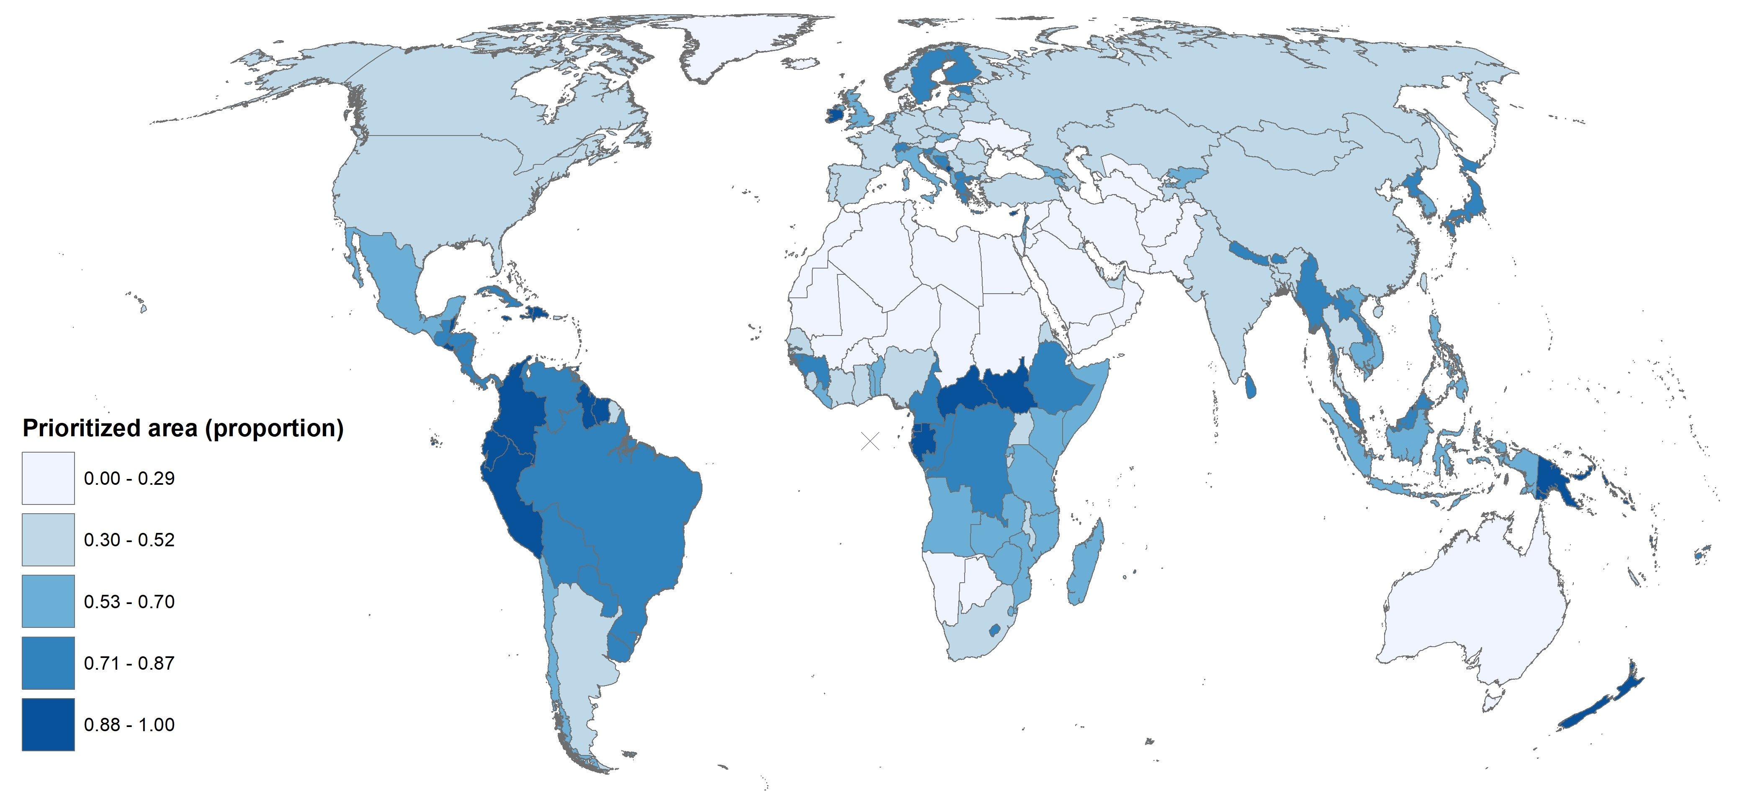

Fig. S8 Proportion of biomes (A) and countries (B) with prioritized areas for NCP (90%) and species
Habitat types (biomes) with a large proportion of prioritized areas include Tropical & Subtropical Moist Broadleaf Forests (78%), Tropical & Subtropical Coniferous Forests (76%), Mangroves (76%), Temperate Conifer Forests (74%), Flooded Grasslands & Savannas (67%), and Temperate Broadleaf & Mixed Forests (57%). Countries with at least 95% of their land area in prioritized areas include Suriname and Guyana (South America), Antigua and Barbuda, Barbados, Jamaica, Dominica, Saint Lucia, Saint Vincent and the Grenadines (Caribbean), Nauru, Samoa, and New Zealand (Oceania), and Central African Republic, Equatorial Guinea, Comoros, and Sao Tome and Principe (Africa). See Table S7 for complete results.
(A)
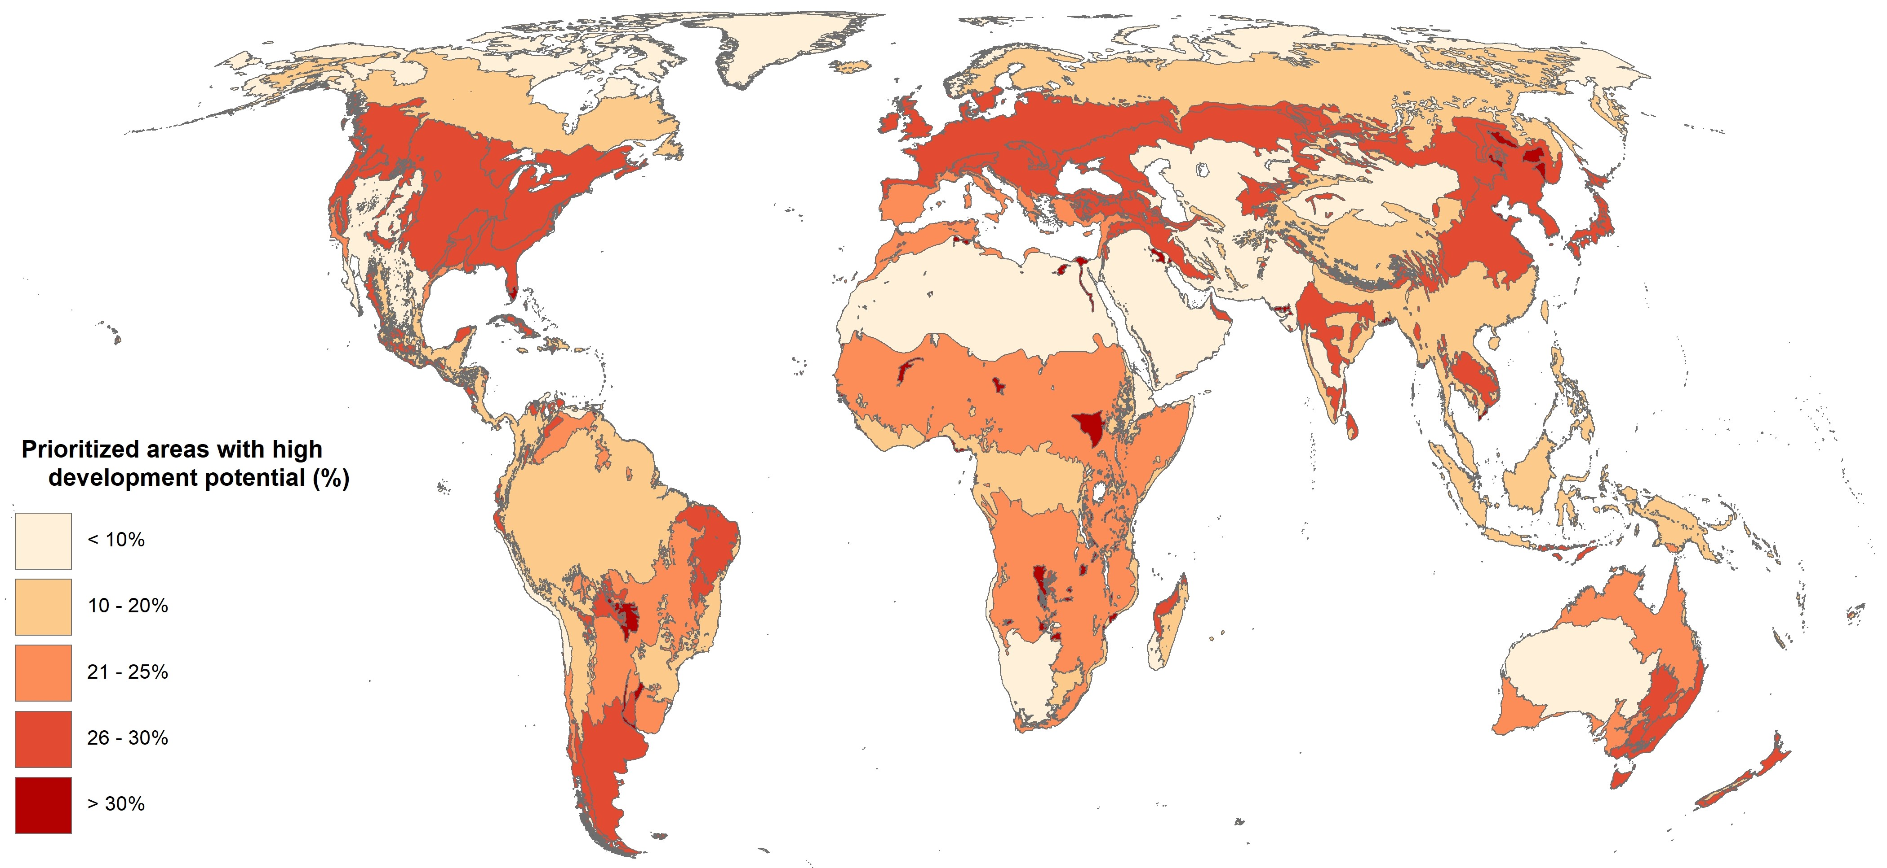
(B)
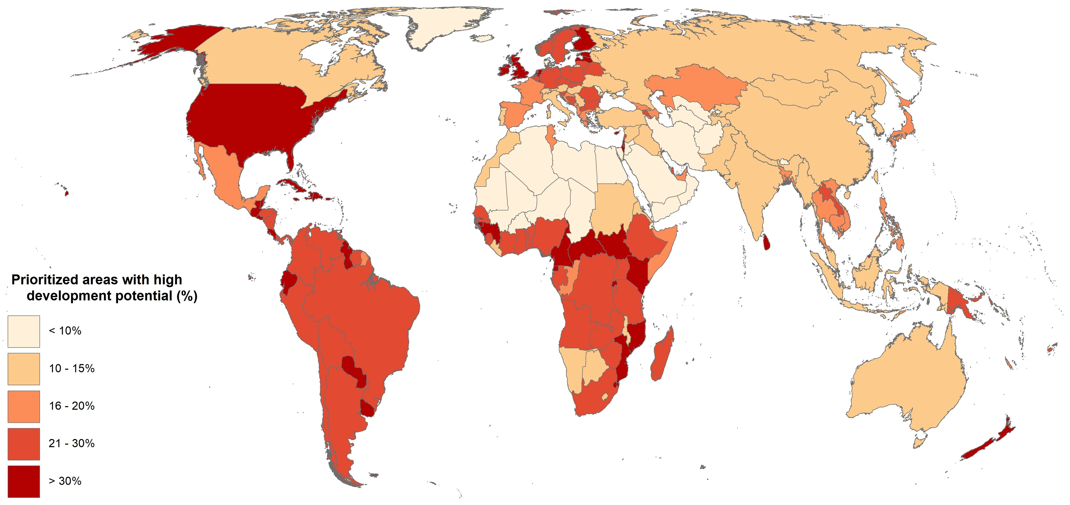

Fig. S9 Proportion of biomes (A) and countries (B) with prioritized areas for NCP (90%) and species that also have high development potential
Major habitat types (biomes) containing extensive prioritized areas that also have high suitability for development include mangroves (32%), temperate broadleaf and mixed forests (30%), and flooded grasslands and savannas (30%). Countries with large proportions of prioritized areas that also have high development potential (>40% of their area) include: Gambia, South Sudan (Africa), Ireland, Cyprus, Estonia, Netherlands (Europe), Jamaica, Barbados, Trinidad and Tobago, Haiti (Caribbean), Sri Lanka, Bahrain (Asia), Uruguay and Ecuador (South America). See Table S7 for complete results.

Table S1. List of nature’s contributions to people (NCP) included in this analysis
“Source” indicates the source of the original data or model documentation, but all datasets were updated (or newly generated) at a global scale by the authors. All NCP are attributed to the natural and semi-natural land cover classes providing the benefit (Table S3). “Original resolution” indicates the spatial resolution of the data provided for analysis, but all data were resampled to 2 km for the spatial optimizations. See details in Chaplin-Kramer et al.¹⁰
 | Nature’s Contribution to People | Source | Units | Original resolution
1 | Nitrogen retention for water quality regulation | Modeled using InVEST^{35,38} | Kg/ha nitrogen retained multiplied by number of people downstream | 10 arc-sec  (~300 m)
2 | Sediment retention for water quality regulation | Modeled using InVEST^{35,38} | Tonnes/ha sediment retained multiplied by number of people downstream | 10 arc-sec  (~300 m)
3 | Crop pollination contribution to nutrition production | Chaplin-Kramer et al. (2019)³⁵ | "Average people fed equivalents"; average of pollination-derived energy (calories), folate, and vitamin A production divided by RDI. | 10 arc-sec  (~300 m)
4 | Fodder production for livestock | Modeled using Co$ting Nature^{39,40} | Index (0-1) of dry matter productivity utilized by livestock | 5 arc-min  (~10 km)
5 | Timber production (commercial and domestic) | Modeled using Co$ting Nature^{39,40} | Index (0-1) of accessible timber harvest for commercial & domestic use (optimized separately) | 5 arc-min  (~10 km)
6 | Fuel wood production | Modeled using Co$ting Nature^{39,40} | Index (0-1) of fuel wood accessible to local rural communities based on production and access | 5 arc-min  (~10 km)
7 | Flood regulation | Modeled using WaterWorld^{41,43} | Index (0-1) of hydrologically influential “green” (canopy, soil, wetland) water storage multiplied by the number of people on downstream floodplains. | 5 arc-min  (~10 km)
8 | Access to nature (habitat within one hour of rural and urban populations) | Chaplin-Kramer et al. (2022)¹⁰ | Count of people within one hour travel time of natural and semi-natural habitat | 10 arc-sec  (~300 m)
9 | Vulnerable ecosystem carbon storage | Noon et al. 2022¹¹ | Tonnes of carbon/ha (for terrestrial ecosystems, soils, and mangroves). Data available from: https://docs.google.com/forms/d/e/1FAIpQLSfhjNksEh5rcRXRtqR5sk3OmrcuzpwLzGmHNUYlktwEOg612A/viewform | 1 arc-sec (~30 m)
10 | Coastal risk reduction | Chaplin-Kramer et al. (2019)³⁵ | Unitless risk reduction index multiplied by number of people within protective distance | 10 arc-sec  (~300 m)

Table S2. Additional data included in the analysis
 | Name | Description | Source | Resolution
1 | Biodiversity | “Area of Habitat” (AOH) for 26,709 terrestrial vertebrate species (see below) | Patrick Roehrdanz, Conservation International, based on IUCN Red List data. Methods described in Brooks et al. ¹² | NA (polygon shapefiles)
2 | Protected areas | Protected areas from World Database of Protected Areas (see below) | Jeffrey Hanson, Carleton University, based on WDPA data. UNEP-WCMC and IUCN, ¹⁷ www.protectedplanet.net | NA (polygon shapefiles)
3 | Development potential | Global development potential for agriculture, renewable energy, oil and gas, mining, agriculture, and urban sectors | Christina Kennedy and James Oakleaf, The Nature Conservancy. Oakleaf et al. ¹⁶ Data available from: https://tnc.box.com/s/cyu1w0c14h8fhl1ln3s01rbj8ickas0t | 1 km
4 | Country and continent boundaries | Country and continent boundaries | Esri. ⁶⁴ Data available from: https://www.arcgis.com/home/item.html?id=d974d9c6bc924ae0a2ffea0a46d71e3d | NA (polygon shapefiles)
5 | Biome boundaries | Terrestrial biomes (groups of ecoregions) | Dinerstein et al. ⁶⁵. Data available from: https://ecoregions2017.appspot.com/ | NA (polygon shapefiles)
7 | Land cover | Masks for NCP layers included all land cover classes from ESA 2015 except for cropland, mosaic cropland, urban areas, bare areas, water bodies, permanent snow & ice | ESA Climate Change Initiative - Land Cover project ⁵⁵ Data available from: https://maps.elie.ucl.ac.be/CCI/viewer/download.php | 10 arc-sec (~300 m)

Table S3. European Space Agency land cover classes to which NCP were masked.
Citation: ESA Land Cover – Climate Change Initiative ⁵⁵
ID | Description | Grazing: herbaceous | Timber: forests | Fuelwood: woody | All other terrestrial NCP: natural / semi-natural
10 | Cropland, rainfed
11 | Cropland, rainfed, herbaceous cover
12 | Cropland, rainfed, tree or shrub cover
20 | Cropland, irrigated or post-flooding
30 | Mosaic cropland (>50%) / natural vegetation (tree, shrub, herbaceous cover)(<50%) | X | X | X | X
40 | Mosaic natural vegetation (tree, shrub, herbaceous cover) (>50%) / cropland(<50%) | X | X | X | X
50 | Tree cover, broadleaved, evergreen, closed to open (>15%) |  | X | X | X
60-62 | Tree cover, broadleaved, deciduous, closed to open (>15%) |  | X | X | X
70-72 | Tree cover, needle leaved, evergreen, closed to open (>15%) |  | X | X | X
80-82 | Tree cover, needle leaved, deciduous, closed to open (>15%) |  | X | X | X
90 | Tree cover, mixed leaf type (broadleaved and needle leaved) |  | X | X | X
100 | Mosaic tree and shrub (>50%) / herbaceous cover (<50%) | X | X | X | X
110 | Mosaic herbaceous cover (>50%) / tree and shrub (<50%) | X | X | X | X
120-122 | Shrubland | X |  | X | X
130 | Grassland | X |  |  | X
140 | Lichens and mosses | X |  |  | X
150 | Sparse vegetation (tree, shrub, herbaceous cover) (<15%) | X | X | X | X
151 | Sparse tree (<15%) | X | X | X | X
152 | Sparse shrub (<15%) | X |  | X | X
153 | Sparse herbaceous cover (<15%) | X |  |  | X
160 | Tree cover, flooded, fresh or brackish water |  | X | X | X
170 | Tree cover, flooded, saline water |  | X | X | X
180 | Shrub/ herbaceous cover, flooded, fresh/saline/brackish water | X |  | X | X
190 | Urban areas
200-202 | Bare areas
210 | Water bodies
220 | Permanent snow and ice

Table S4. Results from all prioritization scenarios
First column: target levels of NCP, ranging from 5%-95% of current levels of all 10 NCP. Second column: global land area required to provide target levels of NCP. Third column: area required to provide target levels of NCP and achieve minimum species representation targets (species targets are consistent across all scenarios, see main text). Fourth column: area required to provide target levels of NCP and achieve minimum species targets, with current PAs and OECM areas “locked in” to prioritization results. Land area percentages exclude Antarctica. NA values indicate that a given NCP target is exceeded once other objectives (e.g. representing species, or locking in protected areas and OECM areas) are achieved. For example, 16% of global land area is required to achieve minimum species representation targets, and those areas already provide 20% of NCP.
Target (% of current levels of NCP provided) | NCP | NCP and species | NCP and species, protected and OECM areas “locked in”
5% | 1% | NA | NA
10% | 2% | NA | NA
15% | 3% | NA | NA
20% | 4% | 16% | NA
25% | 6% | 18% | NA
30% | 7% | 19% | NA
35% | 8% | 21% | 28%
40% | 10% | 22% | 29%
45% | 12% | 23% | 30%
50% | 14% | 25% | 31%
55% | 15% | 27% | 33%
60% | 18% | 28% | 34%
65% | 20% | 30% | 36%
70% | 23% | 32% | 38%
75% | 25% | 35% | 40%
80% | 29% | 37% | 43%
85% | 32% | 40% | 46%
90% | 36% | 44% | 49%
95% | 42% | 49% | 53%

Table S5. Percent of land area required to provide different levels of NCP (5%-95% of current levels) at different spatial resolutions.
NCP provided | Spatial resolution
 | 2km | 3km | 5km | 10km
5% | 1% | 1% | 1% | 1%
10% | 2% | 2% | 2% | 3%
15% | 3% | 4% | 4% | 4%
20% | 4% | 5% | 6% | 6%
25% | 6% | 7% | 7% | 8%
30% | 7% | 8% | 9% | 10%
35% | 8% | 10% | 11% | 12%
40% | 10% | 12% | 13% | 14%
45% | 12% | 14% | 15% | 17%
50% | 14% | 17% | 18% | 19%
55% | 15% | 19% | 20% | 22%
60% | 18% | 22% | 23% | 25%
65% | 20% | 24% | 26% | 28%
70% | 23% | 28% | 30% | 32%
75% | 25% | 31% | 34% | 36%
80% | 29% | 35% | 38% | 40%
85% | 32% | 39% | 42% | 45%
90% | 36% | 44% | 48% | 51%
95% | 42% | 51% | 54% | 58%

Table S6. Areas prioritized for NCP (90% target) and species that also have high development potential, by economic sector.

Economic sector | Percent of prioritized areas | Percent of global land area
Renewable energy | 10% | 4%
Agriculture | 7% | 3%
Mining | 6% | 3%
Oil and gas | 5% | 2%
Urban expansion | 1% | 0%
(Multiple sectors) | 8% | 4%
TOTAL | 37% | 16%

Table S7. (separate file) Critical natural assets (NCP and biodiversity) results by country, continent and biome
https://docs.google.com/spreadsheets/d/1WngHq7UlalBh7JnGZrzLNixL9HjWPl6f/edit?usp=sharing&ouid=106124856137576449848&rtpof=true&sd=true

Table S8. (separate file) Critical natural assets + Development Potential Index results by country, continent, and biome
https://docs.google.com/spreadsheets/d/1ZwXPSQH45dd5hLiV6K1CQGkiIBxnjj7f/edit?usp=sharing&ouid=106124856137576449848&rtpof=true&sd=true

