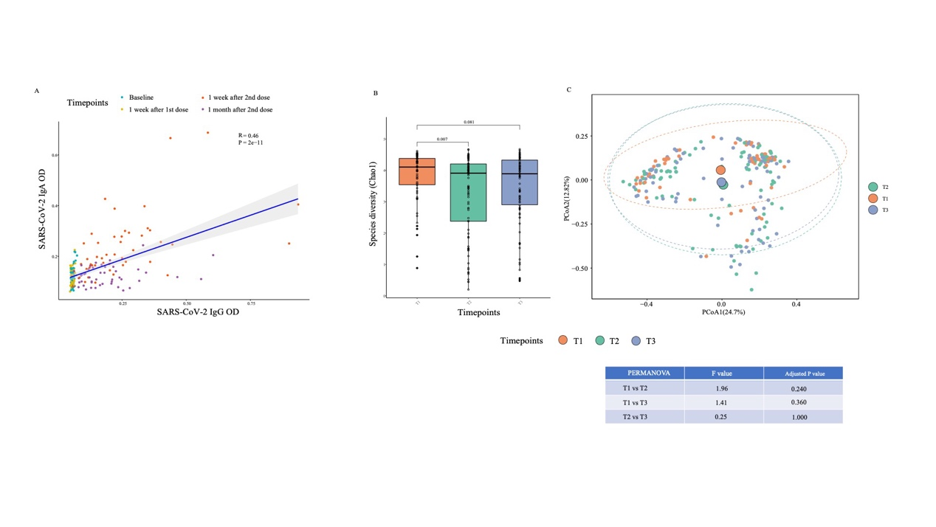Supplementary Figure 1. Correlation plot for immunity parameters and alpha diversity for the control cohort. (A) The correlation plot between immunoglobulin A and immunoglobulin G in breast milk over different timepoints (Sample size, Baseline: 49, One week after 1st dose: 48, One week after 2nd dose: 48, One month after second dose: 48). The Spearman’s correlation coefficient (rho value) and corresponding p value are shown. (B) The species diversity and Chao1 index was compared using Wilcoxon signed-rank test over the first three months postpartum at three time points: Week 4 (T1), Week 8 (T2), and Week 12 (T3) (Sample size, 110). Elements on boxplots: centre line, median; box limits, upper and lower quartiles; whiskers, 1.5×IQR.
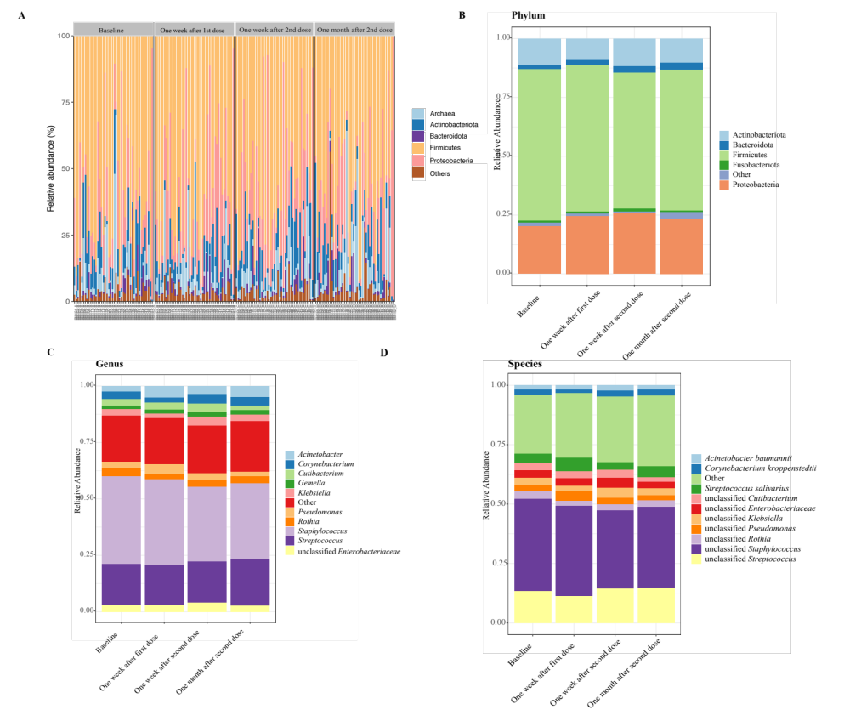
Supplementary Figure 2. Compositional differences in breast milk microbiota of lactating mothers before and after vaccination at baseline, one week post-first dose, one week post-second dose, and one month post-second dose of BNT162b2 (Sample size, Baseline: 44, One week after 1st dose: 44, One week after 2nd dose: 43, One month after second dose: 44). (A) Breast milk microbiota profile at the phylum level across samples. (B) Breast milk microbiota profile at the phylum level across timepoints. (C) Breast milk microbiota profile at the genus level across timepoints. (D) Breast milk microbiota profile at the species level across timepoints.
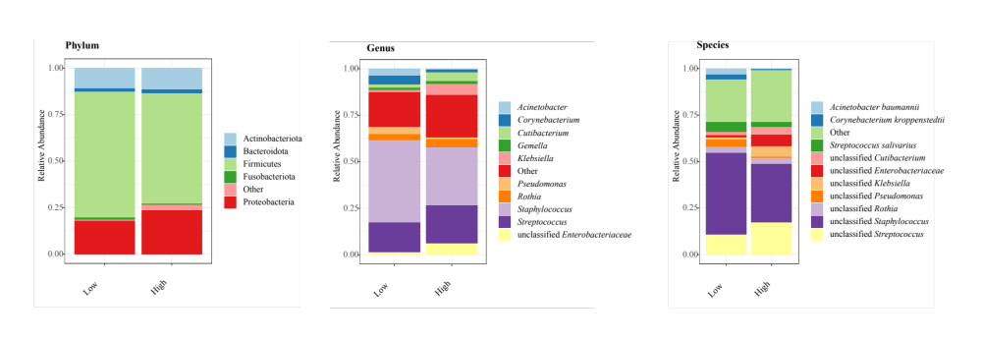
Supplementary Figure 3. Compositional differences in baseline breast milk microbiota of lactating mothers with high- and low-IgA subjects to BNT162b2 vaccination one week post-second dose (N=43; High IgA: 18, Low IgA: 25). (A) Breast milk microbiota profile at the phylum level across timepoints. (C) Breast milk microbiota profile at the genus level across timepoints. (D) Breast milk microbiota profile at the species level across timepoints.

