A novel gene LbHLH from the halophyte Limonium bicolor enhances salt tolerance via alleviating osmotic stress and reducing root hair development

Xi Wang, Yingli Zhou, Yanyu Xu, Baoshan Wang*, Fang Yuan*

Shandong Provincial Key Laboratory of Plant Stress, College of Life Sciences, Shandong Normal University, Ji’nan, Shandong, P.R. China

*Corresponding authors
E-mail:
Baoshan Wang: bswang@sdnu.edu.cn
Fang Yuan: yuanfang@sdnu.edu.cn

Tel.: 0086 531 86180197; Fax: 0086 531 86180197
Running title: LbHLH functions in salt resistance

Figure S1
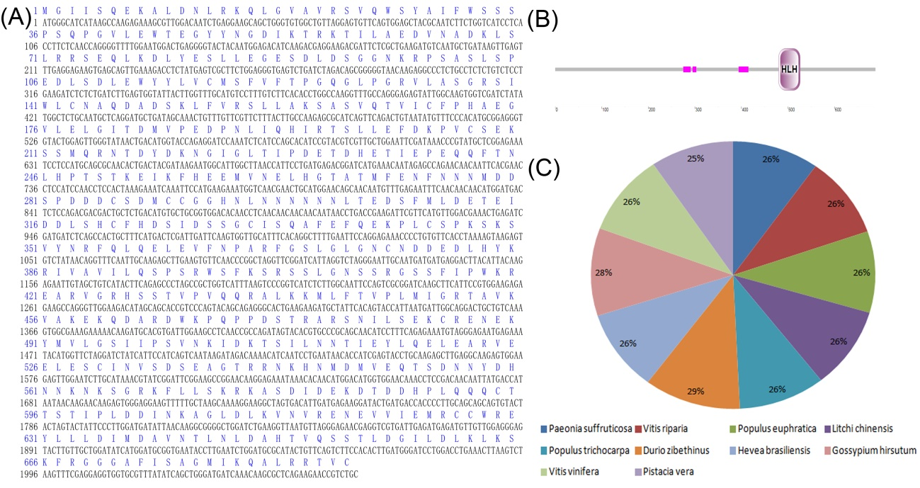
Figure S2
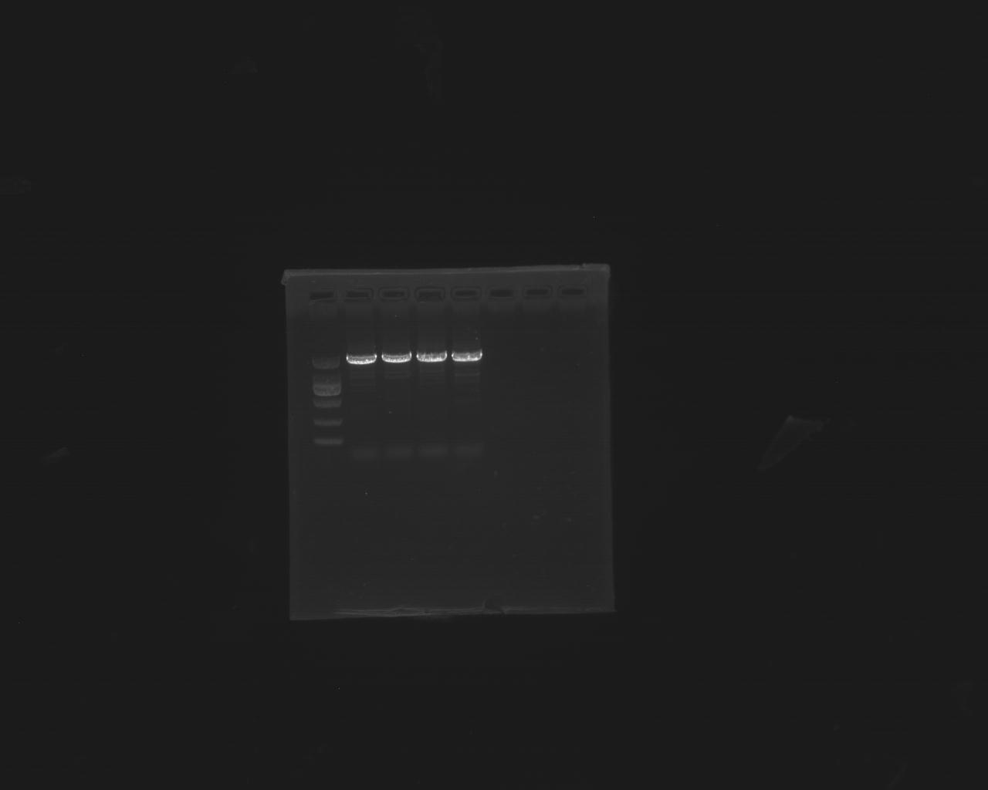
Figure S3
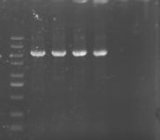
Table S1 The primers used in this paper
Name | Oligonucleotide sequence | Role
LbHLH-S | 5-TCCTTTTCTGGGGTTTGGGG-3 | Full length amplification
LbHLH-A | 5-GTCATCGCAACAGTCTCCAT-3 | Full length amplification
LbHLH OE-S | 5-CGGGGATCCTCTAGAGTCGACATGGGCATCATAAGCCAAGAGA-3 | Construction of p35S::LbHLH-GFP vectors digested with SalⅠ
LbHLH OE-A | 5-GCCCTTGCTCACCATGTCGACGCAGACGGTTCTTCTGAGCG-3 | Construction of p35S::LbHLH-GFP vectors digested with SalⅠ
LbHLH-RT-S | 5-AGTGGAAGAGTTGGAATC-3 | Real-time PCR in different developmental stages, condition and Arabidopsis overexpression lines
LbHLH-RT-A | 5- TAATTGTTGTCGGAGGTT -3
Lbtubulin-RT-S | 5-GGTTGAGTGAGCAGTTCAC-3
Lbtubulin-RT-A | 5-GATAACCAGCCACACCTTAGC-3
RT-Atactin-S | 5-GGTAACATTGTGCTCAGTGGTGG-3
RT-Atactin-A | 5-AACGACCTTAATCTTCATGCTGC-3
LbHLH OEAt-S | 5- ACGGGGGACTCTTGACCATGGATGGGCATCATAAGCCAAGAGA-3 | Construction of Col-35S::LbHLH and Col::pLbHLH-GUS
LbHLH OEAt-A  LbHLH-P-S  LbHLH-P-S  3301-LbHLH-P-S  3301-LbHLH-P-A | 5- TTACCCTCAGATCTACCATGGGCAGACGGTTCTTCTGAGCG-3  5- CTTTCTCTTGGCTTATGAT-3  5-CATTTCGTGCAACCTCAC-3  5-TGCAGGCATGCAAGCTtAGATTAAAGTTAATGCGCTCCTGC-3  5-CCTCAGATCTACCATGgTTCGTGCAACCTCACAAAATAGA-3 | Construction of Col-35S::LbHLH and Col::pLbHLH-GUS
AtTRY-RT-S | 5-CTTCTTCTTCTTGTTCGCTCTA-3 | RT-qPCR verification of trichome development and root hair fate decision genes in OE-LbHLH
AtTRY- RT-A | 5-ACGGTCAGTGTTATCCATTAC-3
AtCPC- RT-S | 5-TCCGAAGAGGTGAGTAGT-3
AtCPC- RT-A | 5-ACGAGTTTATACATCCGAGAA-3
AtTTG1- RT-S | 5-TATTGAGAAGTCTGTTGT-3
AtTTG1- RT-A | 5-ATTGTAGAATGTTCCTTATC-3
AtGL1- RT-S | 5-CCTTCTTCTTGTCATCAT-3
AtGL1- RT-A  AtGL3- RT-S  AtGL3- RT-A  AtEGL3- RT-S  AtEGL3- RT-A | 5-ATCATTAGTAGTTGCCATT-3  5-GCTTAGATGTGCTTGGAGAG-3  5-GAGGATTGAACCGAATGAGAA-3  5-AATCTTCTGGTCTGTCTC-3  5-AATCGTCTTCCTTGTCTT-3
AtSAD2- RT-S  AtSAD2- RT-A  AtGL2- RT-S | 5-TGGAGCTCTTTGTGACAAATTG-3  5-GTGCAATGCTTTACGAAAGTTG-3  5-GACAGTGAAATCGAGAGA-3
AtGL2- RT-A | 5-GTGACTCTACTCCATCAG-3
AtMYB23 - RT-S | 5-GACGAATCCAAACTCAAA-3
AtMYB23 - RT-A | 5-AGGCAATACCCATTAGTAA-3
AtZFP5- RT-S | 5-AGAGGCTTCAGCTTCAAG-3
AtZFP5- RT-A | 5-GACCAATCTTCGTTGTACAC-3
AtRHD6 - RT-S | 5-ACGAGAGTTATTGGAATCA-3 | RT-qPCR verification of root hair initation and elongation genes in OE-LbHLH
AtRHD6- RT-A | 5-TGCCAACTAAAGTGAGAG-3
AtRSL1 - RT-S | 5-CTTGGTTCTCATCACAAC-3
AtRSL1 - RT-A | 5-GGAACAACGGTGTAATATC-3
AtLRL1- RT- S | 5-TTGCGGAAAGAATGAAAG-3
AtLRL1- RT-A | 5-CCTTGACTTGGAGTTGTA-3
AtSOS1- RT-S | 5-TTCATCATCCTCACAATGGCTCTAA-3 | RT-qPCR verification of salt tolerance related marker genes in OE-LbHLH
AtSOS1- RT-A | 5-CCCTCATCAAGCATCTCCCAGTA-3
AtSOS3- RT-S | 5-AGAGGAAGATAGAGATGTAAGC-3
AtSOS3- RT-A | 5-ATTATGTATGTGAGATGGAGAGT-3
AtP5CS1- RT-S | 5-CAAGATGAGATTACATTCG-3
AtP5CS1- RT-A | 5-GGTTATGATGACAGGAAT-3
AtP5CS2- RT-S | 5-GTGACGGAAGATAGTGAA-3
AtP5CS2- RT-A | 5-TCCTGCTTGTGCTTATTC-3

