Magnetized metformin-functionalized carrageenan as a solid acid-base bifunctional nanocatalyst for the one-pot synthesis of dihydropyrano[2,3-c]pyrazoles
Forozan Heydari¹, Mohsen Bakhtiarian¹, Mohammad Mehdi Khodaei^{1,2}*
¹Department of Organic Chemistry, Razi University, 67149-67346 Kermanshah, Iran; E-mail: mmkhoda@razi.ac.ir
²Nanoscience and Nanotechnology Research Center (NNRC), Razi University, 67149-67346 Kermanshah, Iran
Content | Page
Figure S1. ¹H-NMR spectrum of 6-amino-3-methyl-4-phenethyl-1,4-dihydropyrano[2,3-c]pyrazole-5-carbonitrile (6g) | 2
Figure S2. ¹³C-NMR spectrum of 6-amino-3-methyl-4-phenethyl-1,4-dihydropyrano[2,3-c]pyrazole-5-carbonitrile (6g) | 3
Figure S3. ¹H-NMR spectrum of 6-amino-3-methyl-4-(naphthalen-1-yl)-1,4-dihydropyrano[2,3-c]pyrazole-5-carbonitrile (6i) | 4
Figure S4. ¹³C-NMR spectrum of 6-amino-3-methyl-4-(naphthalen-1-yl)-1,4-dihydropyrano[2,3-c]pyrazole-5-carbonitrile (6i) | 5
Figure S5. ¹H-NMR spectrum of 6-amino-3-methyl-4-phenyl-1,4-dihydropyrano[2,3-c]pyrazole-5-carbonitrile (6j) | 6
Figure S6. ¹³C-NMR spectrum of 6-amino-3-methyl-4-phenyl-1,4-dihydropyrano[2,3-c]pyrazole-5-carbonitrile (6j) | 7
Calculation of number of active sites, turnover number (TON), and turnover frequency (TOF) | 8
Figure S7. EDX of reused catalyst after run 5th | 9

Figure S1. ¹H-NMR spectrum of 6-amino-3-methyl-4-phenethyl-1,4-dihydropyrano[2,3-c]pyrazole-5-carbonitrile (6g)

Figure S2. ¹³C-NMR spectrum of 5-amino-1, 3-diphenyl-1H-pyrazole-4-carbonitrile (6g).

Figure S3. ¹H-NMR spectrum of 6-amino-3-methyl-4-(naphthalen-1-yl)-1, 4-dihydropyrano[2,3-c]pyrazole-5-carbonitrile (6i)
Figure S4. ¹³C-NMR spectrum of 6-amino-3-methyl-4-(naphthalen-1-yl)-1, 4-dihydropyrano[2,3-c]pyrazole-5-carbonitrile (6i)

Figure S5. ¹H-NMR spectrum of 6-amino-3-methyl-4-phenyl-1, 4-dihydropyrano[2,3-c]pyrazole-5-carbonitrile (6j)

Figure S6. ¹³C-NMR spectrum of 6-amino-3-methyl-4-phenyl-1, 4-dihydropyrano[2,3-c]pyrazole-5-carbonitrile (6j)

Calculation of number of active sites, turnover number (TON), and turnover frequency (TOF)
The effectiveness of a catalyst is defined by turnover number (TON) parameter.
$$TON=\frac{Yield ×mole of reactants}{mole\% of catalyst}$$
$$TOF=\frac{TON}{Time (h)}$$
- From titration the amount of acid sites will be = 0.76 mmol/g and amount of basic sites will be 0.56 mmol/g.
- Hence, the amount of active sites will be 1.32 mmol/g.
- Since we used 0.03 g of Carr-Met-MNPs under optimized conditions, the amount of active sites will be 0.0396 mmol.
- The mol% of sulfonic acid groups will be: (0.0396/0.0396 +1) × 100 = 3.8 mol%, where 1 is the mmol of limiting reactant.
For the model reaction:
$$TON=\frac{94×4}{3.8}=98.94$$
$$TOF=\frac{98.94}{0.25}=395.8$$
Using this method, TON and TOF were calculated for all reactions and the results are collected in Table 3.

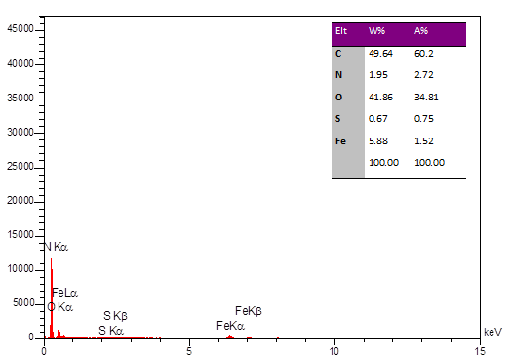
Figure S7. EDX of reused catalyst after run 5th.

