Supplementary Figures

Figure S1. The si-RNA3 (APE1-siRNA) was the most efficient in terms of knocking down APE1 in A549 and H1650 cells.
(A) The protein expression level of si-RNA2 (APE1-siRNA) and si-RNA3 (APE1-siRNA) were efficient in terms of knocking down APE1 in A549 and H1650 cells. (B) The mRNA expression was determined using RT-PCR and the results were consistent with those above.

Figure S2. APE1 promotes cell proliferation, migration and invasion inPC-9 cells PC-9 cells was transfected with stable plasmid of APE1 (PC-9/OE), and corresponding control cells (Vector).
(A-B) Cell proliferation was examined by CCK8. EdU incorporation assay in which cells synthesizing DNA stained with EDU (green), nuclei counter stained with Hoechst 33342 (blue). Error bars correspond to means ± standard deviations from three independent experiments. (C) Measurement of apoptosis by flow cytometry in PC-9 cells overexpressing APE1 showed significant enhancement. (D) The wound healing assay was used to show the migration of APE1 in PC-9 cells. The cells migrated into the wounded areas were photographed at 0h and 48h. (E) The migration and invasion of APE1 in PC-9 cells were also examined by Transwell assays. Cell migration/invasion was significantly promoted by APE1 overexpressed in PC-9 cells compared to that in controls. The results were represented as mean ± SD, *P < 0.05, **P < 0.01, ***P < 0.001. Scale bar is 100 µm.

Figure S3. APE1 affected radiation sensitivity in PC-9 cells.
(A) Clone formation of A549 and H1650 cells after knockdown of APE1 by different doses of X-ray irradiation. Clone formation of PC-9 cells after overexpressed APE1 by different doses of X-ray irradiation. PC-9 cells with APE1 overexpressed were less sensitive to irradiation than control cells. (B) The number of foci in γ-H2AX and 53BP1 after irradiation. Scale bars is 10 μm. (C-D) Flow cytometric analysis of apoptosis in PC-9 cells after irradiation by Annexin-V and PI staining. Flow cytometric analysis of the cell cycle in PC-9 cells after irradiation compared to control cells. Error bars correspond to means ± standard deviations from three independent experiments. *P < 0.05; **P < 0.01; ***P < 0.005.

Figure S4. The GSVA results showed that APE1 was enriched in many pathways.
The correlations between individual gene and pathway score was analysed with Spearman. The abscissa represents the distribution of the gene expression, and the ordinate represents the distribution of the pathway score. The density curve on the right represents the trend in distribution of pathway immune score, the upper density curve represents the trend in distribution of the gene expression. The value on the top represents the correlation p value, correlation coefficient and correlation calculation method. It showed that APE1 was enriched in tumor information signature, cellular response to hypoxia tumor proliferation signature, angiogenesis, apoptosis, DNA repair, G2M checkpoint, DNA replication, inflammatory-response, the mTOR pathway, the P53 pathway.
Figure S5. The RNA-seq data were detected from BGI-Shenzhen, China. The contact number is F22FTSNCKF5095, including the data of A549/Vector and A549/Vector+IR.
(A) In order to show the number of genes in different expression intervals of each sample more visually, we counted the number of genes in three cases of expression levels (exp<=1, exp 1-10, exp>=10). (B) The hot map showed the expression quantity of different genes. The horizontal axis is the log2 of the sample (expression value +1), and the vertical axis is the gene. Under the default color scheme, the more red the color block is, the higher the expression, while the bluer the color block is, the lower the expression. (C) KEGG pathway bubble analysis. The X-axis is the enrichment Ratio [the ratio between the number of genes annotated to an item in the selected Gene set and the total number of genes annotated to the item in the species, calculated by the formula Rich Ratio = Term Candidate Gene Num/Term Gene Num], and the Y-axis is KEGG Pathway. The size of the bubble represents the number of genes annotated to a KEGG Pathway, and the color represents the enrichment significance value (Qvalue or Pvalue, see the legend for details). The redder the color, the smaller the significance value. The differential genes annotated to these KEGG pathways are shown in the table below by selecting one of the bubbles in the figure or multiple bubbles in the "multiple selection" mode in the upper right corner. Double-click the title or axis title to modify the text, click the legend color bar to modify the color. (D) Go cellular component analysis. The X-axis is the enrichment Ratio [the ratio between the number of genes annotated to an item in the selected Gene set and the total number of genes annotated to the item in the species, calculated by the formula Rich Ratio = Term Candidate Gene Num/Term Gene Num], and the Y-axis is GO Term. The size of the bubble represents the number of differential genes annotated to a certain GO Term, and the color represents the enrichment significance value (Qvalue or Pvalue, see the legend for details). The redder the color, the smaller the significance value. Selecting one of the bubbles in the figure or multiple bubbles in the "multiple Select" mode in the upper right corner will display a list of genes annotated to these GO entries in the table below. Double-click the title or axis title to change the text, click the legend color block to change the color. (E) KEGG Pathway category analysis. The X-axis is the number of genes annotated to a KEGG Pathway category, and the Y-axis is the KEGG Pathway category. The differential genes annotated to these KEGG Pathway classifications are shown in the table below by selecting a column in the figure or multiple columns in the "multiple selection" mode in the upper right corner. Double-click the title or axis title to modify the text, click the legend color block to modify the color. (F) Go analysis. The X-axis represents the number of genes annotated to GO entries, and the Y-axis represents GO functional classification. Selecting a column in the figure or multiple columns in the "multiple Select" mode in the upper right corner will display a list of genes annotated to these GO entries in the table below. Double-click the title of the diagram or axis to modify the text.

Figure S6. The RNA-seq data were from the A549/shRNA and A549/Vector.
(A) In order to show the number of genes in different expression intervals of each sample more visually, we counted the number of genes in three cases of expression levels (exp<=1, exp 1-10, exp>=10). (B) The hot map showed the expression quantity of different genes. The horizontal axis is the log2 of the sample (expression value +1), and the vertical axis is the gene. Under the default color scheme, the more red the color block is, the higher the expression, while the bluer the color block is, the lower the expression. (C) KEGG pathway bubble analysis. The X-axis is the enrichment Ratio [the ratio between the number of genes annotated to an item in the selected Gene set and the total number of genes annotated to the item in the species, calculated by the formula Rich Ratio = Term Candidate Gene Num/Term Gene Num], and the Y-axis is KEGG Pathway. The size of the bubble represents the number of genes annotated to a KEGG Pathway, and the color represents the enrichment significance value (Qvalue or Pvalue, see the legend for details). The redder the color, the smaller the significance value. The differential genes annotated to these KEGG pathways are shown in the table below by selecting one of the bubbles in the figure or multiple bubbles in the "multiple selection" mode in the upper right corner. Double-click the title or axis title to modify the text, click the legend color bar to modify the color. (D) Go cellular component analysis. The X-axis is the enrichment Ratio [the ratio between the number of genes annotated to an item in the selected Gene set and the total number of genes annotated to the item in the species, calculated by the formula Rich Ratio = Term Candidate Gene Num/Term Gene Num], and the Y-axis is GO Term. The size of the bubble represents the number of differential genes annotated to a certain GO Term, and the color represents the enrichment significance value (Qvalue or Pvalue, see the legend for details). The redder the color, the smaller the significance value. Selecting one of the bubbles in the figure or multiple bubbles in the "multiple Select" mode in the upper right corner will display a list of genes annotated to these GO entries in the table below. Double-click the title or axis title to change the text, click the legend color block to change the color. (E) KEGG Pathway category analysis. The X-axis is the number of genes annotated to a KEGG Pathway category, and the Y-axis is the KEGG Pathway category. The differential genes annotated to these KEGG Pathway classifications are shown in the table below by selecting a column in the figure or multiple columns in the "multiple selection" mode in the upper right corner. Double-click the title or axis title to modify the text, click the legend color block to modify the color. (F) Go analysis. The X-axis represents the number of genes annotated to GO entries, and the Y-axis represents GO functional classification. Selecting a column in the figure or multiple columns in the "multiple Select" mode in the upper right corner will display a list of genes annotated to these GO entries in the table below. Double-click the title of the diagram or axis to modify the text.

Figure S7. The STING can reverse radiation resistance.
(A-B) The apoptosis rate and percentage of cells under G2/M cell cycle arrest also increased after irradiation. (C) The expression of p-STING increased in A549 shAPE1 cells after the radiation compared to control cells. The expression of p-STING declined in A549 shAPE1 cells with DDX41overexpressed.
Figure S8. The expression levels of DDX41 in APE1 over-expressed and knock-out conditions by western blots.
(A) The protein expression level of DDX41 in terms of knocking down APE1 in A549. (B) The protein expression level of DDX41 in PC-9 cells with APE1 overexpression was verified by western. **P <0.01, ***P <0.001. (C) The images showed the interaction of DDX41 and STING in A549/Vector and A549sh.

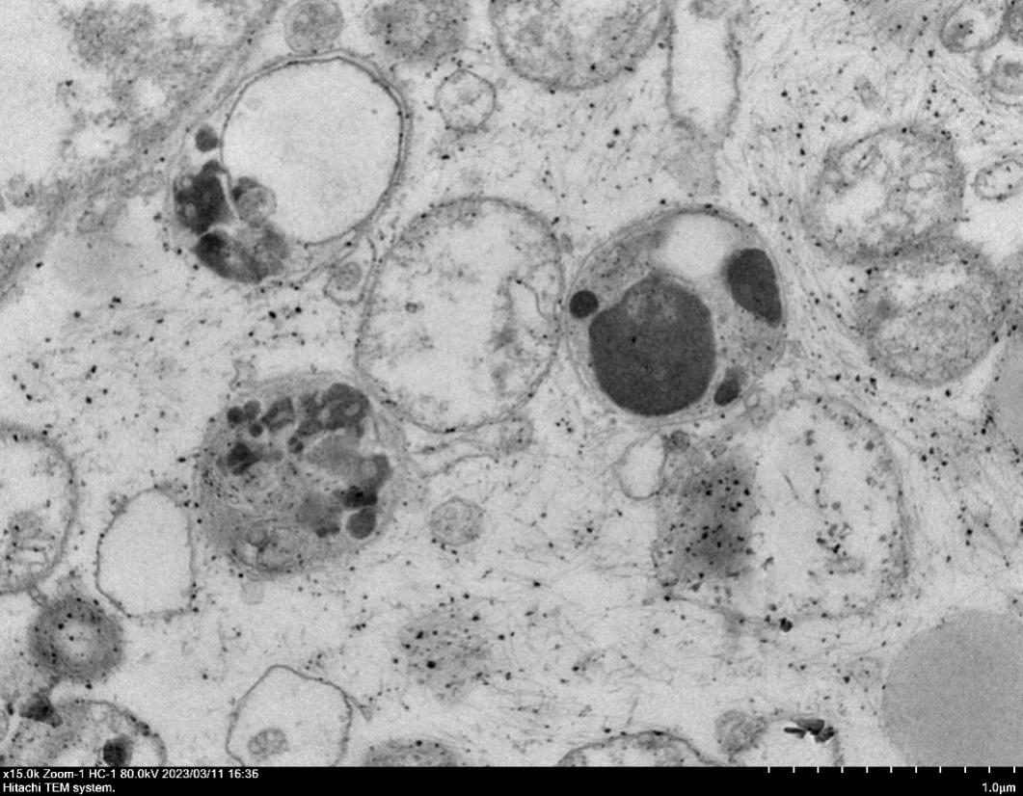
A549

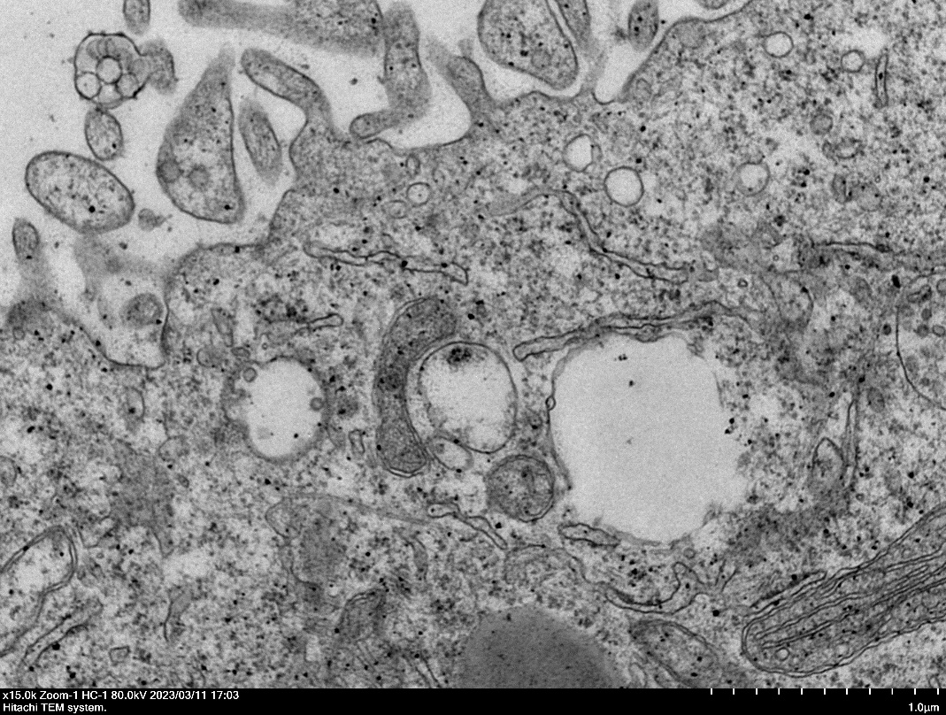
H1650

Figure S9. A549 and H1650 cells were observed with transmission electron microscopy microscope after irradiation.

Figure S10. The validation of the stably transfected A549 with APE1 knock down and overexpression of APE1 in PC9 in mRNA level and protein level
(A) The protein expression level of sh-APE1 was efficient in terms of knocking down APE1 in A549. (B) The expression level in mRNA was determined and the results were consistent with those above in A549 cells. (C) The overexpression level of APE1 in PC-9 cells was verified by western. (D) The expression level in mRNA was determined and the results were consistent with those above in PC-9 cells. ***P <0.001.

Figure S11. The quantification data of Ki67 staining in vivo.

