Supplementary Material for

Metal concentrations in fish tissues in the Kara, Bolshoi Patok, and Maly Patok

River basins, North-Eastern European Russia

Claire Hughsonª, Vasily I. Ponomarev^{b}, Boris M. Kondratenok^{b}, Tony R. Walker^{a *}

ª School for Resource and Environmental Studies, Dalhousie University, Halifax, NS, B3H 4R2, Canada
^{b} Institute of Biology, Federal Research Center Коmi Science Centre of the Ural Branch of the Russian Academy of Sciences, Syktyvkar, Komi Republic, Russian Federation

* Corresponding author: Tony R. Walker (trwalker@dal.ca)
Fig. S1. The three study sites; the Kara, Bolshoi Patok, and Maly Patok rivers located in North-Eastern European Russia.

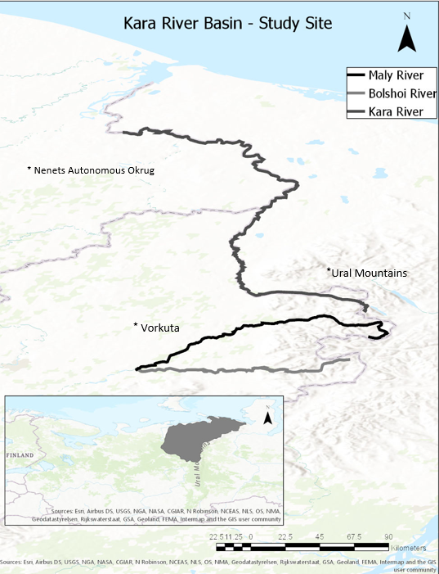
Fig. S2. Copper, cadmium, zinc, and lead concentrations (µg/g dry weight) in Arctic Char tissues from the Kara River. Error bars represent ±SD.

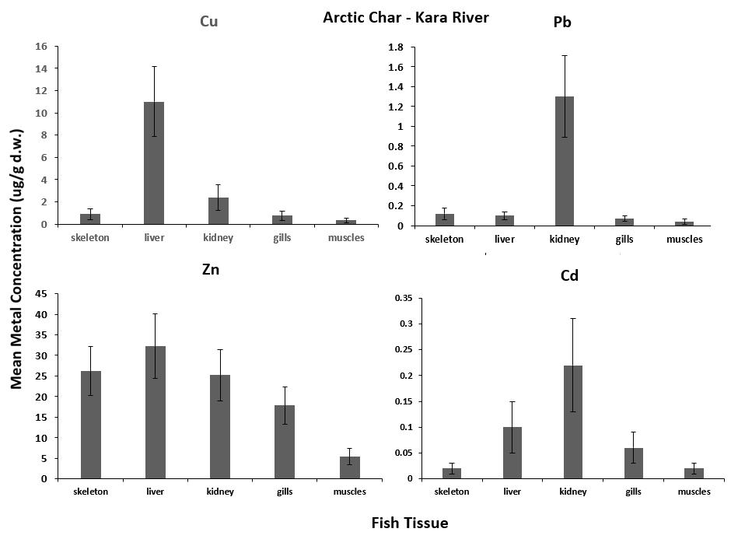

Fig. S3. Copper, cadmium, zinc, and lead concentrations (µg/g dry weight) in Whitefish tissues from the Maly Patok River. Error bars represent ±SD.

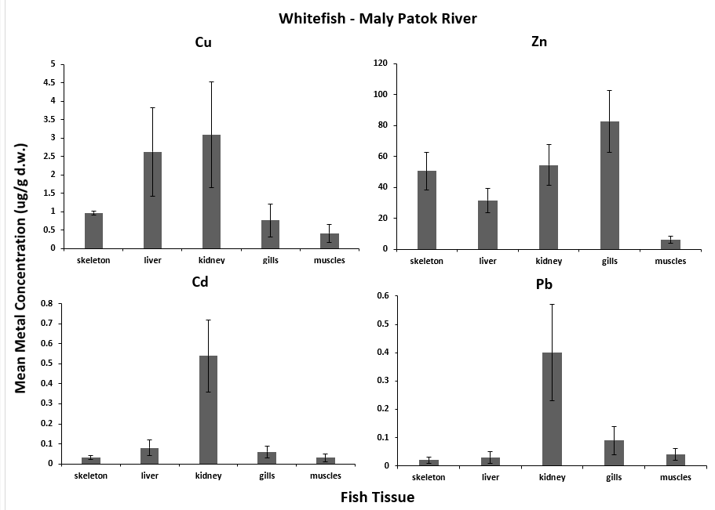

Fig. S4. Copper, cadmium, and zinc concentrations (µg/g dry weight) in Peled tissues from the Bolshoi River. Error bars represent ±SD.

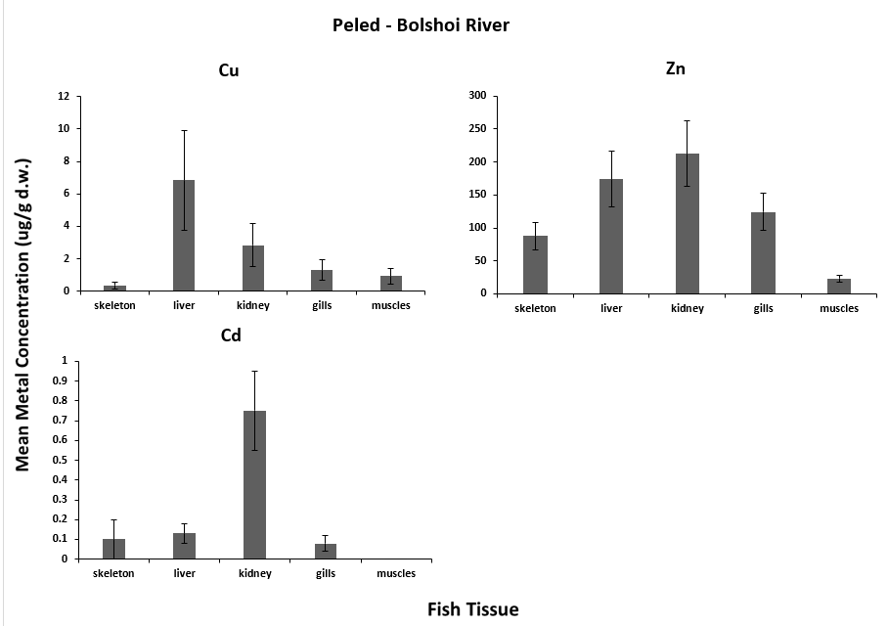

Fig. S5. Copper, cadmium, zinc, and lead concentrations (µg/g dry weight) in Pike tissues from the Maly Patok River. Error bars represent ±SD.

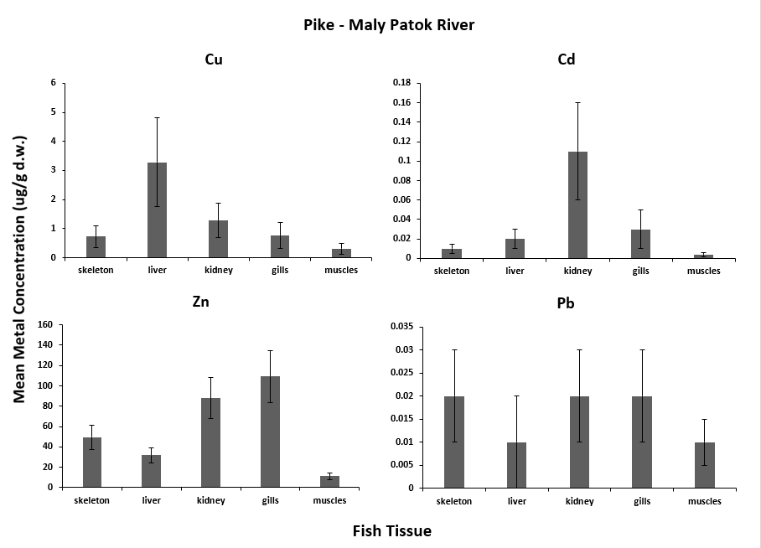

Fig. S6. Copper, cadmium, zinc, and lead concentrations (µg/g dry weight) in Roach tissues from the Maly Patok River. Error bars represent ±SD.

