Supplementary Data(Figure)
Figure S1 Demonstration of the cervical and thoracic “Daoyin” training.
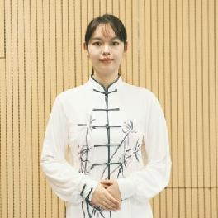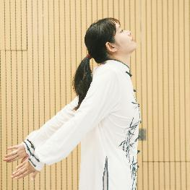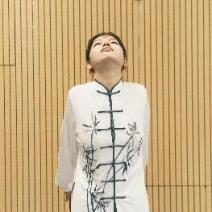
A B C
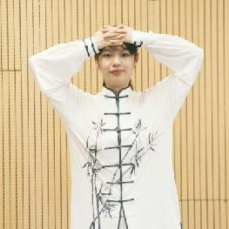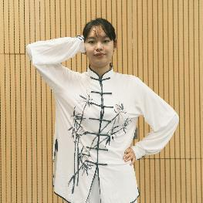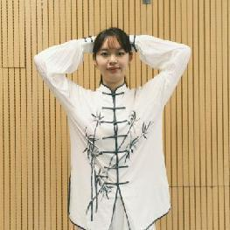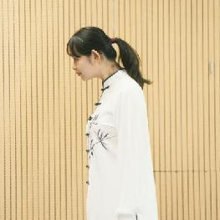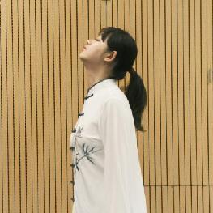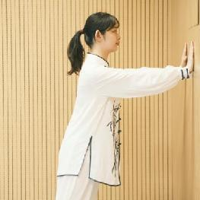
H I J
D E F

Figure S1: Demonstration of the cervical and thoracic “Daoyin” training. The figure was a schematic diagram of five actions. (A) Dantian Gong; (B) Turtle shrinking its neck 1; (C) Turtle shrinking its neck 2; (D) Roc spreading its wings 1; (E) Roc spreading its wings 2; (F) Roc spreading its wings 3; (H) White goose stretching its neck 1; (I) White goose stretching its neck 2; (J) Tiger lying

Table S1
Details of the operation of the cervical and thoracic “Daoyin” training.
Sequence of actions |  | Repetitions | Action details
Dantian Gong |  | 2 | Put your hands on the Dantian (under the navel), slowly inhale through the nose, open the chest and abdominal cavity, and keep the abdominal bulge for about 5 seconds, then exhale through the mouth, while stretching the waist, abdomen and anus. Ten times were taken as a set.
Turtle shrinking its neck |  | 2 | For example, a turtle pulls its head and neck back into its body. Slowly force to extreme shoulder, expand the chest, arms naturally drop, can be placed behind the body, two eyes directly above the head, exhale to expand the chest, make the back muscles strong contraction for 5 seconds, and then completely relax back. Fifteen times were used as a set.
Roc spreading its wings | 1 | 1 | Like a roc spreading its wings ready to go. The two arms are extended, the hands are intercrossed, the lower chin is adduced, the palms are buckled on the top of the back of the head, the palms are pressed forward and down, the head and the head are pressed to maintain the center, and the palms are contractile, and the palms are completely relaxed after 3 seconds. Fifteen times were used as a set.
Roc spreading its wings | 2 | 1 | The palm of one hand is placed on the side of the head, and the head part is kept in the middle, and the palm is contracted against it. After 3 seconds, the position is completely relaxed, and the left and right sides are alternated. Fifteen times were used as a set.
Roc spreading its wings | 3 | 1 | The two palms are interlocked on the forehead, the palms are pressed backward and down, and the head part is pressed to maintain the center, and the palms are contracted against each other, and the position is completely relaxed after 3 seconds. Fifteen times were used as a set.
White goose stretching its neck |  | 2 | Like a swan spreading its long neck and swallowing. The torso remained motionless, and the lower chin guided the head and neck on the sagittal plane. A circular activity of forward extension and backward contraction was performed. During the backward contraction, the lower chin was adducted as far as possible to make the cervical spine extend upwards as far as possible. spread the shoulders, and expand the chest. Fifteen times were used as a set.
Tiger lying |  | 2 | Like a tiger descending a mountain. Exercisers can use tables and chairs around them as props, hands parallel slightly wider than shoulder, two elbows slowly bend elbow, body pressure, shoulder, back and hip parallel, head and neck slightly forward, for 5 seconds, two elbows slowly straight, so alternately. Fifteen times were used as a set.

