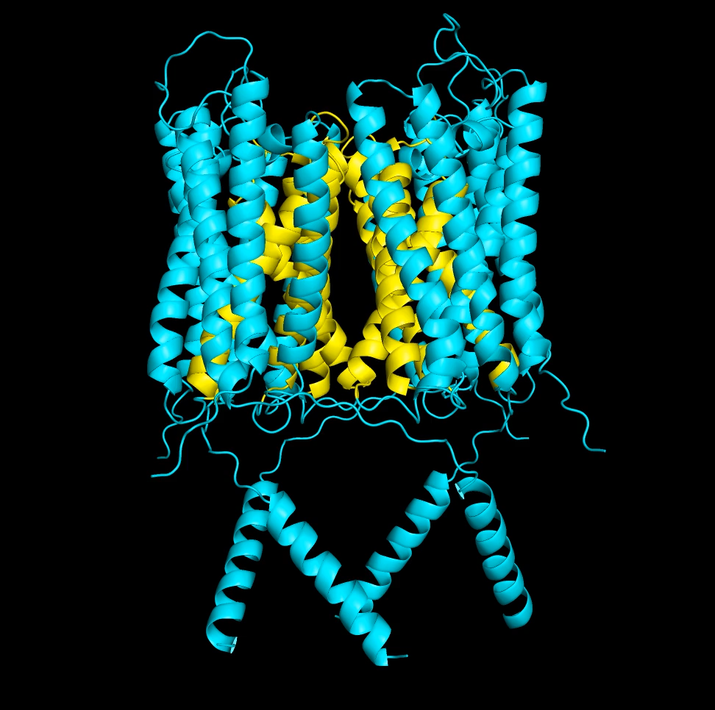

Supplementary Video 1. Movie showing the tetrameric structure of mTTN3. Inner helices
(S3 and S4) are shown in yellow.
Supplementary Figures
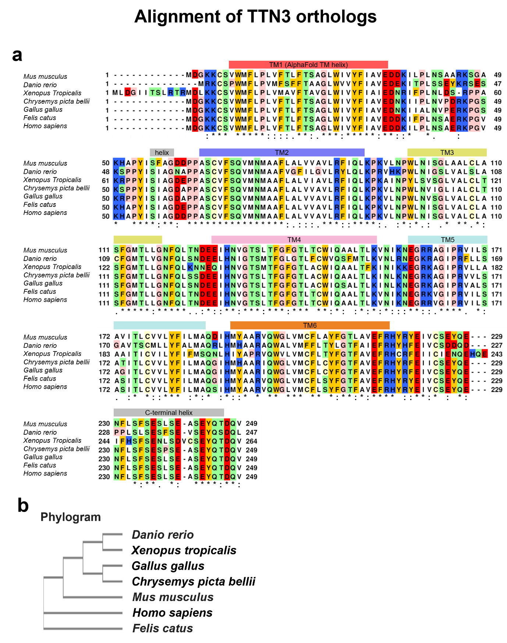
Supplementary Figure 1. Amino-acid sequences and phylogeny of TTN3 orthologs
- Multiple sequence alignment was performed with Clustal Omega. Asterisks (*) are the conserved residues among the TTN3 proteins.
- Phylogeny of the TTN3 orthologs.
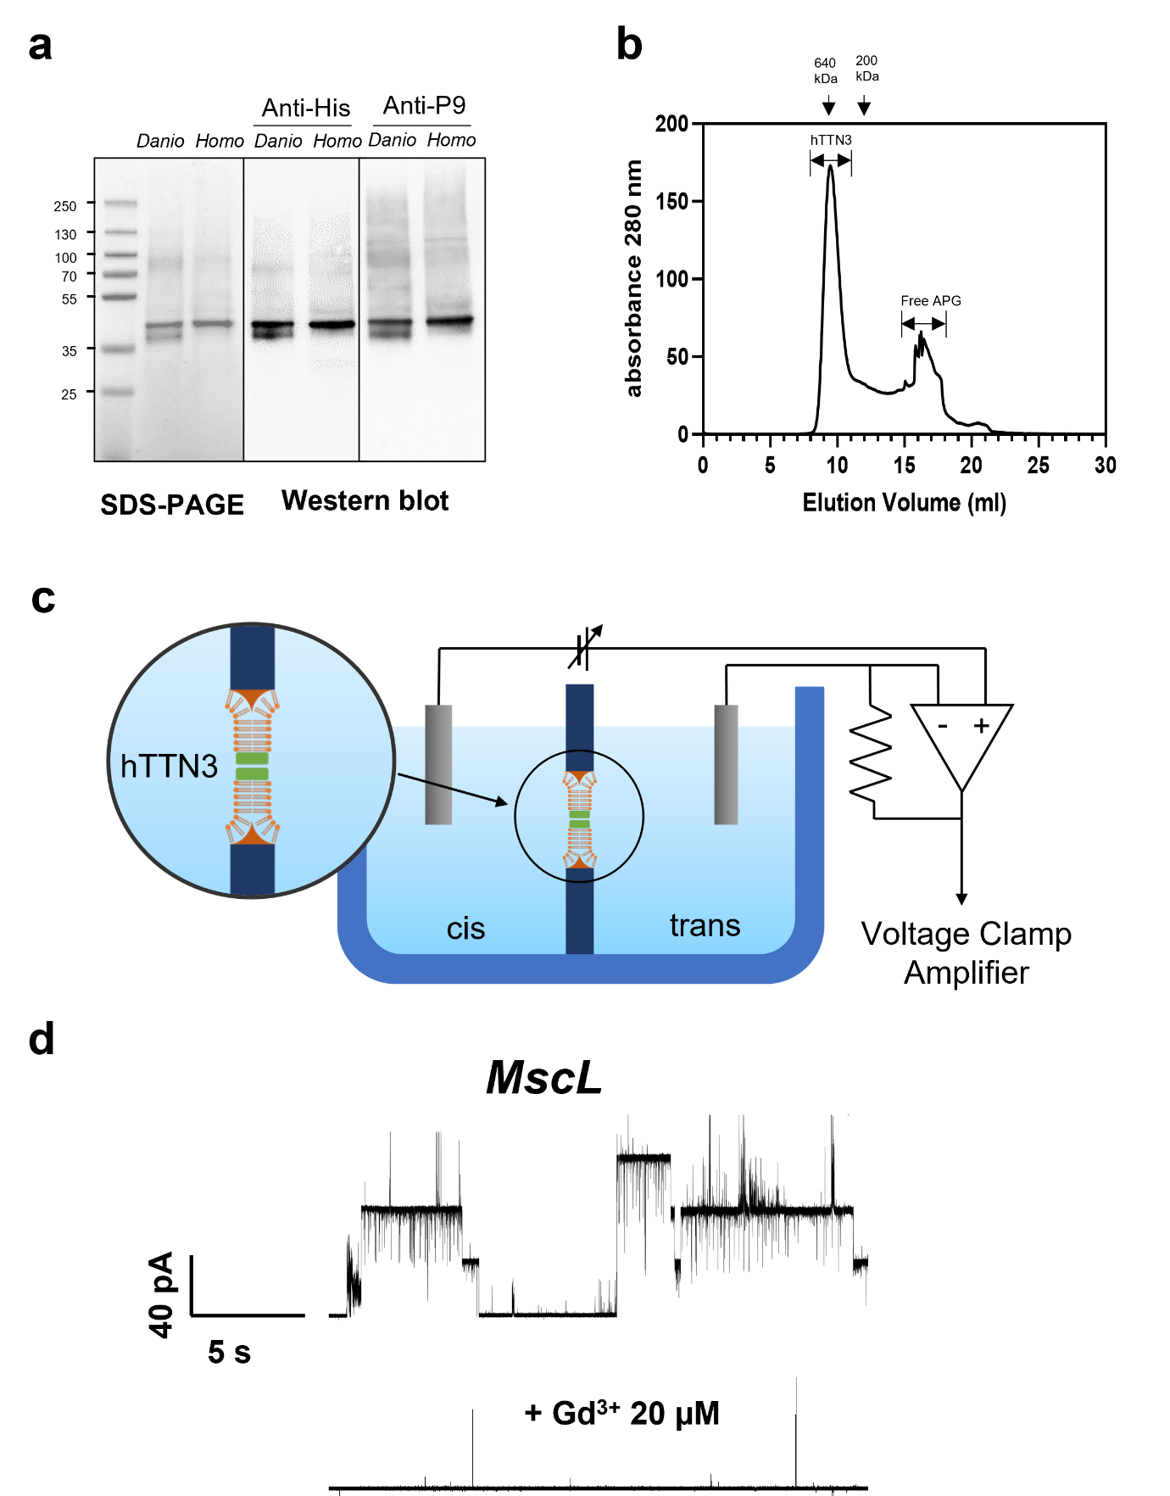
Supplementary Figure 2. Purification of human and zebrafish TTN3
- SDS-PAGE and western blot images of purified human (Homo) and zebrafish (Danio) P9-TTN3. Human and zebrafish P9-TTN3 were tagged with hexa histidine. Anti-his tag (Anti-His) and anti-P9 specific (Anti-P9) antibodies were used in the Western blot.
- Size exclusion chromatogram of the alkyl polyglycoside (APG)-stabilised hTTN3 using a Superdex 200 increase 10/300 GL column.
- Schematic diagram depicting the recording of single-channel currents from the DPhPC lipid bilayer incorporated with purified TTN3 proteins.
- Representative traces of spontaneous single-channel currents of MscL. MscL proteins were purified and reconstituted in the DPhPC lipid bilayer. Channel currents were recorded at 100 mV. Lower panel: spontaneous channel currents blocked by application of 20 µM Gd3+.

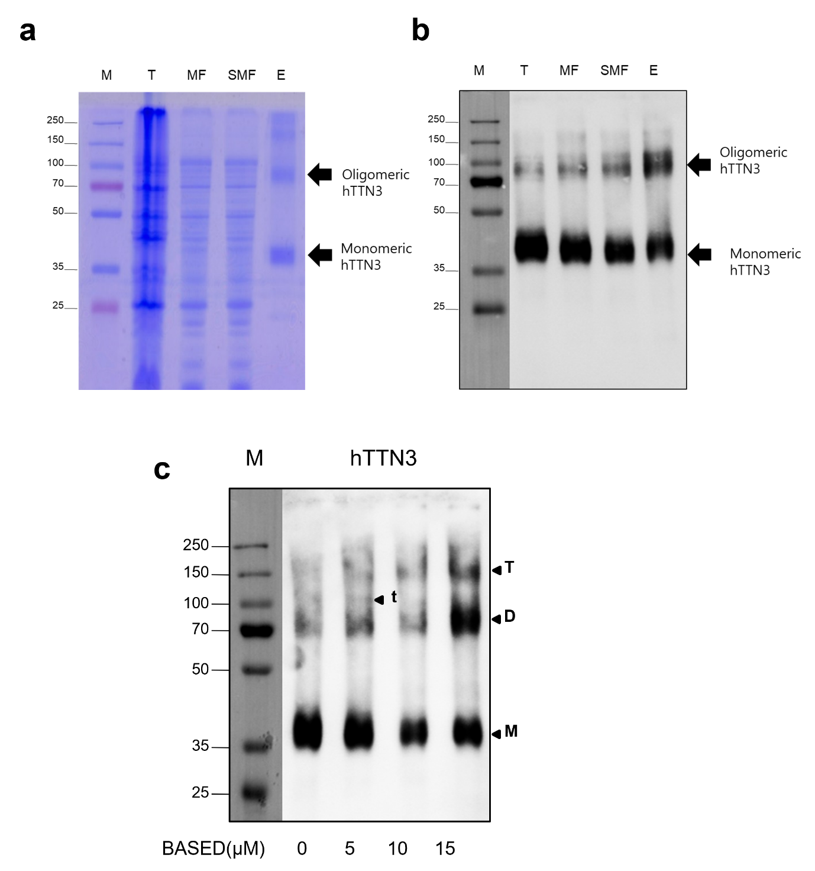
Supplementary Figure 3. Purification and determination of subunit composition of hTTN3
- SDS-PAGE of hTTN3 after Ni-NTA chromatography. M = size marker, T = total cell lysate, MF = membrane fraction, SMF = solubilised membrane fraction, E = elution fraction of Ni-NTA column. Monomeric and oligomeric forms of hTTN3 are indicated by arrows.
- Western blot of hTTN3 after Ni-NTA chromatography using anti-His₆ antibody.
- Western blots of cross-linking products of purified P9-hTTN3 by Ni-NTA chromatography after using anti-His₆ antibody. Concentrations of 0, 5, 10, or 15 µM of Bis(β-[4-azidosalicylamido]-ethyl) disulphide (BASED) was used for the cross-linking reactions. M = size marker. Monomeric (M), dimeric (D), trimeric (t) and tetrameric (T) products of cross-linking reaction are indicated with triangles.

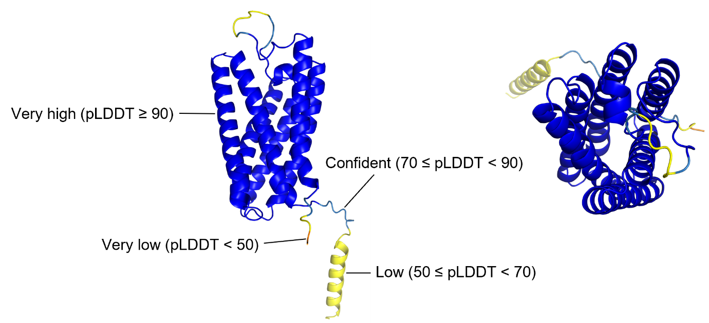
Supplementary Figure 4. mTTN3 monomeric model (side [left] and top [right] views) The model was generated with the AlphaFold2 program. The protein structure is displayed as a cartoon representation with colour-coded predicted local-distance difference test (pLDDT) scores. The average pLDDT score of all residues was 91.9.
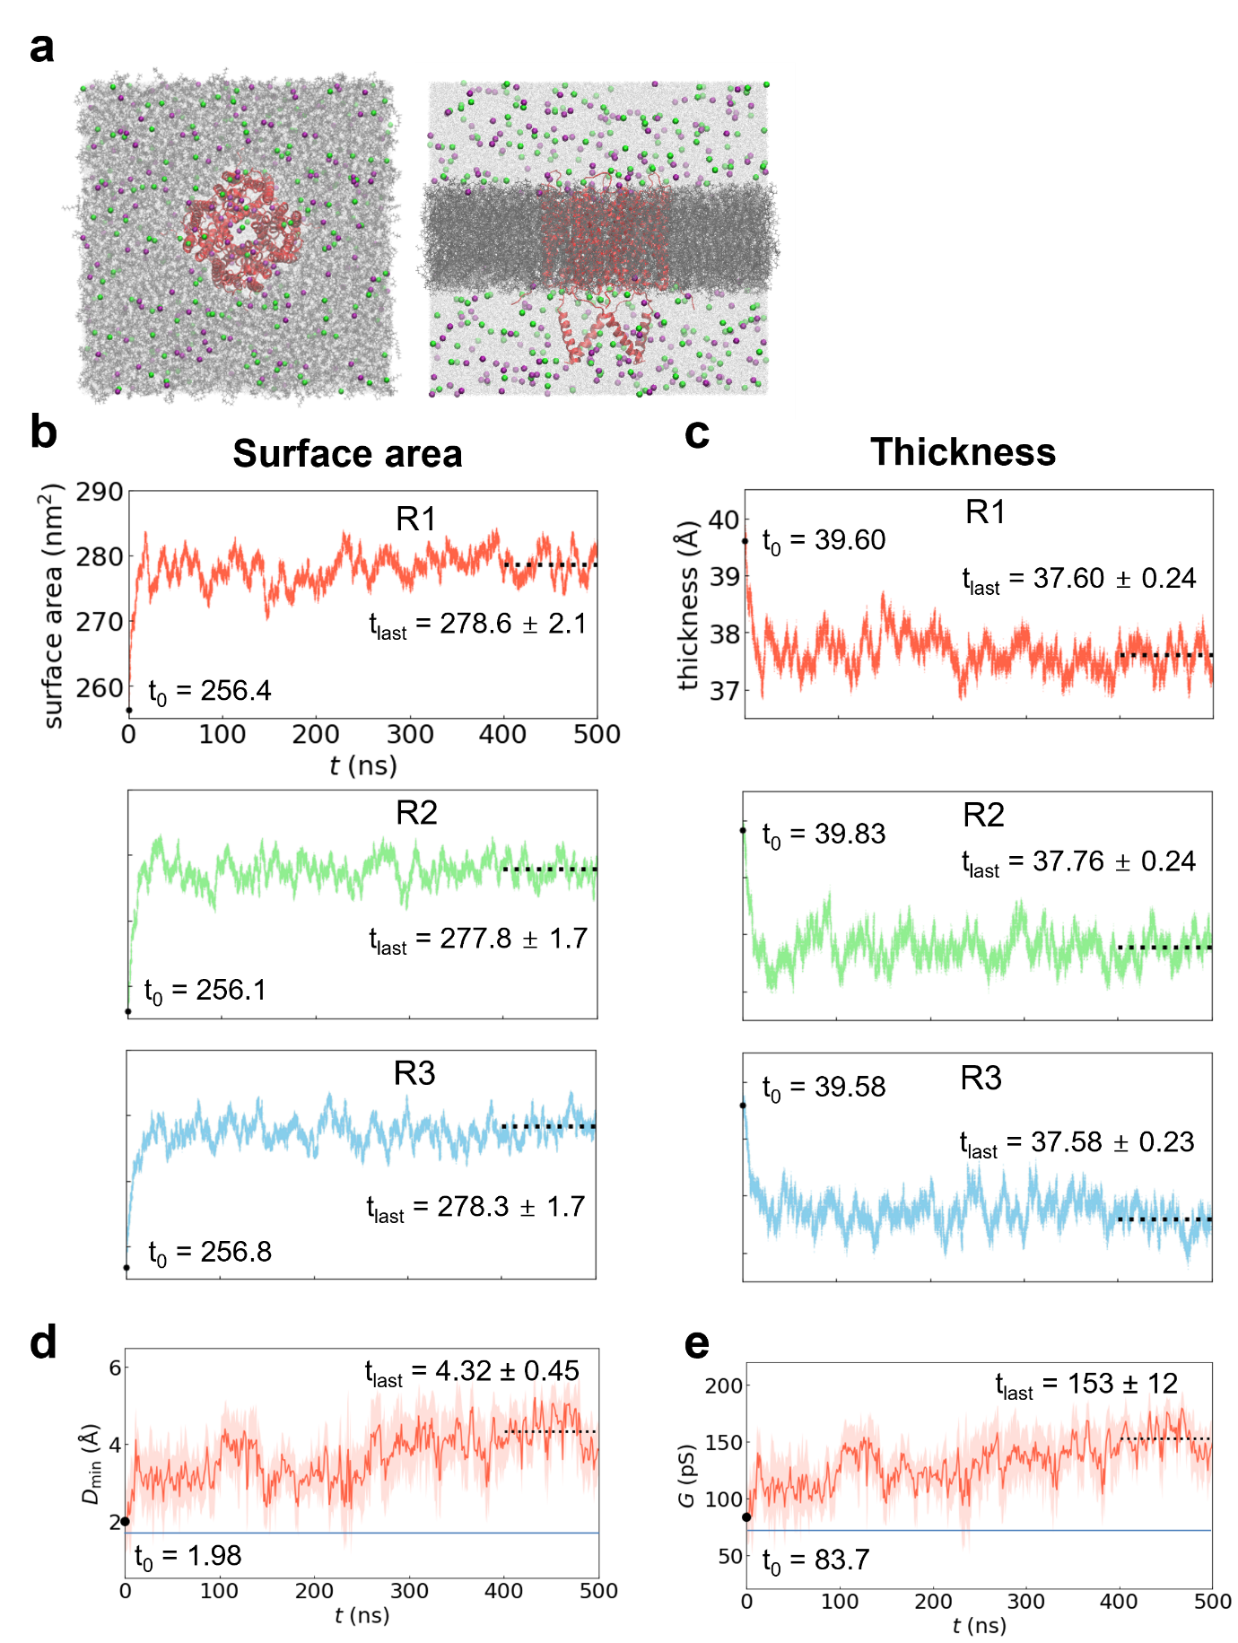
Supplementary Figure 5. Snapshot and time evolution of the molecular dynamics simulations upon stretching the lipid bilayer
(a) Snapshot of the molecular dynamics simulation system at the starting point of the production run. Top (left) and side (right) view. The system consisted of a TTN3 tetramer, 1,2-dioleoyl-sn-glycero-3-phosphocholine (DOPC) bilayer, and ionic solution. TTN3 tetramer, red; DOPC, grey; K⁺, purple; Cl–, green.
(b and c) Time evolution of the total surface area (b) and thickness (c) upon stretching the lipid bilayer for three replicas (R1 – R3). The black dot and horizontal dotted line are the initial values (after equilibration run; ‘t₀’) and average values (with standard deviation) for the last 100 ns of the production run (‘t_{last}’) for each replica.
(d and e) Time evolution of the minimum pore diameter of the pore (d) and channel conductance (e) upon stretching the lipid bilayer for R1. The pore diameter and channel conductance were calculated using the program HOLE ³⁸. The line and shaded area represent the mean and the standard deviation for every 1 ns trajectory, respectively. The diameter was largest at 433 ns. The channel conductance also increases during the 500 ns production run. The remaining two replicas (R2 and R3) follow the same trend.

