Methods
The X-ray images of seeds. The embryos of 35 batches of Juhe samples are all intact (Fig. S1). And the samples corresponding to the numbers in the figures are shown in Table S1.
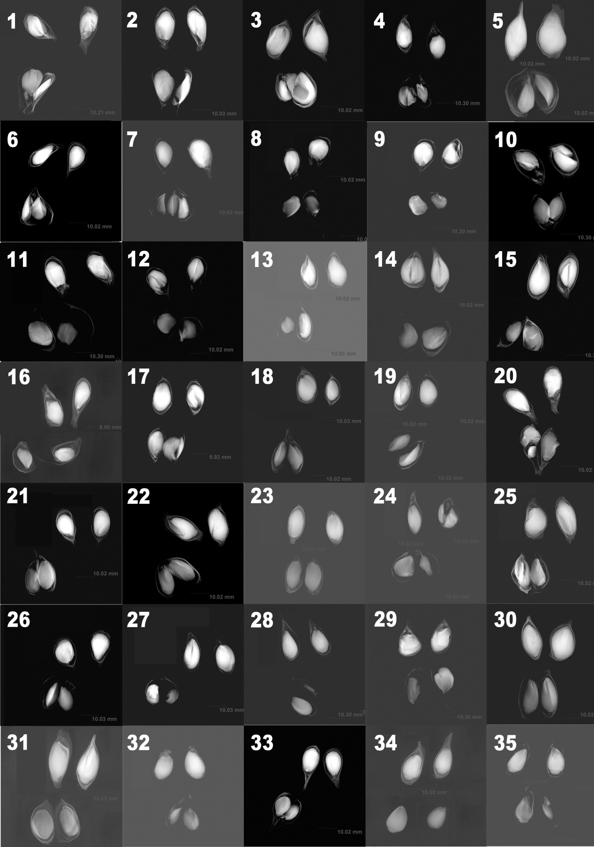
Fig. S1 The X-ray images of 35 batches of samples

Table S1 35 batches of samples’ numbers, varieties and collection places
No. | Variety | place | No. | Variety | place
1 | C. ‘Dahongpao’ | Qionglai | 19 | C. ‘Ponkan’ | Yaan
2 | C. ‘Ponkan’ | Qionglai | 20 | C. ‘Dahongpao’ | Meishan
3 | C. sinensis | Qionglai | 21 | C. ‘Ponkan’ | Meishan
4 | C. ‘Ponkan’ | Luzhou | 22 | C. sinensis | Meishan
5 | C. reticulata | Guangyuan | 23 | Fortunella margarita (Lour.) Swingle | Chengdu
6 | C. ‘Ponkan’ | Guangyuan | 24 | C. ‘Dahongpao’ | Ziyang
7 | C. ‘Dahongpao’ | Guangyuan | 25 | C. sinensis | Ziyang
8 | C. ‘Dahongpao’ | Leshan | 26 | C. ‘Ponkan’ | Ziyang
9 | C. ‘Ponkan’ | Leshan | 27 | C. ‘Ponkan’ | Neijiang
10 | C. sinensis | Leshan | 28 | C. ‘Dahongpao’ | Neijiang
11 | C. ‘Dahongpao’ | Yibin | 29 | C. ‘Dahongpao’ | Nanchong
12 | C. ‘Ponkan’1 | Yibin | 30 | C. ichangensis Swingle | Nanchong
13 | C. ‘Ponkan’2 | Yibin | 31 | C. sinensis | Nanchong
14 | C. (L.) Osbeck | Yibin | 32 | C. ‘Ponkan’ | Nanchong
15 | C. sinensis | Yibin | 33 | C. ‘Dahongpao’ | Suining
16 | C. ‘Dahongpao’ | Zigong | 34 | C. ‘Ponkan’ | Jiangyou
17 | C. ‘Ponkan’ | Zigong | 35 | C. ‘Dahongpao’ | Jiangyou
18 | C. ‘Dahongpao’ | Yaan

Results
The linearity of all calibration curves were R²>0.999, and the established HPLC methods could be used for accurate and sensitive quantitative analysis (Table S2 and S3).

Table S2 Calibration curve of three tested compounds (n=3)
Reference substance | Calibration curve | R² | Linear range(μg/mL)
Naringin | y=11129x+2.5167 | 0.9997 | 1.2-8.8
Hesperidin | y=20842x+9.3431 | 0.9995 | 2.0-50.0
Neohesperidin | y=49691x+15.857 | 0.9998 | 0.1-2.9

Table S3 Stability, repeatability, precision and recovery rate of four tested compounds
Compound | Stablility RSD(%)(n=6) | Repeatability RSD(%)(n=6) | Precision RSD(%)(n=6) | Recovery RSD(%)(n=3)
Naringin | 0.2 | 2.6 | 2.29 | 1.92
Hesperidin | 2.1 | 1.3 | 1.91 | 2.4
Neohesperidin | 1.4 | 0.8 | 1.93 | 1.26

