Supplementary Information

Numerical method
There are several methods for interface capturing of two-phase flow systems and the level set is one of them. Also, some studies have reported modeling guidelines for decreasing the simulation time and to mitigate numerical artifacts.
The continuity, Navier-Stokes, and level set equations are given by:
$∇.u=0$ (1)
$\frac{∂ϕ}{∂t}+∇.\left(ϕu\right)=ψ∇.\left(ω∇ϕ-ϕ(1-ϕ)\frac{∇ϕ}{\left|∇ϕ\right|}\right)$ (2)
$ρ(\frac{∂u}{∂t}+\left(u.∇\right)u)=∇.\left[-pI+μ(∇u+({∇u)}^{T})\right]+σkδn$ (3)
where $ρ$, $μ$, $σ$, $u$, $p$, $I$, $k$, $δ$, and $n$ represent the density, the dynamic viscosity, the surface tension, the velocity, the pressure, the identity matrix, the interface curvature, the Dirac delta function, and the unit vector normal to the droplet interface, respectively. $ϕ$ represents the level set function and takes a value between 0 (the continuous phase) to 1 (the dispersed phase) across the interface. $ψ$ and $ω$ determine the amount of reinitialization of the level set function $ϕ$ and the thickness of the interface, respectively. An appropriate $ψ$ can be the maximum value of $u$ and optimum values can be calculated on a trial-and-error basis. $δ$, $n$, and $k$ can be calculated from:
$δ=6\left|∇ϕ\right|\left|ϕ(1-ϕ)\right|$ (4)
$n=\frac{∇ϕ}{\left|∇ϕ\right|}$ (5)
$k=-∇.n$ (6)
The density and dynamic viscosity vary smoothly over the interface as follow:
$ρ=ρ_{c}+({ρ_{d}-ρ}_{c })ϕ$ (7)
$μ=μ_{c}+(μ_{d}-μ_{c})ϕ$ (8)
The implicit backward differentiation formula was employed to progress in time with a time step of 10 μs and a residual tolerance of 5×10⁻⁴. We used 0.265 for $ψ$ and half of the maximum mesh size for $ω$.

Validation
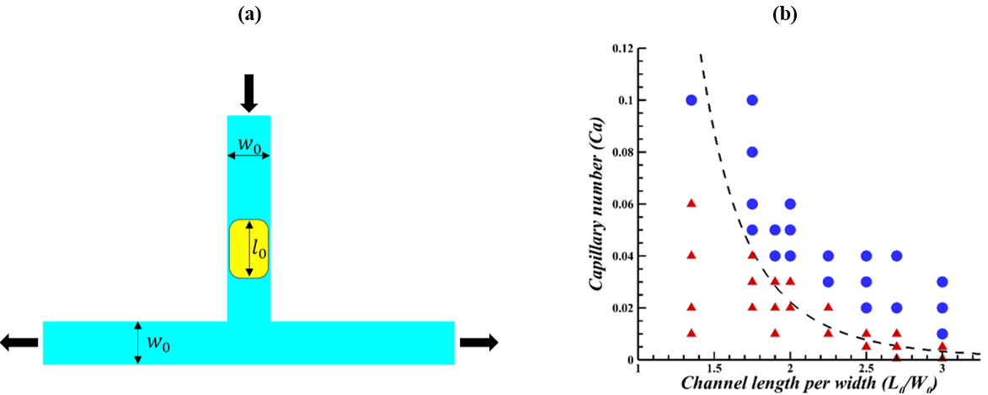
FIG S1. (a) The general geometry of droplet breakup in the T-junction. (b) The breakup phase diagram of the present study and the numerical research of Afkhami et al. [1] ( λ = 1). The dashed curve is the theoretical analysis of Afkhami et al. [1]. The current results and those obtained by Afkhami et al. [1] were marked by () for breaking and (▲) for non-breaking.
At first, the numerical method was validated by inspecting the droplet breakup process in a symmetric T-junction with the channel width ${(w}_{0})$. Afkhami et al. [1] have obtained a phase diagram with various droplet initial lengths ${(l}_{0})$ and the capillary numbers $(Ca={μ_{c}U_{in}}/{σ)}$ where $μ_{c}$, $U_{in}$, and $σ$ as the continuous phase viscosity, velocity of the continuous fluid in the inlet, and surface tension between two fluids, respectively. Afkhami et al. [1] have shown how the viscosity ratio of fluids $(λ={μ_{d}}/{μ_{c})}$ affects the boundary between the splitting and non-splitting areas. Figure S1b illustrates great accordance between this study and the published reports of Afkhami et al.[1] for λ = 1.

Boundary condition and fluid properties
Some assumptions that we considered in our simulation are: (1) A parabolic fully developed laminar velocity profile at the inlet with the velocity of 0.06m/s, a pressure-based outflow at the outlet, and a wall boundary condition with a static contact angle of 180° was considered, (2) The dispersed and continuous fluids are assumed to be water and oil, respectively, and the properties of the two fluids are given in Table S1, (3) The width of three main channels were supposed to be 45 µm , (4) Laplace pressure due to surface tension and branch width prevents water droplets from entering bifurcations.
TABLE S1. Fluid properties.
Fluid | Density (kg/m³$)$ | Dynamic viscosity (Pa.s) | Surface tension (mN/m)
Oil | 967 | 0.006 | 45.57
Water | 997.1 | 0.001 | 45.57
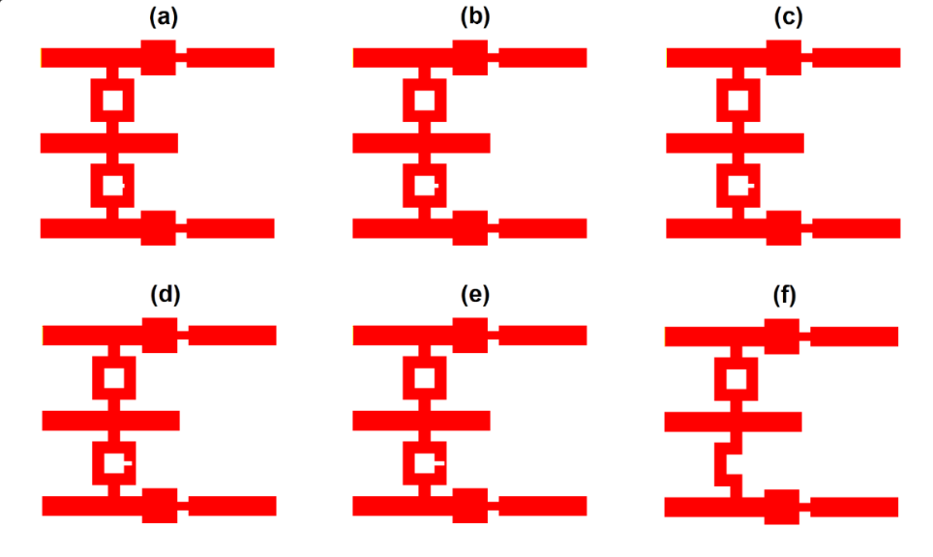
FIG S2. Different states of the valve for desynchronization between the droplets. (a) 5/6 of the bifurcation width, (b) 4/6 of the bifurcation width, (c) 3/6 of the bifurcation width, (d) 2/6 of the bifurcation width, (e) 1/6 of the bifurcation width, and (f) 0/6 of the bifurcation width.
References
1. Afkhami, S., Leshansky, A.M., Renardy, Y.: Numerical investigation of elongated drops in a microfluidic T-junction. Physics of Fluids. 23, 022002 (2011). https://doi.org/10.1063/1.3549266

