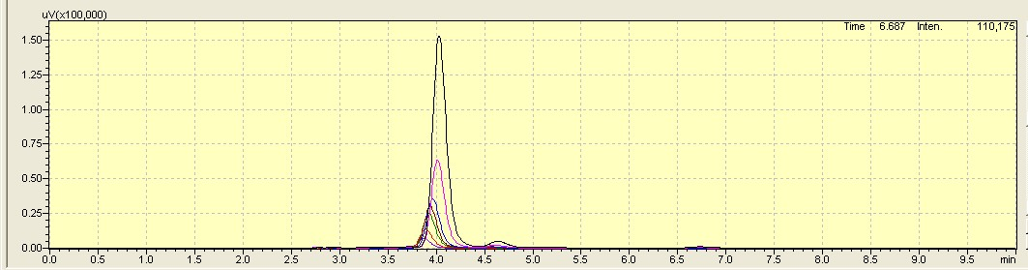

Fig S1. Draw rutin content standard curve according to different dilution concentrations and corresponding peak areas of reference materials.

