Supplementary information
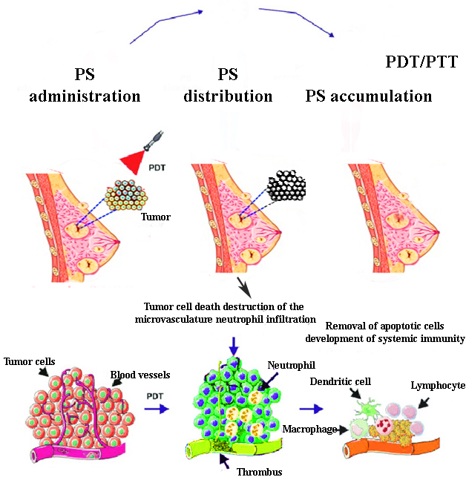
A diagrammatic illustration of a photodynamic therapy on tumor cells

