Devosia sediminis sp. nov., isolated from subterranean sediment

Fu Ma¹ · Zhi-Da Zi¹ · Wei Li¹ · Zhao-Xuan Wang² · Jun Lu³ · Jie Lv¹*
1. College of Life Science and Technology, Beijing University of Chemical Technology, Beijing 100029, China
2. Shijiazhuang People's Medical College, Shijiazhuang, Hebei, 050091, China
3. Faculty of Health and Environmental Sciences, Auckland University of Technology, Auckland 1142, New Zealand

Running title: Devosia sediminis sp. nov.

Keywords Novel species · Devosia · Polyphasic taxonomy · Genome · Sediment

*Corresponding author: Jie Lv
E-mail: lvjie@mail.buct.edu.cn (J. Lv)

Supplementary Fig. S1. Neighbour-Joining phylogenetic tree based on 16S rRNA gene sequences showing the taxonomic position of strain MSA67^{T} in the genus Devosia. Numbers at nodes indicate bootstrap percentages (based on 1000 replications); values >50% are shown. Bar, 0.01 substitutions per nucleotide position. Escherichia coli ATCC 11775^{T}(X80725) was used as an outgroup.

Supplementary Fig. S2. Maximum-Parsimony phylogenetic tree based on 16S rRNA gene sequences showing the taxonomic position of strain MSA67^{T} in the genus Devosia. Numbers at nodes indicate bootstrap percentages (based on 1000 replications); values > 50 % are shown. Bar, 20 substitutions per nucleotide position. Escherichia coli ATCC 11775^{T}(X80725) was used as an outgroup.

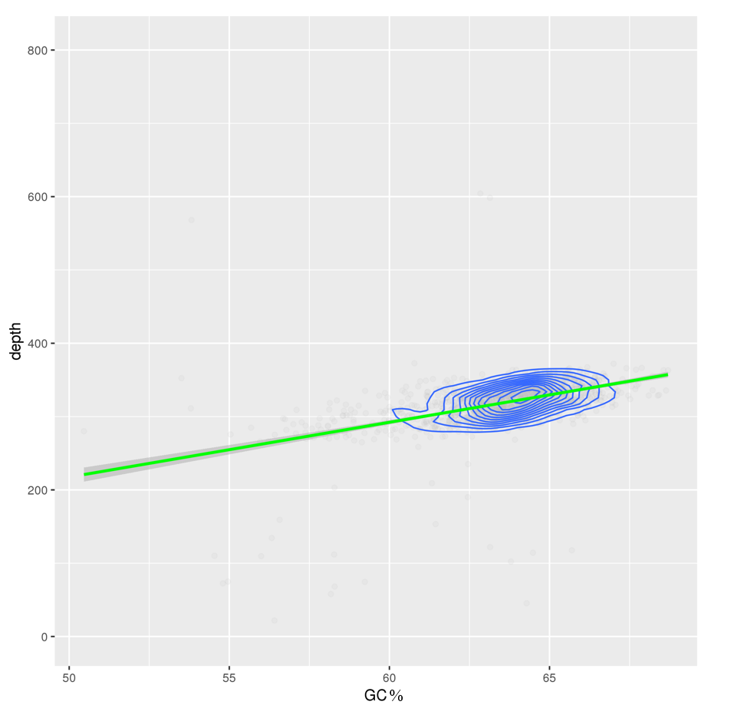

Supplementary Fig. S3. Analysis of sequencing depth and GC-Depth. The abscissa indicates the GC content, the ordinate indicates the sequencing depth.

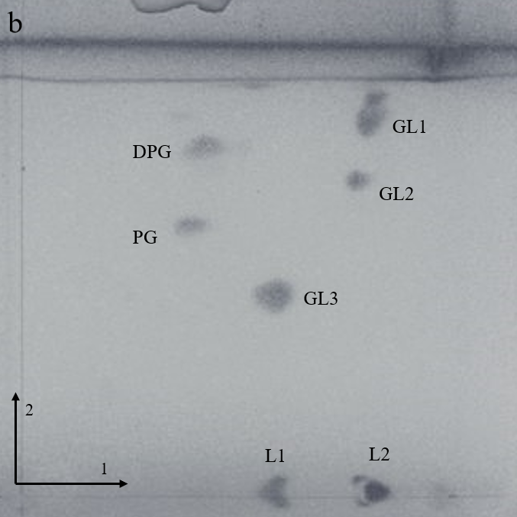
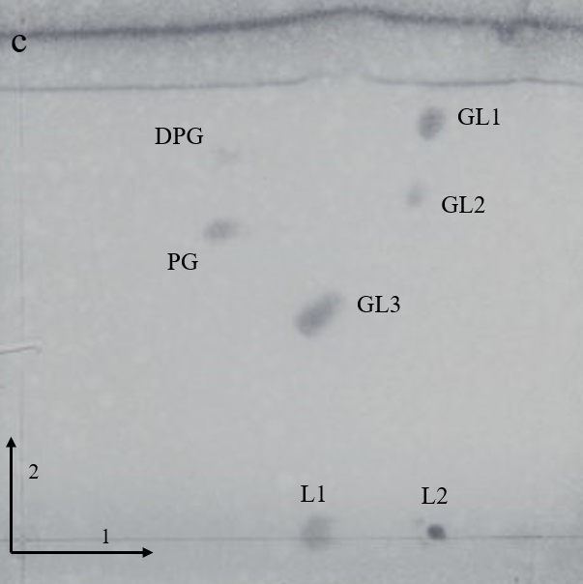
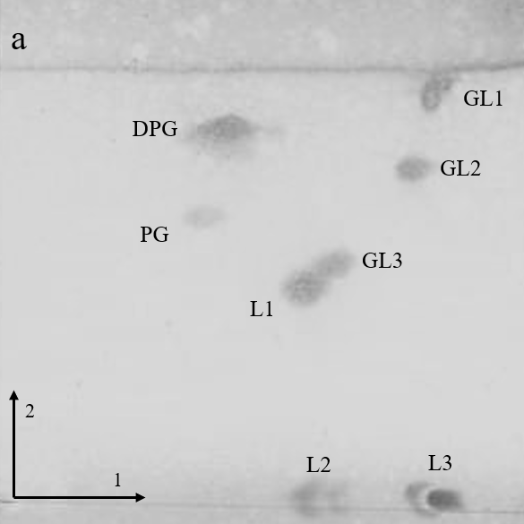

Supplementary Fig. S4. Two-dimensional TLC of the total polar lipids of strain MSA67^{T}. TLC of polar lipids of strain MSA67^{T} (a); Devosia chinhatensis (b); Devosia riboflavina (c); DPG, diphosphatidylglycerol; PG, phosphatidylglycerol; GL, glycolipids; L, undentified lipids.

Supplementary Table S1. Genome characteristics of strain MSA67^{T} and other related strains used for comparison and phylogenetic reconstructions (All data of the related strains come from NCBI. -, not found).

Species | Strain | Genome size (Mbp) | Contigs/Scaffold | G+C content (mol %) | ANI (%) | dDDH (%) | DDBJ/EMBL/GenBank accession number | RefSeq assembly accession
Devosia sediminis | MSA67^{T} | 4.1 | 16 | 63.6 | 100.0 | 100.0 | JAEKMH000000000 | GCF_016411825.1
Devosia riboflavina | IFO13584^{T} | 5.1 | 113 | 61.8 | 78.6 | 22.6 | JQGC01000000 | GCF_000743575.1
Devosia chinhatensis | IPL18^{T} | 3.5 | 98 | 62.4 | 78.7 | 21.8 | JZEY01000000 | GCF_000969445.1
Devosia indica | IO390501^{T} | 4.0 | 69 | 61.9 | 80.4 | 22.9 | PYVZ01000000 | GCF_003056405.1
Devosia soli | GH2-10^{T} | 4.1 | 48 | 61.0 | 77.5 | 20.0 | LAJG01000000 | GCF_000970455.1
Devosia subaequoris | HST3-14^{T} | 3.8 | 29 | 61.1 | 79.5 | 22.4 | JACIEW010000000 | GCF_014197055.1
Devosia crocina | IPL20^{T} | 3.7 | 6 | 61.3 | 76.9 | 21.4 | FPCK01000000 | GCF_900116545.1
Devosia marina | L53-10-65^{T} | 3.9 | 33 | 61.3 | 79.6 | 22.6 | WQRF01000000 | GCF_009758415.1
Devosia submarina | KMM 9415^{T} | 4.0 | 45 | 60.4 | 75.5 | 20.1 | PYWB01000000 | GCF_003056345.1
Devosia elaeis | S37^{T} | 3.9 | 151 | 64.1 | 80.4 | 23.2 | LVVY01000000 | GCF_001650025.1
Devosia naphthalenivorans | CM5-1^{T} | 4.5 | 55 | 61.4 | 75.8 | 20.2 | PYVW01000000 | GCF_003056355.1
Devosia limi | DSM 17137^{T} | 4.3 | 25 | 62.7 | 76.4 | 20.2 | FQVC01000000 | GCF_900128975.1
Devosia psychrophila | Cr7-05^{T} | 4.3 | 85 | 61.2 | 76.1 | 20.2 | FOMB01000000 | GCF_900112505.1
Devosia epidermidihirudinis | E84^{T} | 3.9 | 47 | 61.1 | 75.9 | 20.1 | LANJ01000000 | GCF_000971295.1
Devosia insulae | DS-56^{T} | 5.8 | 410 | 65.3 | 73.5 | 19.5 | LAJE02000000 | GCF_000970465.2
Devosia enhydra | ATCC 23634^{T} | 4.2 | 5 | 65.7 | 73.5 | 19.4 | FPKU01000000 | GCF_900119845.1
Devosia geojensis | BD-c194^{T} | 4.5 | 207 | 65.9 | 75.7 | 20.6 | JZEX01000000 | GCF_000969415.1

Supplementary Table S2. Genome statistics of strain MSA67^{T}

Attribute | Value | Explanation
Raw data (Mb) | 8.97
Filtered reads (%) | 2.11 | Filtered Reads/ Raw Data Total Reads
Clean data (Mb) | 8.78
Clean data Q20 (%) | 97.8 | Q20 value of valid data
Clean data Q30 (%) | 93.9 | Q30 value of valid data
Contigs | 16
Total length (bp) | 4,087,120 | Total length of the Scaffold or Contig mentioned above
N50 length (bp) | 1,186,958 | N50 length of the Scaffold or Contig mentioned above
N90 length (bp) | 182,054 | N90 length of the Scaffold or Contig mentioned above.
Max length (bp) | 1,401,618 | Maximum length of the Scaffold or Contig mentioned above
Min length (bp) | 1,059 | Minimum length of the Scaffold or Contig mentioned above
Sequence GC (%) | 63.6 | GC content of Assembly Sequence
Coding gene
Gene number | 4,016
Gene total length (bp) | 3,646,294
Gene average length(bp) | 907.9417
raw data/ genome size | 200X | Sequencing depth of coverage
Type | Number | Total length (bp) | Average length (bp)
Rnase P RNA | 1 | 398 | 398
rRNA | 3 | 4,321 | 1,440.33
tRNA | 45 | 3,525 | 78.33
sRNA | - | - | -
tmRNA | 1 | 359 | 359
repeat sequence
SINE | 12 | 1,162 | 96.83
Simple repeat | 337 | 16,043 | 47.61
Low complexity | 19 | 842 | 44.32
LINE | - | - | -
RC | - | - | -
Unkown | - | - | -
Total | 368 | 18,047 | 49.04
(-, not found). RNA, ribonucleic acid; tRNA, transfer ribonucleic acid; sRNA, small ribonucleic acid; LINE, longinterspersed nuclear elements; SINE, short interspersed nuclear elements; RC, rolling circle;

Supplementary Table S3. Number of genes associated with the 25 general COG functional categories
Code | Gene number | Description
A | 25 | RNA processing and modification
B | 19 | Chromatin structure and dynamics
C | 258 | Energy production and conversion
D | 72 | Cell cycle control, cell division, chromosome partitioning
E | 270 | Amino acid transport and metabolism
F | 95 | Nucleotide transport and metabolism
G | 230 | Carbohydrate transport and metabolism
H | 179 | Coenzyme transport and metabolism
I | 94 | Lipid transport and metabolism
J | 245 | Translation, ribosomal structure and biogenesis
K | 231 | Transcription
L | 238 | Replication, recombination and repair
M | 188 | Cell wall/membrane/envelope biogenesis
N | 96 | Cell motility
O | 203 | Posttranslational modification, protein turnover, chaperones
P | 212 | Inorganic ion transport and metabolism
Q | 88 | Secondary metabolites biosynthesis, transport and catabolism
R | 702 | General function prediction only
S | 1347 | Function unknown
T | 152 | Signal transduction mechanisms
U | 158 | Intracellular trafficking, secretion, and vesicular transport
V | 46 | Defense mechanisms
W | 1 | Extracellular structures
Y | 2 | Nuclear structure
Z | 12 | Cytoskeleton

