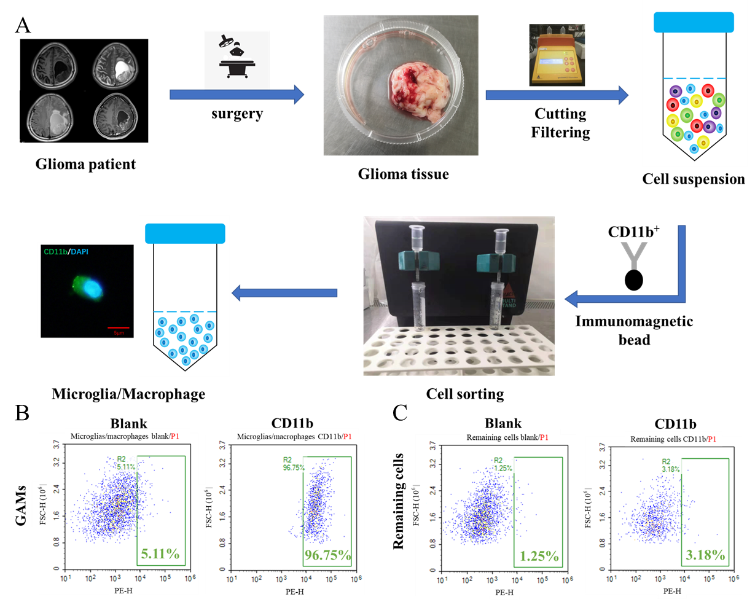
Supplementary Figure 1. GAMs isolation. The process of isolating GAMs from glioma tissue (A). Isolated cells (GAMs) highly express CD11b (B). Residual cells contain a small number of GAMs (C).

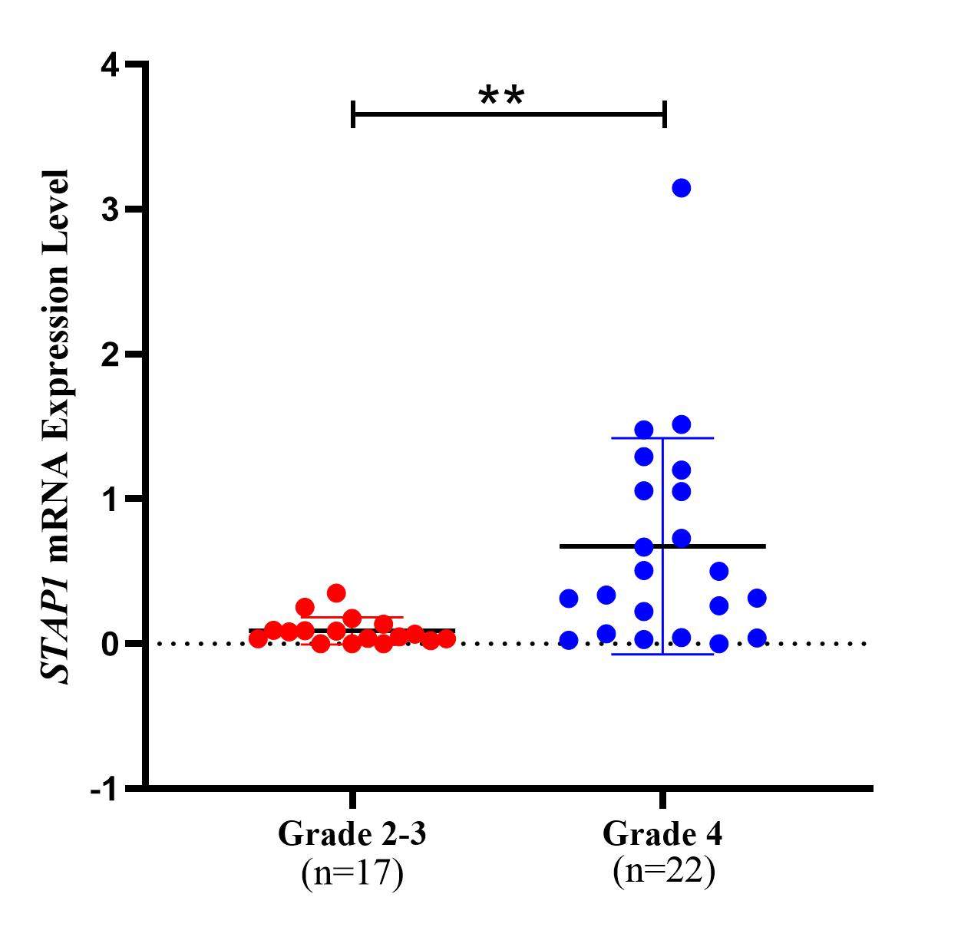
Supplementary Figure 2. STAP1 was found by transcriptome sequencing of GAMs. STAP1 mRNA was higher in GAMs of grade 4 glioma than of grade 2-3 glioma.

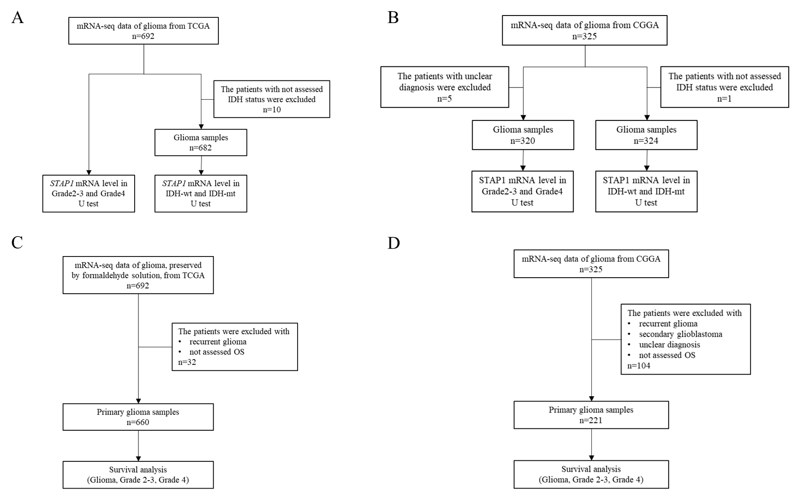
Supplementary Figure 3. Inclusion criteria and exclusion criteria of TCGA data and CGGA data. Inclusion criteria and exclusion criteria of STAP1 mRNA level in TCGA (A) and CGGA (B). Inclusion criteria and exclusion criteria of survival analysis in TCGA (C) and CGGA (D).

Number | Pathological grade | IHC | WB | qRT-PCR
2020-001 | 3 | √ |  | √
2020-002 | 2 |  |  | √
2020-003 | 2 | √ |  | √
2020-004 | 2 | √ |  | √
2020-005 | 4 | √ | √ | √
2021-001 | 3 | √ | √ | √
2021-002 | 4 | √ | √ | √
2021-003 | 2 | √ | √ | √
2021-004 | 3 | √ | √ | √
2021-005 | 4 | √ | √ | √
2021-006 | 2 | √ | √ | √
2021-007 | 2 |  | √ | √
2021-008 | 4 | √ | √ | √
2021-009 | 4 | √ | √ | √
2021-010 | 2 | √ | √ | √
2021-011 | 4 | √ | √ | √
2021-012 | 2 | √ | √ | √
2021-013 | 3 | √ | √
2021-014 | 3 |  | √
2021-015 | 4 | √ | √ | √
2021-016 | 3 | √ | √ | √
2021-017 | 4 | √ | √ | √
2021-018 | 2 | √ | √ | √
2021-019 | 4 | √ | √ | √
2021-020 | 4 | √ | √ | √
2021-021 | 2 | √ | √
2021-022 | 2 |  | √
2021-023 | 4 | √ | √ | √
2021-024 | 4 | √ | √ | √
2021-025 | 4 | √ | √ | √
Supplementary Table 1. Glioma samples for immunohistochemistry and their GAMs for western blot and qRT-PCR.

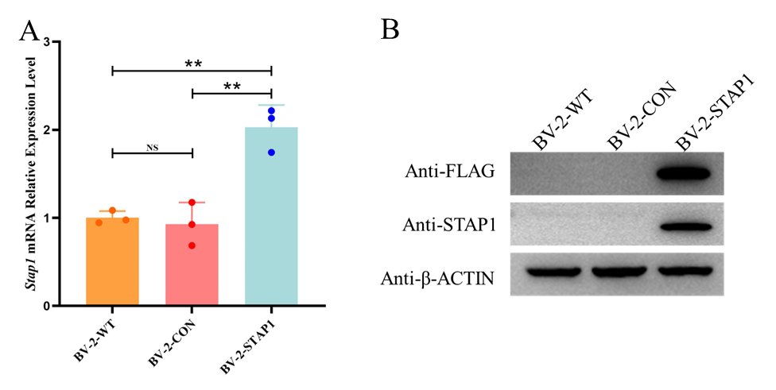
Supplementary Figure 4. Establishment of high STAP1 microglia models. Stap1 mRNA was higher in BV-2-STAP1 (A). STAP1 protein was higher in BV-2-STAP1 (B).

Target | Species | Forward Primer | Reverse Primer
STAP1 | Human | CGGTCAGGATACCGGGAGTA | GCTCAGTAAGGCATGTGAGGT
GAPDH | Human | GAAGGTGAAGGTCGGAGTC | GAAGATGGTGATGGGATTTC
Stap1 | Murine | GGAGGGGCTTCATTCTTACA | TGCCCAGGTAGAAGTGACA
Arg1 | Murine | AGGAAAGCTGGTCTGCTGGAA | AGATGCTTCCAACTGCCAGAC
Gapdh | Murine | TGACCTCAACTACATGGTCTACA | CTTCCCATTCTCGGCCTTG
Supplementary Table 2. Primers of qRT-PCR

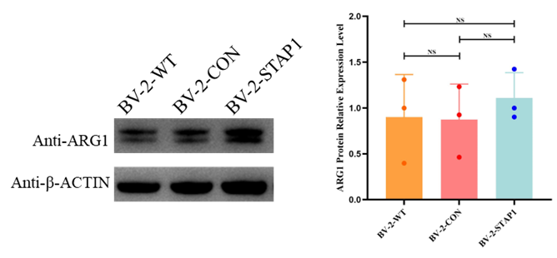
Supplementary Figure 5. ARG1 expression level. ARG1 was increased slightly in BV-2-STAP1 with no significance.

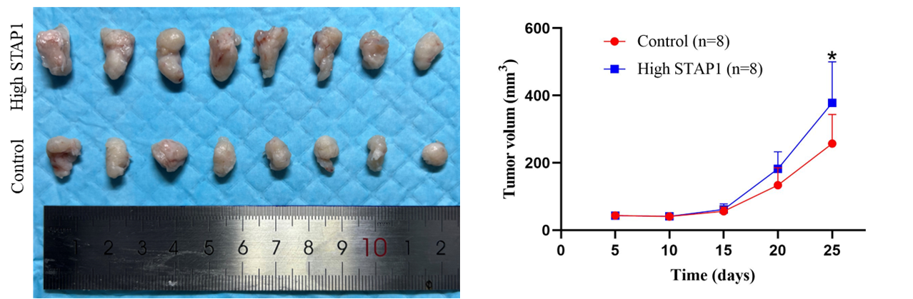
Supplementary Figure 6. STAP1 promotes growth of glioma in subcutaneous glioma mouse models. Subcutaneous glioma grew faster in high STAP1 group especially on day 25.

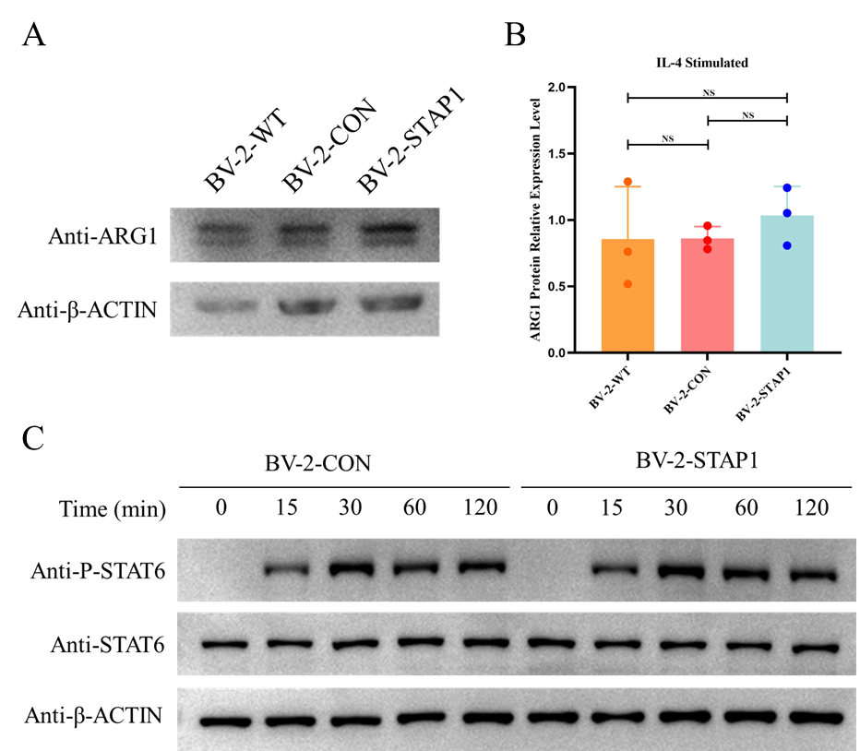
Supplementary Figure 7. ARG1 expression level after Il-4 stimulation. No differences of ARG1 protein level could be found after IL-4 stimulation (A, B). No differences of phosphorylated STAT6 level could be found after IL-4 stimulation (C).

