Supplementary Information (SI) for
Role of iron species in the production of iron-modified hydrochar for arsenic removal via hydrothermal carbonization
Yiwei Zhang^{1,2}, Dandan Chen²,*, Yutong Xing², Bangwei Liu², Yan Zhou², Ping Lu².
1. School of Environment, Nanjing Normal University, Nanjing 210023, China;
2. School of Energy and Mechanical Engineering, Nanjing Normal University, Nanjing 210023, China;
*Corresponding Author: Tel/Fax: +86–25–85481085; E-mail: dandanchen@njnu.edu.cn

The Supporting Information includes:
0 Texts
3 Tables
5 Figures

References
Table S1. Preparation conditions of iron-modified hydrochar
Iron species | Preparation Time  (min) | Iron concentration in solution  (mol/L) | the mass ratio of iron in the feed iron solution (%)
FeCl₃·6H₂O | 120 | 0.107 | 6
FeSO₄·7H₂O | 120 | 0.107 | 6
Fe(NO₃)₃·9H₂O | 60, 120, 240, 480 | 0.0357, 0.0714, 0.107, 0.143 | 2,4,6,8

Table S2. Pore structure of modified hydrochar prepared under different conditions
Sample | BET surface area /m²/g | Average pore diameter /nm | Pore volume/ 10⁻²cc/g
PWC | 0.91 | - | -
6%FN@HC | 7.107 | 7.8 | 1.386
6%FS@SO₄ | 2.445 | 6.3 | 0.386
6%FC@Cl₃ | 1.726 | 3.1 | 0.133
2% FN@HC | 7.151 | 10.5 | 1.868
4% FN@HC | 5.653 | 9.2 | 1.293
6% FN@HC | 7.107 | 7.8 | 1.386
8% FN@HC | 10.335 | 7.5 | 1.941
6% FN@HC-60 | 6.995 | 8.5 | 1.480
6% FN@HC | 7.107 | 7.8 | 1.386
6% FN@HC-240 | 17.898 | 10.7 | 4.767
6% FN@HC-480 | 29.825 | 9.57 | 7.139
Table S3. Kinetic parameters of As (Ⅲ) and As (Ⅴ) adsorption by iron-modified hydrochars
Heavy metal | Pseudo-first-order |  |  | Pseudo-second-order
Heavy metal | Q_{e}(mg/g) | k₁(1/h) | R² | Q_{e}(mg/g) | k₁(g/mg h) | R²
As(Ⅲ) | 2.385 | 6.24 | 0.905 | 2.568 | 0.39 | 0.958
As(Ⅴ) | 7.03 | 0.176 | 0.974 | 8.5 | 0.02316 | 0.982
Table S4. Isotherm model parameters of As (Ⅲ) and As (Ⅴ) adsorption by iron-modified hydrochars
Heavy metal | Q_{m}(mg/g) | Langmuir |  | Freundlich
Heavy metal | Q_{m}(mg/g) | K_{L}(L/mg) | R² | n | K_{F} | R²
As(Ⅲ) | 5.15 | 0.055 | 0.981 | 2.568 | 0.39 | 0.985
As(Ⅴ) | 11.19 | 0.045 | 0.957 | 8.5 | 0.02316 | 0.983

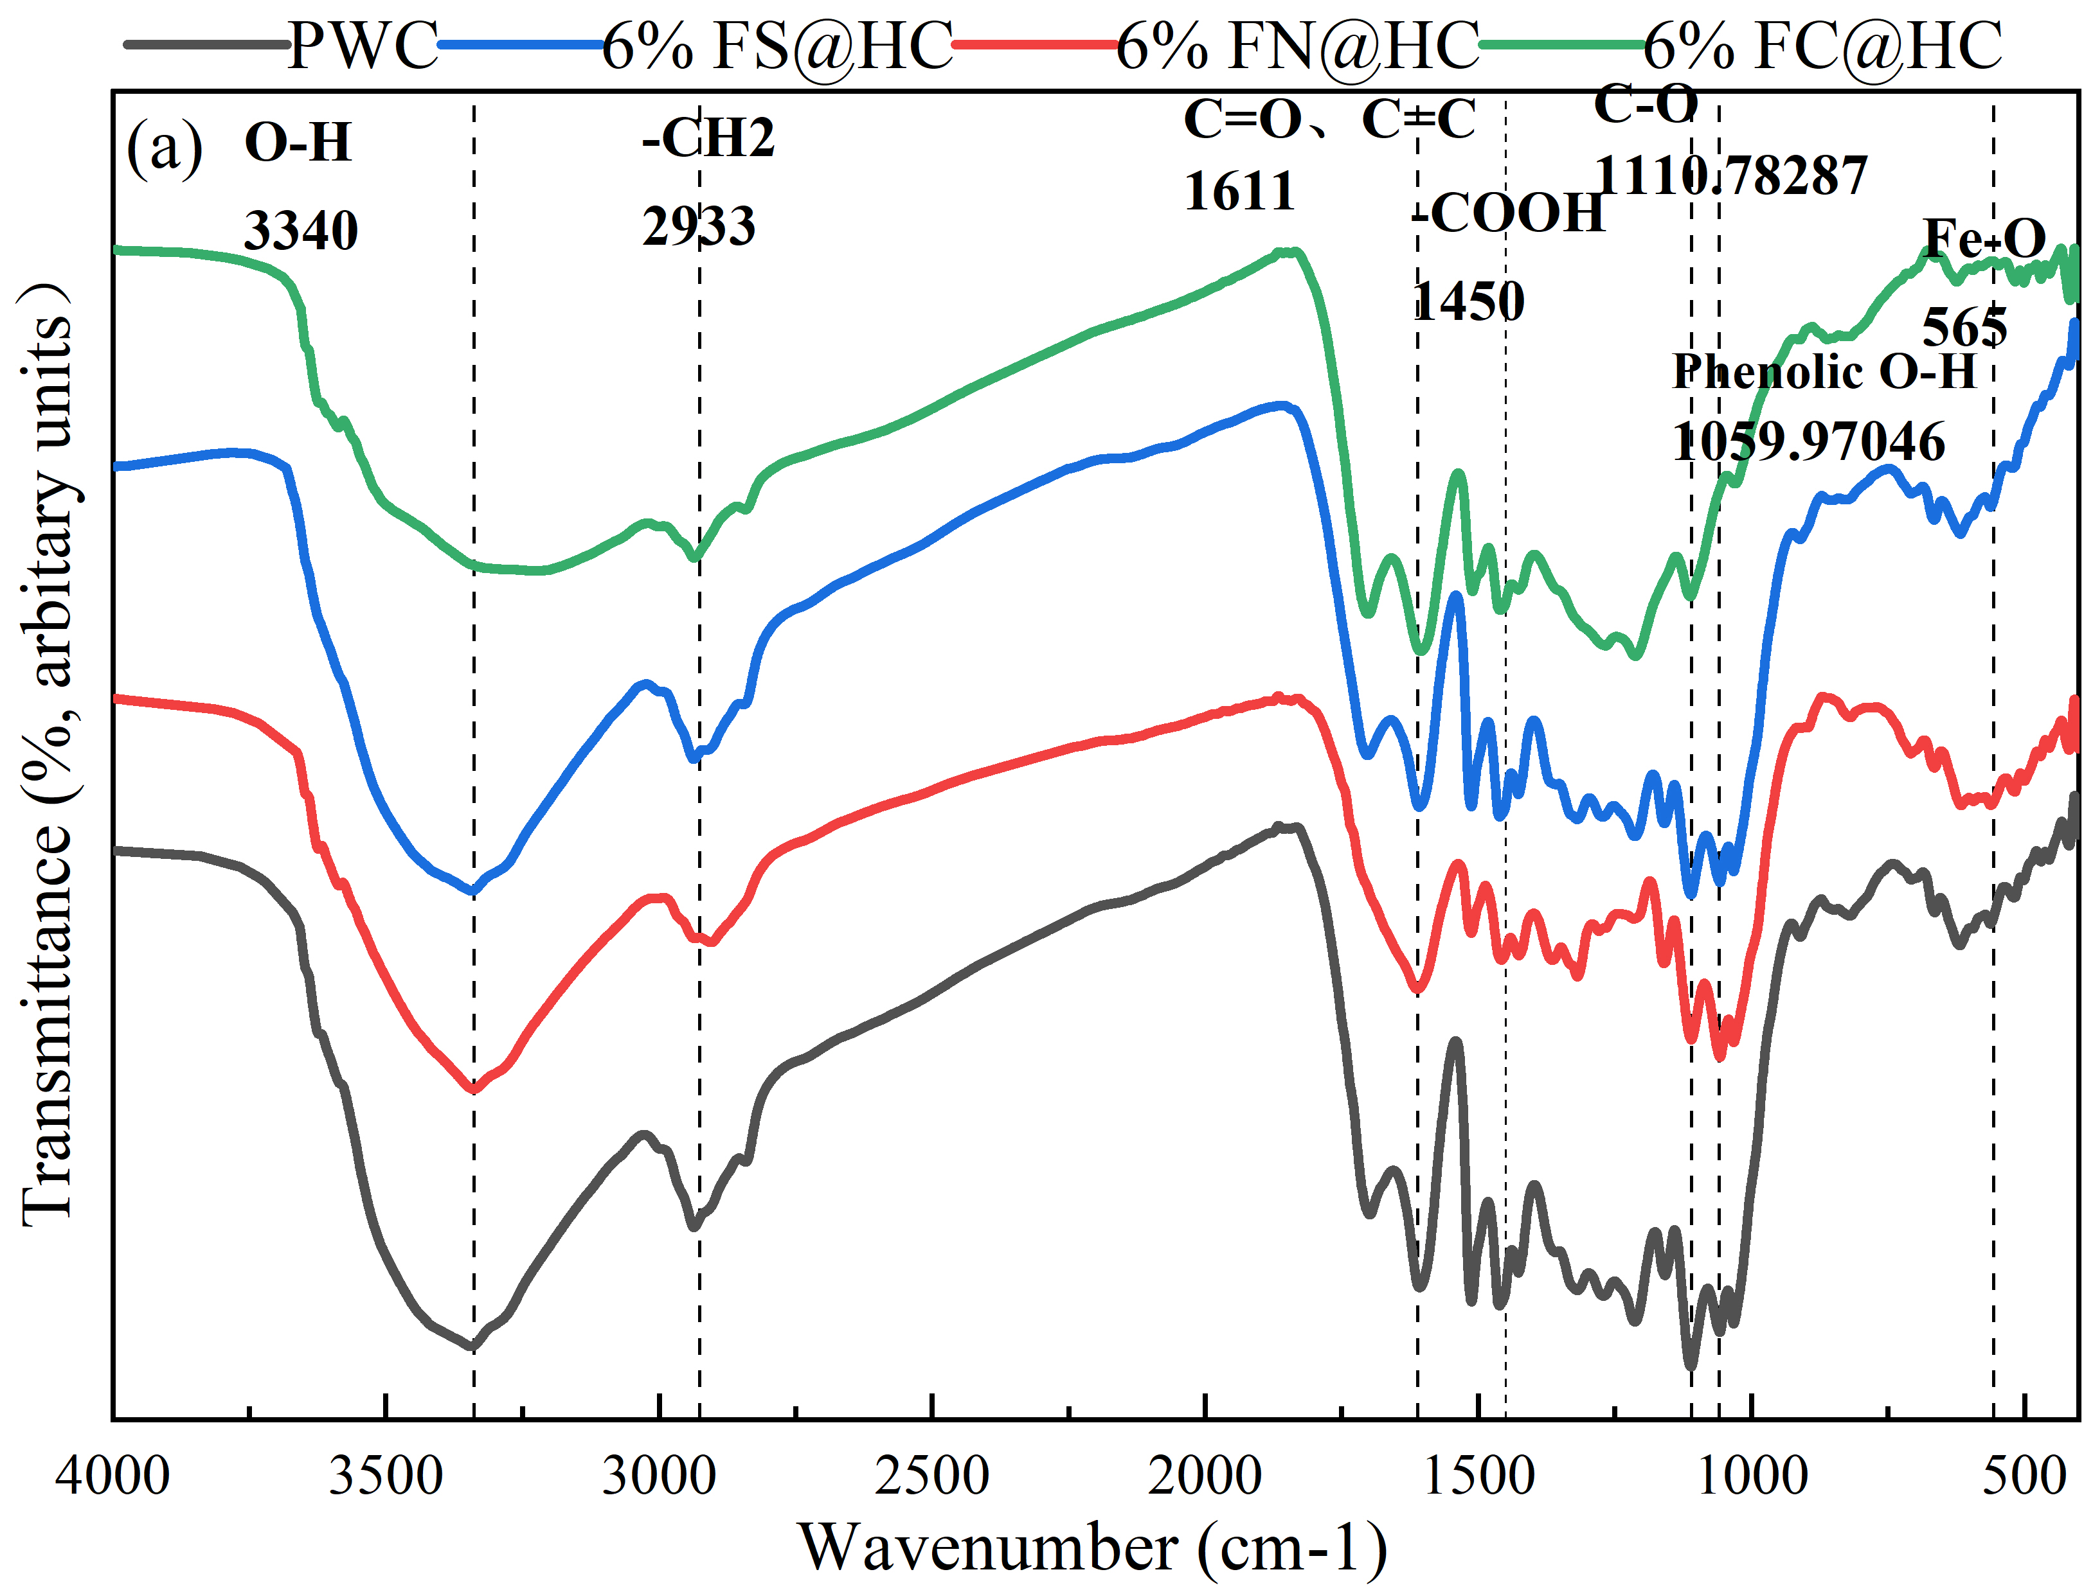
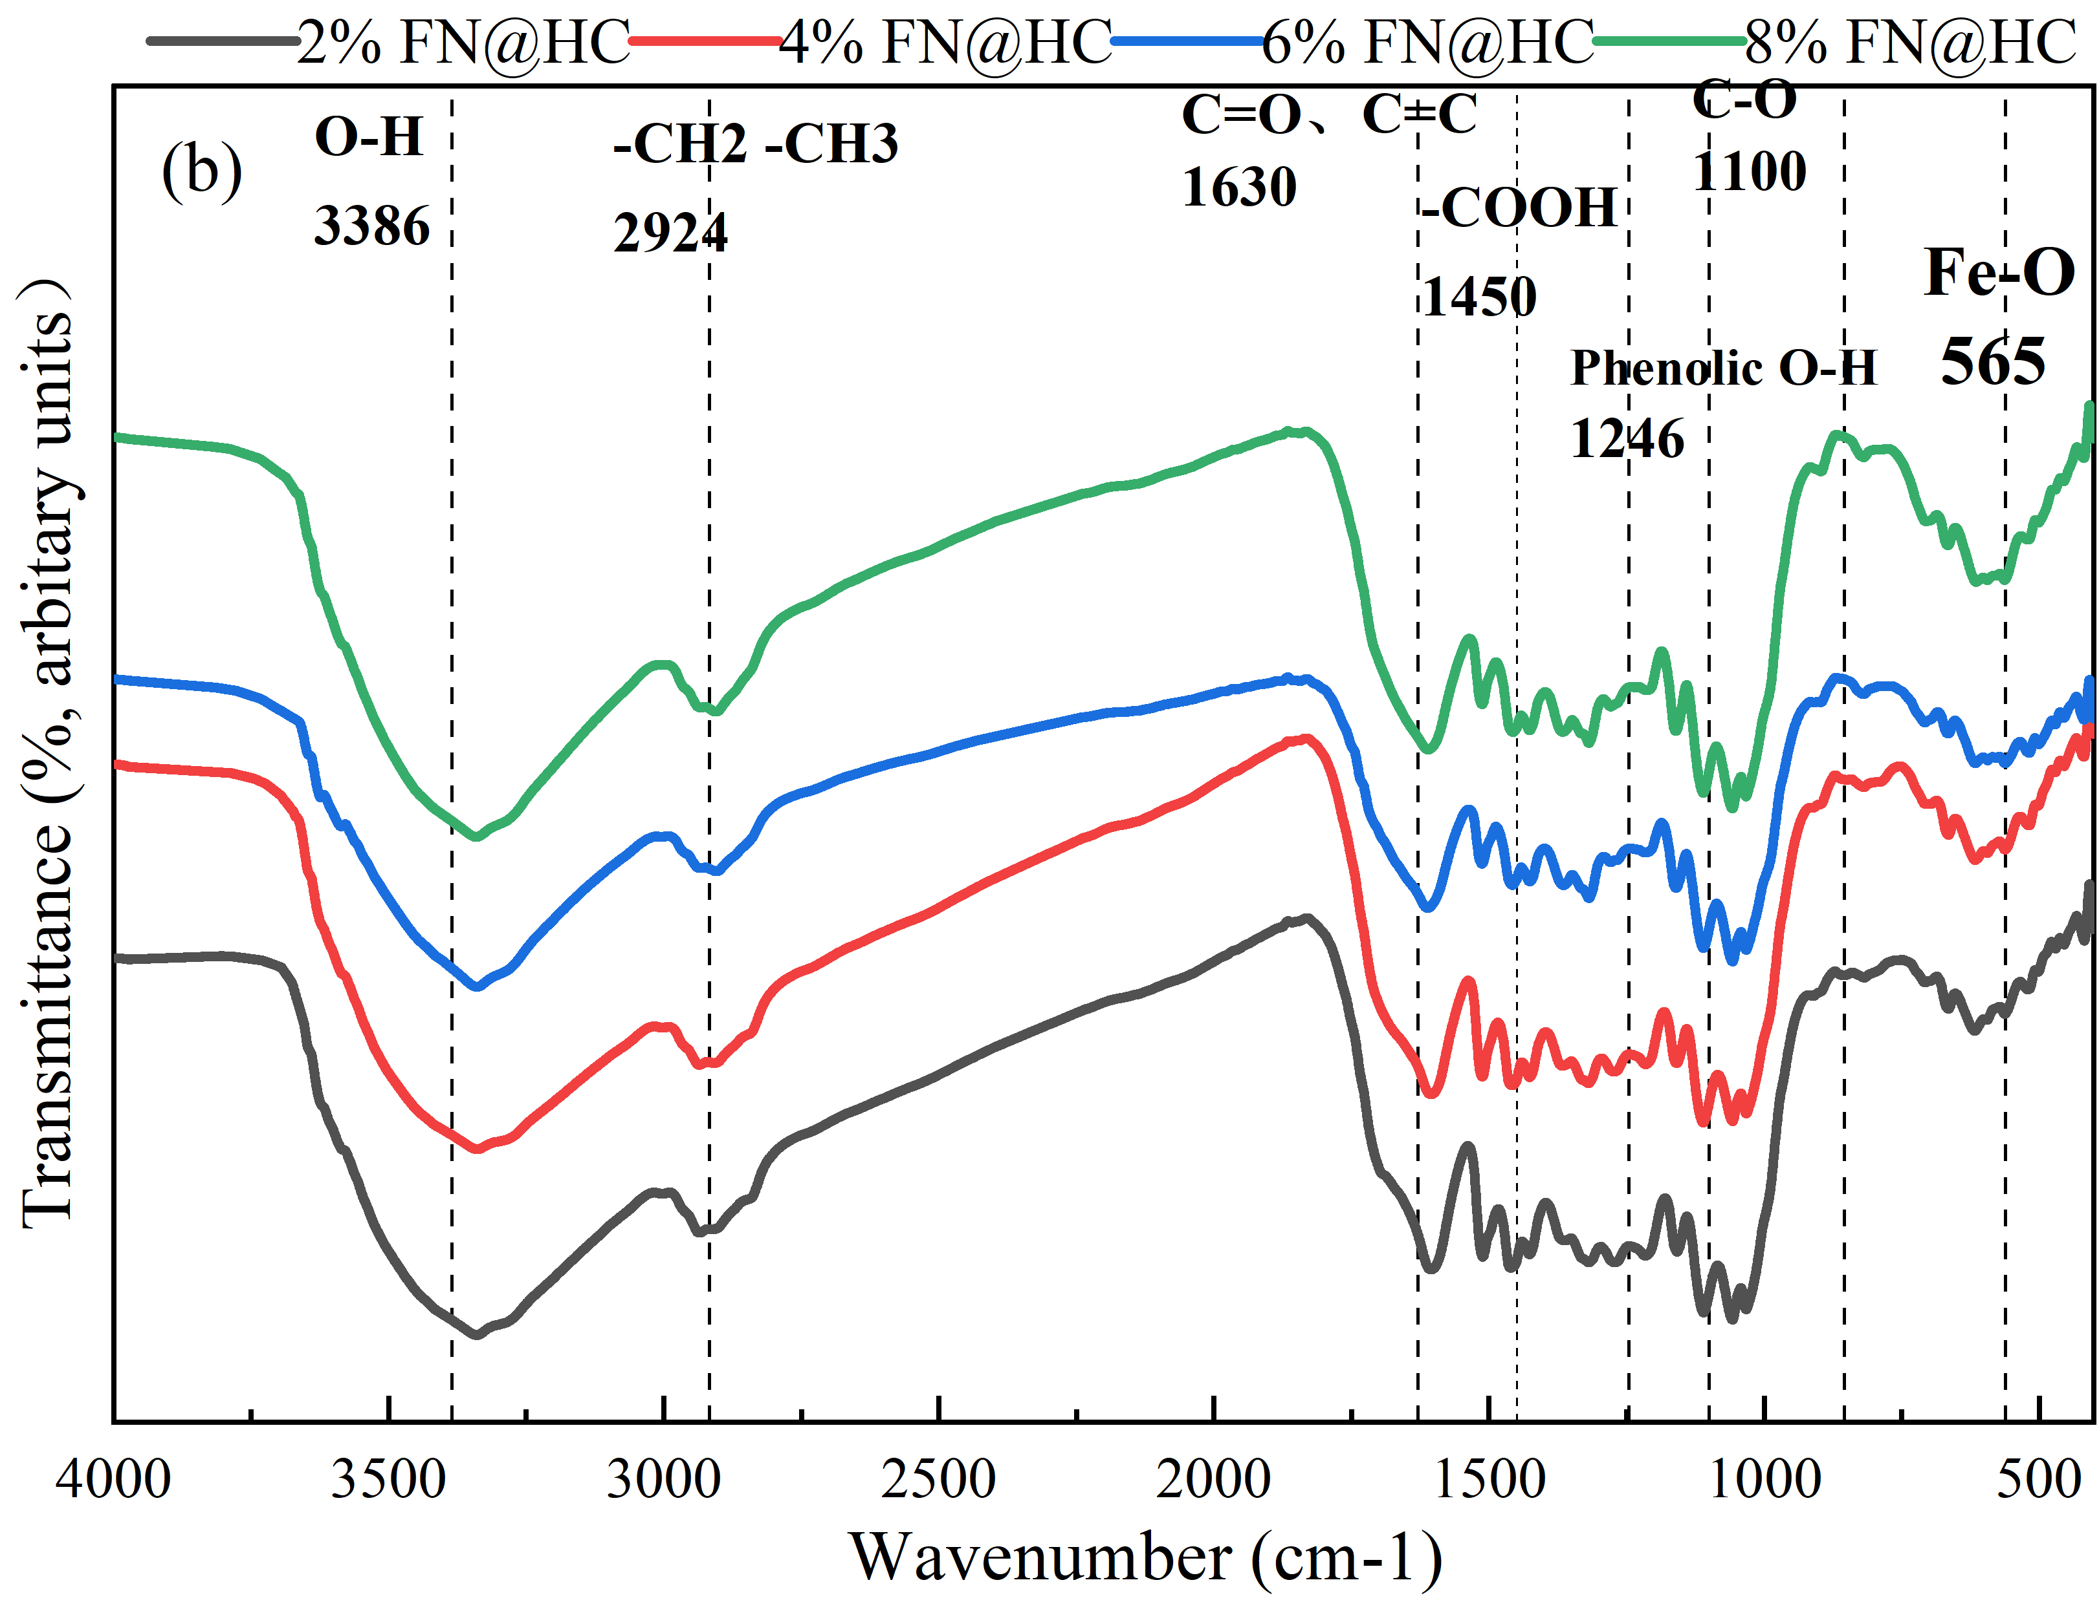
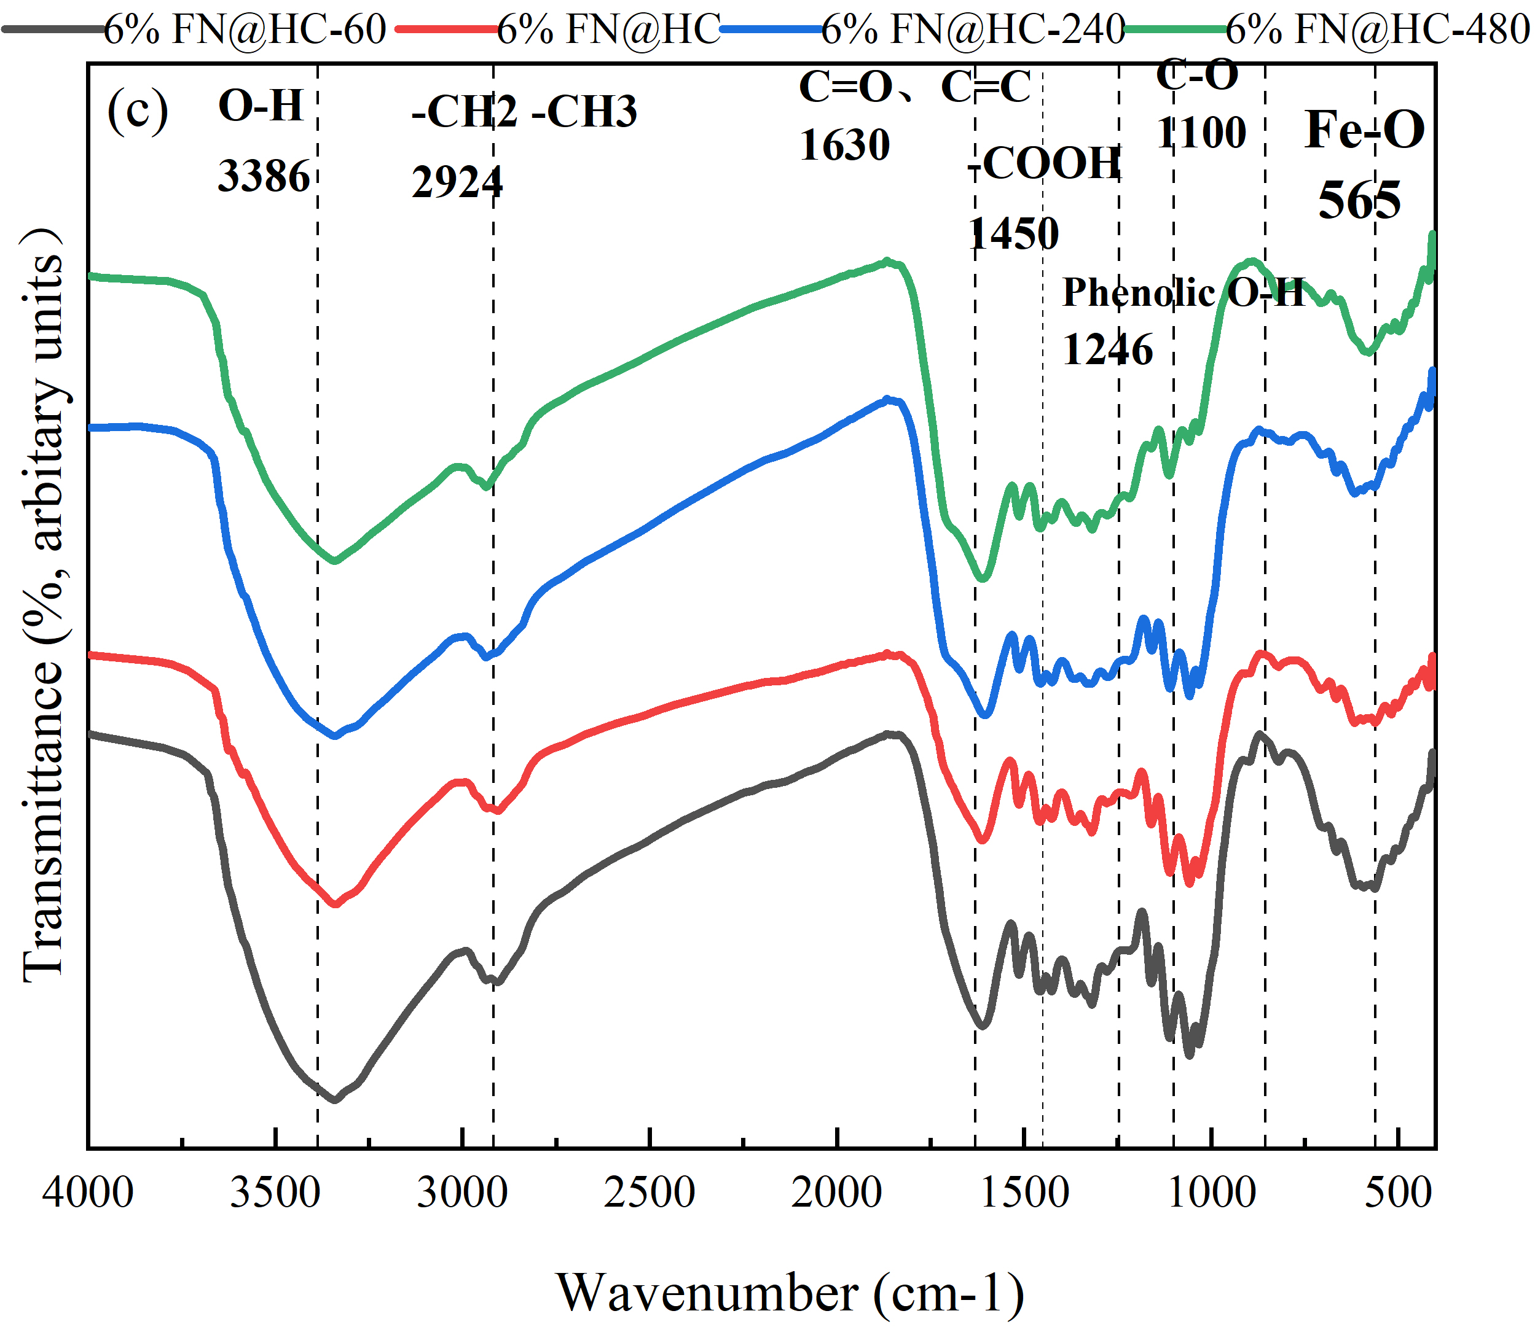
Fig. S1. FTIR spectra of modified hydrochar prepared with the (a)different iron salts, (b) preparation time and (c) iron dosage on the FTIR spectrum of iron modified hydrochars
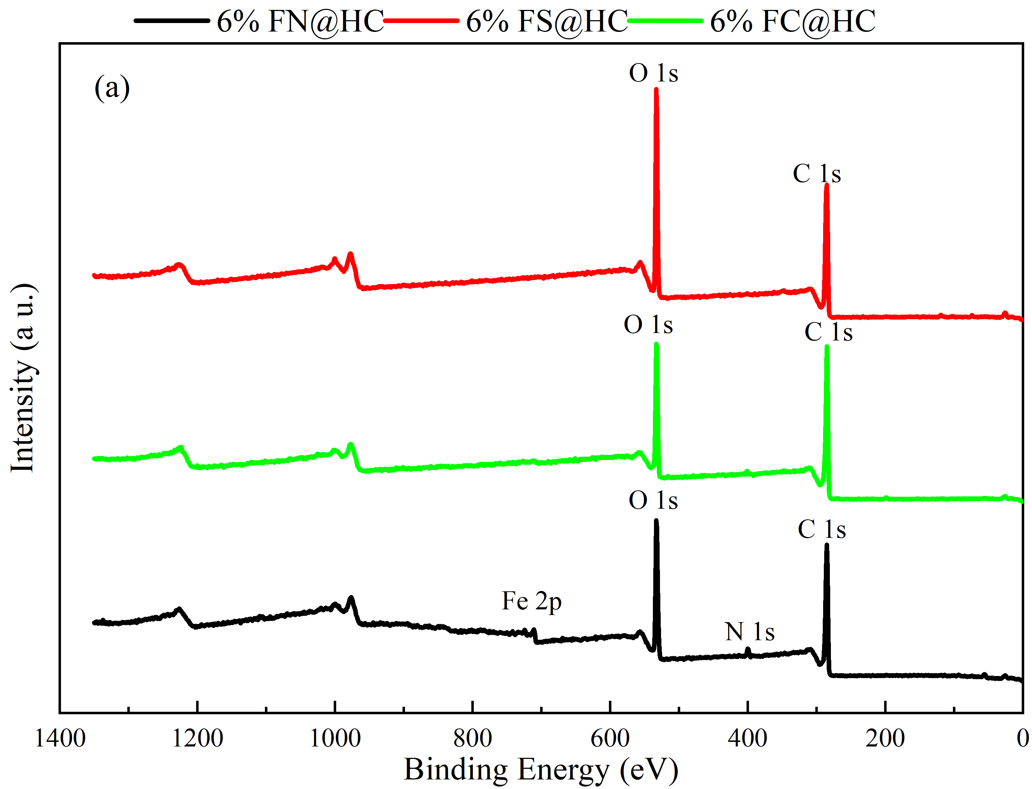 | 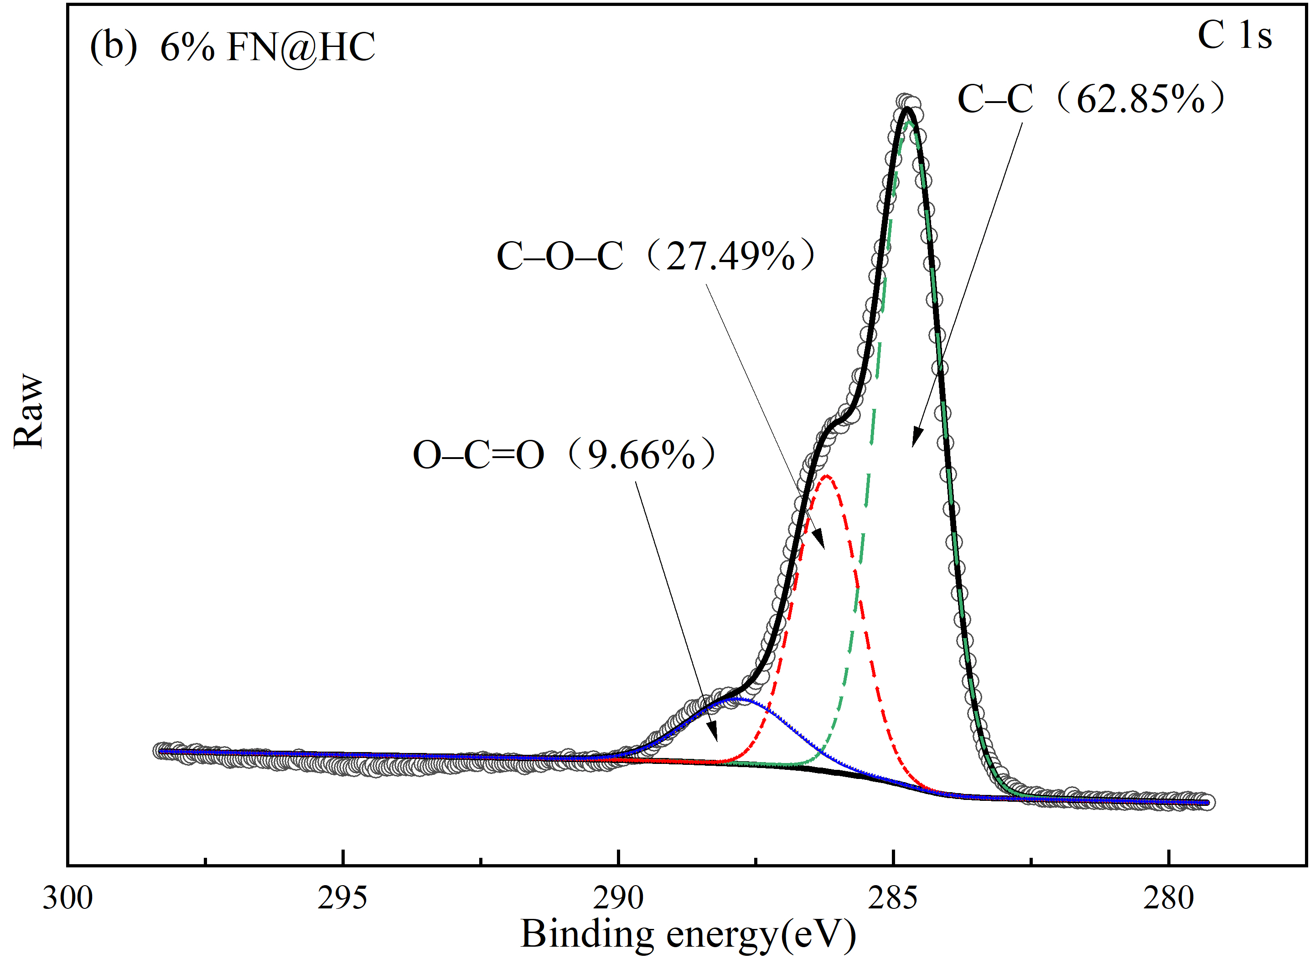
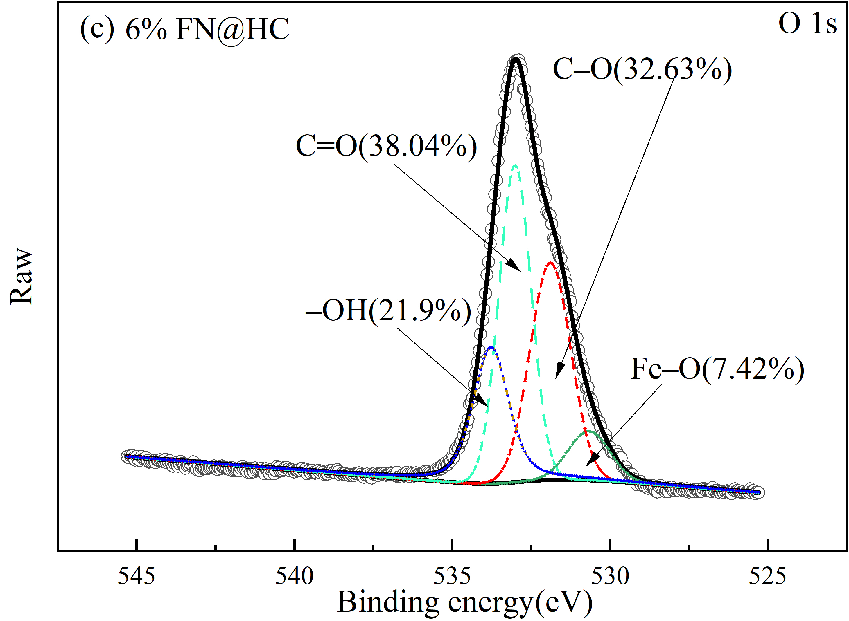 | 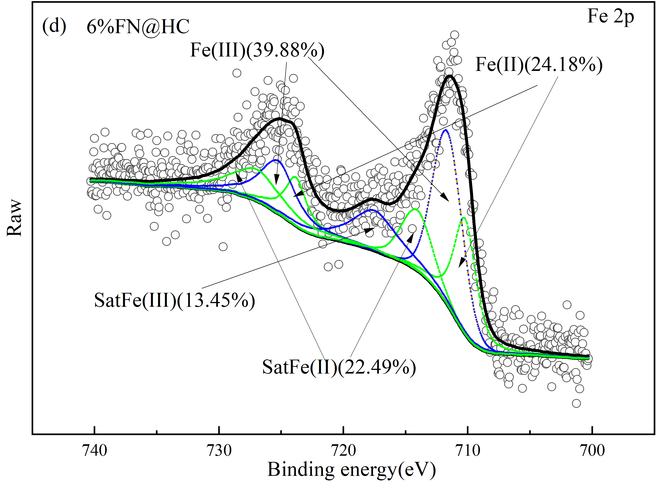
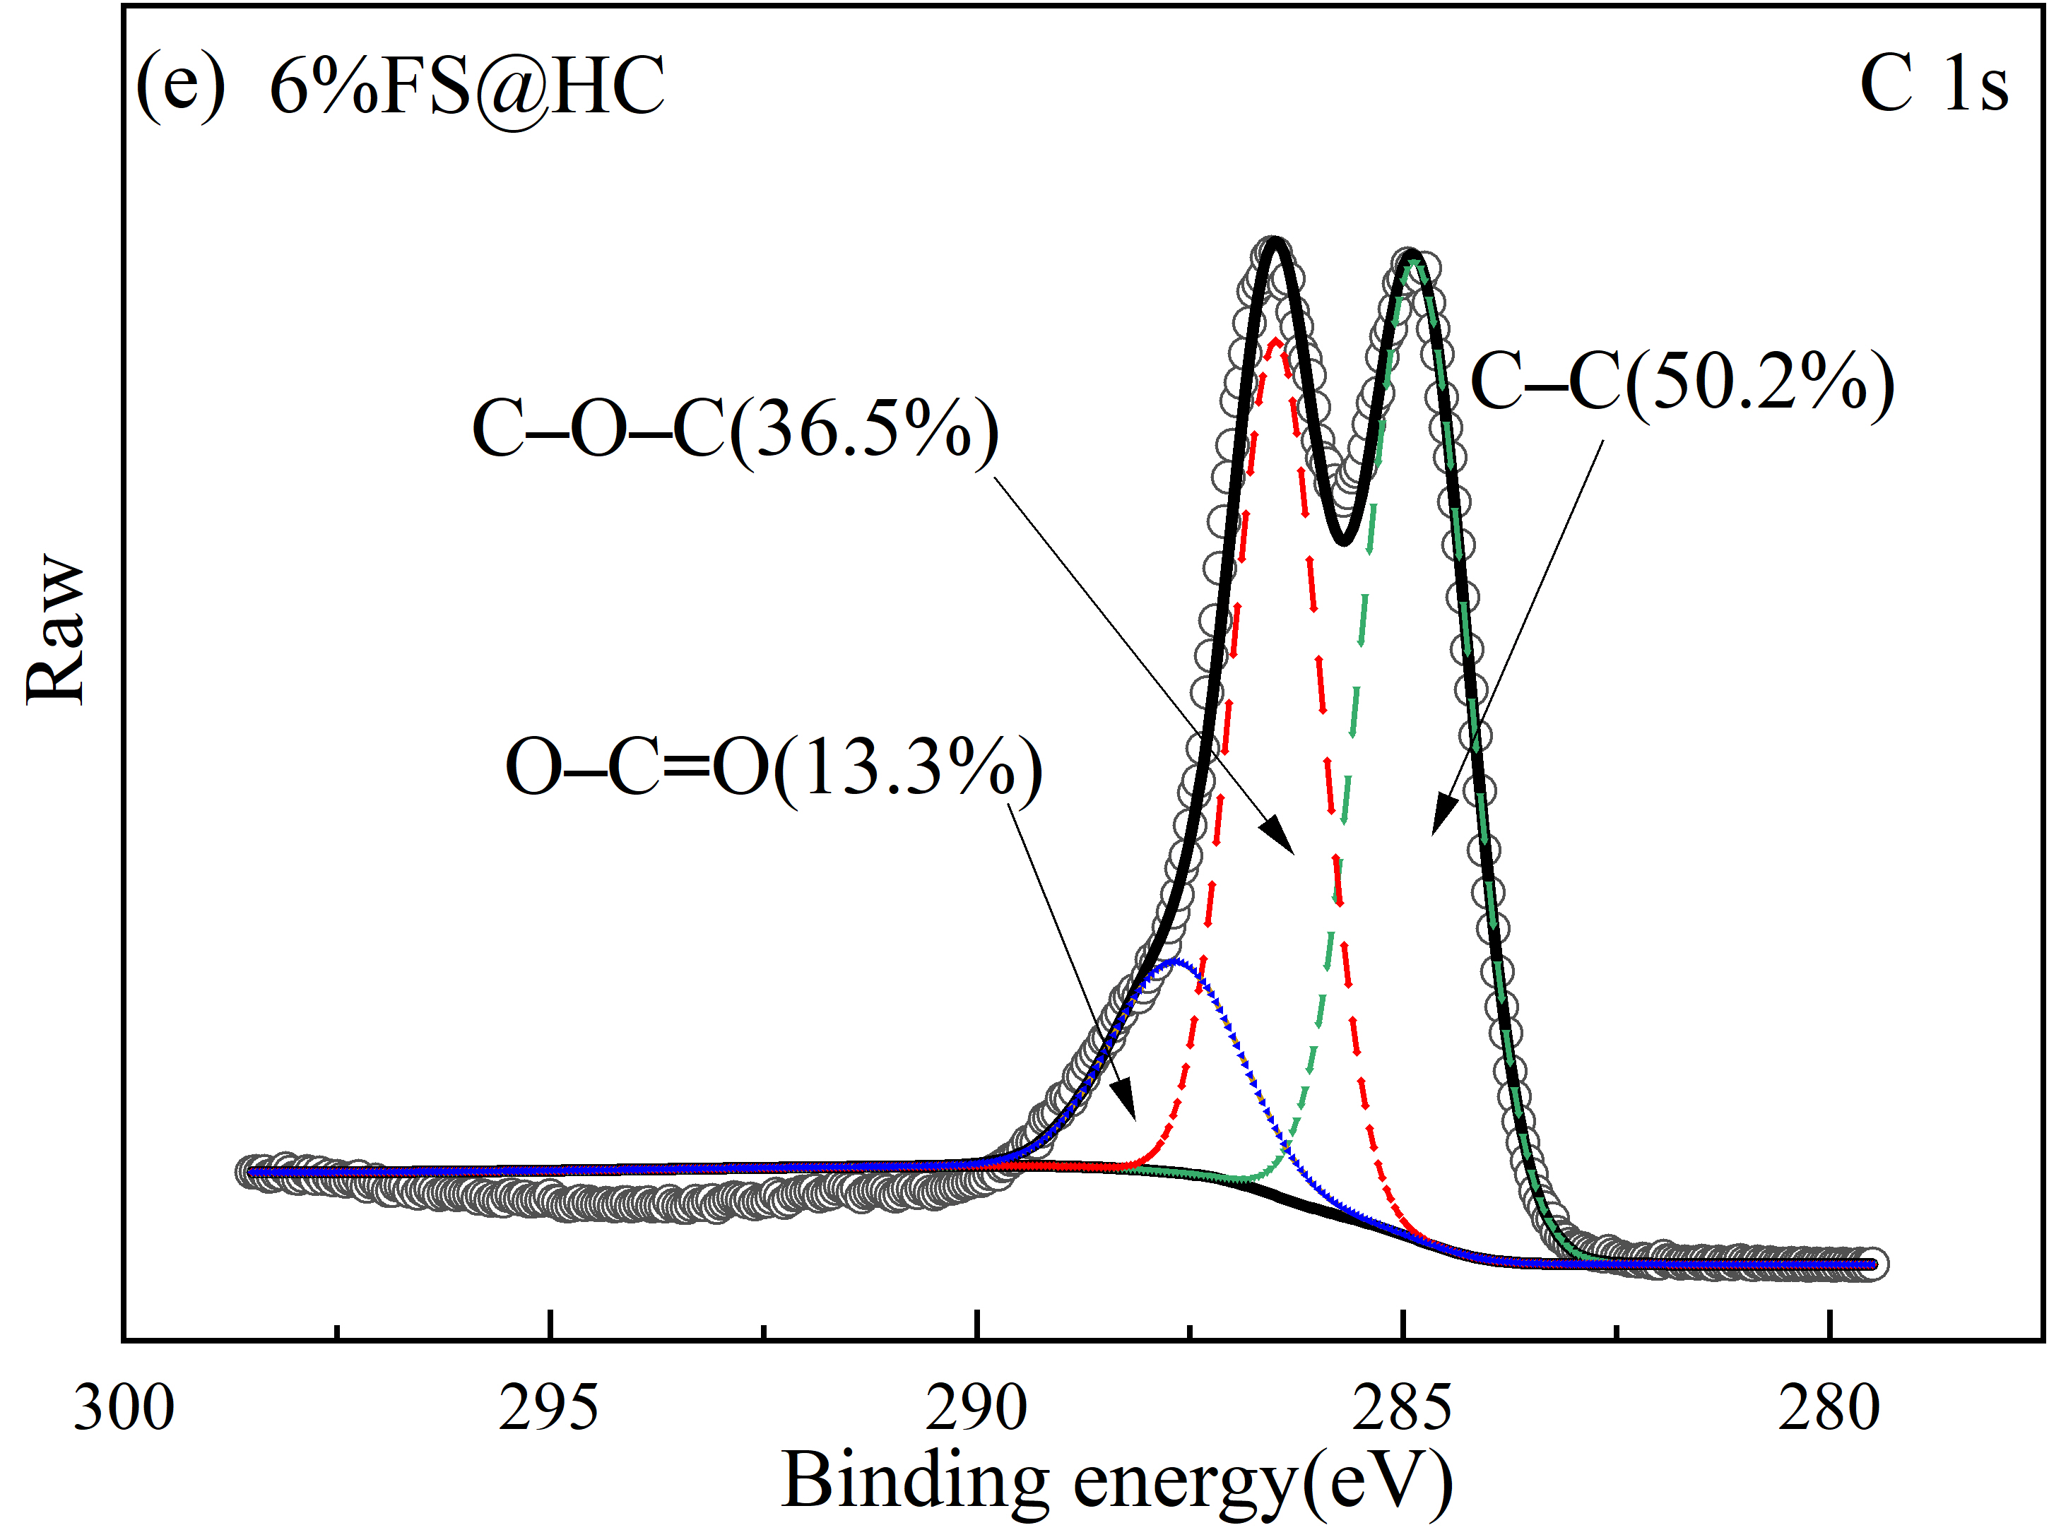 | 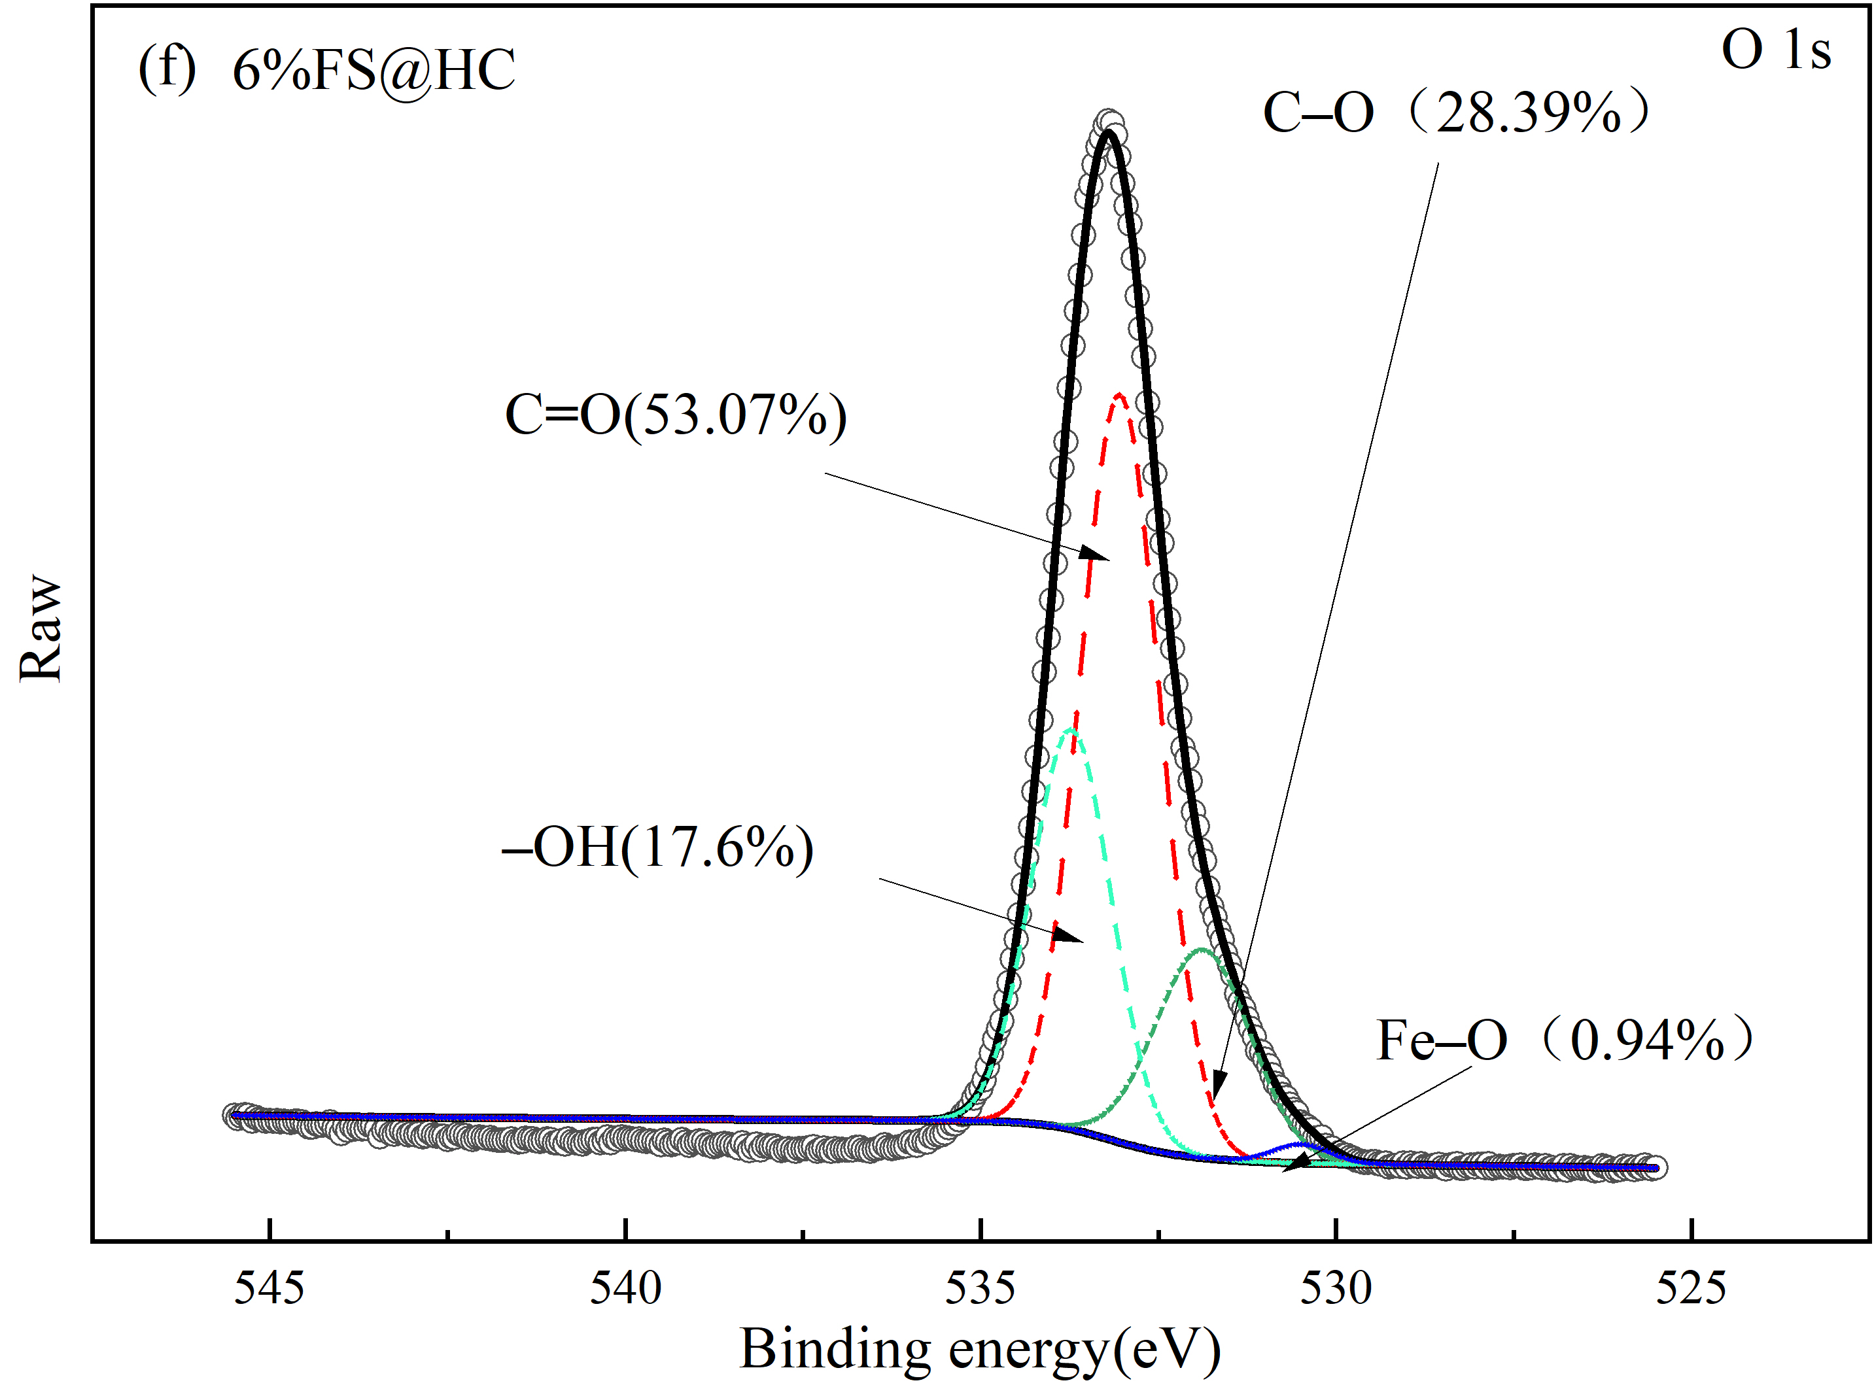
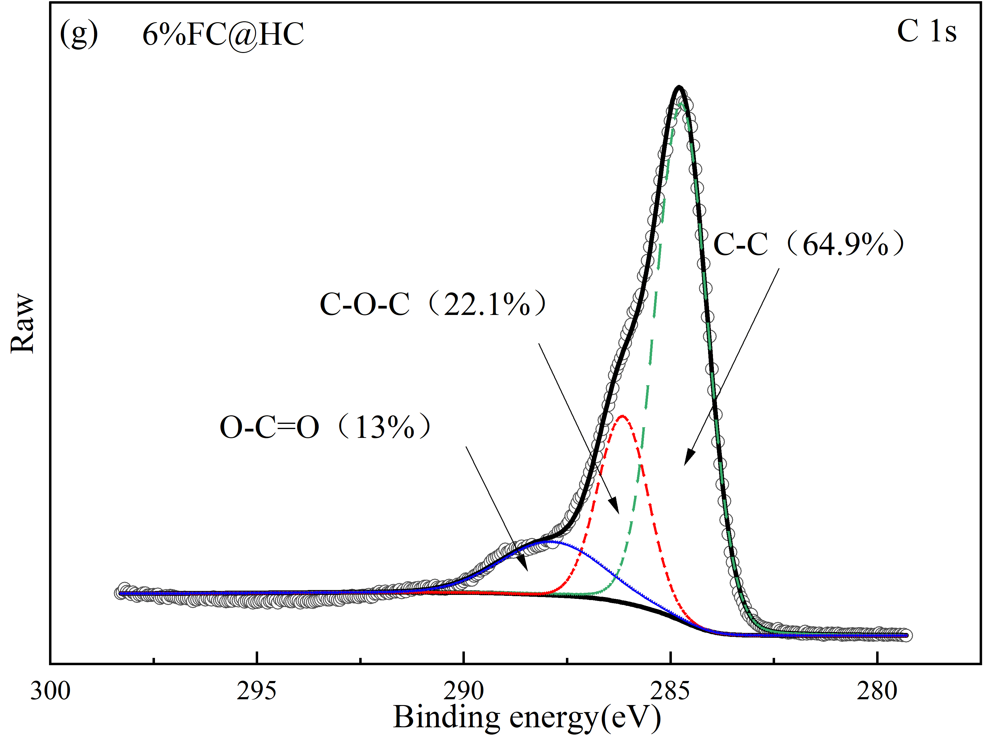 | 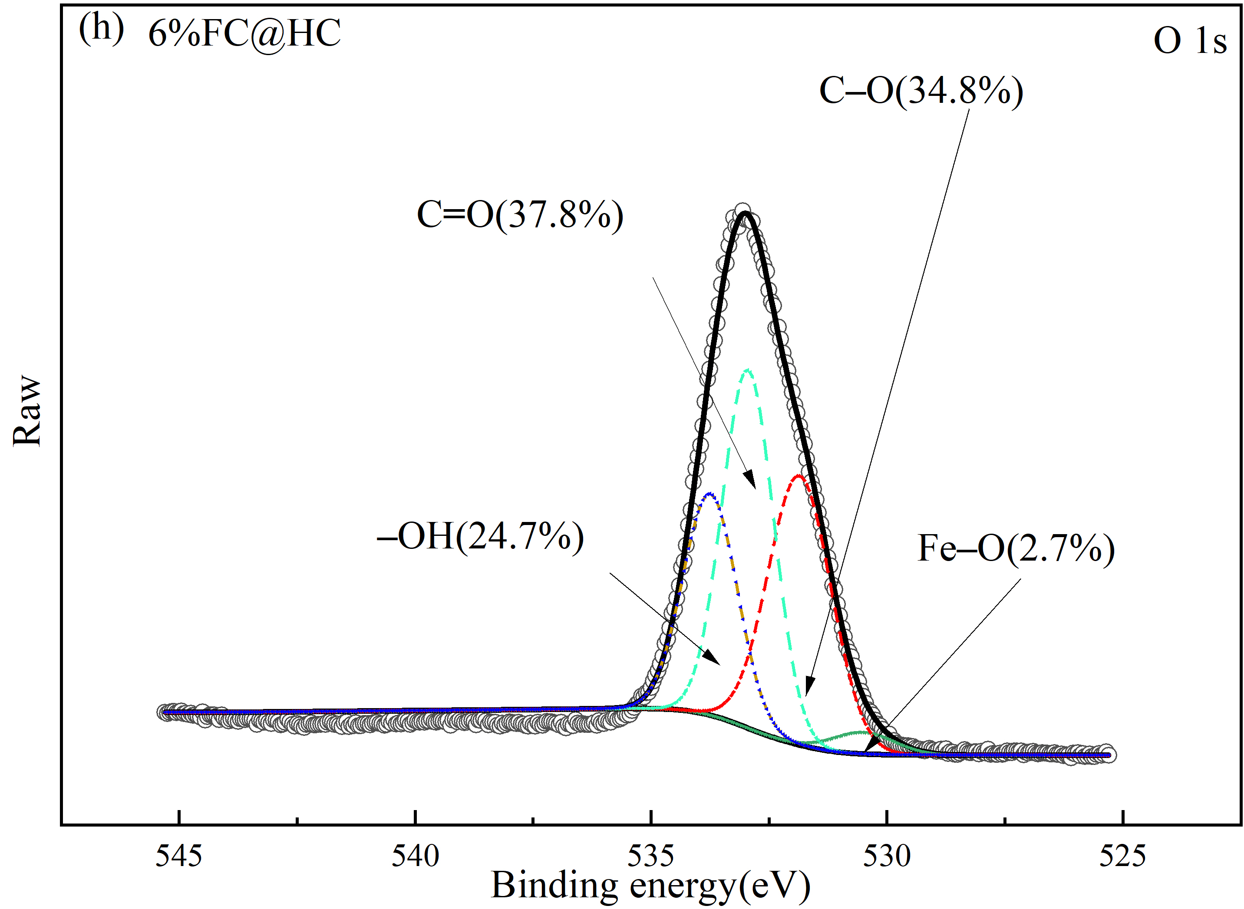
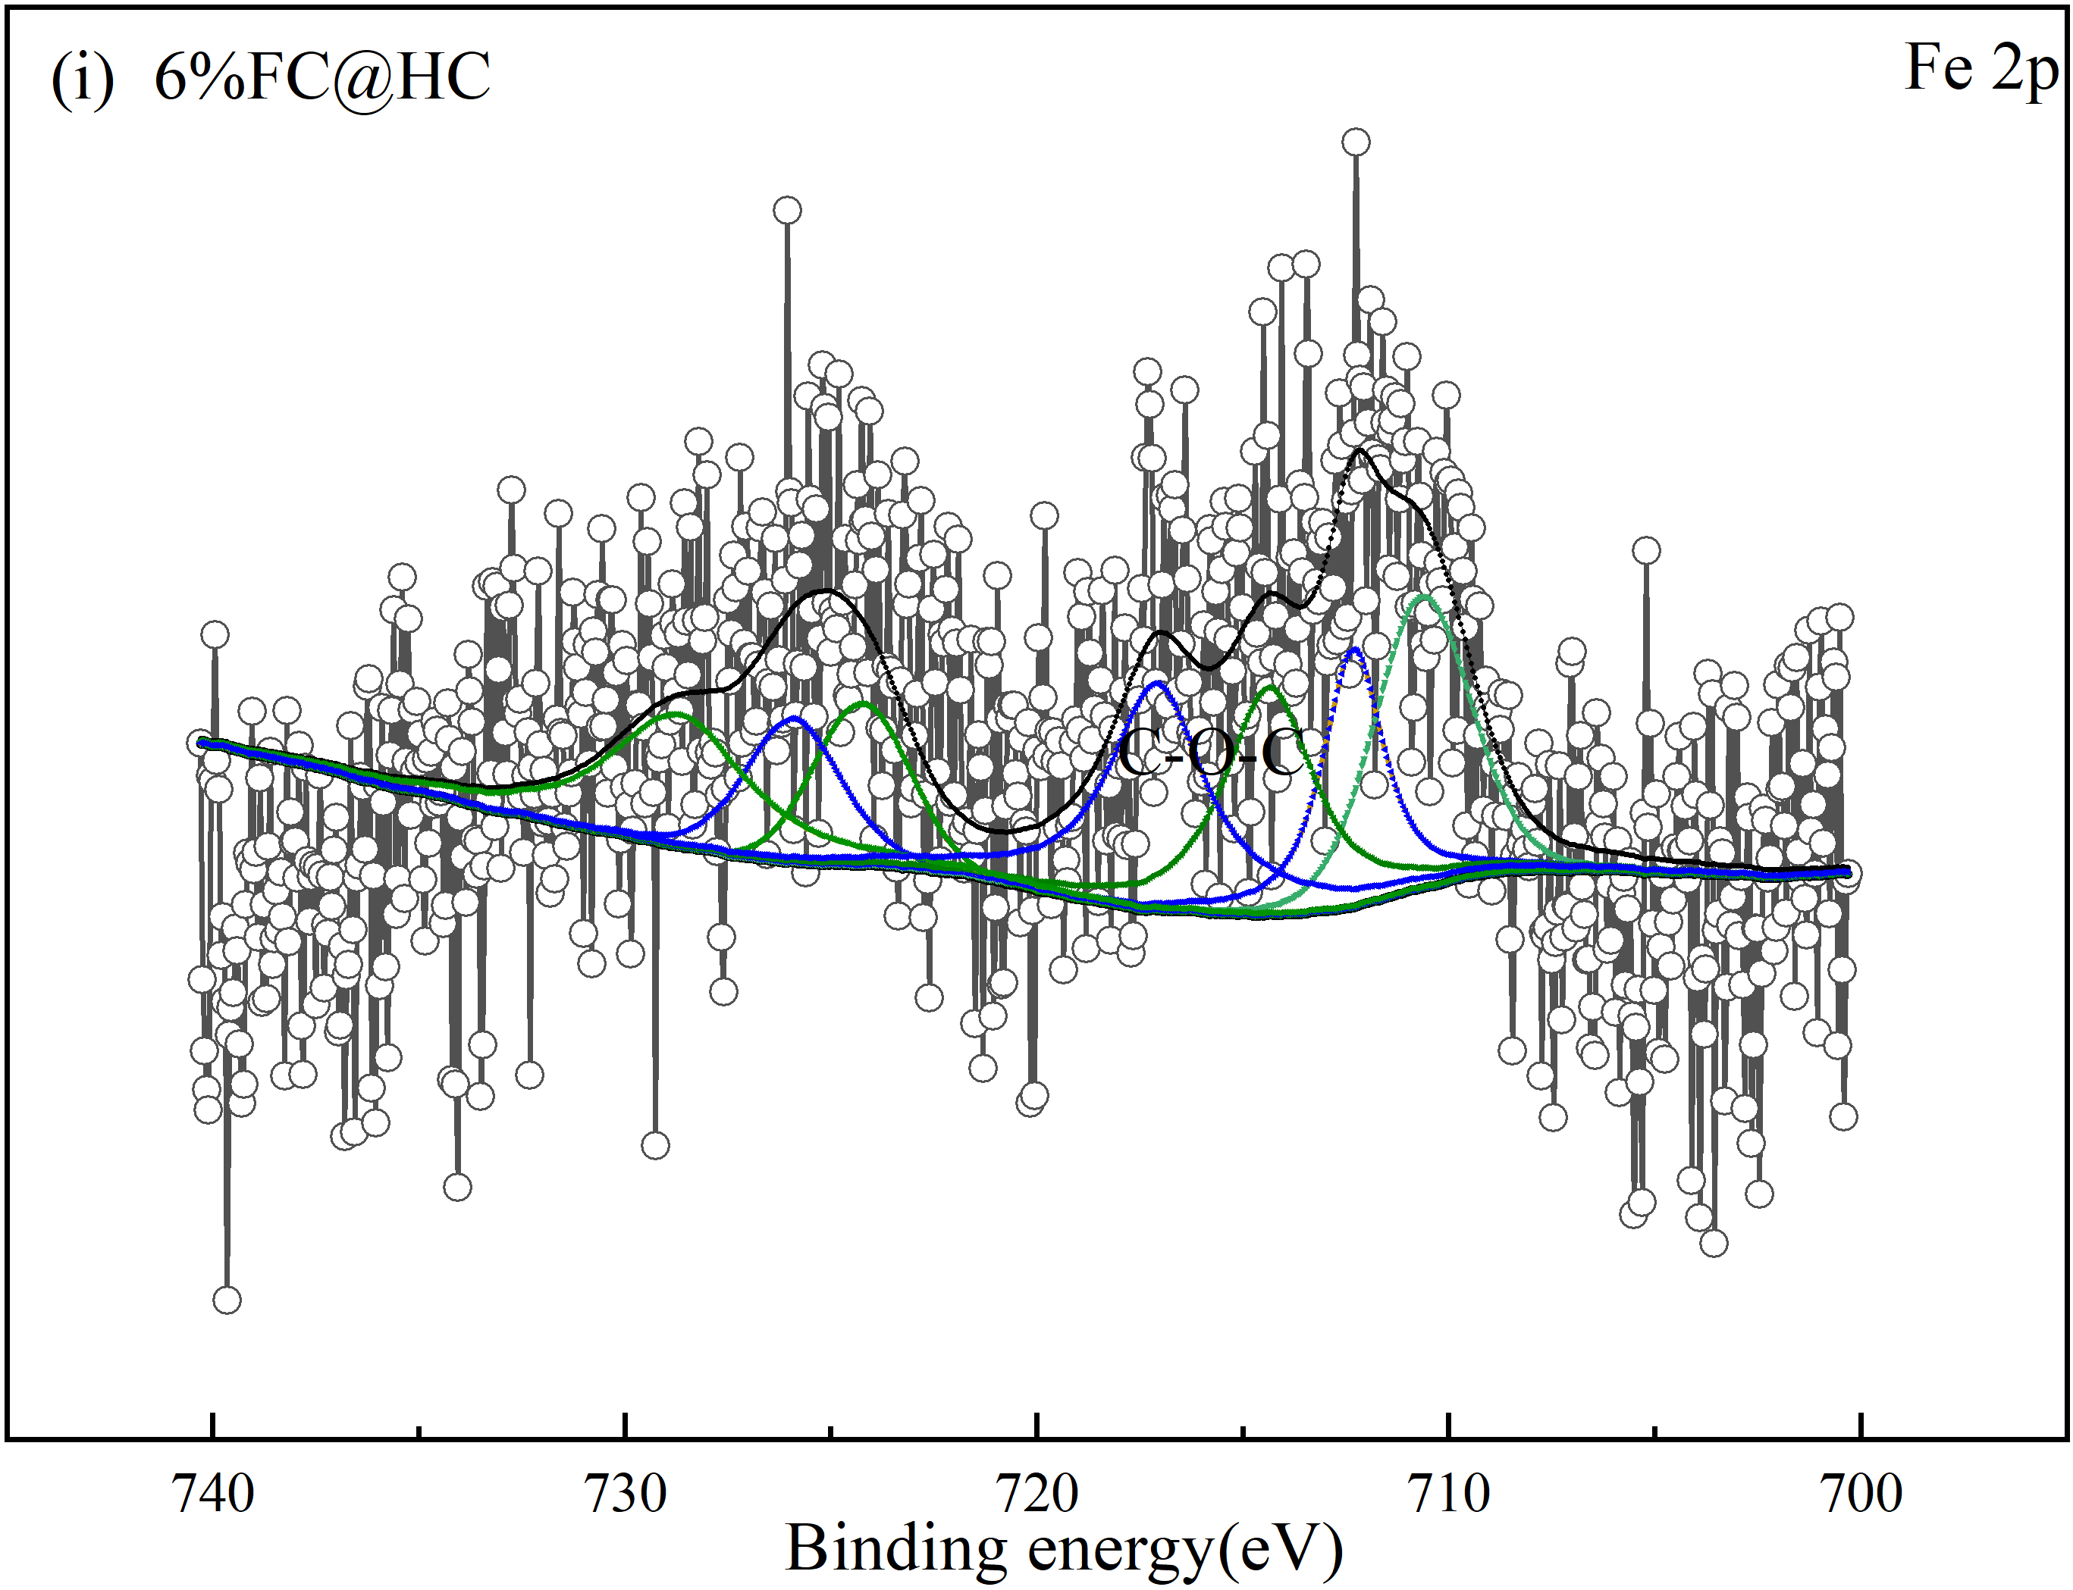
Fig. S2. XPS Spectra of hydrochars modified by different iron specie

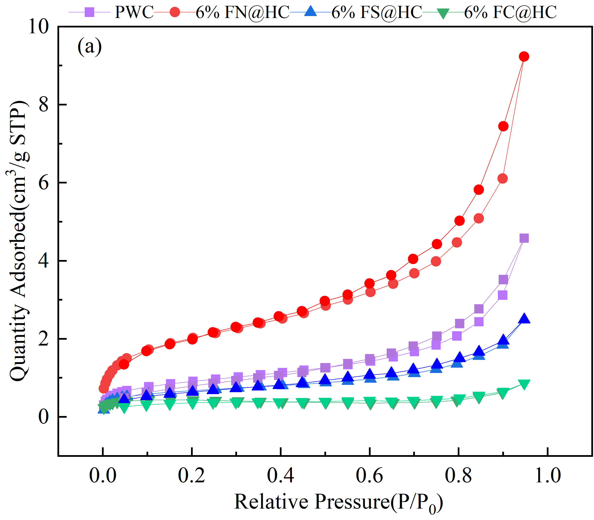 | 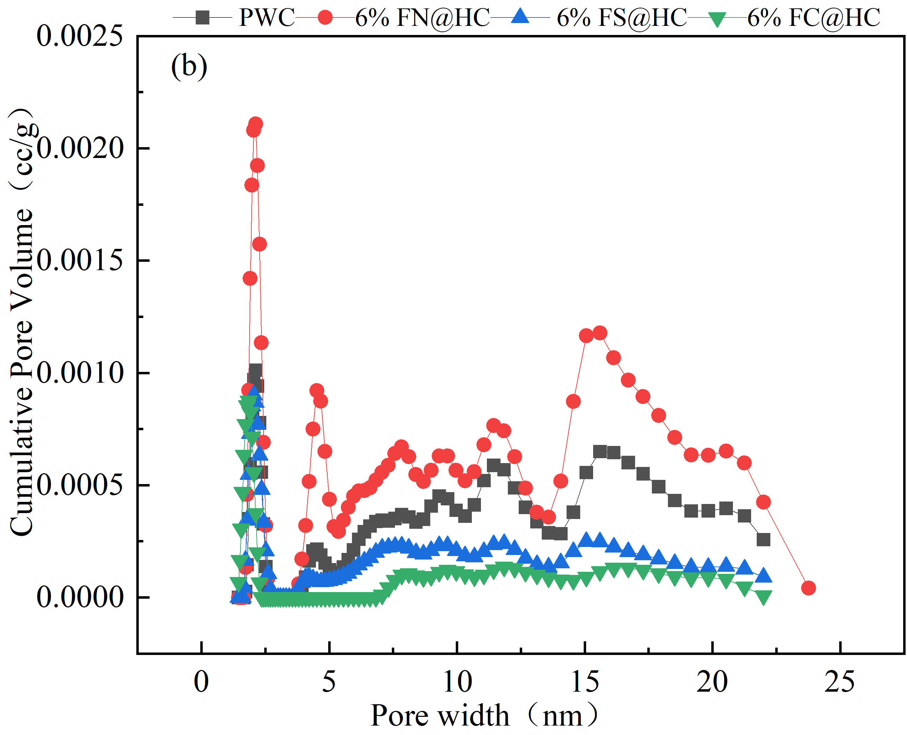
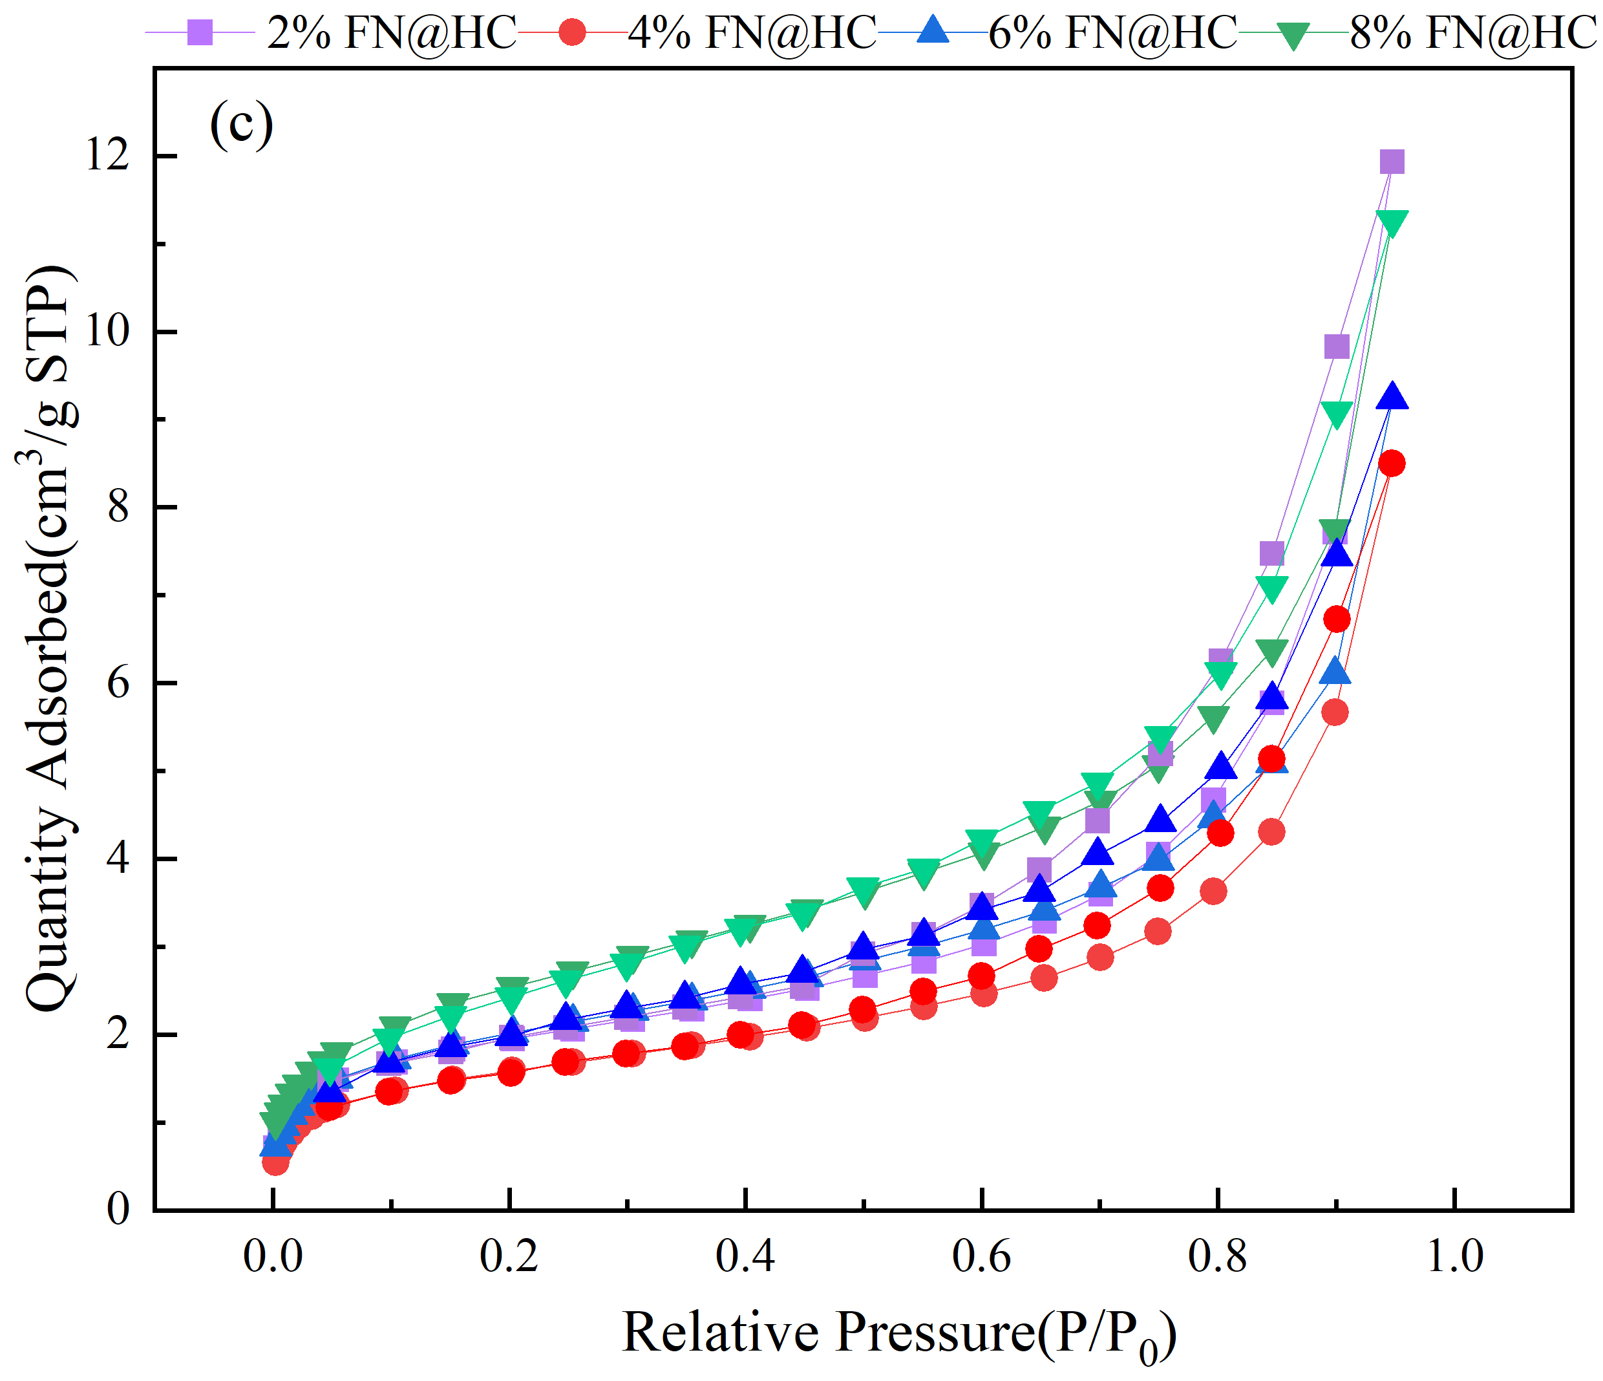 | 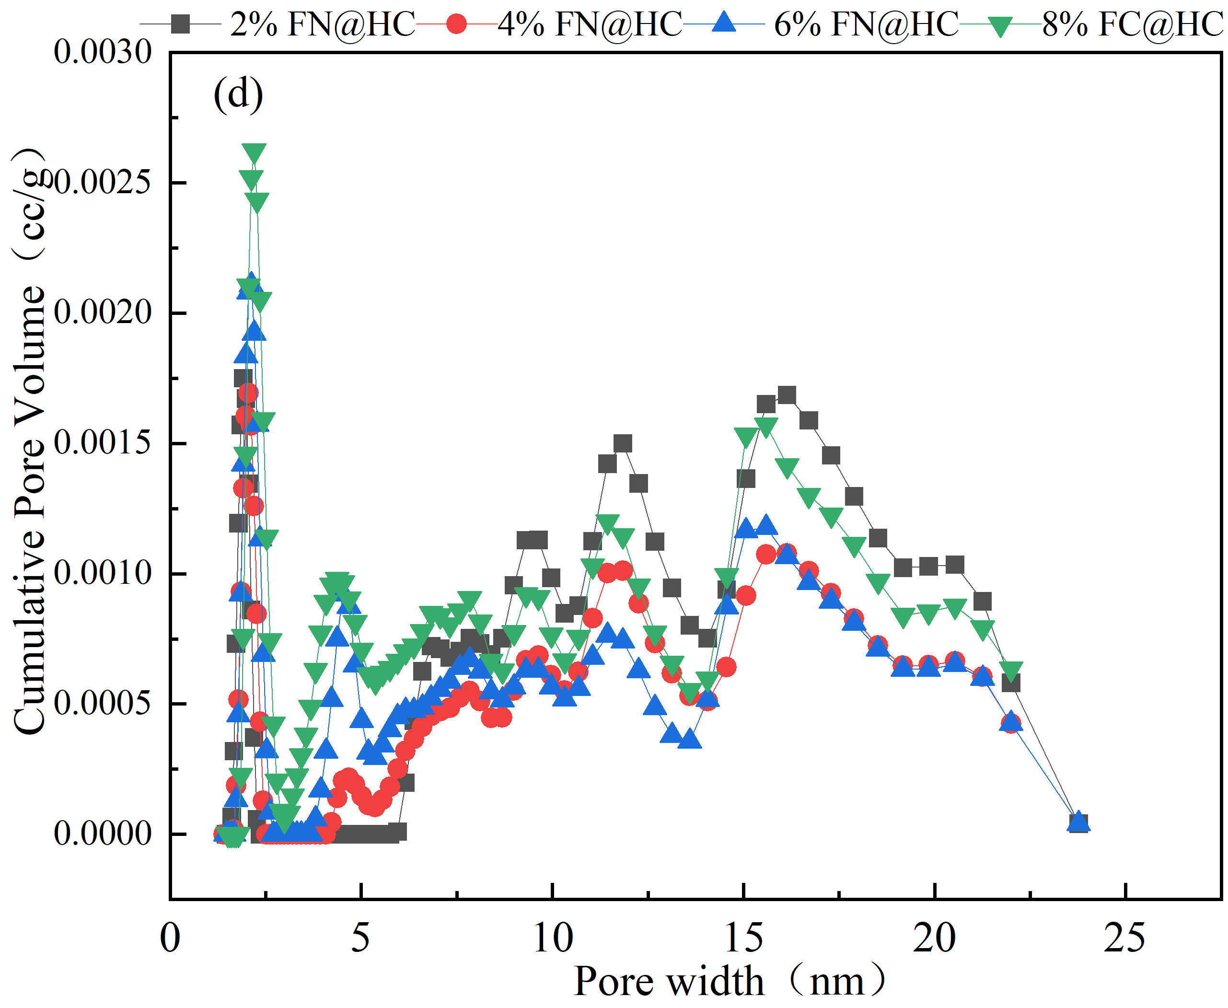
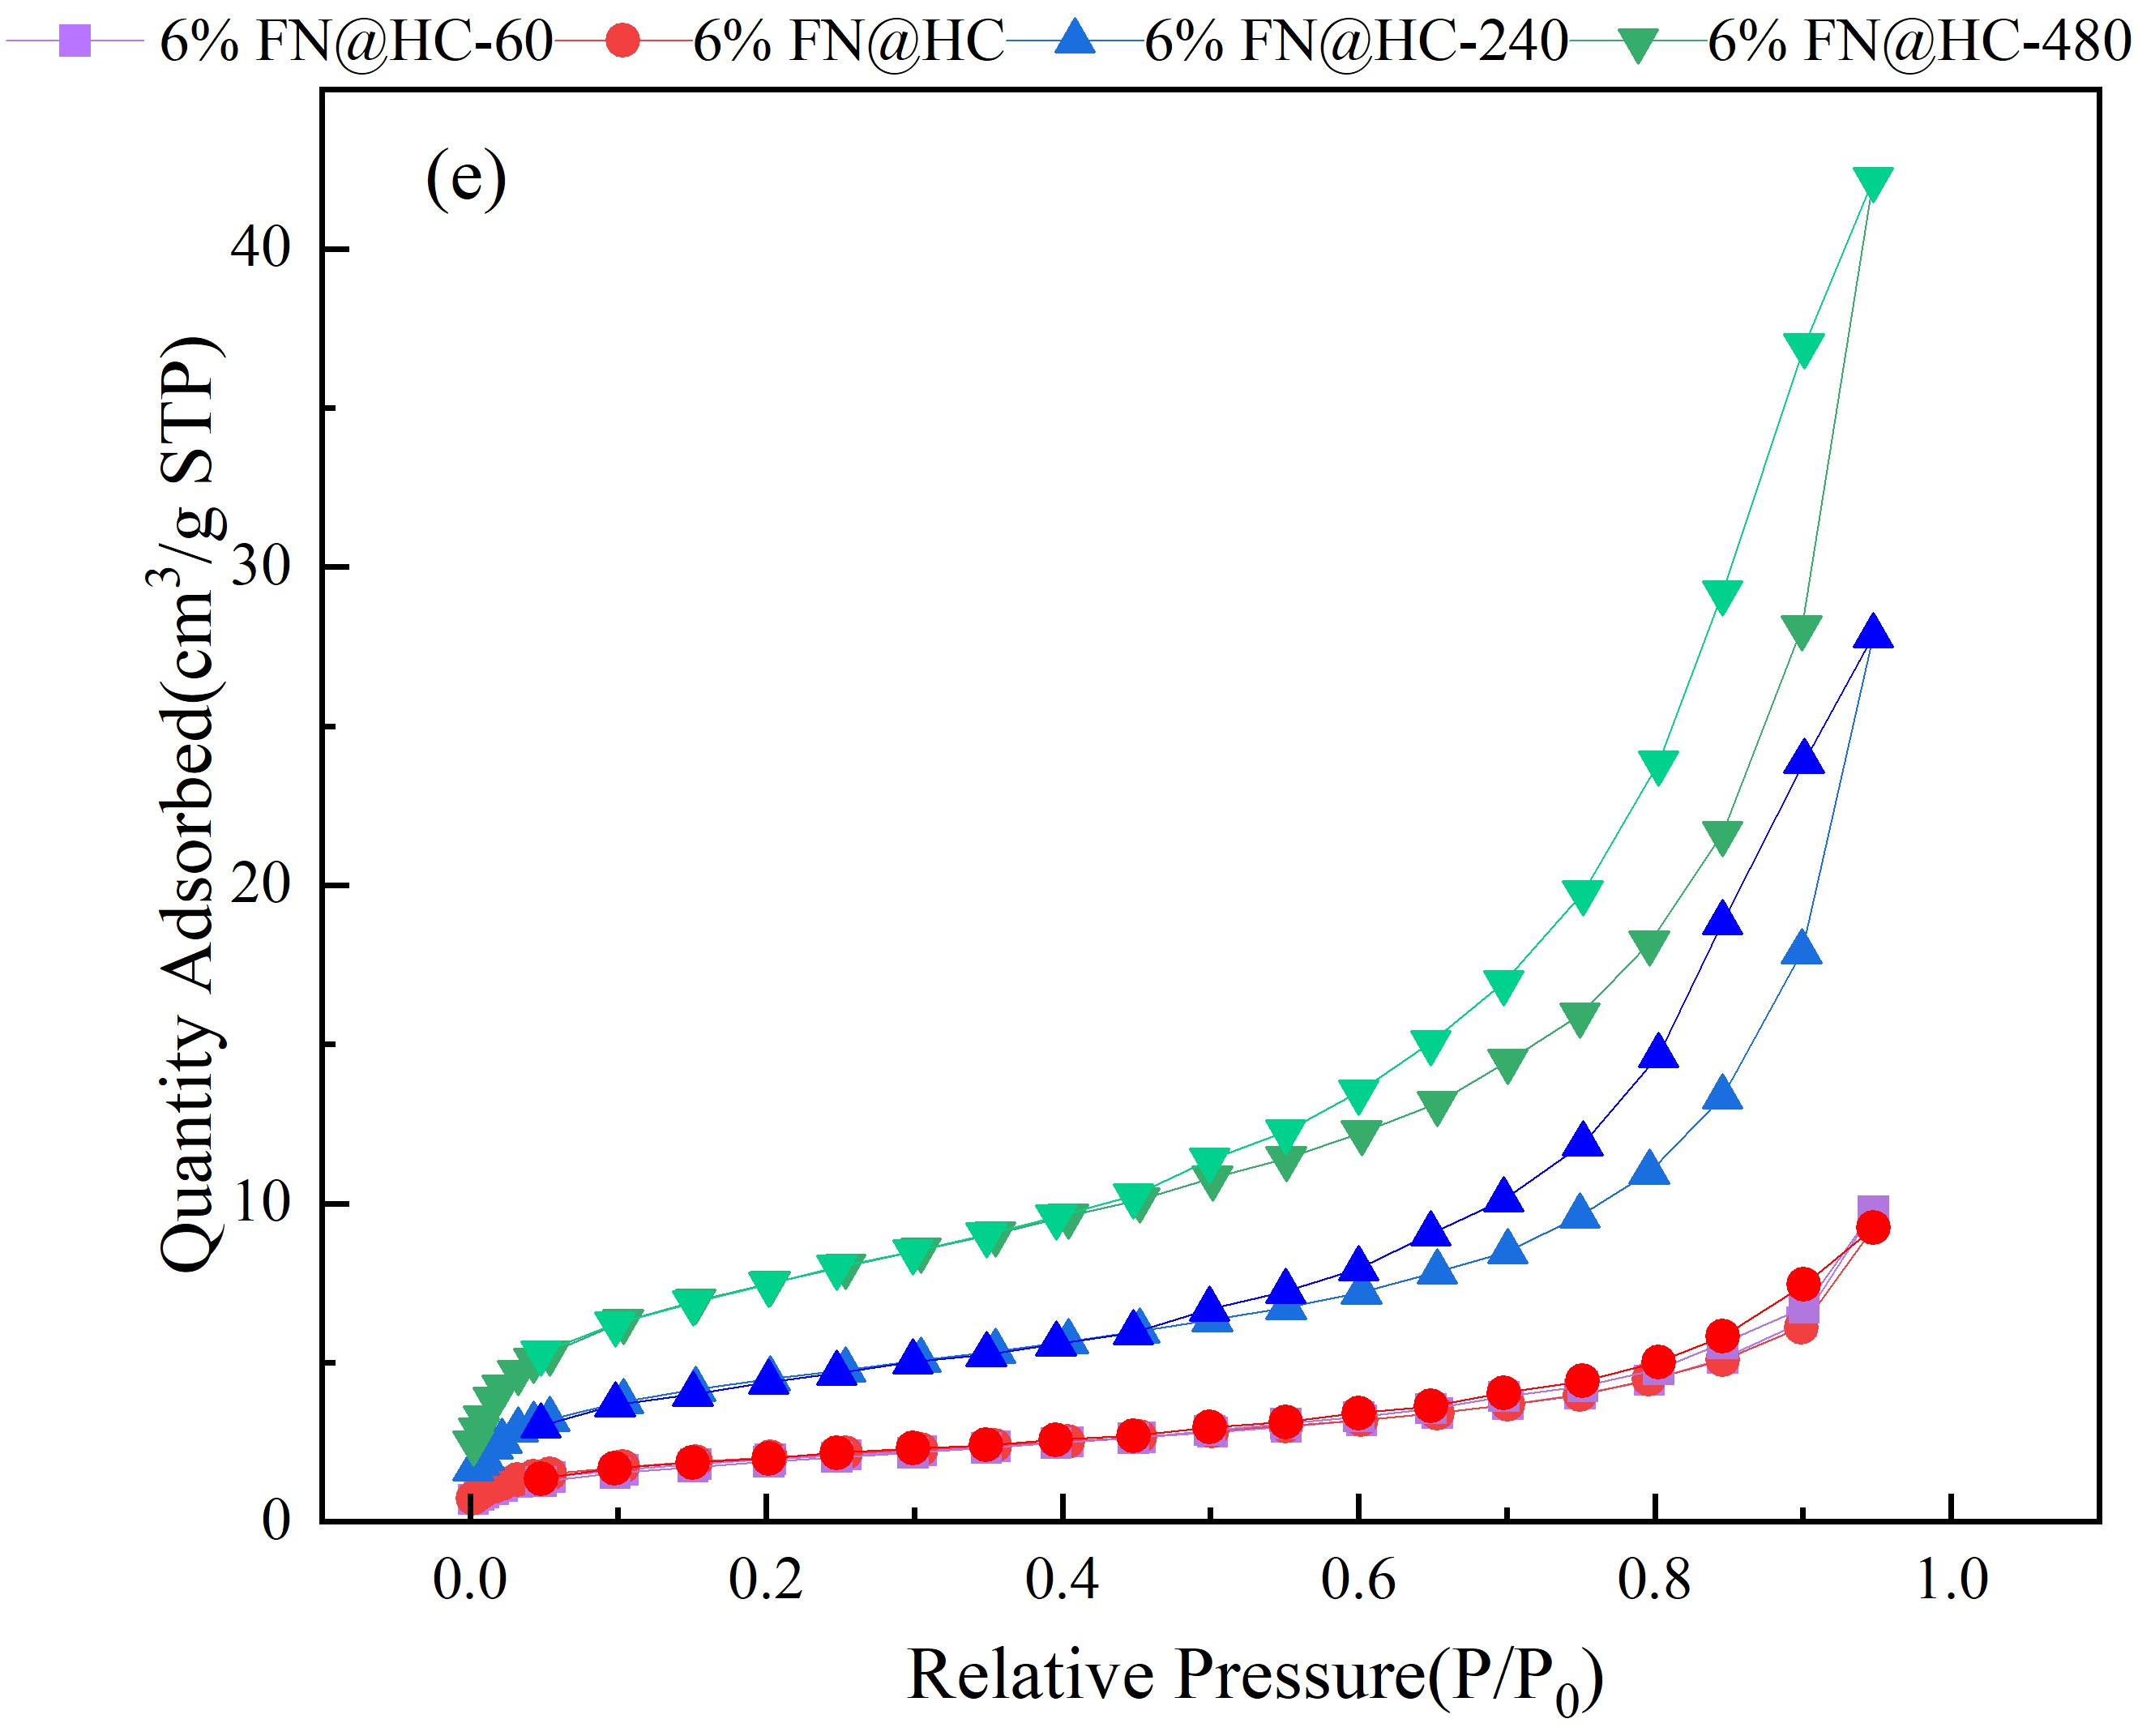 | 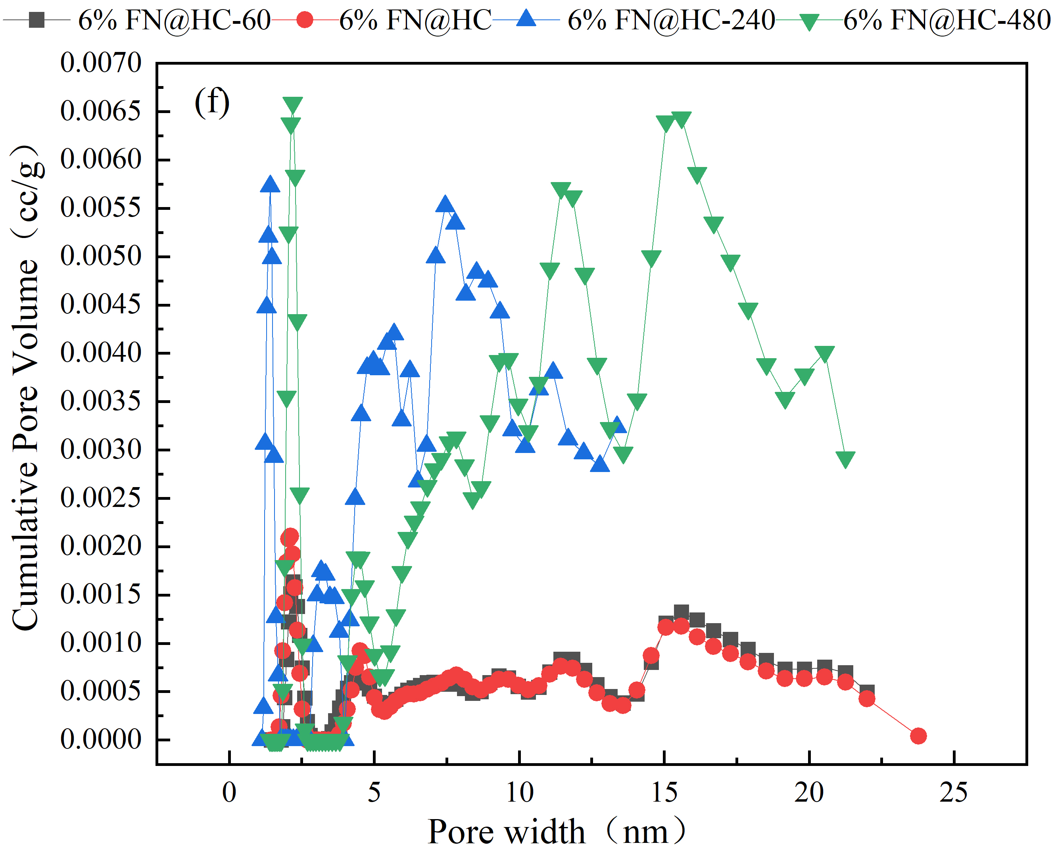
Fig. S3. N₂ adsorption isotherms (a) (c) (e) and the pore size distribution (b) (d) (f) of different iron species, different iron dosage, and different preparation time

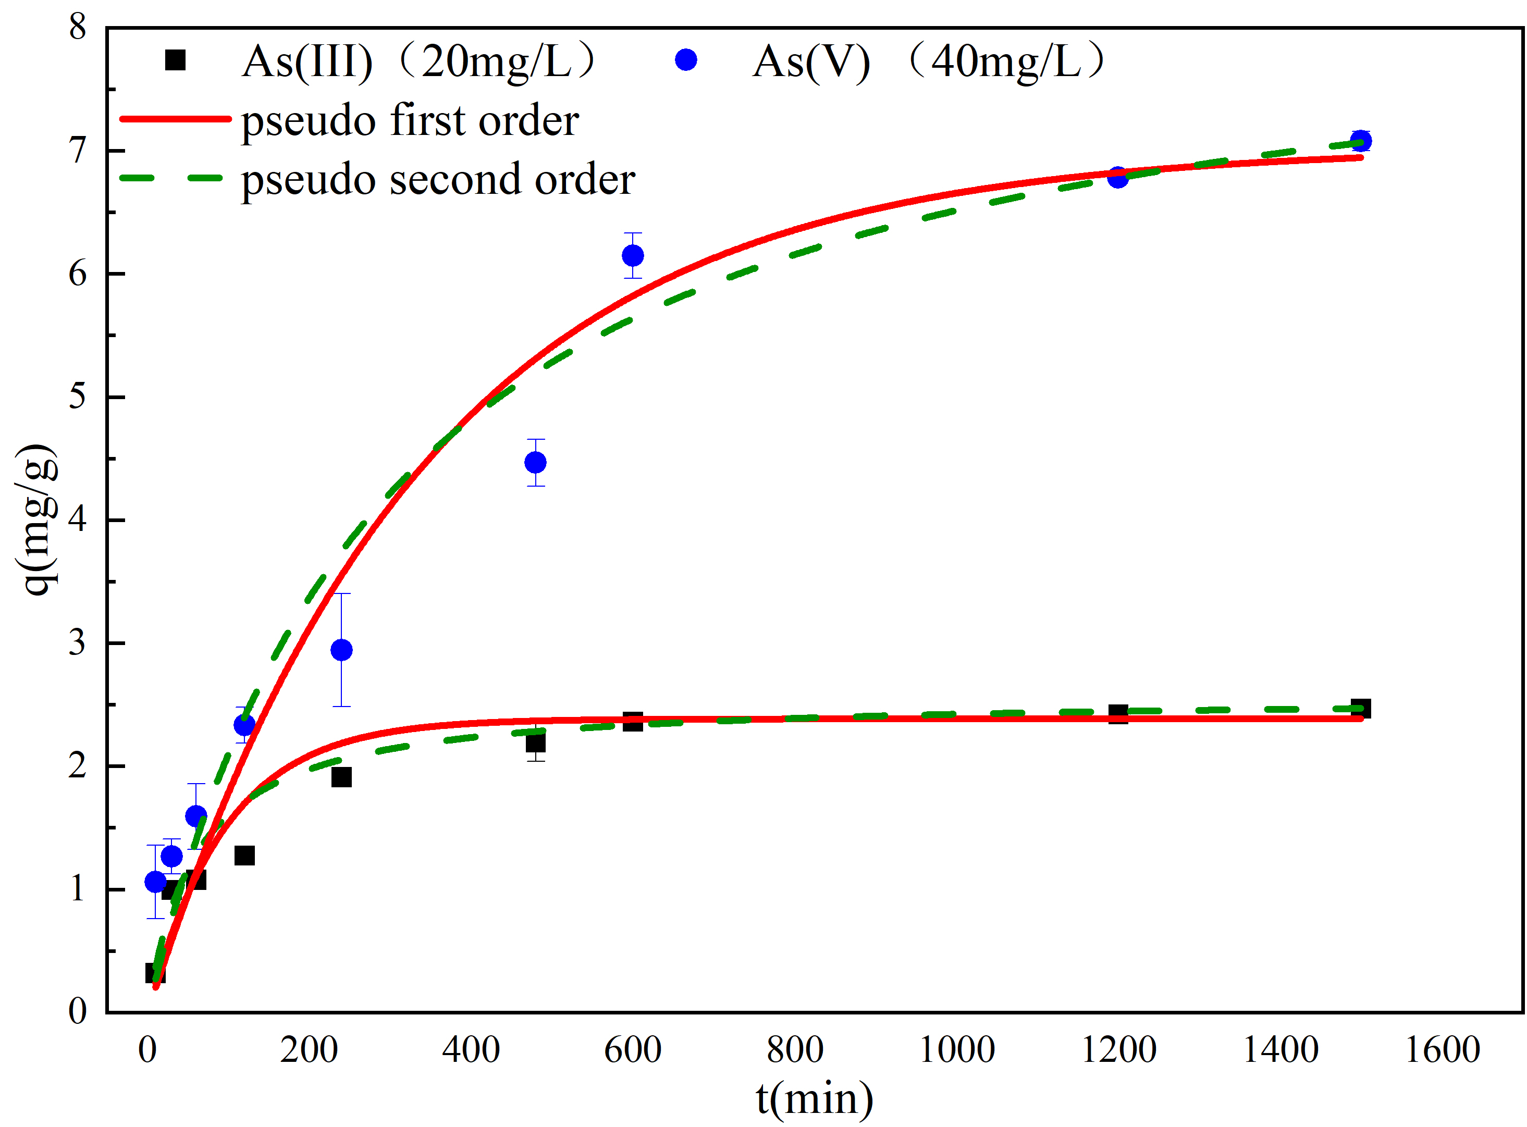
Fig. S4. Adsorption kinetics curves of As (Ⅲ) and As (Ⅴ) by using 8%FN@HC. As (Ⅲ) concentration is 20mg/L; PH, 9± 0.2; Temperature, 25±1°C. As (Ⅴ) concentration is 40mg/L; PH 7±0.2; Temperature, 25± 1 °C
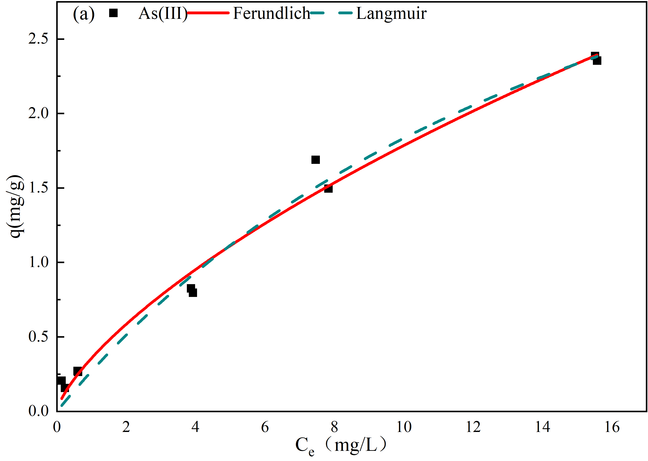
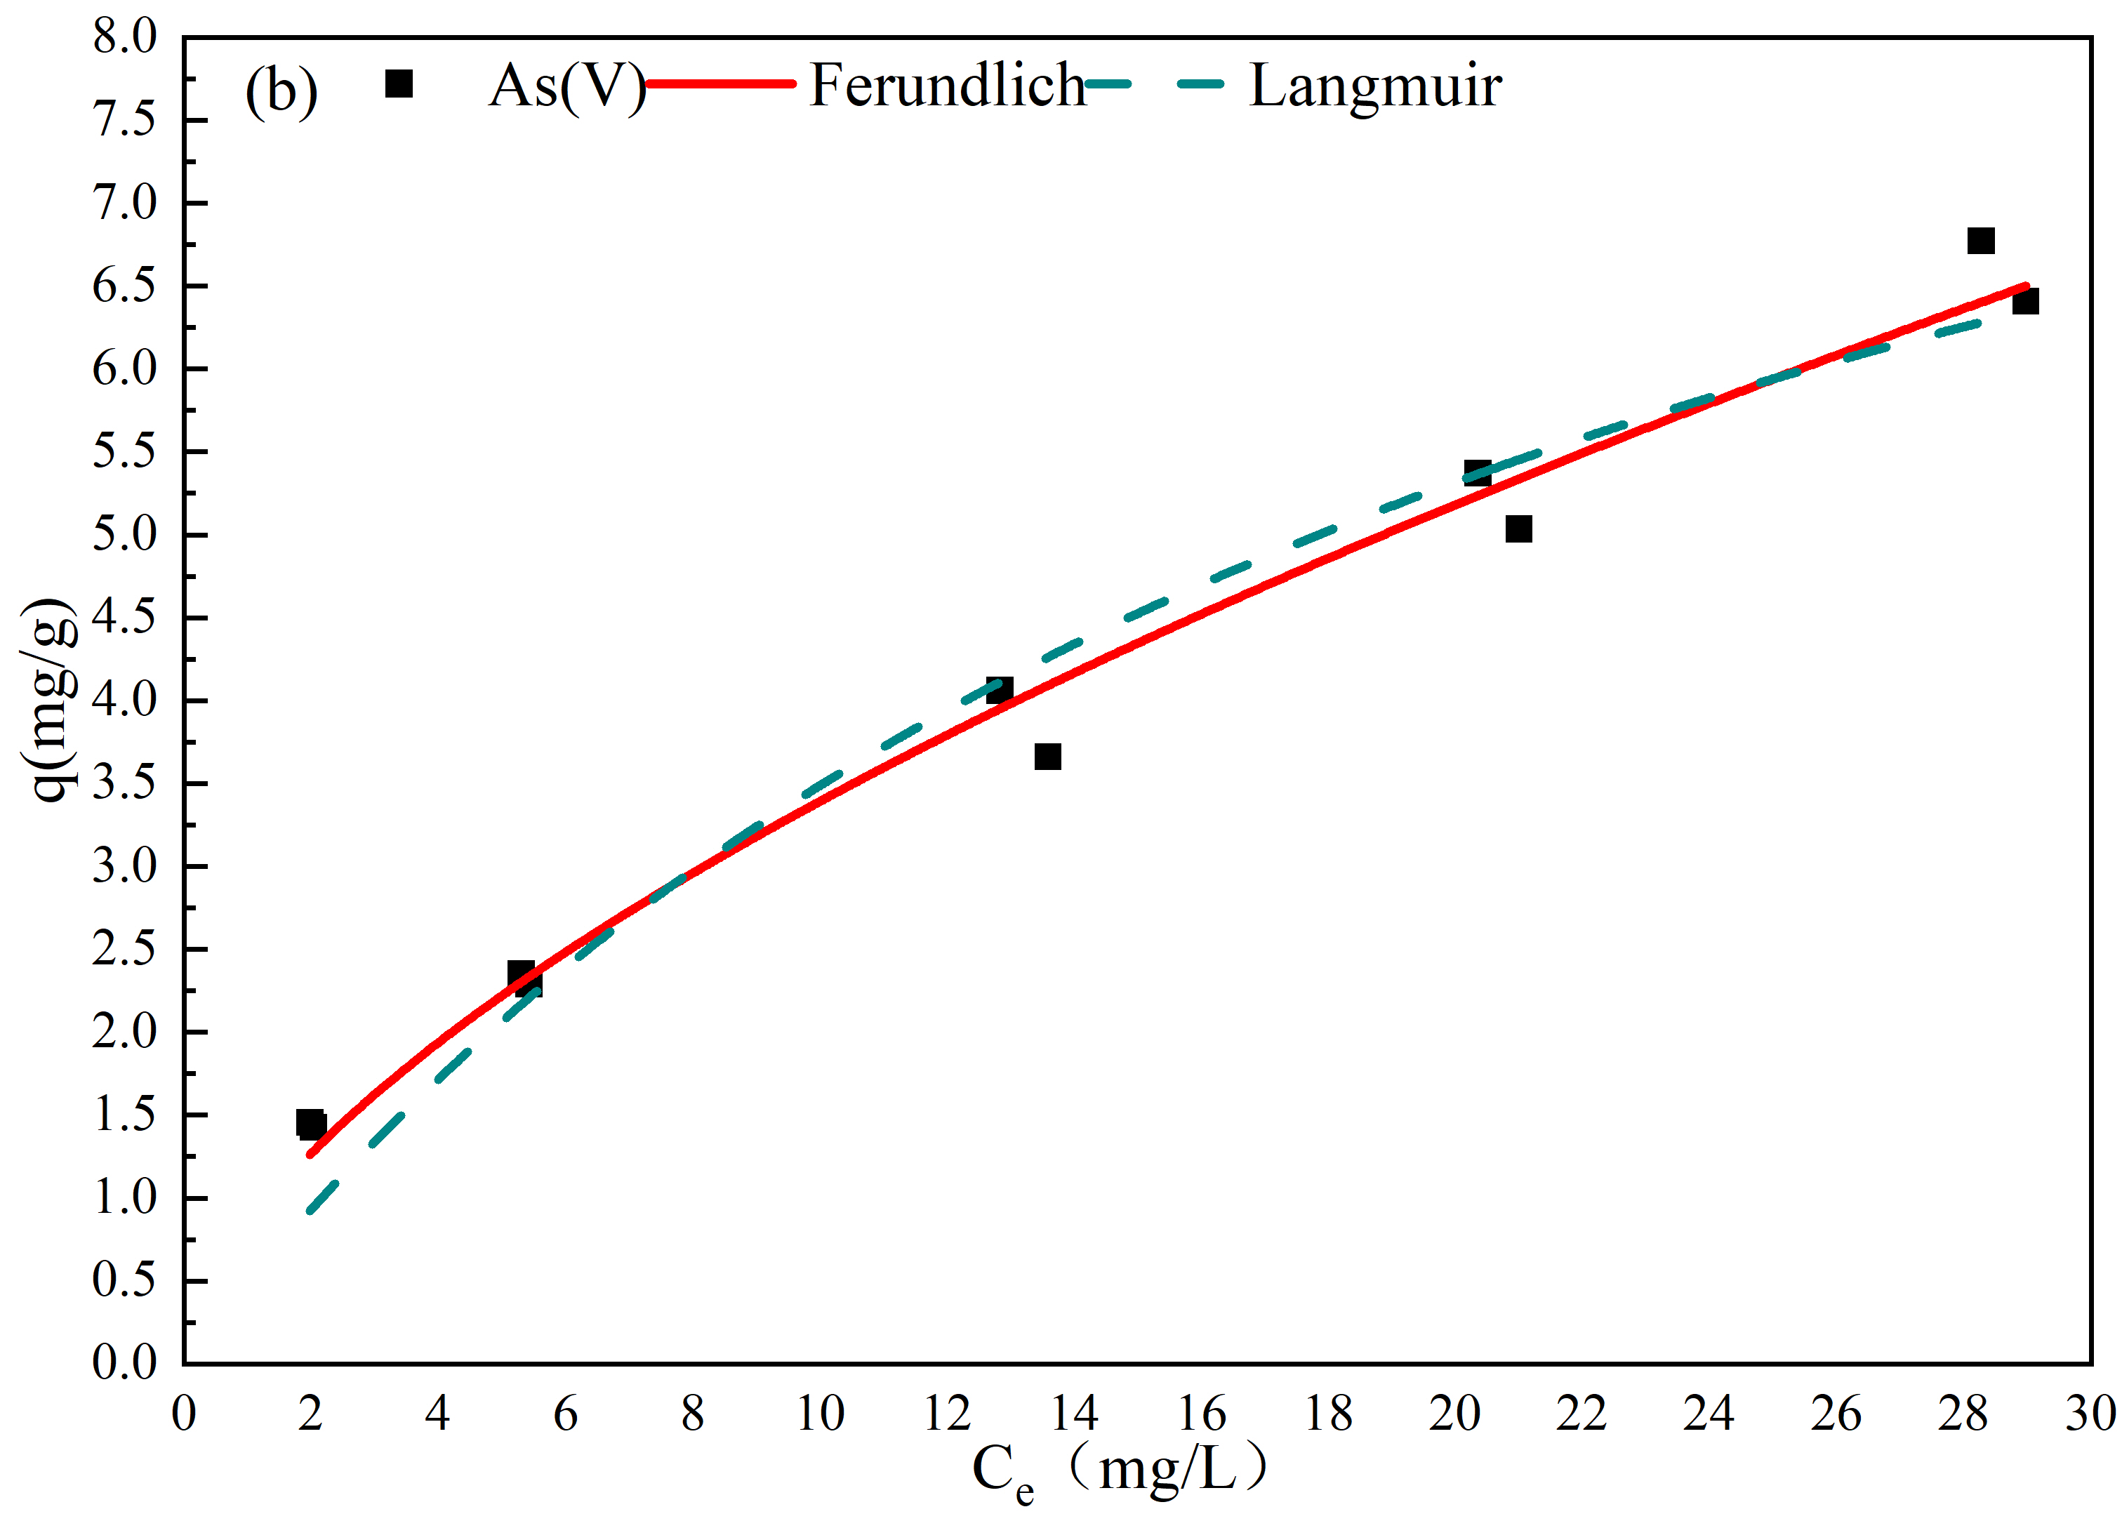
Fig. S5. Adsorption isotherms of As (Ⅲ) and As (Ⅴ) by using 8%FN@HC. (a) As (Ⅲ) concentration is 20 mg/L; PH, 9± 0.2; Temperature, 25±1°C. (b) As (Ⅴ) concentration is 40 mg/L; PH 7±0.2; Temperature, 25± 1 °C

