Supplementary Material
Supplementary Table 1. Univariate Cox regression analysis for PFS in the training cohort.
Variables | HR (95% CI) | p
Age (years) | 0.98 (0.96-1.01) | .227
ALT (U/L) | 1.007 (1.002-1.012) | .012
AST (U/L) | 1.01 (1.004-1.017) | .002
PLT (×10⁹/L) | 1.002 (0.997-1.005) | .364
Albumin (g/L) | 0.94 (0.85-1.03) | .199
TBIL (μmol/L) | 1.01 (0.96-1.07) | .596
Child-Pugh class (A vs. B) | 0.63 (0.24-1.62) | .336
NLR | 1.16 (1.04-1.31) | .011
PLR | 1.01 (1.0009-1.011) | .020
AFP (ng/ml) (≤ 400 vs. > 400) | 1.24 (0.70-2.19) | .461
No. of lesions (Solitary vs. Multifocal) | 1.63 (0.92-2.91) | .097
Diameter (cm) | 1.13 (1.05-1.22) | .002
Vascular invasion (Absence vs. Presence) | 1.96 (1.02-3.74) | .042
Tumor extent (Unilobar vs. Bilobar) | 1.50 (0.82-2.73) | .187
Enhancing capsule (Absence vs. Presence) | 0.87 (0.49-1.55) | .644
Margin appearance (Smooth vs. Non-smooth) | 2.12 (1.12-3.99) | .020
AEF-RT (%) | 1.04 (1.02-1.07) | < .001
Note.—For variables Child-Pugh class, AFP, No. of lesions, vascular invasion, tumor extent, enhancing capsule and margin appearance, the former categories in parentheses were reference. AEF-RT = arterial enhancement fraction of residual tumor, AFP = α-fetoprotein, ALT = alanine transaminase, AST = aspartate transaminase, HR = hazard ratio, NLR = neutrophil-to-lymphocyte ratio, PFS = progression-free survival, PLR = platelet‑to‑lymphocyte ratio, PLT = peripheric platelet count, TBIL = total bilirubin

Supplementary Table 2. The scores assignment and classification strategies of existing prognostic systems
Prognostic Score Systems | Scores Assignment | Classification Strategies
HAP | (1 point for each item, 0 if did not fit)  ·Alb < 36 g/dl  ·AFP > 400 ng/ml  ·TBIL > 17 μmol/L  ·Tumor size > 7 cm | A: 0  B: 1  C: 2  D: > 2
mHAP | (1 point for each item, 0 if did not fit)  ·Alb < 36 g/dl  ·AFP > 400 ng/ml  ·Tumor size > 7 cm | A: 0  B: 1  C: 2  D: > 2
mHAP-II | (1 point for each item, 0 if did not fit)  ·Alb < 36 g/dl  ·AFP > 400 ng/ml  ·TBIL > 17 μmol/L  ·Tumor size > 7 cm  ·Tumor number >= 2 | A: 0  B: 1  C: 2  D: > 2
Six-and-Twelve | Tumor size + Tumor number | Sum no more than 6  Sum between 6 and 12  Sum beyond 12
Up-to-11 | Tumor size + Tumor number | Sum no more than 11  Sum beyond 11
Alb = albumin, AFP = α-fetoprotein, TBIL = total bilirubin

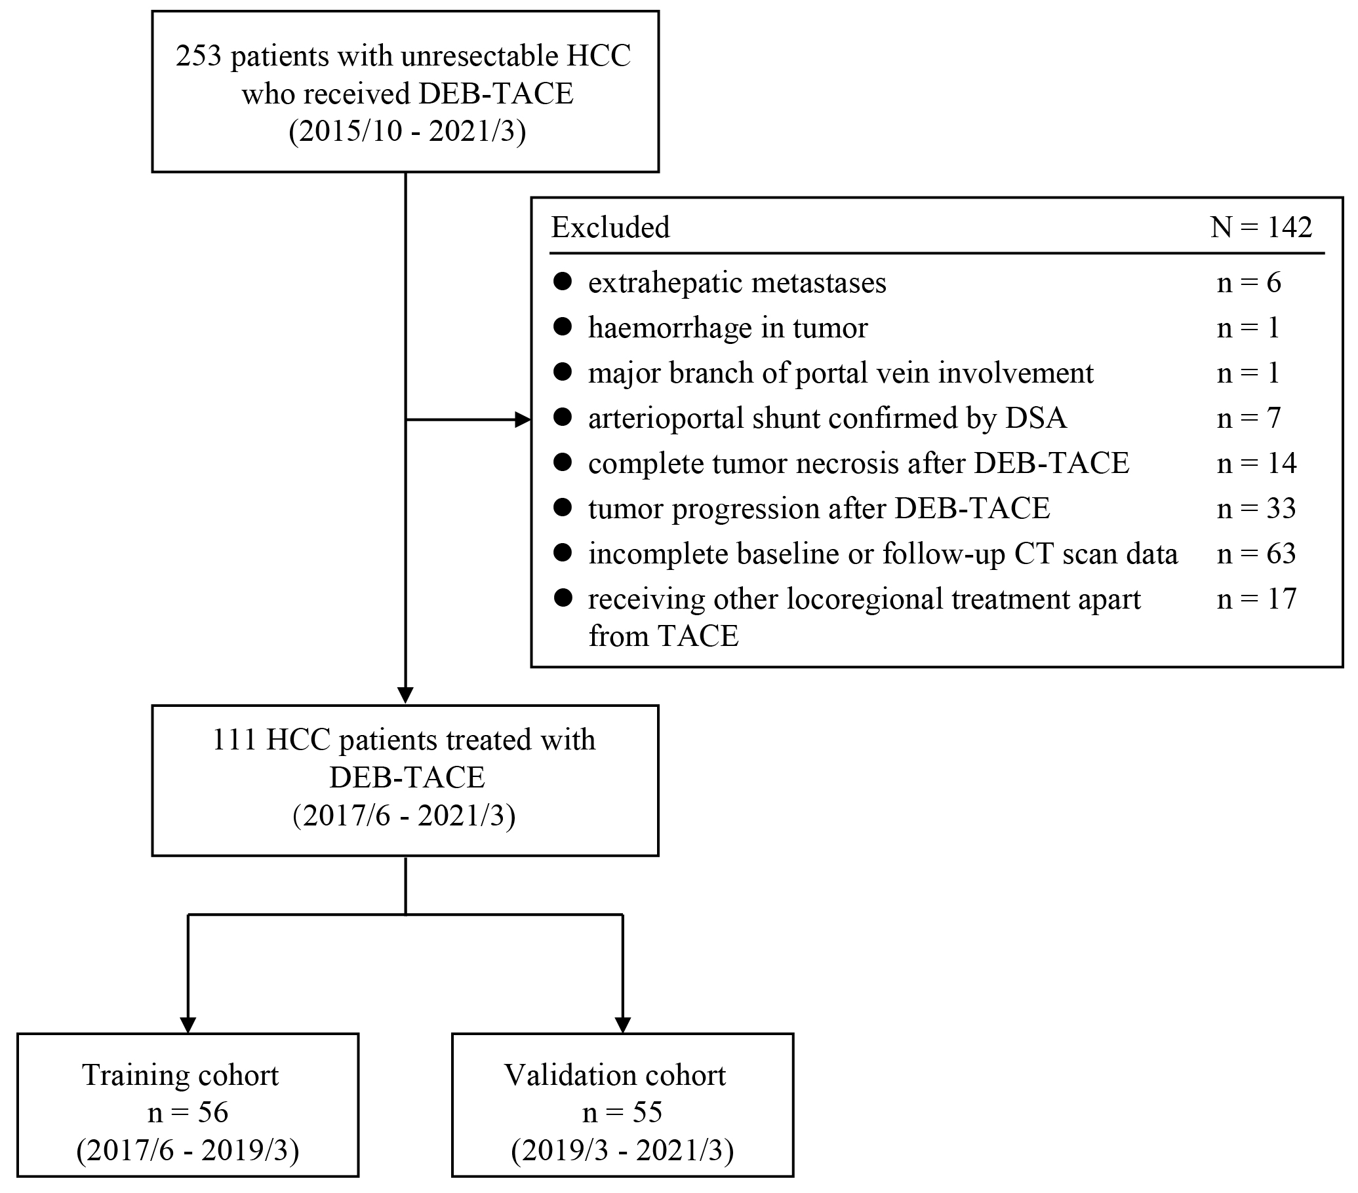
Supplementary Figure 1― Flowchart showing the patient selection and grouping strategy for model derivation and validation. DEB-TACE = drug-eluting bead transarterial chemoembolization; HCC = hepatocellular carcinoma; DSA = digital subtraction angiography.

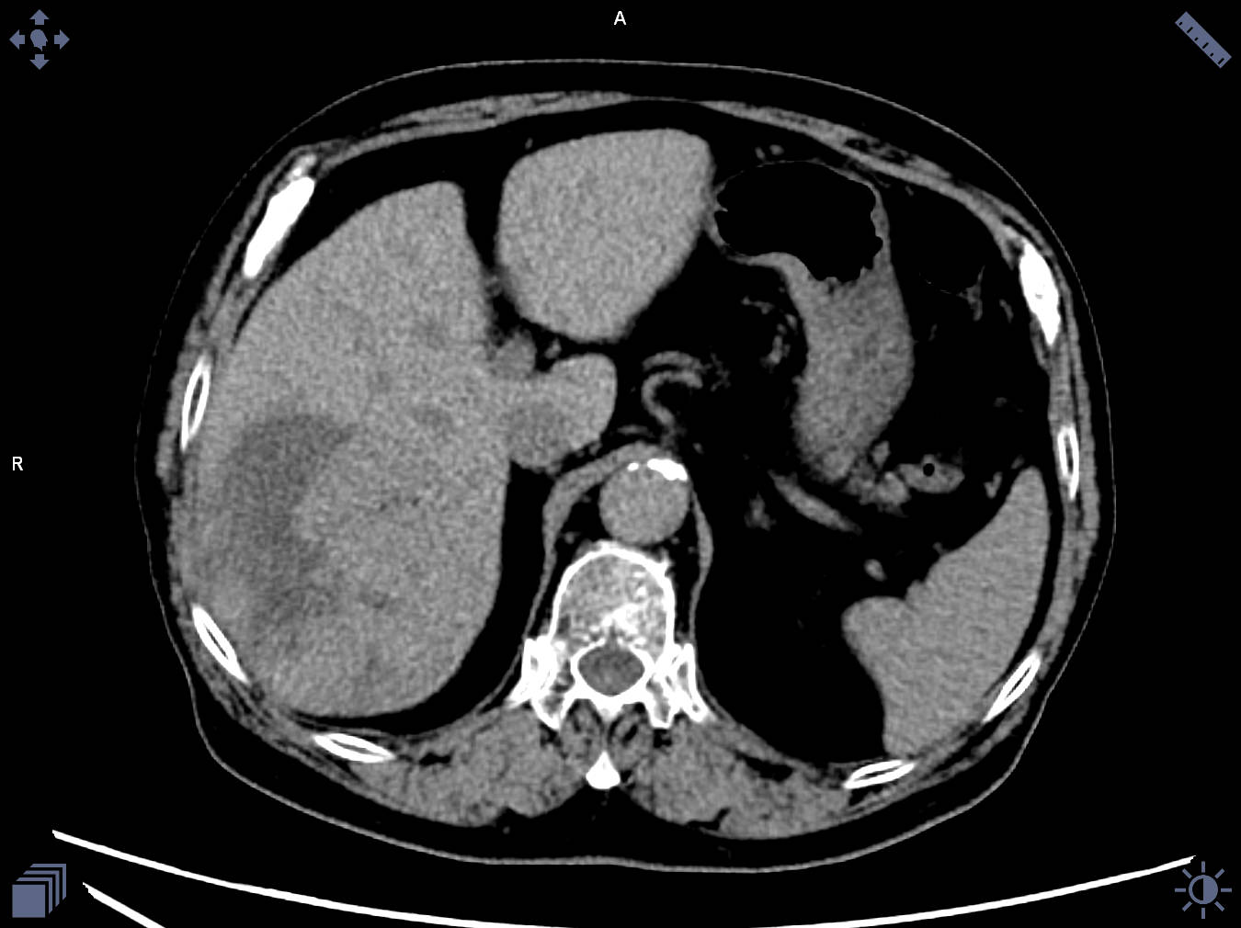
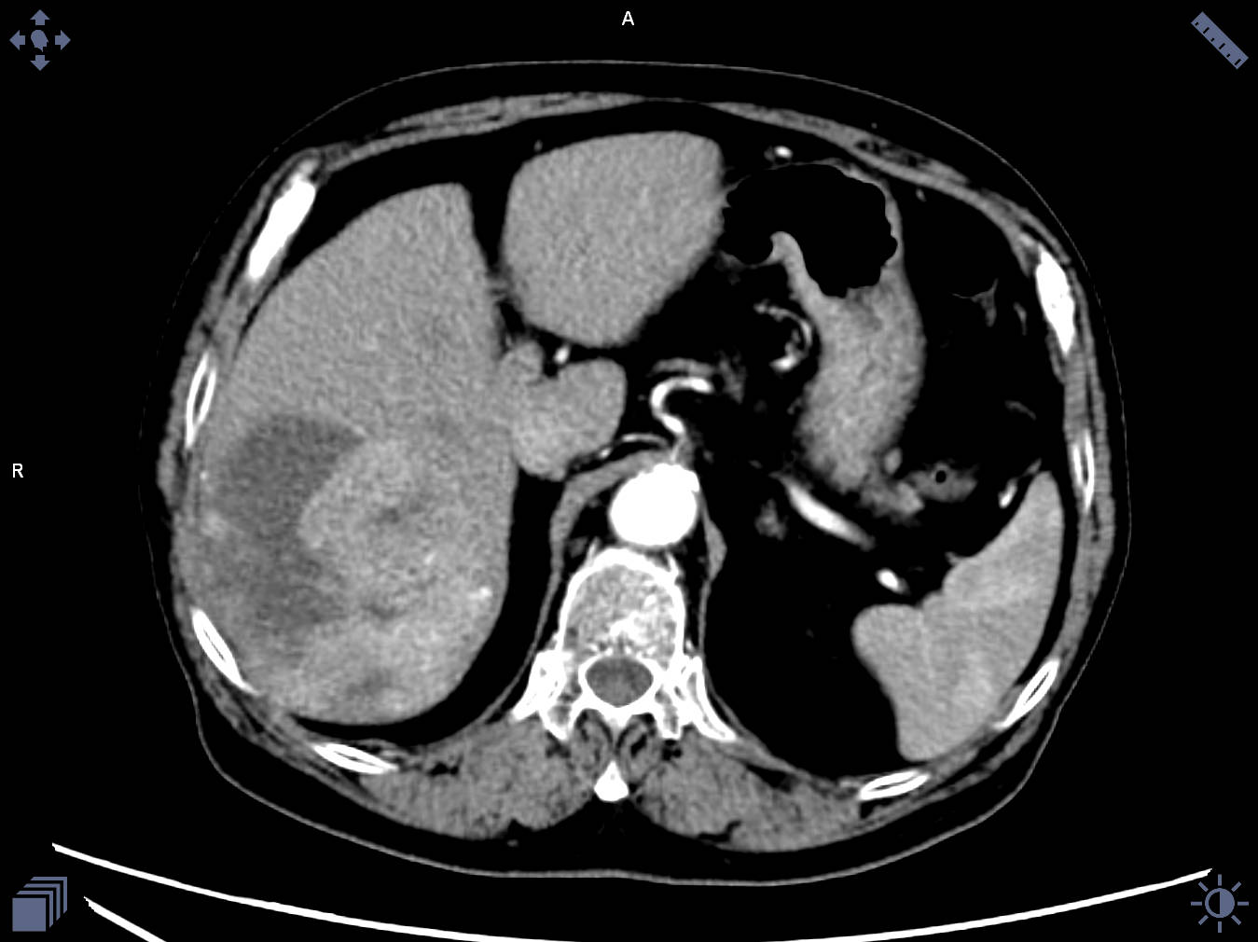
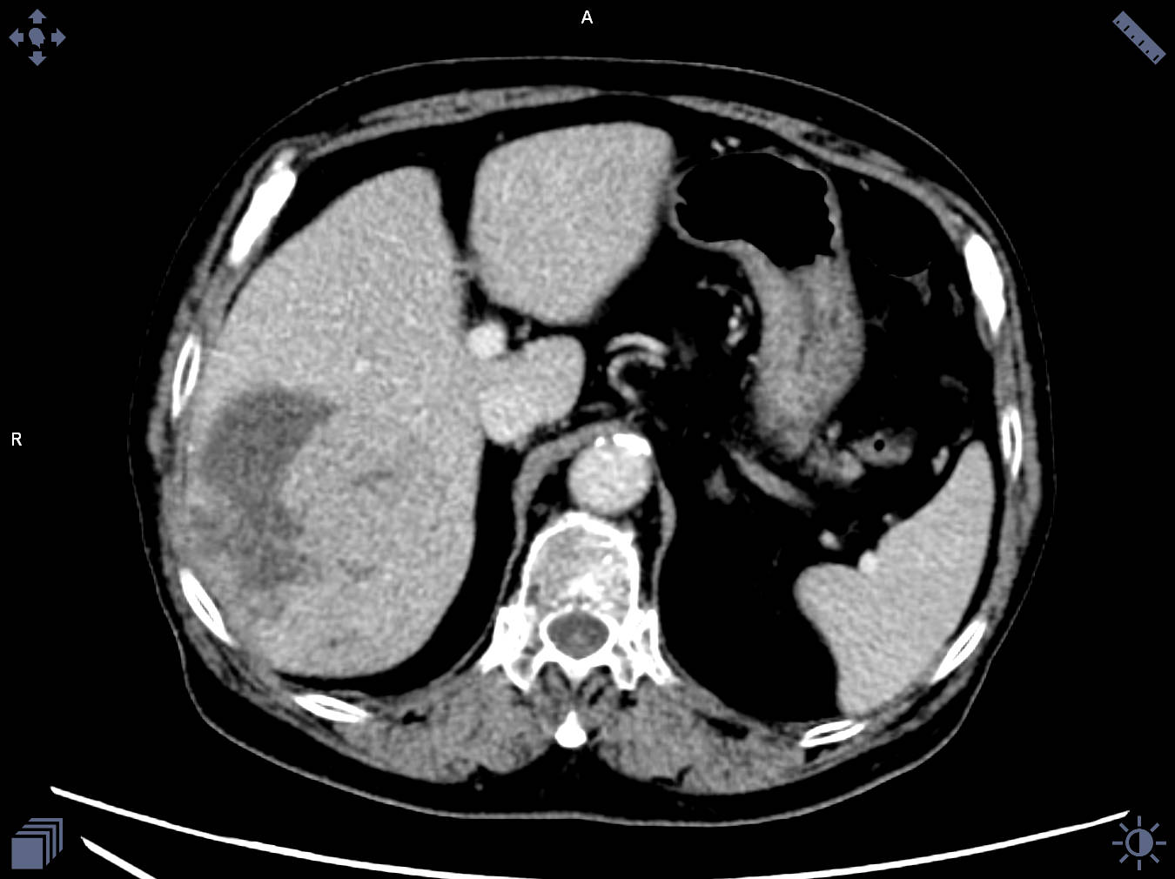
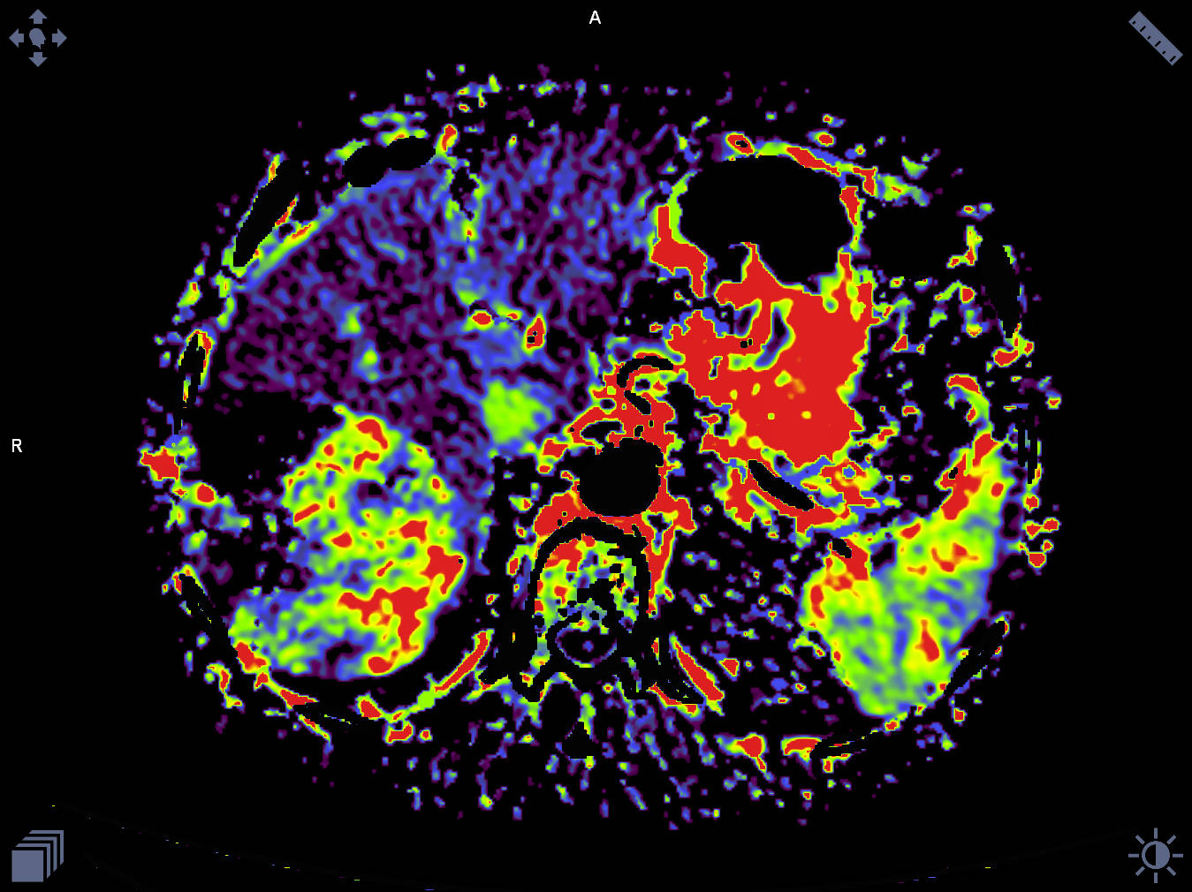
Supplementary Figure 2― The quantitative color mapping of AEF (d) for AEF-RT measuring was generated from unenhanced (a), arterial phase (b), portal venous phase (c) images after DEB-TACE.
a
b
c
c

